Scrum Project Implementation
Question 1 – write Agile Manifesto
4 Core Values
- Individuals and interactions over processes and tools
- Working software over comprehensive documentation
- Customer collaboration over contract negotiation
- Responding to change over following a plan
12 Principles Behind the Agile Manifesto
- Customer satisfaction through early and continuous delivery of valuable software
- Welcome changing requirements, even late in development
- Deliver working software frequently, from a couple of weeks to a couple of months
- Business people and developers must work together daily throughout the project
- Build projects around motivated individuals. Give them the environment and support they need and trust them to get the job done
- Face-to-face conversation is the most efficient and effective method of conveying information
- Working software is the primary measure of progress
- Agile processes promote sustainable development. The sponsors, developers, and users should be able to maintain a constant pace indefinitely
- Continuous attention to technical excellence and good design enhances agility
- Simplicity—the art of maximizing the amount of work not done—is essential
- The best architectures, requirements, and designs emerge from self-organizing teams
- At regular intervals, the team reflects on how to become more effective, then tunes and adjusts its behaviour accordingly
Question 2 – User Stories- Acceptance Criteria-BV-CP
No | User Story | Acceptance Criteria | BV | CP | Priority
1 | As a Delivery Boy,  I want to register on the app,  so that I can start receiving delivery orders | - The registration screen should have fields for Name, Phone  Number, Email, and Password  - All fields must be mandatory  - A submit button should be available to complete the registration.  - The app must show a success message after submitting the form  - If any field is empty or invalid, show an error message  - The delivery boy should get a confirmation via SMS or email  - All registration details must be saved in the system | 500 | 2 | High
2 | As a Restaurant,  I want to view the list of customer orders,  so that I can start preparing and processing them on time | - The restaurant must be able to log in to their account  - There should be a "View Orders" option on the dashboard  - All new, pending, and completed orders must be shown in a table format  - Each order should show details like: Order ID, Customer Name, Items Ordered, Order Time, Delivery Address  - Orders should be sorted by time (latest first)  - Each order should have a "Mark as Processed" button once it’s prepared  - The system should update the order status to "Processed" when clicked  - An optional search or filter should be available (e.g., by status or date) | 500 | 2 | High
3 | As a Customer,  I want to add my delivery address,  so that food can be delivered to the correct location | - Customer must be able to log in to their account  - There should be an option to “Add Address” in the profile or during checkout  - The address form should have fields for: House Number, City, Pincode  - The customer must be able to save multiple addresses  - There should be a "Save Address" button after filling the form | 500 | 2 | High
4 | As a Customer,  I want to select a payment mode,  so that I can make a payment for my food order | - Customer should see available payment modes at the checkout screen: COD, CARD, UPI  - Each option should be presented with a radio button or selection box.  - The system must allow selecting only one payment mode at a time | 500 | 3 | High
5 | As an Admin,  I want to view the list of restaurant registration requests,  so that I can approve or reject them based on their details. | - Admin must be able to log in to the admin panel  - There should be a “Pending Restaurants” section on the dashboard  - The list should display: Restaurant Name, Owner Name etc..  - Once approved or rejected, the restaurant should move out of the pending list  - Admin should be able to search or filter restaurants by name, location, or status | 500 | 2 | High
6 | I want to register or log in,  so that I can access the food delivery app and place orders | For Registration:  The user should see a “Register” option on the home/login screen  Registration form should include:  - Full Name  - Mobile Number  - Email ID  For Login:  - The user should see a “Login” option  - Login form should include: Mobile number or Email, Password | 500 | 3 | High
7 | As a Customer,  I want to search for restaurants,  so that I can view food options and place an order | - Customer should see a search bar on the home screen after logging in  - User can type the restaurant name, cuisine, or dish in the search bar  - Clicking on a restaurant should open its menu page for ordering | 500 | 3 | High
8 | As a Restaurant,  I want to update my menu,  so that customers can view the latest items and prices | - Restaurant should be able to log in to their dashboard.  - There should be a “Menu Management” or “Edit Menu” section.  - System should validate fields | 500 | 3 | Medium
9 | As a Customer,  I want to track my order,  so that I know when it will arrive at my location | - Once the order is placed, a “Track Order” button should appear in the customer's dashboard or order history  - Tracking should update in real time as the order progresses  - The user can refresh the status manually or see it auto-refresh every few seconds | 500 | 3 | High
10 | As a Delivery Boy,  I want to accept orders,  so that I can start the delivery process | - After logging in, the delivery boy should see a list of new orders available for pickup in their area  - The delivery boy should be able to click “Accept” to take up an order  - Status of the order should update to “Accepted by Delivery Boy” | 500 | 3 | High
11 | As a Customer,  I want to rate a delivery,  so that I can give feedback on my experience | - After the order is marked “Delivered”, a rating prompt should appear on the app  - Rating should be submitted via a “Submit Feedback” button  - If the user doesn’t give feedback immediately, they can go to “Order History” and provide feedback later | 200 | 2 | Medium
12 | As an Admin,  I want to see customer feedback,  so that I can monitor the quality of deliveries and services | - Admin should be able to log in and access the “Customer Feedback” section from the dashboard  - Admin can click on any feedback to view full details of the order  - If any feedback violates terms (abuse, spam), admin can flag or delete it  - Feedback should be updated in real-time as customers submit them | 200 | 2 | Medium
13 | As a Delivery Boy,  I want to see delivery history,  so that I can track my past deliveries and performance | Delivery boy logs into the app and selects the “My Deliveries” or “Delivery History” option  Option to download or export history report as PDF  History should be read-only and updated automatically after each delivery | 100 | 2 | Low
14 | As a Restaurant,  I want to see payment reports,  so that I can reconcile my income from orders | - Restaurant logs into the Scrum Foods application and navigates to “Payment Reports”  - Ability to filter by date range  - Reports should support summary view  - System displays last payment status | 500 | 3 | Medium
15 | As a Customer,  I want to cancel orders,  so that I have flexibility in case of changes or mistakes | - Customer logs into the Scrum Foods app and goes to “My Orders”.  - Each order should display a “Cancel” button | 500 | 3 | High
16 | As a Customer,  I want to reorder previous items,  so that I can save time and avoid selecting everything again | - Customer logs into the Scrum Foods app and goes to “Order History”  - Each past order shows a “Reorder” button  - Confirmation page shows “Order placed successfully” after reordering | 200 | 2 | Medium
17 | As a Customer,  I want to filter restaurants by delivery time,  so that I can get food delivered faster | - Customer logs into the Scrum Foods app and goes to the “Search Restaurants” section  - Filtered results should maintain responsiveness and accuracy | 200 | 2 | Low
18 | As a Regional Admin,  I want to manage delivery boys,  so that I can assign them to specific regions and monitor their performance | - Regional Admin logs into the Scrum Foods dashboard  - Delivery boys are notified about their updated assignments via app notification | 500 | 3 | Medium
19 | As a Business Owner,  I want to see revenue reports,  so that I can analyze business growth and performance | - Business Owner logs into the Scrum Foods admin dashboard  - Navigates to the “Revenue Reports” section  - Filters available for date range, region, and restaurant | 500 | 3 | High
20 | As a Customer,  I want to receive order confirmations via SMS or email,  so that I stay informed about my order status | - Customer can choose preferred notification method in profile settings (SMS / Email / Both)  - If delivery is delayed or status changes, updated notifications are sent | 200 | 2 | Medium
21 | As a Customer,  I want to see restaurant ratings,  so that I can make informed choices before placing an order | - Ratings are updated in real-time based on customer feedback  - If a restaurant has no ratings yet, display: No ratings available | 500 | 2 | Medium
22 | As a Delivery Boy,  I want to update the delivery status,  so that customers are kept informed about their order progress | - Delivery Boy logs into the app and sees a list of assigned deliveries  - Delivery Boy can tap on a status to update it in real time  - Once marked as Delivered, the order is locked from further updates | 500 | 2 | High
23 | As a Customer,  I want to apply coupons,  so that I can save money on my order | - On the checkout page, there is a “Apply Coupon” field  - Only one coupon can be applied per order | 200 | 3 | Medium
24 | As an Admin,  I want to view refund requests,  so that I can process them efficiently and maintain customer trust | - Admin logs into the dashboard and selects the “Refund Requests” section  - Admin can filter/search refund requests by date, status, or customer name | 200 | 2 | Medium
25 | As a Restaurant,  I want to pause my service,  so that I can manage my operating hours or handle temporary unavailability | - Restaurant logs into the Scrum Foods app/dashboard  - On the home or settings page, there is a “Pause Service” toggle/button  - System logs the pause/resume timestamps for reporting purposes | 100 | 2 | Low
26 | As a Customer,  I want to contact support,  so that I can resolve any issues related to my orders, payments, or app usage | - Customer logs into the Scrum Foods app  - A “Contact Support” option is available in the menu or help section  - The user can track previous tickets and their status | 200 | 3 | Medium
27 | As a Regional Admin,  I want to assign zones to delivery boys,  so that delivery coverage is efficiently managed within my region | - Regional Admin logs into the Scrum Foods admin portal  - Navigates to “Delivery Boy Management” section  - System prevents assigning one delivery boy to multiple overlapping zones  - Report generation feature shows zone-wise delivery boy assignments | 500 | 3 | Medium
28 | As a Customer,  I want to pay using a wallet,  so that I have flexibility and a quicker checkout experience | - On the payment screen, “Pay via Wallet” option is available along with other payment modes  - Wallet balance can be checked in the user's Profile | 200 | 3 | Medium
29 | As a Business Owner,  I want to export revenue and performance reports,  so that I can share them with stakeholders or analyze them offline | - Business Owner logs into the Scrum Foods dashboard.  - Navigates to the “Reports” section  - System ensures data security – only authorized Business Owners can export | 200 | 2 | Low
30 | As a Delivery Boy,  I want to raise issues from the app,  so that my problems are reported and resolved quickly | - Delivery Boy logs in and navigates to the “Raise Issue” section  - Issue status values include: Pending, In Progress, Resolved, Closed.  - Delivery Boy receives notifications or messages when the issue is updated or resolved. | 200 | 2 | Medium
31 | As a Customer,  I want to get notifications for offers and discounts,  so that I stay informed and save money | - Customer opts in to receive notifications during registration or in app settings  - Customer should see a “Offers” section in the app to review all active promotions  - Users can unsubscribe from notifications anytime via profile settings | 100 | 2 | Low
32 | As a Restaurant,  I want to receive low stock alerts,  so that I can refill ingredients or items on time and avoid order delays | - Restaurant can define a minimum stock level for each ingredient or menu item  - System checks inventory levels automatically after each order or update  - Option to enable/disable alerts or change delivery mode | 200 | 3 | Medium
33 | As a Customer,  I want to schedule orders,  so that food arrives at my chosen time | - A “Schedule Order” option is available during checkout.  - Customer can select date and time for delivery.  - System shows only valid delivery times | 200 | 3 | Medium
34 | As an Admin,  I want to blacklist users or vendors,  so that I can maintain service quality and prevent misuse | - Admin can view list of all users and vendors.  - Each record has a “Blacklist” button next to it.  - On clicking blacklist, system asks for confirmation  - Admin can reactivate the account if needed | 200 | 2 | Medium
35 | As a Regional Admin,  I want to track delivery boy performance,  so that I can identify and reward top performers. | - Regional Admin can view a list of delivery boys under their region  - Admin can filter by date range (weekly/monthly)  - Option to export the report in Excel | 200 | 3 | Medium
36 | As a Restaurant,  I want to create combo offers,  so that I can attract more customers and increase sales | - Restaurant owner can log in and go to “Combo Offers” section.  - Can select multiple items to include in a combo.  - Set a discounted price for the combo | 200 | 3 | Medium
37 | As a Customer,  I want to favorite restaurants,  so that I can access them quickly whenever I want to order | - Customer sees a “heart” or “favorite” icon next to each restaurant.  - Clicking the icon adds the restaurant to My Favorites list  - Changes are saved immediately and work across devices | 200 | 2 | Medium
38 | As a Delivery Boy,  I want to update my bank details,  so that I can receive payments to the correct account | - Delivery boy can log in and go to "Bank Details" section.  - Fields for Account Holder Name, Bank Name, Account Number, IFSC Code, UPI ID  - Only one set of bank details is stored per delivery boy  - Admin receives a notification when bank details are updated | 200 | 2 | Medium
39 | As a Restaurant,  I want to view top-selling items,  so that I can optimize my menu and improve sales | - Restaurant can log in to their dashboard.  - A "Top-Selling Items" section is visible on the dashboard or reports page  - Option to download the report in PDF format  - Data is refreshed automatically every 24 hours | 200 | 2 | Medium
40 | As a Customer,  I want multilingual support,  so that I can use the app in my preferred language | - Language selection option is available on login/registration and in settings  - User can switch language anytime from the settings menu  - System messages and notifications appear in selected language | 500 | 3 | High

Question 3– What is epic? Write 2 epics
In Agile, an Epic is a large user story that cannot be completed in a single sprint.
It represents a broad business goal or feature that is too big or complex, so it's broken down into smaller user stories for easier planning, development, and delivery
- Epic = Big picture / broad functionality
- User Stories = Smaller pieces of that functionality
Customer Order Management
This epic focuses on all activities a customer performs to place, track, and manage food orders
Restaurant Partner Management
This epic deals with features that help restaurant partners manage their operations on the app
Question 4 –What is the difference between BV and CP
Difference between BV (Business Value) and CP (Complexity Points) in Agile:
BV – Business Value
- What it is:
Business Value measures how valuable a feature or user story is to the business or customer
- Why it's used:
Helps prioritize work based on what delivers the most impact or benefit
- Who decides it:
Usually the Product Owner or stakeholders
- Example:
A feature that allows customers to pay online might have high BV (e.g., 1000) because it increases conversion and convenience
CP – Complexity Points
- What it is:
Complexity Points also called Story Points estimate how complex, time-consuming a task is for the development team
- Why it's used:
Helps the team plan their capacity during a sprint
- Who decides it:
Development team during sprint planning
- Example:
A feature requiring lots of backend integration might have high CP (e.g., 8) because it's technically difficult
Question 5 –Explain about Sprint
A Sprint is a fixed time period in Scrum (usually 1 to 4 weeks) during which a Scrum team works to complete a specific set of Product Backlog Items (PBIs) and deliver a potentially shippable product increment
Sprint Duration: 2 Weeks
Each sprint delivers value to the customer
Sprints are repeated cycles that continue until the product is completed
What is Scrum?
Scrum refers to the daily Scrum meeting — a 15-minute daily stand-up that helps the team inspect progress and plan the next 24 hours
Scrum Duration: 1 Day (once every day for 15 minutes)
Focuses on 3 questions:
- What did I do yesterday?
- What will I do today?
- Are there any blockers?
Product Backlog Item(PBI)
- A feature, bug, or requirement to be delivered
- Comes from the Product Backlog
- Examples: User login, Payment integration, Order tracking
Task: Unit of Work
- A small piece of work assigned to one developer
- It is the breakdown of a PBI
- A task should be completed in one day during the scrum
WIP: Work In Progress
- Refers to PBIs or tasks that are currently being worked on by the team
- Helps track what is not yet done
Sprint Backlog
The Sprint Backlog includes:
- Selected PBIs for the sprint
- Tasks for each PBI
- WIP status (Not Started / In Progress / Done)
Term | Description
Sprint | 2-week cycle to deliver product features
Scrum | Daily 15-min meeting to plan and review progress
PBI | Product Backlog Item – feature/requirement
Task | Unit of work done by one developer in one scrum
WIP | Work In Progress- Items that are currently being worked on
Sprint Backlog | List of PBIs, their tasks, and progress status

Question 6 – Explain Product backlog and sprint back log
Product Backlog
The Product Backlog is a master list of everything that needs to be developed in the product. It includes all user stories, features, enhancements, bug fixes, and technical work. It is maintained by the Product Owner
- Items in the product backlog are called PBIs (Product Backlog Items)
- The backlog is prioritized based on business value
- It is a living document — items can be added, updated, or removed anytime
Sprint Backlog
The Sprint Backlog is a subset of the Product Backlog. It includes only those PBIs (user stories) that the team has committed to complete in the current sprint (2 weeks in your case)
- Created during the Sprint Planning Meeting
- Each PBI is broken down into tasks
- The team works on these tasks daily and updates their WIP (Work In Progress) status
Example PBIs:
- As a Customer, I want to register
- As a Delivery Boy, I want to accept orders
- As a Restaurant, I want to update the menu
Sprint Planning Meeting
- Held before the sprint starts
- All 8 Scrum Developers and the Product Owner participate
- The team decides how many user stories they can develop in the sprint (based on past velocity and story points)
- They take input from the Sprint Retrospective of the previous sprint to improve planning
- Selected PBIs are moved from the Product Backlog to the Sprint Backlog
Daily Scrum (Scrum Meeting)
- Also called Daily Stand-up
- Happens once every day, typically for 15 minutes
- All Scrum Developers attend
- Each developer answers questions
Workflow
- Product Owner prepares the Product Backlog
- During Sprint Planning, the team selects 10 user stories → moves them to Sprint Backlog
- Each story is broken down into Tasks
- Every day, during the Scrum Meeting, the team tracks
  - Tasks in progress (WIP),
  - Completed tasks,
  - Any blocker
- At the end of the sprint, all Done stories are reviewed and potentially released
Question 7 – What is impediments log? write 2 impediments
An Impediments Log is a document or tracking system used by the Scrum team to record and monitor any issues, obstacles, or blockers that prevent team members from completing their tasks efficiently during a sprint
These impediments are usually identified during Daily Scrum meetings, and it's the Scrum Master's responsibility to help remove or resolve them quickly
Purpose of Impediments Log:
- Track and document all challenges faced by the team
- Ensure transparency and accountability
- Help the Scrum Master take action to resolve issues early
- Prevent delays in delivery
Impediments Log:
No | Impediment Description | Date Logged | Impact | Status | Resolved By
1 | API not responding for payment gateway integration | 24-Jul-25 | Delaying backend progress | In Progress | Scrum Master
2 | Login page design not finalized by UI/UX team | 25-Jul-25 | Blocking frontend tasks | Pending | Product Owner/UX Team

Question 8 – Explain Velocity of the Team
Velocity in Agile refers to the total number of Complexity Points (CP) completed by the Scrum Team in a single sprint
Velocity helps the team and stakeholders understand how much work the team can complete in one Sprint. It is used to plan future sprints more accurately
Why is Velocity Important?
- It tells how fast your team is delivering
- Helps Product Owner in forecasting how many sprints are needed
- Helps in sprint planning: If team velocity is 20 CP, they will pick ~20 CP worth of stories for the next sprint
Represented In:
- Sprint Burndown Chart: Shows how CPs decrease every day
- Sprint Review: Velocity is discussed to understand progress

Question 9 – Draw Sprint Burn Charts n Product Burn Down Charts

Sprint BurnDown Chart shows how the team reduced Complexity Points (CP) day-by-day over a 10-day sprint (2 weeks)
Product BurnDown Chart shows how the overall project CP reduces across 13 sprints until the product is complete

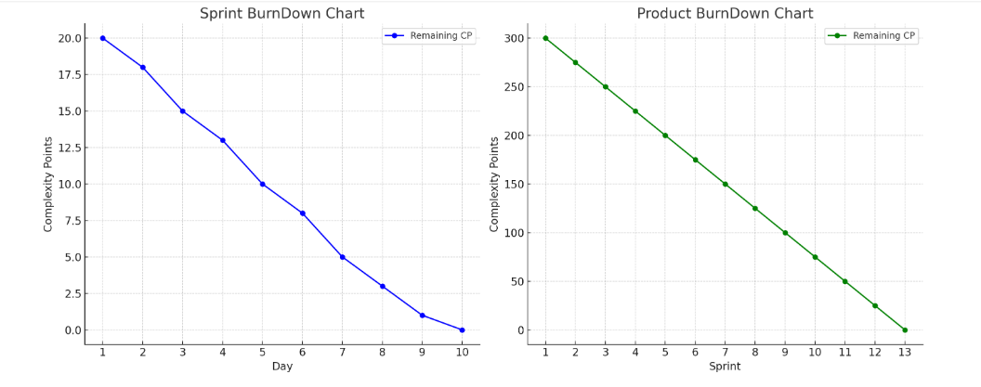
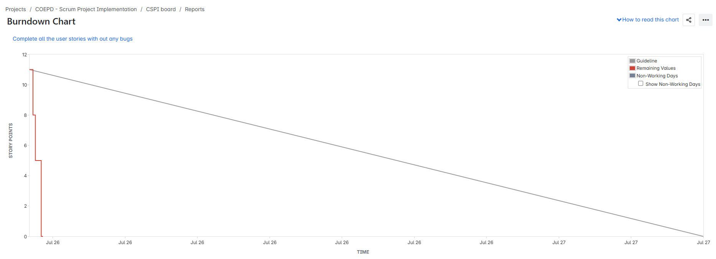
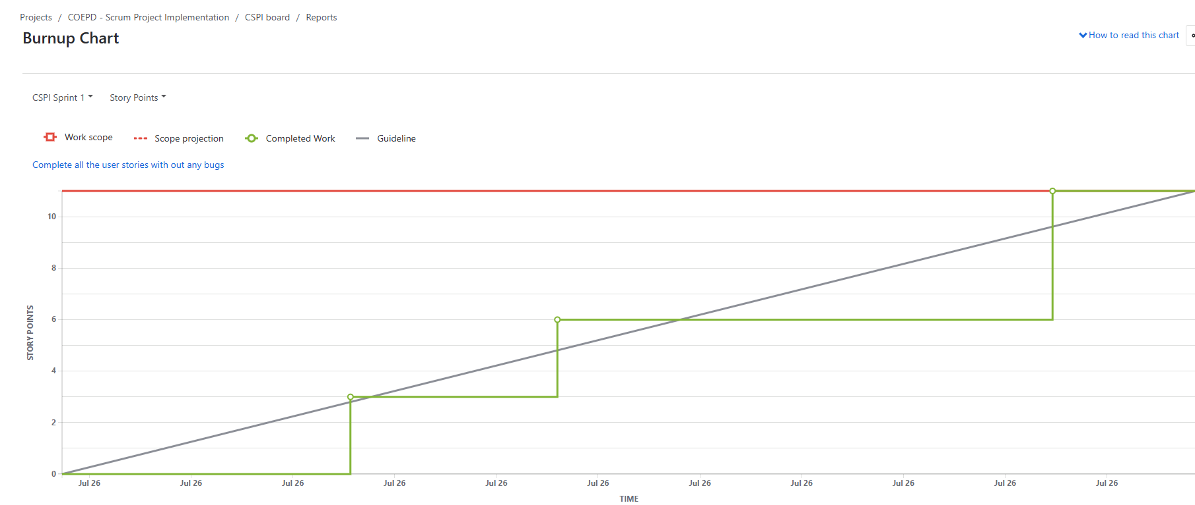
Question 10 – Explain about Product Grooming
Product Grooming also called Backlog Refinement is a regular meeting where the Product Owner and the Scrum Team review and refine the Product Backlog. The goal is to ensure that backlog items are well-defined, prioritized, and ready to be taken into future sprints
Product Insights for Improvement help the Scrum Team make smarter decisions during Product Grooming, so the product continuously evolves in the right direction and stays user-focused
Product Insights refer to data, feedback, and observations collected from:
- Customer reviews and ratings
- Support tickets and complaints
- App usage behaviour
- Market trends
- Sprint Retrospective feedback
- Bug reports or usability issues
Key Activities in Product Grooming:
- Reviewing user stories – Making sure the stories are clear and understandable
- Breaking down large stories (Epics) – Splitting them into smaller, manageable stories
- Estimating Complexity Points (CP) – Developers give effort estimates using techniques like Planning Poker
- Prioritizing stories – Product Owner decides which stories bring more Business Value (BV)
- Clarifying requirements – Developers ask questions and clear doubts about the stories
Question 11 – Explain the roles of Scrum Master and Product Owner
Scrum Master – Role & Responsibilities:
The Scrum Master is like a coach or facilitator who ensures that the Scrum process is followed properly by the team
Responsibilities:
- Facilitates daily stand-ups (Scrum meetings)
- Removes impediments/challenges faced by the team
- Protects the team from external interruptions
- Guides the team on Agile principles
- Helps the team continuously improve (Kaizen)
- Facilitates Sprint Planning, Review, and Retrospective
Product Owner – Role & Responsibilities:
The Product Owner represents the client or business and is responsible for maximizing the value of the product being built
Responsibilities:
- Owns the Product Backlog
- Writes clear User Stories with BV, CP, Priority
- Prioritizes backlog items based on customer needs
- Works closely with stakeholders to gather requirements
- Participates in Product Grooming
- Gives final approval on user story completion
I(Me) Experience as Product Owner – Sprint 1:
In Sprint 1, Me acted as the Product Owner and played the following roles:
🔹 Planning:
- Participated in Sprint Planning Meeting
- Selected 10 MVP user stories based on BV and complexity
- Collaborated with Scrum Master to guide developers
🔹 Grooming & Prioritizing:
- Conducted Backlog Grooming sessions
- Assigned BV (Business Value) and CP (Complexity Points)
- Ensured stories were clear, concise, and ready for development
🔹 Communication:
- Communicated client expectations to the team
- Addressed developer queries during Scrum meetings
- Actively participated in Sprint Review to validate output
🔹 Outcome:
- Successfully delivered the Product Increment
- Collected feedback from stakeholders for next sprint
- Helped improve team focus and velocity
Question 12 – Explain all Meetings Conducted in Scrum Project
Scrum projects involve 5 key meetings to ensure smooth planning, execution, tracking, and improvement. These meetings help the Scrum Team stay focused, aligned, and productive.
1. Sprint Planning Meeting
When: Beginning of each Sprint
Duration: 2 hours for a 2-week sprint
Participants: Scrum Master, Product Owner, Scrum Developers
Purpose:
Decide what user stories will be delivered in the Sprint
Break down PBIs (Product Backlog Items) into Tasks
Move selected PBIs to Sprint Backlog
Set the Sprint Goal
2. Daily Scrum (Stand-Up Meeting)
When: Daily (usually morning)
Duration: 15 minutes
Participants: Scrum Developers (Scrum Master can facilitate)
Purpose:
Each team member answers:
What did I do yesterday?
What will I do today?
Any challenges or impediments?
3. Sprint Review Meeting
When: End of Sprint
Duration: ~1 hour
Participants: Scrum Master, Product Owner, Scrum Team, Client, Stakeholders
Purpose:
Demo the completed Product Increment
Gather feedback from stakeholders
Discuss Business Value delivered
Evaluate Sprint Goals vs. Achievements
4. Sprint Retrospective
When: End of Sprint (after Review)
Duration: ~30–60 minutes
Participants: Scrum Developers only
Purpose:
Discuss what went well, what didn’t
Identify lessons learned
Plan improvements for the next Sprint
5. Product Backlog Grooming (Refinement)
When: Mid-sprint or regularly scheduled
Duration: As needed (~1–2 hours/week)
Participants: Product Owner, Scrum Developers
Purpose:
Review and refine the Product Backlog
Update BV, CP, and priorities
Ensure User Stories are clear, concise, and ready for planning
Meeting | When | Participants | Purpose
Sprint Planning | Start of Sprint | All Scrum Roles | Select user stories for the sprint
Daily Scrum | Every Day | Scrum Developers | Share progress & blockers
Sprint Review | End of Sprint | All Stakeholders | Demo product & gather feedback
Sprint Retrospective | After Sprint Review | Scrum Developers | Reflect and improve
Backlog Grooming | Mid-sprint / Regular | PO + Scrum Team | Refine and prioritize backlog items

Question 13 – Explain Sprint Size and Scrum Size
Sprint Size
Definition:
Sprint size refers to the total duration of a Sprint — the timebox within which the Scrum Team completes a set of Product Backlog Items (PBIs).
- Typical Duration: 2 weeks
- Why 2 Weeks?
  - Short enough for fast feedback
  - Long enough to build meaningful features
Sprint Size in Our Project:
- Duration: 2 Weeks
- Total Scrums: 10 (1 Scrum per working day)
- Planned PBIs: 10 User Stories per Sprint (based on team capacity and previous velocity)
Scrum Size
Definition:
Scrum Size refers to the number of Scrum sessions conducted within a Sprint. A Scrum is a daily meeting (stand-up) to track the team’s progress.
- Each Scrum Duration: 15 minutes
- Participants: Scrum Developers
What Happens in Each Scrum
Team members answer:
- What did I do in the last Scrum
- What will I do today
- Any blockers or challenges
Scrum Size in Our Project:
- Total Scrums in 1 Sprint: 10
(1 Scrum × 10 working days in a 2-week sprint)
Aspect | Sprint Size | Scrum Size
Definition | Total duration of the Sprint | Total number of Scrum meetings
Frequency | Once every 2 weeks (per Sprint) | Daily (once per working day)
Duration | 2 weeks | 15 minutes per day
Purpose | Deliver a set of user stories | Track daily progress and blockers
Example (our project) | 1 Sprint = 2 weeks | 1 Sprint = 10 Scrums (10 working days)

Question 14 – Explain DOR and DOD
DOR – Definition of Ready
DOR is a checklist of conditions that must be met before a user story or task can be picked up by the development team
It ensures that the work is clear, well-understood, and actionable
When is a user story “Ready”
- Be clearly defined and understood by the team
- Have acceptance criteria written
- Be estimated with CP (Complexity Points)
- Be prioritized in the Product Backlog
- Have all necessary dependencies resolved
- Be testable
DOD – Definition of Done
DOD is a checklist of criteria that must be fulfilled for a user story or task to be considered completed and shippable
When is a user story “Done”?
- Be fully developed
- Code is reviewed
- Pass all functional and non-functional testing
- Be integrated and deployed in test/staging environment
- Be accepted by the Product Owner
- Be ready for release (if required)
Question 15 – Explain Prioritization Techniques and MVP
Prioritization in Agile means deciding which features, user stories, or tasks should be done first based on factors like customer value, urgency, complexity, and business goals. This helps the team focus on what truly matters in delivering value
Common Prioritization Techniques: MoSCoW Method
- Must Have: Critical requirements (no delivery without them)
- Should Have: Important but not critical
- Could Have: Nice to have if time permits
- Won’t Have (now): Lowest priority, not included in current sprint
MVP – Minimum Viable Product
MVP is the smallest set of features that delivers value to early users and allows the team to collect feedback with minimal effort
Key Characteristics of MVP:
- Solves a core problem
- Has enough features to be usable
- Reduces time to market
- Helps gather user insights for future improvements
Example:
For a Food Delivery App:
- MVP may include:
  - Customer Registration/Login
  - Restaurant Listings
  - Place an Order
  - Payment
  - Track Delivery
Question 16 – Difference between Business Analyst n Product Owner
Difference between Business Analyst (BA) and Product Owner (PO)
Though both roles focus on understanding user needs and delivering business value, there are some clear differences between a Business Analyst and a Product Owner in an Agile project:
Aspect | Business Analyst (BA) | Product Owner (PO)
Role Focus | Gathers, analyzes, and documents requirements | Owns the product vision and prioritizes the product backlog
Customer Interaction | Works closely with stakeholders to understand needs | Represents the customer’s voice and makes product decisions
Backlog Management | Supports PO in refining and clarifying user stories | Maintains and prioritizes the product backlog
Decision Making | Provides insights and recommendations | Has final authority on what features are built and when
Documentation | Creates BRDs, FRDs, process flows, and wireframes | Focuses more on Epics, User Stories, and Acceptance Criteria
Project Lifecycle | Involved from discovery to testing phases | Actively engaged throughout the project, especially during sprints
Stakeholder Role | Bridges gap between business and technical teams | Acts as the owner of the product and guides development team
Agile Presence | Optional in Agile teams (depends on organization) | Mandatory role in Scrum

Question 17 – Prepare a sample Resume of 3yrs exp Product Owner
Sample Resume – Product Owner (3 Years Experience)
Name: Anirudh Gottipamula
Email: anirudh.g@email.com
Phone: +91-8019181932
Location: Hyderabad, India
LinkedIn: linkedin.com/in/anirudh-gottipamula
Professional Summary
Enthusiastic and results-driven Product Owner with over 3 years of experience in Agile software development. Proven ability to define and manage product backlogs, prioritize user stories using business value, collaborate with cross-functional Scrum teams, and deliver customer-centric solutions. Skilled in stakeholder engagement, sprint planning, and product grooming. Successfully led multiple sprints for web and mobile-based platforms in the food delivery and e-commerce domains.
Skills
- Agile/Scrum Framework
- Product Backlog Management
- Sprint Planning & Retrospectives
- MVP & Prioritization Techniques (MoSCoW)
- User Story Mapping
- JIRA
- Wireframing (Balsamiq)
- MS Excel, PowerPoint, Visio
- UAT Coordination
- Stakeholder Communication
Professional Experience
Product Owner – Scrum Foods Project
COEPD IT Solutions | Hyderabad | Aug 2022 – Present
- Owned the product vision for a web and mobile food delivery platform used by restaurants, customers, and delivery partners.
- Created and managed a backlog of 50+ user stories, including EPICs and detailed acceptance criteria.
- Conducted Sprint Planning with 8 Scrum Developers and tracked progress using Velocity and Burn Down Charts.
- Prioritized features based on Business Value (BV), Complexity Points (CP), and MVP.
- Facilitated Daily Standups, Sprint Review, Retrospective meetings.
- Engaged with stakeholders and end users to gather feedback and iterate product design.
- Delivered product increments every 2-week sprint, ensuring timely releases.
- Collaborated with BA to document Product Requirements and wireframes.
Key Achievements:
- Improved delivery tracking experience based on real-time customer feedback.
- Introduced a multilingual feature that increased regional adoption by 30%.
- Recognized as “Top Contributor” in the Sprint Retrospective Meetings.
Certifications
- Certified Scrum Product Owner (CSPO) – Scrum Alliance (2023)
- Agile Business Analyst – COEPD
Education
Bachelor of Technology in Computer Science
JNTU University, Hyderabad
Graduation: 2017

