Question 1 – Functional Requirements - 15 M
Identify minimum 20 functional requirement
Answer:
Functional Requirements:
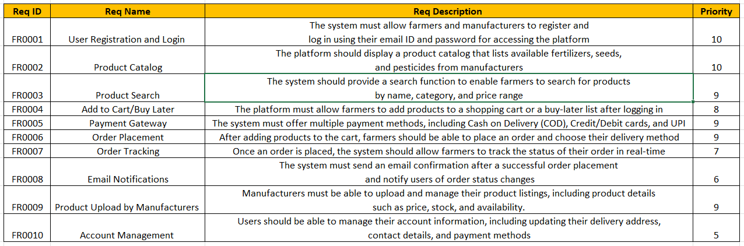

Non-Functional Requirements:
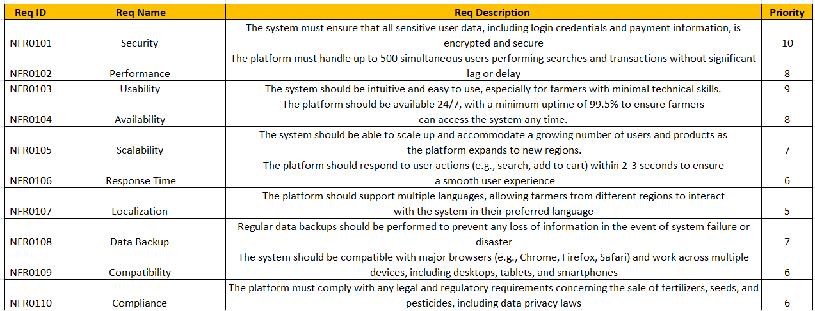

Question 2–Minimum 5 page designs - 15 M
Make wireframe and prototype
Answer:

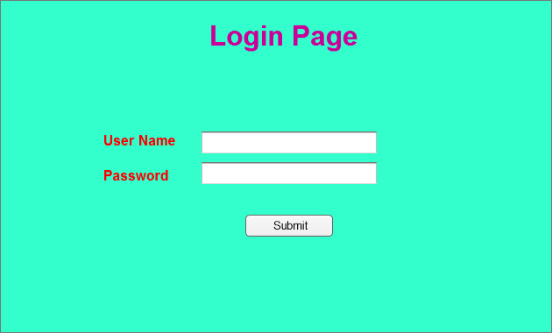

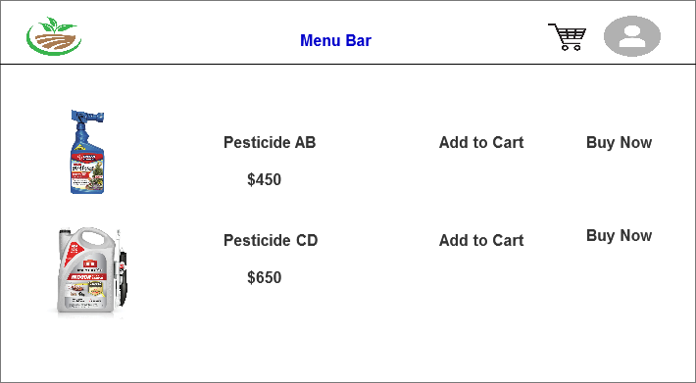

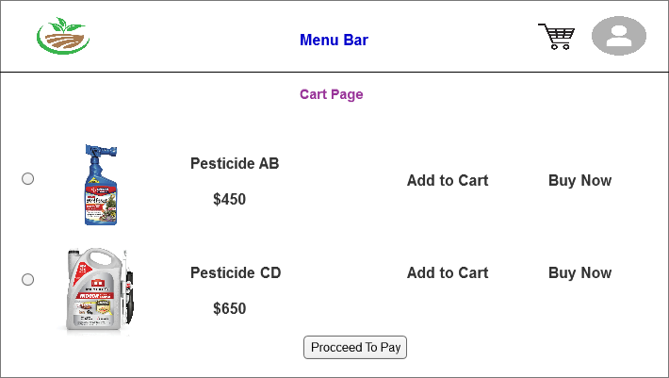

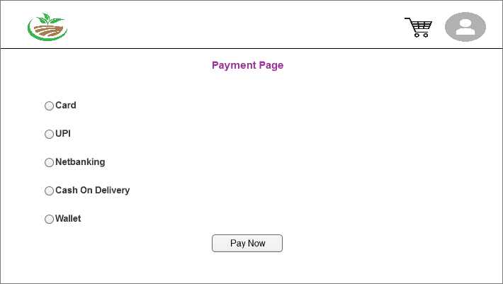

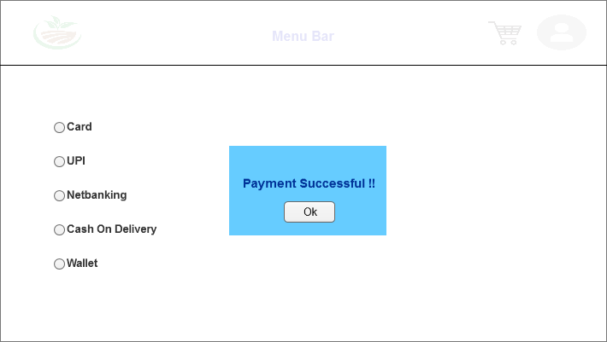

Question 3 – Tools (Visio, Balsamiq) –
Make a note of the Tools, which you are using for above concepts
Answer:

Microsoft Visio:
Microsoft Visio is a diagramming tool widely used for creating flowcharts, organizational charts, network diagrams, and use case diagrams. It provides a variety of templates and shapes, making it easy to visually represent complex systems and processes. For the case study, Visio helps in designing system architecture and process flows.

Balsamiq:
Balsamiq is a wireframing tool used to create low-fidelity mockups quickly. It focuses on simplicity, helping teams design user interfaces without being distracted by too many design details. In this case study, Balsamiq can be used to sketch early versions of the website or app to communicate the layout and basic functionality.

Axure:
Axure is a powerful prototyping tool that allows for the creation of detailed, interactive mockups. It's particularly useful for demonstrating dynamic functionality, creating wireframes with conditional logic, and simulating user flows. For the case study, Axure can provide high-fidelity prototypes to help stakeholders visualize and interact with the proposed online agriculture store before development.
Question 4 – Prepare RTM - 6 Marks
A business analyst’s key responsibilities are to keep track of the requirements and make sure that
no requirement is missed.
Mr. Henry and peter have approached you regarding the current status of the project. How will you tackle this situation?
Answer:
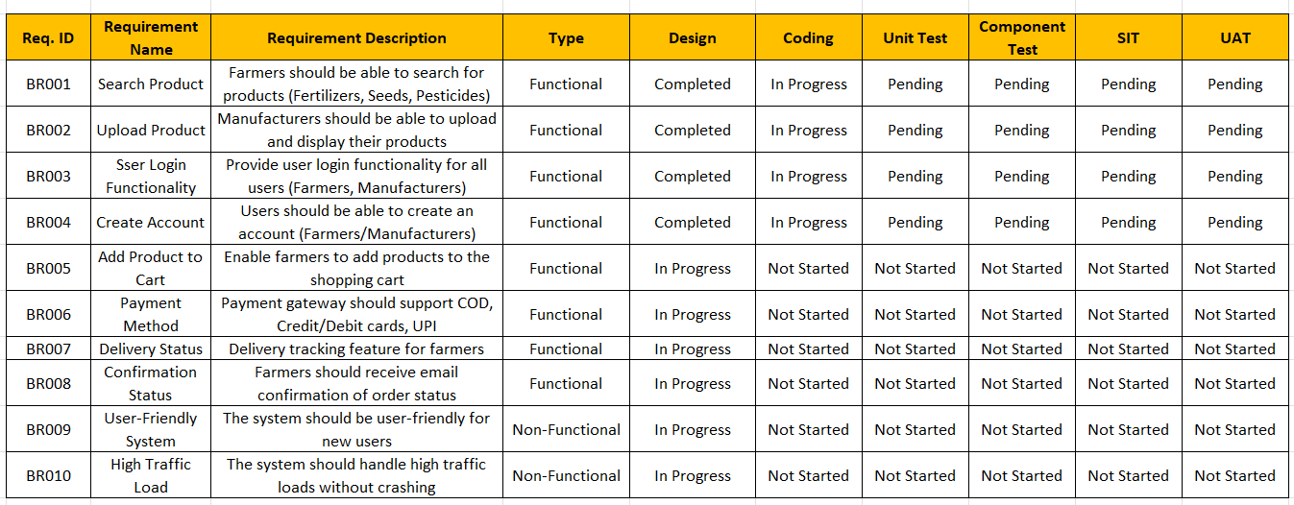

Question 5 – 10 Test Case Documents - 10 Marks
Prepare 10 Test Case Documents
Answer:
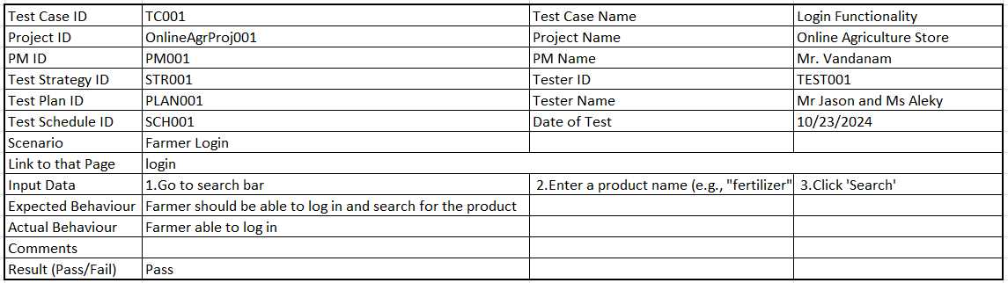
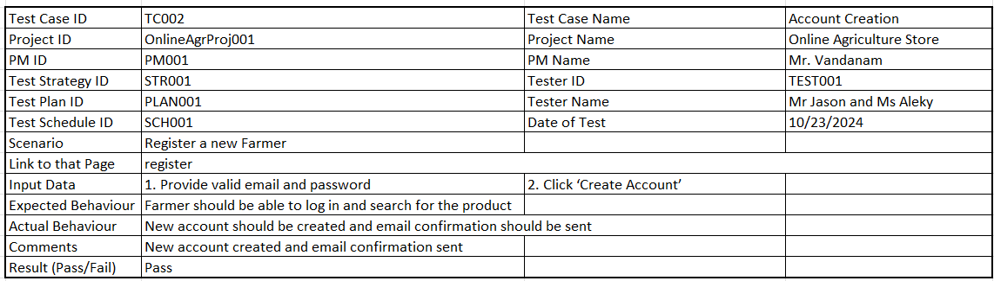

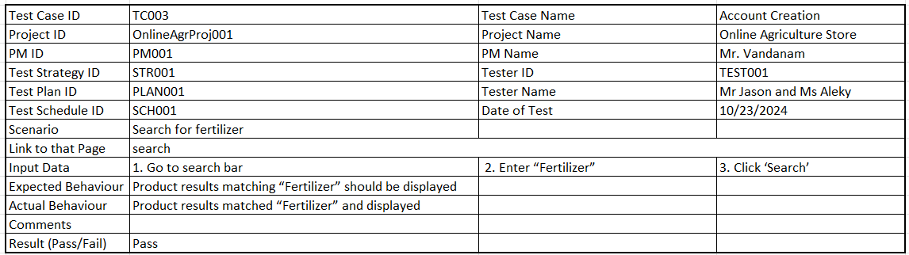
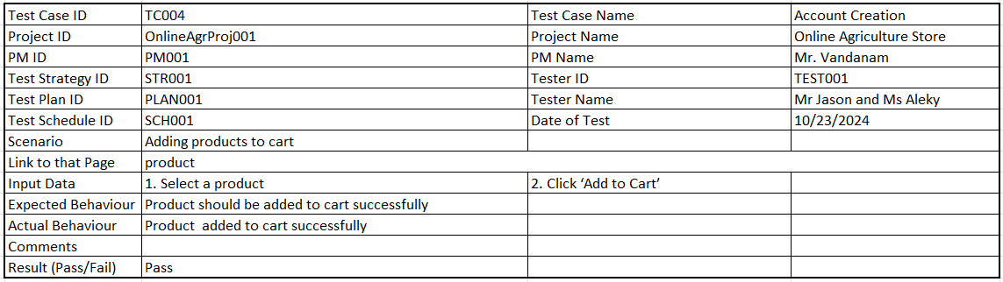
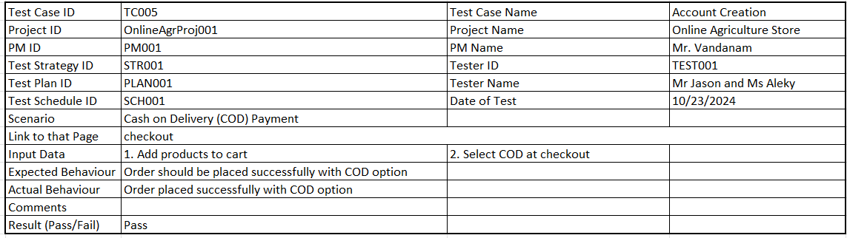
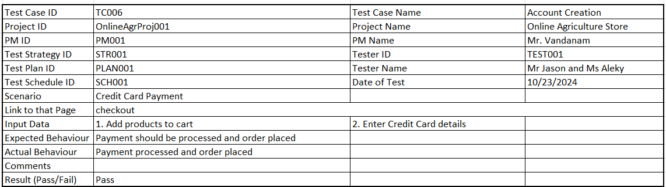
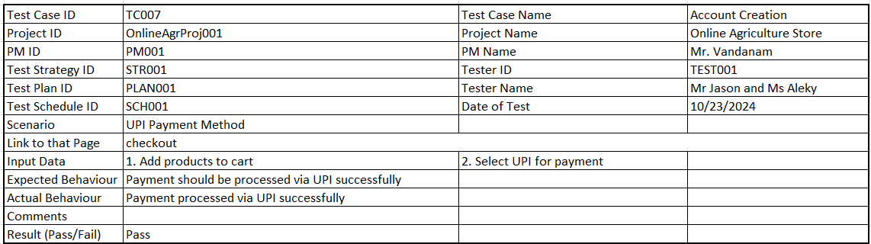
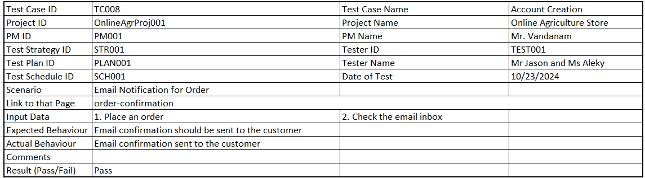
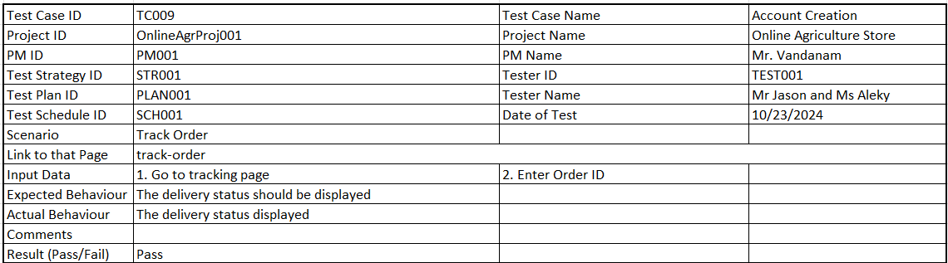
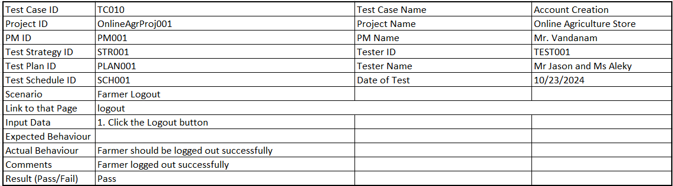

Question 6 – DB Design – 8 Marks
After the requirements are thoroughly explained to the entire project team by business analyst, the Database architects have decided to do the database design and also to represent the in-flow and out-flow of data.
Answer:
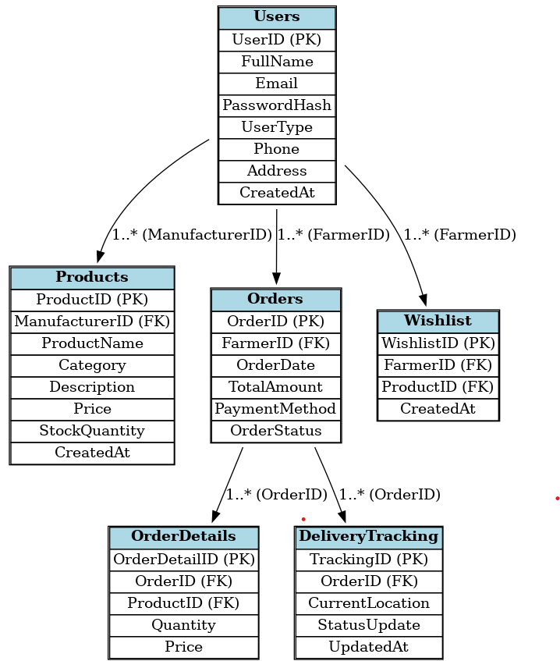

Question 7 – Data Flow Diagram
Answer:

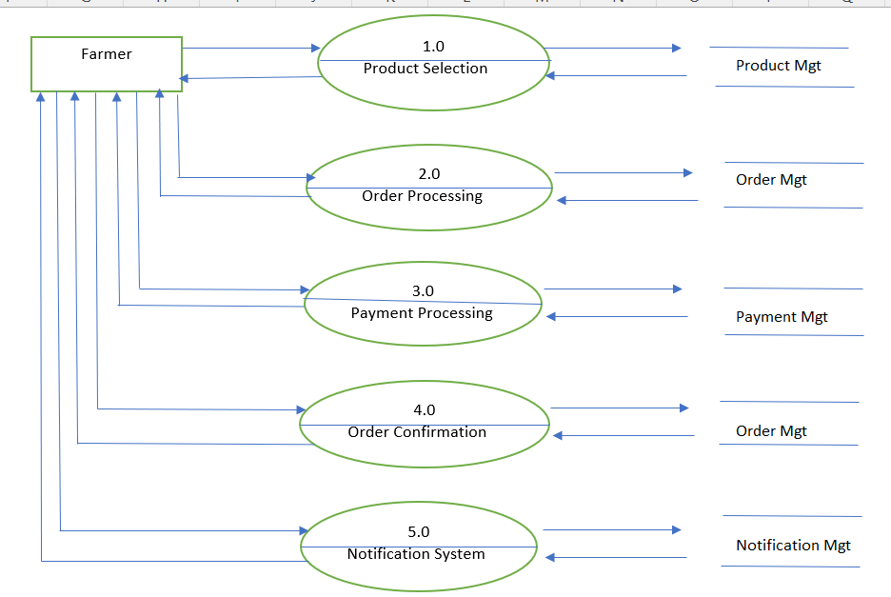
Question 8 – Change Request - 10 Marks
Answer:
1. Receive and Document the Change Request
Formally document the change request details, including who requested it, the reason for the change, and specifics of the new tax structure.
Ensure the request includes details like the new tax rates, effective dates, and any relevant regulatory requirements.
2. Conduct Impact Analysis
Assess how the new tax structure affects existing systems, especially in areas like billing, payment calculations, and accounting.
Identify impacted modules, such as the product catalog (for price adjustments), the checkout/payment module, and the reporting module.
Evaluate the time, resources, and budget required to implement this change.
3. Stakeholder Review and Approval
Engage relevant stakeholders (e.g., project manager, developers, financial team) to review the impact of the change.
Prepare a change request document summarizing the impacts, risks, costs, and benefits.
Present the change request to the stakeholders, including any external parties if necessary, and obtain formal approval to proceed.
4. Update Project Documentation
Modify affected documents, such as the Requirements Specification Document, Functional and Technical Specifications, and the Test Plan, to reflect the change.
Update any relevant diagrams (e.g., ER diagrams or DFDs) if necessary to incorporate tax changes.
5. Develop and Implement the Change
Coordinate with the development team to implement the new tax structure.
Ensure that necessary code changes are made, tested, and documented.
Inform the testing team to validate that the changes work correctly across different scenarios (e.g., varying order amounts and customer locations).
6. Testing and Quality Assurance
Conduct thorough testing to ensure that the updated tax calculations are accurate and compliant with government regulations.
Perform regression testing to ensure the new tax structure does not impact other parts of the system.
Prepare test cases focusing on scenarios like order placement, tax calculations, refunds, and reporting.
7. Communicate and Train End-Users (if applicable)
Inform users and stakeholders of the change, especially if it impacts the end-user experience (e.g., updated prices or tax details displayed).
If necessary, prepare a training guide or FAQs to assist users in understanding the changes.
8. Deployment and Monitoring
Once approved, deploy the changes to the live environment as per the project’s deployment protocol.
Monitor the implementation post-deployment to catch any issues related to tax calculation and reporting.
9. Update Change Management Log
Record the details of the change request in the Change Management Log, including its status, implementation details, and any lessons learned for future reference.

Question 9 – Change Request Vs an Enhancement t - 5 Marks
As the project is in process, Ben and Kevin have contacted you. The reason is to inform you that they want the Farmers to sell their crop yields through this application i.e. Farmers should be able to add their crop yields or products and display to general public and should be able to sell them. They also want to introduce Auction system for their Crop yields. As a BA, what will be your response? Is this a change request or an enhancement???
Answer:
This request qualifies as an enhancement to the existing scope, rather than a change request, because it introduces significant new features that were not part of the initial requirements. Here’s why:
New Scope Addition: The original project requirements focused on creating an online store for agricultural products like seeds, pesticides, and fertilizers, where farmers are the buyers. Adding a marketplace and auction functionality is a substantial expansion to this scope, as it allows farmers to act as sellers.
Different Functionality: The new requirements introduce functionalities such as product listing, public display, transaction handling for crop sales, and an auction feature—elements that were not part of the existing solution.
Impact on System: This enhancement would likely affect multiple aspects of the application, including UI design, database schema, and transaction processing. It may require new modules for seller management, auction tracking, and potentially regulatory compliance.

My Response as a Business Analyst
Acknowledge the Request:
"Thank you, Ben and Kevin, for sharing these new ideas. The ability for farmers to sell their crops and introduce an auction system is a valuable addition that could significantly expand the application’s impact."

Clarify and Gather Requirements:
"To understand this better, could you share specific details on how you envision the auction process working? For example, should the auctions be timed or open-ended? Are there specific requirements for listing and displaying crop yields to the public?"
Impact Analysis:
"I’ll work with the technical and project management teams to perform an impact assessment. This will help determine the potential changes needed in design, development, and testing for adding these features, as well as any budget or timeline implications."

Communicate Process:
"Since this is an enhancement to the original scope, we’ll need to assess this as part of a formal change management process. I’ll document the requirements and coordinate with the team to determine how best we can accommodate this addition."

Follow-up with the Committee:
After gathering detailed requirements, I would prepare a report and consult with the project committee (including Mr. Henry, Mr. Pandu, and Mr. Dooku) to review the potential impact on project budget, resources, and timelines.

Question 10 – Estimations - 6 Marks
Come up with estimations – How many Manhours required
Answer:
Based on the detailed requirements and project complexity, I’ll estimate the man-hours required for each phase. This project includes setting up a login system, product catalog, search functionality, payment processing, order tracking, and other key functionalities. The estimate will be divided into tasks across different roles.
Overall Estimation:
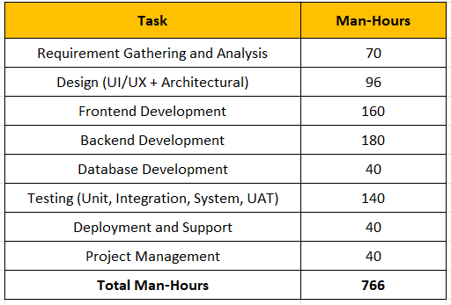
Total Estimated Man-Hours: 766 Hours
This estimation provides a comprehensive view of each phase. The estimate assumes the development team is familiar with similar projects and includes time for stakeholder feedback and initial adjustments.
Adding a contingency buffer of 10-15% (approximately 76-115 hours) for any unexpected issues or change requests, the final estimate would be around 842 - 881 man-hours.

Question 11 – UAT – 6 Marks
Project has finally completed all the stages i.e., design, development, testing etc. Now, it is the roleof a business analyst to contact the client for testing of the final product and have to successfully complete it. How are you going to handle this situation? And once it is done, what will be the process to close the project? Explain UAT Acceptance process
Answer:
To handle this situation as a Business Analyst, I would take a structured approach to ensure the final product aligns with the client's expectations and meets all requirements before official handover. Here’s how I would approach the UAT (User Acceptance Testing) and project closure:
1. UAT Preparation and Communication with the Client
Schedule a UAT Meeting: I would contact the client, represented by Mr. Henry and the stakeholders, to schedule an official User Acceptance Testing session. This would include providing a timeline for UAT activities and outlining the goals and expectations for the client.
Prepare UAT Test Cases and Scenarios: Ensure that all UAT test cases are documented, focusing on critical user flows like product search, ordering, payment, and delivery tracking. I’d provide these documents to the client so they understand what aspects of the product we’ll be testing.
Set Up the UAT Environment: Ensure the product is deployed in a controlled environment (UAT server) that mirrors the production environment closely, providing the client with a stable testing setup.
Train the Client on UAT Procedures: Before starting UAT, I would guide the client and stakeholders on using the application, highlighting key functions. This ensures they have a smooth experience during testing.
2. Conducting UAT (User Acceptance Testing)
Provide UAT Access: Share necessary login credentials and instructions with the client to access the UAT environment.
Monitor the UAT Process: During UAT, I’d stay in contact with the client, addressing any issues they encounter and assisting with understanding the functionality. This also involves making notes on any feedback or defects identified by the client.
Document Feedback and Issues: Capture all feedback, whether they’re enhancement requests, critical issues, or minor adjustments. Maintain a UAT log for transparency with the development team and client.
3. Addressing UAT Feedback and Issues
Prioritize and Resolve Issues: Based on the feedback, I would categorize issues and enhancements by priority (high, medium, low). Critical issues would be fixed immediately, while lower-priority enhancements might be scheduled for a future phase.
UAT Sign-Off: Once all critical and major issues are addressed, I would ask the client to review and confirm if the product meets their requirements. Upon receiving positive feedback, I’d request a formal UAT sign-off document as an official approval to proceed with deployment.

Question 12 – Project Closure Document - 6 Marks
Explain Project closure document
Answer:
Project Closure Process
Once UAT is successfully completed and sign-off is obtained, I’d follow these steps to close the project effectively:
Final Documentation Handover:

Project Closure Document-
Project Name: Online Agriculture Product Store
Prepared by: Arjun Raut, Business Analyst
Date: 25-08-12

1. Project Overview
The Online Agriculture Product Store was initiated by SOONY Company under the CSR initiative led by Mr. Henry, with the vision of addressing agricultural procurement challenges faced by farmers in remote areas.
The solution was a web and mobile application that connects farmers and manufacturers of fertilizers, seeds, and pesticides, enabling easy purchase and delivery tracking.
Budget: ₹2 Crores INR
Duration: 18 months (Completed in 17.5 months)
Vendor: APT IT Solutions

2. Project Objectives
- Create a platform for direct farmer–manufacturer interaction.
- Ensure accessibility in low-network rural areas.
- Provide secure login, product browsing, search, payment, and delivery tracking.
- Improve farmers’ procurement efficiency and reduce dependency on intermediaries.

3. Quality Assurance
Testing Strategy:
- Unit Testing: Each module tested individually (login, search, payment gateway).
- Integration Testing: Verified smooth data flow between modules.
- System Testing: Full functional testing for both web and mobile platforms.
- User Acceptance Testing (UAT): Conducted with Peter, Kevin, and Ben as farmer representatives.
- Security Testing: Password encryption, secure transactions, and protection against common attacks.
- Performance Testing: Simulated low bandwidth to ensure accessibility in remote areas.
Key QA Outcomes:
- Total Defects Logged: 132
- Critical Issues Fixed: 5 before UAT
- Post-Go-Live Defects: None critical
- UAT Sign-off: Achieved with 100% requirement coverage

4. Resources Utilized
Human Resources:
- SOONY Company:
  - Mr. Henry (Sponsor)
  - Mr. Pandu (Financial Head)
  - Mr. Dooku (Project Coordinator)
  - Peter, Kevin, Ben (Farmer Representatives & Stakeholders)
- APT IT Solutions:
  - Project Manager: Mr. Vandanam
  - Senior Java Developer: Ms. Juhi
  - Java Developers: Mr. Teyson, Ms. Lucie, Mr. Tucker, Mr. Bravo
  - Network Admin: Mr. Mike
  - DB Admin: Mr. John
  - Testers: Mr. Jason, Ms. Alekya
  - Business Analyst: Arjun Raut
Technical Resources:
- Java Spring Boot (backend)
- MySQL Database
- HTML, CSS, JavaScript (frontend)
- AWS Cloud Hosting
- Payment Gateway Integration (Razorpay/UPI APIs)
Financial Resources:
- Planned Budget: ₹2 Crores INR
- Actual Spend: ₹1.96 Crores INR (saved ₹4 Lakhs)

5. Challenges Faced
- Low Internet Connectivity in Rural Areas: Required optimization for slow networks.
- First-Time Technology Users: Needed extra UI simplification and training for farmers.
- Payment Gateway Integration Issues: Early testing revealed bugs in UPI payments, resolved before go-live.
- Requirement Changes: Added wishlist feature after stakeholder review, without affecting project timeline.

6. Value to the Company
- CSR Impact: Strengthened SOONY Company’s image as a socially responsible leader.
- Economic Empowerment: Farmers now directly access products, reducing middleman costs.
- Market Reach: Manufacturers gain access to a new customer base in remote areas.
- Digital Adoption: Encouraged digital literacy among rural farmers.
- Scalable Platform: Can be extended to include agricultural tools, services, and marketplace expansion.

7. Lessons Learned
- Early stakeholder engagement leads to fewer reworks.
- Prototyping with real users helps fine-tune usability.
- Performance testing in target environments is crucial for adoption.

8. Project Sign-off
This document confirms that the project objectives have been met, deliverables are complete, and stakeholders have approved the final system.

Approved By:

Name | Designation | Signature | Date
Mr. Henry | Project Sponsor | Henry | 25-08-12
Mr. Pandu | Financial Head | Pandu | 25-08-12
Mr. Dooku | Project Coordinator | Dooku | 25-08-12
Mr. Karthik | Delivery Head, APT IT Solutions | Karthik | 25-08-12
Arjun Raut | Business Analyst | Arjun | 25-08-12

