- Identify Business Process Model for Online Agriculture Store – (Goal, Inputs, Resources, Outputs, Activities, Value created to the end Customer)
Business Process Model – Online Agriculture Store
- Goal:
Enable farmers to buy fertilizers, seeds, and pesticides online easily.
- Inputs:
Product details from manufacturers, farmer requirements, internet access.
- Resources:
BA, PM, Developers, Testers, Network & DB Admins, Hardware, Software.
- Activities:
Product listing, farmer registration, product browsing, order placement, delivery.
- Outputs:
Successful product delivery to farmers, order tracking, invoice generation.
- Value to Customer:
Easy access to quality agriculture products from remote areas, time and cost savings.
- Mr Karthik is doing SWOT analysis before he accepts this project. What Aspects he Should consider as Strengths, as Weaknesses, as Opportunity and as Threats.
SWOT Analysis – Online Agriculture Store
- Strengths:
Skilled project team
Fixed budget and timeline
Social impact under CSR
- Weaknesses:
New domain (agriculture)
Low digital literacy among farmers
Dependence on internet access
- Opportunities:
Large rural market
App can support local languages
Future government or NGO tie-ups
- Threats:
Delivery issues in remote areas
Competition from other agriculture apps
Resistance to using online platforms

- Mr Karthik is trying to do feasibility study on doing this project in Technology (Java), Please help him with points (HW SW Trained Resources Budget Time frame) to consider in feasibility Study.
The project is feasible in Java as the required hardware like servers and systems are available. Standard software tools such as JDK, IDEs, databases, and testing tools are accessible. Skilled resources including Java developers, testers, and admins are already in place. The budget of ₹2 Crores under the CSR initiative is sufficient. The 18-month timeline is realistic for completing the project across all SDLC phases.
- Mr Karthik must submit Gap Analysis to Mr Henry to convince to initiate this project. What points (compare AS-IS existing process with TO-BE future Process) to showcase in the GAP Analysis.
Gap Analysis – Online Agriculture Store
AS-IS:
Farmers manually visit markets to buy seeds, fertilizers, and pesticides. The process is time-consuming, offers limited product choices, lacks price transparency, and has no direct link to manufacturers.
TO-BE:
A digital platform will enable farmers to browse, compare, and order products online directly from manufacturers, with home delivery and better pricing.
Identified Gaps:
Manual process → Digital platform
Limited access → Wide product availability
No direct manufacturer link → Direct manufacturer-farmer interaction
Time & effort intensive → Convenient and time-saving process
- List down different risk factors that may be involved (BA Risks And process/Project Risks)
BA Risks:
- Misinterpretation of farmer requirements
- Low stakeholder involvement during analysis phase
Project/Process Risks:
- Internet access issues in rural areas
- Delays in delivery and logistics in remote locations
- Perform stakeholder analysis (RACI Matrix) to find out the key stakeholders who can take Decisions and Who are the influencers
The RACI matrix clarifies stakeholder roles in each project activity. It defines who is Responsible, Accountable, Consulted, and Informed throughout the project lifecycle.
Activity | BA | PM (Vandanam) | Mr. Karthik (Delivery Head) | Committee (Henry, Pandu, Dooku) | Farmers (Peter, Kevin, Ben) | Dev/Test/Admin Team
Requirement Gathering | R | A | C | I | C | I
Finalizing Requirements | R | A | A | A | C | I
Budget Approval | I | I | C | A | I | I
Solution Design | C | R | C | I | I | R
Development & Testing Oversight | I | R | C | I | I | R
UAT Planning | R | R | C | A | C | I
Go-Live & Deployment | I | R | A | A | I | R

- Help Mr Karthik to prepare a business case document
Business Case – Online Agriculture Products Store
Section | Details
Project Name | Online Agriculture Products Store
Project Sponsor | Mr. Henry (SOONY Company)
Delivery Owner | Mr. Karthik (APT IT Solutions)
Objective | To enable farmers to easily access and purchase seeds, fertilizers, and pesticides through a digital platform.
Problem Statement | Farmers face challenges in product availability, pricing transparency, and accessibility in remote areas.
Proposed Solution | Develop a web/mobile application to connect farmers with manufacturers for direct product purchase and delivery.
Key Benefits | • Reduces farmers' travel and cost  • Direct access to manufacturers  • Supports rural digital inclusion
Budget | ₹2 Crores (CSR Initiative)
Project Duration | 18 Months
Key Stakeholders | Mr. Henry, Mr. Pandu, Mr. Dooku, Mr. Karthik, Farmers (Peter, Kevin, Ben)
Risks Identified | • Low digital literacy  • Internet connectivity in villages  • Delivery in remote areas
Risk Mitigation | • User-friendly multilingual UI  • App optimization for low bandwidth  • Local logistics tie-ups
Recommendation | Proceed with development, as the solution is socially impactful, feasible, and aligns with CSR goals.
8.Mr Karthik explained to Mr. Henry about SDLC. And four methodologies like Sequential Iterative Evolutionary and Agile. Please share your thoughts and clarity on Methodologies
Methodology | Description | Best Used When
Sequential (Waterfall) | Follows a strict linear phase-by-phase process. Suitable for fixed, well-defined requirements. | Requirements are clear and unlikely to change.
Iterative | Breaks down development into smaller cycles. Feedback is collected after each iteration. | Some requirements are unclear and need gradual improvement.
Evolutionary | Combines iterative and incremental development. System evolves based on user feedback. | Requirements evolve over time with ongoing feedback.
Agile | Delivers software in short sprints with continuous feedback and adaptability. Ideal for changing requirements. | Frequent changes are expected and quick delivery is needed.

9.Waterfall RUP Spiral and Scrum Models – 8
They discussed models in SDLC like waterfall RUP Spiral and Scrum. You put forth your understanding on these models
When the APT IT SOLUTIONS company got the project to make this online agriculture product store, there is a difference of opinion between a couple of SMEs and the project team regarding which methodology would be more suitable for this project. SMEs are stressing on using the V model and the project team is leaning more onto the side of waterfall model. As a business analyst, which methodology do you think would be better for this project?
- Waterfall, RUP, Spiral, and Scrum are key SDLC models. Waterfall is linear and best for stable requirements. RUP is iterative with clear phase-wise structure. Spiral focuses on risk handling through repeated cycles. Scrum is agile, delivering working software in short sprints with regular feedback.
- For this project, I recommend the V-Model because it ensures clear documentation, early testing, and strong validation at each stage. Since this is a CSR initiative with fixed budget, scope, and rural users, the V-Model offers better control, traceability, and quality assurance.

10. Waterfall Vs V-Model - 5 Marks
Write down the differences between waterfall model and V model.
Aspect | Waterfall Model | V-Model
Approach | Linear and sequential | Extension of Waterfall with testing in parallel
Testing Phase | Starts after development is complete | Testing is planned in parallel with each development phase
Verification & Validation | Done after implementation | Done at every stage with corresponding test phase
Risk Handling | Risk of late error detection | Early detection through test planning
Suitability | Best for simple, low-risk projects with clear requirements | Suitable for critical applications where quality is key

11. Justify your choice - 3 Marks Question
As a BA, state your reason for choosing one model for this project
Justification for Choosing V-Model
As a Business Analyst, I recommend the V-Model for this project due to its structured approach that emphasizes early testing and validation at each development stage. Given that the project is part of a CSR initiative with fixed budget, defined scope, and limited flexibility, the V-Model ensures quality assurance, traceability, and reduced rework. It aligns well with the project’s need for accuracy, stakeholder confidence, and timely delivery—especially when catering to end-users like farmers who may have limited digital exposure.

12 – Gantt Chart - 5 Marks Question

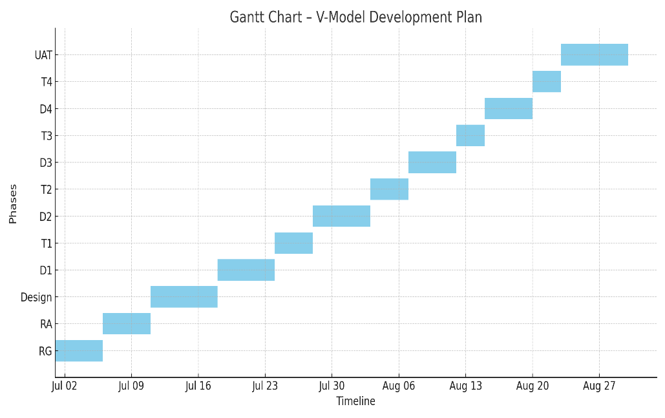

13 – Fixed Bid Vs Billing - 5 Marks 20Write down the differences between waterfall model and V model.
Aspect | Fixed Bid | Billing (Time & Material)
Pricing | Pre-agreed lump sum amount | Based on actual hours or resources used
Scope | Fixed and clearly defined | Flexible; can change as the project evolves
Risk | Vendor bears more risk | Client bears more risk
Budget Control | Predictable, best for projects with clear requirements | Less predictable, better for dynamic or ongoing work
Usage | Suitable for short-term, well-defined projects | Ideal for long-term, evolving, or support-based engagements

14. Question 14 – Preparer Timesheets of a BA in various stages of SDLC
BA Timesheet Across SDLC Phases
SDLC Phase | Key Responsibilities | Effort Allocation (Hours/Week) | Contribution Justification
Design | Prepare BRD, SRS, Use Cases, UI Mockups, and review design documents with stakeholders. | 20 | High contribution in defining project scope and stakeholder alignment
Development | Clarify requirements to developers, ensure scope alignment, and attend daily stand-up meetings. | 15 | Medium contribution by bridging between dev and business
Testing | Support test case preparation, perform requirement traceability, review test execution, and log defects. | 18 | High involvement in quality assurance and requirement coverage
User Acceptance Testing | Coordinate with end users, document feedback, and validate final business readiness. | 12 | Moderate involvement in end-user validation and feedback
Deployment & Implementation | Assist with deployment planning, update user manuals, support training, and verify go-live readiness. | 10 | Support role in go-live and documentation

