A company has manufacturing plants and warehouses in various parts of the country. They
manufacture ice-cream and milk products. They want to build software to achieve two goals.
Manage the inventory
Quickest delivery to the customers

Assignment 1:

1. Please make a BRD which can be presented to the client along with complete development
and resource plan.



PARAG MILK AND MILK PRODUCTS
Project ID: PRTECH0005
Version: V1.0
Author: Shweta Garse

1. INTRODUCTION
1.1. DOCUMENT PURPOSE
This document is intended to outline in detail the business requirements for developing a software solution that supports inventory management and enables the fastest possible delivery of ice-cream and milk products across the company’s nationwide network of manufacturing plants and warehouses. It provides structured guidance for aligning stakeholders, guiding development teams, and ensuring the final product meets operational goals and customer expectations.
1.2. INTENDED AUDIENCE
Role | Name | Title | Signature | Date
Project Sponsor | Sandeep Batra | Sales and Business Head | Do | MM/DD/YYYY
Business Owner | Yogesh Kane | MD | Do | MM/DD/YYYY
Project Manager | Mohan Garse | Business Analyst | Do | MM/DD/YYYY
System Architect | Shweta Ales | System Architect | Do | MM/DD/YYYY
Development Lead | Moksh Bonde | Team Lead | Do | MM/DD/YYYY
User Experience Lead | Rudransh Zope | Team Lead | Do | MM/DD/YYYY
Quality Lead | Chris C | Team Lead | Do | MM/DD/YYYY
Content Lead | Harshal chopade | Team Lead | Do | MM/DD/YYYY
1.2.1 RACI Matrix
Role | Name | Title | * | R | A | S | C | I
Project Sponsor | Sandeep Batra | Sales and Business Head | ✔ |  |  |  | ✔ | ✔
Business Owner | Yogesh Kane | MD | ✔ |  |  |  | ✔ | ✔
Project Manager | Mohan Garse | Business Analyst |  | ✔ | ✔ | ✔
System Architect | Shweta Ales | System Architect |  |  | ✔ | ✔
Development Lead | Moksh Bonde | Team Lead |  |  | ✔ | ✔
User Experience Lead | Rudransh Zope | Team Lead |  | ✔ | ✔ | ✔
Quality Lead | Chris C | Team Lead |  |  |  | ✔ | ✔ | ✔
Content Lead | Harshal chopade | Team Lead |  |  |  | ✔ | ✔ | ✔
1.3. PROJECT BACKGROUND
The organization operates a nationwide network of manufacturing plants and warehouses for ice-cream and milk products. With rising demand and operational complexity, current inventory and delivery systems—largely manual and disconnected—struggle to keep pace. This leads to stock imbalances, delivery delays, and restricted visibility into operations.
To address these challenges, the company is launching a centralized software platform to streamline inventory tracking, automate replenishment, optimize delivery routes, and integrate with existing systems. The goal is to increase operational efficiency, minimize wastage, and elevate customer satisfaction.
1.4. PURPOSE OF THE BUSINESS REQUIREMENTS
This Business Requirements Document (BRD) aims to establish and align the functional and non-functional needs of the proposed centralized inventory and delivery management system. It serves as a foundation for:
- Clarifying Business Needs: Outlining the problems to be solved and the goals to be achieved.
- Aligning Stakeholders: Ensuring all departments and decision-makers share a common understanding.
- Guiding Solution Design: Providing a blueprint for system development, configuration, and integration.
- Supporting Project Planning: Helping estimate timelines, resources, and budget requirements.
- Establishing Success Criteria: Defining measurable outcomes to evaluate project effectiveness.
1.5. BUSINESS GOALS/OBJECTIVES TO BE ACHIEVED
· Streamline Inventory Management Implement real-time tracking to reduce stockouts, overstocking, and wastage.
· Optimize Delivery Operations Improve route planning and scheduling to ensure faster, more reliable deliveries.
· Digitize Manual Processes Replace paper-based workflows with automated systems accessible via mobile and desktop.
· Integrate Core Systems Ensure seamless connectivity between inventory, ERP, CRM, and logistics platforms.
· Enhance Decision-Making Provide actionable insights through dashboards and analytics for better forecasting.
· Minimize Product Loss Improve handling and storage of perishable goods to reduce spoilage and returns.
· Improve Customer Experience Ensure product availability and timely service to boost satisfaction and loyalty.
· Reduce Operational Costs Lower overhead through automation, better resource allocation, and reduced waste.
1.6. BENEFITS/RATIONALE
· Improved Inventory Control Real-time tracking reduces stockouts, overstocking, and spoilage of perishable goods.
· Faster & Smarter Deliveries Route optimization and scheduling ensure timely, cost-effective distribution.
· Operational Digitization Automating manual tasks boosts productivity and reduces human error.
· System Integration Seamless data flow between ERP, CRM, and logistics systems enhances coordination.
· Better Decision-Making Analytics and dashboards provide insights for demand forecasting and resource planning.
· Cost Reduction Lower operational expenses through efficient resource use and reduced waste.
· Enhanced Customer Satisfaction Reliable product availability and faster service improve customer loyalty.
1.7. STAKEHOLDERS
Operations Manager, Inventory Manager, Logistics Manager, IT Department, Customers
1.8. DEPENDENCIES ON EXISTING SYSTEMS
The success of this project relies on seamless interaction with several existing systems and infrastructure components. Key dependencies include:
- ERP System Integration The new platform must connect with the current Enterprise Resource Planning (ERP) system to access product data, inventory levels, and financial records.
- CRM System Connectivity Customer profiles, order histories, and service preferences stored in the CRM must be accessible for delivery planning and customer service enhancements.
- Legacy Inventory Databases Historical inventory data from existing databases must be migrated or synchronized to ensure continuity and accuracy.
- GPS & Fleet Tracking Systems Real-time location data from existing vehicle tracking systems must be integrated for route optimization and delivery monitoring.
- Authentication & User Management The platform must align with current user access protocols and identity management systems to maintain security and access based on user roles and responsibilities.
- Reporting Tools Compatibility with existing BI/reporting tools is essential for generating analytics and performance dashboards.
1.9. REFERENCES
Internal process documentation,
ERP system manuals.
1.10. ASSUMPTIONS
· Internet connectivity at all locations
· Availability of GPS-enabled delivery vehicles
· Existing ERP and CRM systems are operational and accessible
· Staff will be trained and available to use the new system
· Historical inventory and delivery data is accurate and retrievable
2. REQUIREMENTS SCOPE
2.1 In Scope Requirements
- Centralized inventory tracking across all manufacturing plants and warehouses
- Real-time stock level monitoring and automated replenishment alerts
- Route optimization for delivery vehicles based on traffic and location data
- Integration with existing ERP and CRM systems
- Mobile application for delivery personnel with live tracking and updates
- Dashboard for warehouse managers to monitor inventory and dispatches
- Customer notification system for order status and delivery ETA
- Role-based access control and user authentication
- Reporting and analytics for inventory, delivery performance, and demand forecasting
- Data migration from legacy inventory systems
- Geo-tagging of warehouse and delivery locations
- Training and onboarding support for end users
2.2 Out of Scope
- Development of a new ERP or CRM system
- Hardware procurement (e.g., mobile devices, GPS units)
- International logistics or cross-border delivery features
- Integration with third-party e-commerce platforms
- AI-based demand prediction beyond basic forecasting models
- Real-time traffic data sourcing from external providers (unless APIs are available)
- In-app payment processing or billing features
- Customer support chatbot or helpdesk automation
- Marketing campaign management tools
- Warehouse automation hardware (e.g., robotics, IoT sensors)
- Fleet procurement or vehicle maintenance tracking
- Support for non-dairy product lines
2.3 Functional Requirements
These define what the system should do:
1. Inventory Tracking
Ability to monitor stock levels in real time across all warehouses and plants.
2. Automated Replenishment Alerts
The system triggers alerts when stock falls below predefined thresholds.
3. Order Management
Users can create, modify, and track customer orders.
4. Route Optimization
Delivery routes are calculated based on traffic, distance, and delivery priority.
5. Delivery Scheduling
Assign delivery windows and track fulfillment status.
6. Mobile App for Delivery Agents
Drivers can view assigned routes, update delivery status, and capture proof of delivery.
7. Warehouse Dashboard
Managers can view inbound/outbound inventory, pending orders, and stock movements.
8. Customer Notifications
Automated SMS/email updates for order confirmation, dispatch, and delivery ETA.
9. Role-Based Access Control
Different user roles (admin, warehouse staff, delivery agent) have specific permissions.
10. Reporting & Analytics
Generate reports on inventory turnover, delivery performance, and demand trends.
3.1. ACTOR PROFILES SPECIFICATION
Functional Requirement | Description | Actor (Role & Type)
Inventory Tracking | Monitor stock levels in real time across warehouses and plants. | Warehouse Manager (Primary)
Order Placement | Customers can browse products and place orders. | Customer (Primary)
Order Modification | Staff can update or cancel orders before dispatch. | Support Staff (Secondary)
Delivery Scheduling | Assign delivery windows and track fulfillment status. | Delivery Agent (Primary)
Route Optimization | Calculate efficient delivery routes based on distance and traffic. | System (Secondary)
Proof of Delivery | Capture digital signature or photo upon delivery completion. | Delivery Agent (Primary)
Stock Replenishment Alerts | Notify the procurement team when inventory falls below threshold. | Procurement Officer (Primary)
Role-Based Access Control | Restrict system access based on user roles and permissions. | Admin (Primary)
Reporting & Analytics | Generate reports on sales, inventory, and delivery performance. | Sales Manager (Primary)
Audit Logging | Record user actions for compliance and review. | System Auditor (Secondary)

3.2 ESSENTIAL USE CASE DIAGRAM
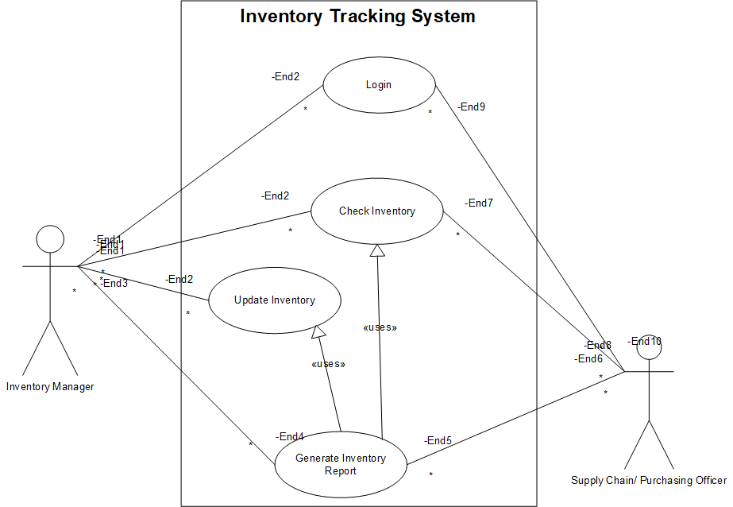

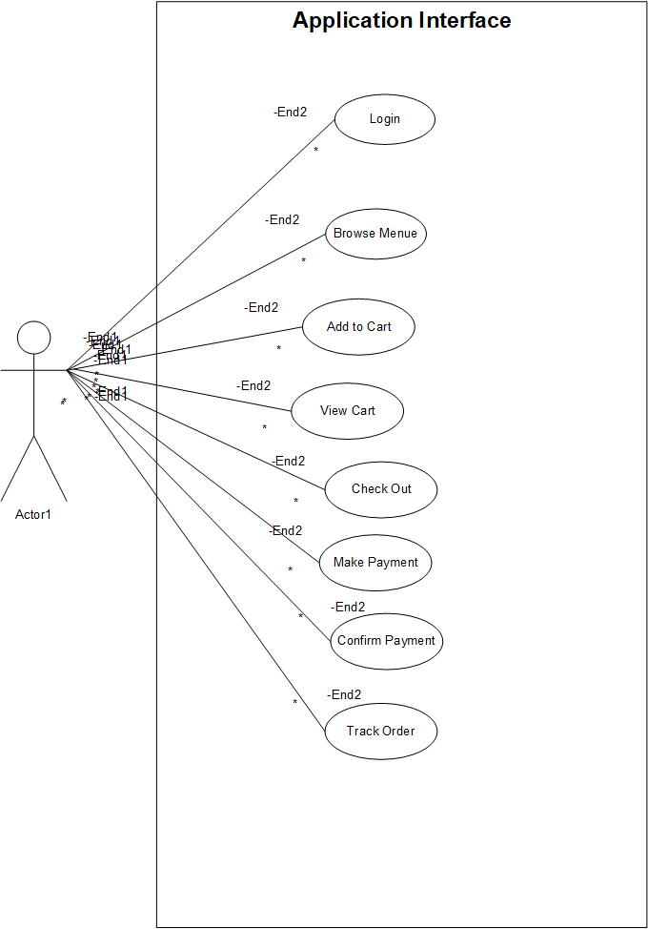

3.3. ESSENTIAL USE CASE SPECIFICATIONS
A Use Case Specification is a detailed textual description of how a system interacts with users (or other systems) to achieve a specific goal. It goes beyond the visual representation of a use case diagram by documenting the functional requirements, flows of events, and conditions that govern the behavior of the system for each use case
Use Case ID: UC-01 — Inventory Tracking
Field | Details
Use Case Name | Inventory Tracking
Description | Monitor and display real-time inventory levels across all storage locations
Actors | Inventory Manager (Primary), System (Secondary)
Business Rules | BR-01, BR-02
Basic Flow | User accesses dashboard → System retrieves and displays stock levels
Alternate Flows | If data sync fails, system shows last known snapshot
Non-Functional Requirements | Real-time refresh ≤ 5 seconds; accessible via mobile and desktop
Pre-Conditions | User is authenticated; data sources are connected
Post-Conditions | Inventory data is visible; alerts are logged
Extension Points | Inventory anomaly detected → Audit Logging
Included Use Cases | Audit Logging
Extended Use Cases | Reporting & Analytics
Inherited Use Cases | None
Use Case ID: UC-02 — Order Placement
Field | Details
Use Case Name | Order Placement
Description | Allow customers or sales reps to place new product orders
Actors | Customer (Primary), Sales Rep (Primary), System (Secondary)
Business Rules | BR-03, BR-04
Basic Flow | User selects products → System validates → Order confirmed
Alternate Flows | If product is out of stock, system suggests alternatives
Non-Functional Requirements | Confirmation ≤ 3 seconds; 99.9% uptime for order service
Pre-Conditions | Product catalog is current; user is authenticated
Post-Conditions | Order stored; confirmation sent
Extension Points | Order exceeds credit limit → Role-Based Access Control
Included Use Cases | Inventory Tracking, Audit Logging
Extended Use Cases | Order Modification
Inherited Use Cases | None
Use Case ID: UC-03 — Order Modification
Field | Details
Use Case Name | Order Modification
Description | Enable users to update or cancel existing orders before dispatch
Actors | Customer (Primary), Sales Rep (Primary), System (Secondary)
Business Rules | BR-05
Basic Flow | User accesses order → Applies changes → System confirms
Alternate Flows | If order is dispatched, modification is blocked
Non-Functional Requirements | Changes reflected ≤ 2 seconds; audit trail maintained
Pre-Conditions | Order exists and is not dispatched
Post-Conditions | Order updated and logged
Extension Points | Price change triggered → Reporting & Analytics
Included Use Cases | Audit Logging
Extended Use Cases | None
Inherited Use Cases | Order Placement
Use Case ID: UC-04 — Delivery Scheduling
Field | Details
Use Case Name | Delivery Scheduling
Description | Assign delivery time slots and vehicles for confirmed orders
Actors | Logistics Coordinator (Primary), System (Secondary)
Business Rules | BR-06
Basic Flow | Select delivery window → Assign vehicle → Update schedule
Alternate Flows | If slot unavailable, system suggests next best option
Non-Functional Requirements | Route assignment ≤ 5 seconds; traffic API integration
Pre-Conditions | Order confirmed; delivery zones mapped
Post-Conditions | Delivery scheduled and visible to driver
Extension Points | Route conflict detected → Route Optimization
Included Use Cases | Order Placement
Extended Use Cases | Route Optimization
Inherited Use Cases | None
Use Case ID: UC-05 — Route Optimization
Field | Details
Use Case Name | Route Optimization
Description | Calculate most efficient delivery routes based on traffic and location
Actors | Dispatcher (Primary), System (Secondary)
Business Rules | BR-07
Basic Flow | Analyze delivery points → Calculate route → Assign to driver
Alternate Flows | If traffic data unavailable, use default routing
Non-Functional Requirements | Route calculation ≤ 10 seconds; ≥ 95% accuracy
Pre-Conditions | Delivery addresses and traffic data available
Post-Conditions | Optimized route stored and assigned
Extension Points | Route delay detected → Delivery Scheduling
Included Use Cases | Delivery Scheduling
Extended Use Cases | None
Inherited Use Cases | None
Use Case ID: UC-06 — Proof of Delivery
Field | Details
Use Case Name | Proof of Delivery
Description | Capture and record confirmation of successful product delivery
Actors | Delivery Personnel (Primary), System (Secondary)
Business Rules
Basic Flow | Delivery completed → System captures timestamp, signature/photo → Status updated
Alternate Flows | If digital proof fails, manual confirmation is logged
Non-Functional Requirements | Capture within 3 seconds; offline mode support
Pre-Conditions | Delivery is scheduled and dispatched
Post-Conditions | Delivery marked complete; proof stored securely
Extension Points | Dispute raised by customer → Audit Logging
Included Use Cases | Delivery Scheduling, Audit Logging
Extended Use Cases | None
Inherited Use Cases | None
Use Case ID: UC-07 — Stock Replenishment Alerts
Field | Details
Use Case Name | Stock Replenishment Alerts
Description | Notify responsible users when inventory falls below defined thresholds
Actors | Inventory Manager (Primary), Procurement Officer (Secondary), System
Business Rules
Basic Flow | System monitors stock → Alert triggered → Notification sent
Alternate Flows | If alert fails, system retries and logs failure
Non-Functional Requirements | Alert delivery within 1 minute; configurable thresholds per SKU
Pre-Conditions | Thresholds are defined; inventory data is available
Post-Conditions | Alert sent and logged; replenishment initiated
Extension Points | Reorder triggered → Order Placement
Included Use Cases | Inventory Tracking
Extended Use Cases | None
Inherited Use Cases | None
Use Case ID: UC-08 — Role-Based Access Control
Field | Details
Use Case Name | Role-Based Access Control
Description | Restrict system access based on user roles and permissions
Actors | System Administrator (Primary), All Users (Secondary)
Business Rules
Basic Flow | User logs in → System verifies role → Access granted to authorized modules
Alternate Flows | If role mismatch occurs, access is denied and logged
Non-Functional Requirements | Access check ≤ 2 seconds; audit trail for all access attempts
Pre-Conditions | User roles are defined and stored
Post-Conditions | Access granted or denied; event logged
Extension Points | Unauthorized access attempt → Audit Logging
Included Use Cases | Audit Logging
Extended Use Cases | None
Inherited Use Cases | None
Use Case ID: UC-09 — Reporting & Analytics
Field | Details
Use Case Name | Reporting & Analytics
Description | Generate operational insights from historical and real-time data
Actors | Operations Manager (Primary), Analyst (Primary), System
Business Rules
Basic Flow | User selects report type → Applies filters → System generates and exports report
Alternate Flows | If data is incomplete, system flags report with warning
Non-Functional Requirements | Report generation ≤ 10 seconds; export formats: PDF, XLSX, CSV
Pre-Conditions | Data is available and categorized
Post-Conditions | Report generated and optionally exported
Extension Points | Report anomaly detected → Audit Logging
Included Use Cases | Inventory Tracking, Audit Logging
Extended Use Cases | None
Inherited Use Cases | None
Use Case ID: UC-10 — Audit Logging
Field | Details
Use Case Name | Audit Logging
Description | Maintain secure logs of all system activities and user actions
Actors | System Administrator (Primary), Compliance Officer (Secondary), System
Business Rules
Basic Flow | System records user actions → Timestamps and stores logs securely
Alternate Flows | If logging service interrupted, system queues logs for later write
Non-Functional Requirements | Logs must be immutable; accessible for audit within 5 seconds
Pre-Conditions | Logging mechanism is active
Post-Conditions | Logs stored securely and available for review
Extension Points | Log tampering attempt → Role-Based Access Control
Included Use Cases | All operational use cases
Extended Use Cases | None
Inherited Use Cases | None
3.4 Function Hierarchy Diagram
Logistics Management System
├── Delivery Management
├── Delivery Scheduling
├── Proof of Delivery
├── Route Optimization
├── Inventory Management
├── Inventory Tracking
├── Stock Replenishment Alerts
├── Product Categorization
├── User & Access Control
├── User Authentication
├── Role-Based Access Control
├── Session Management
├── Reporting & Analytics
├── Operational Reports
├── Performance Dashboards
├── Export & Sharing Tools
├── System Governance
├── Audit Logging
├── Error Handling & Alerts
├── Configuration Management
3.5 Function Definition Report
Function: Delivery Scheduling
· Description: Assigns delivery tasks to drivers based on availability, location, and priority.
· Inputs: Delivery orders, driver availability, route data
· Outputs: Scheduled delivery tasks, notifications to drivers
· Constraints: Must avoid overlapping assignments; respect delivery time windows
Function: Proof of Delivery
· Description: Captures confirmation of successful delivery via digital signature, photo, or timestamp.
· Inputs: Delivery ID, customer confirmation, GPS data
· Outputs: Delivery status update, stored proof
· Constraints: Must work offline; must be tamper-proof
Function: Route Optimization
· Description: Calculates the most efficient delivery route based on traffic, distance, and delivery priority.
· Inputs: Delivery locations, traffic data, vehicle type
· Outputs: Optimized route map
· Constraints: Must recalculate in real-time if conditions change
Function: Inventory Tracking
· Description: Monitors stock levels across warehouses and updates in real time.
· Inputs: Stock transactions, product IDs
· Outputs: Current inventory levels, alerts
· Constraints: Must sync across distributed systems
Function: Stock Replenishment Alerts
· Description: Sends notifications when stock falls below predefined thresholds.
· Inputs: Inventory data, threshold settings
· Outputs: Alert messages, reorder suggestions
· Constraints: Must avoid duplicate alerts; configurable per SKU
Function: Role-Based Access Control
· Description: Manages user permissions based on assigned roles.
· Inputs: User credentials, role definitions
· Outputs: Access granted/denied logs
· Constraints: Must enforce least privilege; audit every access attempt
Function: Operational Reports
· Description: Generates reports on delivery performance, inventory status, and user activity.
· Inputs: Historical data, filters
· Outputs: PDF/Excel reports, dashboards
· Constraints: Must support export formats; must be generated within 10 seconds
Function: Audit Logging
· Description: Records all system activities and user actions for compliance and troubleshooting.
· Inputs: System events, user actions
· Outputs: Immutable log entries
· Constraints: Must be secure, timestamped, and searchable
3.6: Business Rules

Rule ID | Business Rule Name | Description
BR-01 | Unique Delivery ID | Every delivery must be assigned a unique identifier for tracking and audit.
BR-02 | Delivery Confirmation Requirement | Proof of delivery must include either a digital signature, photo, or timestamp.
BR-03 | Route Optimization Trigger | Routes must be recalculated if traffic delay exceeds 15 minutes.
BR-04 | Inventory Threshold Monitoring | The system must check inventory levels every 30 minutes and trigger alerts if below threshold.
BR-05 | Replenishment Alert Suppression | Duplicate alerts for the same SKU must be suppressed within a 2-hour window.
BR-06 | Role-Based Access Enforcement | Users may only access modules explicitly permitted by their assigned role.
BR-07 | Session Timeout | User sessions must expire after 15 minutes of inactivity.
BR-08 | Report Generation Time Limit | All reports must be generated within 10 seconds or flagged for performance review.
BR-09 | Export Format Compliance | Reports must support export in PDF, XLSX, and CSV formats.
BR-10 | Audit Log Immutability | Audit logs must be write-once and cannot be altered or deleted.
BR-11 | Access Attempt Logging | All access attempts—successful or failed—must be logged with timestamp and user ID.
BR-12 | Offline Delivery Capture | Proof of delivery must be capturable offline and synced when connectivity resumes.

4. Data Architecture Report
The following section outlines the data structure, flow, and governance for the Inventory and Delivery Management System. It defines how data is captured, stored, related, and protected throughout the system lifecycle.
4.1 Data Requirements
Definition: The following section identifies the types of data the system must collect, manage, and utilize to function effectively.
Requirements Overview:
- Product Data: Details of items available for sale or delivery.
- Inventory Data: Real-time stock levels and location tracking.
- Order Data: Customer orders including items, quantities, and status.
- Delivery Data: Scheduling and tracking of deliveries.
- User Data: Authentication and access based on user roles and responsibilities control.
- Audit Logs: System activity for compliance and traceability.
4.2 Entity Relationship Diagram (ERD)
Definition: An ERD visually represents the relationships between data entities in the system, helping to understand how data flows and connects.
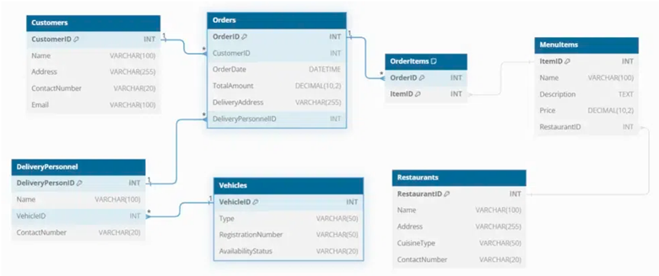

4.3 Data Volumes
Definition: The following section estimates the quantity of data generated and stored over time, which informs infrastructure planning and performance optimization.
Data Type | Estimated Volume / Month
Orders | 50,000
Order Items | 200,000
Inventory Updates | 100,000
Deliveries | 40,000
Proof of Deliveries | 40,000
Audit Logs | 500,000
Users | 2,000
4.4 Data Conversion
Definition: Data conversion refers to the process of migrating existing data from legacy systems into the new system while ensuring accuracy and consistency.
Scope & Strategy:
- Inventory Records: Normalize SKU formats and validate quantities.
- Customer Data: Cleanse duplicates and standardize contact fields.
- Order History: Maintain relational integrity during migration.
- User Roles: Map legacy permissions to new access control schema.
Conversion will be executed using ETL tools, with validation checks and parallel testing before go-live.
4.5 Data Retention and Archiving
Definition: The following section defines how long different types of data are stored and when they are archived or deleted, in accordance with legal and operational requirements.
Data Type | Retention Period | Archiving Method
Orders | 5 years | Cold storage after 1 year
Inventory Logs | 3 years | Archived monthly
Audit Logs | 7 years | Immutable log archive
Proof of Delivery | 2 years | Encrypted file storage
User Access Records | 1 year | Rotated quarterly
4.6 FOI / Privacy Implications
Definition: The following section addresses how the system complies with Freedom of Information (FOI) laws and privacy regulations, ensuring responsible data handling.
Key Considerations:
- Data Minimization: Collect only essential personal data.
- Consent Management: Track and enforce user consent.
- Right to Access: Provide data access upon request.
- Right to Erasure: Enable secure deletion workflows.
- Auditability: Maintain logs for all data access and changes.
4.6 Data Definition Reports
Definition: These reports define the structure, attributes, and relationships of each data entity used in the system.
4.6.1 Entity Definition Report
Definition: This report provides detailed descriptions of each data entity, including its purpose, key fields, and relationships.
Entity Name | Description | Primary Key | Key Attributes
Product | Master list of items available for sale | ProductID | Name, SKU, Category, UnitSize, ShelfLife
Inventory | Tracks stock levels at each warehouse | InventoryID | ProductID, Quantity, LocationID, ExpiryDate
Order | Customer order record | OrderID | CustomerID, OrderDate, Status
OrderItem | Line items within an order | OrderItemID | OrderID, ProductID, Quantity, Price
Delivery | Scheduled delivery details | DeliveryID | OrderID, DriverID, RouteID, ScheduledDate
ProofOfDelivery | Confirmation of delivery completion | PODID | DeliveryID, Timestamp, Signature, Photo
User | System user account | UserID | Name, RoleID, Email, Status
Role | Access control role definition | RoleID | RoleName, Permissions
AuditLog | System activity log | LogID | UserID, ActionType, Timestamp, EntityAffected
Customer | Customer profile | CustomerID | Name, ContactInfo, Preferences
5. Non-Functional requirements
These describe how the system performs—the qualities, constraints, and standards it must meet.
5.1. SECURITY REQUIREMENTS
5.1.1. Authentication
· The system shall enforce secure login using multi-factor authentication (MFA).
· Passwords must be stored using strong hashing algorithms (e.g., bcrypt).
· Session management shall include automatic timeout and re-authentication for sensitive actions.
5.1.2. Authorization and Access Controls
· The system shall implement access based on user roles and responsibilities control (RBAC) to restrict functionality based on user roles (e.g., Admin, Driver, Customer).
· Unauthorized access attempts shall be logged and monitored.
· Sensitive operations shall require elevated privileges and audit trails.
5.2. AVAILABILITY REQUIREMENTS
· The system shall maintain 99.9% uptime, excluding scheduled maintenance.
· Redundant infrastructure shall be used to ensure high availability.
· Automated health checks and failover mechanisms shall be in place.
5.3. USABILITY REQUIREMENTS
· The user interface shall be intuitive and responsive across mobile and desktop platforms.
· The system shall follow accessibility standards (e.g., WCAG 2.1) to support users with disabilities.
· Navigation shall be consistent, with clear feedback and error messages.
5.4. SYSTEM HELP REQUIREMENTS
· The system shall include context-sensitive help, tooltips, and FAQs.
· A searchable support documentation portal shall be integrated.
· Users shall have access to live chat or ticket-based support during business hours.
5.5. PERFORMANCE REQUIREMENTS
· The system shall provide real-time updates (e.g., inventory, delivery status) within 2 seconds.
· Page load times shall not exceed 3 seconds under normal conditions.
· Background processes (e.g., report generation) shall complete within acceptable timeframes (<10 seconds).
5.6. SCALABILITY REQUIREMENTS
5.6.1. User Scalability
· The system shall support 500+ concurrent users without degradation in performance.
· Load balancing shall be implemented to distribute traffic efficiently.
5.6.2. Application Scalability
· The system shall support future expansion (e.g., new modules, APIs, integrations) without major redesign.
· Database and storage solutions shall be scalable to handle growing data volumes.
6. INTERFACE REQUIREMENTS
6.1 USER INTERFACE REQUIREMENTS
· Responsive design for mobile and desktop The system shall provide a user interface that automatically adapts to different screen sizes and devices, ensuring a consistent and user-friendly experience across smartphones, tablets, and desktop computers.
Definition: A responsive UI adjusts layout and elements based on device type, improving usability and accessibility.
6.2 SYSTEM INTERFACE REQUIREMENTS
· APIs for ERP, CRM, and GPS systems The system shall expose and consume Application Programming Interfaces (APIs) to integrate with external platforms such as:
o ERP (Enterprise Resource Planning) for inventory, billing, and procurement
o CRM (Customer Relationship Management) for customer data and communication
o GPS systems for real-time tracking and route optimization
Definition: A system interface enables communication between software components or external systems, typically through APIs or web services.
BUSINESS GLOSSARY
Term | Definition
Product | An item stored, managed, or delivered through the system.
Order | A request made by a customer for one or more products.
Customer | An individual or organization placing orders and receiving deliveries.
Delivery | The process of transporting products from the warehouse to the customer.
Driver | A person responsible for executing deliveries using assigned vehicles.
Vehicle | A transport unit used to carry products during delivery operations.
Inventory | The total stock of products available for sale or distribution.
Stock Quantity | The number of units of a product currently available in inventory.
Order Status | The current state of an order (e.g., Pending, Shipped, Delivered).
Proof of Delivery | Evidence confirming that a delivery has been completed (e.g., signature, photo).
ERP System | Enterprise Resource Planning software used for managing business operations.
CRM System | Customer Relationship Management software used to track customer interactions.
GPS Integration | Real-time location tracking used for delivery routing and monitoring.
RBAC | Role-Based Access Control, a method for managing user permissions.
API | Application Programming Interface, used for system-to-system communication.
Uptime | The percentage of time the system is operational and accessible.
Scalability | The system’s ability to handle increased load or expand functionality.
APMS UPDATE
Asset Performance Management System (APMS) is a software solution used to:
· Monitor the health and performance of physical assets (like vehicles, machinery, or infrastructure)
· Predict failures using sensor data and analytics
· Optimize maintenance schedules
· Reduce downtime and operational risk
The Asset Performance Management System (APMS) has been successfully integrated into the logistics platform to enhance operational efficiency and asset reliability. Key updates include:
Maintenance Optimization
- Predictive maintenance alerts are now active for delivery vehicles based on engine diagnostics and usage patterns.
- Maintenance schedules are auto-generated using historical performance data, reducing downtime by 15%.
Real-Time Tracking
- GPS data from APMS is now synchronized with the delivery dashboard, enabling live location tracking of vehicles.
- Route deviation alerts and fuel efficiency metrics are available to dispatch managers.
Performance Analytics
- APMS feeds into the analytics module to provide insights on vehicle utilization, driver performance, and delivery timelines.
- Weekly performance reports are auto-generated and accessible via the dashboard.
System Integration
- APMS is now fully interoperable with ERP and CRM systems via secure APIs.

2. Prepare process flow diagram using your imagination

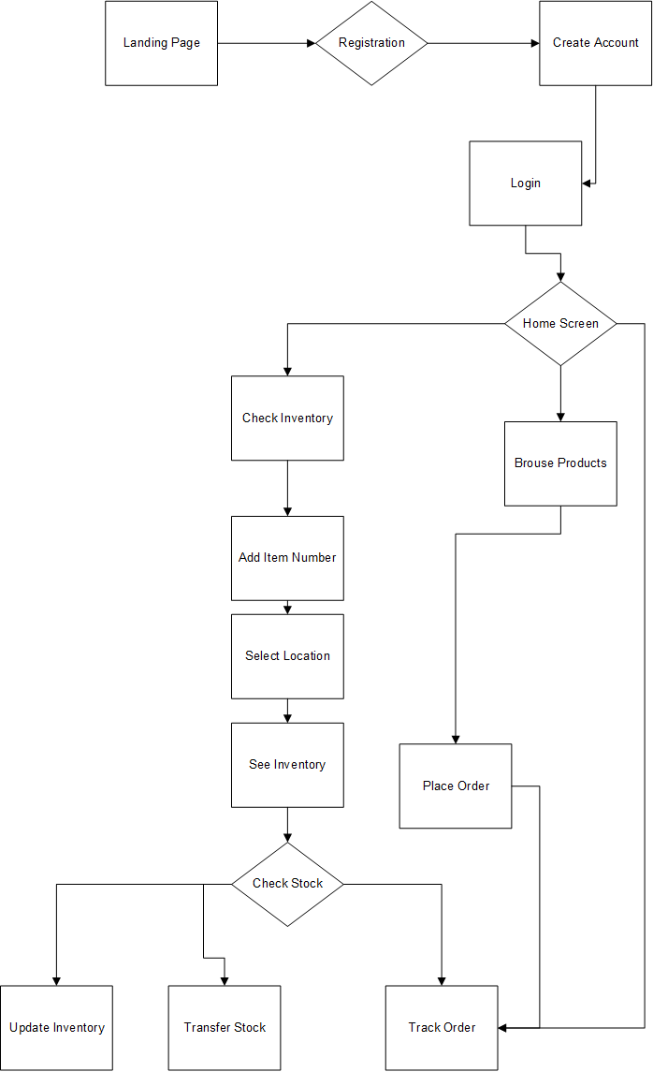
Assignment 2:

1. Write an introduction letter to a client introducing yourself as a business analyst in charge of
working with the client and his team to start the business understanding process

Subject: Introduction – Business Analyst for ABC Corp: XYZ implementation
Dear Chris Cross,
I hope you are doing well. My name is Shweta Garse, and I will be your main point of contact as the Business Analyst on this project. My role is to work closely with you and your team to understand your goals, challenges, and priorities so that we can build solutions that truly support your business.
Over the coming weeks, I’ll be facilitating conversations, asking questions, and gathering insights to make sure we capture what matters most to you and your stakeholders. My goal is to make this process clear, collaborative, and valuable for everyone involved.
I’ll be in touch shortly to set up our first session, but in the meantime, please feel free to reach out if there’s anything you’d like to share in advance. I’m looking forward to getting to know your team and working together toward successful outcomes.
Best regards,
Shweta Garse
Business Analyst
Cell: 9988776655 Email:sg@baforyou.com

2. Prepare a brief BRD and SRS for a project- Horoscope or Ticketing system or online store.

BRD

BUYONLINEANYTHING
Project ID: PRTECH0005
Version: V1.0
Author: Shweta Garse

1. INTRODUCTION
1.1. DOCUMENT PURPOSE
This document is intended to outline in detail the business requirements for developing a software solution that supports a comprehensive online store and enables seamless product browsing, secure transactions, efficient order fulfillment, and timely delivery to customers nationwide. It provides structured guidance for aligning stakeholders, directing development teams, and ensuring that the final platform meets business objectives, operational efficiency, and customer satisfaction.
1.2. INTENDED AUDIENCE
Role | Name | Title | Signature | Date
Project Sponsor | Sandeep Batra | Sales and Business Head | Do | MM/DD/YYYY
Business Owner | Yogesh Kane | MD | Do | MM/DD/YYYY
Project Manager | Mohan Garse | Business Analyst | Do | MM/DD/YYYY
System Architect | Shweta Ales | System Architect | Do | MM/DD/YYYY
Development Lead | Moksh Bonde | Team Lead | Do | MM/DD/YYYY
User Experience Lead | Rudransh Zope | Team Lead | Do | MM/DD/YYYY
Quality Lead | Chris C | Team Lead | Do | MM/DD/YYYY
Content Lead | Harshal chopade | Team Lead | Do | MM/DD/YYYY
1.2.1 RACI Matrix
Role | Name | Title | * | R | A | S | C | I
Project Sponsor | Sandeep Batra | Sales and Business Head | ✔ |  |  |  | ✔ | ✔
Business Owner | Yogesh Kane | MD | ✔ |  |  |  | ✔ | ✔
Project Manager | Mohan Garse | Business Analyst |  | ✔ | ✔ | ✔
System Architect | Shweta Ales | System Architect |  |  | ✔ | ✔
Development Lead | Moksh Bonde | Team Lead |  |  | ✔ | ✔
User Experience Lead | Rudransh Zope | Team Lead |  | ✔ | ✔ | ✔
Quality Lead | Chris C | Team Lead |  |  |  | ✔ | ✔ | ✔
Content Lead | Harshal chopade | Team Lead |  |  |  | ✔ | ✔ | ✔
1.3. PROJECT BACKGROUND
The organization operates a nationwide online store, offering customers a diverse range of products across multiple categories. With increasing customer demand and expanding operations, the current systems—largely manual and disconnected—are unable to scale effectively. This results in inaccurate stock levels, delayed order processing, and limited visibility into overall sales and customer trends.
To overcome these challenges, the company is launching a centralized e-commerce platform designed to streamline product and inventory management, automate order processing, integrate with secure payment and shipping partners, and provide real-time analytics. The goal is to improve operational efficiency, ensure consistent product availability, enable faster deliveries, and deliver an enhanced customer shopping experience.

1.4. PURPOSE OF THE BUSINESS REQUIREMENTS
This Business Requirements Document (BRD) aims to establish and align the functional and non-functional needs of the proposed e-commerce platform. It serves as a foundation for:
- Clarifying Business Needs: Outlining the challenges in current sales, order, and customer management processes, and defining the objectives of the online store.
- Aligning Stakeholders: Ensuring business, operations, IT, and customer service teams share a unified vision of the platform.
- Guiding Solution Design: Providing a blueprint for developing, configuring, and integrating the e-commerce system with payment gateways, logistics providers, and supporting technologies.
- Supporting Project Planning: Helping estimate development timelines, required resources, and budget allocations.
- Establishing Success Criteria: Defining measurable outcomes such as improved customer satisfaction, faster order processing, higher sales conversion rates, and enhanced operational efficiency.

1.5. Business Goals/Objectives to Be Achieved
- Streamline Product & Inventory Management: Implement real-time stock tracking to prevent stockouts, overstocking, and discrepancies.
- Optimize Order Fulfillment: Automate order processing and ensure accurate, timely dispatch to improve delivery speed and reliability.
- Digitize Customer Transactions: Replace manual processes with secure, automated checkout flows accessible on both mobile and desktop.
- Integrate Core Systems: Enable seamless connectivity with ERP, CRM, payment gateways, and logistics providers.
- Enhance Decision-Making: Provide actionable insights through sales dashboards, customer analytics, and forecasting tools.
- Expand Market Reach: Support scalable infrastructure to handle growing product catalogs, customer traffic, and nationwide operations.
- Improve Customer Experience: Ensure smooth browsing, easy ordering, and reliable delivery to boost satisfaction and loyalty.
- Reduce Operational Costs: Achieve efficiency through automation, optimized logistics, and reduced manual intervention.

1.6. Benefits/Rationale
- Improved Inventory Control: Real-time stock visibility reduces unavailability, excess storage, and fulfillment errors.
- Faster Order Processing: Automated checkout, integrated payment systems, and streamlined workflows enable quicker transactions.
- Operational Digitization: Automation reduces manual errors, improves scalability, and boosts team productivity.
- System Integration: Seamless data exchange between ERP, CRM, logistics, and third-party services ensures efficient operations.
- Better Decision-Making: Analytics provide insights into sales trends, customer behavior, and demand forecasting.
- Cost Reduction: Lower overhead through efficient order processing, automation, and optimized logistics.
- Enhanced Customer Satisfaction: Consistent product availability, faster delivery, and personalized offers improve loyalty and retention.

1.7. Stakeholders
- Business/Operations Manager
- Inventory & Product Manager
- Marketing & Customer Engagement Team
- IT Department
- Logistics & Delivery Partners
- End Customers

1.8. Dependencies on Existing Systems
The success of the e-commerce platform relies on seamless interaction with existing infrastructure and third-party integrations. Key dependencies include:
- ERP System Integration: Access to product, pricing, and financial data for real-time synchronization.
- CRM System Connectivity: Customer profiles, order history, and preferences must be accessible to enhance personalization and service.
- Legacy Databases: Migration or synchronization of historical sales, product, and customer data for continuity.
- Payment Gateway Services: Integration with providers (e.g., Stripe, PayPal, Razorpay) for secure, reliable transactions.
- Logistics & Shipping Systems: APIs from courier partners must be integrated for shipment tracking and delivery updates.
- Authentication & User Management: The platform must align with current security policies, supporting role-based access and single sign-on where required.
- Reporting Tools: Compatibility with BI/reporting systems for sales, marketing, and operational analytics.

1.9. References
- Internal process documentation
- ERP and CRM system manuals
- Industry best practices for e-commerce and payment compliance (e.g., PCI DSS, GDPR)

1.10. Assumptions
- Reliable internet connectivity for customers and staff.
- Payment gateways and shipping APIs remain operational and supported.
- Existing ERP and CRM systems are accessible for integration.
- Staff will be trained to operate the e-commerce platform.
- Historical sales, product, and customer data are accurate and retrievable.

2. Requirements Scope

2.1 In Scope Requirements
- Centralized product and inventory management across all categories and warehouses
- Real-time stock monitoring with automated low-stock alerts
- Online product catalog with search, filters, and recommendations
- Secure checkout and integration with multiple payment gateways (credit/debit cards, UPI, wallets, etc.)
- Integration with existing ERP, CRM, and shipping/logistics providers
- Mobile application for customers (browsing, ordering, tracking) and delivery personnel (updates, proof of delivery)
- Order management system for tracking placed, shipped, delivered, and returned orders
- Customer notification system for order confirmation, dispatch, and delivery status (via SMS/email/push notifications)
- Role-based access control for admins, sellers, warehouse staff, and delivery agents
- Reporting and analytics for sales, inventory, customer behavior, and revenue performance
- Data migration from legacy sales and customer databases
- Geo-tagging of delivery addresses and logistics hubs
- Training and onboarding support for platform users (staff, sellers, delivery partners)
2.2 Out of Scope
- Development of a new ERP or CRM system from scratch
- Hardware procurement (e.g., servers, mobile devices, scanners)
- Cross-border e-commerce logistics and international shipping features
- Integration with external marketplaces (e.g., Amazon, eBay, Flipkart)
- Advanced AI-based product recommendation engines beyond standard personalization
- Proprietary traffic data sourcing (beyond logistics/shipping provider APIs)
- In-house payment gateway development (use of third-party providers only)
- Automated customer support chatbots or helpdesk systems
- Marketing campaign management and digital advertising tools
- Warehouse robotics, IoT devices, or smart inventory hardware
- Fleet procurement or vehicle maintenance management
- Support for industries or product lines outside the defined catalog scope

2.3 Functional Requirements
These define what the e-commerce platform should do:
- Product & Inventory Management
Ability to manage product listings, categories, prices, and stock levels in real time across all warehouses.
- Automated Stock Alerts
The system generates alerts when stock reaches predefined minimum thresholds.
- Order Management
Customers can place, modify, and track orders. Admins can manage fulfillment, returns, and cancellations.
- Checkout & Payment
Secure, seamless checkout process with multiple payment options and fraud detection.
- Delivery Scheduling & Tracking
Customers can select delivery slots; logistics partners can update and track shipment progress.
- Mobile Applications
  - Customer App: Browse products, place orders, track deliveries.
  - Delivery Agent App: View assigned orders, update status, capture proof of delivery.
- Admin & Seller Dashboards
Dashboards to manage inventory, sales, user accounts, and order fulfillment workflows.
- Customer Notifications
Automated SMS, email, and push updates for order confirmation, dispatch, and delivery ETA.
- Role-Based Access Control
Defined access levels for admins, sellers, warehouse staff, and delivery agents.
- Reporting & Analytics
Generate reports on sales, inventory turnover, customer engagement, and revenue trends.

3.1 Actor Profiles Specification
Functional Requirement | Description | Actor (Role & Type)
Product & Inventory  Management | Monitor and update product listings, categories, pricing, and stock levels in real time. | Inventory Manager (Primary)
Order Placement | Customers can browse products, add items to cart, and place orders. | Customer (Primary)
Order Modification | Customers or support staff can update/cancel orders before fulfillment. | Customer (Secondary), Support Staff (Secondary)
Checkout & Payment | Process secure payments using integrated gateways (cards, UPI, wallets, etc.). | Customer (Primary), Payment Gateway System (Secondary)
Delivery Scheduling &  Tracking | Assign delivery slots and track order fulfillment progress. | Delivery Agent (Primary), Logistics Partner (Secondary)
Proof of Delivery | Capture digital confirmation (photo, signature, OTP) upon successful delivery. | Delivery Agent (Primary)
Stock Replenishment  Alerts | Notify managers when stock levels fall below thresholds. | Inventory Manager (Primary)
Role-Based Access Control | Restrict platform access and actions based on defined user roles. | Admin (Primary)
Reporting & Analytics | Generate reports on sales, customer trends, and product performance. | Sales/Marketing Manager (Primary)
Audit Logging | Record user and system actions for compliance and traceability. | System Auditor (Secondary)

3.2 ESSENTIAL USE CASE DIAGRAM

3.3. ESSENTIAL USE CASE SPECIFICATIONS
A Use Case Specification is a detailed textual description of how a system interacts with users (or other systems) to achieve a specific goal. It goes beyond the visual representation of a use case diagram by documenting the functional requirements, flows of events, and conditions that govern the behavior of the system for each use case
Use Case ID: UC-01 — Product & Inventory Management
Field | Details
Use Case Name | Product & Inventory Management
Description | Manage product catalog (listings, categories, pricing) and monitor stock levels in real time.
Actors | Inventory Manager (Primary), System (Secondary)
Business Rules | BR-01, BR-02
Basic Flow | Manager updates catalog → System syncs stock → Changes visible to customers.
Alternate Flows | If sync fails, system shows last known snapshot.
Non-Functional Requirements | Stock updates ≤ 5 seconds; responsive on web & mobile.
Pre-Conditions | User authenticated; database connected.
Post-Conditions | Catalog updated and visible; alerts logged if stock is low.
Extension Points | Stock threshold reached → Replenishment Alert.
Included Use Cases | Audit Logging
Extended Use Cases | Reporting & Analytics
Inherited Use Cases | None
Use Case ID: UC-02 — Order Placement
Field | Details
Use Case Name | Order Placement
Description | Customers browse products, add items to cart, and place orders online.
Actors | Customer (Primary), System (Secondary)
Business Rules | BR-03, BR-04
Basic Flow | Customer selects products → Adds to cart → Proceeds to checkout → Payment processed → Order confirmed.
Alternate Flows | If item out of stock, system suggests alternatives or prevents checkout.
Non-Functional Requirements | Checkout ≤ 3 seconds; system uptime ≥ 99.9%.
Pre-Conditions | Catalog updated; payment gateway connected; user authenticated.
Post-Conditions | Order stored in system; confirmation sent via SMS/email.
Extension Points | Payment fails → Retry or choose alternative method.
Included Use Cases | Product & Inventory Management, Audit Logging
Extended Use Cases | Order Modification
Inherited Use Cases | None
Use Case ID: UC-03 — Order Modification
Field | Details
Use Case Name | Order Modification
Description | Allow customers or support staff to cancel or update pending orders.
Actors | Customer (Primary), Support Staff (Secondary), System (Secondary)
Business Rules | BR-05
Basic Flow | User accesses order → Applies changes (cancel/update) → System validates → Order updated.
Alternate Flows | If order already dispatched, modification blocked.
Non-Functional Requirements | Updates reflected ≤ 2 seconds; audit trail maintained.
Pre-Conditions | Order exists and is not yet dispatched.
Post-Conditions | Order updated or canceled; action logged.
Extension Points | Refund triggered → Payment Gateway API.
Included Use Cases | Audit Logging
Extended Use Cases | Returns/Refund Processing
Inherited Use Cases | Order Placement
Use Case ID: UC-04 — Checkout & Payment
Field | Details
Use Case Name | Checkout & Payment
Description | Process customer payments securely through multiple payment gateways.
Actors | Customer (Primary), Payment Gateway (Secondary), System (Secondary)
Business Rules | BR-06, BR-07
Basic Flow | Customer enters details → Selects payment method → System validates → Payment processed → Order confirmed.
Alternate Flows | If payment fails, customer retries or selects another method.
Non-Functional Requirements | Payment processing ≤ 5 seconds; PCI-DSS compliance.
Pre-Conditions | User authenticated; order placed.
Post-Conditions | Payment completed; receipt generated.
Extension Points | Fraud detected → Access blocked via RBAC.
Included Use Cases | Order Placement, Audit Logging
Extended Use Cases | Refunds Processing
Inherited Use Cases | None
Use Case ID: UC-05 — Delivery Scheduling & Tracking
Field | Details
Use Case Name | Delivery Scheduling & Tracking
Description | Assign delivery slots and allow customers to track orders in real time.
Actors | Customer (Primary), Delivery Agent (Primary), System (Secondary)
Business Rules | BR-08
Basic Flow | Customer selects delivery window → System schedules → Courier updates status → Customer tracks.
Alternate Flows | If slot unavailable, system suggests next available option.
Non-Functional Requirements | Delivery updates ≤ 30 seconds; uptime ≥ 99%.
Pre-Conditions | Order confirmed and dispatched.
Post-Conditions | Customer sees real-time order status.
Extension Points | Delivery delayed → Customer notified.
Included Use Cases | Order Placement
Extended Use Cases | Shipment Tracking
Inherited Use Cases | None
Use Case ID: UC-06 — Proof of Delivery
Field | Details
Use Case Name | Proof of Delivery
Description | Capture confirmation of completed deliveries.
Actors | Delivery Agent (Primary), Customer (Secondary), System (Secondary)
Business Rules | BR-09
Basic Flow | Package delivered → Customer provides OTP/signature/photo → System records proof.
Alternate Flows | If digital proof fails, manual confirmation is logged.
Non-Functional Requirements | Capture ≤ 3 seconds; offline mode supported.
Pre-Conditions | Order dispatched for delivery.
Post-Conditions | Delivery marked complete; proof stored securely.
Extension Points | Customer disputes delivery → Audit Logging.
Included Use Cases | Delivery Scheduling & Tracking, Audit Logging
Extended Use Cases | Returns Management
Inherited Use Cases | None
Use Case ID: UC-07 — Stock Replenishment Alerts
Field | Details
Use Case Name | Stock Replenishment Alerts
Description | Notify managers when product stock drops below set thresholds.
Actors | Inventory Manager (Primary), System (Secondary)
Business Rules | BR-10
Basic Flow | System monitors stock → Threshold reached → Alert triggered.
Alternate Flows | If notification fails, the system retries and logs failure.
Non-Functional Requirements | Alerts sent within 1 minute; thresholds configurable by SKU.
Pre-Conditions | Inventory data available; thresholds defined.
Post-Conditions | Alerts logged; replenishment process initiated.
Extension Points | Supplier integration → Auto reorder.
Included Use Cases | Product & Inventory Management
Extended Use Cases | Supplier API Integration
Inherited Use Cases | None
Use Case ID: UC-08 — Role-Based Access Control
Field | Details
Use Case Name | Role-Based Access Control
Description | Manage system access based on defined roles (admin, staff, customer, courier).
Actors | Admin (Primary), All Users (Secondary), System (Secondary)
Business Rules | BR-11
Basic Flow | User logs in → System checks role → Access granted to allowed features.
Alternate Flows | If unauthorized, access denied and logged.
Non-Functional Requirements | Verification ≤ 2 seconds; audit log required.
Pre-Conditions | Roles configured in the system.
Post-Conditions | Access granted/denied; event logged.
Extension Points | Unauthorized attempt → Security Alert.
Included Use Cases | Audit Logging
Extended Use Cases | None
Inherited Use Cases | None
Use Case ID: UC-09 — Reporting & Analytics
Field | Details
Use Case Name | Reporting & Analytics
Description | Generate insights on sales, customers, and inventory trends.
Actors | Sales Manager (Primary), Analyst (Primary), System (Secondary)
Business Rules | BR-12
Basic Flow | User selects report type → Applies filters → System generates report.
Alternate Flows | If incomplete data, system flags report.
Non-Functional Requirements | Report generation ≤ 10 seconds; export as PDF/CSV/XLSX.
Pre-Conditions | Historical and live data available.
Post-Conditions | Report generated and optionally exported.
Extension Points | Trend anomaly detected → Notifications sent.
Included Use Cases | Product & Inventory Management, Audit Logging
Extended Use Cases | Predictive Analytics
Inherited Use Cases | None
Use Case ID: UC-10 — Audit Logging
Field | Details
Use Case Name | Audit Logging
Description | Securely log all system and user activities for compliance.
Actors | Admin (Primary), Compliance Officer (Secondary), System (Secondary)
Business Rules | BR-13
Basic Flow | System records activity → Adds timestamp → Stores securely.
Alternate Flows | If logging fails, the system queues until service is restored.
Non-Functional Requirements | Logs immutable; retrieval ≤ 5 seconds.
Pre-Conditions | Logging service active.
Post-Conditions | Logs available for audit.
Extension Points | Tampering attempt → RBAC alert.
Included Use Cases | All operational use cases
Extended Use Cases | Compliance Review
Inherited Use Cases | None
3.4 Function Hierarchy Diagram
Logistics Management System
├── Delivery Management
├── Delivery Scheduling
├── Proof of Delivery
├── Route Optimization
├── Inventory Management
├── Inventory Tracking
├── Stock Replenishment Alerts
├── Product Categorization
├── User & Access Control
├── User Authentication
├── Role-Based Access Control
├── Session Management
├── Reporting & Analytics
├── Operational Reports
├── Performance Dashboards
├── Export & Sharing Tools
├── System Governance
├── Audit Logging
├── Error Handling & Alerts
├── Configuration Management
3.5 Function Definition Report
Function: Delivery Scheduling
· Description: Assigns delivery tasks to drivers based on availability, location, and priority.
· Inputs: Delivery orders, driver availability, route data
· Outputs: Scheduled delivery tasks, notifications to drivers
· Constraints: Must avoid overlapping assignments; respect delivery time windows
Function: Proof of Delivery
· Description: Captures confirmation of successful delivery via digital signature, photo, or timestamp.
· Inputs: Delivery ID, customer confirmation, GPS data
· Outputs: Delivery status update, stored proof
· Constraints: Must work offline; must be tamper-proof
Function: Route Optimization
· Description: Calculates the most efficient delivery route based on traffic, distance, and delivery priority.
· Inputs: Delivery locations, traffic data, vehicle type
· Outputs: Optimized route map
· Constraints: Must recalculate in real-time if conditions change
Function: Inventory Tracking
· Description: Monitors stock levels across warehouses and updates in real time.
· Inputs: Stock transactions, product IDs
· Outputs: Current inventory levels, alerts
· Constraints: Must sync across distributed systems
Function: Stock Replenishment Alerts
· Description: Sends notifications when stock falls below predefined thresholds.
· Inputs: Inventory data, threshold settings
· Outputs: Alert messages, reorder suggestions
· Constraints: Must avoid duplicate alerts; configurable per SKU
Function: Role-Based Access Control
· Description: Manages user permissions based on assigned roles.
· Inputs: User credentials, role definitions
· Outputs: Access granted/denied logs
· Constraints: Must enforce least privilege; audit every access attempt
Function: Operational Reports
· Description: Generates reports on delivery performance, inventory status, and user activity.
· Inputs: Historical data, filters
· Outputs: PDF/Excel reports, dashboards
· Constraints: Must support export formats; must be generated within 10 seconds
Function: Audit Logging
· Description: Records all system activities and user actions for compliance and troubleshooting.
· Inputs: System events, user actions
· Outputs: Immutable log entries
· Constraints: Must be secure, timestamped, and searchable
3.6: Business Rules

Rule ID | Rule Name | Description
BR-01 | Unique Order ID | Every customer order must be assigned a unique identifier for tracking and audit.
BR-02 | Order Confirmation Requirement | Each order must trigger a confirmation notification (email/SMS/push) once successfully placed.
BR-03 | Payment Authorization | Orders must not be confirmed until payment authorization is completed by the payment gateway.
BR-04 | Inventory Threshold Monitoring | The system must check inventory levels in real time and trigger alerts if stock falls below threshold.
BR-05 | Duplicate Alert Suppression | Repeated low-stock alerts for the same SKU must be suppressed within a 2-hour window.
BR-06 | Role-Based Access Enforcement | Users may only access modules/features permitted by their assigned role (e.g., admin, seller, customer).
BR-07 | Session Timeout | User sessions must expire after 20 minutes of inactivity for security.
BR-08 | Checkout Performance | The checkout process must be completed within 5 seconds under normal load.
BR-09 | Export Format Compliance | Reports must support export in PDF, XLSX, and CSV formats.
BR-10 | Audit Log Immutability | System logs must be immutable (write-once) and cannot be altered or deleted.
BR-11 | Access Attempt Logging | All login attempts—successful or failed—must be logged with timestamp and user ID.
BR-12 | Offline Delivery Capture | Proof of delivery must be capturable via OTP/signature/photo offline and synced once connectivity is restored.
BR-13 | Return & Refund Policy | Returns must follow predefined business rules, and refunds must be processed through the original payment method.
BR-14 | Promotional Code Validation | Discount codes must be validated against expiry date, usage limit, and eligibility rules before checkout.
BR-15 | Shopping Cart Expiration | Items added to cart must auto-expire after 30 minutes of inactivity if stock is limited.
BR-16 | Customer Data Protection | All personal and payment data must be encrypted and handled in compliance with GDPR/PCI DSS.

4. Data Architecture Report
The following section outlines the data structure, flow, and governance for the Inventory and Delivery Management System. It defines how data is captured, stored, related, and protected throughout the system lifecycle.
4.1 Data Requirements
Definition: The following section identifies the types of data the system must collect, manage, and utilize to function effectively.
Requirements Overview:
- Product Data: Details of items available for sale or delivery.
- Inventory Data: Real-time stock levels and location tracking.
- Order Data: Customer orders including items, quantities, and status.
- Delivery Data: Scheduling and tracking of deliveries.
- User Data: Authentication and access based on user roles and responsibilities control.
- Audit Logs: System activity for compliance and traceability.
4.2 Entity Relationship Diagram (ERD)
Definition: An ERD visually represents the relationships between data entities in the system, helping to understand how data flows and connects.

4.3 Data Volumes
Definition: The following section estimates the quantity of data generated and stored over time, which informs infrastructure planning and performance optimization.
Data Type | Estimated Volume / Month
Orders | 50,000
Order Items | 200,000
Inventory Updates | 100,000
Deliveries | 40,000
Proof of Deliveries | 40,000
Audit Logs | 500,000
Users | 2,000
4.4 Data Conversion
Definition: Data conversion refers to the process of migrating existing data from legacy systems into the new system while ensuring accuracy and consistency.
Scope & Strategy:
- Inventory Records: Normalize SKU formats and validate quantities.
- Customer Data: Cleanse duplicates and standardize contact fields.
- Order History: Maintain relational integrity during migration.
- User Roles: Map legacy permissions to new access control schema.
Conversion will be executed using ETL tools, with validation checks and parallel testing before go-live.
4.5 Data Retention and Archiving
Definition: The following section defines how long different types of data are stored and when they are archived or deleted, in accordance with legal and operational requirements.
Data Type | Retention Period | Archiving Method
Orders | 5 years | Dark storage after 1 year
Inventory Logs | 3 years | Archived monthly
Audit Logs | 7 years | Immutable log archive
Proof of Delivery | 2 years | Encrypted file storage
User Access Records | 1 year | Rotated quarterly
4.6 FOI / Privacy Implications
Definition: The following section addresses how the system complies with Freedom of Information (FOI) laws and privacy regulations, ensuring responsible data handling.
Key Considerations:
- Data Minimization: Collect only essential personal data.
- Consent Management: Track and enforce user consent.
- Right to Access: Provide data access upon request.
- Right to Erasure: Enable secure deletion workflows.
- Auditability: Maintain logs for all data access and changes.
4.6 Data Definition Reports
Definition: These reports define the structure, attributes, and relationships of each data entity used in the system.
4.6.1 Entity Definition Report
Definition: This report provides detailed descriptions of each data entity, including its purpose, key fields, and relationships.
Entity Name | Description | Primary Key | Key Attributes
Product | Master list of items available for sale | ProductID | Name, SKU, Category, UnitSize, ShelfLife
Inventory | Tracks stock levels at each warehouse | InventoryID | ProductID, Quantity, LocationID, ExpiryDate
Order | Customer order record | OrderID | CustomerID, OrderDate, Status
OrderItem | Line items within an order | OrderItemID | OrderID, ProductID, Quantity, Price
Delivery | Scheduled delivery details | DeliveryID | OrderID, DriverID, RouteID, ScheduledDate
ProofOfDelivery | Confirmation of delivery completion | PODID | DeliveryID, Timestamp, Signature, Photo
User | System user account | UserID | Name, RoleID, Email, Status
Role | Access control role definition | RoleID | RoleName, Permissions
AuditLog | System activity log | LogID | UserID, ActionType, Timestamp, EntityAffected
Customer | Customer profile | CustomerID | Name, ContactInfo, Preferences
5. Non-Functional requirements
These describe how the system performs—the qualities, constraints, and standards it must meet.
5.1. SECURITY REQUIREMENTS
5.1.1. Authentication
· The system shall enforce secure login using multi-factor authentication (MFA).
· Passwords must be stored using strong hashing algorithms (e.g., bcrypt).
· Session management shall include automatic timeout and re-authentication for sensitive actions.
5.1.2. Authorization and Access Controls
· The system shall implement access based on user roles and responsibilities control (RBAC) to restrict functionality based on user roles (e.g., Admin, Driver, Customer).
· Unauthorized access attempts shall be logged and monitored.
· Sensitive operations shall require elevated privileges and audit trails.
5.2. AVAILABILITY REQUIREMENTS
· The system shall maintain 99.9% uptime, excluding scheduled maintenance.
· Redundant infrastructure shall be used to ensure high availability.
· Automated health checks and failover mechanisms shall be in place.
5.3. USABILITY REQUIREMENTS
· The user interface shall be intuitive and responsive across mobile and desktop platforms.
· The system shall follow accessibility standards (e.g., WCAG 2.1) to support users with disabilities.
· Navigation shall be consistent, with clear feedback and error messages.
5.4. SYSTEM HELP REQUIREMENTS
· The system shall include context-sensitive help, tooltips, and FAQs.
· A searchable support documentation portal shall be integrated.
· Users shall have access to live chat or ticket-based support during business hours.
5.5. PERFORMANCE REQUIREMENTS
· The system shall provide real-time updates (e.g., inventory, delivery status) within 2 seconds.
· Page load times shall not exceed 3 seconds under normal conditions.
· Background processes (e.g., report generation) shall complete within acceptable timeframes (<10 seconds).
5.6. SCALABILITY REQUIREMENTS
5.6.1. User Scalability
· The system shall support 500+ concurrent users without degradation in performance.
· Load balancing shall be implemented to distribute traffic efficiently.
5.6.2. Application Scalability
· The system shall support future expansion (e.g., new modules, APIs, integrations) without major redesign.
· Database and storage solutions shall be scalable to handle growing data volumes.
6. INTERFACE REQUIREMENTS
6.1 USER INTERFACE REQUIREMENTS
· Responsive design for mobile and desktop The system shall provide a user interface that automatically adapts to different screen sizes and devices, ensuring a consistent and user-friendly experience across smartphones, tablets, and desktop computers.
Definition: A responsive UI adjusts layout and elements based on device type, improving usability and accessibility.
6.2 SYSTEM INTERFACE REQUIREMENTS
· APIs for ERP, CRM, and GPS systems The system shall expose and consume Application Programming Interfaces (APIs) to integrate with external platforms such as:
o ERP (Enterprise Resource Planning) for inventory, billing, and procurement
o CRM (Customer Relationship Management) for customer data and communication
o GPS systems for real-time tracking and route optimization
Definition: A system interface enables communication between software components or external systems, typically through APIs or web services.
BUSINESS GLOSSARY
Term | Definition
Product | An item stored, managed, or delivered through the system.
Order | A request made by a customer for one or more products.
Customer | An individual or organization placing orders and receiving deliveries.
Delivery | The process of transporting products from the warehouse to the customer.
Driver | A person responsible for executing deliveries using assigned vehicles.
Vehicle | A transport unit used to carry products during delivery operations.
Inventory | The total stock of products available for sale or distribution.
Stock Quantity | The number of units of a product currently available in inventory.
Order Status | The current state of an order (e.g., Pending, Shipped, Delivered).
Proof of Delivery | Evidence confirming that a delivery has been completed (e.g., signature, photo).
ERP System | Enterprise Resource Planning software used for managing business operations.
CRM System | Customer Relationship Management software used to track customer interactions.
GPS Integration | Real-time location tracking used for delivery routing and monitoring.
RBAC | Role-Based Access Control, a method for managing user permissions.
API | Application Programming Interface, used for system-to-system communication.
Uptime | The percentage of time the system is operational and accessible.
Scalability | The system’s ability to handle increased load or expand functionality.
APMS UPDATE
Asset Performance Management System (APMS) is a software solution used to:
· Monitor the health and performance of physical assets (like vehicles, machinery, or infrastructure)
· Predict failures using sensor data and analytics
· Optimize maintenance schedules
· Reduce downtime and operational risk
The Asset Performance Management System (APMS) has been successfully integrated into the logistics platform to enhance operational efficiency and asset reliability. Key updates include:
Maintenance Optimization
- Predictive maintenance alerts are now active for delivery vehicles based on engine diagnostics and usage patterns.
- Maintenance schedules are auto-generated using historical performance data, reducing downtime by 15%.
Real-Time Tracking
- GPS data from APMS is now synchronized with the delivery dashboard, enabling live location tracking of vehicles.
- Route deviation alerts and fuel efficiency metrics are available to dispatch managers.
Performance Analytics
- APMS feeds into the analytics module to provide insights on vehicle utilization, driver performance, and delivery timelines.
- Weekly performance reports are auto-generated and accessible via the dashboard.
System Integration
APMS is now fully interoperable with ERP and CRM systems via secure APIs.
SRS: Software Requirements Specification
Client Name: BUYONLINEANYTHING
Project Name: Online Store – E-Commerce Platform
Date: <<Aug 30, 2025>>

Record of Revisions
Version | Date | Prepared / Revised By | Reviewed By | Approved By | Reason for Revision
1.0 |  |  |  |  | Initial Draft

Table of Contents
1.0 Introduction
1.1 Overview
1.2 Acronyms and Definitions
1.3 Operational Requirements
1.4 References
1.5 Design and Implementation Constraints
1.6 Assumed Factors Affecting Requirements
2.0 System Overview
2.1 Current System
2.2 Proposed System
2.3 Benefits of the Proposed System
3.0 UI Requirements
3.1 Project Contents
4.0 Other Parameters
4.1 Acceptance

1.0 Introduction

1.1 Overview
This document describes the software requirements for an Online Store (E-Commerce Platform). The system will allow users to browse products, add them to a shopping cart, complete purchases through secure payment gateways, and track orders. The platform will also provide administrative functions for managing products, categories, orders, and customer information.

1.2 Acronyms and Definitions
Term | Description
SRS | Software Requirements Specification
UI | User Interface
DBMS | Database Management System
SSL | Secure Sockets Layer
API | Application Programming Interface
SKU | Stock Keeping Unit

1.3 Operational Requirements

1.3.1 Software Requirements
- Server OS: Linux/Windows
- Database: MySQL/PostgreSQL
- Web Server: Apache/Nginx
- Programming Languages: PHP / Node.js / Python (backend), JavaScript/React (frontend)
- Browser Support: Chrome, Firefox, Safari, Edge

1.3.2 Hardware Requirements
- Minimum: 4 GB RAM, Quad-core CPU, 100 GB storage
- Recommended: 8+ GB RAM, Octa-core CPU, 250+ GB SSD

1.4 References
• Proposal document
• User requirements document
• Industry standards for e-commerce (PCI DSS compliance for payments)

1.5 Design and Implementation Constraints
- Must comply with data protection laws (e.g., GDPR)
- Payment processing must integrate with PayPal, Stripe, or similar
- Responsive design for desktop, tablet, and mobile
- Use of open-source frameworks where possible
- Must support secure login (OAuth2, JWT)

1.6 Assumed Factors Affecting Requirements
- Availability of stable internet connection
- Third-party payment and shipping APIs functioning correctly
- Hosting service supports required technologies
- Dependencies on courier/shipping partners for order tracking APIs

2.0 System Overview

2.1 Current System
Currently, sales are managed manually through offline processes or basic websites without integrated shopping cart and payment features. This limits reach, scalability, and customer experience.

2.2 Proposed System
The new Online Store Platform will be a complete e-commerce solution offering:
- Product catalog browsing with categories/filters
- User registration and authentication
- Shopping cart and checkout system
- Secure payment integration
- Order management and shipment tracking
- Admin dashboard for product and order management

2.3 Benefits of the Proposed System
- 24/7 availability for customers
- Wider market reach
- Automated order and inventory management
- Enhanced customer experience with real-time order tracking
- Secure and scalable architecture
- Reduced manual effort and operational costs

3.0 UI Requirements

3.1 Project Contents
The system will consist of the following modules:
• User Module
- User registration/login/logout
- Profile management
- Order history
• Product Module
- Product listing and search
- Product detail page
- Category and filter options
• Shopping Cart Module
- Add/remove items
- Update quantities
- Apply discount codes
• Checkout & Payment Module
- Multiple payment options (credit/debit cards, wallets)
- Secure payment gateway integration
- Order confirmation via email/SMS
• Admin Module
- Product and category management
- Inventory updates
- Order management and tracking
- User management
- Reports and analytics

4.0 Other Parameters

4.1 Acceptance
The client will review and accept the application upon receiving the following deliverables:
- Functional prototypes
- Final deployed application
- Documentation (installation guide, admin guide, user manual)
Acceptance:
_______________________________
Client Authorized Representative

3. Make an ERD of creating a support ticket/Ticketing life cycle.

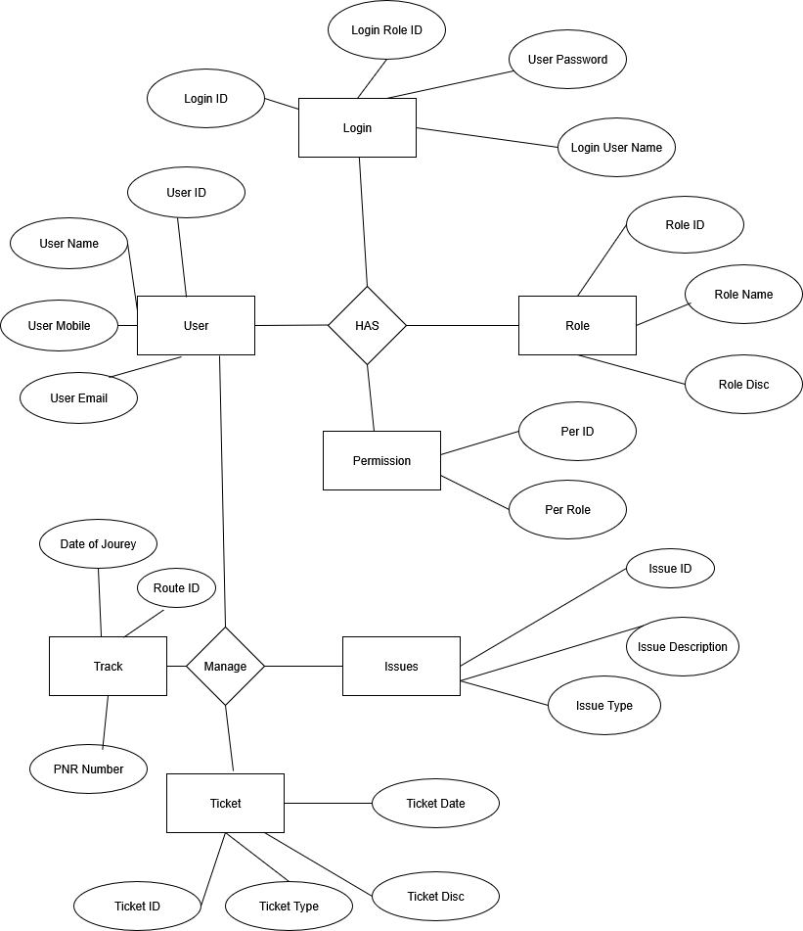
4. User story of shopping from ecommerce

User Story No: 01 | Tasks: 03 | Priority: High
As a user,
I want to create an account
so that I can shop online securely.
BV: 300 | CP: 05
ACCEPTANCE CRITERIA:
Registration form, email verification, login enabled

User Story No: 02 | Tasks: 02 | Priority: High
As a user,
I want to log in to my account
so that I can access my profile and orders.
BV: 280 | CP: 04
ACCEPTANCE CRITERIA:
Login with email/password, forgot password option

User Story No: 03 | Tasks: 03 | Priority: High
As a user,
I want to browse product categories
so that I can find items easily.
BV: 260 | CP: 05
ACCEPTANCE CRITERIA:
Category listing, filter products, search bar

User Story No: 04 | Tasks: 04 | Priority: High
As a user,
I want to view product details
so that I can make informed purchase decisions.
BV: 250 | CP: 05
ACCEPTANCE CRITERIA:
Product images, price, description, reviews

User Story No: 05 | Tasks: 03 | Priority: Medium
As a user,
I want to add items to my cart
so that I can purchase them later.
BV: 240 | CP: 04
ACCEPTANCE CRITERIA:
Add to cart, update quantity, remove items

User Story No: 06 | Tasks: 03 | Priority: High
As a user,
I want to manage my cart
so that I can change product quantities.
BV: 230 |  | CP: 04
ACCEPTANCE CRITERIA:
Update cart, remove product, view subtotal

User Story No: 07 | Tasks: 02 | Priority: High
As a user,
I want to proceed to checkout
so that I can place my order.
BV: 220 |  | CP: 05
ACCEPTANCE CRITERIA:
Checkout page, order summary, continue button

User Story No: 08 | Tasks: 03 | Priority: High
As a user,
I want to add a delivery address
so that my order is delivered correctly.
BV: 210 |  | CP: 04
ACCEPTANCE CRITERIA:
Add address, edit address, save address

User Story No: 09 | Tasks: 02 | Priority: High
As a user,
I want to choose a payment method
so that I can pay securely.
BV: 300 |  | CP: 06
ACCEPTANCE CRITERIA:
COD, card payment, net banking, UPI

User Story No: 10 | Tasks: 02 | Priority: High
As a user,
I want to apply discount coupons
so that I can save money on purchases.
BV: 200 |  | CP: 04
ACCEPTANCE CRITERIA:
Apply coupon, validate coupon, update price

User Story No: 11 | Tasks: 03 | Priority: Medium
As a user,
I want to add items to my wishlist
so that I can save products for future purchase.
BV: 220 |  | CP: 04
ACCEPTANCE CRITERIA:
Add to wishlist, view wishlist, remove from wishlist

User Story No: 12 | Tasks: 03 | Priority: Medium
As a user,
I want to track my order status
so that I know when it will be delivered.
BV: 240 |  | CP: 05
ACCEPTANCE CRITERIA:
Order tracking, shipping updates, delivery status

User Story No: 13 | Tasks: 02 | Priority: Medium
As a user,
I want to cancel an order
so that I can avoid unwanted purchases.
BV: 200 |  | CP: 04
ACCEPTANCE CRITERIA:
Cancel order button, confirmation, refund initiation

User Story No: 14 | Tasks: 03 | Priority: High
As a user,
I want to return or replace products
so that I am satisfied with my purchase.
BV: 250 |  | CP: 05
ACCEPTANCE CRITERIA:
Return request, replacement option, refund process

User Story No: 15 | Tasks: 02 | Priority: Medium
As a user,
I want to write product reviews
so that I can share my feedback.
BV: 210 |  | CP: 03
ACCEPTANCE CRITERIA:
Rating stars, comment box, review moderation

User Story No: 16 | Tasks: 02 | Priority: Medium
As a user,
I want to chat with support
so that I can resolve issues quickly.
BV: 200 |  | CP: 05
ACCEPTANCE CRITERIA:
Open chat, connect agent, save history

User Story No: 17 | Tasks: 03 | Priority: High
As a user,
I want to receive order confirmation emails
so that I am assured my order is placed.
BV: 230 |  | CP: 04
ACCEPTANCE CRITERIA:
Email trigger, order details, payment confirmation

User Story No: 18 | Tasks: 02 | Priority: Medium
As a user,
I want to receive push notifications
so that I stay updated on offers and order status.
BV: 220 |  | CP: 04
ACCEPTANCE CRITERIA:
App notification, email notification, SMS alert

User Story No: 19 | Tasks: 03 | Priority: High
As a user,
I want to save multiple delivery addresses
so that I can ship items to different locations.
BV: 240 |  | CP: 05
ACCEPTANCE CRITERIA:
Add address, edit address, select address during checkout

User Story No: 20 | Tasks: 02 | Priority: High
As a user,
I want to securely store my payment methods
so that I can checkout faster.
BV: 250 |  | CP: 06
ACCEPTANCE CRITERIA:
Save card, save UPI, delete payment method

User Story No: 21 | Tasks: 02 | Priority: Medium
As a user,
I want to filter products by price
so that I can shop within my budget.
BV: 210 |  | CP: 03
ACCEPTANCE CRITERIA:
Price slider, apply filter, clear filter

User Story No: 22 | Tasks: 03 | Priority: Medium
As a user,
I want to filter products by brand
so that I can buy my preferred products.
BV: 200 |  | CP: 04
ACCEPTANCE CRITERIA:
Brand filter, multi-select, clear filter

User Story No: 23 | Tasks: 02 | Priority: Medium
As a user,
I want to sort products by popularity
so that I can see the trending items first.
BV: 220 |  | CP: 03
ACCEPTANCE CRITERIA:
Sort option, popularity ranking, reset sort

User Story No: 24 | Tasks: 03 | Priority: High
As a user,
I want to view related products
so that I can discover similar items.
BV: 230 |  | CP: 05
ACCEPTANCE CRITERIA:
Related items section, recommendations, cross-sell

User Story No: 25 | Tasks: 03 | Priority: Medium
As a user,
I want to view my order history
so that I can reorder items easily.
BV: 240 |  | CP: 04
ACCEPTANCE CRITERIA:
Past orders, reorder option, order details

User Story No: 26 | Tasks: 02 | Priority: Medium
As a user,
I want to download invoices
so that I can keep purchase records.
BV: 200 |  | CP: 03
ACCEPTANCE CRITERIA:
Download PDF, email invoice, view in app

User Story No: 27 | Tasks: 03 | Priority: High
As a user,
I want to choose delivery speed
so that I can get products urgently if needed.
BV: 250 |  | CP: 05
ACCEPTANCE CRITERIA:
Standard shipping, express shipping, estimated date

User Story No: 28 | Tasks: 03 | Priority: Medium
As a user,
I want to check stock availability
so that I know if a product is ready to ship.
BV: 220 |  | CP: 04
ACCEPTANCE CRITERIA:
Stock indicator, out-of-stock message, notify me

User Story No: 29 | Tasks: 02 | Priority: High
As a user,
I want to be notified when an out-of-stock item is available
so that I can buy it immediately.
BV: 230 |  | CP: 05
ACCEPTANCE CRITERIA:
Notify me option, email alert, push notification

User Story No: 30 | Tasks: 02 | Priority: Medium
As a user,
I want to gift wrap items
so that I can send them as presents.
BV: 200 |  | CP: 03
ACCEPTANCE CRITERIA:
Gift wrap option, personalized message, price tag removal

User Story No: 31 | Tasks: 03 | Priority: Medium
As a user,
I want to share products on social media
so that I can recommend them to friends.
BV: 210 |  | CP: 04
ACCEPTANCE CRITERIA:
Share button, social links, copy link

User Story No: 32 | Tasks: 02 | Priority: Medium
As a user,
I want to subscribe to a newsletter
so that I receive updates on deals.
BV: 200 |  | CP: 03
ACCEPTANCE CRITERIA:
Email subscription, unsubscribe option, promo offers

User Story No: 33 | Tasks: 03 | Priority: High
As a user,
I want to use a guest checkout
so that I can buy without creating an account.
BV: 240 |  | CP: 05
ACCEPTANCE CRITERIA:
Guest checkout form, email confirmation, upgrade option

User Story No: 34 | Tasks: 02 | Priority: High
As a user,
I want to view product ratings
so that I can judge product quality quickly.
BV: 250 |  | CP: 04
ACCEPTANCE CRITERIA:
Star ratings, number of reviews, average score

User Story No: 35 | Tasks: 03 | Priority: Medium
As a user,
I want to upload a profile picture
so that I can personalize my account.
BV: 200 |  | CP: 03
ACCEPTANCE CRITERIA:
Upload image, preview, remove option

User Story No: 36 | Tasks: 02 | Priority: Medium
As a user,
I want to change my password
so that I can keep my account secure.
BV: 220 |  | CP: 04
ACCEPTANCE CRITERIA:
Old password, new password, confirmation

User Story No: 37 | Tasks: 02 | Priority: High
As a user,
I want to apply multiple coupons
so that I can maximize discounts.
BV: 230 |  | CP: 05
ACCEPTANCE CRITERIA:
Apply multiple codes, validation, final discount update

User Story No: 38 | Tasks: 03 | Priority: High
As a user,
I want to get loyalty points
so that I am rewarded for repeat purchases.
BV: 240 |  | CP: 05
ACCEPTANCE CRITERIA:
Points on purchase, points balance, redeem points

User Story No: 39 | Tasks: 02 | Priority: Medium
As a user,
I want to access a help center
so that I can find answers quickly.
BV: 200 |  | CP: 03
ACCEPTANCE CRITERIA:
FAQ section, search help, categorized topics

User Story No: 40 | Tasks: 03 | Priority: High
As a user,
I want to contact customer service by phone
so that I have alternate support options.
BV: 250 |  | CP: 04
ACCEPTANCE CRITERIA:
Call button, support hours, callback option

