COEPD-Scrum Project Implementation–100 Marks–Pass is 60%
Instructions to follow:
- Copy paste (image, diagram or text) is not entertained. If done; the document will not be evaluated.
- After submission of the answers of this prep exam, you should be prepared to attend viva and justify your answers in the prep exams. If in Viva, participant is NOT justifying the answers, Viva will be repeated until Candidates justify 60% correctness.
- Mentor calls are scheduled only if the participants have submitted their task at least for one time. (Should apply their knowledge in this task first)
- For attempting prep exams participant should be thorough on the topics using their references.
- Please form at the document properly (Always have a question no., question and answer).
- Have a consistent format (Font name: Arial/Calibri-Fontsize12, Font Color: Black).
- Few Questions are related to the case study; check Questions thoroughly before you answer.
- Answers should be elaborated in detail (*not as per the allotted marks).
- Please focus on learning and applying the knowledge as this knowledge will be helpful in contributing at your BA job.
- In the evaluation, students must answer all questions and should be able to justify at least 60% content and correctness of each answer.

Question1–write Agile Manifesto–8 Marks
The Agile Manifesto was created in 2001 by a group of software developers to improve the software development process through flexibility, collaboration, and customer-centric approaches. It defines four key values and twelve principles that guide agile teams. The four key values of the Agile Manifesto are:
1. Individuals and interactions over processes and tools
2. Working software over comprehensive documentation
3. Customer collaboration over contract negotiation
4. Responding to change over following a plan
These values emphasize teamwork, adaptability, and delivering functional results. Agile believes that requirements evolve and customers' needs change, hence continuous improvement, feedback, and iteration are essential. The Scrum Foods project aligns with these principles by focusing on real-time customer requirements, faster delivery, and continuous collaboration between stakeholders, developers, and end users.
Twelve Principles of Agile Software
1. Satisfy the customer through early and continuous delivery of valuable software.
2. Welcome changing requirements, even late in development. Agile processes harness change for the customer's competitive advantage.
3. Deliver working software frequently, from a couple of weeks to a couple of months, with preference to the shorter timescale.
4. Business people and developers must work together daily throughout the project.
5. Build projects around motivated individuals. Give them the environment and support they need, and trust them to get the job done.
6. The most efficient and effective method of conveying information to and within a development team is face-to-face conversation.
7. Working software is the primary measure of progress.
8. Agile processes promote sustainable development. The sponsors, developers, and users should be able to maintain a constant pace indefinitely.
9. Continuous attention to technical excellence and good design enhances agility.
10. Simplicity--the art of maximizing the amount of work not done--is essential.
11. The best architectures, requirements, and designs emerge from self-organizing teams.
12. At regular intervals, the team reflects on how to become more effective, then tunes and adjusts its behavior accordingly.
Scrum Project Name: Scrum Foods (Foods Delivery Applications)

Scrum Project Description:
Scrum Foods provides fast, reliable online food delivery application targeting customers of all age group offering 24/7 service along with tracking of the delivery real time.

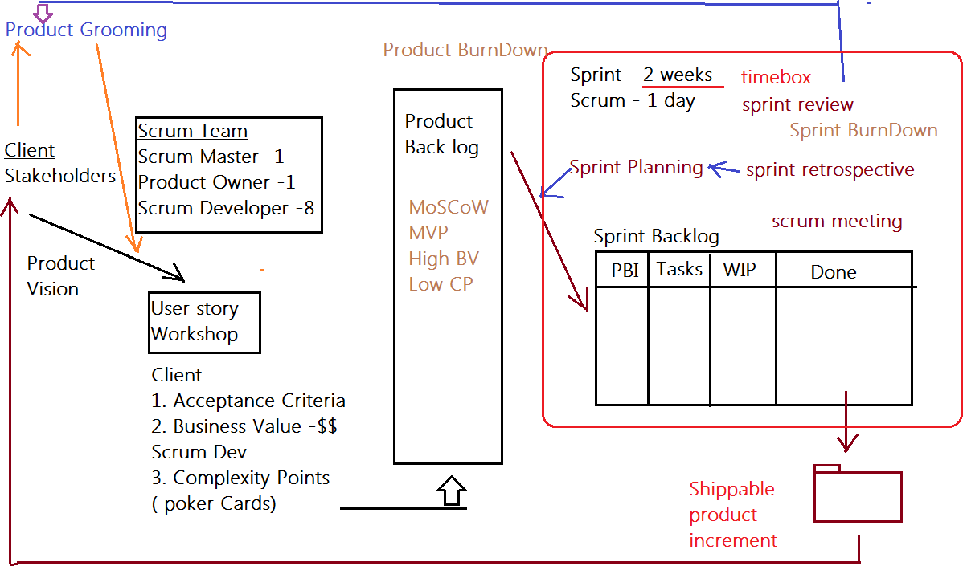

Client: COEPD IT Solutions
Stakeholder List:
1.Business Owner
2.Administrator
3.Regional Administrator
4. Restaurant
5.Delivery boy
6.Customer

Product Vision

Meeting–Discussion–Document-

Scrum Project Name: Scrum Foods
Venue:
Date: Start Time: End Time: Duration:
Client: COEPD IT Solutions
Stakeholder List:
1.Business Owner
2.Administrator
3.Regional Administrator
4. Restaurant
5.Delivery boy
6.Customer
Scrum Team
Scrum Master: Satya Rathnakar
Product Owner: YOU
Scrum Developer 1: LineshVegad
Scrum Developer 2: Yogender
Scrum Developer 3: Gowri
Scrum Developer 4: A. Lakshmikala
Scrum Developer 5: Madhuri
Scrum Developer 6: Varun
Scrum Developer 7: Rakesh
Scrum Developer 8: Rajesh
You are the Product Owner

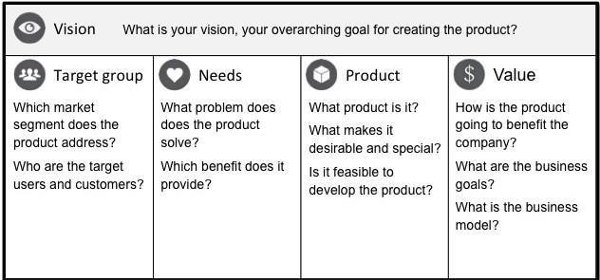

VISION: Customers of any age group who want to have top-rated restaurant’s delicious food in one- go at their doorstep with lighting fast delivery, 24/7 availability and reliable services are SCRUM FOODS. Unlike any other food delivery app in market, our utmost priority is customer need and
Customers at is faction which makes us stand out of any other food delivery app in this industry.
Online food delivery industry is our target segment.  Users/Customers: People who want food deliveries within stipulated time at their required place | Scrum foods provide guaranteed safe food delivery in one-go of top-rated licensed restaurants.  Customers can receive with safe packaged food within expected time to clear their hunger. | Scrum foods will be on mobile, tablets and desktop application.  Real time tracking and providing24/7services and customer support  Product feasibility can be complex and require attention in every aspect | Open up revenue stream  Be leading online food delivery app in country  Create reputed brand image for other business opportunities.

Product Vision–Description–Notes

Customer: Registration, Login, Search and View restaurants, View restaurant's menu, Order food, Payment, Tracking, Cancel order, Feedback & Rating and Logout.
Delivery Boy: Registration, Login, View orders, Select and accept orders, Order pickup and delivery, Status updates, Payment (COD), View Feedback, Raise Issues, View Deliveries report and revenue generated, Logout.
Restaurants: Registration, Login, View Orders, Delivery Boy Verification, Payment, View Feedback, Raise Issues, View revenue generated through Scrum Food app, Logout.
Regional Admin: Admin Login, Tracking/status, Customer feedback, Managing Regional delivery boys and restaurant, view regional revenue, Issues, Refunds, View payment made to regional restaurant and Logout.
Admin: Login, Managing Regional Admin, Issues, Customer Feedback, Approval/Rejections privileges on restaurants, Delivery boy, Restaurants and Regional Admin requests, Resolve Issues and Logout
Business Owner: Login, Issues, Reports, Update payments for restaurants and delivery boy sand Logout

End of Product Vision

User Story Workshop
How to write a user story:
Take a Sticky Note and take a contract color Sketch Pen and write the user story in CAPITAL letters only. Make sure the user story is short, clear and unambiguous and one Scrum Developer can develop in one agreed sprint.
If you come across complex, big User stories…these are called epics. We can divide the epics into Themes and then into User Stories

Finalized User Stories |Count:
USER STORIES
SPRINT-1
User Story No:1 | Tasks:2 |  | Priority: HIGHEST
AS A DELIVERYBOY I WANT TO REGISTER IN SCRUM FOODS SO THAT I CAN DELIVER ORDERS
BV:500 |  | CP:02
ACCEPTANCE CRITERIA
Registration Screen
Text Boxes for User Name, Password, Nation ID, Mobile No, Email, Address, Phone Number.
Click on Register Button.
Send Successful Notification to the user

User Story No:02 | Tasks: 2 |  | Priority: HIGHEST
AS A RESTAURANT OWNER I WANT TO VIEW ORDERS
SO THAT I CAN VIEW THE LIST OF ORDERS
BV: 500 |  | CP: 2
Acceptance Criteria:
View Order, Display List of orders in the tabular Form

User Story No:3 | Tasks:2 |  | Priority: HIGHEST
AS A CUSTOMER
I WANT TO ADD THE ADDRESS
SO THAT I CAN GET THE ORDER TO MY ADDRESS
BV:500 |  | CP:2
Acceptance Criteria:
Text Box to enter.
Business Rules: Within the radius of 5 km

User Story No:4 | Tasks:2 |  | Priority: HIGHEST
AS A CUSTOMER
I WANT TO SELECT THE PAYMENT MODE
SO THAT I CAN MAKE PAYMENT OF MY CHOICE
BV:500 |  | CP:3
Acceptance Criteria:
Display payment modes, radio buttons to select payment modes, payments button.
Business Rule. Can select only one payment mode

User Story No:5 | Tasks:2 |  | Priority: HIGHEST
AS AN ADMIN
I WANT TO VIEW THE RESTAURANTS
SO THAT I CAN APPROVE THEIR REGISTRATION
BV:500 |  | CP:2
ACCEPTANCE CRITERIA
List of restaurants, select Restaurants, verify restaurant details, approve button, reject button, notification to the restaurant.

UserStoryNo:6 | Tasks:2 |  | Priority: LOW
AS A CUSTOMER
I WANT TO VIEW THE PRICE
SO THAT I CAN ORDER THE FOOD
BV:50 |  | CP:1
Acceptance Criteria:
1.Display price in the list of menu items

User StoryNo:7 | Tasks:2 |  | Priority: LOW
AS A CUSTOMER
I WANT TO VIEW THE CONTACT NUMBER OF DELIVERY BOY SO THAT I CAN CONTACT DELIVERY BOY FOR THE STATUS
BV:50 |  | CP:1
Acceptance Criteria:
- Display delivery boy mobile number
- Display delivery boy name in tracking field
- Display delivery boy picture

UserStoryNo:8 | Tasks:2 |  | Priority: MEDIUM
AS A RESTAURANT OWNER
I WANT TO PROVIDE TIME SLOTS
SOTHATCUSTOMERCANCHECKOPENINGANDCLOSINGHOURS
BV:100 |  | CP:2
Acceptance Criteria:
- Click on restaurant dashboard
- Add from time to time
- Click on submit
- Display updated successfully

UserStoryNo:9 | Tasks:2 |  | Priority: HIGH
AS A Business OWNER
I WANT TO VIEW RESTAURANT REVENUE REPORT SO THAT I CAN VIEW THE RESTAURANT’S REVENUE
BV:200 |  | CP:3
Acceptance Criteria: Select Reports
Select Revenue Reports Select to and from date Select Region (can select all) Generate Report
Download Report in EXCEL

User Story No:10 | Tasks:03 |  | Priority: High
AS A REG ADMIN
I WANT TO MANAGE REGIONAL RESTAURANTS,
SO THAT, I CAN TRACK THE PERFORMANCE OF REGIONAL RESTAURANTS.
BV:200 |  | CP:03
Acceptance Criteria:
CLICK ON PERFORMANCE OF RESTAURANTS SELECT FROM DATE TO DATE
CLINCK ON GENERATE REPORT WHICH IN CLUSES RESTAURANTS ID, NAME, REVENUE
CLICK ON DOWNLOAD REPORT SHOULD BE IN EXCEL

UserStoryNo:11 | Tasks:02 |  | Priority: Medium
AS ADMIN
I WANT TO SEE THE REGIONAL REVENUE REPORTS, SO THAT I CAN VIEW THE REGIONAL PERFORMANCE
BV:100 |  | CP:03
Acceptance Criteria:
Select regional drop down
View performance of each rest of that region in tabular form which includes rest name, revenue, generated
Download in excel or PDF

User Story No:12 | Tasks:02 |  | Priority: High
AS A CUSTOMER
I WANT TO CHAT WITH REG ADMIN SO THAT I CAN REQUEST FOR REFUND
BV:200 |  | CP:02
Acceptance Criteria:
- BR-ALL MANDATORY
- TEXT BOX FIELDS
- DISPLAY ORDER ID
- TEXT BOX, FOR DESCRIPTION
- SUBMIT BUTTON
- GENERATE ISSUEID
- DISPLAY SUCCESSFUL

Adding BV and CP to User stories
BV–Business Value
This is not the cost of Development or the complexity of the feature. Business Value is how important is this feature (user Story) to the Business. This is estimated by Scrum Currency Notes. We provide Rs 1000. Rs 500, Rs 100, Rs 50, Rs 20 and Rs 10 Denominations. These estimations are done by the Stakeholders (Clients). If different values are selected by the stakeholders, then discussions will happen, and they agree to one BV value to that user story.

CP–Complexity Points
CP is also known as Story Points (SP). CP is the effort required by the Scrum Developers to develop this feature (user story) using technology. Efforts include time taken to solve the complexity and write the code. CP is estimated by the Scrum Developers by using Poker cards. We provide pokers with values“?”, 1, 2, 3, 5, 8, 13, 20, 40, 100 and BIG. If the entire Project development takes 200 points, then this user
Story coding effort will be… how many points? Thinking in this way, Scrum Developers will give CP to the User story.). If different values are selected by the Scrum Developers, then discussions will happen, and they agree to one CP value to that user story.

Question2–User Stories-Acceptance Criteria-BV-CP– 40 Marks
Write minimum 40 User stories and their Acceptance Criteria along with their BV and CP
User stories represent features or functionalities that provide value to users and are written from the user's perspective. Each story includes Acceptance Criteria, Business Value (BV), and Complexity Points (CP). Below are 40 detailed user stories for the Scrum Foods application. (Note: BV = Business Value, CP = Complexity Points).

SPRINT-2 (New User Stories 13–24)
User Story No: 13
AS A CUSTOMER, I WANT TO SEARCH FOR RESTAURANTS SO THAT I CAN EASILY FIND MY PREFERRED ONE.
BV: ₹500 CP: 2 PRIORITY: HIGH TASKS: 2
Acceptance Criteria:
• Search bar available on homepage
• Type restaurant name or cuisine
• Display results in list view
User Story No: 14
AS A CUSTOMER, I WANT TO FILTER RESTAURANTS BY CUISINE AND RATING SO THAT I CAN CHOOSE BETTER OPTIONS.
BV: ₹200 CP: 3 PRIORITY: MEDIUM TASKS: 2
Acceptance Criteria:
• Filter by cuisine type, rating, and price range
• Display results dynamically
User Story No: 15
AS A CUSTOMER, I WANT TO VIEW MY ORDER HISTORY SO THAT I CAN REORDER OR TRACK PREVIOUS ORDERS.
BV: ₹500 CP: 3 PRIORITY: HIGH TASKS: 3
Acceptance Criteria:
• Order history section in profile
• Display order ID, items, total, date
• Option to reorder
User Story No: 16
As a CUSTOMER, I want to rate and review restaurants so that I can share my experience.
BV: ₹200 CP: 2 Priority: MEDIUM Tasks: 2
Acceptance Criteria:
• Rating scale 1–5
• Text review box
• Submit review confirmation
User Story No: 17
AS A CUSTOMER, I WANT TO RECEIVE ORDER CONFIRMATION VIA SMS/EMAIL SO THAT I AM INFORMED OF ORDER STATUS.
BV: ₹100 CP: 2 PRIORITY: HIGH TASKS: 2
Acceptance Criteria:
• Send confirmation after payment
• Include estimated delivery time
User Story No: 18
AS A DELIVERY BOY, I WANT TO UPDATE ORDER DELIVERY STATUS SO THAT CUSTOMERS CAN TRACK DELIVERY.
BV: ₹500 CP: 3 PRIORITY: HIGH TASKS: 3
ACCEPTANCE CRITERIA:
• Options: Picked, On the Way, Delivered
• Real-time update to customer screen
User Story No: 19
AS A DELIVERY BOY, I WANT TO VIEW MY ASSIGNED DELIVERIES SO THAT I CAN PLAN MY ROUTE.
BV: ₹200 CP: 2 PRIORITY: HIGH TASKS: 2
Acceptance Criteria:
• List of pending and delivered orders
• Include delivery address and customer contact
User Story No: 20
AS A RESTAURANT OWNER, I WANT TO UPDATE MY MENU ITEMS SO THAT CUSTOMERS CAN VIEW LATEST OFFERINGS.
BV: ₹200 CP: 3 PRIORITY: HIGH TASKS: 3
Acceptance Criteria:
• Add/Edit/Delete menu items
• Confirmation message “Updated successfully”
User Story No: 21
AS A RESTAURANT OWNER, I WANT TO SET DAILY SPECIALS SO THAT CUSTOMERS CAN SEE PROMOTIONS.
BV: ₹100 CP: 2 PRIORITY: MEDIUM TASKS: 2
Acceptance Criteria:
• Option to mark item as “Special Today”
• Display tag on menu
User Story No: 22
AS AN ADMIN, I WANT TO SUSPEND OR DEACTIVATE RESTAURANTS SO THAT I CAN MANAGE PLATFORM QUALITY.
BV: ₹200 CP: 3 PRIORITY: HIGH TASKS: 2
Acceptance Criteria:
• Select restaurant → Suspend/Deactivate
• Send notification email
User Story No: 23
As an ADMIN, I want to generate daily order reports so that I can monitor platform activity.
BV: ₹200 CP: 3 Priority: MEDIUM Tasks: 3
Acceptance Criteria:
• Select date range
• Display order count, revenue, cancellations
• Download Excel/PDF
User Story No: 24
AS A REGIONAL ADMIN, I WANT TO ASSIGN RESTAURANTS TO REGIONS SO THAT MANAGEMENT IS ORGANIZED.
BV: ₹100 CP: 2 PRIORITY: MEDIUM TASKS: 2
Acceptance Criteria:
• Drop-down for region
• Save and update message confirmation
SPRINT–3 (User Stories 25–36)
User Story No: 25
AS A CUSTOMER, I WANT TO TRACK MY ORDER IN REAL TIME SO THAT I KNOW DELIVERY STATUS.
BV: ₹500 CP: 3 PRIORITY: HIGH TASKS: 3
Acceptance Criteria:
• Map integration for delivery route
• Auto-refresh every 30 seconds
User Story No: 26
AS A CUSTOMER, I WANT TO APPLY DISCOUNT COUPONS SO THAT I CAN SAVE MONEY.
BV: ₹200 CP: 2 PRIORITY: MEDIUM TASKS: 2
Acceptance Criteria:
• Coupon text box
• Validate and show discount amount

User Story No: 27
AS A CUSTOMER, I WANT TO SAVE MULTIPLE DELIVERY ADDRESSES SO THAT I CAN CHOOSE BASED ON CONVENIENCE.
BV: ₹200 CP: 3 PRIORITY: MEDIUM TASKS: 3
ACCEPTANCE CRITERIA:
• Add/Edit/Delete addresses
• Mark one as default
User Story No: 28
AS A CUSTOMER, I WANT TO RECEIVE PUSH NOTIFICATIONS SO THAT I STAY UPDATED ON ORDER PROGRESS.
BV: ₹100 CP: 2 PRIORITY: LOW TASKS: 2
Acceptance Criteria:
• Notifications for confirmation, out for delivery, delivered
User Story No: 29
AS A DELIVERY BOY, I WANT TO VIEW MY EARNINGS SO THAT I CAN TRACK MY INCOME.
BV: ₹200 CP: 2 PRIORITY: MEDIUM TASKS: 2
Acceptance Criteria:
• Dashboard showing daily and monthly earnings
User Story No: 30
AS A DELIVERY BOY, I WANT TO UPDATE MY AVAILABILITY STATUS SO THAT THE ADMIN CAN ASSIGN ORDERS PROPERLY.
BV: ₹100 CP: 2 PRIORITY: MEDIUM TASKS: 2
Acceptance Criteria:
• Toggle “Available/Not Available”
User Story No: 31
AS A RESTAURANT OWNER, I WANT TO VIEW CUSTOMER FEEDBACK SO THAT I CAN IMPROVE SERVICE.
BV: ₹100 CP: 2 PRIORITY: MEDIUM TASKS: 2
Acceptance Criteria:
• Feedback section showing ratings and comments
User Story No: 32
AS AN ADMIN, I WANT TO MANAGE DELIVERY PERSONNEL PROFILES SO THAT ONLY VERIFIED USERS OPERATE.
BV: ₹200 CP: 3 PRIORITY: HIGH TASKS: 3
Acceptance Criteria:
• View/Edit/Delete delivery boy data
• Verification checkbox
User Story No: 33
AS AN ADMIN, I WANT TO MONITOR CUSTOMER COMPLAINTS SO THAT ISSUES ARE RESOLVED TIMELY.
BV: ₹200 CP: 3 PRIORITY: HIGH TASKS: 3
Acceptance Criteria:
• Complaint list with filter by status
• Option to mark “Resolved”
User Story No: 34
AS A REGIONAL ADMIN, I WANT TO VIEW PERFORMANCE CHARTS SO THAT I CAN ANALYZE RESTAURANT METRICS VISUALLY.
BV: ₹200 CP: 3 PRIORITY: MEDIUM TASKS: 3
Acceptance Criteria:
• Graph of revenue and orders per restaurant
• Export as image
User Story No: 35
AS A CUSTOMER, I WANT TO CONTACT CUSTOMER SUPPORT SO THAT I CAN RESOLVE ISSUES QUICKLY.
BV: ₹100 CP: 2 PRIORITY: MEDIUM TASKS: 2
Acceptance Criteria:
• Contact form with chat or email option
• Auto-generated ticket ID
User Story No: 36
AS A BUSINESS OWNER, I WANT TO SET COMMISSION RATES FOR RESTAURANTS SO THAT REVENUE DISTRIBUTION IS CLEAR.
BV: ₹100 CP: 3 PRIORITY: MEDIUM TASKS: 2
Acceptance Criteria:
• Field for commission %
• Apply and save confirmation
SPRINT–4 (User Stories 37–40)
User Story No: 37
AS AN ADMIN, I WANT TO GENERATE TAX REPORTS SO THAT FINANCIAL DATA IS AUDIT-READY.
BV: ₹100 CP: 3 PRIORITY: MEDIUM TASKS: 2
Acceptance Criteria:
• Tax breakdown by restaurant
• Export PDF
User Story No: 38
As a CUSTOMER, I want to receive refund confirmation so that I am aware of refund status.
BV: ₹100 CP: 2 Priority: MEDIUM Tasks: 2
Acceptance Criteria:
• Display refund ID
• Email and SMS notification
User Story No: 39
AS A RESTAURANT OWNER, I WANT TO UPLOAD FOOD PHOTOS SO THAT CUSTOMERS CAN VIEW ITEMS VISUALLY.
BV: ₹50 CP: 2 PRIORITY: LOW TASKS: 2
Acceptance Criteria:
• Upload image (JPG/PNG)
• Preview before saving
User Story No: 40
AS A REGIONAL ADMIN, I WANT TO COMPARE REVENUE BETWEEN REGIONS SO THAT I CAN ASSESS PERFORMANCE TRENDS.
BV: ₹200 CP: 3 PRIORITY: HIGH TASKS: 3
Acceptance Criteria:
• Select regions
• Display comparative graph
• Download Excel report
Question3–What is epic? Write 2 epics–5Marks

An epic is a large user story or collection of related user stories that represents a significant feature or functionality. Epics are high-level, often spanning multiple sprints or iterations, and they provide a way to organize and prioritize work in a product backlog.

2 Epics
1.Ratings and reviews
2.Scheduled orders

Epics 1: Restaurant Ratings and Reviews
As a user, I want to view ratings for restaurants on ScrumFoods, so that I can make informed decisions about where to order food from.

As a user, I want to provide ratings and reviews for restaurants on ScrumFoods, so that I can share my experiences with other users and contribute to the community.

Acceptance Criteria:
- Users can view average ratings and reviews for each restaurant on the restaurant details page.
- Users can read detailed reviews and comments left by other customers.
- Users can sort and filter reviews based on criteria such as ratings and relevance
- Users can rate a restaurant and leave a review after placing an order.
- Users can edit or delete their own reviews within a specified timeframe.
- Reviews are displayed in a way that provides helpful insights to order users.
- The ratings and reviews system maintains the integrity and authenticity of user feedback

Epic 2: Scheduled Orders
As a user, I want to schedule food orders in advance on ScrumFoods so that I can plan meals ahead of time and avoid last-minute hassles.
As a user, I want to have the flexibility to choose specific delivery time slots for scheduled orders on ScrumFoods

Acceptance Criteria:
- Users can select a future date and time for placing a scheduled order.
- Users can choose from available delivery time slots during the days, evening and nights.
- Users can browse and order from all available restaurants during scheduled order placements.
- Users can modify or cancel scheduled orders within a specified timeframe.
- Users receive reminders and notifications regarding their scheduled orders, including order confirmation and upcoming delivery alerts.
- Delivery executives receive clear instructions about scheduled orders and prioritize them accordingly.
- The system handles scheduled orders seamlessly, ensuring timely delivery and accurate order fulfillment.

Question 4–What is the difference between BV and CP–2Marks
Business Value represents the overall value that a user story or feature brings to the business or organization.
Techniques used: Moscow, Currency notes technique

Evaluate Business Value:
- Assess the potential impact on revenue generation, cost savings, or other measurable business metrics. For example, a user story that enables upselling or introduces a new revenue stream would have higher BV.
- Consider the alignment of the user story with the strategic objectives and long-term vision of the ScrumFood application.
- Assign a relative value or weight to each user story based on its potential business impact.

Complexity Points represents the importance and urgency of a user story or feature from the perspective of the customer or end user.
Techniques used: Planning poker
Evaluate Complexity Points:
- Understand the needs, pain points, and expectations of the end users (customers) of the ScrumFood application.
- Consider user feedback, user research and market demand to gauge the importance of the user story from customer’s perspective.
- Assess the potential impact on enhancing the user experience, improving convenience, or addressing critical user needs.
- Assign a relative priority or weight to each user story based on its significance to the customers.

Question 5–Explain about Sprint– 5 Marks
A Sprint is the fundamental unit of work in the Scrum framework. It is a time-boxed iteration during which a Scrum Team works to deliver a usable, potentially shippable product increment. Each Sprint begins immediately after the previous one ends and results in a tangible output that adds value to the product.
Purpose for Business Analyst:
As a BA, you define clear requirements, ensure understanding among developers, and confirm that the deliverables align with business goals during the Sprint.
Time-Boxed Duration
A Sprint is time-boxed, meaning it has a fixed duration that cannot be extended.
- Typically lasts 1 to 4 weeks, most commonly 2 weeks.
- The time-box ensures the team maintains a regular rhythm and predictable delivery cycle.
For BAs:
The fixed duration helps you plan requirement refinement, stakeholder reviews, and acceptance testing efficiently.
Defined Goal
Each Sprint has a Sprint Goal, which describes what the team aims to achieve during that Sprint.
It gives the team a clear direction and purpose. For example: Improve the order tracking feature so users can view delivery status in real-time.”
Role of BA:
- Help define and clarify the Sprint Goal.
- Ensure the goal aligns with business priorities and customer needs.
Sprint Planning
Sprint Planning is the first ceremony of every Sprint.
The team collaboratively plans what work will be done (Sprint Backlog) and how it will be accomplished.
Agenda:
- Select high-priority items from the Product Backlog.
- Define the Sprint Goal.
- Break selected items into tasks.
BA’s Role:
- Clarify user stories, acceptance criteria, and dependencies.
- Ensure selected backlog items meet business value expectations.
Daily Stand-up Meetings
Also known as the Daily Scrum, it’s a 15-minute meeting held every day during the Sprint.
Team members discuss:
- What they did yesterday,
- What they plan to do today, and
- Any blockers they face.
BA’s Role:
- Observe progress and identify any requirement or dependency issues early.
- Collaborate with the team to remove blockers impacting business objectives.
Development and Testing
During the Sprint, developers and testers work collaboratively to build, test, and validate the product increment.
Agile encourages continuous integration and testing to ensure quality.
BA’s Role:
- Validate that feature meet business and user requirements.
- Participate in testing and user acceptance processes.
- Provide feedback or clarification on features.
Incremental Delivery
At the end of each Sprint, the team delivers a working product increment — a small, functional piece of the overall system.
Each increment adds value and brings the product closer to completion.
BA’s Role:
- Verify that the increment delivers measurable business value.
- Demonstrate functionality to stakeholders and gather feedback.

Sprint Review and Retrospective
- Sprint Review: Conducted at the end of the Sprint to showcase the completed work to stakeholders. Feedback is gathered for improvement.
- Sprint Retrospective: Conducted after the review, focusing on team improvement — what went well, what didn’t, and how to enhance the next Sprint.
BA’s Role:
- In Sprint Review: Present business outcomes, ensure stakeholder alignment.
- In Retrospective: Contribute insights on communication, process improvements, and requirement clarity.

Backlog Refinement (Grooming)
Backlog Refinement is an ongoing process of reviewing, clarifying, and prioritizing items in the Product Backlog.
It ensures that backlog items are well-defined and ready for upcoming Sprints.
BA’s Role:
- Collaborate with Product Owner to write clear user stories.
- Add acceptance criteria and update priorities based on stakeholder input.
- Ensure that the backlog is “Sprint-ready.”

What is Sprint?

Sprint is a time-boxed iteration in Scrum, typically lasting 1–4 weeks, during which the Scrum team develops a set of features defined in the Sprint Backlog. Each sprint aims to produce a potentially shippable product increment. In Scrum Foods, each sprint is two weeks long. The Scrum team meets daily, tracks progress, and adapts to changes. At the end of each sprint, a review and retrospective are conducted to evaluate performance and plan improvements.

Sprint Understanding
What is sprint Duration: 2 Weeks-Your sprint Value?
Scrum is a sub unit of Sprint.
What is scrum Duration: 1 day – Your scrum Value ? PBI: Product Backlog Item
Task: Unit of Work done by 1 Developer in 1 Scrum WIP: Work in Progress
Sprint Backlog

PBI | Tasks | WIP | Done

Question 6–Explain Product backlog and sprint backlog–5 Marks

 | Product Backlog | Sprint Backlog
 | Anything that needed to accomplish the project vision | Anything that is needed to fulfill the sprint goal
 | Product Owner owns | Development team owns
 | Contains requirements, defects, tasks | A subset of product backlog items defined as a priority by the product owner
 | Everyone contributes to the product backlog | Only the development team contribute to the sprint backlog
 | Product backlog refinement meeting is to refine the product backlog | Sprints Planning meeting is to refine the sprint backlog items
 | Product backlog evolve and changes will be done by the PO through the product lifecycle | No changes are allowed to the sprint backlog items once the sprints have started
 | Release burndown metric is used | Sprint burndown metric is used
 | Estimation is done at a user story level | Estimation is done at the activity or task level
 | Daily stand-up meeting does not discuss it | Daily stand-up meeting discusses the sprint

Question7–What is impediments log? write 2 impediments–5 Marks
An impediment log, also known as an issue log or obstacle log, is a document or tool used in Agile software development to track and manage obstacles, bottlenecks, or any factors that impede the progress or team.
2 Impediment
- Delivery partner shortage in a specific region.
- Technical issue causing intermittent order processing failures.

Impediments Log:

All challenges faced by the team will be logged in this impediments log
Once the Sprint is completed
- From the Done state of the sprint Backlog, we will product Increment and we can deliver it to the client
- Sprint Retrospective meeting: Only the Scrum Developers will participate and will discuss about Challenges faced and come up with lessons learnt. We can use these lessons learnt in Sprint planning meeting to select user stories for the next sprint.
- Sprint Review meeting: All Stakeholders like Scrum Developers, Product owner, Scrum master, Client, 3rd party reviewers will participate. What they discuss is
  - Velocity–How many CP is covered in this sprint
  - Sprint Burn Down Chart

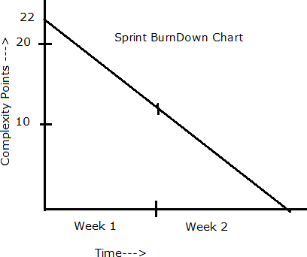

  - Product Burn Down Chart

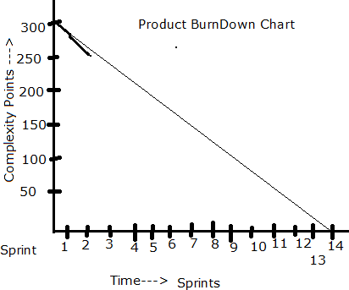

  - Product insights for improvement

Sprint1
Start Time: 11:00AM End Time: 13:00 Duration: 2hrs

Sprint Planning Meeting
Participants
Discussion Points: Discussed on the Sprint Velocity and the BV with the user stories. Discussed with
The associates on resources provided to the Mandal so communicated to the team on sprint duration as well as expectations from the client.
User Stories Selected:10(MVP)

Sprint Backlog

PBI | Tasks | WIP | Done
10 | 20 | 0 | 10

Prepare Tasks from PBI
How many Scrums, we will have in this sprint? Allocate Tasks to Developers

Scrum 1
Start Time: End Time: Duration:
Participant and Task Selected

Scrum Meeting
End of every Scrum, Scrum Developers will participate in Scrum meeting. Here they must answer3 Questions.
- What ask did you work in this scrum?
- What ask will you work on next scrum?
- Any Challenges/impediments? When you will complete the user story?

Scrum2
Scrum3
Scrum4
Repeat the same activities for all scrums

Sprint1–Closing Activities
From the Done state of the sprint Backlog, we will product Increment and we can deliver it to the client what is the Product Increment we made now?
Sprint Retrospective meeting: Only the Scrum Developers will participate and will discuss about Challenges faced and come up with lessons learnt. We can use these lessons learnt in Sprint Planning Meeting to select user stories for the next sprint.

Write here
Sprint Review meeting: All Stakeholders like Scrum Developers, Product owner, Scrum master, Client, 3rd party reviewers will participate. What they discuss is

We as team,
Write here

Question 8–Explain Velocity of the Team–1 Marks
Velocity refers to the measure of the amount of work a development team can complete during a sprint.
The calculation of velocity is performed by the development team itself, as they are responsible for estimating the effort required to complete each user story or backlog item.
How is it calculated
- Story Point Estimation
- Tracking completed work
- Summing Completed Work
- Average Velocity

Question9–Draw Sprint Burn Charts and Product Burn Down Charts–3 Marks
A Sprint Burn Down Chart is a graphical representation showing the remaining work (in story points or hours) versus time during a Sprint.
It helps the Scrum team track progress and predict whether they will complete the sprint goal on time.
Key Points:
- X-axis → Days of the sprint
- Y-axis → Remaining work (hours or story points)
- The line should ideally go downward and reach zero at sprint end.
- Shows daily progress and helps identify delays or bottlenecks.
A Product Burn Down Chart tracks the remaining work in the entire product backlog across multiple sprints.
It shows how much scope remains before the product or release is completed.
Key Points:
- X-axis → Sprint numbers or weeks
- Y-axis → Remaining product backlog (story points)
- Helps stakeholders see overall project progress.
- Indicates if the team is on track to complete all backlog items within planned sprints.

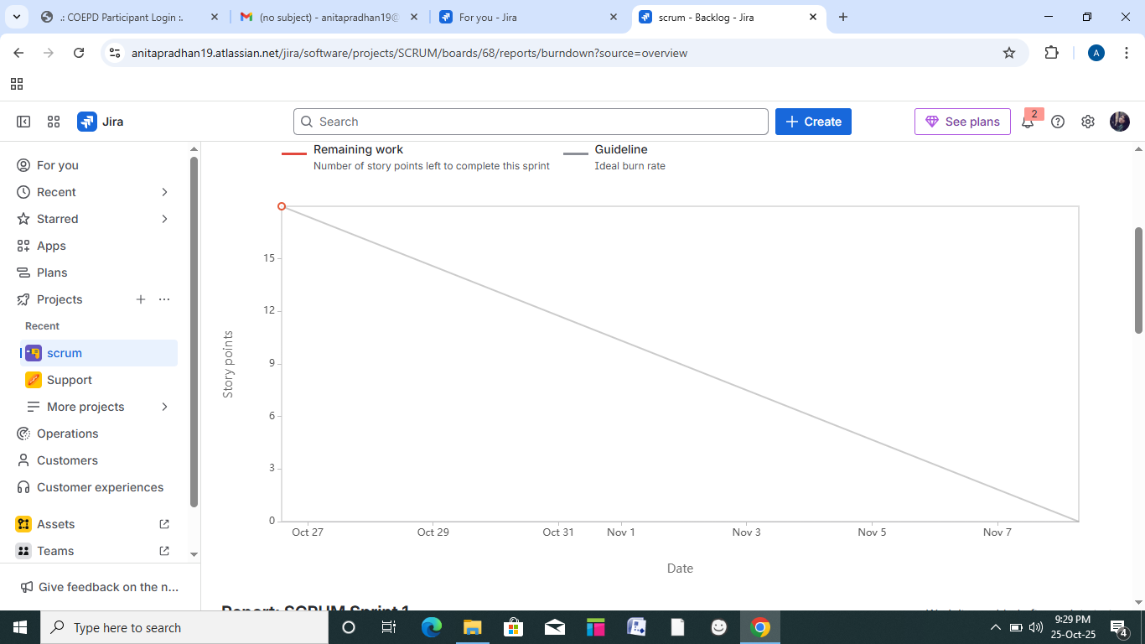

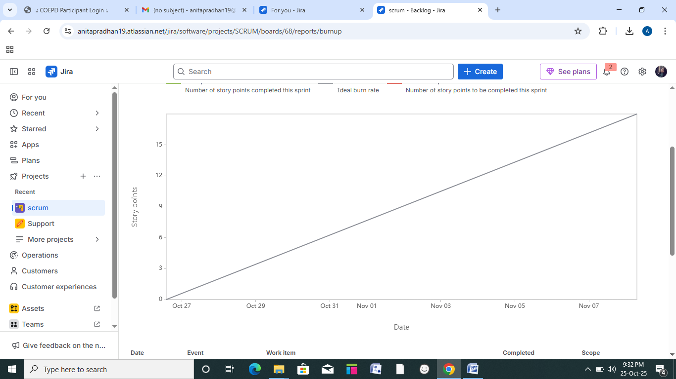

Question10–Explain about Product Grooming–2Marks
- Product Grooming, also called Backlog Grooming or Refinement, is an important activity in Agile software development that involves reviewing, prioritizing, and refining items in the product backlog.
- The goal of product grooming is to ensure that the backlog is well-prepared, organized, and ready for implementation in upcoming sprints.
- It is typically a collaborative effort involving the product owner, development team and the other relevant stakeholders.
How is it conducted
- Setting the Context
- Backlog Review
- Priorization
- Refinement and Estimation
- Dependency Analysis
- Acceptance Criteria
- Backlog Grooming Meeting

Question11–Explain the roles of Scrum Master and Product Owner–3 Marks

Criteria | Product Owner | Scrum Master
Nature of work | Collaborates with all stakeholders and brings the vision of a product | Acts as a team coach and is responsible for maintain the quality of the product
Responsibilities | Responsible for completing the project on time. Acts as an intermediary between the development team and the customers. | Ensure the Scrum framework is followed and helps the development team create a quality product.
Accountability | Responsible for the project backlog, the timely completion of the product, and for providing updates to the clients and stakeholders | Accountable for the quality of the entire project and for giving updates to management about the completion of the product.
Reporting | Reports to top management and the clients. | Reports to top management about the efficiency of the team and the quality of the product.
Qualities | Communication and leadership skills, creativity, critical thinking and a sharp mind are key assets for any Product Owner. | Thorough Knowledge of scrum theory and practices. Being able to lead a team but without a sense of authority

Team Experiences with Sprint1

Scrum Master:

Product Owner

You acted as Product Owner.

Question12–Explain all Meetings Conducted in Scrum Project–8Marks
In a Scrum project, several key meetings (also called Scrum ceremonies) are conducted to ensure effective planning, communication, and continuous improvement. These meetings help the Scrum team stay aligned and deliver value incrementally.

1. Sprint Planning Meeting
- This meeting marks the beginning of each Sprint.
- The team, along with the Product Owner and Scrum Master, defines the Sprint Goal and selects the Product Backlog Items that will be completed during the sprint.
- The team also estimates effort and creates the Sprint Backlog, which contains tasks to be performed.
- To plan what work will be delivered and how it will be achieved.

2. Daily Scrum (Daily Stand-up)
- A short 15-minute daily meeting held by the development team.
- Each member answers three key questions:
  - What did I do yesterday?
  - What will I do today?
  - Are there any impediments blocking my work?
- Purpose: To synchronize team activities, track progress, and identify obstacles early.
- The Scrum Master ensures the meeting stays focused and time-boxed.

3. Sprint Review
- Conducted at the end of the Sprint.
- The team demonstrates the completed product increment to stakeholders and receives feedback.
- The Product Owner discusses what backlog items were “Done” and what remains pending.
- Purpose: To inspect the outcome of the Sprint and adapt the Product Backlog based on feedback.
- Promotes transparency and stakeholder collaboration.

4. Sprint Retrospective
- Held after the Sprint Review and before the next Sprint Planning.
- The Scrum Team reflects on the process — what went well, what didn’t, and how to improve in the next Sprint.
- Purpose: Continuous process improvement.
- The team identifies action items to enhance efficiency, teamwork, and product quality.
Question 13 – Explain Sprint Size and Scrum Size–2 Marks
Sprint Size:
Sprint Size refers to the total duration of a Sprint, which is a fixed time-box in which the team works to complete selected user stories.
For example, in the Scrum Foods project, the Sprint Size is 2 weeks.
Scrum Size:
Scrum Size refers to the duration of each Scrum cycle, typically 1 day, during which the team holds the Daily Scrum meeting to review progress and plan the next 24 hours.
A single Sprint includes multiple Scrum cycles to achieve the planned Sprint Goal.
Question 14 – Explain DOR and DOD– 2 Marks
Definition of Ready (DOR):
DOR refers to the set of criteria that a user story or backlog item must meet before it can be included in a Sprint.
It ensures that the story is clear, well-defined, and ready for development.
Example: User story has acceptance criteria, estimated effort, and required inputs available.
Definition of Done (DOD):
DOD refers to the set of criteria that must be met for a backlog item to be considered completed.
It ensures the product increment is tested, reviewed, and meets quality standards.
Example: Code completed, tested, reviewed, and accepted by Product Owner.
Question 15 – Explain Prioritization Techniques and MVP – 3 Marks
Prioritization Techniques:
In Scrum, prioritization techniques help the Product Owner decide which user stories or features should be developed first based on value, risk, and business needs.
Common prioritization techniques include:
- MoSCoW Method: Classifies requirements as Must Have, Should Have, Could Have, and Won’t Have.
- Kano Model: Categorizes features based on customer satisfaction (Basic, Performance, Excitement).
- Value vs. Effort Matrix: Helps select features that provide maximum value with minimum effort.
MVP (Minimum Viable Product):
MVP is the simplest version of a product that includes only the core features necessary to meet user needs and gather feedback.
It helps teams validate ideas quickly with minimum cost and effort before full-scale development.
Example:
In the Scrum Foods project, the MVP could be a basic food ordering system with registration, menu display, and payment options before adding advanced tracking features.
Question 16 – Difference between Business Analyst and Product Owner –3 Marks

Aspect | Business Analyst (BA) | Product Owner (PO)
Primary Role | Acts as a bridge between business stakeholders and the technical team. | Represents the customer and owns the product vision and backlog.
Focus Area | Focuses on eliciting, analyzing, and documenting requirements. | Focuses on prioritizing, managing, and delivering product features.
Decision Authority | Provides recommendations but does not make final product decisions. | Has decision-making authority over product scope and priorities.
Key Deliverables | Business Requirement Documents (BRDs), Use Cases, User Stories. | Product Backlog, Sprint Goals, Release Plans.
Interaction | Works closely with PO, developers, and testers to ensure clarity. | Works closely with stakeholders and Scrum Team to align business value.

Question 17 – Prepare a sample Resume of 3 yrs. exp Product Owner–3Marks

Name: Anita Pradhan
Experience: 3 Years
Role: Product Owner – Scrum Foods Project

Professional Experience
Product Owner – Scrum Foods (Online Food Delivery Project)
APT IT Solutions Pvt. Ltd., Bengaluru | Jan 2022 – Present
- Defined product vision and roadmap aligned with business objectives.
- Collaborated with stakeholders and Business Analysts to prioritize backlog items.
- Conducted Sprint Planning, Reviews, and Retrospectives.
- Ensured timely delivery of high-quality product increments in 2-week Sprints.
- Coordinated with development, QA, and UI/UX teams to meet acceptance criteria.
Key Achievements:
- Increased customer satisfaction by 25% through user feedback integration.
- Reduced sprint delivery delays by 15% using effective backlog prioritization.

Technical Skills
- Tools: Jira, Trello, Confluence, MS Excel
- Methodologies: Agile, Scrum, Kanban
- Documentation: User Stories, Acceptance Criteria, Product Backlog Management

Education
MBA – Information Technology and Systems
O.P. Jindal Global University, Sonipat – 2021
B.Tech – Computer Science
VTU, Belagavi – 2019

Certifications
- Certified Scrum Product Owner (CSPO) – Scrum Alliance
- Agile Project Management – Coursera

Personal Strengths
- Strong analytical and decision-making skills
- Excellent communication and stakeholder management
- Quick adaptability to dynamic product environments

