Question 1: Draw a Use Case Diagram?
Answer:
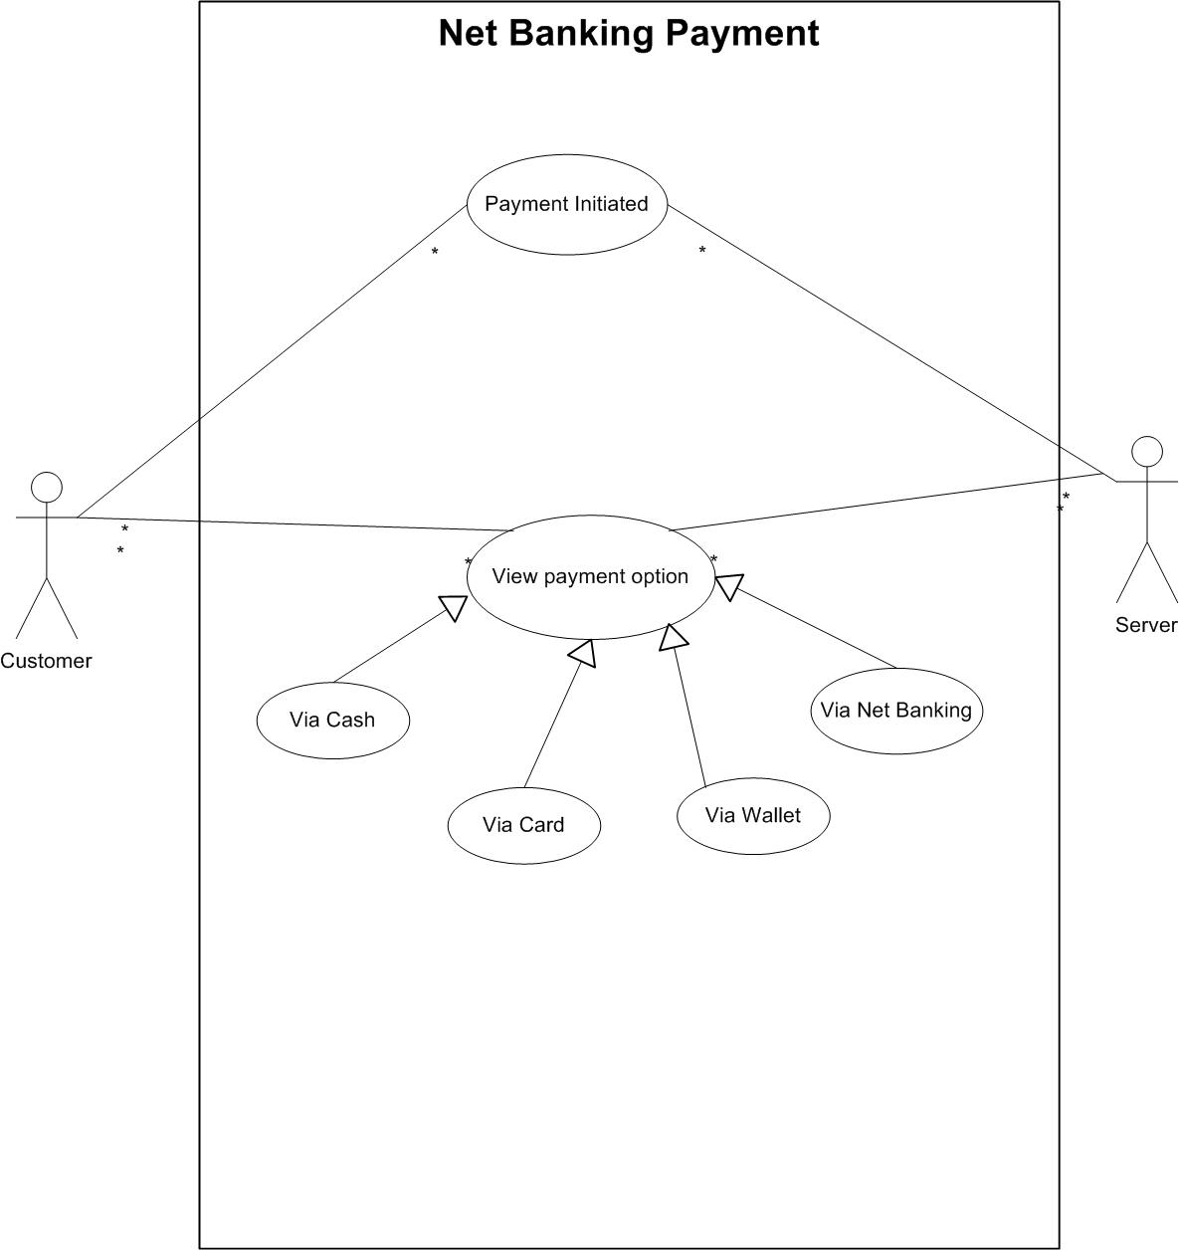

Question 2: What is Boundary Classes, Controller Classes and Entity Classes?
Answer:
Boundary Classes: used to handle interaction between system and external actors. It include all use cases. Combination of 1 actor and a use case is one boundary class. Combination of 2 actor and a use case is two boundary class and so on.
Example: Payment option boundary, card payment boundary, wallet payment boundary, cashpaymentboundary, Netbankingpaymentboundary.

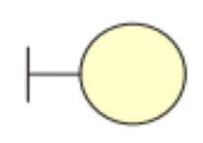
Controller Classes: These act as an intermediates between boundary and entity classes. These handle user input and processes the data. Use case will be considered as Controller classes.
Example - Payment initiated controller, card payment controller, wallet payment controller, cash payment controller, Net banking payment controller.


Entity Classes: Represents the core data and business logic of the application. It includes all actors. Each actor will be considered as one entity.
Example: customer, payment, Card, wallet, server.

Question 3: Place these classes on a 3-Tier Architecture?
Answer: In 3- Tier architecture, the application tier handles the user interface, the business logic manages the business logic and coordinate between the other tiers, the data tier handles the data storage and retrieval.

Application layer | PaymentMethodSelectionBoundary  Cardpaymentboundary  WalletPaymenrBoundary  CashPaymentBoundary  NetBnakingPaymntBoundary
Business Logic Layer  (primary actors associated with the boundary class) | PaymentController  CardPaymentController  WalletPaymentController  CashPaymentController  NetBankingController
Data Layer  (All the entity classes) | Customer (Entity class)  Bank Account (Entity class)  Cash (Entity class)  Card (Entity class)  Payment (Entity class)

Question 4: Explain Domain Model for customer making payment through Net banking?
Answer: A domain model is a conceptual representation that defines the structure, relationship and behaviour of entities within a specific problem domain. It is used throughout the software development life cycle.
In the below diagram:
The customer table is connected to bank table, which is why the customer is able to make payment.
Customer table is also connected to payment table because he should make payment.
Now the payment is done by net banking so the payment table is connected to net banking table.
The account is in the bank so the account table is connected to the bank table.
The authentication table is connected to both Net banking table and bank table because authentication is performed there.
Also, authentication table is connected to transaction table, because authentication be done when transaction will happen.

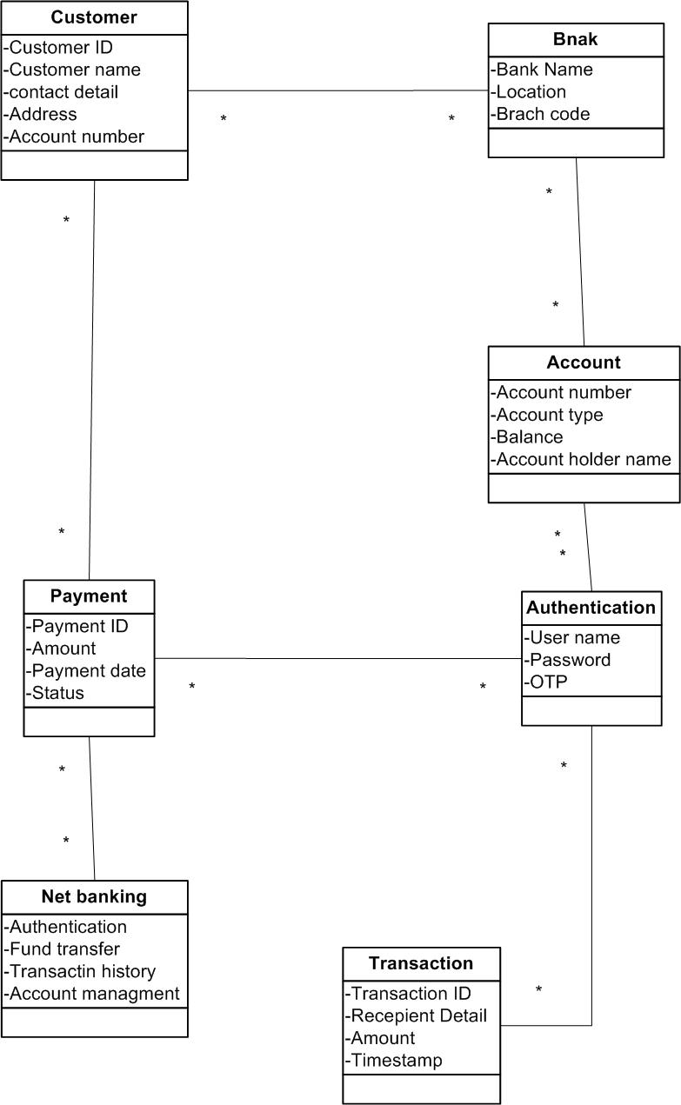
Question 5: Draw sequence diagram for payment done by customer net banking?
Answer: This diagram show how the object in the system interact and communicate with each other with time to achieve specific task. Developers will draw this.it is used to show flow of event, messages or action between the objects of the system.
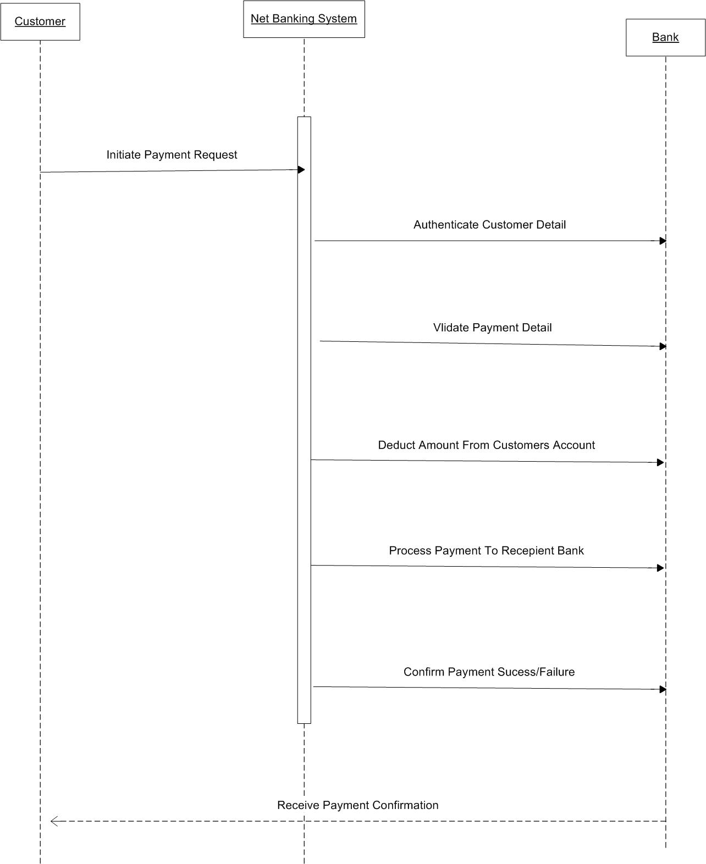
Question6: Explain conceptual model for this case?
Answer: The conceptual model helps in understanding the key concepts, their relationship and the overall structure of the net banking payment system. It serves as a foundation for designing the database schema, defining the application architecture and implementing the necessary functionalities within the system. It provide a clear and simplified view of domain, making it easier to understand.

Key elements of the conceptual model are:
Entities: In this case since customer is initiating the online through net banking following entities will be there: Bank, Customer, and Net Banking system of bank.
Attributes:
Relationships-
- Customer will be initiating the payment with multiple beneficiaries, so it will be one to many relationship.
- Bank system will interact with customer so it will be one to one relationship.
- Bank will facilitate payment for multiple customer so it will be one to many relationship.
Based on the entity and relationship we will be creating entity relationship diagram which will be used as a representation to take sign-off from client.

Question 7: What is MVC architecture? Explain MVC rules to derive classes from use case diagram and guidelines to place classes in 3-Tier architecture?
Answer: MVC is a design pattern where, the application is divided into 3 logical parts Model, View and Controller. Each of these parts will have specific responsibility.
Model-
The model represents the data and the business logic of the application. Model is responsible for multiple tasks like managing the applications data, performing data validation, implementing business rules and handling data access operation. Model does not depend on how the data is presented or how user interact with application. The model class is known about all the data that is needed to be displayed. This layer correspond to data-related logic that the user works with.it represents the data is being transferred between View and Controller.it can add or retrieve the data from database.it respond to the controller request because the controller cannot interact with database by itself. The model interact with database and give the requested data. All the model classes are nothing but entities. Model classes are represented as entity class.

View-
The view is responsible for presenting the data to the user for handling the user interface. The view can be a webpage, a desktop application window or any other form of user interface. It receives the input from user and passes it to the controller for processing. It represents the presentation of the application. View refers to the model.it takes the data from model and renders it in a way that is suitable for user display or interaction. For rendering the data it uses query method. View does not depend upon application logic. View class are represented as boundary class.

Controller-
Controller act as an intermediary between model and the view.it receives the input from user, processes the input by invoking the appropriate method in the model and then updates the view with new data or state. The controller handles user interaction, interpret user input and translate it into instruction for the model or he view.it coordinate the flow of data between model and the view, ensuring that they remain separated and independent of each other. Whenever the user request anything that request first goes to the controller and works on it.

Advantages of MVC:
MVC has feature of scalability, which in turn helps the growth of application.
The components are easy to maintain.
Using MVC application become more manageable.
Rules to derive the Class from Use Case diagram
- Combination Of one actor and one use case result in one boundary class.
Combination of two actor and one use case result in two boundary class
Combination of three actor and one use case result in two boundary class
- Use case will result in controller class
- Each actor will result in one entity class.

Guidelines to place classes in 3-Tier Architecture:
Presentation layer-it is nothing but a user interface. View is inside this layer.
These classes interact directly with user. Presentation layer is responsible for displaying information and also receiving the input from user.

Application Layer
This layer is nothing but business logic. Model and controller are inside this. Controller handles the user input, process the request and co-ordinate the interaction between model and view.

Data layer:
Classes which are responsible for data access and storage are in this layer.
It contain the classes which interact with the database, files and other data sources.

Question 8: Explain BA contribution in project (Waterfall model)?
Answer:
Requirement gathering:
Identify stakeholder, all the requirements are gathered from stakeholder.
BA and Project Manager participate in this phase. After completing this phase BRD will be generated.
Requirement Analysis: the requirement are analysed to understand the scope of project. Analysis means BA will check all the requirements, if he find conflicting requirement then he will talk to the concerned stakeholder to clear it, remove the ambiguous requirement.BA will prepare functional requirement. FRS (functional requirement specification) is the document which contain functional requirement.
BA will combine FRS with SSD (supplementary support document) to form SRS (Supplementary support document).
BA will prepare RTM by referring SRS.
Design: after requirement are clear, design phase start. This has detailed document that outline the software architecture, user interface, and system component.
HDD, ADD and solution document will be generated here.
BA collaborate with designers, Architect, and developers to translate requirements into system design.
BA ensure that the design aligns with the documented requirement and addresses the stakeholders need.
Development: this phase include implementation.it involves coding the software based on the design specification.
Programmers or developers are involved in this. Here BA act as a mediator between the development team and the stakeholder.BA clarifies the requirement, check if the development is going on right track or not. BA also participate in scrum meetings.
Testing: in this phase the software is tested as a whole to ensure that it meets the requirement and is free from defects.
Testers are involved in this phase. Test documents are generated here.
BA works with testing team to ensure that the solution meets the requirement.
BA facilitate UAT. BA help the user to know the functionality of the system and also help them to use the system.
Deployment:
Once the software has been tested and approved, it is deployed to the production environment.
BA ensure that there is smooth transition from development phase to production phase
Implementation:
This is the final stage of waterfall model. It involves running the code for the very first time in production phase. Release manager handle this phase.BA will update the documentation and requirement specifications to reflect changes in the system over time.

Question 9: what is conflict management? Explain using Thomas-Kilmann technique?
Answer: Conflict can occur due to various reasons such as –differences in goals, values, personalities, resources or communication breakdown. Conflict is an inevitable part of any workplace.so it is important to resolve it to promote growth and learning.
Conflict management is nothing but the process of identifying and addressing conflicts in a healthy and constructive manner.it consist of strategies and techniques aimed at resolving disputes, disagreement or differing perspective among individuals or groups.
By identifying conflict efficiently: it will in turn be helpful to reduce negative impact and increase positive impact s the process or skill to find creative ways to handle the conflict.
Thomas-Kilmann approach is widely used to recognise the approach for conflict management.
High Assertiveness and High Cooperativeness: Collaboration- means working together to find solution.
High Assertiveness and Low Cooperativeness: Competition- means defensive that is standing for your individual beliefs and trying to win.
Low Assertiveness and High Cooperativeness: Accommodations – stakeholder will prioritize their needs over others.
Low Assertiveness and Low Cooperativeness: Avoidance means ignoring the conflict.

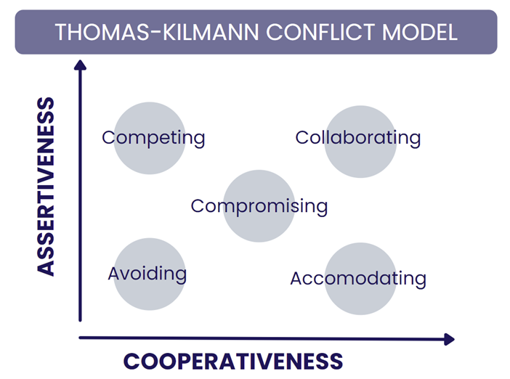
Assertiveness: the extent to which a person attempts to satisfy his own concerns.
Cooperativeness: the extent to which the person attempt to satisfy the other persons concerns.

Question 10: List down the reason for Project Failure?
Answer: Reason for Project Failure are –
Improper requirement Gathering: if the requirement of project are gathered incorrectly, then this can lead to project failure.
Lack of Stakeholder involvement: A project can fail if the stakeholders are not participating in the process because their input and feedback play very important role to meet the goal.
Ineffective or less Communication: if there are communication issues between stakeholders , team member then this can lead to misunderstanding or delay in projector even can lead to project failure.
Poor Risk Management: the team fails to identify the risk and do the mitigation, which can lead to unexpected challenges or project delays. Lack of user involvement and executive support’s
Continuous Change Requirements: these can lead to project failure as continuous change requirement s will lead to changing project scope continuously.
Unrealistic Expectation: means the goal that cannot be achieved or goals that are out of scope.
Improper Planning: the project can fail if the planning is not done properly. The milestone, Goals should be discussed.
If there is no proper planning then team may face difficulties in addressing the issue or to track the progress.
Insufficient Resources: the project may also fail due to lack of technology knowledge or lack of finances.
Question 11: List the challenges faced in a Project for BA?
Answer:
- Lack of training
- Obtaining sign-off on the requirement
- Changing requirements
- Co-ordination between developers and tester
- Conducting meetings
- Driving client for UAT completion.
- Gathering clear and ambiguous requirement
- Scope creep
- Managing the stakeholders with the conflicting interest
- Understanding the requirement if the domain is not familiar to BA
- Technical complexity

Question 12: write about Document Naming Standards?
Answer: A Document Naming Standard is a systematic approach to assigning unique identifiers to various document created and used throughout the development process.
[Project ID][Document type]V[X]D[Y].extension
Suppose we have a project
Project ID: PROJ123
Document type: REQ
Version: 2.0
Date – 2025-07-16
The document identifier could be: PROJ123-REQ-2.0-2025-07-16.docx

QUESTION 13: what are Do’s and Don’ts of a Business Analysts?
Answer:
S.No | DO’S | DON’TS
1 | Try to concentrate only on important and required thing | Never say “NO” to clients
2 | Consult with SME for clarification in requirement | Never imagine anything in terms of GUI
3 | Try to extract maximum leads to the solution from the client himself | Don’t interrupt the client when he is giving you the problem , first listen to him and when he is done then ask question
4 | Question the existence of existence/ question everything | Never try to give solutions to the client right away from your previous experience and assumptions.
5 | Be like Lotus in Mud if a client comes with a fancy requirement , then talk to project manager | There is no word called as “BY DEFAULT”
6 | Always appreciate the stakeholder even for the small effort | Never criticise the stakeholder

Question 14: Write the difference between the packages and subsystem?
Answer:
Packages are collection of components which are not reusable in nature and also the group of classes that are used to organise model element. Packages can be nested within other packages. These are used as container to organise other elements. It is very useful to represent system architecture.
E.g.: Application development companies work on packages.
Subsystem: it is logical grouping of related components which are reusable in nature. It is collection of classes, packages, libraries and other subsystem that work together to deliver a specific set of functionalities.
e.g.: Product development companies work on subsystem.

Question 15: What is Camel-casing and explain where it will be used?
Answer: Camel-casing refers to the naming convention of variables, function and identifier used in computer programming. Here multiple words are combined together. In this the starting letter of first word start with small letter and other words first letter start with capital letter.
E.g. camelCaseExample
Uses:
For BA, it is used in requirement documentation. BA often uses camel- casing to name the entity like use case, feature, user stories like calculateInterestRate.
In documentation use of camel-casing helps to maintain consistency in the entire document and also increases readability.
The database table name also uses camel-casing.

Question 16: illustrate Development Server and what are the accesses does Business Analysts has?
Answer: a development server refers to dedicated environment or server that is used during the software development process. it provide a platform for developers and testers to build, test and debug application before they are deployed to a production environment.
A BA has only limited access:
Read only - this will allow them to view the user interface of the application, navigate through features and also they will be able to observe the behaviour of application.
Depending upon Project BA will be be granted limited access to the specific module in the application.
BA have authority to make changes in certain areas of application where they have access.

Question 17: what is Data mapping?
Answer: Data Mapping Is the process of connecting one source to another. It’s like creating a map or guide that shows how data in one place is correspond to data in another place. This is especially important when you are moving the data between different systems or databases to ensure that the data stays consistence and accurate.it is necessary in cases where we want quick manner.
PURPOSE OF DATA MAPPING
DATA INTEGRATION – while combining the data from different sources, it ensure that the data is properly matched.
DATA MIGRATION- while migrating the data from source to destination the data elements are mapped accurately into the new system.
DATA TRANSFORMATION- while transforming the data it ensure that the data of legacy is mapped correctly to the data of new system.

Question 18: what is API? Explain how would you use API integration in case of your application Date format is dd-mm-yyyy and it is accepting some data from other application from US whose date format is mm-dd-yyyy?
Answer: API stands for application programming interface .it is a set of rules and tools that allow different software application to communicate with each other.it defines the method and data format that application can use to request and exchange information. API allows sharing of only necessary information and keeps internal detail hidden, which helps the system security.
For the given scenario
Establish API communication: set up API communication between your application and other application to exchange data.
Do Data Formatting-while sending the data from one application to other, convert the date format from dd-mm-yyyy to mm-dd-yyyy.
While receiving the data from other application, parse the data and extract the date, month and year and re-arrange them accordingly.
Perform data Validation and ensure that the converted date remain in valid format.

