CAPSTONE PROJECT
PREP – 3, PART 1

DRAW A USE CASE DIAGRAM

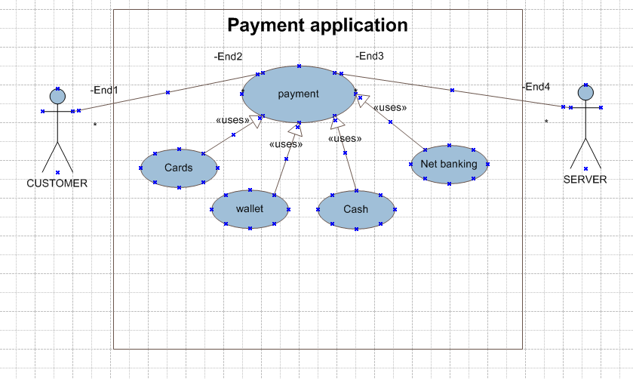

QUESTION – 2
Derive Boundary classes , controller classes , Entity classes
Boundary class
The boundary class is used to handle interactions system and external actor
- CustomermakespayBC()
- Payby cardBC()
- PaybycashBC()
- PaybywalletBC()
- paybynetbankBC()

Controller class
The controller class acts as intermediaries between the boundary class and entity classes.
- PaymentCC()
Entity class
The entity class represent the core data and business logic of the application
- CustomerEC()
- CardEC()
- CashEC()
- WalletEC()
- NetbankEC()

Question – 3
Place these classes on three tier architecture
As per the guidelines to place identified MVC classes in a 3 Teir Architecture
- Place all the entity classes in DB layer
- Place primary actor associated boundary classes in application layer
- Place controller class in application layer
- If the government body influence or reusability is there with any of remaining boundary classes ,place them in the business logic layer else place them in application layer
Application  Layer | PaymentCC()  PaybycashBC()
Business logic  Layer | CustomermakespayBC()  PaybywalletBC()  paybynetbankBC()  Payby cardBC()
Data layer | CustomerEC()  CardEC()  CashEC()  WalletEC()  NetbankEC()

Question- 4
Explain Domain model for Customer making payment through Net banking ?
A domain model is similar to the entity relationship model , it is a conceptual representation of the key entities and their relationships In a particular domain.
In our case the customer making payment through Net banking. By the table given below helps the developer and the stakeholders will understands how the system
works in high level.
In the below diagram the customer table is connected to the bank table that shows why the customer is able to make payment.
And the customer table is also connected to the payment table , because he should make the payment and now the payment is done by the net banking . for this the payment table is connected to net banking.
The account is in his respective bank. So the account table is connected to the bank table , and the authentication table is connected to both net banking table and Bank table, because authentication activity should be performed to both as it secure the transaction done by the customer

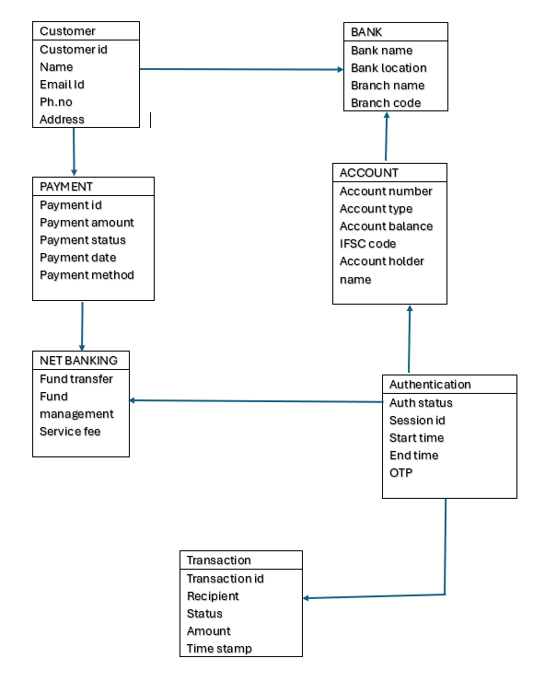

Question 5
Draw a sequence diagram for payment done by customer through net banking?

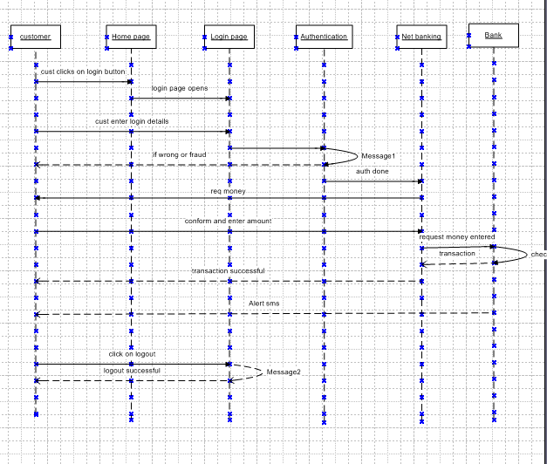

Question – 6
Explain conceptual for this case ?
The conceptual model is a high level representation of a system , focusing on what the system does rather than the how it does it , it describes the ,main entities , their relationships and major functions without going into the technical or implementation details
The conceptual models are typically used during the early stages of the system design to help the stakeholders understand and agree the system requirements
The main entities of this case are

- User
A person who initiates the payments
- Payment
This represents the transaction initiated by the user
- Payment method
The abstract representation of how the payment method is made
- Card
A type of the payment method involving the debit cards , credit cards .
- Wallet
A type of payment method involving as digital wallet
- Cash
A type of the payment method involving the physical cash
- Net banking
A type of payment method involving direct bank transfer.

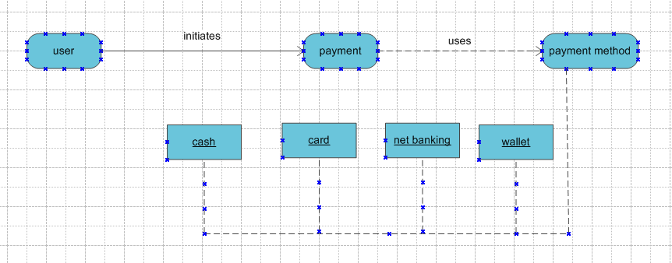

- User login and initiates the payment
- Select the option make payment
- Choose the option of payment methos
- System validates accordingly
- If card , net banking , wallet deduct amount and updates the status
The benefits of using the conceptual model is easy to communicate between the business and technical team , foundation of creating logical and physical data models

Question -7
What is MVC architecture? Explain MVC rules to derive classes from use case diagram and guidelines to place classes in 3-tier architecture?
The MVA stands for ( Model View Controller )
The MVC architecture is a design pattern used to separate an application into three main logical components
- Model
The model class known about the all data that need to be displayed. It is a model who is aware about all the operations that can be applied to transfer that class .
It only represents the data of an application, the model represents enterprise data and the business rules that govern access to and updates of this data , this represents Database ( Tables in Database) all model classes are represented as entity classes.
- View
The view represents the presentation of the application. The view class refers to the model . it uses the query methods of the model to obtain the contents and renders it
The view is not dependent on the application logic , it remains same if there is any modification in the business logic .
View class is data required by the query ,view class is represented as Boundary class or Form class
Actor speaks to system and vice versa through boundary , authentication information between boundary and entity class.

- Controller
Whenever the user sends a request for something then it always go through the controller .the controller is responsible for intercepting the requests from the view and passes it to the model for the appropriate action
After the action has been taken on the data the controller is responsible for directing the appropriate view to the user. In GUIs, the views and the controllers often work very closely together
Controller class is working based on the users command understands the command / request given by user through boundary/form class
MVC architecture rules
- Combination of one actor and one use case results in one boundary class
- Combination of two actors and an use case results in two boundary class
- Combination of three actors and an use case results in three boundary class and soon
- Use case will results in a controller class
- Each actor will result in one entity class
Consider our scenario as an example for the following
Model class: customer , payments, net banking , card , cash
View class : login view , payment option view, net banking view , bank selection view , payment amount view, credentials view, logout view.
Controller view: login view controller, payment option view controller, net banking view controller, bank selection view controller, payment amount view controller, credentials view controller, logout view controller.
- The guide lines to place classes in 3 tier architecture
- Place all the entity classes in DB layer
- Place primary actor associated boundary classes in application layer
- Place controller class in application layer
- If the government body influence or reusability is there with any of remaining boundary classes, place them in the business logic layer else place them in application layer

In the three tier architecture there are divided into three types of layers
- Application layer
- Business logic layer
- Data layer
Some of the detailed information about the layer
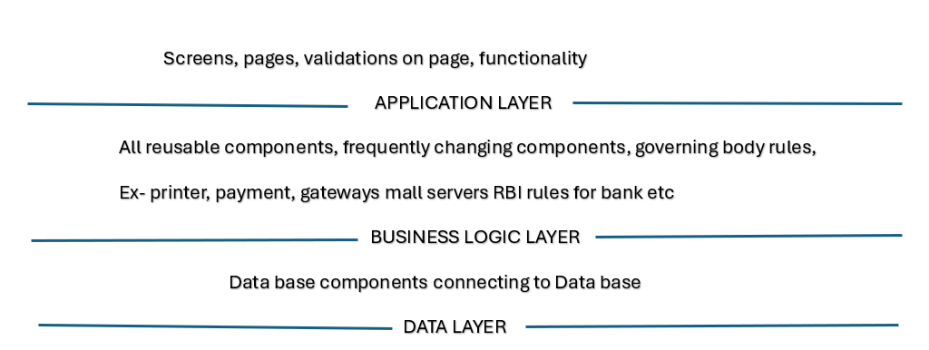
The some of the benefits of the MVC is it has the feature of scalability which helps to turn growth of the application and the components are easy to maintain , A model can be used multiple views that provide reusability of code
By using the MVC the application becomes more manageable as all the three layers are independent and maintained separately.

Question – 8
Explain BA contributions in project Waterfall Model?

In the waterfall model of the software development , the each phase is completed before the next phase begins with little to no overlap
The business analyst plays a crucial role in each stage , especially in ensuring that business needs are well understood , documented and translated into the actionable development of the tasks
The following shows the break down of business analyst contribution across all the stages of waterfall model

- Requirements gathering and analysis
. Elicit requirement: he will conduct the stakeholders interviews ,workshops and surveys to understand the business needs .
. Documents requirements : He will create the business requirement document (BRD) , functional requirement specification (FRS) and use cases
. Prioritize Needs : he will work with stakeholders to prioritize requirement based on the business value and constrains
. Requirements validation: Ensure that the document requirements align with stakeholders expectations through walkthrough or sign offs
Traceability: he will set up the requirement traceability matrices (RTMs) to track each requirement through the project life cycle
- Design
Support solution design : he will collaborate with solution architects and the developers to ensure weather the design meet the business needs or not.
. clarify requirements : He will address queries from the technical teams and clarify the functional aspects
Review Design Artifacts : He will validate the design documents like system architecture ,data flow diagrams to align with the business requirements
. Interface specifications : he will help define and review the interface or integration requirements between the systems.
- Implementation ( Development )
.Bridge communication: he will as a mediator between the business stake holders and the development team
.Support the developers: he will provide clarifications on requirements and edge cases during the coding.
. Monitor Scope: he will ensure that development aligns with the agreed upon scope and prevent scope creep .
. Assist with use case testing: he will help the developers understand business scenarios during initial testing

- Testing
Support test planning: he will help the QA teams to understand the business logic to create test cases.
Review test cases: He will ensure test cases comprehensively cover business requirements
User acceptance testing (UAT) : He will coordinate UAT and prepare UAT scenarios and support the user in testing the solution
Defect triage: He will help to prioritize and clarify defects by linking them back to business needs
- Deployment
.Support Rollout planning: Assist in creating a deployment strategy that minimizes business disruption.
User training & Documentation: He will contribute the user manuals , training material and change management.
Stakeholder communication: He will ensure stakeholders are informed and prepared for go live .
- Maintenance
Monitor system use: He will gather the feedback from the user to identify improvement areas .
Issue analysis: He helps to do analysis for post deployment issues or the enhancement request.
Change request: he will document and manage new or updated requirements as change request
Continues Improvements: He will propose enhancements based on the user feedback and business goals.

Question – 9
What is conflict management? Explain using Thomas – Kilmann technique?
The conflict management is the process of identifying and handling conflicts in a sensible manner ,fair and efficient way.
In the business or a project environment the conflicts can arise between the team members , departments or stakeholders due t different in goals , values , opinions or resources.
The effective conflict management aims to –
- Minimize negative outcomes
- Maximize the mutual gains
- Improve communication and collaboration
- Maintain positive relationships
The Thomas – kilmann conflict management technique is a widely used method that identifies five conflict handling style based on two dimensions
- Assertiveness – X-axis ,the extend to which a person tries to satisfy their own needs.
- Cooperativeness – Y-axis , the extend to which a person tries to satisfy other needs .
The five conflict management options are _
- Competing
- Avoiding
- Accommodating
- Collaborating
- Comprising
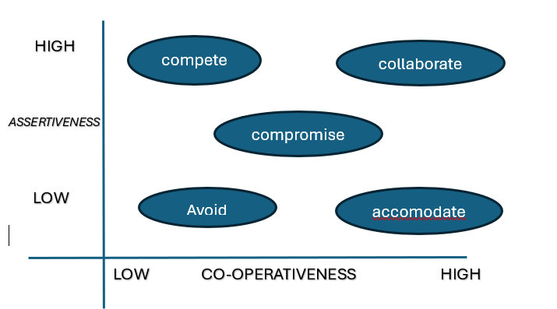

Question- 10
List down the reasons for project failure?
The following are the reasons for project failure
- Improper Requirement gathering
The BA is responsible for the requirement gathering , not fully understanding what the client and the end users actually needs , and he is not using the BA tools properly and this leads to rework ,delays and complete project failure
- Continues change request (CR)
The change request mostly been from the client side and BA , adding new features in the middle of the development without adjusting the timeline and budget can lead to missed deadlines ,resource overload , and confusion among team , it also makes harder to reach the goals and may leads to poor quality product and project failure.
- Lack of user involvement
The key stakeholders are not involved early or regularly and misalignment between the business and the technical teams might leads to the project failure
- Lack of executive support
If the leadership is not engaged or does not promote the project importance , and if the other departments may not take it seriously
Leading to poor collaboration and lack of urgency
- Unrealistic expectations
The unrealistic expectations happen when the goals, timelines or outcomes expected from the project are not practical or achievable , this often occurs when the stake holders demand too much in too little time without understanding the effort , cost and complexity involved.
- Improper planning
The improper planning is been done by the project manager like inaccurate timelines or budget ,overlooked risks and dependences and no realistic resource planning.
- Scroop Creep
Uncontrolled changes or continuous additions without impact assessment and poor
Change management process by this project might not get completed in time and budget it leads to project failure.

Question – 11
List the Challenges faced in projects for BA?
The following are the challenges in a project for BA
- Lack of training
- Obtaining sign-off on the requirements
- Change management
- Conducting meetings
- Making sure status report is effective
- Driving client for UAT
- Making sure that the project going on right track and delivered as per timelines without anu issues
- Gathering clear requirements can be challenging
- Scope creep
- Traceability issues
Question -12
Write about Document Naming Standards?
The document naming standards refers to a structured and consistent approach to naming files and documents within a project organization or system
These standards helps ensure that documents are easily identifiable,searchable and version controlled , they also reduce the confusion and maintain uniformity especially when working in teams .
All the documents will be named using some standards
Like [ProjectID] [DocumentType]V[x]D[y].ext
Ex- PQ786BRDV1D2.docx
PQ786BRD1.2.docx

Questions – 13
What are the Do’s and Don’ts of a Business analyst?
Don’t s
- Never say no to client
- There is no word called By Default
- Never imagine any thing in terms of GUI
- Don’t ignore stakeholder feedback
- Don’t delay clarification
- Don’t work in isolation
- Don’t jump to solution too Early
Do’s
- Question the existence of existence
- Do understand the business ‘
- Do ask right questions
- Do consult an SME for clarification of requirements
- Do document clearly and completely
- Do collaborate across the team
- Do focus on problem solving.
Question – 14
Write the difference between packages and sub-systems?
In the context of the software engineering , system design or unified modeling language , pakages and subsystems are both used to organize and manage complexity but they serve different purposes and have different level of abstractions
- Packages
A packages is a logical grouping of related elements such as classes , interfaces or components . its mainly used for organizing code or models to keep the system modular and maintainable.
- Key points
. Used primarily in UML diagrams or programming languages
. Help with code organizations and name space management
. Do not represent executable units or functionality directly
. typically used during the design and modeling phase
- Sub- systems
A sub-system is a self-contained functional unit of a larger system. It can operate independently to some extent and often corresponds to a specific business function or process.
- Key Points
. Represents a functional decompositions of the systems
. May contain multiple packages, modules or components
. IT can be developed , deployed and tested separately
. Often aligns with business domain ex- billing subsystem, inventory subsystem

Question – 15
What is camel-casing and explain where it will be used?
The camel casing refers to the naming convention of variable , parameters or properties , in this the multiple words are combined together
In camel casing the starting letter of the first word will starts with the smaller letter and the other next word starts with the capital letter
For ex- userName, eamilAddress ,firstName, lastName
In the business analysis the camel casing is used in requirements documentation, In the requirement documentation business analyst use camel casing to name the entities like use case,features , user stories like validateCustomerDetails.
When the documentation of the business process or the work flow camel casing can be used to individual in steps , this will help to maintain consistency of document
It is also used to name the functional and non functional requirements
And it is the consistent way of naming variables , functions, classes and properties and making the codes more readable and standardized
It is especially common in programming languages like java , java script ,c# and API
Some of the benefits are
- Improves readability without spaces
- Widely accepted and language – agnostic
- Helps in standardizing naming across terms and systems

Question – 16
Illustrate Development server and what are the accesses does business analyst has?
A development server is an environment where the software is actively built , configured and tested by the developers during the initial stages of a software development life cycle. It is separate from staging, testing on production server
A development server is a safe environment for coding debugging and integration features , it is used by developers to test early versions of applications , Typically has less strict security or performance setting than production servers , This may include Application code , Database setup , APIs and services in test mode
The Access for Business analyst have in the development server-
- To Read-only access to view early builds or configurations
- To Access to logs is given to analyze issues , user stories or process flow
- To UI/UX validation given because to review the early interface designs or feature implementation
- To Database (limited) is given due to verify data structure or sample data
- To API via postman/swagger to understand endpoints or test API request
- To error reports / logs for investigate defects or clarify system behaviour

Question 17
What is Data mapping?
The data mapping is the process of matching fields from one data sources to another . it involves defining how the data in one format , structure or system corresponds to data in another
So it can be transferred , transformed or integrated correctly
The data mapping is important because it prevents the data loss or misinterpretation and it ensures data integrity across the system and it reduces manual errors.
The purpose of Data mapping is :
- Ensure accurate data migration between system
- Enable system integration like connecting a CRM to an ERP
- Support data transformation in ETL – Extract ,Transform, Load process
- Align business data with technical structure like data base columns , API fields
And the data mapping for the business analysis is for translating business terms to technical fields .

Question – 18
What is API. Explain how you would use API integration in the case of your application Date format is dd-mm-yyyy and it is accepting some data from Other Application from US whose Date Format is mm-dd-yyyy?
An API is a set of rules and protocols that allows two software sytem to communicate and exchange data with each other
API defines how request are made , what data is sent and how responses are returned.
API allows only sharing necessary information and keeps the internal systems details hidden which helps to system security.
KEY concepts of an API
- Request : sent from an one application (client) to another (server) asking for data or services
- Response : The results sent back from the server to the client
- Format : Usually data is exchanged in the formats like JSON or XML
- Methods: Common HTTP methods include get, post, put, delete .
The step by step to handle this with API Integration
- Understand the API structure
We should check the API documentation of the US system and identify which fields are dates and what format they use like mm-dd-yyyy
- Receive the Data
Application sends an API get or receives a POST request with the incoming data like sample incoming data like customer name : “pradeep” , dob 04-11-1999
- Convert the Date format
Use a date conversion function in your backend to transform mm-dd-yyyy to dd- mm-yyyy by the back end programming like python and java script etc.
- Store or Process the converted date
Use the transformed date in your application like save to database display to users.

- Automate the Process
You should ensure your API integration layer like backend service automatically
. It identifies incoming data fields
. Converts format correctly
. Logs or handles errors gracefully.

For our scenario API integration allows the system with different formats and standards to work together , in our case a date format conversion in the integration layer ensures that US formatted dates mm-dd-yyyy are correctly converted into our apps in expected format dd-mm-yyyy for maintaining data accuracy and avoiding processing errors.

