Document 1: Definition of Done
"Definition of Done is a checklist of criteria that a product increment must meet to be considered complete and ready for delivery or deployment.
Definition of Done is a technique where the team agrees on, and prominently displays, a list of criteria which must be met before a backlog item is considered done. That is the team has to create a well-defined, unambiguous, measurable, agreed-upon, and shared Definition of Done between all team members.
The best form of Definition of Done representation is a checklist of activities that has to demonstrate the agreed value and quality of a user story. So, this checklist should include:
- acceptance criteria (to satisfy customer requirements for a product)
- quality criteria (to satisfy quality requirements for a product)
Checklist for DOD:
- Produced code for all intended integration functionalities (data transfer, handshake, response handling).
- Assumptions of user story and integration logic met (e.g., cash note classification mapping to Saksham transactions).
- Project builds without errors in the integration environment.
- Unit tests for interface modules and transaction logic are written and passing.
- Integration deployed on a test environment that mirrors Axis Bank’s production setup.
- Tests on expected hardware (IBASS NSM models) and relevant platforms passed.
- Data flow and UI responses ok-ed by UX designer (if UI is involved).
- QA testing performed with all major/minor issues resolved.
- Integration tested against acceptance criteria in Jira/user story.
- Feature and transaction handling approved by Product Owner/stakeholder.
- Refactoring completed for maintainability and performance.
- Any changes in configuration or deployment scripts are documented.
- All integration-related documentation (API specs, flowcharts, SOPs) updated.
- Peer code review completed with feedback incorporated.

Document 2- Product Vision
Scrum Project
Name: | Digital Banking and automation for cash and services management
Venue: | Axis Head Office
Date:12.06.2025 | Start time:11:00AM | End time: 01:00 PM |  | Duration: 2 Hours
Client: | Axis Bank Ltd
Stakeholder list: | Operations dept head | Technical Head IBASS Team and Saksham team |  | ITS (Information Technology Services) Specialists
 | Scrum Team
Scrum Master: | Mr. Sachin H
Product owner: | Miss. Janes Havalad
Scrum Developer 1: | Mr. Kiran A
Scrum Developer 2: | Mrs. Swati
Scrum Developer 3: | Mr. Girish
Scrum Developer 4: | Mr.Raj
Scrum Developer 5: | Miss. Sumitra
Scrum Developer 6: | Mr. Rajan

Vision:
What is your vision, your overarching goal for creating the product?
To automate the cash transactions with the NSM Machine”
Target group :
Which market segment does the product address?
Retails branch banking employees
Who are the target users and customers?
Targeted users are bank tellers and other employees and bank customers

Needs :
What problem does the product solve?
The problem of manual transactions ,time consumption, accountability of notes ,Non Centralized control in processing the cash transaction
Which benefit does it provide?
It has centralized control over each and every transaction .
Product :
What product is it?
It is a feature integrated with the Banks Saksham software and IBASS NSM Machine.
What makes it desirable and special?
Its function of keeping the accountability of Currency note, each transaction history with the voucher scan and autopropulation.
Is it feasible to develop the product?
Yes it is feasible to integrate the project
Value:
How is the product going to benefit the company?
The integration would enhance the productivity of the staff and thus increases the profitability of the company and digitization would be enhanced for the Axis Bank Ltd
What are the business goals?
Business aims at more accurate ,digitized and profitable to grow by 50%.
What is the business model?
Business model is a software based integration of NSM IBSS as a functionality.

Document 3: User stories
User Story No: 1 | Tasks: 2 | Priority: HIGHEST
Value Statement:
AS A Teller
I WANT TO scan cash receipt vouchers using IBASS NSM
SO THAT I CAN auto-populate the details in Saksham with a single keystroke.

BV: 1000 | CP: 8
Acceptance Criteria:
- Voucher is successfully scanned through IBASS NSM
- Data appears correctly in Saksham upon pressing enter
- No manual entry required

User Story No: 2 | Tasks: 1 | Priority: HIGHEST
Value Statement:
AS A Teller
I WANT TO immediately view scanned voucher data in Saksham
SO THAT I CAN verify its accuracy before proceeding

BV: 500 | CP: 5
Acceptance Criteria:
- Scanned voucher is visible without delay
- Data accuracy is verifiable
- Mismatch prompts error

User Story No: 3 | Tasks: 2 | Priority: HIGHEST
Value Statement:
AS A Teller
I WANT TO scan received cheques in IBASS NSM
SO THAT I CAN view and verify it in Saksham.

BV: 1000 | CP: 8
Acceptance Criteria:
- Cheque image is accurately scanned
- Image is visible in Saksham
- Cheque number and details match system entry

User Story No: 4 | Tasks: 1 | Priority: MEDIUM
Value Statement:
AS A Teller
I WANT TO be alerted of mismatches between scanned and system data
SO THAT I CAN correct them before proceeding.

BV: 500 | CP: 3
Acceptance Criteria:

- Alerts are generated when mismatch occurs
- Alert describes nature of mismatch
- Allows correction before transaction

User Story No: 5 | Tasks: 1 | Priority: HIGHEST
Value Statement:
AS A Branch Operations Manager
I WANT TO track scanned vouchers centrally
SO THAT I CAN easily reconcile transactions.

BV: 1000 | CP: 8
Acceptance Criteria:
- Central database is accessible
- Filters by date, teller ID, voucher type
- Exportable report for audit

User Story No: 6 | Tasks: 2 | Priority: HIGHEST
Value Statement:
AS A Teller
I WANT TO run physical currency through NSM after voucher entry
SO THAT I CAN count and match it with system amount.

BV: 500 | CP: 5
Acceptance Criteria:
- NSM counts cash accurately
- Tally report matches voucher
- Alert if mismatch

User Story No: 7 | Tasks: 1 | Priority: HIGHEST
Value Statement:
AS A Teller
I WANT TO receive validation if NSM count differs from voucher
SO THAT I CAN resolve the issue immediately.

BV:1000 | CP: 8
Acceptance Criteria:
- Immediate error popup if mismatch
- Option to recount or cancel
- Logged for audit

User Story No: 8 | Tasks: 1 | Priority: HIGHEST
Value Statement:
AS A User
I WANT TO get a confirmation once cash is matched
SO THAT I CAN proceed confidently with the transaction.

BV: 1000 | CP: 8
Acceptance Criteria:

- Pop-up confirmation appears
- Teller must approve to proceed
- Timestamp recorded

User Story No: 9 | Tasks: 1 | Priority: HIGHEST
Value Statement:
AS A System Administrator
I WANT TO log each cash receipt transaction
SO THAT I CAN audit teller-wise records.

BV: 1000 | CP: 8
Acceptance Criteria:
- Log includes teller ID, timestamp, voucher ID
- View and export options available

User Story No: 10 | Tasks: 1 | Priority: HIGHEST
Value Statement:
AS A Teller
I WANT TO auto-generate and print receipt after cash validation
SO THAT I CAN provide customers with immediate proof of transaction.

BV: 500 | CP: 5
Acceptance Criteria:
- Receipt prints only after NSM validation
- Includes transaction ID, amount, teller ID

User Story No: 11 | Tasks: 2 | Priority: HIGHEST
Value Statement:
AS A Teller
I WANT TO scan the cash payment cheque
SO THAT I CAN auto-load it in IBASS before disbursing funds.

BV: 500 | CP: 5
Acceptance Criteria:
- Voucher details appear instantly in Saksham
- Payment initiated only after scan and verification

User Story No: 12 | Tasks: 1 | Priority: HIGHEST
Value Statement:
AS A Teller
I WANT TO verify outgoing cash through NSM
SO THAT it matches the payment voucher before cash disbursement.

BV: 500 | CP: 5
Acceptance Criteria:
- NSM validates amount before disbursal
- Block disbursement if mismatch

User Story No: 13 | Tasks: 2 | Priority: HIGHEST
Value Statement:
AS A Teller
I WANT TO scan cheques and verify them in Saksham
SO THAT payment is made against validated instrument.

BV: 500 | CP: 5
Acceptance Criteria:
- Cheque scan matches system data
- Physical copy verification confirmed

User Story No: 14 | Tasks: 1 | Priority: HIGHEST
Value Statement:
AS A Teller
I WANT TO print receipt immediately after cash payment
SO THAT the customer gets official confirmation.

BV: 500 | CP: 5
Acceptance Criteria:
- Receipt includes payment ID, customer name, amount
- Linked to NSM count data

User Story No: 15 | Tasks: 1 | Priority: MEDIUM
Value Statement:
AS A User
I WANT TO reprint lost receipts using transaction ID
SO THAT customer issues are addressed.

BV: 100 | CP: 2
Acceptance Criteria:
- Searchable by ID
- Accurate reprint format

User Story No: 16 | Tasks: 1 | Priority: HIGHEST
Value Statement:
AS A Branch IT Officer
I WANT TO sync data between NSM and Saksham in real time
SO THAT there’s no delay in transaction processing.

BV: 500 | CP: 5
Acceptance Criteria:
- Data reflects instantly in both systems
- Alerts on sync failure

User Story No: 17 | Tasks: 1 | Priority: HIGHEST
Value Statement:
AS An Auditor
I WANT TO see who scanned each voucher
SO THAT I CAN verify accountability.

BV: 500 | CP: 5
Acceptance Criteria:
- Scanner ID and timestamp stored
- Audit-ready logs

User Story No: 18 | Tasks: 1 | Priority: HIGHEST
Value Statement:
AS A Compliance Officer
I WANT TO be alerted if any transaction bypasses scanning
SO THAT I CAN flag it for review.

BV: 500 | CP: 5
Acceptance Criteria:
- Alert pop-ups for skipped steps
- Manual override blocked

User Story No: 19 | Tasks: 1 | Priority: MEDIUM
Value Statement:
AS A Teller
I WANT TO retrieve past scanned vouchers
SO THAT I CAN resolve customer disputes.

BV: 500 | CP: 5
Acceptance Criteria:

- Searchable archive
- Print or preview option

User Story No: 20 | Tasks: 1 | Priority: HIGHEST
Value Statement:
AS A System
I WANT TO log teller actions (scanning, approving, counting)
SO THAT I CAN generate end-of-day summaries.

BV: 500 | CP: 5
Acceptance Criteria:
- Time stamped action logs.
- Summary report generation available.

Document 4: Agile PO Experience
The Product Owner has a vision of the product keeping the domain/industry experience and the market need.
❖ Following are the responsibilities of PO in a project

➢ Market Analysis
▫ Analysis of market need/demand
• Manual cash and cheque handling is time-consuming, error-prone, and inefficient, leading to increased turnaround time at bank counters.
• Frontline banking staff need quick and accurate cash counting and voucher validation tools to improve service delivery.
• Rising demand in banking industry for digitization and automation of cash handling operations to meet RBI audit standards and reduce fraud.
• Banks want to reduce manual reconciliation efforts and increase customer satisfaction by speeding up the transaction process.

▫ Availability of similar products in the market
• Some private and PSU banks have integrated cheque scanning or note sorting machines, but full integration with core transaction processing software like Saksham is rare or partial.
• Products like CTS-integrated cheque scanners or standalone cash recycler machines (CRM) exist, but lack real-time integration with internal voucher systems.
• Opportunity lies in developing a custom, cost-effective integration specifically tailored for Axis Bank’s operational structure and Saksham’s architecture.

➢ Enterprise Analysis
▫ Due diligence on the market opportunity
• Integration improves branch productivity by automating repetitive tasks, thereby reducing transaction processing time by 30–40%.
• Reduces the risk of manual errors, especially in high-value cash transactions and cheque deposits.
• Aligns with Axis Bank’s digital-first strategy and RBI's emphasis on transaction traceability and audit-readiness.
• Helps optimize manpower fewer staff required at each counter, enabling cost savings.
• Supports multi-channel banking goals by digitizing branch-level operations and creating a blueprint for future integrations (e.g., cash recyclers, kiosks).
• Internal pilot studies suggest a potential ROI within 12–18 months post implementation due to savings on manpower, error correction, and audit overhead.

➢ Product Vision and Roadmap
▫ Product vision keeping the need analysis in mind
To automate the cash transactions with the NSM Machine.
This Includes
• To automate cash transactions and instrument processing
• Seamless integration of IBASS NSM Machine with Saksham (Axis Bank’s transaction processing system)
• Eliminate manual cash/voucher handling
• Improve speed, accuracy, and operational efficiency at branch level
• Support Axis Bank's digital transformation goals

▫ Product roadmap with high-level features and timeline

Sprint 1: Discovery & Initial Backlog Setup (Weeks 1–4)
Goals: Understand, Design, and Plan MVP
- Conduct stakeholder workshops and interviews
- Define product backlog and prioritize epics/user stories
- Create initial wireframes and integration design
- Analyze Saksham and IBASS NSM system capabilities
- Identify technical dependencies and interfaces
- Define MVP scope and acceptance criteria
- Setup Agile tools (Jira/ClickUp/etc.) for tracking

Sprint 2: Core Integration Development (Weeks 5–8)
Goals: Build core functionality
- Develop integration between Saksham and NSM for:
  - Real-time cash count capture
  - Voucher scanning interface
- Implement user authentication and session handling
- Write unit test cases for all major functions
- Conduct internal demo at sprint end (Sprint Review)
- Collect feedback and refine backlog for next sprint

Sprint 3: UAT + Enhancements + Pilot Launch (Weeks 9–12)
Goals: Deliver a testable product and validate in real environment
- Deploy MVP to 2–3 pilot branches
- Conduct User Acceptance Testing (UAT)
- Gather feedback from real users
- Add key features:
  - Denomination summary
  - Recount/mismatch alerts
  - Cheque scanning and tagging
  - Audit log generation
- Fix defects and optimize system performance
- Prepare user training material and help guides

Sprint 4: Final Deployment & Scale (Weeks 13–16)
Goals: Go-Live, training, and stabilization
- Final deployment to all selected branches
- Deliver SOPs, user guides, and training sessions
- Monitor post-Go-Live performance
- Setup support channels for issue handling
- Conduct Sprint Review and Sprint Retrospective
- Close project with demo to all stakeholders

➢ Managing Product Features
▫ Managing stakeholder expectations and prioritizing needs
- Conducted regular meetings with stakeholders from Operations, Branch Banking, Compliance, and IT to understand real-time challenges in cash/voucher processing.
- Gathered user pain points (e.g., delays in voucher entry, cash mismatch issues) to drive backlog creation.
- Ensured transparency by maintaining a shared product backlog visible to all key stakeholders.
- Used MoSCoW prioritization technique to classify features into:
  - Must-Have: Core integration, real-time cash sync
  - Should-Have: Auto voucher tagging, audit logs
  - Could-Have: Denomination summary UI
  - Won’t-Have (for now): Integration with external systems like CRM machines
- Balanced technical feasibility with business urgency to set realistic expectations.
- Ensured continuous feedback loops through sprint reviews, ensuring evolving priorities were reflected in upcoming sprints.

▫ Prioritization of the epics, stories, and features based on criticality and ROI involved
- Created high-level epics, broken down into smaller user stories using INVEST principle (Independent, Negotiable, Valuable, Estimable, Small, Testable).
- Prioritized features using ROI-driven analysis:
  - High ROI & High Criticality (Top Priority):
    - Real-time cash count from NSM to Saksham
    - Voucher scanning and tagging into Saksham
  - Medium ROI (Mid Priority):
    - Denomination-wise summary
    - Recount/mismatch alerts
  - Compliance & Audit-driven (Must-have but ROI neutral):
    - Transaction logs and audit trail
    - Cheque image tagging and tracking
  - Low ROI (Deferred):
    - Optional UI enhancements
    - Extended reporting capabilities
- Stories with higher regulatory impact or efficiency gain were picked early in the sprints.
- ROI was calculated based on:
  - Time saved per transaction
  - Reduction in manual errors
  - Improved turnaround time (TAT) at counters
  - Faster audit readiness
➢ Managing Product Backlog ▫ Prioritization of user stories ▫ Reprioritization based on stakeholders' needs ▫ Epics planning

▫ Prioritization of User Stories
- User stories were prioritized based on:
  - Business impact (e.g., time saved, error reduction)
  - Regulatory compliance (e.g., audit trails)
  - Technical dependencies (e.g., NSM driver development before transaction sync)
- Techniques used for prioritization:
  - MoSCoW method: Must-Have, Should-Have, Could-Have, Won’t-Have
- High-priority stories included:
  - Real-time cash count integration with Saksham
  - Auto voucher scanning and tagging
  - Transaction mismatch alerts

Reprioritization Based on Stakeholders' Needs
- Maintained continuous communication with stakeholders through:
  - Sprint Reviews
  - Weekly PO-BA catch-up calls
  - Branch pilot feedback loop
- Based on stakeholder feedback:
  - Some low-priority stories were moved up (e.g., denomination-wise summary display)
  - Certain enhancements were pushed to later sprints to stay within MVP scope
- Backlog was refined regularly (during backlog grooming sessions) to reflect:
  - Operational urgency
  - Technical blockers
  - Budgetary constraints

▫ Epics Planning
- Epics were created to group related functionalities for smoother planning and tracking:
Epic Name | Purpose
Cash Transaction Automation | Real-time NSM-to-Saksham integration for cash counting
Voucher Scanning Integration | Automating voucher image scanning and data capture
Cheque Image Processing | Scanning and linking cheque images to transaction IDs
Audit & Compliance | Audit trail, mismatch detection, error logging
Pilot Deployment & Rollout | UAT in pilot branches, feedback, final rollout
Training & Documentation | SOPs, user manuals, and staff training material
➢ Managing Overall Iteration Progress ▫ Sprint progress review ▫ Reprioritization of sprints and epics if needed ▫ Sprint retrospectives with Business Analyst
▫ Led Sprint Progress Reviews to ensure development was aligned with prioritized business objectives and user story acceptance criteria
▫ Took ownership of reprioritizing Sprints and Epics based on stakeholder feedback, market changes, and ROI considerations
▫ Facilitated and actively participated in Sprint Retrospectives with the Scrum team and Business Analyst to capture lessons learned and refine the product backlog for continuous improvement

❖ From this project I have learned how to handle sprint meetings such as
➢ Sprint Planning Meeting – Collaborated with the Scrum team to define sprint goals, finalize prioritized user stories from the product backlog, and ensure clarity on acceptance criteria for smooth execution.
➢ Daily Stand-ups – Actively participated to track progress, remove blockers, and align the team on daily goals.
➢ Sprint Review Meeting – Engaged stakeholders to demonstrate completed features, gather feedback, and validate deliverables against the business objectives.
➢ Sprint Retrospective – Led discussions with the team to identify process improvements, analyze what went well and what didn't, and incorporate learnings into upcoming sprints.
➢ Backlog Refinement Meeting – Participated in reviewing and grooming the product backlog by breaking down epics into smaller user stories, clarifying requirements, estimating effort, and ensuring stories are ready for future sprints.

❖ Also, User stories creation and what things will be included in user stories such as
➢ Story Number – A unique identifier assigned for easy tracking and reference (e.g., 01).
➢ Tasks – Breakdown of development, testing, and design tasks associated with the user story.
➢ Priority – Categorized as High, Medium, or Low based on business value and urgency, often defined using MoSCoW .
➢ Acceptance Criteria – Clearly defined conditions that must be met for the story to be considered complete and acceptable to the business stakeholders.
➢ Business Value (BV) – A numerical value (e.g., 100, 200, 500) representing the estimated business impact or benefit derived from implementing the story.
➢ Complexity Points (CP) – Estimated effort or complexity rated using planning poker cards (e.g., 1, 3, 5, 8), helping in sprint planning and velocity tracking.
❖ In Scrum, a product owner serves as the liaison between multiple areas of an organization. This person communicates with business stakeholders and collaborates closely with Scrum teams to keep all areas of the business informed on a project's development.
❖ The product owner develops a vision of a product's function and operation, which in turn allows this Scrum team member to define product features and break those features into product backlog items.

Document 5: Product and sprint backlog and product and sprint burndown charts.
User Story ID | User Story | Tasks | Priority | BV | CP | Sprint
01 | AS A Teller  I WANT TO scan cash receipt vouchers using IBASS NSM  SO THAT I CAN auto-populate the details in Saksham with a single keystroke. | 2 | High | 1000 | 8 | 1
02 | AS A Teller  I WANT TO immediately view scanned voucher data in Saksham  SO THAT I CAN verify its accuracy before proceeding | 1 | High | 500 | 5 | 2
03 | AS A Teller  I WANT TO scan received cheques in IBASS NSM  SO THAT I CAN view and verify it in Saksham. | 2 | High | 1000 | 8 | 1
04 | AS A Teller  I WANT TO be alerted of mismatches between scanned and system data  SO THAT I CAN correct them before proceeding. | 1 | Medium | 500 | 3 | 2
05 | AS A Branch Operations Manager  I WANT TO track scanned vouchers centrally  SO THAT I CAN easily reconcile transactions. | 1 | High | 1000 | 8 | 1
06 | AS A Teller  I WANT TO run physical currency through NSM after voucher entry  SO THAT I CAN count and match it with system amount. | 2 | High | 500 | 5 | 2
07 | AS A Teller  I WANT TO receive validation if NSM count differs from voucher  SO THAT I CAN resolve the issue immediately. | 1 | High | 1000 | 8 | 1
08 | AS A User  I WANT TO get a confirmation once cash is matched  SO THAT I CAN proceed confidently with the transaction. | 1 | High | 1000 | 8 | 1
09 | AS A System Administrator  I WANT TO log each cash receipt transaction  SO THAT I CAN audit teller-wise records. | 1 | High | 1000 | 8 | 1
10 | AS A Teller  I WANT TO auto-generate and print receipt after cash validation  SO THAT I CAN provide customers with immediate proof of transaction. | 1 | High | 500 | 5 | 2
11 | AS A Teller  I WANT TO scan the cash payment cheque  SO THAT I CAN auto-load it in IBASS before disbursing funds. | 2 | High | 500 | 5 | 1
12 | AS A Teller  I WANT TO verify outgoing cash through NSM  SO THAT it matches the payment voucher before cash disbursement. | 1 | High | 500 | 5 | 2
13 | AS A Teller  I WANT TO scan cheques and verify them in Saksham  SO THAT payment is made against validated instrument. | 2 | High | 500 | 5 | 2
14 | AS A Teller  I WANT TO print receipt immediately after cash payment  SO THAT the customer gets official confirmation. | 1 | High | 500 | 5 | 2
15 | AS A User  I WANT TO reprint lost receipts using transaction ID  SO THAT customer issues are addressed. | 1 | Medium | 100 | 2 | 2
16 | AS A Branch IT Officer  I WANT TO sync data between NSM and Saksham in real time  SO THAT there’s no delay in transaction processing. | 1 | High | 500 | 5 | 2
17 | AS An Auditor  I WANT TO see who scanned each voucher  SO THAT I CAN verify accountability. | 1 | High | 500 | 5 | 2
18 | AS A Compliance Officer  I WANT TO be alerted if any transaction bypasses scanning  SO THAT I CAN flag it for review. | 1 | High | 500 | 5 | 2
19 | AS A Teller  I WANT TO retrieve past scanned vouchers  SO THAT I CAN resolve customer disputes. | 1 | Medium | 500 | 5 | 2
20 | AS A System  I WANT TO log teller actions (scanning, approving, counting)  SO THAT I CAN generate end-of-day summaries. | 1 | High | 500 | 5 | 2

Sprint backlog:
User story ID | User story | Tasks | Owner | Status | Estimated effort
01 | AS A Teller I WANT TO scan cash receipt vouchers using IBASS NSM SO THAT I CAN auto-populate the details in Saksham with a single keystroke. | 1 | Developer | Done | 5
02 | AS A Branch Operations Manager I WANT TO track scanned vouchers centrally SO THAT I CAN easily reconcile transactions. | 1 | Developer | Done | 8
03 | AS A Teller I WANT TO scan the cash payment cheque SO THAT I CAN auto-load it in IBASS before disbursing funds. | 1 | Developer | Done | 5
04 | AS A Teller I WANT TO receive validation if NSM count differs from voucher SO THAT I CAN resolve the issue immediately. | 1 | Developer | Done | 8
06 | AS A Teller I WANT TO scan received cheques in IBASS NSM SO THAT I CAN view and verify it in Saksham. | 1 | Developer | Done | 8
07 | AS A Teller I WANT TO scan cash receipt vouchers using IBASS NSM SO THAT I CAN auto-populate the details in Saksham with a single keystroke. | 1 | Developer | Done | 8
08 | AS A User I WANT TO get a confirmation once cash is matched SO THAT I CAN proceed confidently with the transaction. | 2 | Developer | Done | 8

Sprint Burn Up
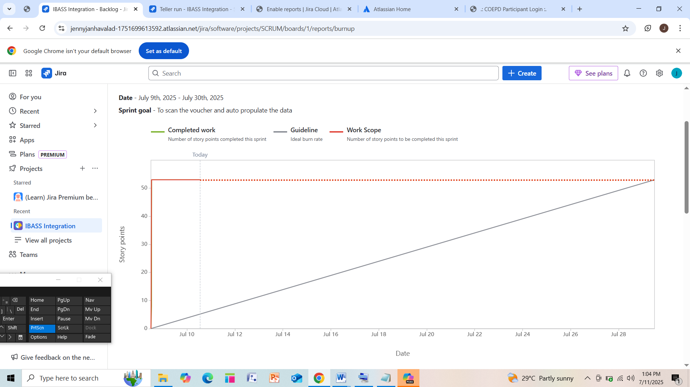

Sprint Burndown chart
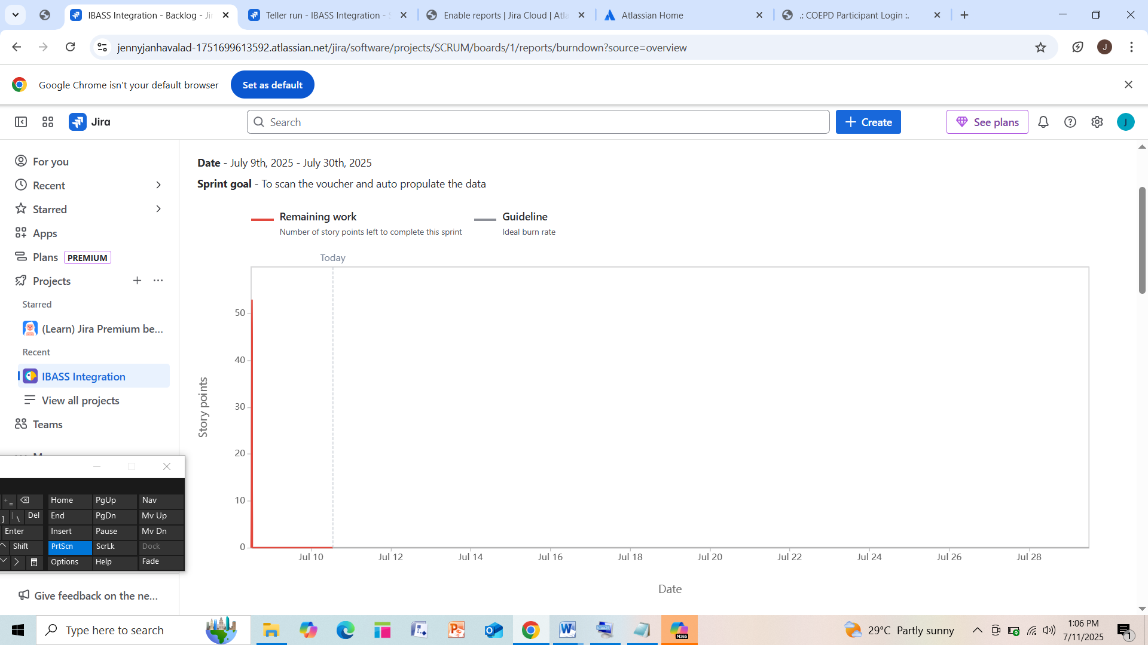

Document 6: Sprint meetings
Meeting Type 1: Sprint Planning meeting Date
Date | 01.07.2025
Time | 12:00PM
Location | Office, Mumbai
Prepared By | Product Owner
Attendees | Scrum Team(Product owner, scrum master, 6 Developer)

Agenda Topics
Topic | Presenter | Time allotted
User scan and auto propulate | Product owner | 3 hour
Teller currency run | Product owner | 3 hour

Other Information
Observers | Axis Bank Senior Operations Heads, Axis Bank IT Compliance/Audit Team, Vendor Representatives(IBASS)
Resources | Product Owner (PO), Scrum Master, Developers
Special Notes

Meeting Type 2: Sprint review meeting
Date | 01.08.2025
Time | 11:00 am
Location | ASA company
Prepared By | Scrum Master
Attendees | Scrum Team

Sprint status | Things to demo | Quick updates | What’s next
5 out of 6 user stories completed | - Cheque scanning with IBASS NSM | Minor delay due to integration issue | Complete pending story (cash payment module)
1 story moved to next sprint | Auto voucher posting in Saksham | Daily stand-ups helped unblock tasks | Plan integration testing
Sprint goal partially met | UI for cash receipt entry | Stakeholder feedback positive | UAT preparation starts next sprint

Meeting Type 3: Sprint retrospective meeting
Date | 01.08.2025
Time | 12:30 pm
Location | ASA company
Prepared By | Developers
Attendees | Scrum master

Agenda | What went well | What didn’t go well | Questions | Reference
Scanning of the vouchers/cheque  - Welcome & Ground Rules (5 mins)  - Review Sprint Goal & Deliverables (5 mins)  - What Went Well (10 mins)  - What Didn’t Go Well (10 mins)  - Improvements & Action Items (10 mins)  - Open Questions / Feedback (5 mins)  - Wrap-Up & Summary (5 mins) | - Successful integration of cash voucher scanning module with IBASS.  - Automated data sync between Saksham and IBASS reduced manual intervention.  - Prompt communication between IT team and operations team for error resolution.  - User stories were well-defined and met acceptance criteria.  - No major defects found in UAT testing for this sprint. | • Delay in environment setup due to dependency on vendor-side hardware readiness.  • Lack of test data for cheque scanning simulation, which caused QA delays.  • Confusion over acceptance criteria for multi-denomination sorting logic.  • BA inputs received late, which impacted development sequencing.  • Some user stories were too big and not broken down into tasks properly. | • Can we engage with Axis Bank’s branch users for early feedback on UI flows?  • How do we ensure that hardware vendors and IT infrastructure team are in sync with sprint goals?  • What is the plan for performance testing in upcoming sprints?  • Can we improve our incident response process during mid-sprint failures? | - Jira: Sprint #[X] Board  - Confluence: “Sprint [X] – IBASS-Saksham Notes”  - Axis Bank SOPs: Version [Date/Ref]  - API Mapping Document: v1.2  - QA Test Results & Defect Logs

Meeting Type 4: Daily Stand-up meeting
Question | Names/Role | Week “X” (from dd-mm-yyyy to dd-mm-yyyy)
Question | Names/Role | Monday | Tuesday | Wednesday | Thursday | Friday | Saturday | Sunday
What did you do yesterday? | Developer 1 | Integrated IBASS with Saksham API | Created test cases for voucher sync | Fixed bug in currency mapping | Worked on deployment script | Code reviewed Dev2’s cheque module
What did you do yesterday? | Developer 2 | Developed cheque scanning UI | Implemented backend cheque logic | Linked UI with backend service | Completed unit tests for cheque scan | Debugged API timeout issues
What did you do yesterday? | Developer 3 | Set up note sorting test cases | Executed test cases on NSM | Logged bugs and shared with QA | Supported UAT test cycle | Updated test plan document
What will you do today? | Developer 1 | Start voucher reconciliation module | Unit test voucher reconciliation | Prepare for code merge | Merge code and resolve conflicts | Start documentation for deployment
What will you do today? | Developer 2 | UAT feedback fixes on UI | Add validation for cheque input | Align UI with BA expectations | Coordinate with BA for field feedback | Finalize UI test scenarios
What will you do today? | Developer 3 | Set up note sorting test cases | Executed test cases on NSM | Logged bugs and shared with QA | Supported UAT test cycle | Updated test plan document
What (if any) is blocking your progress? | Developer 1 | Start voucher reconciliation module | Unit test voucher reconciliation | Prepare for code merge | Merge code and resolve conflicts | Start documentation for deployment
What (if any) is blocking your progress? | Developer 2 | Delay in getting UI feedback | None | — | — | Blocked on third-party component
What (if any) is blocking your progress? | Developer 3 | NSM hardware not responsive | — | Awaiting Axis IT support | — | None

