Q.1. Identify minimum 20 functional requirements Example : Functional requirement: When an order is fulfilled, the local printer shall print a packing slip. Non-Functional Requirement: Packing slips shall be printed on both sides of 4”x 6” white paper, the standard size for packing slips used by local printers.
Req ID | Req Name | Req Description | Priority
FR0001 | Farmer Registration | Farmers should be able to register with the application | 8
FR0002 | Farmer Search for Products | Farmers should be able to search for available products in fertilizers, seeds, pesticides | 8
NFR0101 | Page Loading Time | Each Page should load within 2 seconds time | 9
NFR0102 | WCAG 2.1. | The system must meet Web Content Accessibility Guidelines WCAG 2.1. | 8

Req ID | Req Name | Req Description | Priority
FR0001 | Farmer Registration | Farmers should be able to register using email and password | 8
FR0002 | Login for Farmers and Manufacturers | Users must authenticate via email/password | 9
FR0003 | Product Search | Farmers can search fertilizers, seeds, pesticides | 10
FR0004 | Category Browsing | Products should be categorized by type | 8
FR0005 | Add to Cart | Farmers can add products to shopping cart | 9
FR0006 | Buy Later List | Save products for future purchase | 7
FR0007 | Payment Gateway | Integrated COD, credit/debit card, UPI payment modes | 10
FR0008 | Order Confirmation Email | Email notifications for order confirmation | 9
FR0009 | Delivery Tracking | Real-time order status and estimated delivery | 8
FR0010 | Manufacturer Product Upload | Allow manufacturers to submit product listings | 9
FR0011 | Product Image Upload | Upload images for product listings | 8
FR0012 | Forgot Password Feature | Password recovery for registered users | 7

FR0013 | Multilingual Support | Application interface in multiple languages | 6
FR0014 | Ratings and Reviews | Farmers can rate and review products | 7
FR0015 | Product Recommendations | Personalized suggestions based on history | 6
FR0016 | Manufacturer Dashboard | View listing stats, edit products | 7
FR0017 | Secure Transactions | Encrypt user payment and personal data | 10
FR0018 | Registration Validation | Validate data entry fields during sign-up | 8
FR0019 | UAT Testing Workflow | Enable UAT cycle for approval before deployment | 7
FR0020 | Help & support | Contact or feedback form for issue resolution | 6

Q.2. Make wireframe and prototypes.
Ans. Home Page Wireframe:
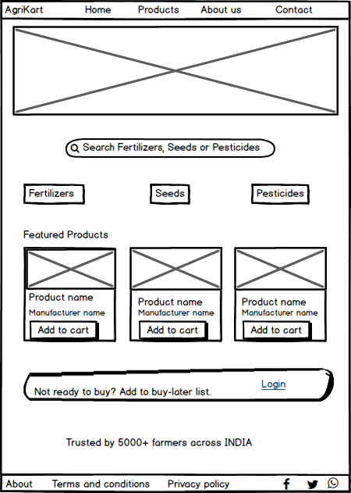
Farmer Dashboard Wireframe:
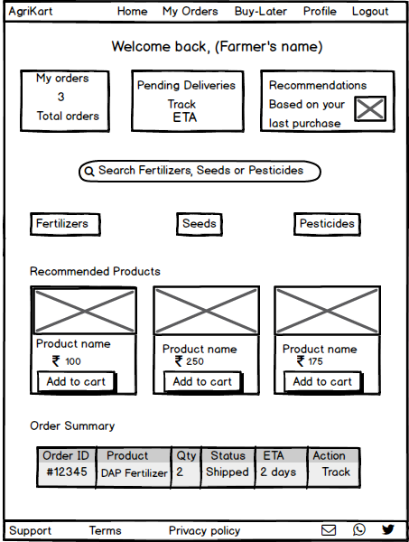

Manufacturer Product Upload Page Wireframe:
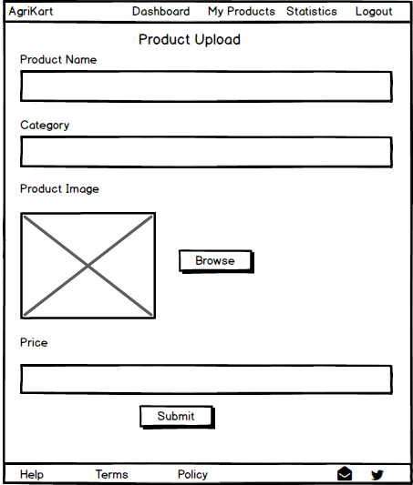
Product Details Page Wireframe:
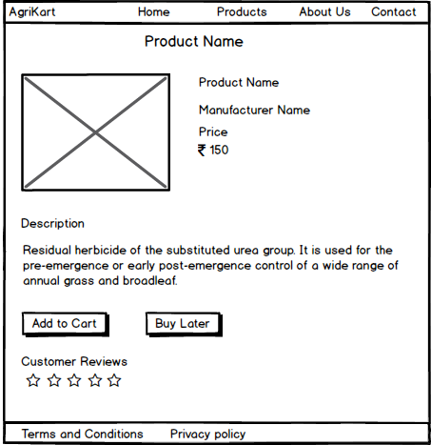
Checkout Page Wireframe:
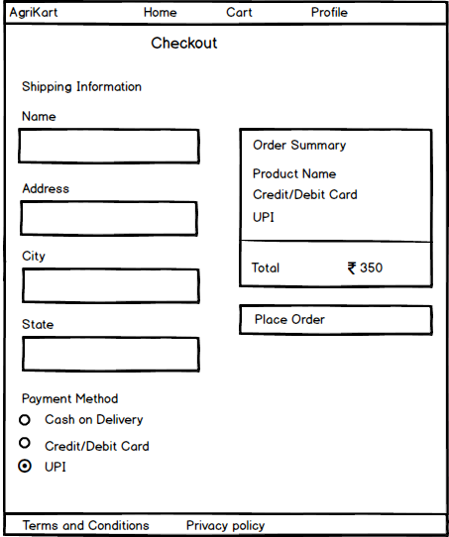
Home page Prototype:
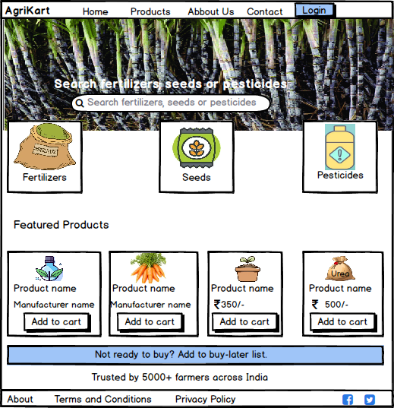
Farmer dashboard prototype:
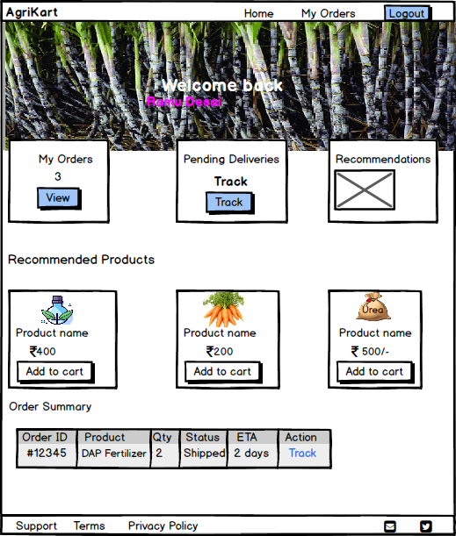
Manufacturer Product Upload Page Prototype:
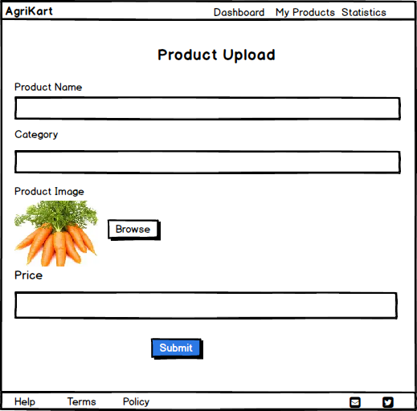

Product Details Page Prototype:
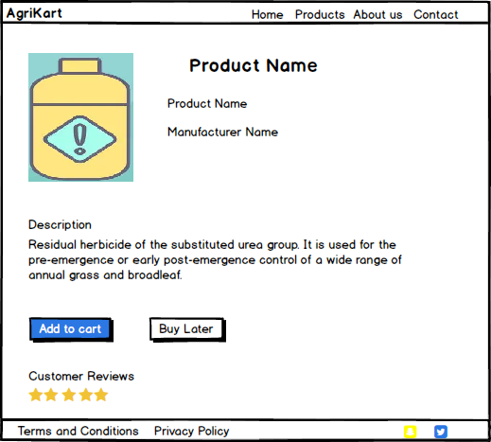
Checkout Page Prototype:
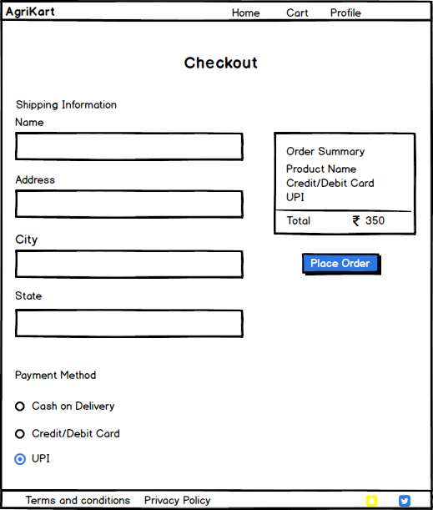
Q.3. Make a note of the Tools, which you are using for above concepts.
Ans. The tools used:
- Balsamiq – For wireframes & page sketches
- Microsoft Visio – For UML diagrams
- Lucidchart/Draw.io – For activity and data flow diagrams
- Excel / Word – For RTM and test case documentation

Balsamiq:-
Purpose: Used for creating low-fidelity wireframes and page layouts.
Use Case: Designed the Home Page, Farmer Dashboard, Manufacturer Upload Page, and Checkout Screens.
Features: Drag-and-drop UI elements, hand-sketched look, fast prototyping.
Why Used: Helps visualize user flow, UI placement, and early-stage design decisions.
Microsoft Visio:-
Purpose: Diagramming tool for creating structured visual documentation.
Use Case: Created UML diagrams, Use Case Diagrams, Activity Diagrams, and Data Flow Diagrams.
Features: Built-in templates for BA artifacts, professional look, easy flow connectors.
Why Used: Ideal for illustrating functional flows and system interactions clearly.
Lucidchart/Draw.io:-
Purpose: Online tools for creating diagrams collaboratively.
Use Case: Used for ER diagrams, Data Flow Diagrams, or as alternatives to Visio for quick diagramming.
Features: Cloud-based, real-time collaboration, intuitive interface.
Why Used: Flexible, accessible from any device, integrates easily with Google Drive and Teams.
Microsoft Excel / Word:-
Excel Purpose: Used for tabular documentation like:
Requirements Traceability Matrix (RTM)
Test Case Documentation
Requirement Prioritization
Word Purpose: Assembled the entire Capstone Report, answers, and final formatting.
Features: Easy table handling (Excel), detailed formatting (Word), standardized reporting.
Q.4. A business analyst’s key responsibilities are to keep track of the requirements and make sure that no requirement is missed. Mr. Henry and peter have approached you regarding the current status of the project. How will you tackle this situation?
Prepare RTM

Req ID | Req Name | Req Description | Design | D1 | T1 | …… | T4 | UAT
FR0001 | Farmer Registration | Farmers should be able to register with the application
FR0002 | Farmer Search for Products | Farmers should be able to search for available products in fertilizers, seeds, pesticides
NFR0101 | Page Loading Time | Each Page should load within 2 seconds time
NFR0102 | WCAG 2.1. | The system must meet Web Content Accessibility Guidelines WCAG 2.1.

Ans.
Req ID | Req Name | Description | Design Doc | Test Case | Test Result | UAT
FR0001 | Farmer Registration | New users create an account | D1 | T1 | Pass | ✓
FR0002 | Search for Products | Farmers can search and browse items | D2 | T2 | Pass | ✓
FR0007 | Payment Gateway | Integrated payment modes | D5 | T5 | In Progress | ✗
FR0009 | Delivery Tracking | Real-time delivery tracking | D6 | T6 | Pending | ✗
NFR0101 | Page Load Time | Each page loads within 2 seconds | D8 | T8 | Pass | ✓
NFR0102 | Accessibility Standard | Adherence to WCAG 2.1 | D9 | T9 | Pass | ✓

Q.5. Prepare 10 Test Case Documents.
Ans. Test Case 1: Farmer Registration
Field | Description
Test Case ID | TC001
Title | Verify Farmer Registration Flow
Objective | Ensure a new farmer can register successfully with valid data
Preconditions | None
Test Steps | 1. Navigate to registration page<br>2. Enter valid email, password<br>3. Click Register
Expected Result | Farmer account is created and redirected to dashboard
Status | Pass/Fail

Test Case 2: Manufacturer Product Upload
Field | Description
Test Case ID | TC002
Title | Upload Product by Manufacturer
Objective | Verify if a manufacturer can upload product details
Preconditions | Manufacturer must be logged in
Test Steps | 1. Navigate to Upload Page<br>2. Enter product name, category, price, image<br>3. Submit
Expected Result | Product is listed and visible in the catalog
Status | Pass/Fail

Test Case 3: Product Search Functionality
Field | Description
Test Case ID | TC003
Title | Search Products in Catalog
Objective | Ensure search bar returns accurate results
Preconditions | Farmer must be logged in
Test Steps | 1. Enter a product keyword<br>2. Click Search
Expected Result | Matching products are displayed
Status | Pass/Fail

Test Case 4: Add to Cart Functionality
Field | Description
Test Case ID | TC004
Title | Add Selected Product to Cart
Objective | Ensure selected product can be added to cart
Preconditions | Product is visible
Test Steps | 1. Click “Add to Cart” on product<br>2. View cart
Expected Result | Product appears in cart with quantity
Status | Pass/Fail

Test Case 5: Payment Gateway – UPI Option
Field | Description
Test Case ID | TC005
Title | Validate UPI Payment Flow
Objective | Confirm successful UPI payment process
Preconditions | Items are present in cart
Test Steps | 1. Go to Checkout<br>2. Select UPI<br>3. Complete payment
Expected Result | Payment success message and order confirmation
Status | Pass/Fail

Test Case 6: Email Order Confirmation
Field | Description
Test Case ID | TC006
Title | Order Confirmation Email Trigger
Objective | Verify that email is sent after successful order
Preconditions | Order has been placed
Test Steps | 1. Place order<br>2. Check email inbox
Expected Result | Order summary email is received
Status | Pass/Fail

Test Case 7: Delivery Tracker Functionality
Field | Description
Test Case ID | TC007
Title | Track Active Order Delivery
Objective | Ensure users can track delivery status
Preconditions | Order must be in “Shipped” status
Test Steps | 1. Login<br>2. Navigate to My Orders<br>3. View order status
Expected Result | Real-time status & ETA displayed
Status | Pass/Fail

Test Case 8: Forgot Password Process
Field | Description
Test Case ID | TC008
Title | Password Reset Flow
Objective | Validate reset email for registered users
Preconditions | Valid registered email is available
Test Steps | 1. Click “Forgot Password”<br>2. Enter email<br>3. Click Send
Expected Result | Reset link email is received
Status | Pass/Fail

Test Case 9: Multilingual Interface
Field | Description
Test Case ID | TC009
Title | Change Language Preference
Objective | Ensure UI changes when language is selected
Preconditions | User is logged in
Test Steps | 1. Click on language dropdown<br>2. Select new language
Expected Result | All UI content updates to selected language
Status | Pass/Fail

Test Case 10: Logout Functionality
Field | Description
Test Case ID | TC010
Title | Verify Successful Logout
Objective | Ensure user is redirected and session ends
Preconditions | User must be logged in
Test Steps | 1. Click Logout<br>2. Attempt to go back
Expected Result | Redirects to login page and session is cleared
Status | Pass/Fail

Q.6. After the requirements are thoroughly explained to the entire project team by business analyst, the Database architects have decided to do the database design and also to represent the in-flow and out-flow of data. Draw database schema and ER diagram.
Ans. Database Schema (Relational Tables)
Table Name | Fields
Users | user_id (PK), name, email, password, role (Farmer/Manufacturer), phone, address
Products | product_id (PK), name, category (Seed/Fertilizer/Pesticide), description, price, stock, manufacturer_id (FK), image_url
Manufacturers | manufacturer_id (PK), company_name, user_id (FK)
Orders | order_id (PK), user_id (FK), order_date, total_amount, status, payment_id (FK)
Order_Items | order_item_id (PK), order_id (FK), product_id (FK), quantity, price
Buy_Later | buy_later_id (PK), user_id (FK), product_id (FK), added_on
Payments | payment_id (PK), method (COD/UPI/Card), status, payment_date
Delivery | delivery_id (PK), order_id (FK), expected_date, tracking_status
Product_Reviews | review_id (PK), product_id (FK), user_id (FK), rating, comments

ER Diagram Outline (Entities & Relationships)
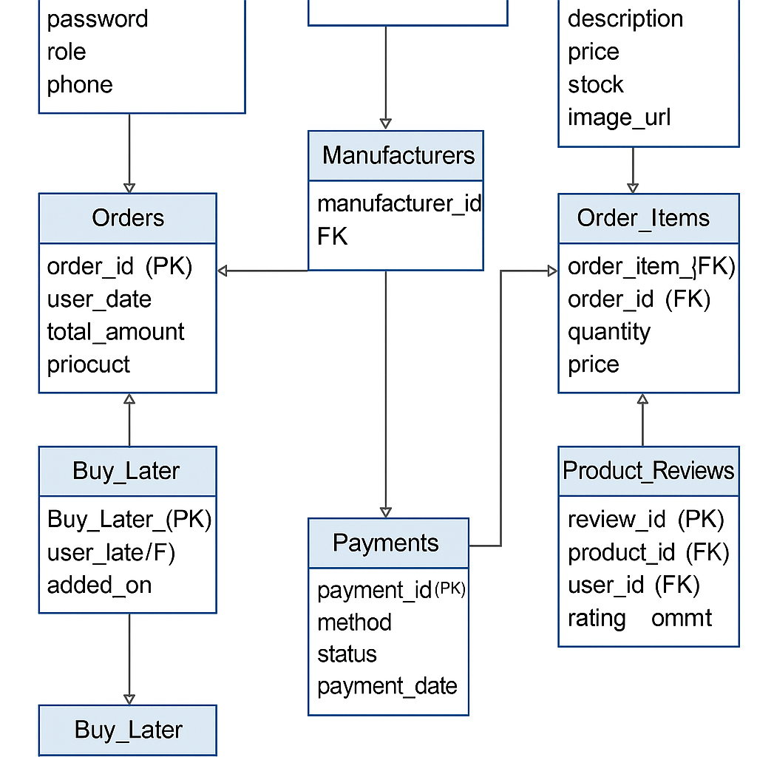
Q.7. What is a data flow diagram? Draw a data flow diagram to represent the in-flow and out-flow of data when a Farmer is placing an order for the product.
Ans. A Data Flow Diagram (DFD) is a visual representation of how data moves through a system, from input to processing to output. It helps identify where data originates, how it flows between processes, where it’s stored, and how it exits the system. DFDs are commonly used by Business Analysts to communicate system functionality without diving into technical code.
Q.8. Due to change in the Government Taxation structure. We should change the Tax structure How do you handle change requests in a project?
Ans. Steps to Handle a Change Request:
- Identify and Record the Request
- The change is initiated due to updated government tax policies.
- Create a Change Request Form that includes:
  - Request originator (e.g. Finance/Compliance)
  - Date and version
  - Description: “Update tax calculation logic as per revised structure”
- Assess Impact
- Functional Impact: How does this affect existing tax logic in checkout, invoice, reporting?
- Non-Functional Impact: Will it affect system performance or compliance standards?
- Dependencies: Integration with payment gateways, accounting reports, etc.

- Consult Stakeholders
- Notify relevant stakeholders:
- Finance head (e.g. Mr. Pandu)
- Development Team (Java devs)
- Testing Team (QA)
- Client-side committee (Mr. Henry and team)
- Conduct a quick meeting if necessary for clarification and consensus.
- Update Documentation

- Modify:
- BRD: Revise any tax-related business rules.
- FRD: Update tax calculation logic and formulas.
- RTM: Add/change traceability links.
- Add note of the change in Version Control Log.
- Get Formal Approval
- Ensure stakeholders approve the change before implementation.
- Use Change Approval Matrix or email sign-off.
- Implement the Change
- Developers update tax logic based on revised formula.
- Ensure configurations (e.g. GST %, surcharge) are flexible for future updates if possible.
- Testing
- Create targeted Test Cases to verify:
- Tax is calculated correctly
- Rounding rules are adhered to
- Invoice reflects correct rates
- Conduct Regression Testing if this change affects payment or reporting modules.
- Deploy & Monitor
- After QA passes it, move to staging and then production with release notes.
- Post-deployment, monitor transactions and logs for anomalies.
- Communicate the Update
- Notify end users or farmers if the tax structure affects total payable amounts.
- Update FAQs or Help sections on the platform as needed.
Q.9. As the project is in process, Ben and Kevin have contacted you. The reason is to inform you that they want the Farmers to sell their crop yields through this application i.e. Farmers should be able to add their crop yields or products and display to general public and should be able to sell them. They also want to introduce Auction system for their Crop yields. As a BA, what will be your response? Is this a change request or an enhancement???
Ans. This is considered an enhancement as enhancement refers to the addition of new features or capabilities that extend the current system's functionality. In this case, the original scope was limited to farmers purchasing agricultural inputs like fertilizers, seeds and pesticides). Ben and Kevin now proposed a new feature set where farmers can sell their own produce, and even engage in auction-based transactions and none of which were part of the initial business requirements.
As a Business Analyst, here is how I would respond:
  - Acknowledge the Value: “That’s a fantastic idea — enabling farmers to sell directly and implement auctions could significantly empower the user base and improve digital reach.”
  - Document as an Enhancement Request:
- Log it in the Change/Enhancement Request Register.
- Classify it as an Enhancement.
- Include justification, stakeholders involved, and potential business value.
  - Initiate Feasibility & Impact Analysis:
- Identify which modules will need to be created or modified (e.g., product listing, payment, public marketplace, bidding engine, delivery flows).
- Consult with developers, testers, and architects on impact to timeline, budget, and architecture.
  - Present to Stakeholders for Approval:
- Share the analysis with the client committee (Mr. Henry, Mr. Pandu, Mr. Dooku).
- If approved, update all project artifacts (BRD, FRD, RTM, UAT plan) accordingly.
  - Plan as a Future Phase or Sprint:

- Since it may introduce significant scope growth, recommend it be managed as part of Phase 2 or a new product backlog item in Agile if applicable.
Q.10. Come up with estimations – How many Manhours required.
Ans. Since our project involves functional modules like product listing, cart, checkout, dashboards, upload interface, database design, and now even auction enhancements, here’s a high-level breakdown:
Phase | Task | Estimated Hours
Requirement Analysis | Stakeholder meetings, BRD, FRD, RTM creation | 25–30 hrs
Wireframing & Prototypes | 5–6 screens (Home, Dashboards, Product Upload, etc.) | 15–20 hrs
Database Design | Schema, ERD, data normalization | 15–18 hrs
Data Flow Diagrams | Level 0 + Level 1 DFDs | 8–10 hrs
UI/Frontend Development | Home Page, Dashboards, Checkout, etc. | 50–60 hrs
Backend Development | Registration, Orders, Payment, Inventory logic | 65–75 hrs
Database Setup & Integration | Table creation, CRUD queries, join logic | 20–25 hrs
Testing | Test cases, UAT, bug fixing | 25–30 hrs
Auction Enhancement (New) | Farmer listings, bidding engine, public view logic | 40–50 hrs (separate)

Total estimated manhours
- Base Project (without auction): ~245–270 hours
- With Auction System: Add ~50 hours
- Grand Total Estimate: ~295–320 Manhours
Q.11. Project has finally completed all the stages i.e., design, development, testing etc. Now, it is the role of a business analyst to contact the client for testing of the final product and have to successfully complete it. How are you going to handle this situation? And once it is done, what will be the process to close the project? Explain UAT Acceptance process.
Ans. Handling UAT (User Acceptance Testing)
  - Initiate UAT Communication
- Send a formal email to the client (e.g., Mr. Henry and committee) announcing that the product is ready for UAT.
- Attach:
- UAT Plan & Schedule
- UAT Test Case Documents
- User Manual or Quick Start Guide
- Bug Reporting Template or access to issue tracker
  - Prepare the UAT Environment
- Coordinate with the tech team to deploy the latest stable build to the UAT server/environment.
- Ensure sample test data is seeded (for dummy orders, user logins, etc.).

  - Support Client During Execution
- Conduct a walkthrough session or demo if needed.
- Stand by for clarifications, bug triaging, and handholding during critical test flows.
- Capture feedback promptly and coordinate quick fixes with dev and QA teams.
  - Track UAT Results
- Document all observations:
- Defects (severity, status)
- Suggestions (future enhancements)
- Signed Test Logs
- Update the RTM to validate that all functional requirements are tested and fulfilled.
  - Client Approval
- Once all major issues are resolved, request a formal UAT Sign-Off using a standard template.
- This indicates the client accepts the system for production deployment.
Project closure process
  - Final documentation
- Update and archive:
- BRD/FRD with version history
- Change Logs
- Final Architecture & Diagrams
- RTM and UAT Report
- Lessons Learned document
  - Handoff deliverables
- Source code, user manuals, training materials, credentials, deployment runbooks.
- Conduct a final Knowledge Transfer (KT) session with stakeholders.
  - Formal Closure Meeting
- Present closure summary:
- Scope Delivered
- Open items (if any)
- Support & Maintenance Details
- Get Project Sign-Off from client sponsor.
  - Internal Debrief
- Hold a retrospective meeting with your team to reflect on:
- What went well
- Challenges faced
- Recommendations for future projects
  - Celebrate the Win!
- Appreciation email from the BA to the team and client.
- Archive project artifacts and revoke access where needed.
Q.12. Explain Project closure document.
Ans. A Project closure document is the final formal deliverable that marks the end of a project. It confirms that all project activities are complete, deliverables have been handed over and the client or sponsor has accepted the outcome. Think of it as the “wrap-up report” that ties everything together operationally, contractually and administratively.
Key Components of a Project Closure Document

  - Project Overview
- Brief summary of the project’s purpose, scope, and timeline.
- Reference to original objectives and whether they were met.
  - Deliverables Summary
- List of all completed deliverables.
- Confirmation of client acceptance or sign-off.
  - Performance Evaluation
- Comparison of planned vs. actual:
- Budget
- Timeline
- Scope
- KPIs or success metrics achieved.
  - Lessons Learned
- What went well?
- What could be improved?
- Recommendations for future projects.
  - Outstanding Issues
- Any unresolved items or deferred features.
- Handover to support or maintenance teams if applicable.
  - Resource Release
- Confirmation that project team members are released from the project.
- Closure of vendor contracts or third-party engagements.
  - Final Sign-Off
- Approval from client/sponsor and project manager.
- Date of official closure.

Why does it matter?
- It ensures accountability and transparency.
- Provides a historical record for audits or future reference.
- Helps improve organizational learning through retrospectives.

