Question 1: Identify minimum 20 functional requirements

Req ID | Req Name | Req Description | Priority
FR001 | User Registration | Users should be able to register for an account by providing their email ID and creating a password | 10
FR002 | Manufacturer Registration | Manufacturers should be able to register and create an account to upload product information | 10
FR003 | User Search for Products | Users should be able to search for available products in fertilizers, seeds, pesticides | 9
FR004 | Product Filtering | Users should be able to filter products by categories such as type (fertilizers, seeds, pesticides), price range, and brand. | 8
FR005 | Product Detail View | Users should be able to view detailed information about a product including description, price, availability, and manufacturer details | 7
FR006 | Add to Cart | Users should be able to add selected products to a shopping cart for purchasing | 6
FR007 | Wishlist Feature | Users should be able to create a wish list to save products for future consideration | 6
FR008 | Checkout Process | There should be a streamlined checkout process for farmers to complete their orders | 7
FR009 | Multiple Payment Option | The application must support various payment methods including Credit/Debit cards, UPI, and Cash on Delivery (COD) | 7
FR010 | Order Confirmation Email | Users should receive an email confirmation with the order details after a successful purchase | 6
FR011 | Order Tracking | Users should be able to track the status of their orders through a delivery tracking feature | 6
FR012 | Help and Support | The application should provide a help section or FAQ for users | 8
FR013 | Feedback and Rating | Users should be able to provide ratings and reviews for the products they purchase | 5
FR014 | Return & Refund Policy | Outline the return and refund policy for customers to ensure a positive customer experience and minimize customer complaint | 8
FR015 | Buy now | On clicking on ‘buy now’, the customer will be redirected to the checkout page :- Payment Gateway | 7
NFR016 | Page Loading Time | The application should respond to user requests within 2 seconds for any action, including loading pages and processing transactions | 10
NFR017 | Usability | The application must have an easy-to-use interface that allows easy navigation | 8
NFR018 | Security | The application must implement data encryption for sensitive information and secure user authentication | 10
NFR019 | Error Handling | The application should provide user-friendly error messages and logging mechanisms for troubleshooting | 8
NFR020 | Accessibility | The system must meet Web Content Accessibility Guidelines WCAG 2.1. | 8

Question 2: 5 Page Designs

Login Page
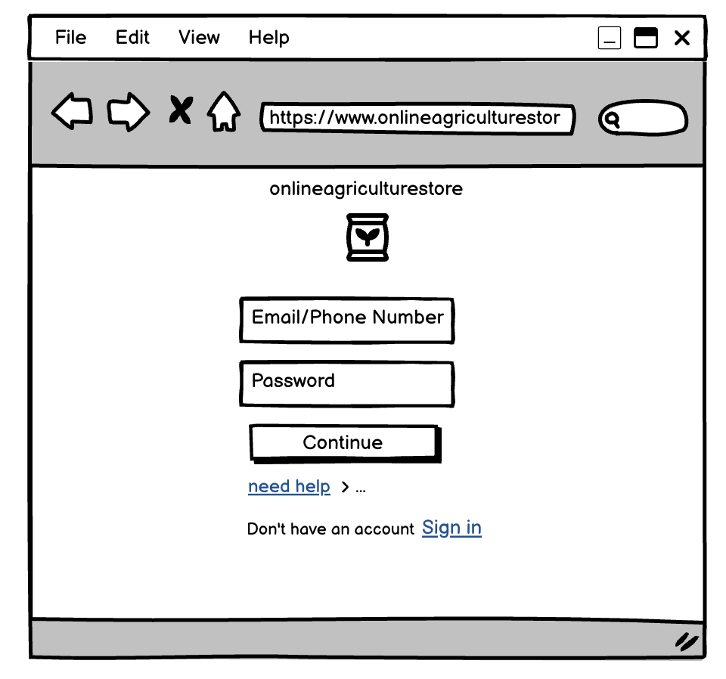

Product Listing Page
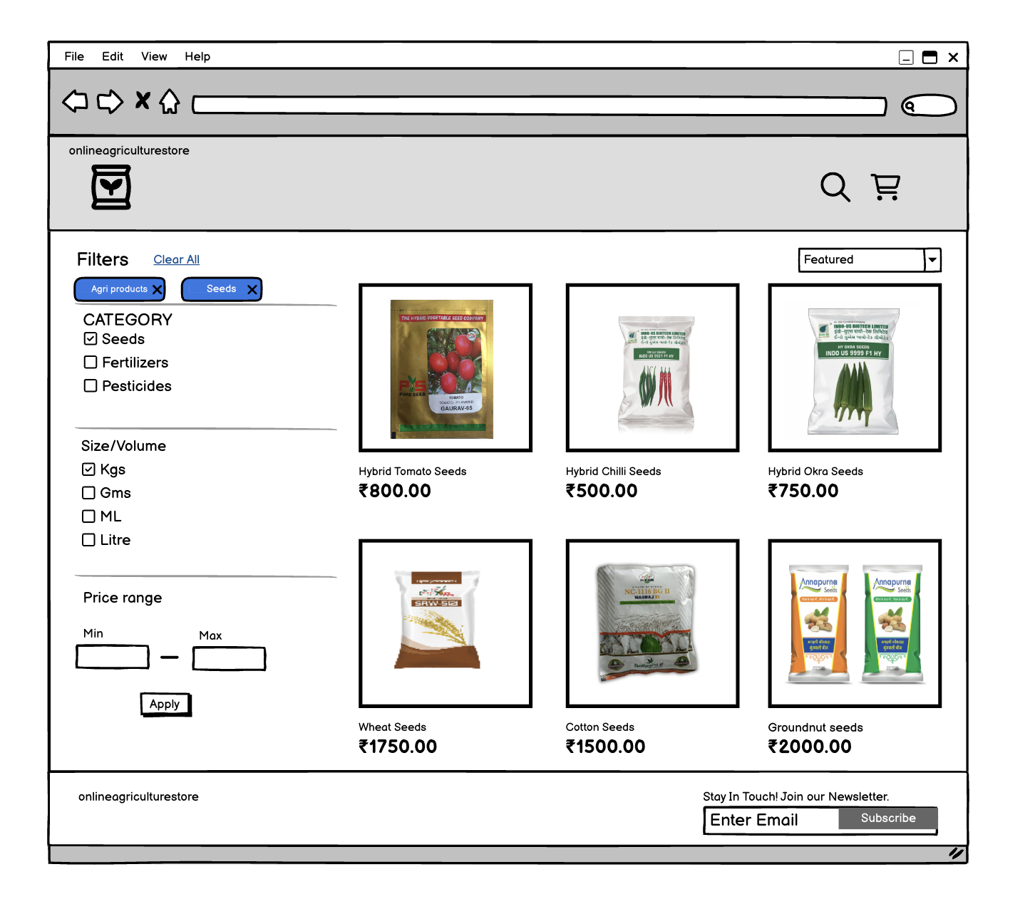

Product Details Page
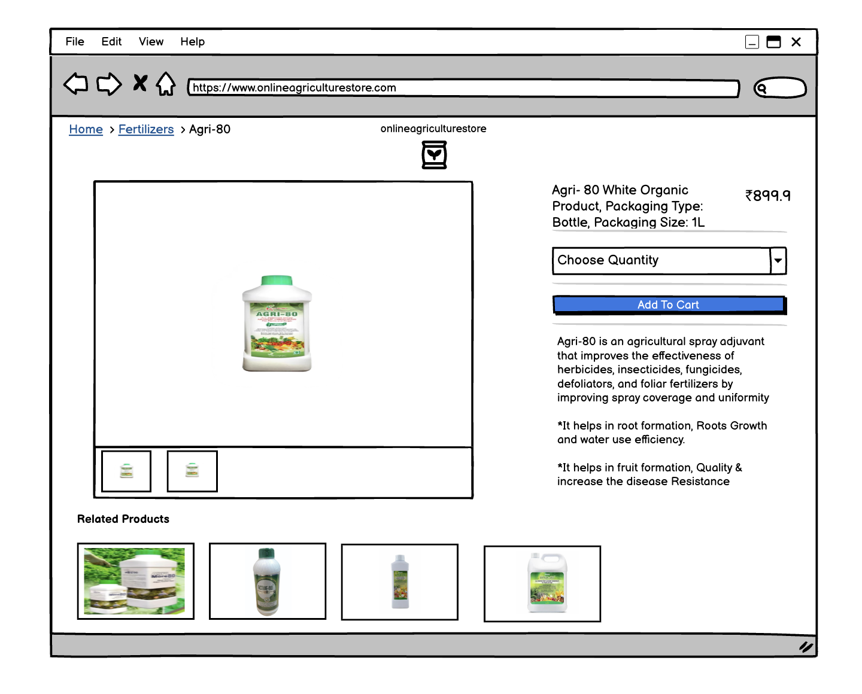

Payment Page
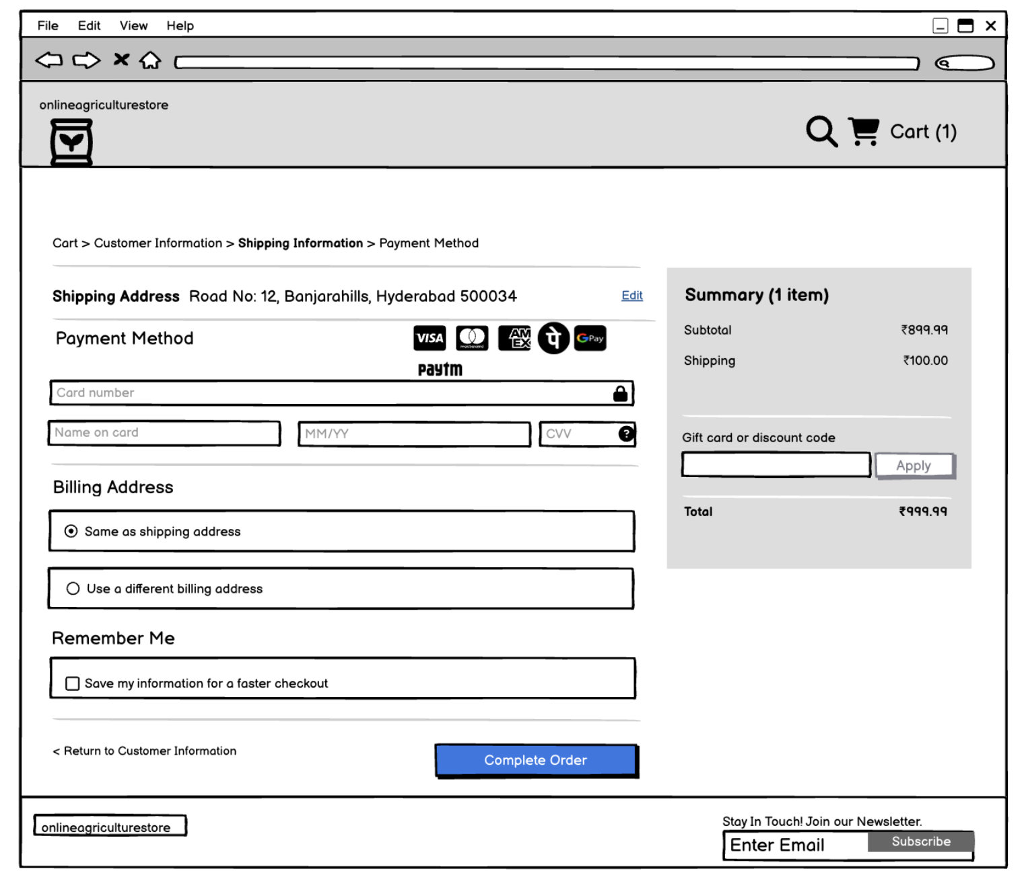

Checkout Success page
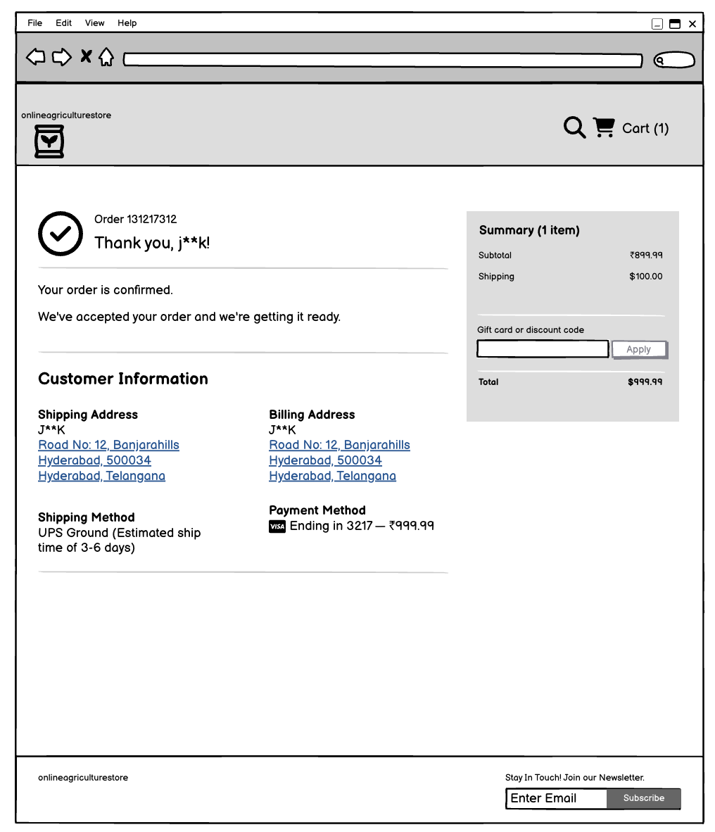

Question 3: Tools

Visio: Microsoft Visio is software for drawing a variety of diagrams. These include flowcharts, org charts, building plans, floor plans, data flow diagrams, process flow diagrams, business process modelling, swim lane diagrams, 3D maps, and many more
|Balsamiq: Balsamiq is a rapid wireframing tool. It creates mock-ups and wireframes for websites, webapps, and desktop software. It allows us to picture ideas and concepts through a simple drag-and-drop interface. The wireframes created using Balsamiq have a hand-drawn style. It focuses on the structure and content of the product rather than visual details.
Axure: Axure is a UX design tool used for creating wireframes and interactive prototypes. Axure is especially useful for designers of desktop and mobile applications, and it is highly regarded among enterprise companies for the high level of functionality and visual detail that can be built into its prototypes.

Question 4: RTM
Req ID | Req Name | Req Description | Design | D1 | D2 | D3 | D4 | T1 | T2 | T3 | T4 | UAT
FR001 | User Registration | Users should be able to register for an account by providing their email ID and creating a password |  |  |  |  |  |  |  | User registration is in T2 phase
FR002 | Manufacturer Registration | Manufacturers should be able to register and create an account to upload product information |  |  |  |  |  |  | Manufacturer registration is in T2 phase
FR003 | User Search for Products | Users should be able to search for available products in fertilizers, seeds, pesticides |  |  |  |  |  | User search is in T1 Phase |  |  | Product Filtering is in T4 phase
FR004 | Product Filtering | Users should be able to filter products by categories such as type (fertilizers, seeds, pesticides), price range, and brand. |  |  |  |  |  |  | Product Detail View is in T2 phase
FR005 | Product Detail View | Users should be able to view detailed information about a product including description, price, availability, and manufacturer details
FR006 | Add to Cart | Users should be able to add selected products to a shopping cart for purchasing |  |  |  |  | Add to Cart is in D4 phase
FR007 | Wishlist Feature | Users should be able to create a Wishlist to save products for future consideration |  |  |  | Wishlist Feature is in D3 phase
FR008 | Checkout Process | There should be a streamlined checkout process for farmers to complete their orders |  |  | Checkout Process is in D2 phase
FR009 | Multiple Payment Option | The application must support various payment methods including Credit/Debit cards, UPI, and Cash on Delivery (COD) |  |  |  |  |  |  |  | Multiple Payment Option is in T3 phase
FR010 | Order Confirmation Email | Users should receive an email confirmation with the order details after a successful purchase |  | Order Confirmation Email is in D1
FR011 | Order Tracking | Users should be able to track the status of their orders through a delivery tracking feature |  |  |  |  | Order Tracking is in D4 phase
FR012 | Help and Support | The application should provide a help section or FAQ for users |  |  |  |  |  |  |  |  |  | Help and Support is in UAT phase
FR013 | Feedback and Rating | Users should be able to provide ratings and reviews for the products they purchase |  |  |  | Feedback and Rating is in D3 phase
FR014 | Return & Refund Policy | Outline the return and refund policy for customers to ensure a positive customer experience and minimize customer complaint |  |  |  |  |  | Return & Refund Policy is in T1 phase
FR015 | Buy now | On clicking on ‘buy now’, the customer will be redirected to the checkout page :- Payment Gateway |  |  |  |  |  |  | Buy now is in T2 phase
NFR016 | Page Loading Time | The application should respond to user requests within 2 seconds for any action, including loading pages and processing transactions |  |  |  |  |  |  |  |  |  | Page Loading Time is in UAT phase
NFR017 | Usability | The application must have an easy-to-use interface that allows easy navigation |  |  |  |  |  |  |  |  |  | Usability is in UAT phase
NFR018 | Security | The application must implement data encryption for sensitive information and secure user authentication |  |  |  |  |  |  |  |  |  | Security is in UAT phase
NFR019 | Error Handling | The application should provide user-friendly error messages and logging mechanisms for troubleshooting |  |  |  |  |  |  |  |  |  | Error handling is in UAT phase
NFR020 | Accessibility | The system must meet Web Content Accessibility Guidelines WCAG 2.1. |  |  |  |  |  |  | Accessibility is in T2 phase

Question 5: 10 Test case Documents

Test Case ID | TCOO1 | Test Case  Name |  | Login
Project ID | 1234 | Project Name |  | Online Agriculture Product  Store
PM ID | XR-3010087 | PM Name |  | Mr Vandanam
Test Strategy ID | TS-1222 | Tester ID |  | XR-696768
Test Plan ID | TS-1222 | Tester Name |  | Miss Alekya
Test Schedule ID | TS-1222 | Date of Test | 2-02-2025
Link to that page
Input Data | User ID, Password, Captcha, OTP
Expected  Behaviour | Home page/ Popup error page
Actual Behaviour | Home page/ Popup error page
Comments | Test Was Successful
Result (Pass/Fail) | Pass

Test Case ID | TCOO2 | Test Case  Name | Product Search Functionality
Project ID | 1234 | Project Name | Online Agriculture Product  Store
PM ID | XR-3010087 | PM Name | Mr Vandanam
Test Strategy ID | TS-1222 | Tester ID | XR-696768
Test Plan ID | TS-1222 | Tester Name | Miss Alekya
Test Schedule ID | TS-1222 | Date of Test | 3-02-2025
Link to that page
Input Data | Search keyword (e.g., "fertilizer")
Expected  Behaviour | Relevant products matching the search keyword should be displayed
Actual Behaviour | Relevant products, including "Organic Fertilizer" and "Chemical Fertilizer," were displayed
Comments | Search function correctly handles both partial matches and synonyms
Result (Pass/Fail) | Pass

Test Case ID | TCOO3 | Test Case  Name |  | Add Product to Cart
Project ID | 1234 | Project Name |  | Online Agriculture Product  Store
PM ID | XR-3010087 | PM Name |  | Mr Vandanam
Test Strategy ID | TS-1222 | Tester ID |  | XR-696768
Test Plan ID | TS-1222 | Tester Name |  | Miss Alekya
Test Schedule ID | TS-1222 | Date of Test | 4-02-2025
Link to that page
Input Data | Select product (e.g., "Organic Fertilizer"), quantity
Expected  Behaviour | Selected product is added to the cart with correct quantity. Confirmation message displayed
Actual Behaviour | Product "Organic Fertilizer" was added to the cart with a quantity ; confirmation message displayed
Comments | Stock decreased appropriately after addition
Result (Pass/Fail) | Pass

Test Case ID | TCOO4 | Test Case  Name |  | Checkout Process
Project ID | 1234 | Project Name |  | Online Agriculture Product  Store
PM ID | XR-3010087 | PM Name |  | Mr Vandanam
Test Strategy ID | TS-1222 | Tester ID |  | XR-696768
Test Plan ID | TS-1222 | Tester Name |  | Miss Alekya
Test Schedule ID | TS-1222 | Date of Test | 5-02-2025
Link to that page
Input Data | Products in cart, delivery address, payment information (e.g., COD
Expected  Behaviour | Order is confirmed, and an order summary is displayed
Actual Behaviour | Order was confirmed and an order summary was correctly displayed
Comments | All totals calculated correctly without any errors
Result (Pass/Fail) | Pass

Test Case ID | TCOO5 | Test Case  Name |  | Email Confirmation on Order
Project ID | 1234 | Project Name |  | Online Agriculture Product  Store
PM ID | XR-3010087 | PM Name |  | Mr Vandanam
Test Strategy ID | TS-1222 | Tester ID |  | XR-696768
Test Plan ID | TS-1222 | Tester Name |  | Miss Alekya
Test Schedule ID | TS-1222 | Date of Test | 6-02-2025
Link to that page
Input Data | Valid email address (test@example.com), confirm order placed
Expected  Behaviour | Email confirmation regarding order status is sent to the registered email
Actual Behaviour | Email confirmation received successfully at test@example.com
Comments | Check ensured that the email also arrived in the inbox, not in spam
Result (Pass/Fail) | Pass

Test Case ID | TCOO6 | Test Case  Name |  | Delivery Tracking
Project ID | 1234 | Project Name |  | Online Agriculture Product  Store
PM ID | XR-3010087 | PM Name |  | Mr Vandanam
Test Strategy ID | TS-1222 | Tester ID |  | XR-696769
Test Plan ID | TS-1222 | Tester Name |  | Mr. Jason
Test Schedule ID | TS-1222 | Date of Test | 7-02-2025
Link to that page
Input Data | Order ID (12345)
Expected  Behaviour | Tracking page shows the current status and location of the order
Actual Behaviour | The tracking page displayed the correct status and location information
Comments | Invalid order ID prompted proper error handling
Result (Pass/Fail) | Pass

Test Case ID | TCOO7 | Test Case  Name |  | User Logout
Project ID | 1234 | Project Name |  | Online Agriculture Product  Store
PM ID | XR-3010087 | PM Name |  | Mr Vandanam
Test Strategy ID | TS-1222 | Tester ID |  | XR-696769
Test Plan ID | TS-1222 | Tester Name |  | Mr. Jason
Test Schedule ID | TS-1222 | Date of Test | 8-02-2025
Link to that page
Input Data | User is logged in
Expected  Behaviour | User is successfully logged out and redirected to the homepage
Actual Behaviour | User was successfully logged out and redirected to the homepage
Comments | Session terminated properly after logout
Result (Pass/Fail) | Pass

Test Case ID | TCOO8 | Test Case  Name |  | Password Recovery
Project ID | 1234 | Project Name |  | Online Agriculture Product  Store
PM ID | XR-3010087 | PM Name |  | Mr Vandanam
Test Strategy ID | TS-1222 | Tester ID |  | XR-696769
Test Plan ID | TS-1222 | Tester Name |  | Mr. Jason
Test Schedule ID | TS-1222 | Date of Test | 8-02-2025
Link to that page
Input Data | Registered email address (test@example.com)
Expected  Behaviour | User receives an email with a link to reset the password.
Actual Behaviour | Password reset email received at test@example.com
Comments | The reset link was functional and directed to the password change page
Result (Pass/Fail) | Pass

Test Case ID | TCOO9 | Test Case  Name |  | Add Product Review
Project ID | 1234 | Project Name |  | Online Agriculture Product  Store
PM ID | XR-3010087 | PM Name |  | Mr Vandanam
Test Strategy ID | TS-1222 | Tester ID |  | XR-696769
Test Plan ID | TS-1222 | Tester Name |  | Mr. Jason
Test Schedule ID | TS-1222 | Date of Test | 9-02-2025
Link to that page
Input Data | Valid product (Organic Fertilizer), review text ("Excellent product!")
Expected  Behaviour | Review is submitted successfully and displayed under product details
Actual Behaviour | Review submitted and displayed correctly under the product
Comments | User notified of successful submission
Result (Pass/Fail) | Pass

Test Case ID | TCO10 | Test Case  Name |  | View Order History
Project ID | 1234 | Project Name |  | Online Agriculture Product  Store
PM ID | XR-3010087 | PM Name |  | Mr Vandanam
Test Strategy ID | TS-1222 | Tester ID |  | XR-696769
Test Plan ID | TS-1222 | Tester Name |  | Mr. Jason
Test Schedule ID | TS-1222 | Date of Test | 10-02-2025
Link to that page
Input Data | User is logged in
Expected  Behaviour | User should see a list of past orders under "Order History."
Actual Behaviour | All past orders were displayed correctly under the section
Comments | Navigation to the order history page was seamless
Result (Pass/Fail) | Pass
Question 6: DB Design

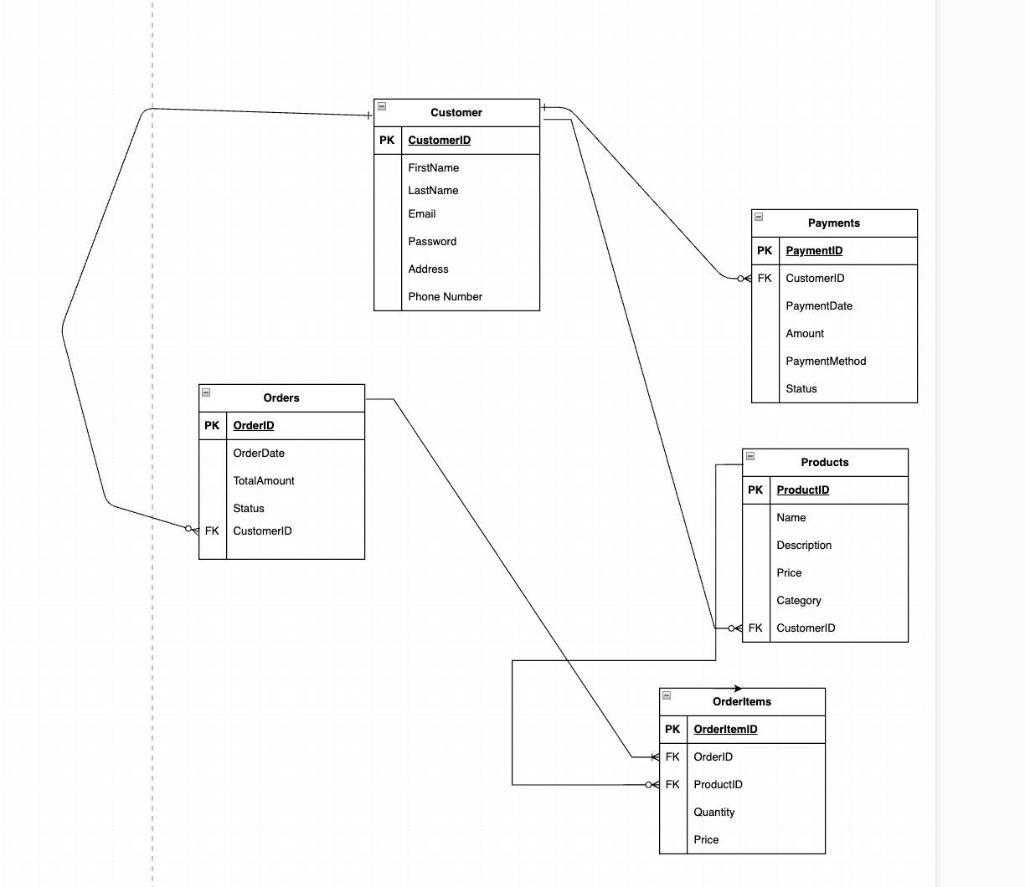

Question 7: What is a data flow diagram? Draw a data flow diagram to represent the in-flow and out-flow of data when a Farmer is placing an order for the product

A Data Flow Diagram (DFD) is a graphical representation that illustrates how data flows within a system, including the inputs, outputs, storage points, and various processes. It helps in visualizing the data processing, highlighting how data moves from one part of the system to another
User
Search
Registration
login
Account
Buy Item
Make order
Payment
ItemMst
UserMst
UserMst
UserMst
ItemMst
OrderMst
PaymentMst
Question 8: Due to change in the Government Taxation structure. we should change the Tax structure
How do you handle change requests in a project?

Managing change requests in a project, especially those prompted by external factors such as changes in government taxation, is essential for ensuring project alignment with regulatory requirements and maintaining stakeholder satisfaction. Below are the steps to effectively handle this change request.

- Document the Change request.
- Look for any Supporting materials to help in adding this Change.
- Need to assess, whether the Change is an Inside or Outside scope. As it’s an outside scope, the Budget and time will get impacted.
- BA and PM should ensure whether the change is a minor or a major change. Policy changes by Govts a major change request and we need to ensure that the change should be done according to the Govt. instruction.
- Fill the Change request Form (CRL) and get the approval from the Project Manager.
- We also need to ensure that our Team understands the priority of this change request.
- We also need to discuss the change with Change Control Board (CCB) who will recommend the necessary change on the Project.
- Once this change is approved, the project deliverables will need to be updated. This can include plans and schedules, business process documents, and the requirements documents.
- Once these updates have been made, the project manager can communicate the new course of action to everyone who will be impacted.
- Now we can delegate the necessary tasks to the people in charge of implementing these new change.

Question 9: Change Request vs Enhancement. Is this a change request or an enhancement???

A change request is a formal proposal for an alteration to some product or system. In project management, a change request often arises when the client wants an addition or alteration to the agreed-upon deliverables for a project. Such a change may involve an additional feature or customization or an extension of service, among other things.

An enhancement project is one in which new capabilities are added to an existing system. Enhancement projects might also involve correcting defects, adding new reports, and modifying functionality to comply with revised business rules or needs.

So, this is an enhancement in the project.

Question 10: Estimations

Manhours Are the required effort of the resources to complete a project. There are three types of projects.

Small up to 500 hours
Medium up 1000 hours
Large up to 1500 hours.

Summary of Estimations
Task | Estimated Manhours
Requirements Gathering & Analysis | 130
System Design | 120
Development | 400
Testing | 200
Deployment | 70
Project Management | 100
Total | 1020 hours

Question 11: Project has finally completed all the stages i.e., design, development, testing etc. Now, it is the role of a business analyst to contact the client for testing of the final product and must successfully complete it. How are you going to handle this situation? And once it is done, what will be the process to close the project?
Explain UAT Acceptance process

Planning: Blueprints are made to implement UAT testing for every feature that needs to test and minimum standards for accepting the test.

Designing: Test cases are designed to hide all possibilities of software packages in a real-world environment.

UAT Testers: A testing team consists of a end users that meet the criteria for the implementation testing. The end user must have expertise in subject matter, the ability to report all problems.

Bug Fixing: The development team works on whatever bugs are found during UAT testing to make the software error free.

Sign off: After removing all the bugs, the testing team indicates acceptance of the completion of the bugs. In this phase, all the stakeholders conclude that the software is ready to GO live and sign it off

Question12: Explain Project Closure Document

Project Closure Document is a crucial component in project management that signifies the formal completion of a project. It serves as the official record that a project has been finalized and outlines the necessary steps for closing out all project activities

Sr No | Points to include | Details | Reference link
1 | Did the client sign off on the UAT Testing
1 | Date of sign off | 20-Feb-25 | Signoff Docx
1 | Name of resources | Mr. Henry | Signoff Docx
2 | Objectives of the project
2 | User friendliness | Achieved
2 | Customer Satisfaction | ROl in 6 months
2 | More categories | Achieved
3 | Functionalities worked on
3 | Secured payment processing | Achieved
3 | Categories | Achieved
4 | Infrastructure
4 | Software installed
4 | Laptops purchased
5 | Funding
5 | Amount approved | 2 Crore | Funds Docx
5 | Amount used | 2 Crore | Funds Docx
6 | Overall project information
6 | Escalations | 25
6 | Customer Satisfaction | High
7 | Value to company
7 | Positive/Negative | • Positive 95%  • Company has successfully made an app  • To help remote farmers to get the products on doorstep.  • Upcoming projects  • Increased users

