Mock 4 Assignment – Business Analysis Report

Assignment 1: Inventory and Delivery Management System
Case Study:
A company manufactures ice-cream and milk products and operates multiple manufacturing plants and warehouses nationwide. They aim to develop a software solution that will help them manage inventory efficiently and ensure the quickest delivery to customers.

Business Requirement Document (BRD)
Project Title: Integrated Inventory and Delivery Management System (IIDMS)
Version History:
Version | Date | Author | Description
1.0 | 02-Nov-2025 | Srikanth Suthari | Initial BRD Draft

1. Introduction
FrostyDelight Foods Pvt. Ltd. manufactures ice-cream and milk products at multiple plants and warehouses across India. Currently, inventory management and delivery tracking are manual, leading to delays and inefficiencies. The company needs a centralized system to automate and monitor operations in real-time.

2. Business Objectives
• Track real-time stock levels
• Optimize routes for fast delivery
• Reduce wastage due to expiry
• Improve customer satisfaction

3. Scope
In Scope: Inventory management, warehouse tracking, order management, route optimization, reporting.
Out of Scope: International logistics, mobile app (Phase 2).

4. Stakeholders
• Client – Approve and monitor project
• Business Analyst – Gather requirements
• Project Manager – Manage delivery
• Developers – Build modules
• QA Team – Testing

5. Functional Requirements
• Real-time inventory tracking
• Order and delivery management
• Alerts for low stock
• Admin dashboard

6. Non-Functional Requirements
• Uptime 99.9%
• Scalable for 10,000+ transactions
• Data encryption
• Fast response time (<3s)

7. Development & Resource Plan
Requirement Gathering – 2 Weeks
Design – 2 Weeks
Development – 4 Weeks
Testing – 2 Weeks
Deployment – 1 Week
Support – Ongoing

8. Process Flow Diagram
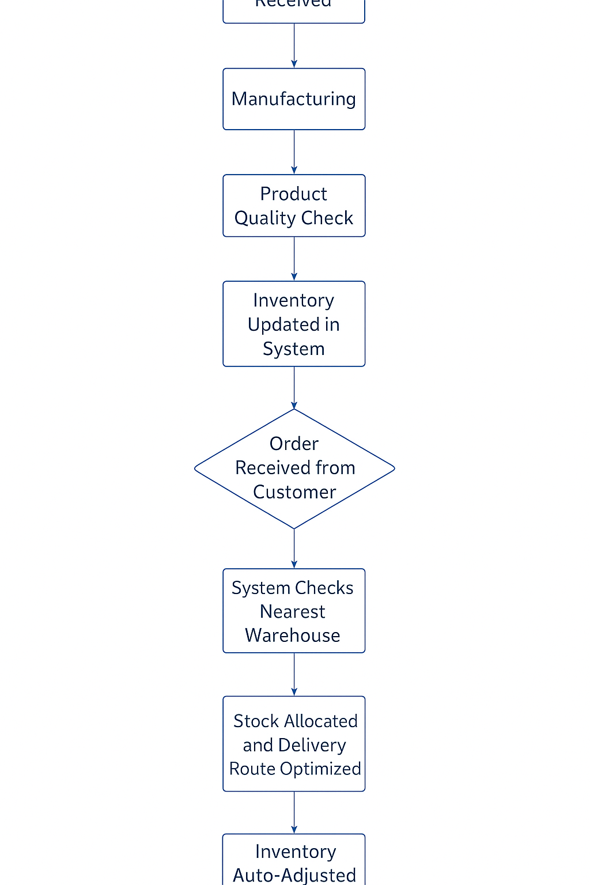
The process begins with raw materials received, followed by manufacturing, quality check, inventory update, order processing, route optimization, delivery dispatch, and final inventory adjustment.

Assignment 2

1. Introduction Letter
Dear Client,
My name is Srikanth Suthari, and I will be your Business Analyst for this project. I will work closely with your team to gather requirements, analyze your current business processes, and ensure our solution aligns with your goals.
Best regards,
Srikanth Suthari
Business Analyst

2. BRD and SRS for Online Store
Project Title: SmartShop – Online Retail Platform
Objective: To develop an online shopping platform for browsing products, secure payments, and order tracking.
Business Requirements:
• User registration and login
• Product catalog
• Cart and checkout
• Payment gateway
• Order tracking
• Admin product management
Software Requirements Specification:
Functional Requirements:
• User module
• Product module
• Cart module
• Order module
• Payment integration
• Notification module
Non-Functional Requirements:
• Secure SSL encryption
• Responsive design
• 24/7 uptime
• Scalable system

3. ER Diagram for Ticketing System
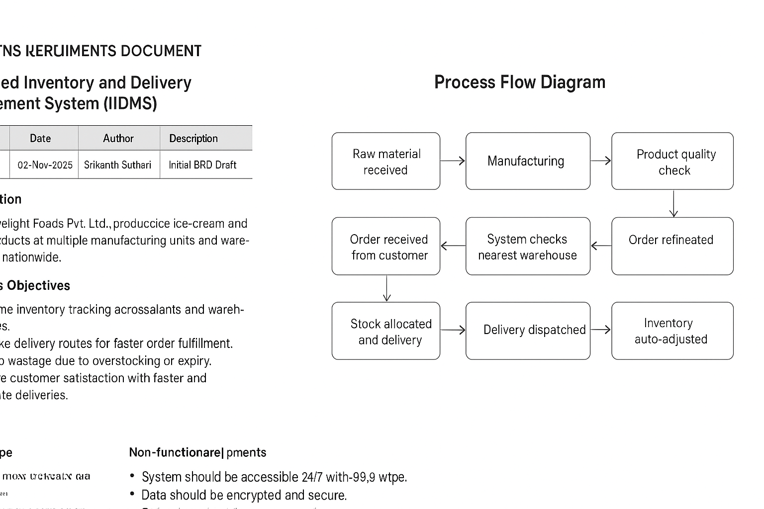
Entities:
User (UserID, Name, Email)
Ticket (TicketID, IssueType, Description, Status, Priority, CreatedDate, ClosedDate, UserID)
SupportAgent (AgentID, Name, Email)
TicketHistory (HistoryID, TicketID, Action, ActionDate)
Relationships:
One User → Many Tickets
One Agent → Many Tickets
One Ticket → Many TicketHistories

4. User Story for E-commerce Shopping
Title: Online Shopping and Checkout
As a registered customer, I want to browse and purchase products online so that I can receive them conveniently at my doorstep.
Acceptance Criteria:
• Add/remove items from cart
• Calculate totals with taxes
• Secure payment
• Receive confirmation via email/SMS
Prepared by: Srikanth Suthari
Date: 02-Nov-2025

Extended User Stories – Online Shopping and Checkout
User Story ID | Title / Feature | As a (Role) | I want (Goal) | So that (Benefit) | Acceptance Criteria
US01 | Product Browsing | Registered Customer | To browse and search products by name, category, or price | I can easily find desired products | • View all available products  • Apply filters (category, brand, price)  • View product details (image, price, description, stock)
US02 | Add to Cart | Customer | To add selected products to my shopping cart | I can review and purchase them later | • Add multiple items to cart  • Auto-update total price and item count  • Remove or change quantities
US03 | View & Manage Cart | Customer | To view and manage items in my cart | I can verify product details before checkout | • Display items, quantity, total amount  • Edit or delete items  • Recalculate totals dynamically
US04 | Checkout Process | Customer | To proceed to checkout securely | I can complete my purchase easily | • Confirm delivery address  • Choose payment method  • View order summary before confirmation
US05 | Payment & Confirmation | Customer | To make payment securely and receive order confirmation | I know my order has been placed successfully | • Secure payment gateway (UPI, card, wallet)  • Confirmation message/email  • Unique order ID generated
US06 | Order Tracking | Customer | To track the delivery status of my order | I know when my product will arrive | • View status: Processing → Shipped → Delivered  • Auto updates on order status  • SMS/email notifications
US07 | Order History | Customer | To view past purchases | I can reorder or check previous orders | • View previous orders with details  • Option to reorder  • Download invoice/payment info

