Document 6- Please prepare a use case diagram, activity diagram and a use case specification document.

Use case Diagram For (PAT)

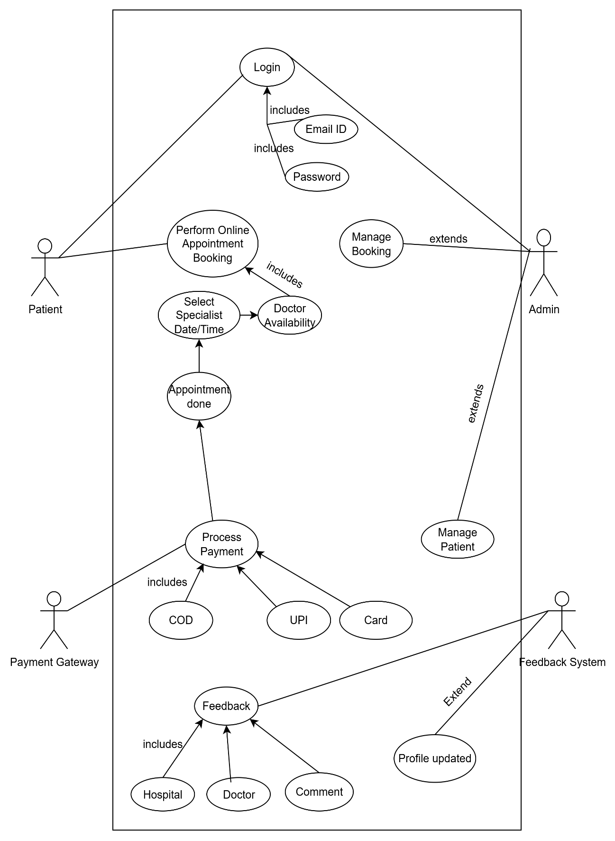
Activity Diagram for PAT

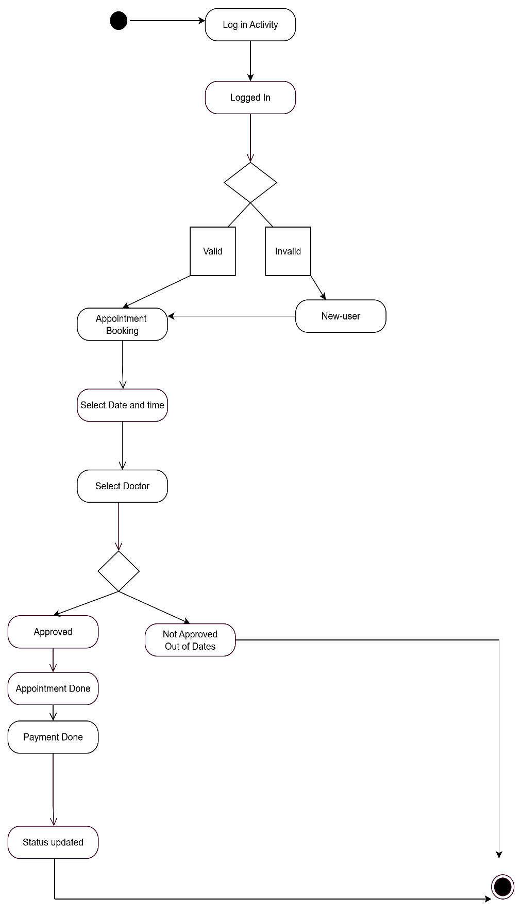

Use Case Specifications -

- Patient Registration

Field | Details
Use Case Name | Patient Registration
Use Case Description | Allows new Patient to create an account on PAT.
Actors | Primary: Patients  Secondary: System (automated email service)
Basic Flow | 1. patient clicks on "Sign Up".  2. Patient enters required details (name, email, password, etc.).  3. System validates inputs and creates an account.  4. System sends an email verification link.  5. patient verifies email and account is activated.
Alternate Flow | If the Patient does not verify their email, the account remains inactive.
Exceptional Flow | If the email is already registered, an error message is displayed.
Pre-Conditions | Patient must have a valid email and internet access.
Post-Conditions | Account is created, and the patient can log in.
Assumptions | Patient provide correct information.
Constraints | Password must meet security guidelines.
Dependencies | Email verification service.
Inputs and Outputs | Input: patient details  Output: Account confirmation email
Business Rules | Duplicate emails are not allowed.
Miscellaneous Information | None

- Patient Login

Field | Details
Use Case Name | Patient Login
Use Case Description | Allows registered Patient to log in.
Actors | Primary: Patients  Secondary: System (to verify credentials and manage sessions)
Basic Flow | 1. Patient enters email and password.  2. System validates credentials.  3. Patient is redirected to the home page.
Alternate Flow | If the Patient forgets their password, they can reset it.
Exceptional Flow | If credentials are incorrect, an error message is shown.
Pre-Conditions | Patient must be registered.
Post-Conditions | Patient is logged in successfully.
Assumptions | Patient remember their credentials.
Constraints | Password retry limit: 3 attempts.
Dependencies | Authentication system.
Inputs and Outputs | Input: Login credentials  Output: User authentication status
Business Rules | Locked out after 3 failed attempts.
Miscellaneous Information | All login attempts (both successful and failed) must be logged with a timestamp and IP address for security auditing purpose.

3. Patient appointment booking.

Field | Details
Use Case Name | Book a New Appointment
Use Case Description | Allow registered patient to book an appointment
Actors | Primary: Patient  Secondary: System (the Backend application handling logic and data)
Basic Flow | 1. Patient navigate to the "Book Appointment” section of the application  2. Patient selects the available time slots  3. The Patient Confirms the booking.
Alternate Flow | If no results are found, Patients select upcoming appointments and choose reschedule.
Exceptional Flow | If Dates are locked, system finds no available slots for the selected creteria.
Pre-Conditions | The patient must be a registered user of the application
Post-Conditions | Patient’s appointment record is created in the system with a Book Status.
Assumptions | Healthcare providers manage their availability calenders within the system, and this data is accurate and up to date.
Constraints | Appointments can only be booked during the providers define working hours
Dependencies | To verify the patient’s login status
Inputs and Outputs | Input: Patient user ID  Output: Appointment confirmation number
Business Rules | A patient can only have one upcoming appointment per doctor per day.
Miscellaneous Information | Search for available slots should return results in less than 3 sec.

4. Patient Appointment Tracking

Field | Details
Use Case Name | Track Patient appointment
Use Case Description | Patient allows to view the details, status, and real-time progress of their upcoming and past schedule appointment.
Actors | Primary: Patient  Secondary: System (Automatically updates status based on inputs from staff system)
Basic Flow | 1. The Patient Navigates to the “My Appointment” section  2. The patient selects the upcoming appointment they wish to track  3. The system display appointment tracking screen
Alternate Flow | The real time tracking elements are not shown. The system displays the final details of the appointment, including its status, summary.
Exceptional Flow | Unauthorized access of person Access gets denied
Pre-Conditions | Patient must have registered and verified account on application
Post-Conditions | Patient is informed about the current status and progress of their appointment.
Assumptions | The patient understands the common status used in the tracking process.
Constraints | The application must comply with healthcare data regulation
Dependencies | User Authentication
Inputs and Outputs | Input: Patient user ID  Output: Current appointment status
Business Rules | Patient can only view the status of their own appointment
Miscellaneous Information | The appointment tracking screen should load in under 3 sec.

5. Checkout and Payment

Field | Details
Use Case Name | Patient Checkout and Payment
Use Case Description | Patient complete visit and system calculating the amount /due
Actors | Primary: Front desk staff  Secondary: Patient
Basic Flow | 1. Patient proceeds to checkout.  2. Enters Payment details.  3. Selects payment method.  4. Completes payment.
Alternate Flow | If the payment fails, user can retry.
Exceptional Flow | If internet disconnects, transaction is canceled.
Pre-Conditions | User must have valid payment details.
Post-Conditions | The appointment status is updated to complete
Assumptions | Payment gateway is working.
Constraints | Payment processing time: < 10 seconds.
Dependencies | Payment service provider.
Inputs and Outputs | Input: Patient ID/ Appointment ID  Output: Calculate amount due.
Business Rules | Secure payment required.
Miscellaneous Information | Credit card no. should not be stored in the system primary database.

6. Manage Appointments

Field | Details
Use Case Name | Manage Patient Appointment
Use Case Description | Allows admins to manage and cancel the appointments within the system, ensures appointment schedule efficiently, avoiding conflicts.
Actors | Primary: Hospital staff  Secondary: Patient
Basic Flow | 1. Admin logs into the system.  2. Admin navigates to the "Manage Appointment" section.  3. Admin views the appointment list  4. Admin selects an Appointment to update status. (Re-schedule efficiently)  5. If needed, admin can cancel Appointments and reschedule it with contact with patient.  6. Admin confirms the changes, and the system updates Appointment status.
Alternate Flow | If a Patient requests cancellation of Appointment, the admin reviews and approves or denies it.
Exceptional Flow | If the Patient ID is invalid, an error message is displayed.  If the system fails to update Appointment status, an error log is generated.
Pre-Conditions | Admin must have the necessary access permissions.  Appointments dates must be available in the system.
Post-Conditions | Appointment status is updated, and Patients receive notifications.
Assumptions | Admin has accurate Appointment details.  Doctors have defined their working hours and availability in the system.
Constraints | Appointments history must be kept for a minimum 5 years.
Dependencies | To verify patient, identify and details
Inputs and Outputs | Input: Patient identifier, Doctor Identifier, Desired date and time.  Output: Appointment confirmation details, success/errors messages.
Business Rules | Only admins with proper permissions can modify Appointments.  An appointment must get schedule at least 24 hours in advanced.
Miscellaneous Information | Searching for available slots must be highly optimized to handle peak loads.

Document 7- Screens and pages

Home Page

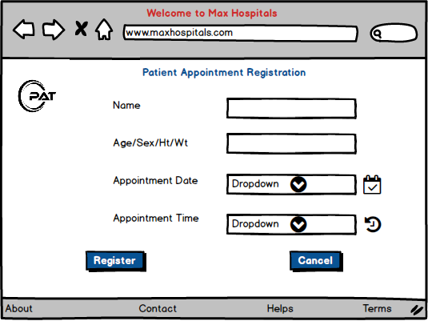

Login Page

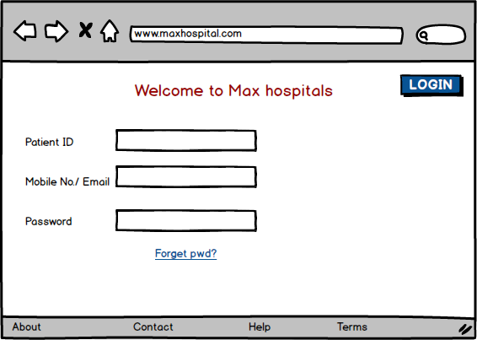

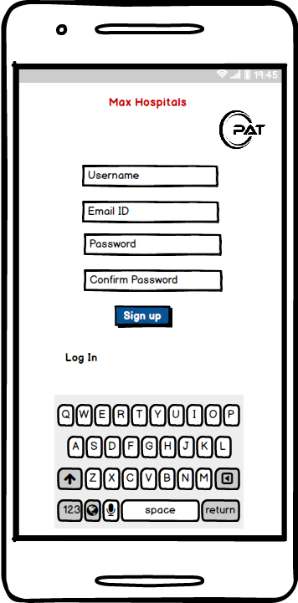

Payment page

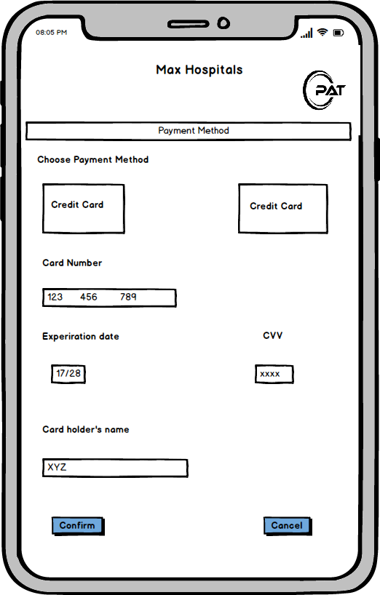

Add to cart / Patient Appointment booking

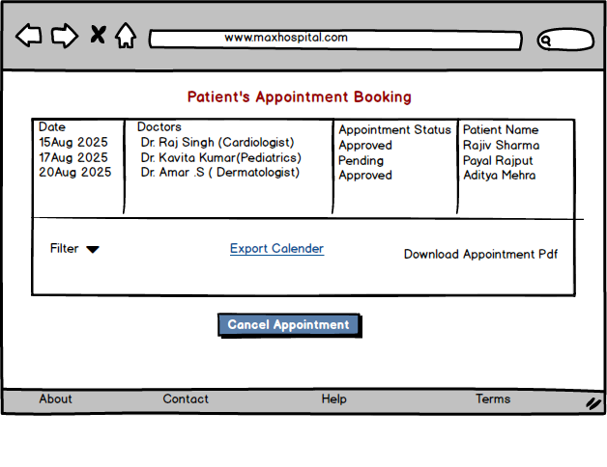

Document 8- Tools-Visio and Axure

I used Visio and Axure for the project. Visio helped me draw diagrams and flowcharts. It was easy to put shapes and lines together to show how things work. Axure let me make prototypes of the app. I created screens and buttons that looked real. Both tools were simple to use and made my work easier.
When I am working on a project, tools like Visio and Axure help me a lot. They make it easy to share ideas and plans with others.

Document 9- BA experience

My experience as BA in following phases:
1. Requirement Gathering
1. Conducted stakeholder meetings using MoSCoW prioritization and FURPS validation.
2. Created the Business Requirement Document (BRD) and gathered inputs via prototyping.
3. Managed stakeholder unavailability by sourcing alternative contacts.
Challenges:
Handled requirement conflicts through impact analysis.

2. Requirement Analysis
1. Created Use Case Diagrams, Activity Diagrams, and RTM to track requirements.
2. Finalized functional/non-functional requirements in the Functional Specification Document (FSD).
3. Conducted peer reviews to align with stakeholders.
Challenges:
Managed mid-phase requirement changes via structured Change Requests (CRF).

3. Design
1. Collaborated with UI/UX designers using Axure to create wireframes & mockups.
2. Ensured easy navigation, accessibility, and responsive UI in the design phase.
3. Created test case scenarios from Use Case Diagrams.
Challenges:
Balanced UI expectations vs. technical feasibility through discussions with designers & developers.

4. Development
1. Conducted JAD sessions to ensure alignment between business and tech teams.
2. Verified business rules implementation and assisted in payment gateway integration.
3. Regularly reviewed progress and provided feedback.
Challenges:
Addressed misinterpretation of requirements through daily standups.

5. Testing
1. Created test cases from use cases and ensured full functional coverage.
2. Assisted QA team with testing and conducted UAT with stakeholders.
3. Verified error handling & security measures before deployment.
Challenges:
Managed post-UAT defect fixes with a prioritized bug resolution approach.

6. Deployment
1. Coordinated training sessions & user manuals for smooth onboarding.
2. Ensured compliance with GDPR & PCI DSS before launch.
3. Planned post-deployment monitoring and resolved user adaptation challenges.
Challenges:
Addressed post-launch bugs via a structured tracking system.

