-Document 1: Definition of Done
Checklist for DOD:
• Produced code for presumed functionalities
• Assumptions of User Story met
• Project builds without errors
• Unit tests written and passing
• Project deployed on the test environment identical to production platform • Tests on devices/browsers listed in the project assumptions passed
• Feature ok-ed by UX designer
• QA performed & issues resolved
• Feature is tested against acceptance criteria
• Feature ok-ed by Product Owner
• Refactoring completed
• Any configuration or build changes documented
• Documentation updated
• Peer Code Review performed

Product Vision Document

Product Vision
Scrum Project Name: Automated Accounts Receivable
Venue
Date: Start Time: End Time: Duration:
Client: T-Mobile
Stakeholder List:
1. Business Owner
2. Adminstrator
3. Regional Administrator
Scrum Team
Scrum Master: Harprit Sharma
Product Owner: You
Scrum Developer1: Dinesh Vegard
Scrum Developer 2: Rohit

Vision What is your vision, your overarching goal for creating the product.
Target group | Needs | Product | Value
Which market segment does the product address? | What problems does the product solve? | What product is it? | How is the product going to benefit the company
Who are the target users and customers? | Which benefit does it provide | What makes it describe and special? | What are the business goals
 |  | Is it feasible to develop the product? | What is the business model

2. Vision Statement:
To streamline and automate the end-to-end payment and refund lifecycle — from customer payments to SAP posting and refunds — enhancing accuracy, reducing manual errors, and accelerating response time to customer queries.

3. Target Audience / Users:
- Accounts Receivable (AR) Teams
- Finance Operations Team
- Customer Support Representatives
- IT/System Administrators
- Customers (indirectly, via better service)

4. Needs :
The product solves the below problems
- Manual payment posting delays in SAP
- High error rates in allocating payments to correct invoices
- Time-consuming cheque and refund processes via CSS
- Delayed resolution of customer payment/refund queries
- Difficulty tracking direct debit, credit card, and cheque transactions

5. Product Features :
- Integration with Bank feeds (Direct Debit, Credit Card, Cheque)
- Automated allocation of payments to accounts/invoices using rules or AI
- Real-time SAP payment posting
- Automated reversal handling based on pre-defined triggers
- Workflow for cheque re-issuance and refund processing via CSS
- Dashboard for payment/refund tracking
- Customer query handling module with auto-response suggestions
- Audit trail and reporting for compliance

6. Business Goals / Objectives:
- Reduce payment posting time by 80%
- Achieve 95%+ accuracy in invoice matching
- Cut manual reversal and refund processing time by 60%
- Improve customer query resolution time by 50%
- Reduce finance team workload by automating routine tasks
User Story 1
User Story No: US01
Tasks:
- Fetch bank transactions
- Match payments to customer accounts
- Post to SAP
Priority: High
Value Statement:
As a finance associate,
I want to automatically allocate incoming payments to the correct customer account and invoice,
so that I can reduce manual effort and posting errors.
BV: ₹1000
CP: 13
Acceptance Criteria:
- System imports transactions from bank daily
- Matches are at least 90% accurate
- Matched entries are auto-posted to SAP with proper logging
- Manual override available for unmatched payments

User Story 2
User Story No: US02
Tasks:
- Build reversal logic
- Connect to SAP reversal function
Priority: Medium
Value Statement:
As an AR executive,
I want to automate payment reversals when requests are validated,
so that I can process reversals quickly and accurately.
BV: ₹500
CP: 8
Acceptance Criteria:
- Reversal trigger is logged in request tracking
- SAP receives reversal request and processes it
- Customer notified of reversal via system update

User Story 3
User Story No: US03
Tasks:
- Integrate cheque re-issue module with CSS
- Add approval workflow
Priority: High
Value Statement:
As a support representative,
I want to cancel and re-issue cheques through the CSS app,
so that I can respond to cheque-related queries effectively.
BV: ₹500
CP: 5
Acceptance Criteria:
- User can search and select a cheque to cancel
- Reason is captured in the system
- New cheque is re-issued within 24 hours
- Confirmation logged in audit trail

User Story 4
User Story No: US04
Tasks:
- Refund processing logic
- Connect to CSS system
Priority: High
Value Statement:
As a customer support agent,
I want to initiate refunds through CSS for overpayments,
so that customers receive timely refunds.
BV: ₹1000
CP: 13
Acceptance Criteria:
- Refund requests validated against payment history
- Approval workflow is followed
- Refund status is tracked in system
- Email/SMS notification sent to customer

User Story 5
User Story No: US05
Tasks:
- Build dashboard for customer queries
- Add real-time tracking and chat
Priority: Medium
Value Statement:
As a customer,
I want to track my payment/refund status and raise queries online,
so that I don't need to contact customer care repeatedly.
BV: ₹1000
CP: 20
Acceptance Criteria:
- Customers can see payment/refund status in their portal
- Queries can be raised from the same interface
- Each query is assigned a ticket number and response SLA
- Agents can respond using templates

Document 4: Agile PO Experience
The Product Owner has a vision of the product keeping the domain/industry experience and the market need.
❖ Following are the responsibilities of PO in a project
➢ Market Analysis ▫ Analysis of market need/demand ▫ Availability of similar products in the market
➢ Enterprise Analysis ▫ Due diligence on the market opportunity
➢ Product Vision and Roadmap ▫ Product vision keeping the need analysis in mind ▫ Product roadmap with high-level features and timeline
➢ Managing Product Features ▫ Managing stakeholder expectations and prioritizing needs ▫ Prioritization of the epics, stories, and features based on criticality and ROI involved
➢ Managing Product Backlog ▫ Prioritization of user stories ▫ Reprioritization based on stakeholders' needs ▫ Epics planning
➢ Managing Overall Iteration Progress ▫ Sprint progress review ▫ Reprioritization of sprints and epics if needed ▫ Sprint retrospectives with Business Analyst
❖ From this project I have learned how to handle sprint meetings such as
➢ Sprint planning meeting
➢ Daily scrum meeting
➢ Sprint review meeting
➢ Sprint retrospective meeting
➢ Backlog refinement meeting
❖ Also, User stories creation and what things will be included in user stories such as
➢ Story no
➢ Tasks ➢ Priority
➢ Acceptance criteria
➢ BV & CP value
❖ In Scrum, a product owner serves as the liaison between multiple areas of an organization. This person communicates with business stakeholders and collaborates closely with Scrum teams to keep all areas of the business informed on a project's development.
❖ The product owner develops a vision of a product's function and operation, which in turn allows this Scrum team member to define product features and break those features into product backlog items.

Document 5: Product and sprint backlog and product and sprint burndown charts
Use Story ID | User Story | Task | Priority | BV | CP | Sprint
US01 | As a finance associate I want to automatically allocate incoming payments to the correct customer account and invoice, so that I can reduce manual effort and posting errors. | Fetch bank transactions. Match payments to customer accounts. Post to SAP | High | 1000 | 13 | Sprint1
US02 | As an AR executive I want to automate payment reversals when requests are validated so that I can process reversals quickly and accurately. | Build reversal logic. Connect to SAP reversal function | Medium | 500 | 8 | Sprint 1
US03 | As a support representative I want to cancel and re-issue cheques through the CSS app so that I can respond to cheque-related queries effectively. | Integrate cheque re-issue module with CSS. Add approval workflow | High | 500 | 5 | Sprint 2
US04 | As a customer support agent I want to initiate refunds through CSS for overpayments so that customers receive timely refunds. | Refund processing logic. Connect to CSS system | High | 1000 | 13 | Sprint 2
US05 | As a customer I want to track my payment/refund status and raise queries online so that I don't need to contact customer care repeatedly. | Build dashboard for customer queries. Add real-time tracking and chat | Medium | 1000 | 13 | Sprint 3
Product backlog:

Sprint backlog:
User Story ID | User story | Task | Owner | Status | Estimate Effort
US01 | As a finance associate I want to automatically allocate incoming payments to the correct customer account and invoice, so that I can reduce manual effort and posting errors. | Fetch bank transactions. Match payments to customer accounts. Post to SAP | Dinesh | To Do | 13
US02 | As an AR executive I want to automate payment reversals when requests are validated so that I can process reversals quickly and accurately. | Build reversal logic. Connect to SAP reversal function | Rohit | To Do | 8
Sprint 1

US03 | As a support representative I want to cancel and re-issue cheques through the CSS app so that I can respond to cheque-related queries effectively. | Integrate cheque re-issue module with CSS. Add approval workflow | Dinesh | To Do | 5
US04 | As a customer support agent I want to initiate refunds through CSS for overpayments so that customers receive timely refunds. | Refund processing logic. Connect to CSS system | Rohit | To Do | 13
Sprint 2

User Story ID | User story | Task | Owner | Status | Estimate Effort
US05 | As a customer I want to track my payment/refund status and raise queries online so that I don't need to contact customer care repeatedly. | Build dashboard for customer queries. Add real-time tracking and chat | Rohit | To Do | 13
Sprint 3

Sprint burndown
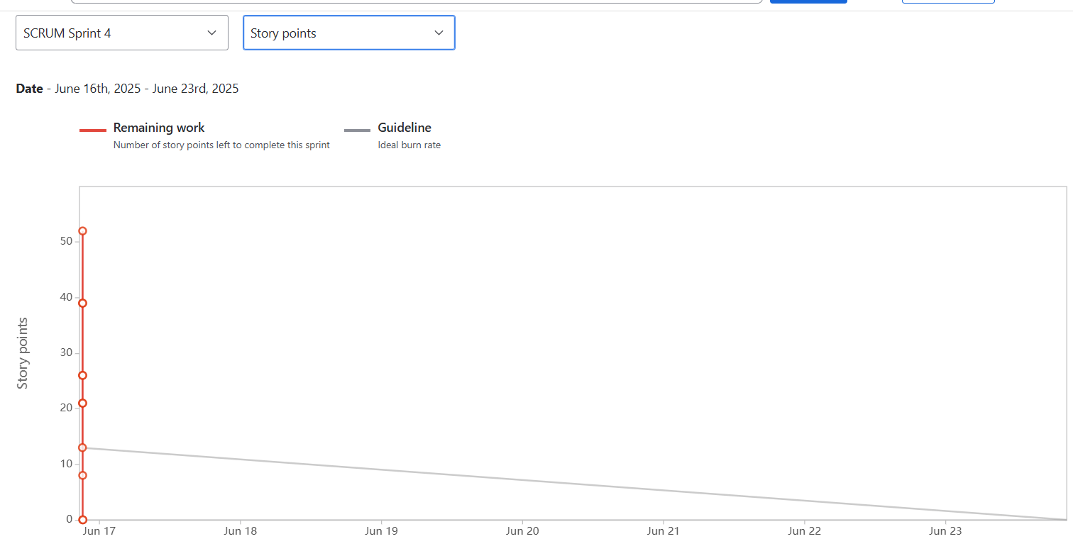

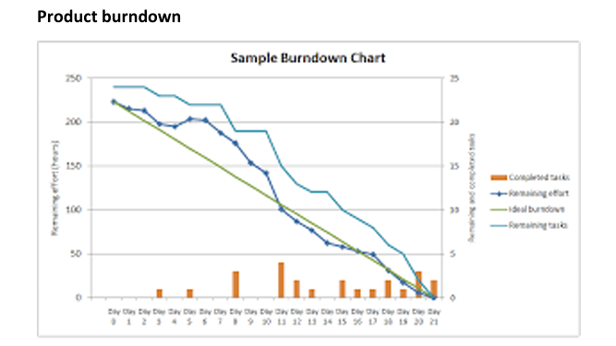

Document 6: Sprint meetings

Meeting Type 1: Sprint Planning Meeting
Date | 17 June 2025
Time | 10:00 AM – 12:00 PM IST
Location | Conference Room 2 / MS Teams
Prepared By | Shahzad Ahmed (Product Owner)
Attendees | Scrum Master, Dev Team, QA, Product Owner, Business Analyst

Agenda Topics
Topic | Presenter | Time Allotted
Overview of Product Vision | Product Owner | 15 mins
Review of User Stories & Acceptance Criteria | Business Analyst | 30 mins
Estimation & Sprint Commitment | Development Team | 45 mins
Task Breakdown & Assignment | Scrum Master | 30 mins
Other Information
Observers | Stakeholders from Finance & Operations
Resources | Product Backlog, Jira Board, SAP Sandbox, CSS API Docs
Special Notes | Focus on automating payment allocation and cheque re-issuance in Sprint 1

Meeting Type 2: Sprint Review Meeting
Date | 28 June 2025
Time | 11:00 AM – 12:30 PM IST
Location | Conference Room 2 / MS Teams
Prepared By | Shahzad Ahmed (Product Owner)
Attendees | Scrum Team, Stakeholders from Finance & IT, QA Team

Sprint Summary Table
Sprint Status | Things to Demo | Quick Updates | What’s Next
Completed all planned stories for Sprint 1 | 1. Auto-payment allocation demo  2. SAP posting integration  3. Cheque reissue module | - Minor bug found in cheque reissue, fixed in hotfix  - User feedback was positive | Start Sprint 2 focusing on refund automation and dashboard for customer support
Meeting Type 3: Sprint Retrospective Meeting
Date | 29 June 2025
Time | 3:00 PM – 4:00 PM IST
Location | Conference Room 2 / MS Teams
Prepared By | XYZ (Scrum Master)
Attendees | Scrum Team, Product Owner, QA, Development Team
Sprint Retrospective Summary
Agenda | What went well | What didn’t go well | Questions | Reference
Sprint 1 Review | - Auto-payment allocation completed  - Cheque module integrated  - Team collaboration strong | - Delay in CSS API testing  - Missed a bug in reversal logic | - How can we improve early testing?  - Do we need mock APIs earlier? | Sprint 1 User Stories, Jira Board
Continuous Improvement | - Daily standups were productive  - Stakeholders gave quick feedback | - Task breakdown not detailed enough  - Documentation was delayed | - Can we assign a documentation owner?  - Can we automate unit tests? | Confluence, Git commits

Meeting Type 4: Daily Stand-up Meeting
Week “X” (from 17-06-2025 to 23-06-2025)
Monday
Question | Name/Role | Monday
What did you do yesterday? | Developer 1 | Completed direct debit payment module
 | Developer 2 | Integrated credit card payment API
What will you do today? | Developer 1 | Begin unit testing for payment allocation logic
 | Developer 2 | Work on reversal logic for overpayments
What (if any) is blocking you? | Developer 1 | No blockers
 | Developer 2 | Waiting for API credentials for CSS app

