Question1_Identify minimum functional requirements and functional requirement
Req ID | Req Name | Description | Priority
FR001 | Farmer search for product | Farmers should be able to search for available products in  fertilizer, seeds, pesticides | 8
FR002 | Add to cart | System should allow farmers to add product to his car which farmers has selected to buy | 6
FR003 | New user login | New users should be able to register with application by  entering email id and own password | 8
FR004 | Existing User Login | System should allow existing user to enter their email id and  password to login | 8
FR005 | Place order | System should allow farmers to place order online for selected product | 7
FR006 | Select Payment  Option | System should allow farmers to select payment option either  cash on delivery or Dr / Cr card or UPI | 9
FR007 | Make Payment | System should allow farmers to make payment who selected  option to make payment either through Dr/ Cr card or UPI | 9
FR008 | Review order | System should allow farmers to review order to check address  and product details before submission | 2
FR00 9 | Update system on  every order | System should update automatically on every order place and  send email confirmation | 4
FR0010 | Delivery Tracker | System should allow Farmers to track the whereabouts of their order | 2
FR0011 | Profile Creation | System should allow farmers to create profile wherein  address can be updated and password can be changed,  mobile number can be updated as an option field | 3
FR0012 | Order History | Farmers should be able to see order history | 2
FR0013 | Select Language | Farmers should be able select either English or Hindi Language | 8
FR0014 | Manufacturer login | Manufacturer should be able to login with email id and password | 9
FR0015 | Upload Products | System should allow manufacturer to use upload option to upload and display their available products | 8
FR0016 | Delivery Tracker | System should allow manufacturer to track the whereabouts  of despatch order | 2
FR0017 | Wish list | Farmer should be able to add products for future purchase | 4
FR0018 | Product recommendation | Farmers should be provided with product recommendation based on their purchase history | 4
FR0019 | Order cancellation | System should allow farmers to cancel their order as per company policy | 3
FR0020 | Mobile App | The application should have a version for farmer to access from their mobile | 2
NON Functional Requirements
NFR0101 | Page loading time | Each page should load within 2 seconds time | 9
NFR0102 | Back Up | All data should have regular backup. | 6
NFR0103 | Connectivity | System must be connected to internet 24/7 | 9
NFR0104 | Interface | Interface must be user friendly for farmers to understand better | 7
NFR0105 | Security | Pop up to change password after every 90 days | 5

Question 2–Minimum 5 page designs - Make wireframe and prototypes
1.Search
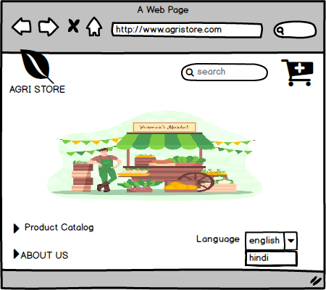
2.product catalog
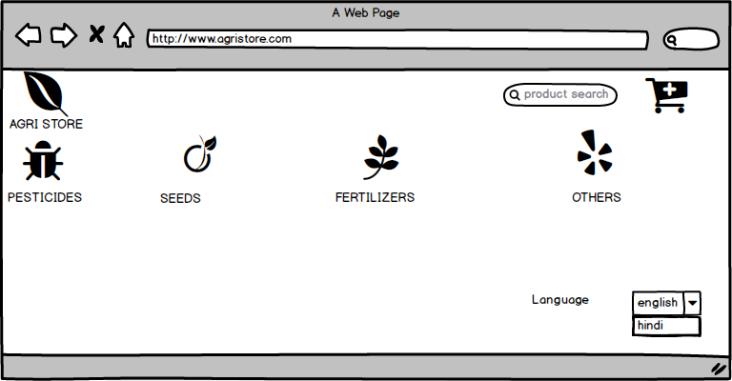
3.cart
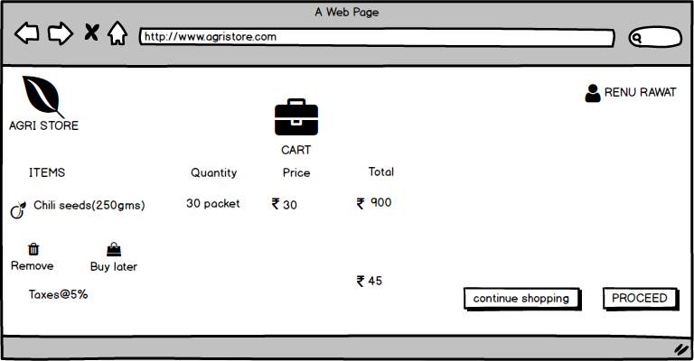
4.Address
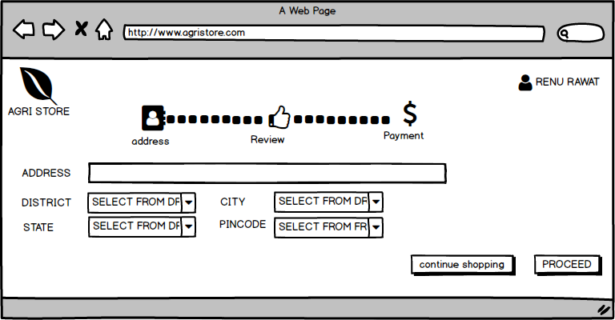
5.Review
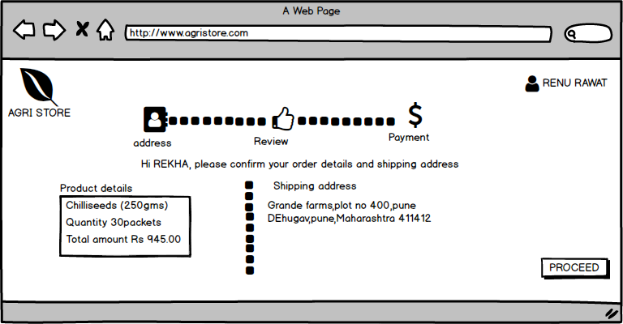
6.Choose payment option
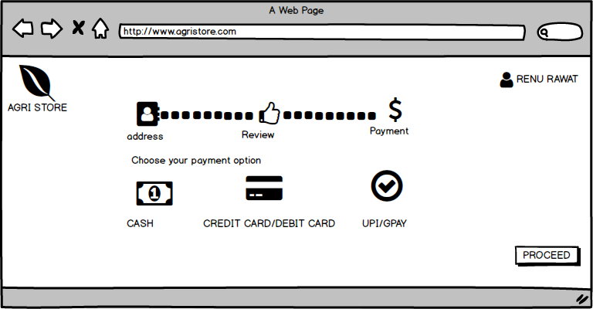
7oreder confirmed
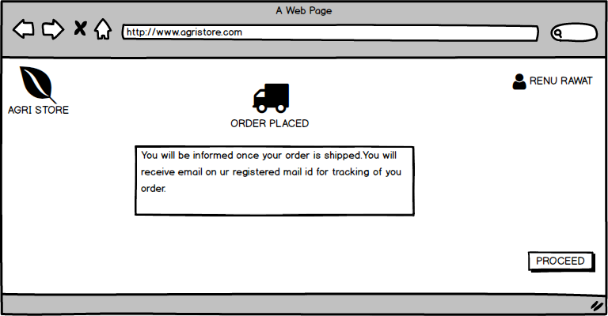
Question 3 – Tools (Visio, Balsamiq) - Make a note of the Tools, which you are using for above concepts
In this project we have use Visio tools for Use case diagram and Activity diagram and Balsamic Tool for Prototyping.
1. MS VISIO
Visio is a Microsoft Windows based diagramming software that includes templates and symbols allowing users to create flowcharts, organizational charts, floor plans, network diagrams, mind maps,infographics and more. Visio is part of the Microsoft Office software suite, although it is sold as a stand-alone program.
Visio is software for drawing a variety of diagrams. These include flowcharts, org charts, building plans,floor plans, data flow diagrams, process flow diagrams, business process modeling, swimlane diagrams,3D maps, and many more. It&#39;s a Microsoft product, sold as an addition to MS Office.
2. BALSAMIQ WIREFRAMES
Balsamiq wireframes is a user interface design tool for creating wireframes (sometimes called mock-ups). You can use it to generate digital sketches of your idea or concept for your application or website,to facilitate discussion and understanding before any code is written. The completed wireframes can be used for user testing, clarifying your vision, getting feedback from stakeholders or getting approval to start development. Balsamiq Wireframes is the easiest, fastest, most fun, best supported wireframing tool on the Internet.
Question 4 – RTM - A business analyst’s key responsibilities are to keep track of the requirements and make sure that no requirement is missed. Mr. Henry and peter have approached you regarding the current status of the project. How will you tackle this situation?
Req ID | Req Name | Description | Design | D1 | T1 | D2 | T2 | D3 | T3 | D4 | T4 | UAT
FR001 | Farmer search for product | Farmers should be able to search for available products in  fertilizer, seeds, pesticides | YES | YES | YES | YES | YES | YES | YES | YES | YES | YES
FR002 | Add to cart | System should allow farmers to add product to his car which farmers has selected to buy | YES | YES | YES | YES
FR003 | New user login | New users should be able to register with application by  entering email id and own password | YES | YES | YES | YES | YES | YES
FR004 | Existing User Login | System should allow existing user to enter their email id and  password to login | YES | YES | YES
FR005 | Place order | System should allow farmers to place order online for selected product | YES | YES | YES
FR006 | Select Payment  Option | System should allow farmers to select payment option either  cash on delivery or Dr / Cr card or UPI | YES | YES | YES | YES | YES | YES | YES | YES
FR007 | Make Payment | System should allow farmers to make payment who selected  option to make payment either through Dr/ Cr card or UPI | YES | YES | YES | YES | YES | YES | YES | YES | YES | YES
FR008 | Review order | System should allow farmers to review order to check address  and product details before submission | YES | YES | YES | YES | YES
FR00 9 | Update system on  every order | System should update automatically on every order place YES and  send email confirmation | YES | YES | YES | YES | YES
FR0010 | Delivery Tracker | System should allow Farmers to track the whereabouts of their order | YES | YES | YES | YES | YES | YES | YES | YES | YES | YES
FR0011 | Profile Creation | System should allow farmers to create profile wherein  address can be updated and password can be changed,  mobile number can be updated as an option field | YES | YES | YES | YES | YES | YES | YES
FR0012 | Order History | Farmers should be able to see order history | YES | YES | YES | YES | YES | YES | YES | YES | YES | YES
FR0013 | Select Language | Farmers should be able select either English or Hindi Language | YES | YES | YES | YES | YES | YES | YES | YES | YES | YES
FR0014 | Manufacturer login | Manufacturer should be able to login with email id and password | YES | YES | YES | YES
FR0015 | Upload Products | System should allow manufacturer to use upload option to upload and display their available products | YES | YES | YES | YES | YES | YES | YES
FR0016 | Delivery Tracker | System should allow manufacturer to track the whereabouts  of despatch order | YES | YES | YES | YES | YES | YES | YES
FR0017 | Wish list | Farmer should be able to add products for future purchase | YES | YES | YES | YES
FR0018 | Product recommendation | Farmers should be provided with product recommendation based on their purchase history | YES | YES | YES | YES
FR0019 | Order cancellation | System should allow farmers to cancel their order as per company policy | YES | YES | YES | YES
FR0020 | Mobile App | The application should have a version for farmer to access from their mobile | YES | YES | YES | YES
NON Functional Requirements
NFR0101 | Page loading time | Each page should load within 2 seconds time | YES | YES | YES | YES
NFR0102 | Back Up | All data should have regular backup. | YES | YES | YES | YES | YES | YES
NFR0103 | Connectivity | System must be connected to internet 24/7 | YES | YES | YES | YES | YES | YES | YES | YES | YES | YES
NFR0104 | Interface | Interface must be user friendly for farmers to understand better | YES | YES | YES | YES | YES | YES | YES | YES
NFR0105 | Security | Pop up to change password after every 90 days | YES | YES | YES | YES

Question 5 – 10 Test Case Documents - Prepare 10 Test Case Documents
PROJECT NAME: |  | ONLINE AGRI STORE
MODULE NAME: |  | LOGIN
REFERENCE DOCUMENT: |  | IF ANY
CREATED BY: |  | JASON AND ALEKYA
DATE OF CREATION: |  | 12-05-2025
DATE OF REVIEW: |  | 20-05-2025
TEST CASE ID | TEST SCENARIO |  | TEST CASE | PRE-CONDITION | TEST STEPS |  | TEST DATA | EXPECTED RESULTS | ACTUAL RESULTS | STATUS  (PASS/ FAIL)
TC_LOGIN 001 | Verify the login feature |  | Enter valid email id and valid password | Need a valid email id and password to login | Enter email id |  | <valid email id> | Successful login | Successful  login | Pass
 |  |  |  |  | Enter password |  | <valid password> | Successful login | Successful  login | Pass
 |  |  |  |  | Click ‘login’ button |  |  | Successful login | Successful  login | Pass
TC_LOGIN 001 | Verify the login feature |  | Enter valid email id and invalid password | Need a valid email id and password to login | Enter email id |  | <valid email id> | A message “the email id and password you entered does not match” is displayed | A message “the email id and password you entered does not match” is displayed | Pass
 |  |  |  |  | Enter password |  | <invalid password> |  |  | Pass
 |  |  |  |  | Click ‘login’ button |  |  |  |  | Pass
TC_LOGIN 001 | Verify the login feature |  | Enter invalid email id and valid password | Need a valid email id and password to login | Enter email id |  | <invalid email id> | A message “the email id and password you entered does not match” is displayed | A message “the email id and password you entered does not match” is displayed | Pass
 |  |  |  |  | Enter password |  | <valid password> |  |  | Pass
 |  |  |  |  | Click ‘login’ button |  |  |  |  | Pass
TC_LOGIN 001 | Verify the login feature |  | Enter invalid email id and invalid password | Need a valid email id and password to login | Enter email id |  | <invalid email id> | A message “the email id and password you entered does not match” is displayed | A message “the email id and password you entered does not match” is displayed | Pass
 |  |  |  |  | Enter password |  | <invalid password> |  |  | Pass
 |  |  |  |  | Click ‘login’ button |  |  |  |  | Pass

PROJECT NAME: |  | ONLINE AGRI STORE
MODULE NAME: |  | SEARCH OPTION
REFERENCE DOCUMENT: |  | IF ANY
CREATED BY: |  | JASON AND ALEKYA
DATE OF CREATION: |  | 12-05-2025
DATE OF REVIEW: |  | 20-05-2025
TEST CASE ID | TEST SCENARIO |  | TEST CASE | PRE-CONDITION | TEST STEPS |  | TEST DATA | EXPECTED RESULTS | ACTUAL RESULTS | STATUS  (PASS/ FAIL)
TC_SEARCH 001 | Search for a product , good search |  | Testing the search functionality of the application | User can access application even without registration. | Navigate to the search page |  |  | System should respond back with 10 onion seeds product | System responded back with 10 onion seeds product | Pass
TC_SEARCH 001 |  |  | Testing the search functionality of the application | All products already uploaded in the system. | Enter product name onion seeds |  | <onion seeds> | No action from system | System responded back with 10 onion seeds product | Pass
TC_SEARCH 001 |  |  | Testing the search functionality of the application |  | Hit enter button |  |  | System should respond with “ no match found” message | System responded back with 10 onion seeds product | Pass
TC_SEARCH 001 | Search for a product , with empty search |  | Testing the search functionality of the application | User can access application even without registration. | Navigate to the search page |  |  | System should respond back with message “ no product found, please enter correct product name” | No action from system | Pass
TC_SEARCH 001 |  |  | Testing the search functionality of the application | All products already uploaded in the system. | Enter no product name |  | <blank> | No action from system | No action from system | Pass
TC_SEARCH 001 |  |  | Testing the search functionality of the application |  | Hit enter button |  |  | System should respond with “ no match found” message | No action from system | Pass
TC_SEARCH 001 | Search for a product , with wrong search |  | Testing the search functionality of the application with product not available in database | User can access application even without registration. | Navigate to the search page |  |  | System should respond back with message “ no product found, please enter correct product name” | System responded with a “ no match found” message | Pass
TC_SEARCH 001 |  |  |  | All products already uploaded in the system. | Enter no product name tata gold |  | <tata gold > | No action from system | System responded with a “ no match found” message | Pass
TC_SEARCH 001 |  |  |  |  | Hit enter button |  |  | System should respond with “ no match found” message | System responded with a “ no match found” message | Pass

PROJECT NAME: |  | ONLINE AGRI STORE
MODULE NAME: |  | BROWSE PRODUCT CATALOGUE
REFERENCE DOCUMENT: |  | IF ANY
CREATED BY: |  | JASON AND ALEKYA
DATE OF CREATION: |  | 12-05-2025
DATE OF REVIEW: |  | 20-05-2025
TEST CASE ID | TEST SCENARIO |  | TEST CASE | PRE-CONDITION | TEST STEPS |  | TEST DATA | EXPECTED RESULTS | ACTUAL RESULTS | STATUS  (PASS/ FAIL)
TC_BROWSE 001 | Browse for a product catalogue |  | Testing the browse product catalogue functionality of the application | User can access application even without registration. | Navigate to the product catalogue page |  |  | System should respond back with product catalogue for basil seeds with product details. | System responded back with product catalogue for basil seeds with product details | Pass
TC_BROWSE 001 |  |  |  | All products already uploaded in the system. | Enter product name basil seeds |  | <basil seeds> | No action from system |  | Pass
TC_BROWSE 001 |  |  |  |  | Hit enter button |  |  | System should respond with “ no match found” message |  | Pass

PROJECT NAME: |  | ONLINE AGRI STORE
MODULE NAME: |  | ADD TO BAG
REFERENCE DOCUMENT: |  | IF ANY
CREATED BY: |  | JASON AND ALEKYA
DATE OF CREATION: |  | 12-05-2025
DATE OF REVIEW: |  | 20-05-2025
TEST CASE ID | TEST SCENARIO |  | TEST CASE | PRE-CONDITION | TEST STEPS |  | TEST DATA | EXPECTED RESULTS | ACTUAL RESULTS | STATUS  (PASS/ FAIL)
TC_ADD TO BAG 001 | ADD TO BAG |  | Testing the add to bag functionality of the application | User can access application even without registration. | Navigate to the search for product option , input chilli seeds |  | <chilli seeds> | System should respond back with another page with quantity options , price and remove option, continue shopping and check out option | System responded back with another page with quantity options , price and remove option, continue shopping and check out option | Pass
TC_ADD TO BAG 001 |  |  | Testing the add to bag functionality of the application | All products already uploaded in the system. | Take cursor to chilli seeds for buy |  |  | No action from system |  | Pass
TC_ADD TO BAG 001 |  |  | Testing the add to bag functionality of the application |  | Click on add to bag button |  |  | System should respond with “ out of stock” message |  | Pass

PROJECT NAME: |  | ONLINE AGRI STORE
MODULE NAME: |  | PLACE ORDER WITH ADDRESS
REFERENCE DOCUMENT: |  | IF ANY
CREATED BY: |  | JASON AND ALEKYA
DATE OF CREATION: |  | 12-05-2025
DATE OF REVIEW: |  | 20-05-2025
TEST CASE ID | TEST SCENARIO |  | TEST CASE | PRE-CONDITION | TEST STEPS |  | TEST DATA | EXPECTED RESULTS | ACTUAL RESULTS | STATUS  (PASS/ FAIL)
TC_PLACE ORDER W/ ADDRESS 001 | Place order with complete address |  | Testing the place order functionality of the application | Need to have a valid account to place order. | Click on the checkout option which takes you to a new page with option to fill in the address |  |  | System responds with new page for making payment | System responded with new page for making payment | Pass
TC_PLACE ORDER W/ ADDRESS 001 |  |  | Testing the place order functionality of the application | All districts, village, tehsils, city and state with pin code must be loaded into the system | Enter address with village , district, tehsil , city and state with pin code from the dropdown list |  | Complete address submitted | No action from system | System responded with new page for making payment | Pass
TC_PLACE ORDER W/ ADDRESS 001 |  |  | Testing the place order functionality of the application |  | Click proceed to pay button |  |  | System should respond with “please mention complete address” message | System responded with new page for making payment | Pass
TC_PLACE ORDER W/ ADDRESS 001 | Place order without complete address |  | Testing the place order functionality of the application | Need to have a valid account to place order | Click on the checkout option which takes you to a new page with option to fill in the address |  |  | System responds with error on the blank sections | System responded with “please mention complete address” message | Pass
TC_PLACE ORDER W/ ADDRESS 001 |  |  | Testing the place order functionality of the application | All districts, village, tehsils, city and state with pin code must be loaded into the system | Enter address without village, district, tehsil, city and state without pin code from the dropdown list |  | Incomplete address submitted | No action from system |  | Pass
TC_PLACE ORDER W/ ADDRESS 001 |  |  | Testing the place order functionality of the application |  | Click proceed to pay button |  |  | System should respond with “please mention complete address” message |  | Pass
TC_PLACE ORDER W/ ADDRESS 001 | Place order without address |  | Testing the place order functionality of the application | Need to have a valid account to place order. | Click on the checkout option which takes you to a new page with option to fill in the address |  |  | System should respond back with “invalid address” message | System responded with an “invalid address” message | Pass
TC_PLACE ORDER W/ ADDRESS 001 |  |  | Testing the place order functionality of the application | All districts, village, tehsils, city and state with pin code must be loaded into the system | Keep the address blank |  | Blank address submitted | No action from system | System responded with an “invalid address” message | Pass
TC_PLACE ORDER W/ ADDRESS 001 |  |  | Testing the place order functionality of the application |  | Click proceed to pay button |  |  | System should respond with “please mention complete address” message | System responded with an “invalid address” message | Pass

MODULE NAME: |  | APPLYING COUPON CODE
REFERENCE DOCUMENT: |  | IF ANY
CREATED BY: |  | JASON AND ALEKYA
DATE OF CREATION: |  | 12-05-2025
DATE OF REVIEW: |  | 20-05-2025
TEST CASE ID | TEST SCENARIO | TEST CASE | PRE-CONDITION | TEST STEPS |  | TEST DATA | EXPECTED RESULTS | ACTUAL RESULTS | STATUS  (PASS/ FAIL)
TC_COUPON CODE001 | Test for adding coupons | Entering the correct coupon code in checkout page | User should be a registered customer | Apply coupon code |  | Coupon code accepted | Coupon code applied and price adjusted accordingly | Tab shows coupon code applied | Pass
TC_COUPON CODE001 | Test for adding coupons | Entering the correct coupon code in checkout page | User should be a registered customer | Apply coupon code |  | Coupon code already used | Coupon code not accepted | Coupon code already used.Enter new coupon code | Fail

MODULE NAME: |  | USING DEBIT CARD
REFERENCE DOCUMENT: |  | IF ANY
CREATED BY: |  | JASON AND ALEKYA
DATE OF CREATION: |  | 12-05-2025
DATE OF REVIEW: |  | 20-05-2025
TEST CASE ID | TEST SCENARIO | TEST CASE | PRE-CONDITION | TEST STEPS |  | TEST DATA | EXPECTED RESULTS | ACTUAL RESULTS | STATUS  (PASS/ FAIL)
TC_DCOO1 | Verifying the selection of debit card as payment mode | Enter card details and OTP correctly | Need to have a debit card and bank account for this payment method | Enter card no |  | Valid card no | Payment successful | Order placed successfully | Pass
 |  |  |  | Enter expiry date |  | Valid expiry | Payment successful | Order placed successfully | Pass
 |  |  |  | Enter cvv |  |  | Payment successful | Order placed successfully | Pass
 |  |  |  | Enter otp |  | Valid otp | Payment successful | Order placed successfully | Pass
TC_DCOO1 | Veryfying the selection of debit card as payment mode | Enter card details correctly,bbut incorrect expirydate | Need to have a debit card and bank account for this payment method | Enter card no |  | Valid card no | Enter correct expiry date | Enter correct expiry date | Fail
 |  |  |  | Enter expiry date |  | InValid expiry date | Enter correct expiry date | Enter correct expiry date | Fail
 |  |  |  | Enter cvv |  |  | Enter correct expiry date | Enter correct expiry date | Fail
 |  |  |  | Enter otp |  |  | Enter correct expiry date | Enter correct expiry date | Fail
TC_DCOO1 | Veryfying the selection of debit card as payment mode | Enter card details and OTP correctly | User should have a debit card and bank account for this payment method | Enter card no |  | Valid card no | Enter correct otp | Enter correct otp | fail
 |  |  |  | Enter expiry date |  | Valid expiry | Enter correct otp | Enter correct otp | fail
 |  |  |  | Enter cvv |  |  | Enter correct otp | Enter correct otp | fail
 |  |  |  | Enter otp |  | Incorrect otp | Enter correct otp | Enter correct otp | fail

MODULE NAME: |  | USING CREDIT CARD
REFERENCE DOCUMENT: |  | IF ANY
CREATED BY: |  | JASON AND ALEKYA
DATE OF CREATION: |  | 12-05-2025
DATE OF REVIEW: |  | 20-05-2025
TEST CASE ID | TEST SCENARIO | TEST CASE | PRE-CONDITION | TEST STEPS |  | TEST DATA | EXPECTED RESULTS | ACTUAL RESULTS | STATUS  (PASS/ FAIL)
TC_CC001 | Verifying the selection of creditcard as payment method | Enter card details and otp correctly | User should have a credit card and bank account for this payment method | Enter card no |  | Valid card number | Payment successful | Order placed sucessfully | pass
 |  |  |  | Enter expiry date |  | Valid expiry | Payment successful | Order placed sucessfully | pass
 |  |  |  | Enter cvv |  |  | Payment successful | Order placed sucessfully | pass
 |  |  |  | Enter otp |  | Valid otp | Payment successful | Order placed sucessfully | pass
TC_CC001 | Verifying the selection of creditcard as payment method | Enter card details correctly,bbut incorrect expirydate | User should have a debit card and bank account for this payment method | Enter card no |  | Valid card no | Enter correct expiry date | Enter correct expiry date | Fail
 |  |  |  | Enter expiry date |  | INValid expiry date | Enter correct expiry date | Enter correct expiry date | Fail
 |  |  |  | Enter cvv |  |  | Enter correct expiry date | Enter correct expiry date | Fail
 |  |  |  | Enter otp |  |  | Enter correct expiry date | Enter correct expiry date | Fail
TC_CC001 | Verifying the selection of creditcard as payment method | Enter card details and OTP correctly | User should have a debit card and bank account for this payment method | Enter card no |  | Valid card no | Enter correct otp | Enter correct otp | fail
 |  |  |  | Enter expiry date |  | Valid expiry | Enter correct otp | Enter correct otp | fail
 |  |  |  | Enter cvv |  |  | Enter correct otp | Enter correct otp | fail
 |  |  |  | Enter otp |  | Incorrect otp | Enter correct otp | Enter correct otp | fail
MODULE NAME: |  | SELLER ADDING PRODUCT
REFERENCE DOCUMENT: |  | IF ANY
CREATED BY: |  | JASON AND ALEKYA
DATE OF CREATION: |  | 12-05-2025
DATE OF REVIEW: |  | 20-05-2025
TEST CASE ID | TEST SCENARIO | TEST CASE | PRE-CONDITION | TEST STEPS |  | TEST DATA | EXPECTED RESULTS | ACTUAL RESULTS | STATUS  (PASS/ FAIL)
TC_sellerprod001 | Test the maximum product adding limit | Seller adding product within limit | Seller should be registered seller | Upload product image |  | Product image uploaded | Product added sucessfully | Tab shows product uploaded sucessfully | pass
 |  |  |  | Enter product name |  | Product name updated |  | Tab shows product uploaded sucessfully | pass
 |  |  |  | Update product price |  | Product price updated |  | Tab shows product uploaded sucessfully | pass
TC_sellerprod001 | Test the maximum product adding limit | Seller adding product limit over |  | Upload product image |  | Product image uploaded | Duplicate product already added | Tab shows product already  Available.Upload new product | Fail
 |  |  |  | Enter product name |  | Duplicate product available | Duplicate product already added | Tab shows product already  Available.Upload new product | Fail
 |  |  |  | Update product price |  |  | Duplicate product already added | Tab shows product already  Available.Upload new product | Fail

Question 6 – DB Design –After the requirements are thoroughly explained to the entire project team by business analyst, the Database architects have decided to do the database design and also to represent the in-flow and out-flow of data. Draw database schema and ER diagram\
Database Schema

 | Customers | Products
 | Cust ID | Product ID
 | gender | Product Name
 | First Name | Product Price
Payment Details | Middle Name | Product Size
Cust Payment ID | Last Name | Product Colour
Cust ID | Email ID | Product Description
Payment Method Code | Login Name | Product Details
Card Number | Login Password
Payment Method Detail | Contact Number
 | Address Line 1
 | Address Line 2
 | City
 | Country
Order Status | Orders
Order Status Code | Order ID
Order Description | Cust ID
Eg. Cancelled, Completed | Order Status
 | Order Date
 | Order Details
Invoice | Shipment | Order Item
Order ID | Shipment ID | Order ID
Invoice No | Order ID | Product Id
Invoice Date | Invoice No | Order Item Quantity
Invoice Details | Tracking No | Item Price
 | Shipment Date | Item Details
 | Shipment Details
Invoice Status | Payment | Shipment Item | Order Status
Invoice Status Code | Payment ID | Shipment ID | Order Status Code
Invoice Status descpition | Invoice No | order item ID | Order Status Description
Eg. Issued, Paid | Pament Date |  | Eg. Delivered
 | Pament Amount

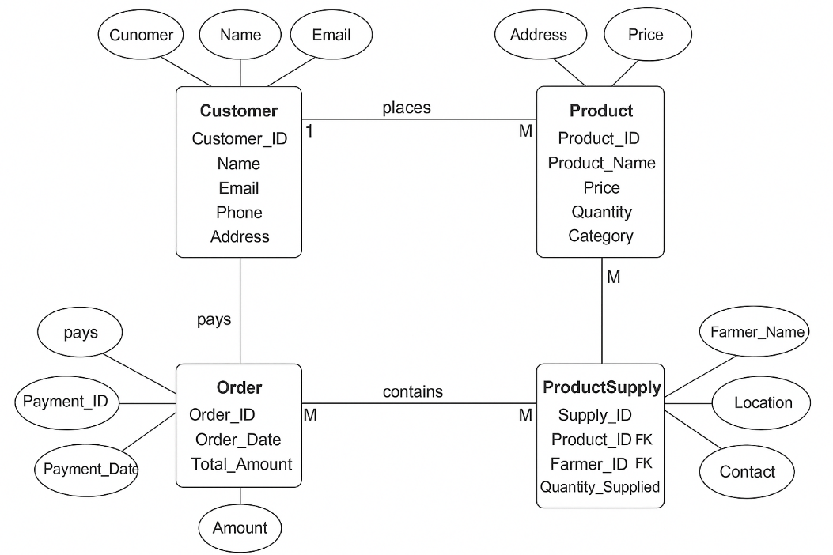

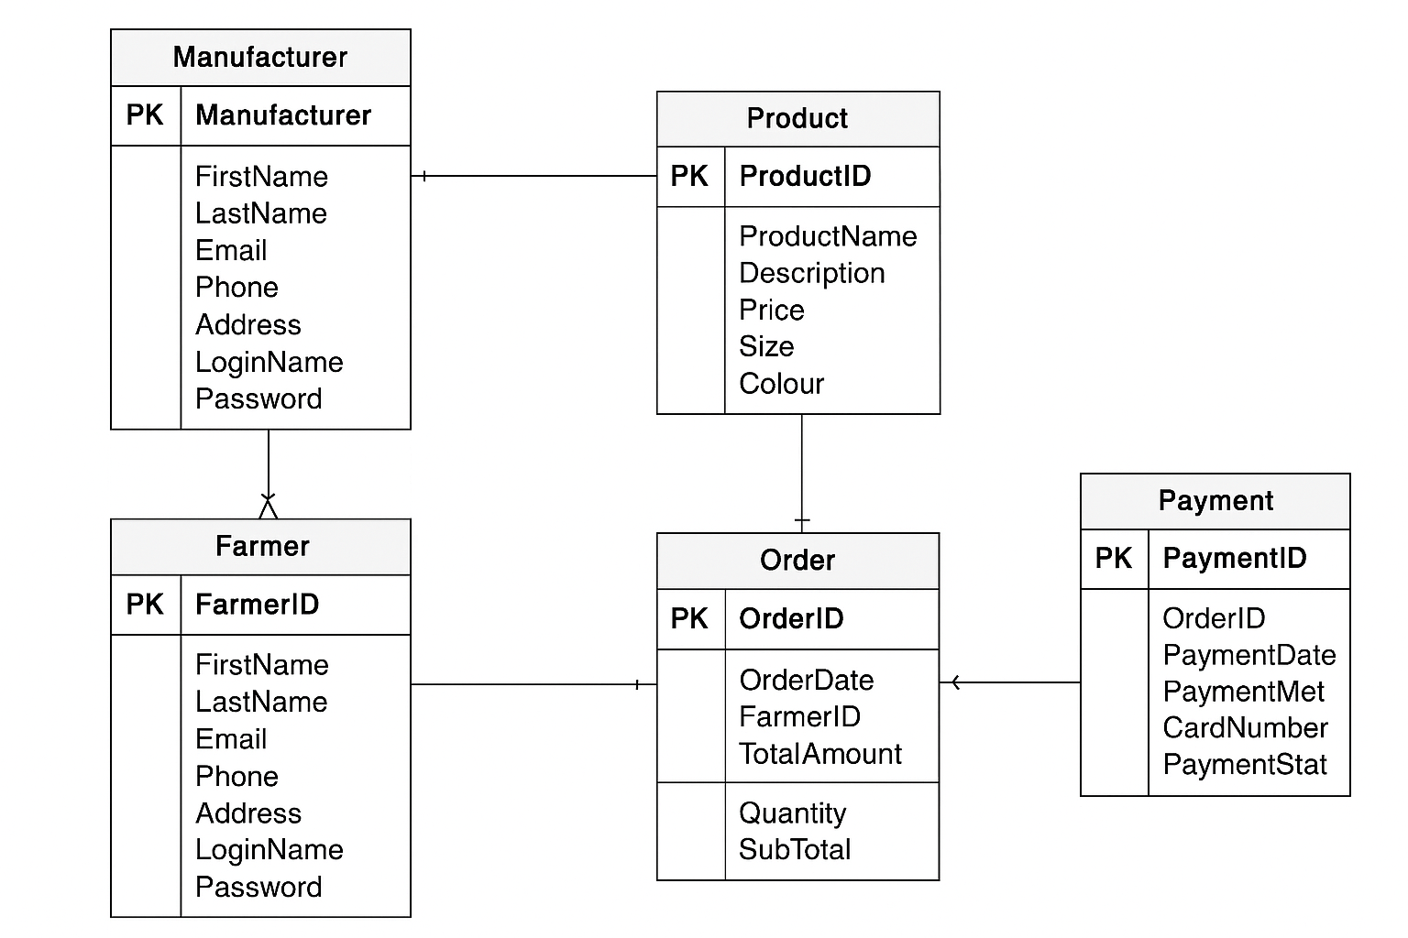

Question 7 – Data Flow Diagram - What is a data flow diagram? Draw a data flow diagram to represent the in-flow and out-flow of data when a Farmer is placing an order for the product
Data Flow Diagram
A data flow diagram shows how data is processed within a system based on inputs and outputs. Visual symbols are used to represent the flow of information, data sources and destinations, and where data is stored. Data flow diagrams are often used as a first step toward redesigning a system

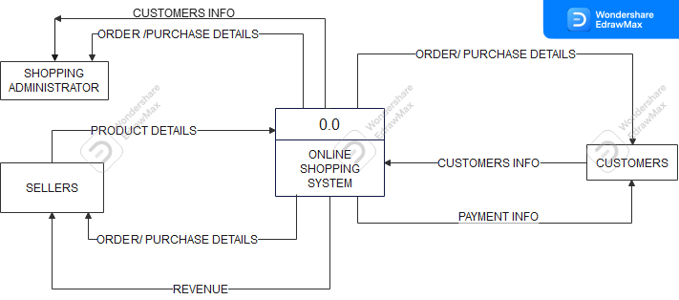
Question 8 – Change Request -Due to change in the Government Taxation structure . we should change the Tax structure How do you handle change requests in a project?
Due to change in government tax structure there would be change in price structure.
The same can be handled in our system, there is no need to go for change structure,
In system the system itself we keep a design with soft coding wherein we can change tax percentage and amount will automatically get revised as per new tax structure.
A change request process is a way for project managers to submit requests to stakeholders for review that are then approved or denied. It’s an important process to help manage large projects with multiple moving parts.
- Steps to handle change request:
1. Change request initiation
In the initiation phase of the change control process, a change is requested. There are numerous reasons why you might request a change. For example, a creative deliverable is taking longer than anticipated. A request would then be made to adjust the deliverable due date. While a request may be more likely to come from a stakeholder or project lead, a proposed change can be requested by anyone.
2. Change request assessment
Once the request has been filled out and the initial form has been submitted and approved, the request will then be assessed. This is different from the initial form submission since the assessment is when the actual change will be evaluated. The assessment phase isn’t necessarily where a decision is made, but rather, reviewed for basic information.
3. Change request analysis
The change impact analysis phase is where there will be a final decision on whether the request is approved or denied by the appropriate project lead. While you may also give input on the decision, it’s a good idea to get official approval from a leader as well. In some cases, there may even be a change control board that is in control of any change approvals.
4. Change request implementation
If the change request is approved, the process will move on to the implementation phase. This is where you and the project stakeholders will work to make the project change. Implementing a change will look different depending on what stage the project is in, but it usually consists of updating project timelines and deliverables, as well as informing the project team. It’s a good idea to evaluate the project scope to ensure any changes to the timeline won’t have a huge impact on projected goals.
5. Change request closure
Once the request has been documented, disseminated, and implemented, the request is ready to be closed. While some teams don’t have a formal closure plan in place, it’s helpful to have one in order to store information in a place that all team members can reference in the future. In the closing phase, any documentation, change logs, and communication should be stored in a shared space that can be accessed later on. You should also store the initial change form and any revised project plans you created along the way.
Question 9 – Change Request Vs an Enhancement - As the project is in process, Ben and Kevin have contacted you. The reason is to inform you that they want the Farmers to sell their crop yields through this application i.e. Farmers should be able to add their crop yields or products and display to general public and should be able to sell them. They also want to introduce Auction system for their Crop yields. As a BA, what will be your response? Is this a change request or an enhancement???
As an I BA would accept the proposal as it will be enhancement into the system as this is not changing the infrastructure but an additional service offering and our company will get additional benefit from the same.
Question 10 – Estimations -Come up with estimations – How many Manhours required
Man-hours, also called person-hours, are the unit of measure that is used in project management to measure the efforts needed to complete a task.
1 man hour = work completed in an hour of uninterrupted effort by an average worker.
Calculating man hours is the basis for being able to measure the cost per project of each type of expert and his contribution to the result.
The total man hours per task is obtained by multiplying the number of people assigned to a task by the total time it takes to complete it.
Let’s say, for example, that 15 workers at a metal plant and devote 10 workdays to complete an order of 800 product units.
Estimating 6 working hours per day, the total man hours is obtained from multiplying the following: 15 x 10 x 6 = 900 hours
So in this case there 11 people in the team and if we assume 30 day for completion enhancement requirement it would take 11 x 30 x 6 = 1980 hours

Question 11 – UAT – 6 Marks Project has finally completed all the stages i.e., design, development, testing etc. Now, it is the roleof a business analyst to contact the client for testing of the final product and have to successfully complete it. How are you going to handle this situation? And once it is done, what will be the process to close the project? Explain UAT Acceptance process
- User Acceptance Testing (UAT) is the final stage of any software development or change request lifecycle before go-live. Actual users test the software to determine if it does what it was designed to do in real-world situations, validating changes made and assessing adherence to their organization’s business requirements.
- The end users or client conducts the UAT. This type of Software Testing usually happens at the client location which is known as Beta Testing. Once Entry criteria for UAT are satisfied, following are the tasks need to be performed by the testers:
- Analysis of Business Requirements - One of the most important activities in the UAT is to identify and develop test scenarios. These test scenarios are derived from the following documents:
- Project Charter
- Business Use Cases
- Process Flow Diagrams
- Business Requirements Document(BRD)
- System Requirements Specification(SRS)

2,Creation of UAT Plan: - The UAT test plan outlines the strategy that will be used to verify and ensure an application meets its business requirements. It documents entry and exit criteria for UAT, Test scenarios and test cases approach and timelines of testing.

The UAT test plan outlines the strategy that will be used to verify and ensure an application meets its business requirements. It documents entry and exit criteria for UAT, Test scenarios and test cases approach and timelines of testing.

3.Identify Test Scenarios and Test Cases: Identify the test scenarios with respect to high-level business process and create test cases with clear test steps. Test Cases should sufficiently cover most of the UAT scenarios. Business Use cases are input for creating the test cases.

4.Preparation of Test Data: It is best advised to use live data for UAT. Data should be scrambled for privacy and security reasons. Tester should be familiar with the database flow.

4.Run and record the results: Execute test cases and report bugs if any. Re-test bugs once fixed. Test Management tools can be used for execution.

5.Confirm Business Objectives met: Business Analysts or UAT Testers needs to send a sign off mail after the UAT testing. After sign-off, the product is good to go for production. Deliverables for UAT testing are Test Plan, UAT Scenarios and Test Cases, Test Results and Defect Log.

- As a project has completed all the stages of SDLC, first as a BA will do test run of project, wherein the entire system as a whole will be tested and after being satisfied will consult with the PM.
- After doing testing analysis with project manager will send an official email to client for UAT and will fix up meeting date and time with client, stakeholder and all our team members.
- On the given day I will showcase the project and will welcome any suggestions from client or stakeholder if any and will take sign off from the client to close the project.
- After this we will start the process of handing over the application to client and we will give all documentation to the client for future help.

- Steps to Closing a Project

The close of the project is the final phase of your job, it’s the last turn of the project life cycle, and like any other aspect of a project, it requires a process. The following are five steps you should take to make sure you’ve dotted all the I’s and crossed all the T’s, as well as taken full advantage of the experience.
- Arrange a Post Mortem

Managing a project isn’t only about tasks and resources, budget and deadlines, it’s an experience you can constantly learn from. While you should have been learning throughout the project, now is a great time to look back without the pressure and distractions that might have dulled your focus.
- Complete Paperwork

As noted, projects generate reams of documents. These documents are going to have to get sign off and approval from stakeholders. Everything needs attention and must be signed for, which is the legal proof that in fact these documents have concluded. That includes closing all contracts you might have made with internal partners or vendors or any other resources you contracted with
- Release Resources

You assemble a team for the project, and now you must cut them loose. It’s a formal process, and a crucial one, which frees them for the next project. Each team is brought together for the mix of skills and experience they bring to a project. The project determines the team members you’ll want to work with, and each project is going to be a little bit different, which will be reflected in the team hired to execute it.
- Archive Documents

There are lessons to be learned from old projects, which is why you meet with your team regularly during the project and look back on the process afterwards. However, if you don’t have an archive in which to pull the old records, then whatever knowledge you gain is lost because of poor organization and management. You worked hard to have great project documentation, don’t lose it.
- Celebrate Success

If it sounds silly to you, then you’re not doing your job. There’s nothing silly about rewarding your team to acknowledge a job well done. It creates closure, which is what this part of the project is all about, but it also plants a seed that will bloom in later projects when you work with members of the old team
Question 12 – Project Closure Document - 6 Marks Explain Project closure document

- A project closure document is the final document that assesses the success of the project and also catalogues project deliverables and officially ends the project. The primary objective of a project closure document is to provide a complete picture of the successes and failures of a project.
- The project closure document should include all important project information that would help stakeholders, auditors and future project managers to clearly understand what was accomplished during the project and how the work was completed.
- Things to include in a project closure document:
- The original project guidelines, including stakeholder requests, budget and timeline.
- Proof that objective goals were met.
- Proof that clients have received their deliverables.
- Invoices from supplies, stakeholders or other sources.
- Release or transfer records of remaining resources.
- Detailed performance reviews on each phase of the project.
- Feedback from senior management, team members and stakeholders.
- A separate folder with all project files and communication for archival purpose.
- A request for project closure approval.
- How to create a project closure report
- Label the document.
- Write an overview of the project.
- Describe the project accomplishments, outcomes and results.
- Describe the projects scope.
- Craft a project performance analysis.
- Highlight challenges and risks that developed.
- Write about lessons learned, suggestions for future projects and project manager comments.
- Create a financial summary.
- Describe the transfer of operations.
- Request project closure approval.

A sample project closure document as bellow

Project Name:
UM Business Unit(s): | ☐MU ☐UMSL ☐UMKC ☐S&T ☐MUHC ☐UMSYS
Governing Body:
Executive Sponsor:
Project Manager:
Date:
Related Project#: | (Future Use. Remove if not needed)

Purpose: The purpose of the Project Closure document is to formally close a project and authorize the handoff from project to operations. It would include final information about the project deliverables, scope, milestones and budget, as well as lessons learned.

- Project Description
(Insert the basic description of the project – often from the initial charter document.)

Scope Statement
(Insert the scope of the project here as a reference to what was accomplished.)

- Project Accomplishments

(From the Charter, insert the intended goal and objectives. If the project was on track, you can talk about these items now as what the project was able to accomplish. If any of these items changed, you should address why and how.)

- (Accomplishment 1)
  - (Details)
  - (Details)

Milestone | Target Date | Completed Date

Project Milestones

Financial Summary
Project Costs | Project Budget | Project Actuals
Hardware
Software
Installation Services
Other
Project Totals
Notes:
On-going (Annual) Costs | Project Budget | Project Actuals
Salaries
Benefits (FY14 & FY15 are 35.37%)
Maintenance (Software & Hardware)
Depreciation of Hardware
External Vendor Services
Other
On-going Totals
Notes:
- Transfer to Operations
(Describe the handoff of ongoing tasks to operations, including identifying operational roles.)
- (Task 1)
  - (Detail)
  - (Detail)
Role | Name | Transition Date
F Functional Owner
Service Owner
Service Manager

Lessons Learned
(Transfer a bulleted list of lessons learned from your team or give a narrative synopsis of the lessons in this section.)
- (Lesson 1)
  - (Detail)
  - (Detail)

Project Manager Comments
(Record closing thoughts about the project here, but remember that this is retained as an official project document. Conclude this section by describing the way you celebrated the completion of the project with your team.)

Project Completion Acceptance
Project Role | Name | Signature (Electronic is acceptable) | Date
Executive Sponsor
Functional Owner
Service owner
Project manager
SPMO Director

