CAPSTONE PROJ 1 PART 3

Question 1 – Functional Requirements - 15 Marks Identify minimum 20 functional requirements

Req ID | Name of Requirment | Description
FR001 | User registration | User should be able to register on the website
 | User login | User should be able to login with username and password
FR002 | Search products | User should be able to search for available products
FR003 | Add to cart | User should be able to add product to cart
FR004 | Upload and display products | Manafacturer should be able to display and upload products
FR005 | Email confirmation | User should be able to get email confirmation regarding product
FR006 | Make payment | User should be able to able to make payment via debit,credit card and COD
FR007 | Add products to wish list | User should be able add products to wish list
FR008 | Track delivery | User should be able to track delivery of product
FR0010 | Get details | User should be able to get details of product

Req Id | Name of requirement | Description
NFR001 | Perfomance | The application must load within 3 seconds
NFR002 | Usuability | The application should be intuitive and user friendly
NFR003 | Security | The application must ensure user aunthentication
NFR004 | Compatibility | The application must be compatible with web browsers such as chrome,explorer,edge
NFR005 | Response Time | The application must respond to input within 2 seconds
NFR006 | Scalability | The application must be scalable upto 10,000 scalable users
NFR007 | Maintainability | The mean time to restore the application must not be more than 10 minutes
NFR008 | Portabilty | The application should be able to run on operating systems ,mobile ,desktop versions.
NFR009 | Reliability | The system should be able to handle and recover errors without incorrect data or data loss
NFR0010 | Localization | The application must have different language features like marathi,English ,hindi.

Question 2–Minimum 5 page designs - 15 Marks Make wireframe and prototypes
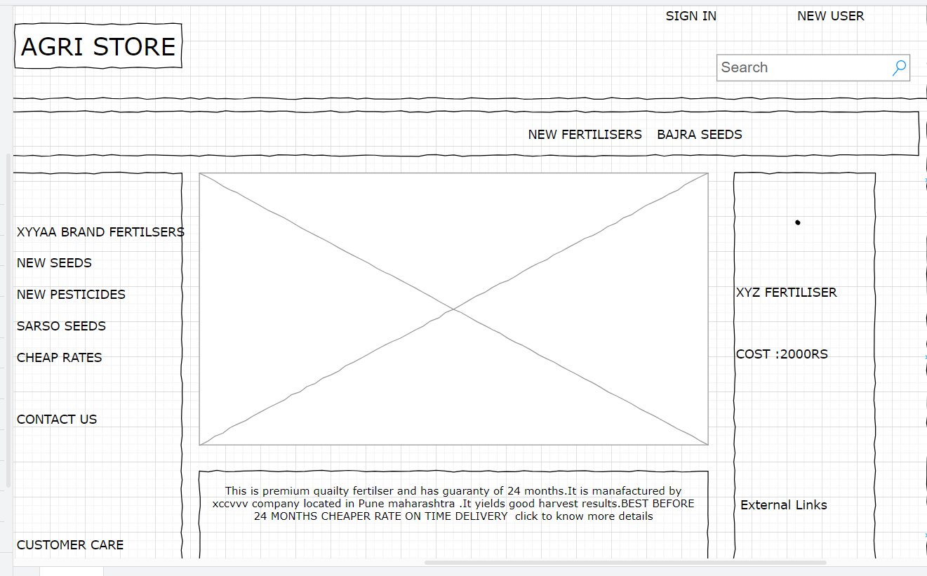

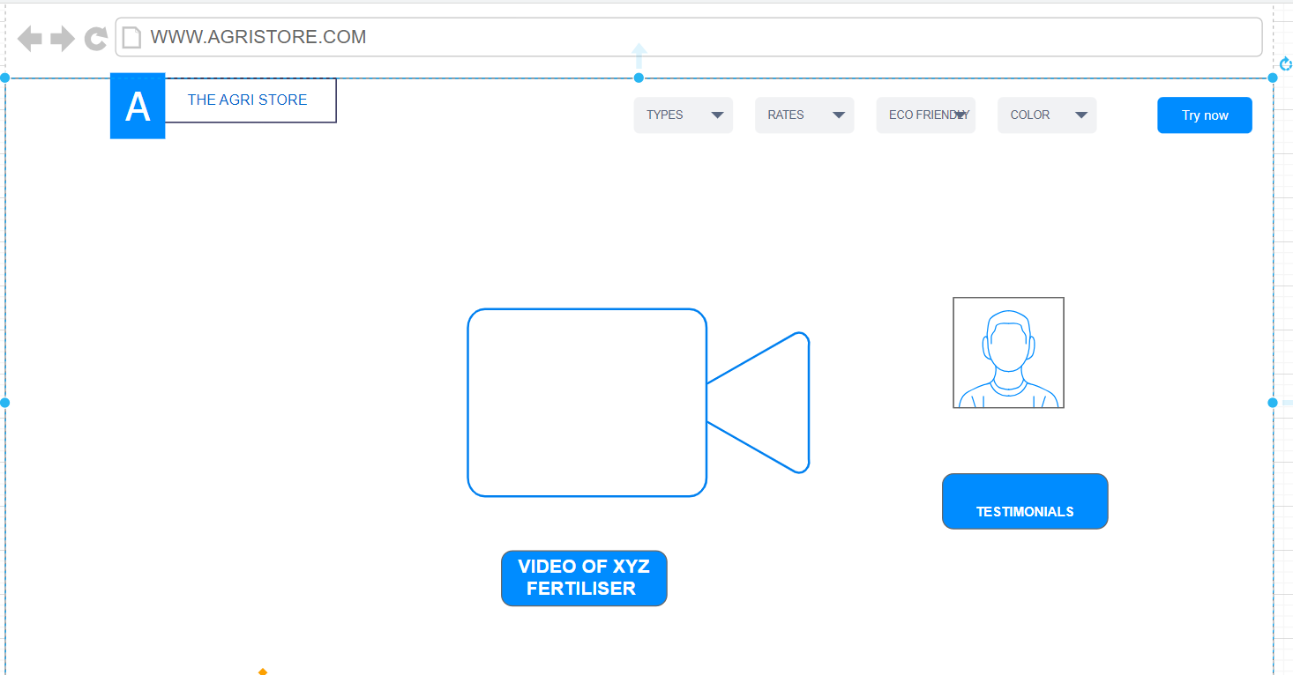

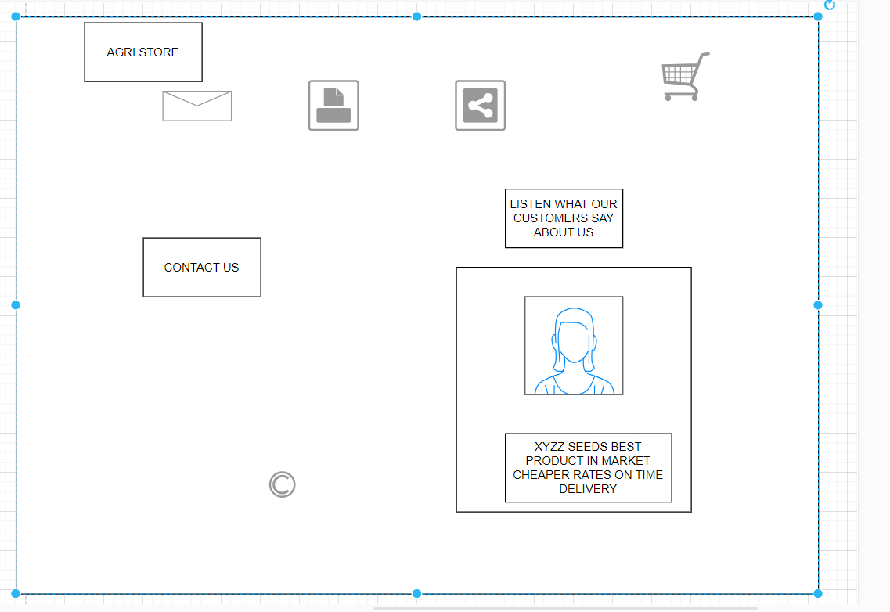

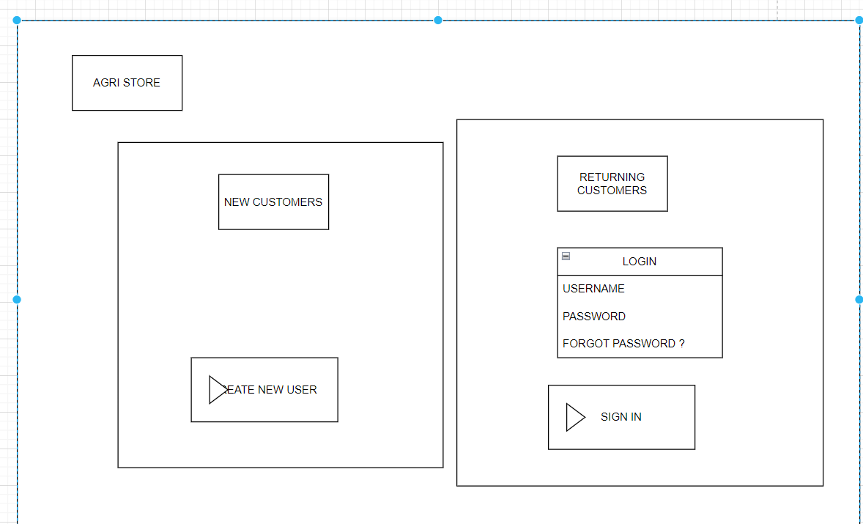

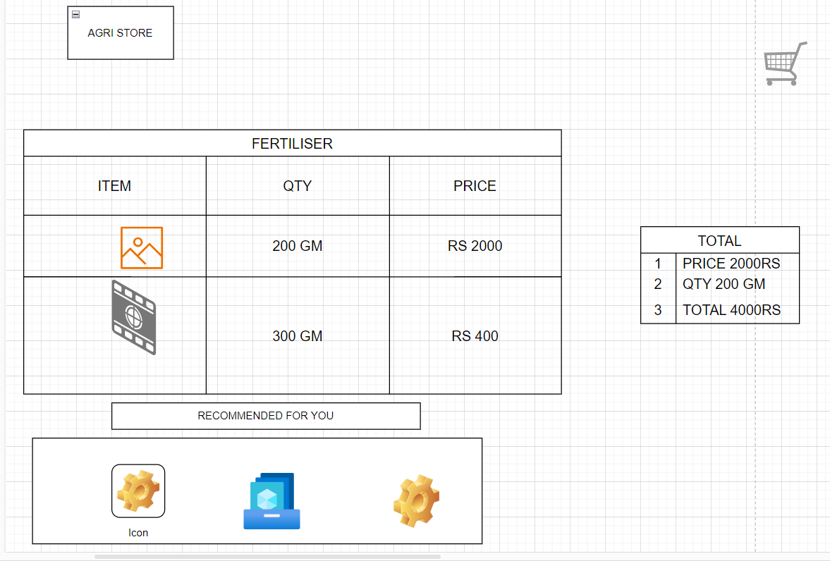

Question 3 – Tools (Visio, Balsamiq) - 15 Marks
Make a note of the Tools, which you are using for above concepts.
Microsoft Visio is a diagramming and flow charting software used to create visual representations of complex information, including flowcharts, organization charts, network diagrams, floor plans, and more, enabling users to organize, communicate, and collaborate on ideas visually.
Here's a more detailed breakdown of Visio's uses:
- Diagramming and Flowcharting:
Visio is primarily used for creating various types of diagrams, such as flowcharts, process maps, workflows, and UML diagrams.
- Organization Charts:
Visio facilitates the creation of organizational structure diagrams, showing reporting relationships and team structures.
- Network Diagrams:
Users can create visual representations of computer networks, including devices, connections, and infrastructure.
- Floor Plans and Building Plans:
Visio can be used to design and visualize floor plans, building layouts, and other spatial diagrams.
- Business Process Modeling:
Visio supports the creation of diagrams that illustrate business processes, workflows, and procedures.
- Data Visualization:
Visio allows users to connect to data sources like Excel or SharePoint and visualize data in various diagram formats.
- Collaboration:
Visio enables users to share and collaborate on diagrams with others, facilitating communication and teamwork.
- Templates and Shapes:
Visio offers a wide variety of templates and shapes for different types of diagrams, making it easy to get started.

Balsamiq is a user interface (UI) design tool primarily used for creating low-fidelity wireframes and mockups, enabling rapid sketching and visualization of software interfaces, websites, and apps, facilitating communication and collaboration in the early stages of design.
Here's a more detailed explanation:
- What it is:
Balsamiq is a software application designed for creating wireframes, which are simplified, visual representations of a user interface (UI).
- Purpose:
It's used to quickly sketch out ideas, test concepts, and communicate design plans with stakeholders before diving into detailed design or coding.
- Key Features:
  - Low-fidelity: Balsamiq focuses on structure and content rather than visual details, encouraging early-stage brainstorming and iteration.
  - Rapid prototyping: It allows users to quickly create and modify wireframes, facilitating fast feedback loops.
  - Collaboration: Balsamiq supports real-time collaboration, enabling teams to work together on wireframes and share feedback.
  - Drag-and-drop design: The tool uses a user-friendly drag-and-drop interface for creating UI elements.
- Who uses it:
Product managers, designers, developers, and other stakeholders use Balsamiq to visualize ideas, get feedback, and ensure everyone is on the same page before starting development.
- Examples of use cases:
  - Brainstorming and concept development: Quickly sketch out different interface layouts and user flows.
  - User testing: Create wireframes to test user interactions and gather feedback.
  - Stakeholder communication: Communicate design ideas and get buy-in from stakeholders.
  - Documentation: Create visual documentation of the user interface structure.

Axure RP is a tool primarily used for creating interactive prototypes and wireframes, allowing UX designers, product managers, and business analysts to design and test user interfaces and flows without coding.
Here's a more detailed breakdown of what Axure is used for:
- Prototyping:
Axure enables the creation of interactive prototypes, allowing users to simulate user interactions and flows, making it easier to test and refine designs before development.
- Wireframing:
It facilitates the creation of wireframes, which are visual representations of the layout and structure of a website or application.
- User Interface (UI) Design:
Axure helps designers create and refine user interfaces by providing a platform to visualize and test different design concepts.
- User Experience (UX) Design:
Axure is a valuable tool for UX professionals, enabling them to focus on functionality, user flows, and interactive elements.
- Collaboration:
Axure supports collaboration through features like Axure Cloud, allowing team members to share prototypes and provide feedback.
- Diagramming and Flowcharts:
Axure can be used to create various diagrams, including flowcharts, customer journeys, and sitemaps, which are helpful for visualizing processes and understanding user behavior.
- Rapid Prototyping:
The tool is designed for rapid prototyping, allowing designers to quickly iterate and create prototypes.
- Dynamic Interactions:
Axure supports dynamic content, conditional logic, and advanced animations, enabling designers to build realistic prototypes without coding.
- Code Export:
Axure allows users to export their prototypes as HTML, which can be used for testing and development purposes.
- Specifications and Notes:
Axure allows users to capture requirements and specifications for developers and stakeholders

I have used draw.io tool to make the wireframes.
Draw.io (now known as diagrams.net) is a significant, free, and widely used online diagramming tool that allows users to create various types of diagrams, flowcharts, and charts, offering a user-friendly interface and integration with multiple platforms.
Here's a more detailed look at its significance:
Key Features and Benefits:
- Versatility:
Draw.io supports a wide range of diagram types, including flowcharts, wireframes, UML diagrams, organizational charts, and network diagrams.
- Ease of Use:
The software features a drag-and-drop interface, making it easy for users of all skill levels to create and edit diagrams.
- Online and Offline Access:
Draw.io is available as a web application and a desktop application for Linux, macOS, and Windows, allowing users to work both online and offline.
- Collaboration:
Draw.io supports real-time collaboration with shared cursors, allowing multiple users to work on the same diagram simultaneously.
- Integrations:
It integrates with various cloud storage services (Google Drive, Dropbox, OneDrive, GitHub, GitLab) and platforms like Atlassian Confluence and Jira.
- Free and Open Source:
Draw.io is free to use and open-source, making it accessible to a wide audience.
- Security:
Draw.io prioritizes data security, with no tracking or external retention of user data.
- Diagramming for various purposes:
It's used by developers, network admins, IT analysts, designers, and other professionals for project planning, documentation, and communication.
- Customization:
It allows for the creation of diagrams with customizable URLs, toggle layers, and text alignment within shapes.

Question 4 – RTM - 6 Marks

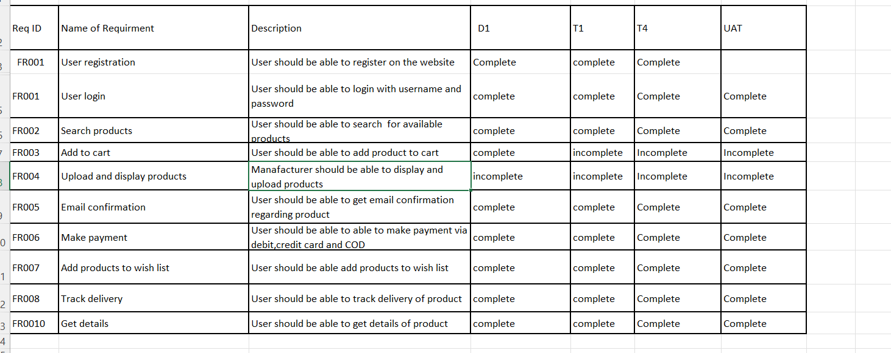

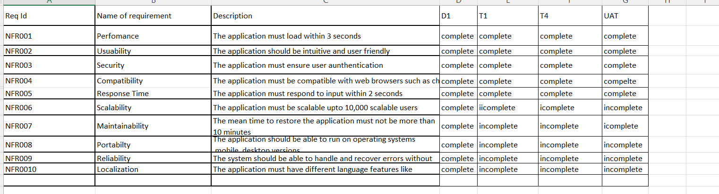

Question 5 – 10 Test Case Documents - 10 Marks Prepare 10 Test Case Documents

Test specification document 1:Login functionality
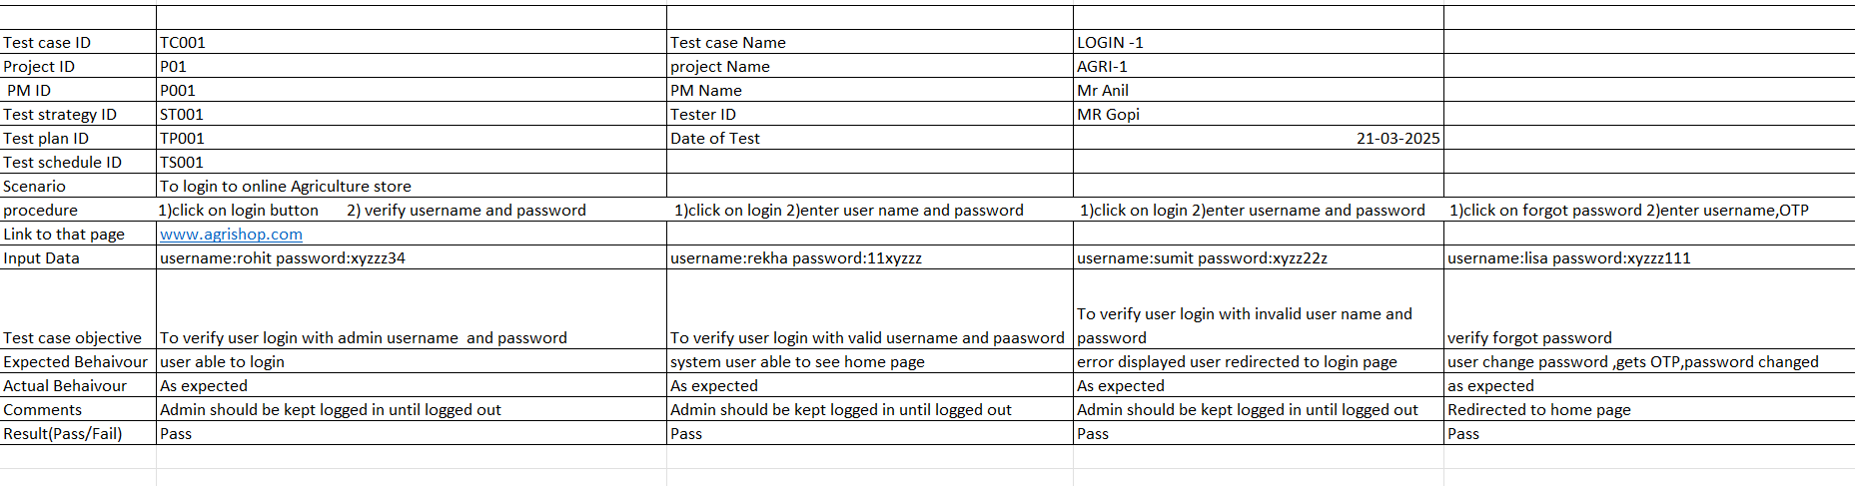

Test specification document 2:Registration
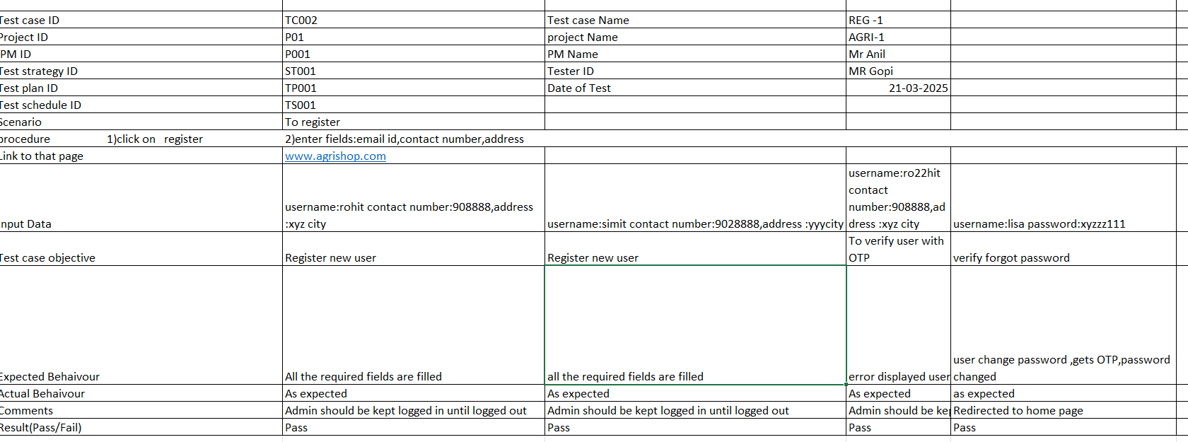

3)Add to cart Test case specification document

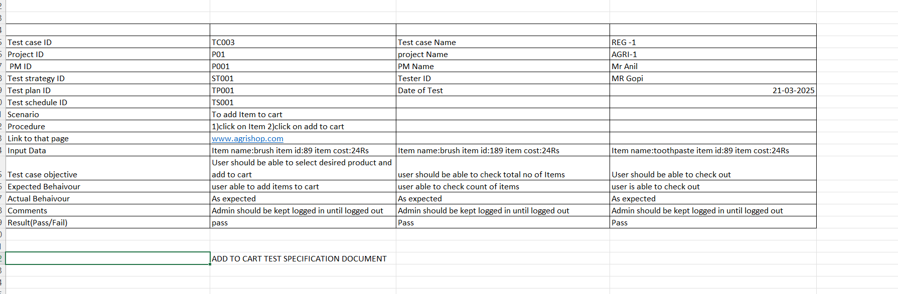

4)Verify that the cart icon updates the item count in list

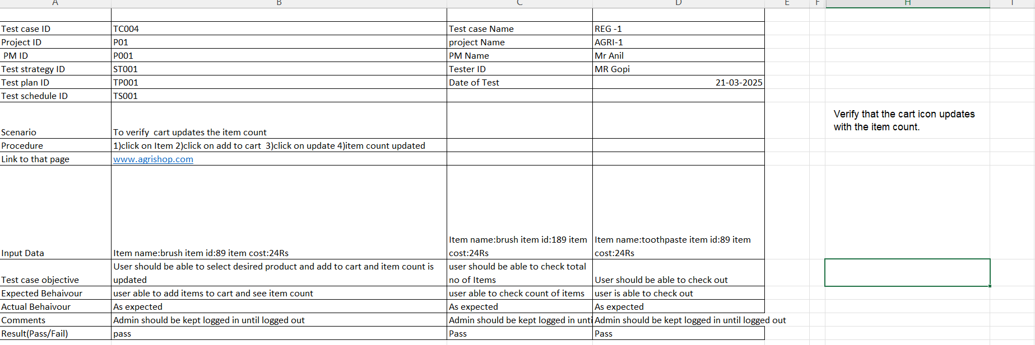

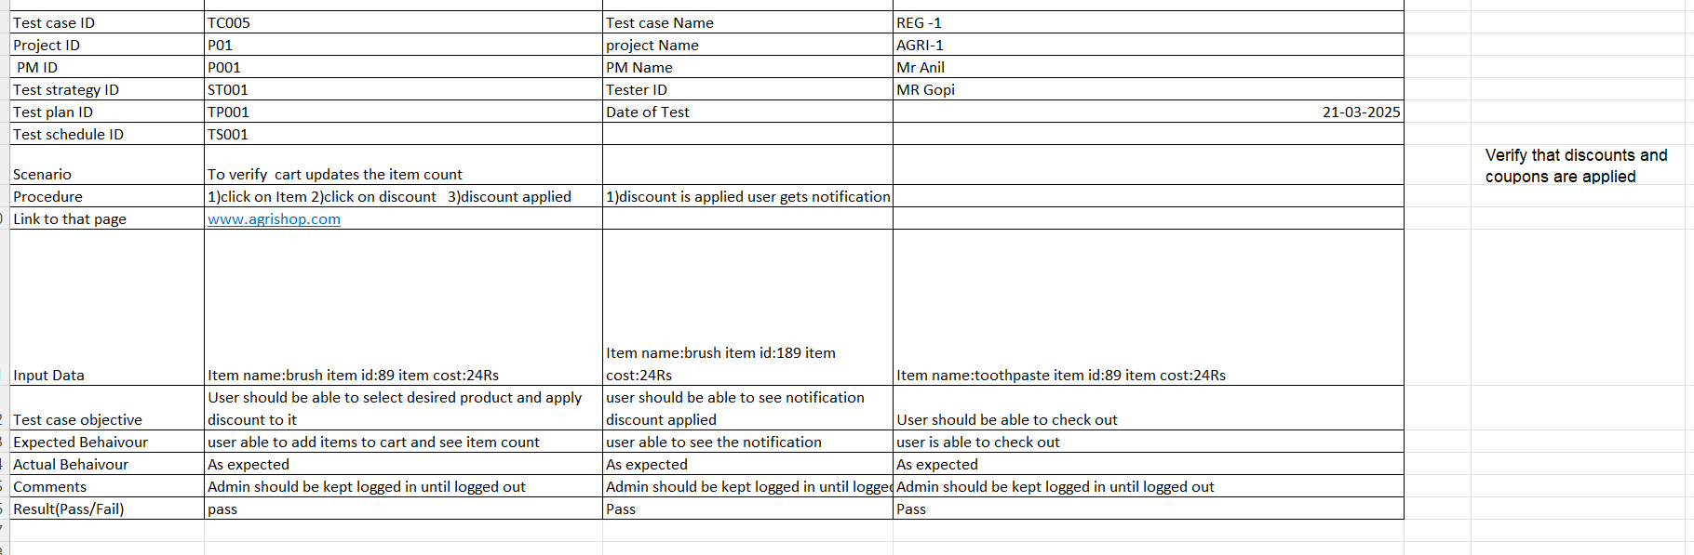
5)verify that discount s and coupons are applied.
6)Test the continue shopping button in the cart
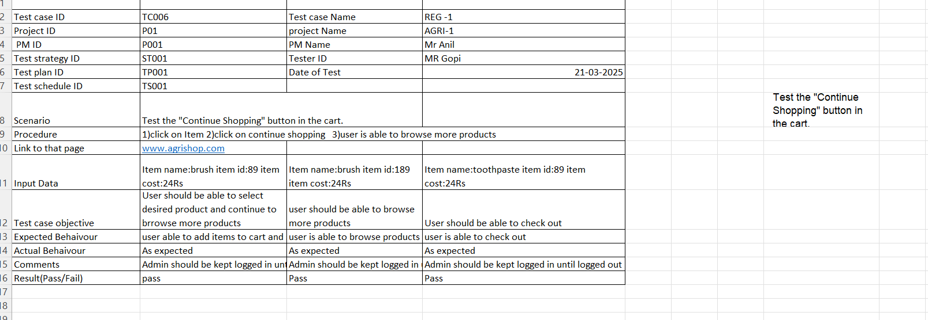

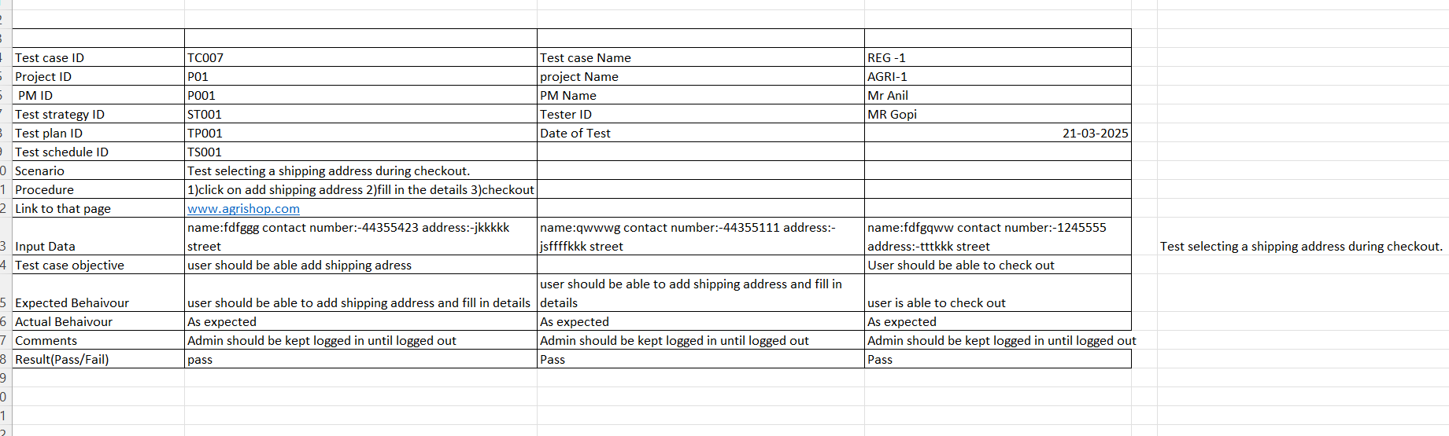

7)Test selecting a shipping address during check out

8)veify the users can add edit /add shipping address
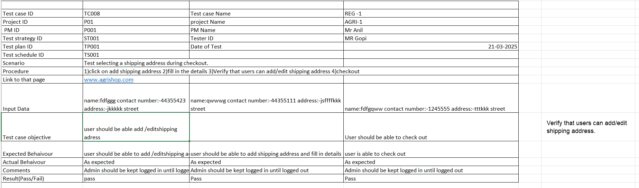

9)Verify the order summary and item details during check out

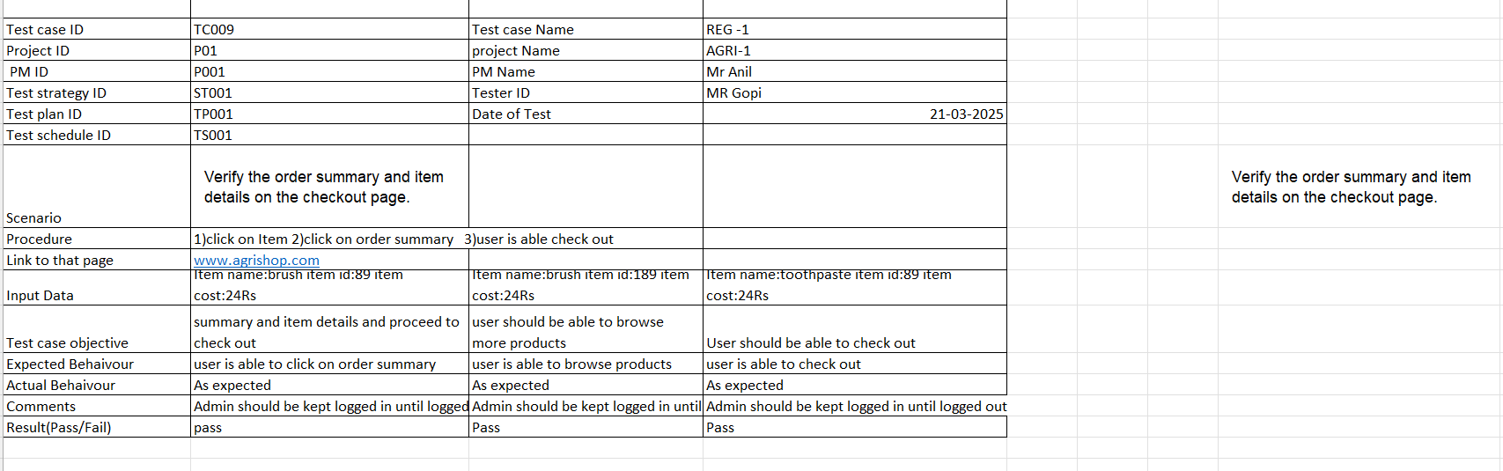

10)verify the display order confirmation details.
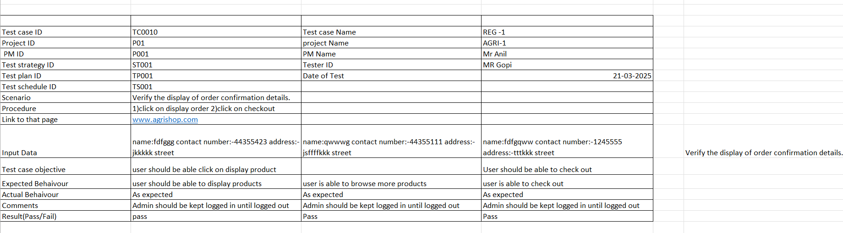

Question 6 – DB Design – 8 Marks After the requirements are thoroughly explained to the entire project team by business analyst, the Database architects have decided to do the database design and also to represent the in-flow and out-flow of data. Draw database schema and ER diagram
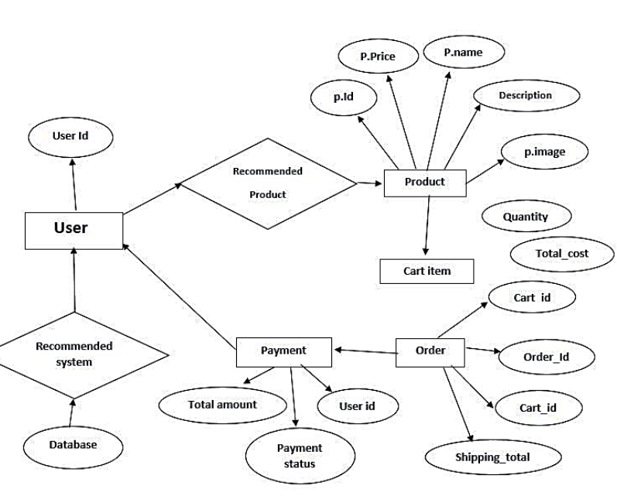

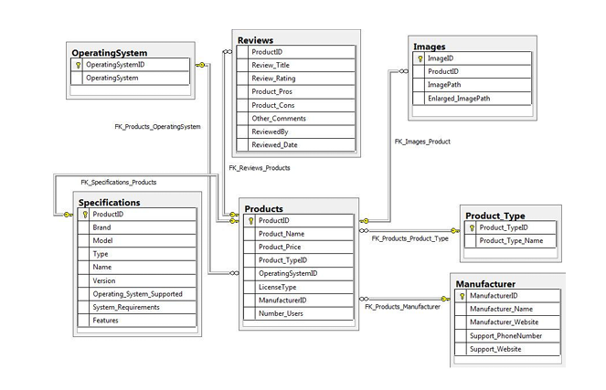

DB SCHEMA DIAGRAM

Question 7 – Data Flow Diagram - 3 Marks What is a data flow diagram?
Draw a data flow diagram to represent the in-flow and out-flow of data when a Farmer is placing an order for the product
A Data Flow Diagram (DFD) is a visual representation that illustrates how data moves through a system or process, using symbols like arrows, rectangles, circles, and text labels to depict data flow and transformation.
Here's a more detailed breakdown:
Key Elements of a DFD:
- Processes (Circles or Rectangles): Represent actions or transformations that data undergoes.
- Data Flows (Arrows): Show the movement of data between processes, inputs, outputs, and stores.
- Data Stores (Rectangles with Open Sides): Represent places where data is stored, such as databases or files.
- External Entities (Rectangles): Represent sources or destinations of data outside the system being modeled.
- Text Labels: Used to describe the data, processes, and stores.
Purpose and Uses of DFDs:
- Visualizing Data Flow:
DFDs provide a clear and concise way to understand how data moves through a system.
- System Analysis and Design:
They are used to model and analyze existing systems or to plan new ones.
- Communication Tool:
DFDs help facilitate communication among stakeholders, including developers, analysts, and end-users.
- Identifying Potential Problems:
By visualizing the data flow, DFDs can help identify bottlenecks, inefficiencies, and areas for improvement.
- Software Development:
DFDs are commonly used in software development, especially in creating and understanding information systems.

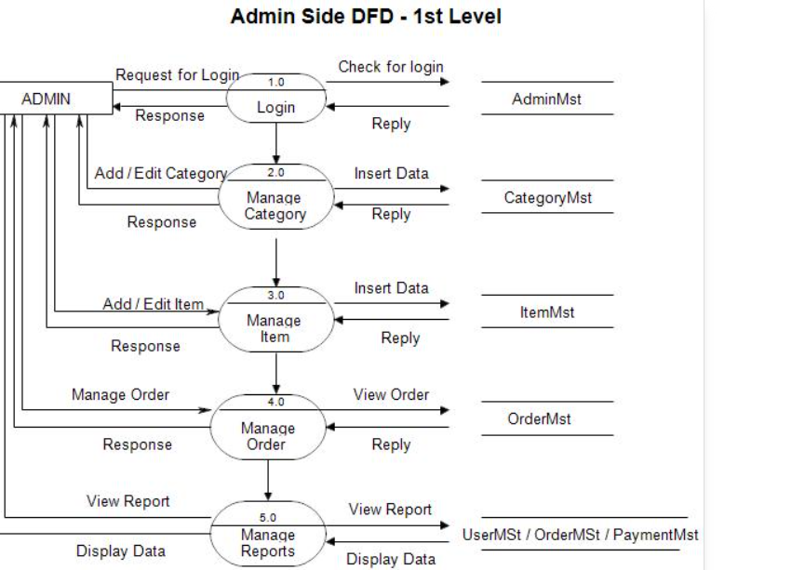

Question 8 – Change Request - 10 Marks
Due to change in the Government Taxation structure . we should change the Tax structure How do you handle change requests in a project?
A "change request" is a formal proposal for an alteration to a product, system, or project, often initiated by a client or team member, and requiring a structured process for evaluation and approval.
Here's a breakdown of what a change request is and its key aspects:
- Definition:
A change request is a formal document that outlines a proposed modification to a project, system, or product.
- Purpose:
It serves as a mechanism to manage changes during a project's lifecycle, ensuring that any alterations are documented, assessed for impact, and approved before implementation.
- Common Scenarios:
Change requests can arise when a client wants to modify the scope, schedule, budget, or quality of a project, or when a team member identifies a need for an improvement or correction.
- Key Elements of a Change Request:
  - Project Name: Clearly identifies the project to which the change request applies.
  - Request Number: A unique identifier for the change request.
  - Requestor: The individual or team initiating the change request.
  - Description of the Change: A detailed explanation of the proposed modification.
  - Reason for the Change: Justification for why the change is needed.
  - Impact of the Change: Assessment of the potential effects of the change on the project's scope, schedule, budget, and quality.
  - Proposed Action: The specific steps or actions required to implement the change.
  - Business Priority: The importance of the change in relation to the overall project goals.
- Change Request Process:
  - Collect Information: Gather all necessary documentation and information related to the proposed change.
  - Evaluate Impact: Assess the potential impact of the change on the project.
  - Prioritize: Determine the priority of the change request based on its importance and urgency.
  - Approve or Reject: Review and either approve or reject the change request.
  - Plan Implementation: If approved, plan the implementation of the change.
- Types of Changes:
  - Standard Changes: Pre-authorized, low-risk changes that follow a well-known procedure.
  - Emergency Changes: Changes that must be implemented immediately, for example, to resolve a major incident.
  - Normal Changes: All other changes that are not standard or emergency changes.

To effectively handle change requests, establish a clear process, collect necessary information, evaluate the impact, prioritize requests, seek approval, and communicate and implement approved changes, ensuring transparency and documentation throughout.
Here's a more detailed breakdown of how to handle change requests:
1. Establish a Clear Process:
- Formalize the Process:
Develop a structured approach for handling change requests, including a change request form or template.
- Define Roles and Responsibilities:
Clearly outline who is responsible for submitting, reviewing, approving, and implementing change requests.
- Communicate the Process:
Ensure all stakeholders are aware of the change request process and how to submit requests.
- Use Change Management Tools:
Consider using project management software or dedicated change management tools to streamline the process.
2. Collect Information:
- Gather Documentation: Request all relevant supporting materials, including the reason for the change, its scope, and potential impact.
- Determine Scope: Clearly define whether the change is within or outside the project scope.
- Assess Priority: Have your team assess the priority of the change request based on its importance and urgency.
3. Evaluate and Prioritize:
- Impact Assessment:
Evaluate the potential impact of the change on project scope, schedule, budget, and resources.
- Risk Analysis:
Identify potential risks associated with implementing the change and develop mitigation strategies.
- Prioritize Requests:
Determine which change requests should be addressed first based on their importance and feasibility.
4. Seek Approval:
- Obtain Sign-Off:
Ensure that all necessary stakeholders and approvals are obtained before implementing the change.
- Document Decisions:
Record all decisions related to change requests, including approvals, rejections, and reasons.
5. Communicate and Implement:
- Inform Stakeholders:
Communicate the status and outcome of each change request to all relevant stakeholders.
- Plan Implementation:
Develop a plan for implementing the approved change, including timelines, resources, and responsibilities.
- Monitor Progress:
Track the progress of the change implementation and address any issues that arise.
6. Document and Close:
- Document the Outcome: Document the outcome of the change request, including the reasons for the change, the implementation process, and any lessons learned.
- Close the Request: Once the change is implemented and verified, close the change request.
- What is Change Request Management

Question 9 – Change Request Vs an Enhancement - 5 Marks
While both enhancements and change requests involve modifications, enhancements are improvements to existing functionality or features, while change requests are broader proposals for altering a project, product, or system, potentially including enhancements, new features, or fixes.
Here's a more detailed breakdown:
Enhancements:
- Focus:
Improving existing functionality, making it more user-friendly, efficient, or powerful.
- Purpose:
To add value, optimize, or enable new capabilities that were not initially possible.
- Example:
Streamlining a user interface, adding a new filter option to an existing feature, or improving the performance of a specific process.
- Nature:
Often considered "nice-to-have" improvements, not necessarily critical for the project's core functionality.
Change Requests:
- Focus:
Any modification to a project, product, or system, including enhancements, new features, or fixes.
- Purpose:
To address changes in requirements, scope, or deliverables.
- Example:
Adding a new feature that wasn't originally planned, addressing a bug that was discovered after the initial release, or changing the project timeline.
- Nature:
Can be critical for the project's success, as they address changes in requirements or address defects.
- Process:
Change requests typically go through a formal process of review, approval, and implementation.

Q 10 )As the project is in process, Ben and Kevin have contacted you. The reason is to inform you that they want the Farmers to sell their crop yields through this application i.e. Farmers should be able to add their crop yields or products and display to general public and should be able to sell them. They also want to introduce Auction system for their Crop yields. As a BA, what will be your response? Is this a change request or an enhancement???
Yes these both requests are enhancements.
Enhancement:
- Purpose: To improve or add functionality to an existing product or system.
- Origin: Can come from users, customers, or internal teams.
- Examples:
  - Adding a new feature to a website.
  - Improving the performance of a software application.
  - Making a product easier to use.
- Process: Enhancement requests are typically reviewed and prioritized by the development team.
- Impact: Enhancements can improve user satisfaction, increase product value, and enhance the overall user experience.

Question 10 – Estimations - 6 Marks Come up with estimations – How many Manhours required

In business analysis, estimation involves forecasting the effort, cost, and resources needed for project activities, aiding in planning, budgeting, and decision-making by providing realistic assessments of scope and requirements.
Here's a more detailed look at estimation in business analysis:
Why is Estimation Important?
- Planning and Budgeting:
Estimates help determine the resources (time, money, personnel) needed for a project, allowing for realistic budgeting and scheduling.
- Scope Management:
Accurate estimates help define the project scope and ensure that it aligns with available resources and timelines.
- Risk Management:
By understanding potential challenges and uncertainties, estimates help identify and mitigate risks that could impact the project.
- Stakeholder Communication:
Clear and realistic estimates build trust and confidence with stakeholders by providing a shared understanding of project timelines and costs.
- Decision Making:
Estimates provide a basis for making informed decisions about project priorities, resource allocation, and whether to proceed with a project.

Common Estimation Techniques:
- Bottom-Up Estimation:
This method involves estimating the effort for individual tasks or components and then summing them up to arrive at the overall project estimate. It's often considered more accurate because it considers granular details.
- Top-Down Estimation:
This approach starts with a high-level estimate for the entire project and then breaks it down into smaller components. It's useful when there's a fixed budget or timeline.
- Parametric Estimation:
This technique uses historical data and statistical models to predict project costs or effort based on specific parameters or factors. It's useful when there's sufficient data available.
- Analogy Estimation:
This method uses estimates from similar past projects to estimate the current project's cost or effort. It's useful when there's limited information about the current project.
- Three-Point Estimation:
This technique involves estimating the most optimistic, most likely, and most pessimistic scenarios for a project's cost or effort. It helps to create a range of possible outcomes.
- Rolling Wave Estimation:
This iterative approach involves estimating the effort for the near-term activities and then refining the estimates as the project progresses.
- Expert Judgment:
This method relies on the knowledge and experience of experts to estimate project costs or effort.
- Delphi Estimation:
This technique involves gathering estimates from a group of experts anonymously, and then iteratively refining the estimates until a consensus is reached.
Key Considerations for Effective Estimation:
- Data Accuracy: Rely on reliable data and historical information when making estimates.
- Scope Clarity: Ensure that the project scope is well-defined before attempting to estimate.
- Uncertainty: Acknowledge and address potential uncertainties and risks that could impact the project.
- Collaboration: Involve stakeholders and experts in the estimation process to gain a broader perspective.
- Iterative Refinement: Regularly review and refine estimates as the project progresses.
- To estimate man-hours, break down the project into smaller tasks, determine the type of workers needed, and estimate the time required for each task, considering factors like complexity and past projects.
- Here's a more detailed approach:
- 1. Break Down the Project:
- Identify Components: Divide the project into smaller, manageable components or tasks.
- List Details: For each component, list the specific activities or tasks that need to be completed.
- 2. Determine the Type of Workers Needed:
- Identify Skills: Determine the skills and expertise required for each task.
- Assign Roles: Assign roles to the necessary workers, considering their experience and productivity.
- 3. Estimate the Time for Each Task:
- Past Projects:
- If you have similar projects, use data from past projects to estimate the time needed for each task.
- Research:
- If you're unfamiliar with a task, research industry standards or consult with experts.
- Factor in Complexity:
- Account for factors like job difficulty, potential challenges, and required administrative tasks.
- Include Breaks and Overheads:
- Factor in time for breaks, meetings, travel, and other non-productive time.
- 4. Calculate Total Man-Hours:
- Multiply:
- Multiply the number of workers assigned to a task by the estimated time (in hours) to complete it.
- Sum:
- Add up the man-hours for all tasks to get the total estimated man-hours for the project.
- 5. Refine Your Estimates:
- Compare Estimates: Compare your estimates with past projects and industry standards.
- Seek Feedback: Get feedback from team members and stakeholders to refine your estimates.
- Track Actual Time: Track the actual time spent on each task and compare it to your estimates to improve future estimations.
- Example:
- Project: Build a small website
- Tasks:
- Design (2 designers, 10 hours each) = 20 man-hours
- Development (2 developers, 20 hours each) = 40 man-hours
- Testing (1 tester, 5 hours) = 5 man-hours
- Deployment (1 developer, 2 hours) = 2 man-hours
- Total Estimated Man-Hours: 20 + 40 + 5 + 2 = 67 man-hours
- How to calculate the cost of your projects with man hours
- 9 Mar 2017 — Man-hours, also called person-hours, are the unit of measure that is used in project management to means.

Question 11 – UAT – 6 Marks Project has finally completed all the stages i.e., design, development, testing etc. Now, it is the role of a business analyst to contact the client for testing of the final product and have to successfully complete it. How are you going to handle this situation? And once it is done, what will be the process to close the project? Explain UAT Acceptance process

We will handle by performing UAT.

User Acceptance Testing (UAT) is a crucial phase in software development where real users test the software to ensure it meets their needs and expectations before deployment, validating functionality and usability in real-world scenarios.
Here's a more detailed breakdown of the UAT process:
Purpose of UAT:
- Validation, not Verification:
UAT focuses on validating that the software meets the business requirements and user needs, rather than just verifying that it functions correctly according to specifications.
- Early Issue Detection:
UAT helps identify and address potential issues and discrepancies before the software is released to the end-users, saving time and resources.
- Improved User Experience:
By involving real users in the testing process, UAT ensures that the software is user-friendly and meets the needs of the target audience.
- Reduced Post-Release Issues:
Thorough UAT can significantly reduce the number of issues that arise after the software is released, improving user satisfaction and product credibility.
Key Steps in the UAT Process:
- 1. Planning and Preparation:
  - Define Scope: Determine the scope of UAT, including which features and functionalities will be tested.
  - Identify Testers: Select a representative group of end-users or stakeholders to participate in UAT.
  - Create a UAT Plan: Develop a comprehensive plan that outlines the objectives, scope, test cases, and expected outcomes of UAT.
  - Prepare the Test Environment: Set up a test environment that closely mirrors the production environment to ensure realistic testing conditions.
- 2. Test Case Development:
  - Develop Test Cases: Create detailed test cases that cover all key functionalities and scenarios, based on user requirements and business needs.
  - Prioritize Test Cases: Prioritize test cases based on their importance and potential impact on the user experience.
- 3. Execution and Reporting:
  - Execute Test Cases: Conduct UAT by having users interact with the software in a real-world context.
  - Record and Report Defects: Document any defects or issues identified during UAT, along with details on how to reproduce them.
  - Prioritize Defects: Prioritize defects based on their severity and impact on the user experience.
- 4. Defect Resolution and Re-testing:
  - Address Defects: Developers should address and fix the identified defects, and then re-test the software to ensure that the issues have been resolved.
- 5. Sign-Off and Release:
  - Obtain Sign-Off: Once all critical defects have been resolved and the software is deemed ready, obtain sign-off from the users or stakeholders to proceed with the release.
  - Release the Software: Deploy the software to the production environment.
Benefits of UAT:
- Improved Software Quality:
UAT helps ensure that the software is of high quality and meets the needs of the end-users.
- Reduced Costs:
Identifying and resolving issues early in the development process can save significant time and costs.
- Increased User Satisfaction:
UAT helps ensure that the software is user-friendly and meets the needs of the target audience, leading to increased user satisfaction.
- Enhanced Product Credibility:
A well-tested product that meets user expectations enhances the credibility of the product and the organization.

After successful User Acceptance Testing (UAT), project closure involves obtaining sign-off, documenting test results, addressing any remaining issues, and preparing for the final release, ensuring a smooth transition to production.
Here's a more detailed breakdown of the project closure process after UAT:
1. Obtain Sign-Off:
- Document Tester Approval:
After UAT, the most crucial step is to document the tester's approval, signifying that the system meets business requirements and is ready for deployment.
- Sign-Off Methods:
Consider using email approvals (perhaps with voting buttons) or physical signatures, depending on your company's culture and communication style.
- Assign Responsibility:
Assign one or more team members to collect sign-offs from testers, ensuring that all necessary approvals are obtained.
- Communicate Next Steps:
Proactively explain the next steps of the project to the testers to address any concerns about abandonment and ensure a smooth transition.
2. Document Test Results and Finalize Reports:
- Create a Comprehensive Report: Compile all test results, including defect reports, bug-fix verifications, and any other relevant documentation.
- Include Out-of-Scope Testing: Mention any out-of-scope testing or retests from previous UAT cycles.
- Sign-Off on the Report: Ensure that all relevant stakeholders sign off on the final UAT report, confirming that the planned tests were conducted and any outstanding issues are addressed.
3. Address Remaining Issues and Prepare for Release:
- Prioritize and Resolve Bugs:
Address any remaining critical or high-priority defects identified during UAT.
- Finalize Release Plan:
Prepare the final release plan, including deployment procedures, rollback plans, and communication strategies.
- User Training and Documentation:
Arrange for user training and ensure that all necessary documentation is finalized and readily available.
- Prepare for Post-Release Support:
Plan for post-release support, including feedback processing infrastructure and a clear process for addressing user queries.
4. Project Closure:
- Finalize Project Documentation: Ensure all project documentation, including test plans, test cases, and final reports, are archived and accessible.
- Conduct a Post-Project Review: Evaluate the project's success, identify lessons learned, and make recommendations for future projects.
- Release the Product: Deploy the product to production, following the finalized release plan.
- User Acceptance Testing (UAT) Process Explained -

Question 12 – Project Closure Document - 6 Marks Explain Project closure document
A project closure document, also known as a project closeout report, is a formal document that summarizes the final outcomes of a project, assesses its success, and documents lessons learned for future projects.
Here's a more detailed explanation:
Purpose of a Project Closure Document:
- Formal Project Completion:
It officially signals the end of a project and ensures all deliverables are finalized.
- Performance Evaluation:
It provides a comprehensive review of the project's performance, highlighting successes and areas for improvement.
- Lessons Learned:
It captures key insights and best practices from the project, which can be used to enhance future projects.
- Resource Release:
It facilitates the release of project resources and the transition of project deliverables to the operations team.
- Stakeholder Communication:
It communicates the final project results and lessons learned to all relevant stakeholders.
- Contract Closure:
It ensures all contracts and agreements related to the project are properly closed.
Key Elements of a Project Closure Document:
- Project Goals and Objectives: A summary of the project's initial goals and whether they were achieved.
- Key Project Deliverables: An overview of the project's key deliverables and their status.
- Project Performance: An assessment of the project's overall performance, including adherence to budget, schedule, and scope.
- Lessons Learned: A detailed account of lessons learned during the project, including both successes and challenges.
- Recommendations: Suggestions for improving future projects based on the lessons learned.
- Outstanding Issues: A list of any outstanding issues or tasks that need to be addressed after the project closure.
- Stakeholder Feedback: Feedback from stakeholders involved in the project.
- Resource Release: A plan for releasing project resources and transferring ownership of deliverables.
- Financial Reconciliation: Confirmation that all project-related financial obligations have been met.
- Contract Closure: Confirmation that all contracts and agreements related to the project are properly closed.

