Document 6- Please prepare a use case diagram, activity diagram and a use case specification document.
Use case Name : clients seeking immigration services
Use Case Description
The use case “Clients Seeking Immigration Services” describes how a client interacts with TrueNorth Immigration Consultants to request immigration-related support. The process begins when the client logs into the system and submits an immigration service request. The client uploads required documents, makes necessary payments, and communicates with consultants for advice and guidance. The consultant then validates the documents, provides consultation, and initiates the visa application process with the respective embassy/government system. The system allows the client to track the progress of their application until completion.

3.Actors
- Appilcant (Primary Actor)
  - The individual seeking immigration services.
  - Initiates the request, uploads documents, makes payments, and tracks status.
- Consultant (Supporting Actor)
  - Provides immigration advice and guidance.
  - Reviews client’s request and documents, submits visa applications, and updates status.
- Embassy / Government System (External Actor)
  - Receives visa applications from consultants.
  - Sends application status updates (approved, rejected, pending).

Immigration Application- Use Case Diagram
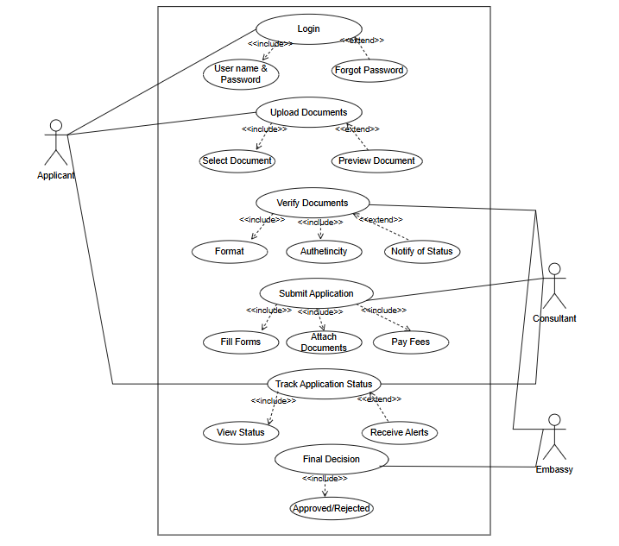

ACTIVITY DIAGRAM
Login Page
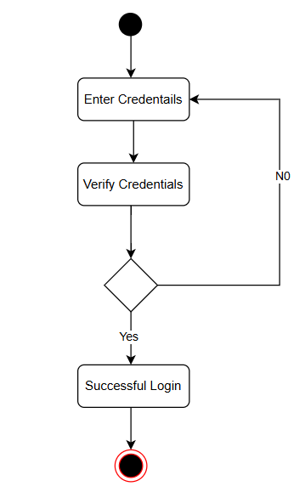
Upload Document
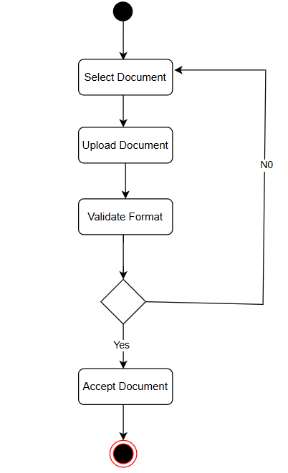

Verify Documents
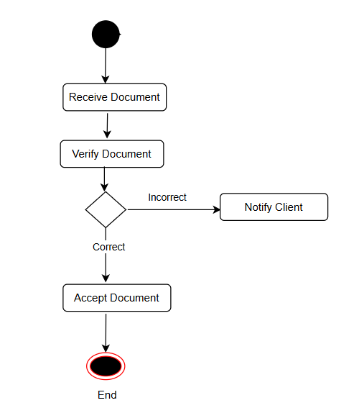
Track Application Status
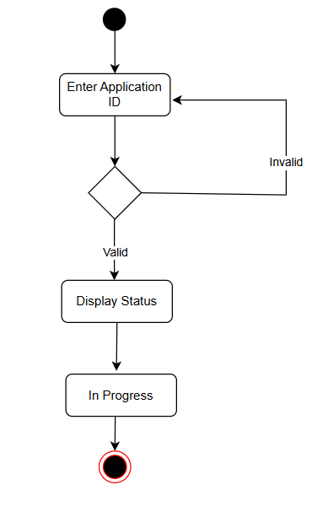

Use Case Specification
Use Case Name: Submit Immigration Service Request
Primary Actor(s): Applicant / Immigration Applicant
Supporting Actors: Immigration Agency Staff, System Admin, External Verification Systems (if needed)
Preconditions: Applicant must be authenticated / registered; Relevant immigration category identified; Applicant must have necessary documentation; System available and service request feature enabled.
Postconditions: Request is submitted; Applicant receives acknowledgement; Internal case/request ticket is created; immigration staff notified; further workflow initiated (e.g. review, verification).
Basic Flow:
1. Client logs in.
2. Client selects "Immigration Services."
3. Client fills service request form.
4. Client uploads documents.
5. System validates and saves the request.
6. Consultant receives notification.
Alternate Flows: AF1: Missing documents → system asks client to re-upload.
AF2: Payment required → system redirects client to payment gateway.
Exceptional Flows: EF1: System downtime → request cannot be submitted.
EF2: Invalid login → access denied.
Inputs: Client details, service request info, uploaded documents.
Outputs: Confirmation message, request ID, consultant notification.
Business Rules: 1. Requests must be accompanied by valid documents.
2. Payment must be completed before processing (if applicable).

Use Case Name: Upload Documents
Primary Actor(s): Applicant
Supporting Actors: System / Document Management Module, Immigration Agency Staff, External Storage/Verification Systems (if needed)
Preconditions: User is authenticated / logged in; user has an active case/application; user has the documents in digital form; system is available; user has permission to upload documents for this case.
Postconditions: Documents are stored; linked to user’s case; user gets confirmation; documents are available for staff review; versioning, if applicable, is maintained; any metadata stored.
Basic Flow:
1. Client selects “Upload Documents.”
2. Client uploads files (passport, ID, financials).
3. System validates format and size.
4. System confirms upload success.
5. Consultant is notified.

Alternate Flows: AF1: Invalid format/size → system rejects and prompts re-upload.
Exceptional Flows: EF1: Upload failure due to poor network → system notifies client.
Inputs: Passport, ID proof, financial documents, supporting files.
Outputs: Upload confirmation message, file records in the system.
Business Rules: 1. Only supported formats (PDF, JPG, PNG).
2. File size must not exceed system limits.
Dependencies: Document Management System, Notification Module

Use Case Name: Track Application Status
Primary Actor(s): Applicant / Immigration Applicant
Supporting Actors: Immigration Agency Staff, System Administrator
Preconditions: Applicant has submitted an immigration application / request; Applicant has credentials / identifier(s) required to track status (e.g. case number, login account). System stores application status and updates it at stages.
Postconditions: Applicant can view the current status of their application; relevant status history / timeline visible; any next steps or outstanding items shown.
Basic Flow:
1. Client logs into the system.
2. Client navigates to “Track Application.”
3. System retrieves the current status.
4. Status is displayed (Submitted, In Process, Approved, Rejected).
Alternate Flows: AF1: No updates available → system shows “Pending.”
Exceptional Flows: EF1: Embassy system unresponsive → system shows “Status temporarily unavailable.”
Inputs: Client request ID.
Outputs: Status display, timeline of updates.
Business Rules: Only authenticated clients can view their own application status.
Dependencies: Consultant updates, Embassy/Government System API

Use Case Name: Make Payment
Primary Actor(s): Applicant /Payer
Supporting Actors: Payment Gateway / External Payment Processor, Bank / Card Network, System Administrator, Notification System
Preconditions: Applicant is logged in / authenticated; Applicant has an application or transaction pending requiring payment; The amount due is known; Payment module is enabled and functional; Applicant has valid payment instrument (card, bank account, digital wallet, etc.).
Postconditions: Payment is captured or scheduled; System updates transaction/application status; Receipt or confirmation generated; Applicant is notified; Accounting records updated.
Basic Flow:
1. Client selects “Make Payment.”
2. System redirects to payment gateway.
3. Client enters payment details.
4. Payment gateway processes transaction.
5. System records payment and generates receipt.
6. Client receives confirmation.
Alternate Flows: AF1: Payment failure → system notifies client to retry with another method.
Exceptional Flows: EF1: Payment gateway timeout → transaction cancelled.
Inputs: Service request ID, payment details (card, UPI, net banking).
Outputs: Payment confirmation, receipt, updated request status.
Business Rules: 1. Services are processed only after successful payment.
2. All transactions must be logged for audit.
Dependencies: Payment Gateway, Admin Reconciliation Module, Notification Module

Document 7- Screens and pages
TrueNorth Immigration Consultants – Wireframes
Login / Sign Up Page
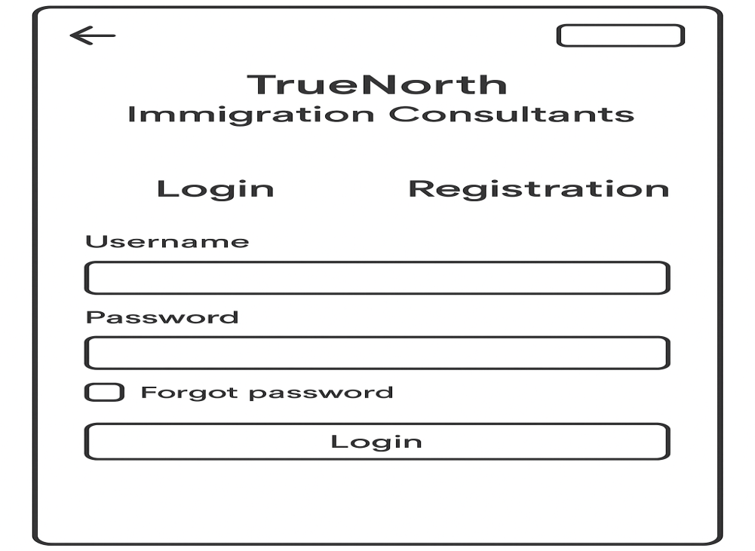
Home Page
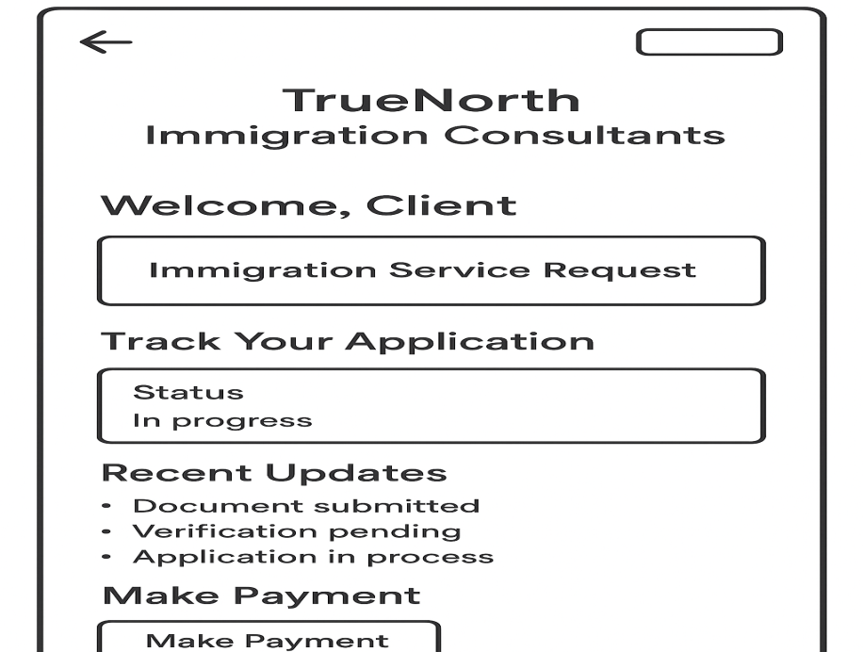
Services Page
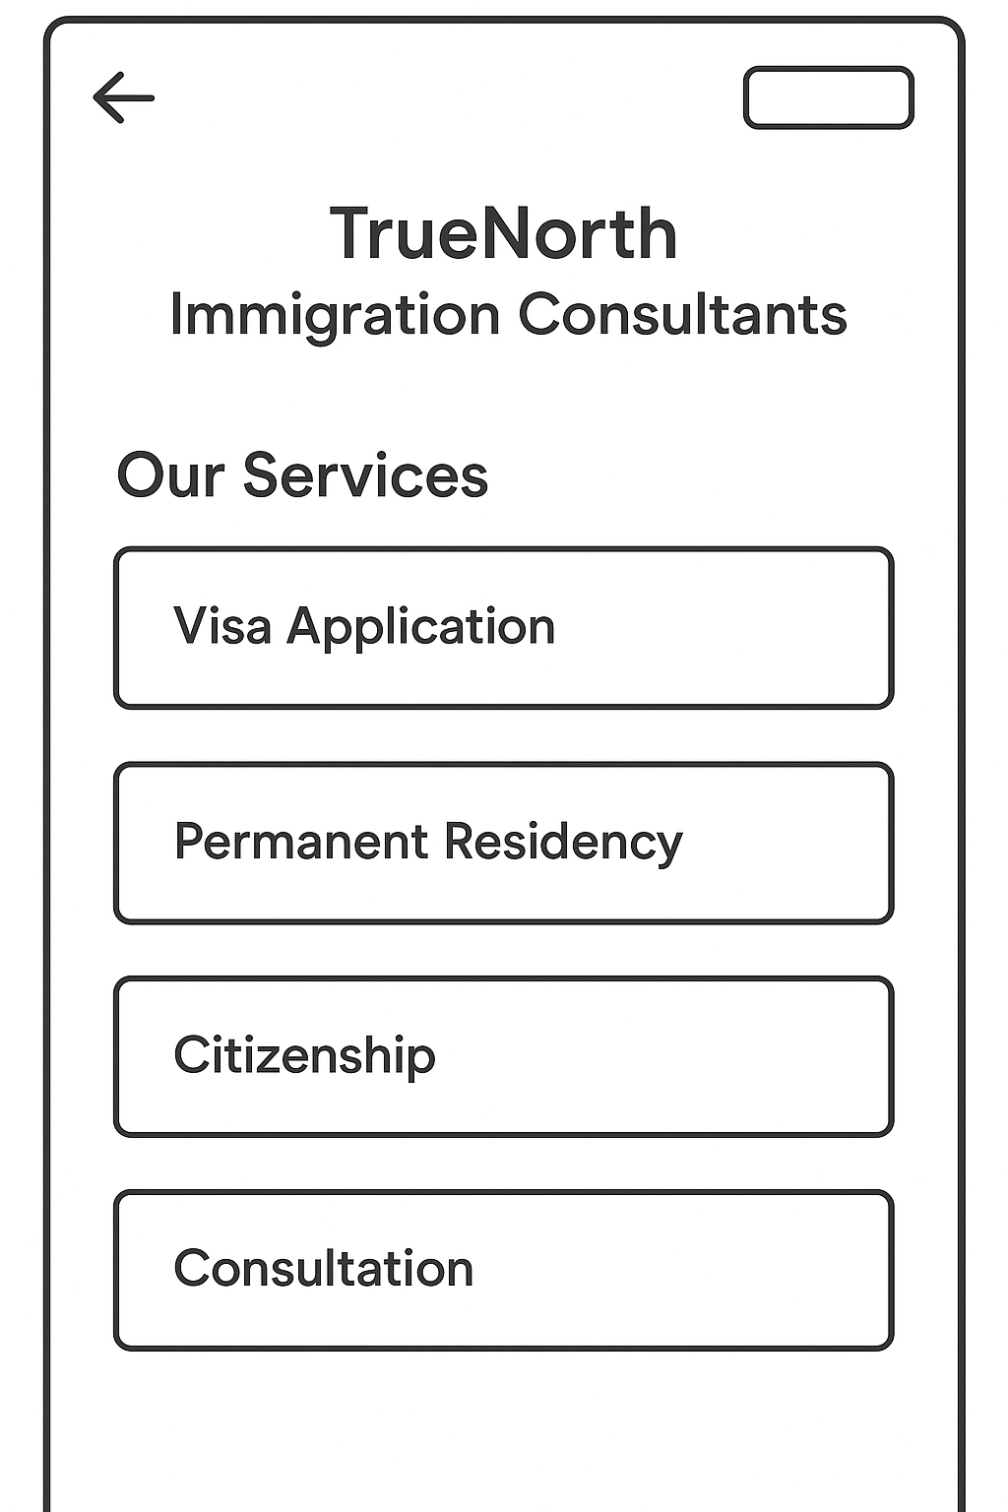

Upload Documents Page
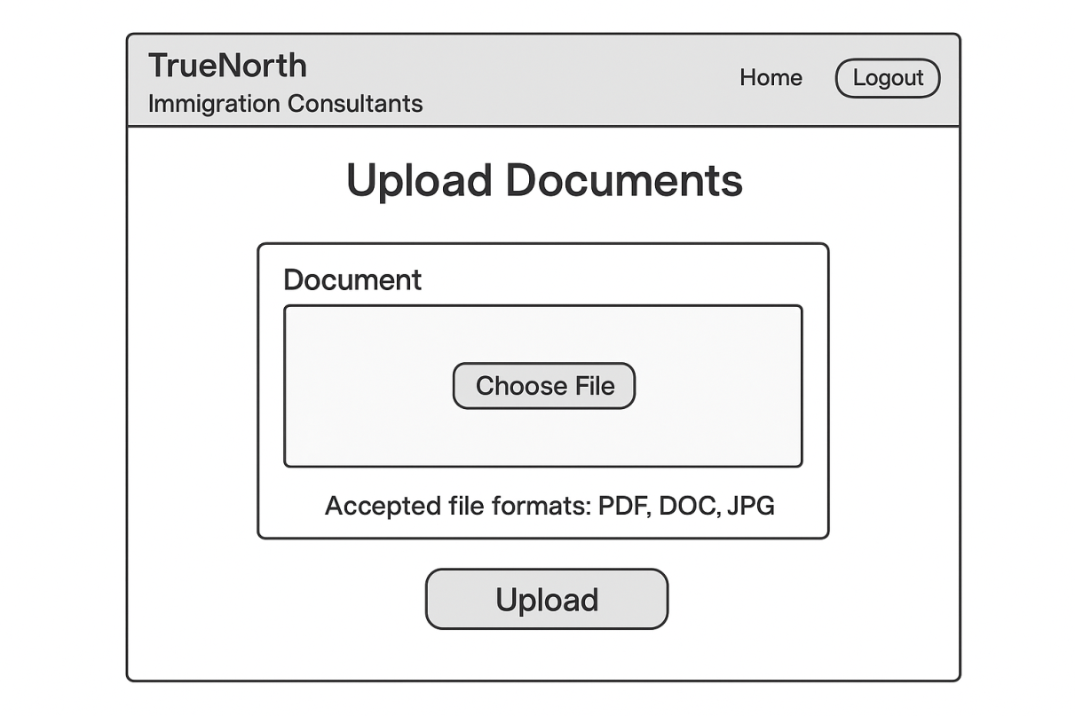
Make Payment Page
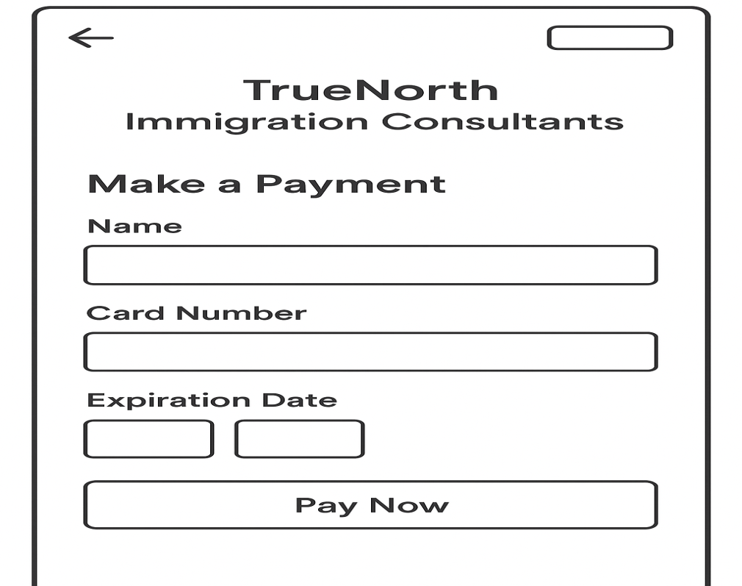

Document 8- Tools-Visio and Axure
Using Visio for the project was a straightforward experience. Its intuitive interface allowed me to quickly create diagrams and flowcharts to visualize the project's architecture and processes. I found it easy to drag and drop shapes, connect them with arrows, and add text to explain each step. Visio's templates also helped me get started quickly, saving time and effort. Overall, Visio proved to be a reliable tool for creating clear and detailed diagrams and enhancing communication and understanding among team members.
Using Axure for the project was a game-changer. Its powerful prototyping capabilities allowed me to create interactive mock-ups of the project's user interface with ease. Axure's drag-and-drop interface made it simple to design each screen and add interactive elements such as buttons, forms, and navigation links. Testing the prototypes in Axure helped identify usability issues early in the development process, leading to smoother user experiences. Overall, Axure proved to be an invaluable tool for designing and refining the project's user interface, ultimately improving its usability and functionality.
Document 9- BA experience
My experience as a BA in the following phases:
- Requirement gathering:
- To gather requirements, we used the MOSCOW technique.
- Engaged stakeholders through interviews, surveys, and workshops.
- Captured comprehensive requirements to align with business goals.
- Ensured clarity and understanding of stakeholder needs and objectives.
- I validate the requirements using the FURPS technique.
- There are many requirements, which are duplicated or repeated. We need to remove them immediately.
- Requirement Analysis:
- We need to draw UML diagrams to visually describe the requirements.
- Activity diagrams are also used to describe the process flow
- Identified dependencies, priorities, and potential challenges.
- Established traceability between requirements and business objectives.
- Prepare BRS and SRS.
- Design:
- From the use case diagrams, we prepare test cases.
- Communicate with the client on design and solution documents
- Created mock-ups and prototypes using tools like Axure and Visio.
- Iteratively refined designs based on stakeholder feedback.
- Ensured designs were user-friendly, intuitive, and aligned with business goals.
- Documented design decisions and rationale for future reference.

- Development:
- Organized JAD sessions
- Worked closely with the development team to provide clear documentation.
- Ensured accurate implementation of design specifications.
- Addressed any questions or concerns from the development team.
- Collaborated on technical solutions to meet project requirements.
- Monitored progress and guided throughout the development process.
- Conduct regular meetings with the technical team and client, which is challenging. Some team members might not be available for the meeting. Recording the session providing that to the missed one and having to one-on-one discussion later with that missed person is all we need to do.
- Testing:
- Developed test plans and scenarios in collaboration with QA teams.
- Conducted regression testing to verify fixes and changes.
- Identified and reported defects, ensuring timely resolution.
- Worked closely with QA teams to prioritize and address issues.
- Updated RTM.
- Take signoff from the client.
- Prepare client for UAT.

- Deployment:
- Coordinated the rollout of the project to ensure a smooth transition.
- Conducted user-training sessions to facilitate the adoption of the solution.
- Communicated updates and progress to stakeholders.
- Ensured project documentation and knowledge transfer for ongoing support and maintenance.
- Make sure all the candidates attend the meeting.
- Coordinates to complete and share end user manuals.

