Assignment 1:

1. Please make a BRD which can be presented to the client along with complete development and resource plan.

ANSWER:-
Project Overview:- The client is a leading manufacturer of ice cream and milk products with manufacturing units and warehouses across the country. To ensure streamlined operations and enhanced customer satisfaction, the client intends to develop a centralized software system with the following objectives:
- Efficient Inventory Management across plants and warehouses.
- Fast and Optimized Customer Delivery using intelligent route and order dispatch mechanisms.
Problem:-
- Difficulty in tracking perishable inventory (milk, ice cream) across multiple warehouses and manufacturing plants in real time
- Milk and ice-cream having a short life it is very difficult to store these item for ling time
- Customer required a fresh milk and ice –cream
- It is affecting on quality of the item
- Day by day negative review are increasing
- It lead to wastage, stock out and over stock
Effected on time delivery
Business Objectives:-
- Reduce product wastage due to poor stock tracking.
- Ensure real-time visibility of inventory at all locations.
- Deliver products to customers in the shortest possible time.
- Automate order dispatch based on stock availability.
- Customer satisfaction
- Avoid the wastage and overstock
- Disconnected systems or manual tracking between plants, warehouses, and central offices.
Opportunity:-
- After the implementation only fresh and quality product will be delivery
- According to the city we set the min time for delivery
- Customer will be happy
- Increase the positive feedback and it will be effected on the business revenue
- It will save the cost of the storage
- The inventory will be on track

Goal :-
- Inventory should be on track
- All the inventory and tracking will be centralised
- Take a minimum time for product delivery
- Fresh and quality item will be provided
- Customer satisfaction
- Increase the positive publicity
- Generate the business revenue

PROJECT SCOPE:-
In-Scope:
- Web-based inventory management dashboard.
- Customer order management system.
- Delivery module with GPS-based routing and delivery tracking.
- Admin panel with user role management.
- Reporting module (stock, orders, delivery time, etc.)
Out-of-Scope:
- Manufacturing process control system.
- Customer billing and invoicing.
- In-app customer payments.
RISK:-
Technical risk:-
Risk Description | Likelihood | Impact | Strategy | Plan
app not compatible with certain Android/iOS versions | Low | Medium | Mitigate | Test on a range of supported OS versions,define minimum spec

Skill risk:-
Risk Description | Likelihood | Impact | Strategy | Plan
The development team may not have prior experience with inventory systems or logistics optimization | Medium | High | Mitigate | Provide hands-on training sessions for warehouse and delivery teams.
delivery staff may not be comfortable using mobile tracking or order delivery apps. | Medium | High | Transfer | Hire or consult domain experts in logistics and inventory systems.
Warehouse operators might struggle to shift from manual stock management to digital systems. | High | Medium | Mitigate | Use intuitive UI/UX to minimize the learning curve.

Political risk :-
Risk Description | Likelihood | Impact | Strategy | Plan
Changes in food safety regulations, especially for dairy and frozen products (e.g., cold chain requirements | Medium | High | Mitigate | Ensure the system is flexible to quickly adapt to regulation updates.
New rules around interstate transport or warehousing licenses. | Medium | High | Transfer | Maintain contact with compliance officers or government advisors.
Potential fuel price hikes or transport policy changes impacting delivery costs. | High | Medium | Mitigate | clude alert and notification systems for regulation updates.
Requirement risk :-
Risk Description | Likelihood | Impact | Strategy | Plan
Stakeholders may give ambiguous requirements | Medium | High | Mitigate | Conduct detailed requirement elicitation workshops with all stakeholders..
some processes (like cold storage tracking) may be undocumented, leading to system gaps. | Medium | High | Transfer | Use prototypes or mock ups to validate understanding early..
Requirements may change mid-project due to operational needs or feedback from users.impacting delivery costs. | High | Medium | Mitigate | mplement a change control process to manage evolving needs..
Other risk :-
Risk Description | Likelihood | Impact | Strategy | Plan
Weather conditions affecting delivery routes, especially for ice cream. | Medium | High | Mitigate | Use cloud backup and data recovery strategies.
Hardware failures | Medium | High | Transfer | Pilot the system in one region before full rollout.
Data loss during migration from Excel/manual systems to the new platform | High | Medium | Mitigate | Have contingency plans for manual fallback during system outages...
Business rule:-
Rule ID | Rule Description
BR-001 | Ensures older stock (especially perishable items like milk) is dispatched first to reduce spoilage.
BR-002 | Stock that is close to expiry (e.g., within 5 days) must be flagged for fast movement or discounting
BR-003 | Ensures visibility and prevents overstocking or stock outs at any plant/warehouse.
BR-005 | Maintains fast delivery standards and customer satisfaction
BR-006 | Reduces transportation cost and improves delivery efficiency.
BR-007 | Prevents data manipulation or unauthorized stock changes.
BR-008 | Ensures product quality, especially for ice-cream, which is highly temperature-sensitive
BR-009 | Helps with timely replenishment to avoid shortages.
BR-010 | Batch numbers and expiry dates must be recorded during stock entry.
BR-011 | Helps in identifying slow-moving stock and making business decisions (e.g., discount, transfer, or remove).
BACKGROUND:-
The client is a leading manufacturer of ice-cream and milk products with multiple manufacturing plants and warehouses located across the country. Currently, the company's inventory and delivery processes are managed through a combination of manual tracking, spreadsheets, and disconnected legacy systems. This fragmented approach has led to:
- Inventory inconsistencies across warehouses and production units.
- Delays in delivery, especially in managing time-sensitive products like ice-cream.
- Lack of real-time visibility into stock levels, expiry dates, and product movement.
- Difficulty in demand forecasting, resulting in either overstocking or stockouts.
- Customer dissatisfaction due to late deliveries and unavailability of popular SKUs.

PROJECT OBJECTIVE:-
- Unified visibility of stock across all warehouses and plants.
- Automated tracking of stock levels, batch numbers, and expiry dates.
- Low stock alerts and intelligent replenishment triggers.
- Fast and efficient route planning using GPS and logistics algorithms.
- Delivery tracking for both internal staff and end customers.
- Integration with cold chain monitoring systems to ensure temperature control during transit
- Minimized manual intervention through automation.
- Improved coordination between production, warehouse, and delivery teams.
- Data-driven insights to support decision-making and demand forecasting.
Legacy system (AS IS)
- inventory is tracked using Excel sheets or paper-based logs at each plant and warehouse.
- Stock updates are done manually and may not reflect real-time availability.
- There is no centralized view of stock across multiple locations.
- Expiry dates and batch numbers are often not tracked properly, leading to wastage or compliance risks.
- Stock discrepancies are common due to human error or delays in updates.
- Delivery schedules are planned manually based on staff knowledge or fixed routes.
- No route optimization — deliveries may not follow the most efficient paths.
- No real-time tracking of delivery vehicles or delivery confirmation.

Proposed recommendation (to be):-
- Automated tracking of batch numbers, expiry dates, and stock movements.
- Low stock alerts and reorder suggestions based on usage patterns.
- Role-based access control to ensure data security and audit trails.
- Orders entered through a centralized dashboard (web or mobile).
- Integrated route optimization engine using GPS maps to suggest fastest delivery paths.
- Mobile app for drivers with live delivery schedules and epode (electronic proof of delivery).
- Integration with cold chain monitoring devices for temperature tracking.
- Advanced reporting and analytics on stock turnover, wastage, delivery timelines.
- Integration with existing ERP/accounting tools (if applicable).
- Scalable to support future expansion or new product lines.
- as delivery, lower fuel cost, better route management
- Real-time updates, less manual error
- Data-driven insights via dashboards and analytics
BUSINESS REQUIRMENT:-
Req. ID | Requirement | Priority | Category | Explanation
BR-01 | Centralized Inventory Management Module | High | Functional | The system must track stock across all plants and warehouses in real-time.
BR-02 | Batch and Expiry Tracking for all products | High | Functional | Products must be tagged with batch numbers and expiry dates to reduce wastage.
BR-03 | Low Stock Alerts | Medium | Functional | The system should trigger notifications when stock falls below a predefined level.
BR-04 | Order Management Module | High | Functional | Capture, update, and monitor orders from distributors or retailers.
BR-05 | Route Optimization for Deliveries | High | Functional | Delivery routes must be automatically optimized based on location and order priority.
BR-06 | Delivery Tracking and ePOD (Proof of Delivery) | High | Functional | Real-time tracking of vehicles and electronic confirmation from customers upon delivery.
BR-07 | Cold Chain Monitoring Integration | Medium | Integration | Monitor and log product temperature during transportation using IoT or sensors.
BR-08 | Role-Based User Access | Medium | Security | Define permissions for admins, warehouse staff, drivers, etc., to control access.
BR-09 | Reporting & Analytics Dashboard | High | Reporting | Provide dashboards for stock status, delivery performance, expiry risk, etc.
BR-10 | System Notification and Alerts | Medium | Functional | Notify users for delays, expired stock, missed delivery, etc.
BR-11 | Mobile Application for Drivers and Warehouse Staff | Medium | Functional | Allow drivers to check routes and orders; warehouse staff to scan and update stock.
BR-12 | Integration with ERP or Accounting Systems (Optional) | Low | Integration | Sync inventory and order data with existing finance/accounting software.
BR-13 | User-Friendly Interface | High | Usability | The system should be simple and intuitive, even for non-technical users.
BR-14 | Audit Trail and History Log | Medium | Compliance | Maintain logs of all changes made to inventory and orders for traceability.

DOCUMENT RIVISION CHART:-
Date | Version Number | Document Changes
05-06-2025 | 0.1 | Initial draft of Business Requirements Document (BRD)
06-06-2025 | 0.2 | Added core business objectives, scope boundaries, and assumption list
15-06-2025 | 0.3 | Added functional requirements for inventory, delivery, routing, and reporting modules
22-06-2025 | 0.4 | Incorporated stakeholder feedback on system security, compliance, and mobile access
30-06-2025 | 0.5 | Updated risks section (skills, political, requirement, other), and refined TO-BE flow
10-07-2025 | 0.6 | Completed RACI chart, resource plan, and included AS-IS vs TO-BE process comparison
15-07-2025 | 1 | Finalized document after stakeholder review for development phase

RACI CHART:-
Name | Position | * | R | A | S | C | I
MR vijay | Project Sponsor (Client Side) | ✓ |  | A |  | C | I
Ms. Anita Sharma | Business Owner (Client Side) |  |  |  |  | R | A
Mr.Mayank paliwal | Project Manager (IT Side) | ✓ |  | A | R | C | I
Ms. Shruti Parashar | Business Analyst (IT Side) |  | R |  | S | C | I
Mrs Shraddha muley | System Architect (IT Side) |  |  |  | S | C | I
Aarya | Development Lead (IT Side) |  |  |  | S | C | I
Ovi | UX Lead (IT Side) |  |  |  | S | C | I
Mr. Nitin Rao | QA/Testing Lead (IT Side) |  |  |  | S | C | I
ATAHNAG | Content Strategist (IT Side) |  |  |  | S | C | I

Resources :-
Role | Quantity | Involved in
Business Analyst | 1 | Requirement phase
UI/UX Designer | 1 | Design phase
Backend Developers | 2 | Development phase
Frontend Developers | 2 | Development phase
QA Engineers | 1 | Testing & UAT
DevOps Engineer | 1 | Deployment
Project Manager | 1 | Full duration
Warehouse Manager | 3 | Requirement phase
3rd party tool | 2 | Design phase

APPROVALS:-
Role | Name | Title | Signature | Date
 | Ram sharma |  |  | 01/06/2025
  Project Sponsor
  Head – All manufacturing plant
 |  |  |  | 01/06/2025
  Business Owner
  Ms. Anita Sharma
  VP – Customer Experience
 | MAYANK PALIWAL |  |  | 02/06/2025
  Project Manager
  IT Project Manager
System Architect | SHRUTI PALIWAL |  |  | 03/06/2025
  Enterprise Architect
Development Lead | Shraddha muley |  |  | 07/06/2015
  Backend Development Lead
User Experience  Lead | Aarya |  |  | 08/06/2025
  UX/UI Lead Designer
 | Ovi |  |  | 10/06/2015
  Quality Lead
  QA & Testing Lead
 | ATAHNAG |  |  | 15/06/2025
  Content Lead
  Digital Content Strategist

List of Acronyms
Acronym | Full Form
BRD | Business Requirements Document
GPS | Global Positioning System
SKU | Stock Keeping Unit
UAT | User Acceptance Testing
API | Application Programming Interface
POD | Proof of Delivery
ePOD | Electronic Proof of Delivery
FIFO | First-In First-Out
KPI | Key Performance Indicator
ETA | Estimated Time of Arrival
WMS | Warehouse Management System
TO-BE | Future State
AS-IS | Current State

2. Prepare process flow diagram using your imagination.
ANSWER:-
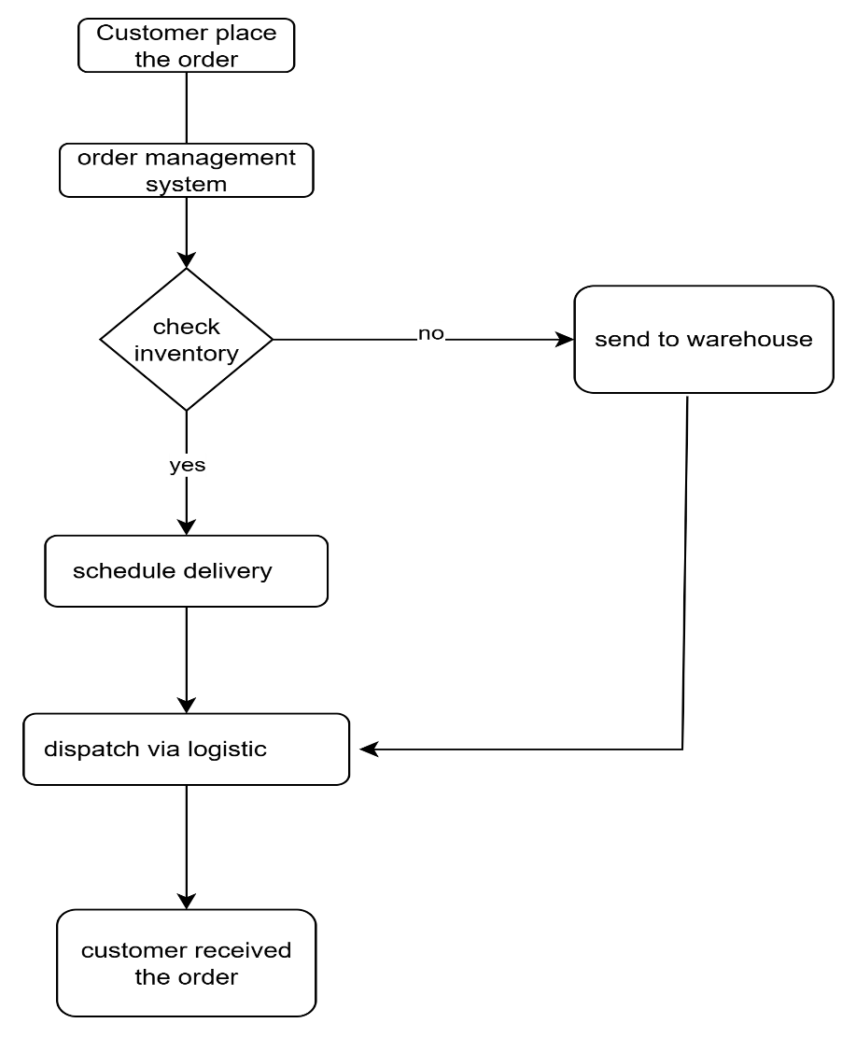

Assignment 2:-
Write an introduction letter to a client introducing yourself as a business analyst in charge of working with the client and his team to start the business understanding process.

ANSWER:-
Subject: Introduction & Kick-off of Business Understanding Phase
Dear Mayank Paliwal
I hope this message finds you well.
My name is Shruti Parashar, and I am pleased to introduce myself as the Business Analyst assigned to your project regarding the development of a software solution to manage inventory and enable the quickest delivery of your ice cream and milk products across the country.
I will be working closely with you and your team to gather detailed business requirements, understand your operational goals, and ensure that the final solution aligns with your expectations and business vision.
Our initial focus will be on:
- Understanding your current processes in inventory management and delivery.
- Identifying areas of improvement and automation.
- Collaborating with stakeholders across your manufacturing plants, warehouses, and distribution channels.
- Defining clear, actionable, and prioritized business requirements to guide our design and development phases.
Over the next few days, I would like to schedule a kick-off meeting with you and key members of your team to start the business understanding and requirement gathering process. I will be sharing an agenda shortly for your review.
Please feel free to share any documents, system overviews, or process flows that could help me get a head start on understanding your operations.
Looking forward to a successful collaboration and delivering a solution that supports your business growth and customer satisfaction goals.
Warm regards,
[Shruti Parashar]
Business Analyst
[Infosys company]
[Shruti.p0991 @infosis.co]
9222888834

2. Prepare a brief BRD and SRS for a project- Horoscope or Ticketing system or online store
ANSWER:-
PROJECT TITLE – BOOK MY SHOW
Business Objective:- The Online Ticketing System aims to provide a centralized platform for users to book tickets for concerts, movies he system will simplify ticket purchasing, cancellation, and customer service interactions.
The “Book My Show” online ticketing system is designed to offer users a seamless and convenient platform to book tickets for movies, concerts, and live events. The system will support real-time booking, secure payment, ticket cancellations, and provide customer service functionalities. It will cater to individual customers and event organizers.

Business Goals :-
- Provide a centralized platform for booking entertainment tickets.
- Reduce manual booking processes and long queues at ticket counters.
- Increase customer satisfaction with a user-friendly and responsive system.
- Enable event organizers to manage listings and track bookings.
Business Objectives :-
- Ensure 24/7 online ticket availability.
- Support high traffic during blockbuster releases or major events.
- Reduce ticket fraud by generating secure e-tickets with QR codes.
- Implement loyalty and promotional features like discount codes or referral bonuses.
Business rules :-
Rule ID | Rule Description
BR-001 | A user can only book a maximum of 10 tickets per show.
BR-002 | Refunds are allowed only within 24 hours before the even
BR-003 | One registered email per user account.
BR-004 | Organizers must register and get approval before listing events.
BR-005 | Maintains fast delivery standards and customer satisfaction
BR-006 | A single seat cannot be left vacant between two booked seats in theatres
BR-007 | Users can only book for active and upcoming events
BR-008 | For popular events, bookings will open only at a specified date and time
BR-009 | Only digital payments are accepted
BR-010 | Partial cancellations are allowed only if the event supports it.
BR-011 | convenience fee is non-refundable even on ticket cancellations.
BR-012 | Each ticket will contain a unique QR code to prevent duplication.
BR-013 | Tickets must be presented (physically or digitally) for event entry.
BR-014 | One ticket = one entry only
BR-015 | QR codes can only be scanned once at the venue.
BR-016 | Users must receive confirmation notifications via email and SMS after each booking.
BR-017 | Users must receive reminder notifications 24 hours before the event.
BR-018 | System must alert users if a booking fails or is timed out.

Background:-
In recent years, the demand for online services has increased significantly due to digital transformation, convenience, and smartphone adoption. The traditional method of booking tickets through counters involves long queues, limited availability, and manual processing, leading to customer dissatisfaction.
With the rise of entertainment events such as movies, concerts, sports matches, stand-up comedy shows, and theater performances, there is a growing need for a centralized online ticketing system that can cater to both customers and event organizers. Customers prefer platforms that allow them to quickly browse events, compare prices, select seats, make payments securely, and receive tickets instantly.
At the same time, event organizers require tools to manage listings, monitor ticket sales, set pricing, and ensure smooth operations.
The "Book My Show" system aims to bridge this gap by offering a robust, scalable, and user-friendly online platform that serves both customers and event managers.
Project Objective:-
- To create a centralized and secure system for ticket booking across different event categories.
- To ensure real-time ticket availability with dynamic seat selection.
- To provide a seamless user experience through mobile-responsive design and simple navigation.
- To integrate secure payment gateways for hassle-free transactions.
- To allow event organizers to register, list events, monitor sales, and manage seat availability.
- To include automated email/SMS notifications for confirmations, reminders, and cancellations.
- To enable data tracking and reporting for both admins and organizers for decision-making and audits.
- To build a scalable architecture that can handle peak booking hours and sudden traffic spikes
Project Scope:-
In Scope Functionalities:-
- User registration and login
- Event search and filtering by city, type, date
- Seat selection and ticket booking
- Payment gateway integration
- E-ticket generation with QR code
- Booking cancellation and refund processing
- Admin and Organizer Dashboards
- Notification system (email/SMS)
Out of Scope Functionalities
- On-ground event coordination
- Offline ticket sales or box office support
- Logistics and crowd management at venues
Assumptions:-
- Users will have access to a stable internet connection.
- Event organizers will upload accurate event details.
- Third-party APIs for payment and SMS will be functional.
Constraints:-
- Integration with only pre-approved payment gateways.
- Initial version to support only English language.
- Data storage must comply with local data protection laws.

RISK:-
Technical risk:-
Risk Description | Likelihood | Impact | Strategy | Plan
Failed bookings | Medium | High | Mitigate | Use the optional web site
Server overload during high-demand events.. | Medium | High | Transfer | Hire or consult domain experts in logistics and inventory systems.
Compatibility issues across mobile and web platforms. | High | Medium | Mitigate | Better internet services should be there

Skills Risks
Risk Description | Likelihood | Impact | Strategy | Plan
Fail to handle edge cases | Medium | High | Mitigate | Use the optional web site
Customer like senior citizen not able to book the ticket | Medium | High | Transfer | Provide the video or instruction in chat box

Political Risks:-

Risk Description | Likelihood | Impact | Strategy | Plan
Booking limits | High | High | Mitigate | Ensure legal and compliance teams review local regulations
Event approvals | Medium | High | Transfer | build regional flexibility into the system.

Business Risks
Risk Description | Likelihood | Impact | Strategy | Plan
Failure to Attract Enough Event Organizers at Launch | low | low | Mitigate | Create attractive onboarding offers, conduct outreach, and offer dashboards with powerful tools for organizer
Revenue will be low | Medium | High | accept | build regional flexibility into the system.

Other Risks:-

Risk Description | Likelihood | Impact | Strategy | Plan
Automate mass bookings to resell tickets | High | medium | Mitigate | rate limiting, secure payment gateways, and encrypted QR code validation.
Revenue will be low Legal Risks Due to Incorrect Event Information or Cancellation Policies | Medium | High | accept | require organizer verification, display clear T&Cs, and automate refund processing as per policy.

Legacy System (As-Is):-
- Offline Ticket Counters: Users must visit physical locations (cinema halls, concert venues) to purchase tickets.
- No Centralized Platform: Event information is scattered—different websites, posters, or local advertisements.
- Limited Access to Seat Information: Customers cannot view real-time seat availability; often rely on box office personnel.
- Manual Payments: Payments are made in cash or via POS terminals with limited refund flexibility.
- No Real-Time Updates: Users do not receive instant booking confirmations or alerts for schedule changes.
- Poor Customer Experience: Long queues, last-minute cancellations without notice, and limited cancellation/refund options.
- Limited Reach: Event organizers rely heavily on local promotion and walk-ins; limited ability to scale to larger audiences.
Proposed Recommendation (To-Be System) :-
- Centralized Online Booking: One platform for booking tickets to movies, concerts, plays, sports, etc.
- Real-Time Seat Availability: Interactive seat maps with live availability updates.
- Secure Digital Payments: Integration with payment gateways (UPI, net banking, wallets, cards).
- Automated Confirmation: Email and SMS notifications for bookings, cancellations, and reminders.
- Mobile-Friendly Interface: Fully responsive website and mobile app for easy access.
- Cancellation and Refund Mechanism: Defined policies for event cancellation or user-initiated cancellation.
- Dashboard for Organizers: Tools for event creation, pricing, seat management, and analytics.
- Data Analytics and Reports: Real-time reports on ticket sales, customer demographics, and event performance.
- Promotions and Offers: Support for discount codes, cashback offers, and loyalty rewards.
- Security Features: Unique QR codes for each ticket, fraud detection, and encryption of sensitive data.

Business requirement:-
Req. ID | Requirement | Priority | Category | Explanation
BR-01 | User Registration & Login | High | Functional | The system must allow users to register and securely log in to access ticket booking features.
BR-02 | Event Search and Filter | High | Functional | Users should be able to search for events by type, location, date, and apply filters.
BR-03 | Real-Time Seat Availability | High | Functional | The system must display real-time availability of seats to avoid double bookings.
BR-04 | Ticket Booking and Payment | High | Functional | Users should be able to select seats, confirm booking, and pay using various payment options.
BR-05 | Booking Confirmation and E-Ticket Generation | High | Functional | After successful payment, the system should generate a digital ticket and send it to the user.
BR-06 | Booking History and Management | Medium | Functional | Users should be able to view, download, or cancel their past bookings.
BR-07 | Admin Panel for Event Management | High | Functional | Admins must be able to create, update, and delete events and monitor ticket sales.
BR-08 | Notification System | Medium | Functional | System should send booking confirmations, reminders, and promotional emails/SMS.
BR-09 | Discount and Promo Code Management | Medium | Functional | Admins should be able to configure promotional codes and users should be able to apply them.
BR-10 | Multi-device Compatibility | Medium | Non-Functional | The application must be responsive and work seamlessly on mobile, tablet, and desktop.
BR-11 | Secure Payment Gateway Integration | High | Non-Functional | The system must ensure secure payment transactions through trusted payment gateways.
BR-12 | Data Privacy and User Information Security | High | Non-Functional | The platform must comply with data protection regulations and ensure user data is secure.

Date | Version Number | Document Changes
15-07-2025 | 0.1 | Initial draft of Business Requirements Document (BRD) created.
17-07-2025 | 0.2 | Added user registration, login, and search/filter requirements.
19-07-2025 | 0.3 | Included real-time seat availability and payment gateway integration.
21-07-2025 | 0.4 | Updated admin panel and notification requirements.
23-07-2025 | 0.5 | Added non-functional requirements like security and compatibility.
24-07-2025 | 1 | Finalized BRD after stakeholder review and approval.

RACI CHART :-

Task / Activity | Business Analyst (BA) | Project Manager (PM) | Development Team (Dev) | QA / Testing Team | UI/UX Designer | Client / Stakeholders
Requirements Gathering | R | A | C | C | C | I
BRD Preparation | A | R | C | I | I | I
SRS Documentation | A | R | C | I | I | I
UI/UX Design | I | I | C | I | A/R | C
Application Development | I | I | A/R | C | C | I
Test Case Design | I | I | C | A/R | I | I
System Testing / UAT | I | I | C | A/R | I | C
Feedback & Approval | C | I | I | I | I | A/R
Project Planning & Timeline Management | C | A/R | I | I | I | C
Deployment & Go-Live | I | A/R | R | C | I | I
Post-Go-Live Support | I | A | R | R | I | I

Approval chart :-

Role | Name | Title | Signature | Date
Project Sponsor | Mr. Arvind Sharma | Director, Strategic Initiatives |  | 01-07-2025
Business Owner | Ms. Priya Mehta | Head of Operations |  | 01-07-2025
Project Manager | Mr. Rajiv Nair | Project Manager |  | 01-07-2025
System Architect | Mr. Sunil Deshmukh | Senior System Architect |  | 03-07-2025
Development Lead | Ms. Kavita Reddy | Lead Developer |  | 03-07-2025
User Experience Lead | Ms. Ayesha Khan | UX/UI Designer Lead |  | 06-07-2025
Quality Lead | Mr. Sandeep Joshi | QA Lead |  | 06-07-2025
Content Lead | Ms. Ritu Sharma | Content Strategist |  | 06-07-2025

3. Make an ERD of creating a support ticket/Ticketing life cycle.

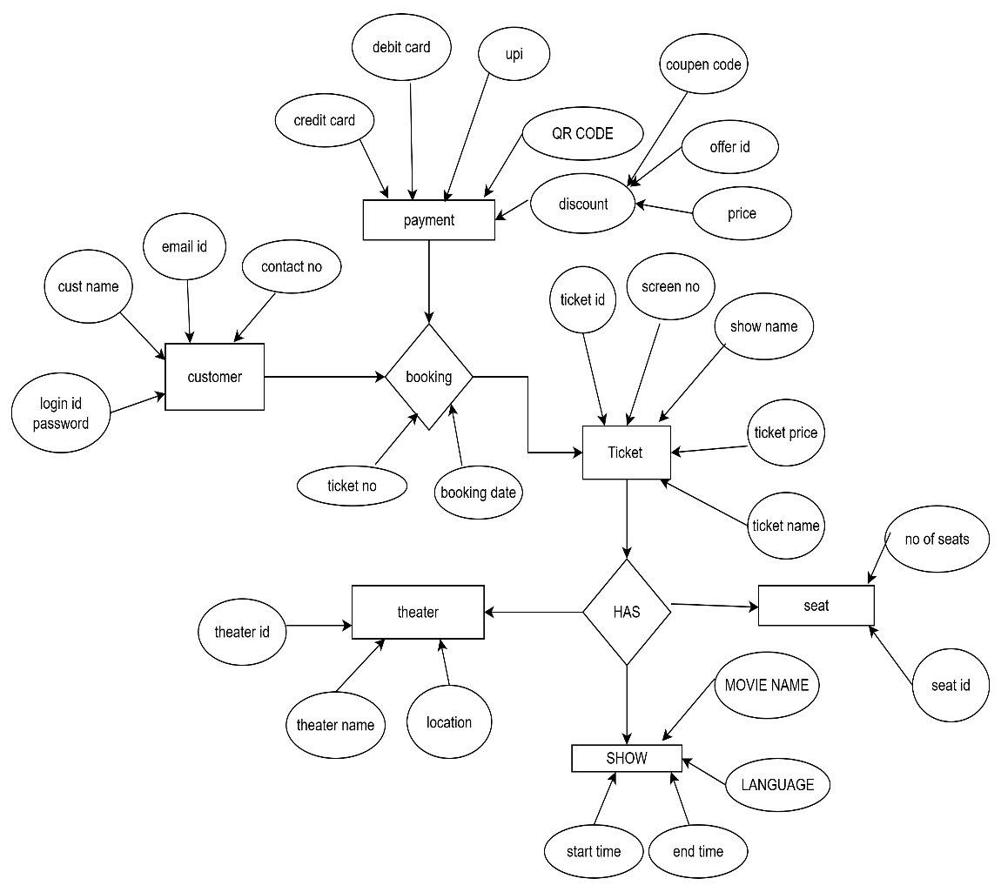

Q4 .User story of shopping from ecommerce
ANSWER:-
USER STORY 1 | TASK -Browse Products |  | PRIORITY- HIGHEST
As a customer,
I want to browse products by category,
So that I can easily find the items I’m interested in.
BV-100 |  | CP-2
ACCEPTANCE CRITERIA

- Products are grouped into categories like clothe jewellery, cosmetics
- User can filter by brand, price, rating, etc.
- User can search by product name or keyword.

USER STORY 2 | TASK -Add to Cart |  | PRIORITY- medium
As a customer,
I want to add products to my shopping cart,
So that I can purchase multiple items at once
BV-200 |  | CP-2
ACCEPTANCE CRITERIA
- Product gets added to cart with selected quantity.
- Cart updates total price in real time.
- User can remove or change quantity from cart.
.

USER STORY 3 | TASK -Place Order |  | PRIORITY- medium
As a customer,
I want to checkout using my saved address and payment method,
So that I can complete my purchase easily.
BV-500 |  | CP-2
ACCEPTANCE CRITERIA
- User sees a summary of items and total price.
- User can select address or enter a new one.
- Multiple payment options available (COD, UPI, Card).
- User receives order confirmation after successful payment.

.

USER STORY 4 | TASK -Track My Order |  | PRIORITY- medium
As a customer,
I want to track the delivery status of my order,
So that I know when to expect it..
BV-500 |  | CP-5
ACCEPTANCE CRITERIA
- Order status updates: Ordered → Packed → Shipped → Out for Delivery → Delivered.
- Delivery estimated date and tracking ID is visible.
- SMS/email notification sent at each stage.
.

.

USER STORY 5 | TASK - Review Product |  | PRIORITY- medium
As a customer,
I want to review and rate the product I purchased,
So that I can help others make informed choices.
BV-500 |  | CP-5
ACCEPTANCE CRITERIA
- User can add star rating (1–5).
- Optional comment box for feedback.
- Only customers who purchased can review.
.

.

USER STORY 6 | TASK -login |  | PRIORITY- HIGHEST
As a user, I want to register with my email and password
so that
I can create an account
BV-200 |  | CP-2
Acceptance Criteria:
- The user must provide a valid email and password.
- Password must meet minimum security criteria.
- User receives a verification email.

USER STORY 7 | TASK -login |  | PRIORITY- HIGHEST
As a user, I want to log in using my credentials
so that
I can access my account.
BV-50 |  | CP-2
Acceptance Criteria:
- User can log in with valid credentials.
- Invalid login attempts display an appropriate error message.
- User is redirected to the dashboard after login

USER STORY 8 | TASK –generate password |  | PRIORITY- HIGHEST
As a user, I want to reset my password if I forget it
so that
I can regain access..
BV-100 |  | CP-2
Acceptance Criteria:
- User receives a reset link via registered email.
- The link allows user to set a new password securely.
- User is notified upon successful reset.

USER STORY 9 | TASK –profile |  | PRIORITY- HIGHEST
As a user,
I want to update my profile details
So that
my information stays current.
BV-100 |  | CP-2
Acceptance Criteria:
- User can edit and save name, phone, and address.
- Changes reflect immediately after saving.
- Validation is performed on input fields.
.

USER STORY 10 | TASK –product search |  | PRIORITY- HIGHEST
As a user, I want to search for products by name
so that
I can find what I’m looking for.
BV-100 |  | CP-5
Acceptance Criteria:
- A search bar is available on the homepage.
- Search results display matching products.
- No results message shown for unmatched keywords.
.

USER STORY 11 | TASK –product search |  | PRIORITY- HIGHEST
As a user,
I want to filter products by price range
so that
I can stay within my budget.
BV-100 |  | CP-3
Acceptance Criteria:
- Price filter is available on category pages.
- Applying filter updates product list.
- User can clear filters anytime
.

USER STORY 12 | TASK –product search |  | PRIORITY- HIGHEST
As a user,
I want to filter products by brand
so that
I can choose my preferred brand.
BV-100 |  | CP-2
Acceptance Criteria:
- Brand filter is shown in side panel.
- Only products of selected brand appear.
- Multiple brand filters can be applied.
.

USER STORY 13 | TASK –sort product |  | PRIORITY- medium
As a user,
I want to sort products by price or popularity
So that
I can make better decisions.
BV-100 |  | CP-2
Acceptance Criteria:
- Sorting options: Low to High, High to Low, and Popularity.
- Product list rearranges as per selected option.
.

USER STORY 14 | TASK –product details |  | PRIORITY- high
As a user,
I want to view detailed information on a product page
so that
I understand what I’m buying..
BV-100 |  | CP-2
Acceptance Criteria:
- Product name, images, description, price, and availability shown.
- Product specs and reviews available on the same page.

USER STORY 15 | TASK –product details |  | PRIORITY- high
As a user,
want to remove items from my cart so that
I can update my purchase.
BV-100 |  | CP-5
Acceptance Criteria:
- User can click “Remove” button to delete an item.
- Cart total updates accordingly.

USER STORY 16 | TASK –summary view |  | PRIORITY- high
As a user,
I want to view a summary of items in my cart
so that
I can review my selections.
BV-500 |  | CP-2
Acceptance Criteria:
- Cart summary shows item name, image, quantity, and price.
- Total cost is displayed at the bottom.

USER STORY 17 | TASK –summary view |  | PRIORITY- high
As a user,
I want to enter my shipping address during checkout
so that
my items are delivered correctly.
BV-50 |  | CP-2
Acceptance Criteria:
- Form for entering address is available.
- Address is validated before proceeding.
- User can save address for future use.

USER STORY 18 | TASK –payment |  | PRIORITY- high
As a user,
I want to choose a payment method
so that
I can complete the purchase.
BV-20 |  | CP-2
Acceptance Criteria:
- Options include credit/debit card, UPI, net banking, and COD.
- Selected method processes payment successfully.

USER STORY 19 | TASK –discount |  | PRIORITY- high
As a user,
I want to apply a promo code
so that
I can get a discount.
BV-200 |  | CP-5
Acceptance Criteria:
- Input for promo code is available.
- Valid code applies discount immediately.
- Invalid code shows error.

USER STORY 20 | TASK –confrimation |  | PRIORITY- high
As a user,
I want to receive an order confirmation email
so that
I know my purchase was successful.
BV-200 |  | CP-5
Acceptance Criteria:
- Email is sent with order ID and item list.
- Email is sent immediately after payment.

USER STORY 21 | TASK –confrimation |  | PRIORITY- high
As a user,
I want to track the shipping status of my order
so that
I know when it will arrive..
BV-100 |  | CP-5
Acceptance Criteria:
- Order tracking link available in order history.
- Status updates include: Processing, Shipped, Out for Delivery, Delivered.
.

USER STORY 22 | TASK –confrimation |  | PRIORITY- high
As a user,
I want to return a product after delivery
so that
I can get a refund or replacement.
BV-100 |  | CP-5
Acceptance Criteria:
- Return button available within return window.
- System captures reason for return and preferred action (refund/replacement).

USER STORY 23 | TASK –history |  | PRIORITY- high
As a user,
I want to view my past order history
so that
I can reorder easily.
BV-100 |  | CP-5
Acceptance Criteria:
- “My Orders” page shows all previous orders.
- Reorder option available.

USER STORY 24 | TASK –change the details |  | PRIORITY- medium
As a user,
I want to choose delivery options (standard/express)
so that
I can decide how fast I want the product.
BV-100 |  | CP-5
Acceptance Criteria:
- Delivery mode selection available at checkout.
- Charges and delivery timelines shown.

USER STORY 25 | TASK –rating |  | PRIORITY- medium
As a user,
I want to rate a product
so that
I can share my feedback.
BV-100 |  | CP-5
Acceptance Criteria:
- Star rating available.
- User must have purchased the item to rate.

USER STORY 26 | TASK –review |  | PRIORITY- medium
As a user,
I want to read reviews from other
so that
I can make informed decisions.
BV-100 |  | CP-2
Acceptance Criteria:
- Reviews sorted by date or helpfulness.
- Star rating and comments are shown

USER STORY 27 | TASK –details |  | PRIORITY- medium
As a user,
I want to upload photos in my review
so that
I can show the actual product.
BV-200 |  | CP-2
Acceptance Criteria:
- Image upload supported in review form.
- Images are previewed before submission.

USER STORY 28 | TASK –sales |  | PRIORITY- medium
As a user,
I want to get notified about flash sales
so that
I can shop at discounted prices..
BV-500 |  | CP-2
Acceptance Criteria:
- Push/email alerts sent for flash deals.
- Deals show start/end time.

USER STORY 29 | TASK –review |  | PRIORITY- medium
. As a user,
I want to receive order status updates via SMS or email
so that
I stay informed.
BV-200 |  | CP-2
Acceptance Criteria:
- Status notifications sent at each stage: Order Placed, Shipped, Delivered.

USER STORY 30 | TASK –review |  | PRIORITY- medium
As a user,
I want to be alerted when a product is back in stock
so that
I can purchase it..
BV-200 |  | CP-2
Acceptance Criteria:
- Notify me button on out-of-stock products.
- Email/SMS sent when available.

USER STORY 31 | TASK –review |  | PRIORITY- medium
As a user,
I want to be alerted when a product is back in stock
so that
I can purchase it..
BV-100 |  | CP-2
Acceptance Criteria:
- Notify me button on out-of-stock products.
- Email/SMS sent when available.

USER STORY 32 | TASK –payment |  | PRIORITY- medium
As a user,
I want to enable two-factor authentication
so that
my account is more secure.
BV-10 |  | CP-2
Acceptance Criteria:
- Option available in settings.
- OTP sent via email/SMS during login

USER STORY 33 | TASK –delet |  | PRIORITY- medium
As a user,
I want to delete my account permanently
so that
I choose to leave the platform.
BV-100 |  | CP-2
Acceptance Criteria:
- Delete account button in profile settings.
- Confirmation prompt shown before deletion.

USER STORY 34 | TASK –delete |  | PRIORITY- medium
As a user, I want my personal and payment data to be protected
so that
I shop safely.
BV-500 |  | CP-2
Acceptance Criteria:
- Platform uses SSL and encryption.
- Payment info stored securely with tokenization.

USER STORY 35 | TASK –delete |  | PRIORITY- medium
. As a user,
I want to share my wishlist with friends and family
so that
they can gift me.
BV-500 |  | CP-2
Acceptance Criteria:
- Wishlist can be shared via link or email.

USER STORY 36 | TASK –confirmation |  | PRIORITY- high
As a user,
I want to receive an order confirmation email
so that
I know my purchase was successful.
BV-500 |  | CP-2
Acceptance Criteria:
- Email is sent with order ID and item list.
- Email is sent immediately after payment.

USER STORY 37 | TASK –mop |  | PRIORITY- high
As a user,
I want to choose a payment method
so that
I can complete the purchase.
BV-200 |  | CP-2
Acceptance Criteria:
- Options include credit/debit card, UPI, net banking, and COD.
- Selected method processes payment successfully.

USER STORY 38 | TASK –purchase quantity |  | PRIORITY- medium
As a user,
I want to update the quantity of items in my cart to match my needs.
So that
I can purchase easily
BV-500 |  | CP-2
Acceptance Criteria:
- Quantity input is editable.
- Total updates dynamically with changes.

USER STORY 39 | TASK –mop |  | PRIORITY- high
As a user,
I want to view total pricing including discounts
So that
Pay taxes before checkout.
BV-200 |  | CP-2
Acceptance Criteria:
- Subtotal, taxes, and any discounts are displayed.
- Final total is accurate.
- .

USER STORY 40 | TASK –alert |  | PRIORITY- high
As a user,
I want to control my notification preferences
so that
I only receive relevant alerts.
BV-200 |  | CP-2
Acceptance Criteria:
- Toggle options for email, SMS, push notifications.
- Preferences are saved successfully.

