Document 1: Definition of Done
Answer- Definition of Done is a technique used in Agile where the team agrees upon and visibly displays a list of criteria that must be fulfilled for a backlog item to be considered complete.
This technique ensures clarity, quality, and alignment across the team by maintaining a well-defined, unambiguous, measurable, and mutually agreed-upon checklist for deliverables.
Purpose of Definition of Done:
- Establishes a shared understanding of completion.
- Ensures value delivery and quality assurance.
- Acts as a commitment to quality for every user story, sprint, and release.
- Minimizes ambiguity, rework, and incomplete deliveries.
Structure of DoD Checklist:
The Definition of Done checklist typically includes:
Acceptance Criteria
- Satisfies customer or stakeholder requirements.
- Aligned with the user story's goals and expected outcomes.
Quality Criteria
- Ensures the deliverable meets internal quality standards (like coding practices, testing, and documentation).
Example Checklist for Definition of Done:
- Produced code for all stated functionalities.
- User story assumptions are met.
- Project builds successfully without errors.
- Unit tests are written and passing.
- Code is deployed to a test environment identical to production.
- Feature is tested on all required devices/browsers.
- Feature is reviewed and approved by the UX Designer.

Document 2- Product Vision
Answer-
Scrum Project Name: | SwiftCart – Agile eCommerce Platform
Venue: | Conference Room 3A / Zoom
Date: | 10-July-2025
Start time: | 10:00 AM
End time: | 12:30 PM
Duration: | 2 hours 30 minutes
Client: | AgroMart Pvt. Ltd.
Stakeholder list: | Mr. Ramesh Kulkarni – CEO
 | Ms. Priya Shah – Head of Sales
 | Mr. Manish Tiwari – Operations Manager

Scrum Master: | Ms. Anjali Mehta
Product Owner: | Mr. Ravi Verma
Scrum Developer 1: | Sneha Reddy
Scrum Developer 2: | Akash Sinha
Scrum Developer 3: | Meera Thomas
Scrum Developer 4: | Rohan Gupta
Scrum Developer 5: | Kavya Nair

Vision- To develop a scalable, secure, and intuitive E-Commerce platform that provides a seamless online shopping experience to customers while enabling vendors to manage their products, inventory, and orders efficiently.
Target group | Needs | Product | Value
Which market segment does the product address?  Online retail market segment – including fashion, electronics, home goods, personal care, and more. | What problem does the product solve?  • Reduces friction in online shopping and product discovery  • Enables sellers to manage catalog and inventory in real time  • Streamlines order tracking, returns, and customer service | What product is it?  A web and mobile e-Commerce platform with admin dashboards, seller panels, customer portals, and integrated payment and delivery modules. | How is the product going to benefit the company?  • Opens a new sales channel with a broad customer base  • Builds a competitive edge through data-driven promotions  • Reduces dependency on physical stores and expands market reach
Who are the target users and customers?  • Online shoppers across India  • Individual and business vendors looking to sell their products  • Logistics and delivery partners  • Internal support and fulfillment teams | Which benefit does it provide?  • One-stop platform for a wide variety of products  • Competitive pricing and faster delivery options  • Simplified vendor onboarding and management tools | What makes it desirable and special?  • User-centric design with personalized recommendations  • multi-vendor support  • Integrated logistics and real-time tracking  • Discounts, loyalty programs, and secure payments | What are the business goals?  • 10,000 user registrations in the first quarter  • 100+ vendor onboardings in 6 months  • Generate ₹50 lakh in gross merchandise value in the first year
 |  | Is it feasible to develop the product?  Yes, with the current tech stack (React.js, Node.js, MongoDB, Stripe/Paytm integration) and sprint planning, the MVP can be delivered within 3–4 sprints. | What is the business model?  • Commission per transaction (3–5%)  • Subscription plans for premium seller tools  • Advertisement revenue from featured product listings

Document 3: User stories
Answer-
User Story No: 01 | Tasks: Design registration and login page.  Implement OTP verification.  Configure user authentication. | Priority: High
Value statement:
As a customer,
I want to register and log in securely,
so that I can access my account and shop safely.

Bv: 10 | CP: 05
Acceptance criteria:
Registration via email/phone is successful
OTP verification is mandatory
Secure login and logout flow
Error messages for invalid credentials

User Story No: 02 | Tasks: Create product catalog view  Add category/brand/price filters  Develop search and sort functionality | Priority: High
Value Statement:
As a customer,
I want to browse and search products,
so that I can find items easily.
Bv: 20 | CP: 08
Acceptance criteria:
Product listing is responsive
Filters and sort options work
Search returns relevant results

User Story No: 03 | Tasks: Create detailed product page  Include product description, price, and reviews | Priority: High
Value Statement:
As a customer,
I want to view product details,
so that I can make an informed purchase.
Bv: 10 | CP: 05
Acceptance criteria:
Product info, price, ratings, and images are visible
“Add to Cart” and “Buy Now” buttons present
Shipping and stock info displayed

User Story No: 04 | Tasks: Develop cart management (add, remove, update quantity)  Show real-time price and summary | Priority: High
Value Statement:
As a customer,
I want to manage my shopping cart,
so that I can review products before buying.
Bv: 20 | CP: 08
Acceptance criteria:
Cart shows all added items with quantity
Price updates automatically
Items can be removed or updated

User Story No: 05 | Tasks: Build multi-step checkout  Add address, payment, and confirmation flows | Priority: High
Value Statement:
As a customer,
I want to place an order easily,
so that I can purchase products securely.
Bv: 50 | CP: 13
Acceptance Criteria:
Valid address required
Multiple payment options available
Confirmation page shown after order placed
User Story No: 06 | Tasks: Develop seller dashboard  Enable product upload with price, image, stock | Priority: Medium
Value Statement:
As a vendor,
I want to list my products,
so that I can sell on the platform
Bv: 100 | CP: 08
Acceptance Criteria:
Seller login and dashboard accessible
Product listing form with validations
Admin approval required for listings

User Story No: 07 | Tasks: Enable order tracking  Integrate shipment status updates | Priority: Medium
Value Statement:
As a customer,
I want to track my order,
so that I can stay informed about delivery.
Bv: 20 | CP: 05
Acceptance Criteria:
Tracking shows real-time status
Status includes Processing, Shipped, Delivered
Notifications sent at each update

User Story No: 08 | Tasks: Create review and rating system  Moderate reviews before publishing | Priority: Low
Value Statement:
As a customer,
I want to read and submit reviews,
so that I can make better buying decisions.
Bv: 10 | CP: 03
Acceptance Criteria:
Customers can post reviews after delivery
Reviews include text and star ratings
Admin approval before display

User Story No: 09 | Tasks: Build "Forgot Password" feature  Integrate OTP/email-based reset link | Priority: High
Value Statement:
As a customer,
I want to recover my account,
so that I can regain access if I forget my password.
Bv: 10 | CP: 04
Acceptance Criteria:
User can request password reset
OTP or reset link sent via email/phone
Password update form has validations

User Story No: 10 | Tasks: Design Wishlist functionality  Enable "Add to Wishlist" on product pages | Priority: Medium
Value Statement:
As a customer,
I want to save products I like,
so that I can buy them later.
Bv: 20 | CP: 05
Acceptance Criteria:
Products can be added/removed from wishlist
Wishlist visible on user profile
Login required to save wishlist

User Story No: 11 | Tasks: Add product recommendation engine  Display "You may also like" section | Priority: Medium
Value Statement:
As a customer,
I want to see similar products,
so that I can explore more options.
Bv: 20 | CP: 08
Acceptance Criteria:
Recommendations are based on category/behavior
Displayed on product and cart pages
Dynamic and personalized

User Story No: 12 | Tasks: Enable coupon/promo code input  Integrate discount calculation logic | Priority: High
Value Statement:
As a customer,
I want to apply coupons at checkout,
so that I can get discounts on my purchase.
Bv: 50 | CP: 08
Acceptance Criteria:
Valid codes apply correct discount
Invalid codes show error
Updated price shown before payment

User Story No: 13 | Tasks: Add guest checkout option  Capture minimal info for order | Priority: High
Value Statement:
As a customer,
I want to place orders without registration,
so that I can shop faster.
Bv: 50 | CP: 08
Acceptance Criteria:
Option available at checkout
Email/phone required for updates
Order tracked via link sent

User Story No: 14 | Tasks: Build return/refund request module.  Define return eligibility and window | Priority: High
Value Statement:
As a customer,
I want to return products easily,
so that I feel confident buying online.
Bv: 50 | CP: 13
Acceptance Criteria:
Return button active after delivery
Reason selection required
Email confirmation and tracking of return

User Story No: 15 | Tasks: Create admin dashboard.  Monitor orders, users, and inventory | Priority: High
Value Statement:
As an admin,
I want to manage platform activity,
so that I can ensure smooth operations.
Bv: 100 | CP: 08
Acceptance Criteria:
Charts and reports visible
Role-based access control
Editable settings for orders and users

User Story No: 16 | Tasks: Implement product comparison tool.  Allow side-by-side view | Priority: Low
Value Statement:
As a customer,
I want to compare products,
so that I can choose the best one.
Bv: 50 | CP: 13
Acceptance Criteria:
Charts and reports visible
Role-based access control
Editable settings for orders and users

User Story No: 17 | Tasks: Integrate multilingual support  Enable language toggle option | Priority: Medium
Value Statement:

As a customer,
I want to use the site in my preferred language,
so that I can navigate comfortably.
Bv: 50 | CP: 08
Acceptance Criteria:
Charts and reports visible
Role-based access control
Editable settings for orders and users
User Story No: 18 | Tasks: Build notification system  Push updates for order, offers, alerts | Priority: Medium
Value Statement:
As a customer,
I want to receive timely notifications,
so that I stay updated on my orders and deals.
Bv: 50 | CP: 05
Acceptance Criteria:
Notifications shown in-app and/or email
Clear labeling (order, offer, alert)
User settings to control notification types

Document 4: Agile PO Experience
Answer- The Product Owner (PO) plays a vital role in an Agile project by owning the product vision, aligning it with the market and business needs, and ensuring the team delivers value in every sprint. The PO acts as a bridge between the stakeholders and the development team, ensuring alignment at every stage of the product lifecycle.
Key Responsibilities of the Product Owner
Area | Responsibilities
Market Analysis | - Conducting a deep analysis of current market demand and trends  - Studying the availability and features of similar products in the market
Enterprise Analysis | - Performing due diligence to assess business opportunities and risks  - Understanding customer segments and competitor landscape
Product Vision & Roadmap | - Defining a clear product vision based on market and business needs  - Outlining a high-level product roadmap with prioritized features and timelines
Managing Product Features | - Gathering, analyzing, and prioritizing stakeholder expectations  - Managing epics, features, and stories based on ROI and business value
Managing Product Backlog | - Creating, prioritizing, and continuously refining the product backlog  - Ensuring alignment with evolving business priorities and feedback
Iteration Progress Tracking | - Monitoring sprint progress and identifying bottlenecks  - Participating in sprint reviews and retrospectives for continuous improvement

Agile Ceremonies Involved and Learned
From this project, I gained hands-on experience in conducting and participating in essential Agile ceremonies, including:
- Sprint Planning Meeting – Define sprint goals and commit to backlog items
- Daily Scrum (Stand-up) Meeting – Monitor daily progress and identify blockers
- Sprint Review Meeting – Showcase completed work to stakeholders and collect feedback
- Sprint Retrospective Meeting – Reflect on team performance and process improvements
- Backlog Refinement (Grooming) Meeting – Review and reprioritize backlog items
User Story Creation and Structure
In Agile, user stories are the core unit of work, and I learned how to structure them effectively. Each user story typically includes:
- Story Number – A unique identifier (e.g., US-101)
- Tasks – Subtasks needed to complete the story
- Priority – Based on business needs (e.g., High/Medium/Low)
- Acceptance Criteria – Conditions that must be met for the story to be accepted
- BV (Business Value) – Value the story brings to the business
- CP (Complexity Points) – Estimated effort or complexity of the story
Role of a Product Owner in Scrum-
As a Product Owner in Scrum:
- I served as the liaison between the stakeholders (business, marketing, users) and the Scrum Team.
- I developed and communicated a clear product vision, helping guide the team toward meaningful goals.
- I collaborated with Business Analysts to break down the vision into features, epics, and user stories.
- I ensured transparency, alignment, and delivery of high-value increments in every sprint.

Document 5: Product and sprint backlog and product and sprint burndown charts
Answer- Product Backlog
User Story ID | User Story (Summary) | Tasks | Priority | BV | CP | Sprint
US-01 | User Registration & Login | UI, OTP auth, error handling | High | 13 | 5 | Sprint 1
US-02 | Browse & Search Products | Catalog, filter, search | High | 21 | 8 | Sprint 1
US-03 | Product Detail View | Images, price, description | High | 13 | 5 | Sprint 1
US-04 | Add/Remove Items to Cart | Cart logic, quantity updates | High | 21 | 8 | Sprint 2
US-05 | Checkout Process | Address, payment, confirmation | High | 21 | 13 | Sprint 2
US-06 | Vendor Product Listing Dashboard | Seller portal, product form, admin approval | Medium | 13 | 8 | Sprint 3
US-07 | Order Tracking | Order status, shipment updates | Medium | 8 | 5 | Sprint 3
US-08 | Product Reviews | Ratings, moderation | Low | 8 | 3 | Sprint 3
Sprint Backlog – Sprint 1
User Story ID | User Story (Summary) | Tasks | Owner | Status | Estimated Effort
US-01 | Registration & Login | Auth logic, OTP, UI validation | Developer 1 | In Progress | 5 SP
US-02 | Product Browse & Search | Catalog, filter, search | Developer 2 | Not Started | 8 SP
US-03 | Product Detail Page | Detail layout, data binding | Developer 3 | In Progress | 5 SP
US-04 | Cart Functionality | Add/remove items, quantity updates | Developer 1 | Not Started | 8 SP
US-05 | Checkout Flow | Address, payment gateway, confirmation | Developer 2 | Not Started | 13 SP

Product burndown chart
A Product Burndown Chart is a visual representation of how much work is left to complete in the entire product backlog over time.
It helps teams and stakeholders track overall progress toward the final goal (release or version completion), not just sprint-by-sprint like Sprint Burndown Charts.

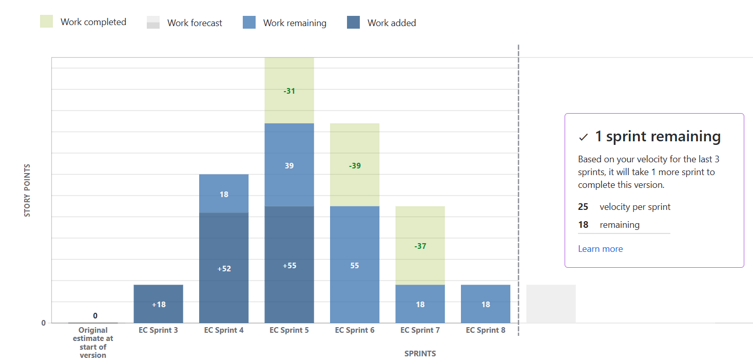

Sprint burndown
A Sprint Burndown Chart is a visual tool in Agile Scrum used to track the amount of work remaining in a sprint on a daily basis. It helps the team and stakeholders see whether the sprint is on track to meet its goal.
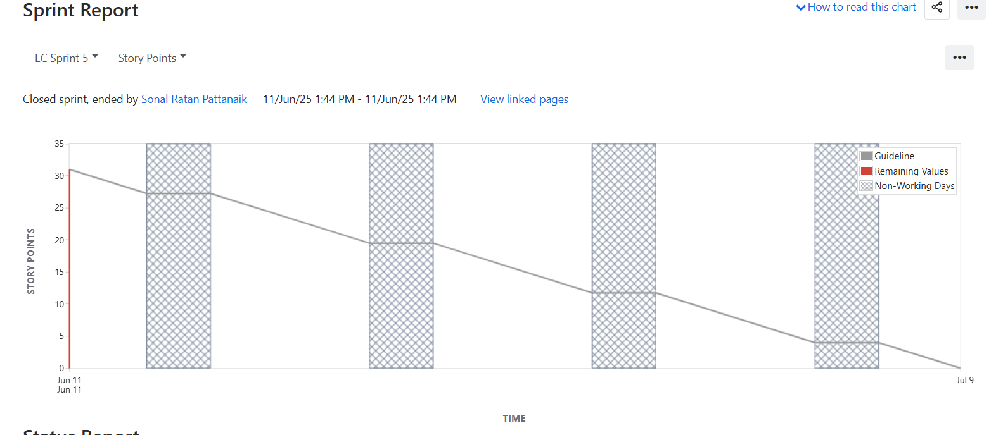

Document 6: Sprint meetings
Answer- Meeting Type 1: Sprint Planning meeting
Date | 01-06-2025
Time | 10:00 AM to 10:30 AM
Location | Zoom Meeting
Prepared by | Sonal, Business Analyst
Attendees | Mr. Rajesh Kumar – Product Owner  Ms. Priya Sharma – Scrum Master  Devendra Jain – Developer 1  Neha Joshi – Developer 2  Akash Mehta – Developer 3
Agenda Topics
Topic | Presenter | Time Allotted
Sprint goal overview | Product owner | 15 Mins
Review of product backlog | Scrum master | 25 Mins
User Story Discussion | BA/ Developer | 25 Mins
Estimation and Capacity Plan | Scrum Master | 15 Mins
Sprint Commitment | Entire Team | 10 Mins

Other Information
Observers | None for this session
Recourses | JIRA Board, Sprint Backlog Sheet, Velocity Charts
Special notes | Devendra will handle UI stories; Neha will work on API integration
Meeting Type 2: Sprint review meeting
Date | 15-06-25
Time | 4:00 PM to :00 PM
Location | Zoom meeting Room
Prepared by | Priya Sharma (Scrum Master)
Attendees | Product Owner, Business Analyst Scrum Master, Developers  Key Stakeholders (Mr. Arvind Rao – Marketing Head, Ms. Sneha Kapoor – QA Lead)

Sprint Status | Things To Demo | Quick updates | What’s Next
8 out of 9 committed stories completed successfully.  1 story deferred due to API dependency | User Registration Form UI (Devendra)  Notification Service Integration (Neha)  Task Dashboard Filters (Akash) | Minor design alignment issue resolved  No critical bugs found during QA testing | Remaining story moved to next sprint  Next sprint will focus on reporting module and analytics dashboard

Meeting Type 3: Sprint retrospective meeting
Date | 16-06-2025
Time | 10:00 AM to 11:00 AM
Location | Microsoft teams
Prepared by | Priya Sharma (Scrum Master)
Attendees | Scrum Master, Product Owner, All Developers, BA

Agenda | What went well | What didn’t go well | Questions | Reference
Review of sprint performance | Team communication was effective | Delay in 3rd party API delivery | Can we plan better for external dependencies? | Previous sprint retrospective notes, updated velocity chart
Capture lessons learned | Sprint goals met on time | Some confusion around story acceptance criteria | Should we include PO in user story walkthroughs?
Improvement planning | Testing completed within timeline

Meeting Type 4: Daily Stand-up meeting
Question | Name/Role | Week “X” (from dd-mm-yyyy to dd-mm-yyyy)
Question | Name/Role | Monday | Tuesday | Wednesday | Thursday | Friday | Saturday | Sunday
What did you do yesterday? | Developer 3 | Completed login UI. | Unit test login page. | Worked on registration. | Fixed CSS issues. | Code review. | - | -
  Developer 1
  Developer 2
What did you do yesterday? |  | Integrated email API. | Set up DB schema. | Wrote API tests. | Fixed validation bugs. | QA support | - | -
What did you do yesterday? |  | Designed dashboard UI | Created filter logic | Connected backend. | Sprint testing | Worked on bug fixes | - | -
What will you do today | Developer 3 | Peer Review | Start registration form | Test registration | Update form logic | Merge PR
  Developer 1
  Developer 2
What will you do today |  | Start OTP logic | Work on email triggers | QA testing | Assist UI dev | Final integration
What will you do today |  | Start analytics UI | Create graph module | Backend logic | Fix reported bugs | Final UI tweaks
What (if any) is blocking your progress | Developer 3 | None | None | API delay | None | None
  Developer 1
  Developer 2
What (if any) is blocking your progress |  | Waiting for test data | None | None | API response delay | API response delay
What (if any) is blocking your progress |  | None | None | None | None | None

