Capstone Project 1 (Part 2/3)

Online Agriculture Product Store

Question 1 : 4 Quarterly Audits are planned Q1 , Q2, Q3, Q4 for this Project. What is your knowledge on how these Audits will happen for a BA ?
Answer:
Audits - Audits in IT projects are systematic, independent examinations of a project's processes, deliverables, and performance against established goals and standards, aiming to ensure efficiency, security, and alignment with business objectives.
The audits for the four quarters can be planned as per the SDLC stages described in the Gantt chart.
For a BA to be audited, the work done by BA for the specific SDLC stages will be assessed. The stages can be, Requirement Gathering, Analysis, Designing, Requirements traceability, Development and testing readiness of the project, and UAT. The BA will be assessed on the performance against the established goals and standards for each specific stage. This is to ensure the alignment with the project deadlines and business standards. Below can be the Audits checklist at the specified stages

Stage | Quarter 1 : Audit Report (Requirement Gathering Phase) |  | Stage | Quarter 2 : Audit Report (Requirement Analysis Phase)
Weeks Completed | 10 Weeks (Week 1 to Week 10) |  | Weeks Completed | 7 Weeks (Week 17 to week 23)
Check List | Checking if Stakeholder requirements are captured properly |  | Check List | Check for proper mapping of requirements to design documents in Requirements traceability matrix.
 | Verifying Business Requirement Document and System Requirement Document |  |  | Verifying Scope Creep
 | Check for use of proper Elicitation Techniques by BA |  |  | Checking UML Diagrams.
 | Ensuring proper Sign-offs from internal stakeholders |  |  | Ensuring client/external stakeholder Sign-offs

Stage | Quarter 3 : Audit Report (Design & Development Phase) |  | Stage | Quarter 4 : Audit Report (UAT and Testing Phase)
Weeks Completed | 20 Weeks (Week 33 to Week 53) |  | Weeks Completed | 20 Weeks (Week 54 to week 74)
Check List | Ensuring proper and appropriate visualization tool usage |  | Check List | Checking Test Case summaries
 | Client communications, BA and developers meeting MoMs. |  |  | Training reports to end users
 | Minutes of Meeting for stakeholder meetings. |  |  | End user testing
 | JAD Session reports |  |  | Learning outcomes

Question 2 : Before the Project is going to Kick Start, The Committee asked Mr Karthik to submit BA Approach Strategy Write BA Approach strategy (As a business analyst, what are the steps that you would need to follow to complete a project – What Elicitation Techniques to apply, how to do Stakeholder Analysis RACI/ILS, What Documents to Write, What process to follow to Sign off on the Documents, How to take Approvals from the Client, What Communication Channels to establish n implement, How to Handle Change Requests, How to update the progress of the project to the Stakeholders, How to take signoff on the UAT- Client Project Acceptance Form )
Your Team
Project Manager - Mr Vandanam Senior Java Developer - Ms. Juhi
Java Developers - Mr Teyson, Ms Lucie, Mr Tucker, Mr Bravo Network Admin - Mr Mike
DB Admin - Mr John.
Testers - Mr Jason and Ms Alekya
BA - You
Technical Team have assembled to discuss on the Project approach and have finalized to follow 3-tier architecture for this project.
Answer:
As a Business Analyst, the responsibility of the project success is in the hands of BA. Thus, the approach to the project is important to be planned well.
- What Elicitation Techniques to Apply??
To capture requirements from farmers, manufacturers, and committee members. These are the elicitation techniques:
- Brainstorming:
  - Brainstorming can be done individually or in group. It can be an effective way to generate lots of ideas on the project and ideas on the system requirement and design.
  - Usually Brainstorming is used in identifying all possible solutions to problems and simplifies the details of opportunities.
  - In this project, Brainstorming will help to connect with farmers to understand their current requirements and conditions.
  - The other stakeholders may be able to share their ideas on the development of the project and useful features.
- Document Analysis:
  - Document analysis helps to understand the current system and then see for some of inputs for the new system requirements.
  - For this project, current agricultural policies, subsidy documents, and existing online agri-platforms need to be analyzed.
  - This will help to analyze the current constraints and best practices used by the competitors.
- Reverse Engineering:
  - Reverse engineering may not be useful for this project, since it is used majorly for migration projects.
  - This basically studies the software for an existing system which has little or outdated documentation and us necessary to understand what the system actually does.
  - It is an elicitation technique that can extract implemented requirements from the software.
- Focus Groups:
  - A focus group is a means to elicit ideas and attitudes about a specific product, service or opportunity in an interactive group or environment.
  - The participants share their impressions, preferences and needs guided by a moderator.
  - For this project, a focus group with farmers, influencers and stakeholders would be helpful to understand their ideas and understanding about the usability of the website/app.
- Observation
  - Observation is an elicitation technique that uses observing, or shadowing users or doing a part of their job to get information about their existing processes, inputs and outputs.
  - Observing helps in cases where the participants are not able to express or explain what they do or need in the new system.
  - Since our participants to be shadowed are farmers, this technique will help to understand the process better since the farmers may not be able to explain the exact needs or requirements.
  - This project would require to observe farmers procurement practices in villages.
  - This will also help to identify bottlenecks such as travel distance, delays, reliance on middlemen.
- Workshops
  - In this elicitation, interactive workshops with committee, farmers and manufacturers can be conducted.
  - It helps resolve conflicting requirements like product pricing, delivery timelines, etc.
  - This technique usually helps to identify important requirements.
  - It encourages collaboration and ensures all voices are heard.
- Joint Application Development
  - The JAD technique is an extended, facilitated workshop.
  - It involves collaboration between stakeholders and systems analysts to identify needs in a concentrated focused effort
  - This technique produces relatively large amount of high quality information in a short period of time.
- Interviews
  - Interviews of the farmers, manufacturers, users and stakeholders would be important for creating a smooth functioning software.
  - An interview is a systematic approach to elicit information from a person or group of people in an informal or formal environment and setting by talking to the person by asking relevant questions and documenting the responses.
  - For this project, one-on-one discussions with farmers (Peter, Kevin, Ben) will help to understand real farming challenges.
  - Interviews with manufacturers will help to capture expectations on listing products, inventory management, and delivery.
  - Interviews with internal stakeholders for understanding on budget, timelines, etc.
- Prototyping
  - Using wireframes/mockups of the application for feedback helps to create a visual representation.
  - Farmers, manufacturers and other stakeholders would find it easy to understand the functionality of the system.
- Questionnaire (Surveys)
  - Questionnaires are useful for obtaining limited system requirement details from the users.
  - It helps to understand the clear inputs from users/stakeholders
  - For this project, it would be useful to gather inputs from large farmer groups in remote areas.
  - This can include product preferences, internet accessibility, and delivery challenges.
Because farmers may not be comfortable with lengthy documents, so observation, surveys, and prototypes will be more effective. Manufacturers and the committee, on the other hand, prefer interviews and document reviews.

- How to do Stakeholder Analysis RACI/ILS
Stakeholder Analysis can be done by performing RACI Matrix. It involves identifying Stakeholders and defining their roles and responsibilities within the project.
- Identifying Stakeholders:
- Sponsor: Mr. Henry (funding, vision)
- Committee: Mr. Henry, Mr. Pandu (finance), Mr. Dooku (coordination)
- End Users: Farmers (buyers), Manufacturers (sellers)
- Delivery Team: PM (Vandanam), Developers (Juhi, Teyson, Lucie, Tucker, Bravo), Network Admin (Mike), DB Admin (John), Testers (Jason, Alekya), BA (me).
- Roles and Responsibilities of Stakeholders:
- Project Sponsor / Committee
- Mr. Henry (CSR Head / Sponsor)
- He will provide funding & strategic vision.
- He will ensure alignment with CSR goals.
- He will be responsible to Approve budgets and major deliverables.
- Mr. Pandu (Finance Head)
- He will be allocating financial resources.
- He will be responsible to approve expenditure, vendor contracts.
- Mr. Dooku (CSR Coordinator)
- He will be acting as a coordinator between committee, farmers, and manufacturers.
- He will ensure smooth communication.
- He will review progress updates and escalations.

2. Project Team
- Project Manager – Mr. Vandanam (Senior)
  - Leads planning, scheduling, and delivery.
  - Ensures scope, budget, and timeline adherence.
  - Facilitates communication between stakeholders and technical team.
- Business Analyst – Myself
  - Conducts requirement elicitation and stakeholder analysis.
  - Prepares BRD, SRS, RTM, and CR Logs.
  - Acts as bridge between business (committee, farmers, manufacturers) and technical teams.
  - Supports testing & UAT.
- Java Developers – Ms. Juhi (Lead), Mr. Teyson, Ms. Lucie, Mr. Tucker, Mr. Bravo
  - Design and develop application modules.
  - Implement business logic in Application Layer.
  - Collaborate with BA & testers to ensure requirements are met.
- Network Admin – Mr. Mike
  - Designs and maintains infrastructure/network for application.
  - Ensures availability, security, and scalability.
- DB Admin – Mr. John
  - Designs, manages, and optimizes database.
  - Ensures secure farmer/manufacturer data storage.
  - Supports data backups and recovery.
- Testers – Mr. Jason, Ms. Alekya
  - Prepare test scenarios & test cases.
  - Validate functionality against requirements.
  - Conduct system testing, regression testing, UAT support.

3. End Users
- Farmers (Peter, Kevin, Ben, etc.)
  - Act as end-users of the system.
  - Provide requirements through workshops & feedback.
  - Participate in UAT to validate usability.
- Manufacturers
  - Provide requirements for product listing & supply chain.
  - Participate in UAT to ensure business processes are covered.
RACI Matrix:
RACI matric gives an idea of roles and responsibilities of an individual in the project by assigning them with one of the four roles in RACI. RACI stands for Responsible, Accountable, Consulted and Informed.
Responsible - The person who performs the task to complete it
Accountable - The person who is the ultimate owner of the task or deliverable, making final decisions and ensuring it gets done.
Consulted - who need to provide input or feedback before a task can be completed.
Informed - People or stakeholders who need to be kept up-to-date on the progress or outcome of a task, but do not provide direct input or perform work.

Below is the RACI Matrix for the assigned roles and responsibilities
Deliverable / Activity | BA (Myself) | PM (Vandanam) | Committee (Henry, Pandu, Dooku) | Developers | Network Admin (Mike) | DB Admin (John) | Testers (Jason, Alekya) | Farmers / Manufacturers
Requirement Gathering | Responsible | Accountable | Consulted | Informed | Informed | Informed | Informed | Consulted
BRD Preparation & Review | Responsible | Accountable | Accountable | Consulted | Informed | Informed | Informed | Consulted
SRS Preparation | Responsible | Accountable | Accountable | Consulted | Consulted | Consulted | Informed | Informed
RTM Creation | Responsible | Accountable | Informed | Consulted | Informed | Informed | Consulted | Informed
Architecture Finalization (3-tier) | Consulted | Accountable | Informed | Responsible | Responsible | Responsible | Informed | Informed
Development Phase | Consulted | Accountable | Informed | Responsible | Consulted | Consulted | Informed | Informed
Test Case Preparation | Consulted | Accountable | Informed | Informed | Informed | Informed | Responsible | Informed
System Testing / Bug Fixing | Consulted | Accountable | Informed | Consulted | Informed | Informed | Responsible | Informed
UAT Planning & Execution | Responsible | Accountable | Accountable | Informed | Informed | Informed | Consulted | Responsible
Change Request Handling | Responsible | Accountable | Accountable | Consulted | Consulted | Consulted | Consulted | Consulted
Progress Reporting | Responsible | Accountable | Accountable | Informed | Informed | Informed | Informed | Informed
Final Client Acceptance | Responsible | Accountable | Accountable | Informed | Informed | Informed | Consulted | Responsible

- What Documents to Write
As BA, I will prepare the following:
- BRD (Business Requirement Document): BRD will capture high-level business needs.
- SRS (System Requirement Specification): This will translate Business Requirement Document into detailed technical requirements.
- Use Cases Document / User Stories: This document will define user interactions (e.g., farmer browsing products, manufacturer adding listings).
- RTM (Requirement Traceability Matrix): Ensures every requirement is mapped to design, development, and testing.
- Test Case Documents – This will define the test cases that the testers will be testing once the development is done.

- What process to follow to Sign off on the Documents
- Share draft documents with committee and technical team.
- Conduct review meetings / walkthroughs to clarify content.
- Incorporate feedback and release the updated version.
- Formal sign-off via email / e-signature is mandatory before moving to design/development.

- How to take Approvals from the Client?
  - Committee (Henry, Pandu, Dooku) must approve all key deliverables.
  - BA maintains a Project Approval Register to track: date, version, approver name, remarks.
  - No development starts until BRD & SRS are approved.

- What Communication Channels to establish and implement
  - Weekly Project Status Meetings - PM + Committee.
  - Daily Stand-ups - BA + PM + Development team + Testing team.
  - Project Management Tool - track requirements, tasks, bugs from tools like Jira.
  - Email - formal communication with committee, stakeholders.

- How to Handle Change Requests (CRs)
- Prepare Change Request Form
- Do impact Analysis
- Getting Approval on the form
- Complete Documentation on the same.

- How to update the progress of the project to the Stakeholders?
- Weekly Status Report
- Monthly Reviews

- UAT & Client Project Acceptance
- BA prepares UAT Plan with testers (Jason, Alekya).
- Farmers & Committee perform UAT on completed application.
- Defects found during UAT are logged, resolved, and re-tested.
- BA ensures all requirements are marked “fulfilled” in RTM.
- Final Review meeting is done then
- Committee sign-offs the document.

- Architecture Consideration
- Since team finalized 3-tier architecture (Presentation Layer, Application Layer, Database Layer):
- BA ensures requirements are structured to fit this model.

My BA approach strategy will ensure:
- Comprehensive elicitation using interviews, workshops, surveys, observation, and prototyping.
- Clear stakeholder analysis and RACI to assign roles.
- Strong documentation practices (BRD, SRS, RTM, CR Log, UAT docs).
- Proper sign-off and approvals from committee.
- Effective communication channels for transparency.
- Strict change request management to avoid scope creep.
- Regular progress reporting and requirement traceability.
- Formal UAT sign-off with farmers & committee for project acceptance.
- This structured approach ensures the project is delivered on time, within scope, and aligned with CSR objectives.

Question 3: Explain and illustrate 3-tier architecture?
Answer:
1. Application Layer (UI / Presentation)
- Front-end where users (farmers, manufacturers) interact.
- Collects inputs like login, product search, and orders.
- Displays outputs like confirmations and delivery status.
- Built using web/mobile technologies (HTML, React, Android).

2. Business Logic Layer (Middle Tier)
- Core processing engine of the system.
- Validates requests and applies business rules.
- Handles order processing, payments, and stock checks.
- Developed with technologies like Java, Spring Boot, APIs.

3. Data Layer (Database Tier)
- Stores all application data securely.
- Manages users, products, orders, and payment info.
- Ensures integrity, backup, and controlled access.
- Uses databases like MySQL, Oracle, PostgreSQL.

- Advantages
- Separation of concerns → Easy maintenance.
- Scalability → Layers can be scaled independently.
- Security → Database hidden behind logic layer.

Illustration
Application Layer
- Farmers and Manufacturers Interaction
- Inputs (Search, Order, Pay, login)
- Outputs: (Order Status, Payment confirmations)

Business Logic Layer
- Core Processing & Validations
- Order, Payment, Inventory Rules

Data Layer
- Secure Storage of Users, Products, Orders
- Backup, Integrity, Access Control

Question 4: Business Analyst should keep What points in his/her mind before he frames a Question to ask to the Stakeholder (5W 1H – SMART – RACI – 3 Tier Architecture – Use Cases, Use case Specs, Activity Diagrams, Models, Page designs)
Answer:
- 5W 1H Approach - A problem-solving technique that frames questions around What, Why, Who, Where, When, and How to ensure all dimensions of a requirement are covered. It helps uncover hidden details. The questions should be like
  - What is the requirement/problem?
  - Why is it needed (business value)?
  - Who will use/benefit from it?
  - Where will it be applied (system, location)?
  - When is it required (timelines, frequency)?
  - How should it be implemented (process/system)?

- SMART Criteria - A method to ensure requirements are Specific, Measurable, Achievable, Relevant, and Time-bound, so that they are clear, testable, and aligned with project goals.
  - Ensure each requirement/question is:
    - Specific (clear, no ambiguity)
    - Measurable (can we track success?)
    - Achievable (practical & realistic)
    - Relevant (aligned with project goals)
    - Time-bound (fits project schedule)

- RACI Consideration - A responsibility assignment matrix that defines who is Responsible, Accountable, Consulted, and Informed. It avoids confusion and helps direct questions to the right stakeholder.
  - Before asking, know who is Responsible, Accountable, Consulted, and Informed.
  - Frame questions differently for decision makers (A) vs. technical doers (R) vs. reviewers (C/I).

- 3-Tier Architecture Alignment - A system design approach that splits applications into three layers: Application/UI layer (front-end), Business Logic layer (processing/rules), and Data layer (storage). It ensures scalability and clarity in requirement gathering.
  - Questions should cover all 3 layers:
    - Application Layer (UI): “What should farmers see on screen?”
    - Business Logic Layer: “What rules should apply when placing an order?”
    - Data Layer: “What data fields need to be stored in DB?”

- Use Cases & Related Artifacts - High-level scenarios describing how a user (actor) interacts with the system to achieve a goal. They guide the BA in asking context-driven questions.
  - Draft high-level use cases before asking details.
  - Ask for use case specifications (actors, triggers, pre/post conditions).
  - Confirm activity diagrams or workflows with stakeholders.
  - Validate if stakeholders have preferences for UI/page designs or models (wireframes, mockups).

- Use Case Specifications - A detailed document capturing the steps, preconditions, post conditions, and exceptions of a use case. It ensures nothing is missed in requirement capture

- Activity Diagrams - Visual workflows (from UML) that show the sequence of activities, decisions, and flows in a process. They help stakeholders visualize system behavior.

- Models - Abstract representations (like process models, ER diagrams, or UML diagrams) that describe how the system will work. Models guide technical discussions and validations.

- Page Designs (Wireframes/Mockups) - Low- or high-fidelity UI sketches that show how a screen/page will look and function. They make discussions with stakeholders more concrete and reduce misunderstandings.
A BA must ask structured, SMART, architecture-aligned questions while keeping RACI roles in mind, and support them with use cases, activity diagrams, and page designs for clarity.

Question 5: As a Business Analyst, What Elicitation Techniques you are aware of? (BDRFOWJIPQU)
Answer:
B – Brainstorming
Brainstorming is a group creativity technique where participants freely share ideas to solve a problem or define requirements. It helps in generating a wide range of possibilities in a short time. A BA facilitates the session and ensures all ideas are captured without judgment. Later, the team filters and prioritizes the best ones.
- Example: Farmers and manufacturers brainstorm on what features the app should have—like order tracking, seasonal product suggestions, or bulk discounts.
D – Document Analysis
This involves studying existing documents like manuals, reports, invoices, policies, or contracts to extract hidden requirements. It is useful when stakeholders are not fully aware of all details. By analyzing documents, BAs understand the “as-is” process and required data fields. It also saves time as existing material gives real insights.
- Example: Review past seed purchase receipts and fertilizer order ledgers to understand product details, units of measurement, and pricing patterns.
R – Reverse Engineering:
Reverse engineering may not be useful for this project, since it is used majorly for migration projects. This basically studies the software for an existing system which has little or outdated documentation and us necessary to understand what the system actually does. It is an elicitation technique that can extract implemented requirements from the software.
F – Focus Groups
Focus groups bring together a small set of users or subject matter experts to provide feedback on product expectations. The discussion is usually guided by a facilitator with pre-defined questions. This technique helps uncover needs, preferences, and challenges directly from the target audience. It provides qualitative data for decision-making.
- Example: Organize a focus group of 10 farmers from different villages to understand what language, icons, and product categories will make the app most user-friendly.
O – Observation (Job Shadowing)
Observation means watching users perform their daily activities to discover requirements they might not express verbally. It helps capture actual workflows, pain points, and shortcuts users follow. A BA may take notes or even shadow the user for a few days. It is useful when users are unaware of their own inefficiencies.
- Example: Observe how farmers currently buy seeds from local shops, including negotiations, bulk purchases, and payment methods, to replicate a smoother digital version.
W – Workshop
A collaborative session where stakeholders gather in one place to define, refine, and validate requirements. It allows faster decision-making and helps resolve conflicts on the spot. Workshops are highly interactive and bring diverse perspectives together. A BA acts as a facilitator to guide the discussion and document consensus.
- Example: Conduct a requirements workshop with Peter, Kevin, Ben, and company representatives to finalize catalog features, payment options, and delivery process.
J – JAD (Joint Application Development) Sessions
JAD sessions are structured workshops that bring together business stakeholders and IT teams to define system requirements collaboratively. They are usually intensive, highly focused, and aim to achieve quick consensus. Facilitators guide the discussions with clear agendas. These sessions reduce back-and-forth communication later in the project.
- Example: A JAD session with SOONY committee members and APT IT developers to finalize functional modules like product catalog, payments, and delivery tracking.
I – Interviews
Interviews are one-on-one or group discussions with stakeholders to capture detailed requirements, concerns, or expectations. They allow deeper probing and flexibility in questioning. Interviews are especially useful to clarify complex or sensitive topics. BAs must prepare structured questions and actively listen.
- Example: Interview Mr. Henry about CSR objectives, the committee about budget expectations, and farmers about their challenges in accessing fertilizers, seeds, and pesticides.
P – Prototyping
Prototyping creates visual models or mockups of the system to help stakeholders imagine how the final product will look. It reduces ambiguity by providing a concrete reference. Stakeholders can give early feedback, leading to better requirement validation. Prototypes can be low-fidelity (sketches) or high-fidelity (interactive demos).
- Example: Build a prototype of the product search and order page to confirm with farmers whether the interface is simple and supports local language.
Q – Questionnaires / Surveys
A questionnaire is a set of structured questions distributed to a larger group of stakeholders. It allows quick collection of requirements, especially when users are spread across locations. Surveys can be quantitative (ratings, yes/no) or qualitative (open-ended responses). They are cost-effective and efficient for mass input.
- Example: Distribute surveys to 200 farmers across villages to identify priority features like offline access, preferred payment modes, and product categories.
U – Use Cases / User Stories
Use cases describe how users interact with the system to achieve a specific goal, while user stories capture needs in a simple format (“As a farmer, I want to…”). They provide context for system behavior, roles, and outcomes. Use cases also support testing and validation later.
- Example: Create a use case for “Farmer places an order for seeds” detailing preconditions (login), steps (select, add to cart, confirm), and outcomes (order receipt).

Question 6: Which Elicitation Techniques can be used in this Project and Justify your selection of Elicitation Techniques? Prototyping Use Case Specs Document Analysis Brainstorming
Answer:
Prototyping is creating visual representations of the system such as wireframes or mockups, which allow stakeholders to see how the final product will look and function. It helps reduce misunderstandings and speeds up feedback. Since many farmers may not be comfortable with technical discussions, showing them prototypes of the app screens makes it easier for them to react and share their needs. For example, a prototype of a product catalog screen with fertilizers, seeds, and pesticides listed in simple icons and local language will let farmers confirm if it is easy to use.
Use case specifications describe step-by-step how users interact with the system to achieve a goal, including actors, flows, and conditions. They ensure all functionalities are captured and can be tested later. In this project, farmers, manufacturers, and committee members act as different user groups, so use cases help to clearly map their workflows. For instance, a farmer placing an order would involve browsing items, selecting a product, adding it to the cart, making payment, and receiving confirmation, with alternate flows like failed payment also being captured.
Document analysis involves reviewing existing materials such as invoices, bills, receipts, or reports to identify important data fields and processes that need to be supported in the system. This technique ensures that the new system covers real-world requirements that are already being followed in manual or paper-based processes. For example, analyzing a farmer’s fertilizer purchase bill reveals fields like product name, quantity, price, dealer name, and delivery date, which become essential inputs for the new system.
Brainstorming brings stakeholders together to generate ideas freely and collaboratively, with ideas later filtered and refined. This approach ensures all perspectives are captured, from farmers and manufacturers to the committee. It encourages creativity and helps discover hidden requirements. For example, farmers may suggest a quick reordering feature for frequently bought products, manufacturers might propose bulk discount options, and the committee may recommend adding reporting for tracking sales and social impact.

Question 7: Make suitable Assumptions and identify at least 10 Business Requirements.
Answer:
Business requirements are the specific needs or conditions that a business must meet to achieve its objectives.
- Business Requirements
BR001 – Farmers should be able to browse and search products (fertilizers, seeds, pesticides) in the catalog.
BR002 – Manufacturers should be able to register, upload, and manage their product details in the application.
BR003 – Farmers and manufacturers should be able to create accounts and log in securely using email ID and password.
BR004 – The system should allow farmers to add products to a cart or wishlist (buy-later list).
BR005 – The system should provide a secure payment gateway supporting COD, Credit/Debit Card, and UPI.
BR006 – Farmers should receive automated email confirmations for successful orders and subsequent status updates.
BR007 – The system should provide delivery tracking for farmers to check the location and status of their order.
BR008 – The application should be user-friendly, supporting simple navigation for farmers from rural areas.
BR009 – The system should allow admin/committee users to monitor transactions, sales, and order statistics for CSR reporting.
BR010 – The system should ensure security of user accounts, product data, and financial transactions.
BR011 – The system should allow farmers to filter products by category, price, brand, and availability.
BR012 – The system should provide multilingual support (e.g., English + local language) to make the platform more inclusive for farmers.
BR013 – The system should generate downloadable invoices/receipts for every successful order.
BR014 – The system should maintain purchase history so that farmers can view and reorder frequently bought products easily.
BR015 – The system should provide manufacturers with sales analytics reports (e.g., most sold products, farmer demand trends).

Question 8: List your Assumptions
Answer:
- Farmers and manufacturers will have access to smartphones or computers with stable internet connectivity.
- All users (farmers, manufacturers, admins) must register to use the system fully.
- Login will be managed using secure email ID and password authentication.
- Users can login using Facebook or Google Account
- Product categories in Phase 1 are limited to fertilizers, seeds, and pesticides only.
- The application will be available on both web and mobile platforms.
- The system will support multilingual interface (English + at least one local language).
- Payment gateway will integrate with standard providers and support COD, UPI, Debit/Credit cards.
- Order deliveries will be handled by logistics partners but tracked through the system.
- Automated email notifications will be sent to users for registration, order confirmation, and delivery updates.
- User data and transactions will be stored securely, with basic data encryption in place.
- Farmers will have basic digital literacy to operate the app with minimal training.
- The project will be implemented within the allocated budget (2 Crores) and timeline (18 months).
- The system will be scalable to add more product categories or advanced features in later phases.
- Internet downtime in rural areas is expected, so the app should allow retries for failed requests.
- Committee users (admin) will have access to dashboards for monitoring and CSR reporting.

Question 9: Give Priority 1 to 10 numbers (1 being low priority – 10 being high priority) to these Requirements after discussions with the stakeholders
Answer:
Prioritized Business Requirements
Req ID | Req Name | Req Description | Priority
BR001 | Farmer Search for Products | Farmers should be able to search for available products in fertilizers, seeds, pesticides | 8
BR002 | Manufacturers upload Products | Manufacturers should be able to upload and display their products in the application | 8
BR003 | User Registration & Login | Farmers and manufacturers should be able to create accounts and log in securely | 10
BR004 | Cart & Wishlist | Farmers should be able to add products to a cart or buy-later list | 7
BR005 | Payment Gateway | Secure payment gateway supporting COD, Debit/Credit cards, and UPI | 10
BR006 | Email Order Confirmations | Farmers should receive automated email confirmations for order status updates | 6
BR007 | Delivery Tracking | Farmers should be able to track the status and location of their orders | 9
BR008 | User-Friendly Interface | Application should be simple and easy-to-use for farmers in rural areas | 10
BR009 | Admin Monitoring & Reporting | Admin/Committee should monitor transactions and generate CSR reports | 5
BR010 | Security of Data & Payments | System should ensure user account, product, and transaction security | 9
BR011 | Product Filtering | Farmers should be able to filter products by category, price, brand, and availability | 7
BR012 | Multilingual Support | System should provide support for multiple languages (English + local language) | 6
BR013 | Invoice Generation | System should generate downloadable invoices/receipts for every successful order | 6
BR014 | Purchase History & Reorder | Farmers should view purchase history and reorder frequently bought products | 7
BR015 | Manufacturer Sales Analytics | Manufacturers should view sales trends and product demand analytics | 4

Justification for priorities:
- High priority (9–10): Login, payments, UI simplicity, delivery tracking, security — core to system success.
- Medium (6–8): Search, upload products, wish list, filtering, invoices, multilingual support — important but can follow after core.
- Low (4–5): Analytics and CSR reports — valuable but secondary in Phase 1.

Question 10: Draw Use case diagram Drawing1.vsd

Question 11: Prepare Use Case Specs for all Use Cases
Answer:
UC-01: New Registration
- Use Case Name: New Registration
- Use Case Description: Enables users (farmers, manufacturers, admins) to create accounts, authenticate, or reset passwords.
- Actors:
  - Primary: Farmer, Manufacturer
  - Secondary: Database, Email service
- Basic Flow:
  - User selects Register or Login.
  - Provides email/username and password.
  - System validates credentials from database or creates account.
  - User redirected to dashboard.
- Alternate Flow:
  - User chooses Forgot Password → system sends reset link.
- Exceptional Flows:
  - Invalid credentials → error message.
  - Duplicate email during registration.
- Pre-Conditions: User has access to the internet and a valid email.
- Post-Conditions: Authenticated session and user has logged in or account created.
- Assumptions: Users know their login details and credentials.
- Constraints: Secure authentication required (hashing, OTP).
- Dependencies: Database, Email/SMS service.
- Inputs/Outputs: Input → credentials; Output → login success/failure, session.
- Business Rules: Email must be unique; passwords must meet complexity rules.
- Miscellaneous Information: -

UC-02: Browse Catalogue
- Use Case Name: Browse Catalogue
- Use Case Description: Allows users to search, filter, and view product details.
- Actors:
  - Primary: Farmer, Manufacturer
  - Secondary: Database
- Basic Flow:
  - User opens catalogue.
  - System displays products.
  - User views details or adds product to cart.
- Alternate Flow:
  - User searches with filters (category, price).
- Exceptional Flows:
  - No products found → display recommendations.
- Pre-Conditions: Products available in catalogue.
- Post-Conditions: User may proceed to cart.
- Assumptions: Database is up-to-date.
- Constraints: Must load quickly, support search filters.
- Dependencies: Product database.
- Inputs/Outputs: Input → search query; Output → product list.
- Business Rules: Display only active/in-stock products.
- Miscellaneous Information: -

UC-03: Add to Cart
- Use Case Name: Add to Cart
- Use Case Description: Add selected products to shopping cart.
- Actors:
  - Primary: Farmer
  - Secondary: Database
- Basic Flow:
  - User selects Add to Cart.
  - System validates stock.
  - Item added to cart.
- Alternate Flow:
  - Adjust quantity before adding.
- Exceptional Flows:
  - Out of stock → show error.
- Pre-Conditions: Product available.
- Post-Conditions: Cart updated.
- Assumptions: User intends to purchase.
- Constraints: Cart persists per user session.
- Dependencies: Product catalogue, database.
- Inputs/Outputs: Input → product ID/quantity; Output → updated cart.
- Business Rules: Quantity ≤ available stock.
- Miscellaneous Information:

UC-04: Manage Product Catalogue
- Use Case Name: Manage Product Catalogue
- Use Case Description: Manufacturers/Admins can upload, edit, and manage products.
- Actors:
  - Primary: Manufacturer, Admin
  - Secondary: Database
- Basic Flow:
  - Actor uploads product details.
  - Adds images, sets price and stock.
  - System saves and publishes product.
- Alternate Flow:
  - Bulk upload via CSV.
- Exceptional Flows:
  - Invalid data → validation error.
- Pre-Conditions: Actor authenticated with proper role.
- Post-Conditions: Products available in catalogue.
- Assumptions: Manufacturer has correct data.
- Constraints: Only authorized roles allowed.
- Dependencies: Database, image storage.
- Inputs/Outputs: Input → product info; Output → updated catalogue.
- Business Rules: Price must be non-negative, stock ≥ 0.
- Miscellaneous Information:

UC-05: Place Order
- Use Case Name: Place Order
- Use Case Description: Enables users to review cart, validate address, choose payment, and confirm order.
- Actors:
  - Primary: Farmer
  - Secondary: Payment Gateway, Delivery Partner, Database
- Basic Flow:
  - User reviews cart.
  - Validates delivery address.
  - Chooses payment method.
  - Makes payment or confirms COD.
  - System generates order ID and confirmation.
- Alternate Flow:
  - User changes delivery address before confirming.
- Exceptional Flows:
  - Payment failure.
  - Address not serviceable.
- Pre-Conditions: Valid cart and address.
- Post-Conditions: Order placed, confirmation sent.
- Assumptions: Payment gateway operational.
- Constraints: Must process in real time.
- Dependencies: Payment gateway, delivery system.
- Inputs/Outputs: Input → order/cart info; Output → order confirmation.
- Business Rules: COD available only in certain regions.

UC-06: Track Order
- Use Case Name: Track Order
- Use Case Description: Provides users with current status and estimated delivery.
- Actors:
  - Primary: Farmer
  - Secondary: Delivery Partner, Database
- Basic Flow:
  - User selects Track Order.
  - System retrieves tracking info.
  - Displays current status and ETA.
- Alternate Flow:
  - Provides link to delivery partner tracking site.
- Exceptional Flows:
  - Tracking unavailable → display last known status.
- Pre-Conditions: Order placed and assigned to delivery partner.
- Post-Conditions: User informed about status.
- Assumptions: Delivery partner updates status regularly.
- Constraints: Depends on delivery partner API.
- Dependencies: Delivery API, database.
- Inputs/Outputs: Input → order ID; Output → tracking info.
- Business Rules: Show only authorized user’s orders.
- Miscellaneous Information:

UC-07: Order Bill Generation
- Use Case Name: Order Bill Generation
- Use Case Description: Generate invoices and sales reports.
- Actors:
  - Primary: System, Admin
  - Secondary: Database
- Basic Flow:
  - System generates bill on successful order.
  - Stores bill in database.
  - Sends invoice to user.
- Alternate Flow:
  - Admin triggers re-generation of bill.
- Exceptional Flows:
  - Tax calculation error → flagged.
- Pre-Conditions: Completed order with payment confirmed.
- Post-Conditions: Invoice available and sent.
- Assumptions: Tax rules configured correctly.
- Constraints: Must comply with local tax laws.
- Dependencies: Payment gateway, tax calculation service.
- Inputs/Outputs: Input → order details; Output → invoice.
- Business Rules: Invoice must include legal tax details.
- Miscellaneous Information:

UC-08: Sales Analytics
- Use Case Name: Sales Analytics
- Use Case Description: Provides reports and insights for admins.
- Actors:
  - Primary: Admin
  - Secondary: Database
- Basic Flow:
  - Admin requests sales report.
  - System generates analytics dashboard.
- Alternate Flow:
  - Scheduled report generation.
- Exceptional Flows:
  - Large dataset → delayed or partial report.
- Pre-Conditions: Order data exists.
- Post-Conditions: Reports generated.
- Assumptions: System has access to complete historical data.
- Constraints: Data privacy restrictions.
- Dependencies: Order database, billing module.
- Inputs/Outputs: Input → report request; Output → analytics dashboard/report.
- Business Rules: Only admins can access analytics.
- Miscellaneous Information:

Question 12: Activity Diagrams

- Registration - Activity 1.vsd
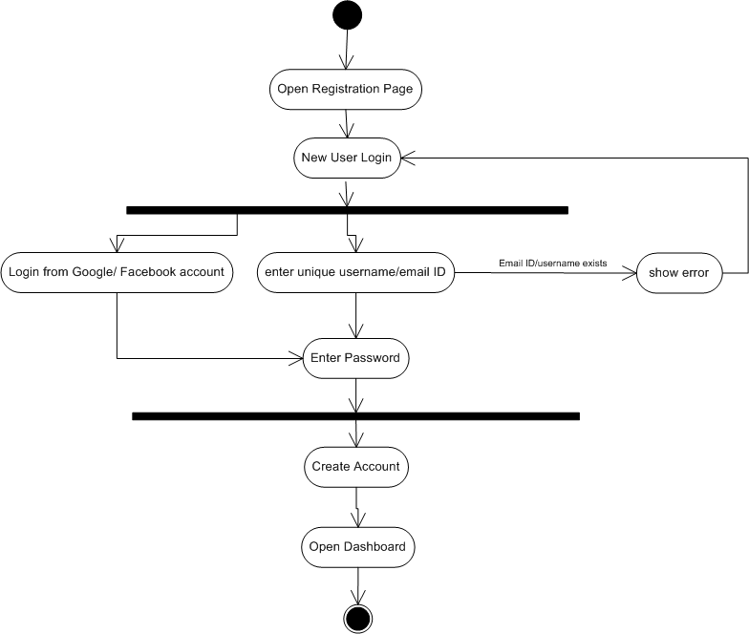

- Browse catalogue - Activity Drawing 2 - Browse Catalogue.vsd
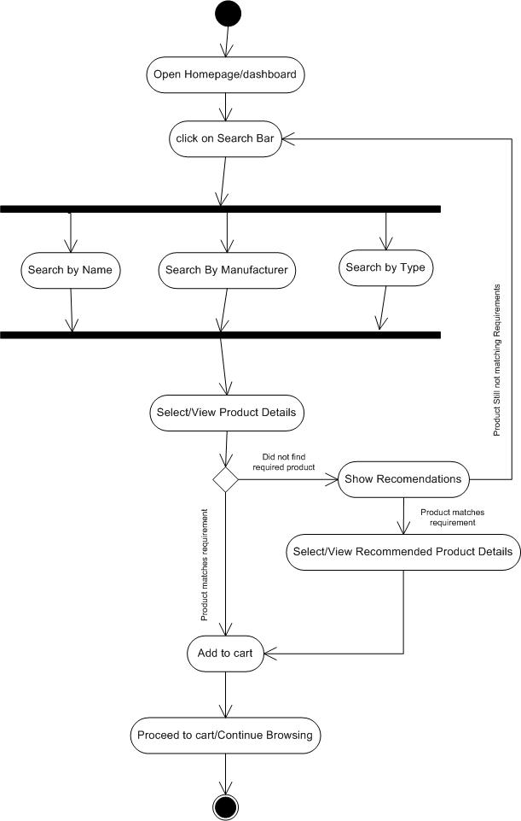

- Add to Cart - Activity Drawing 3 - add to cart.vsd
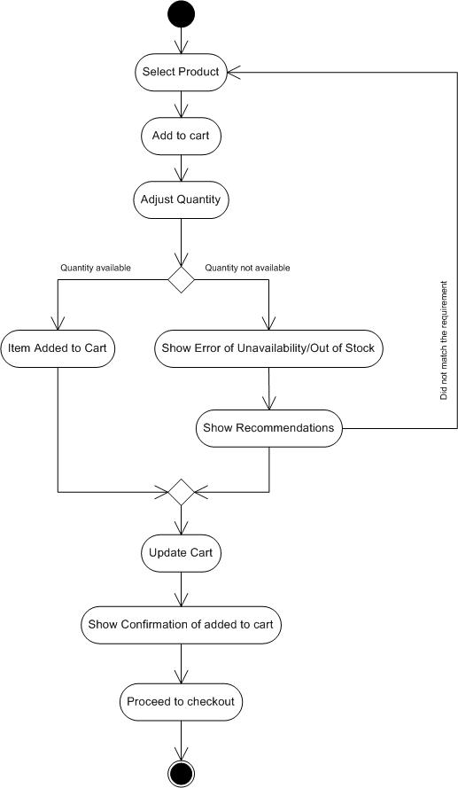

- Manage Products - Activity Drawing 4 - manage Products.vsd
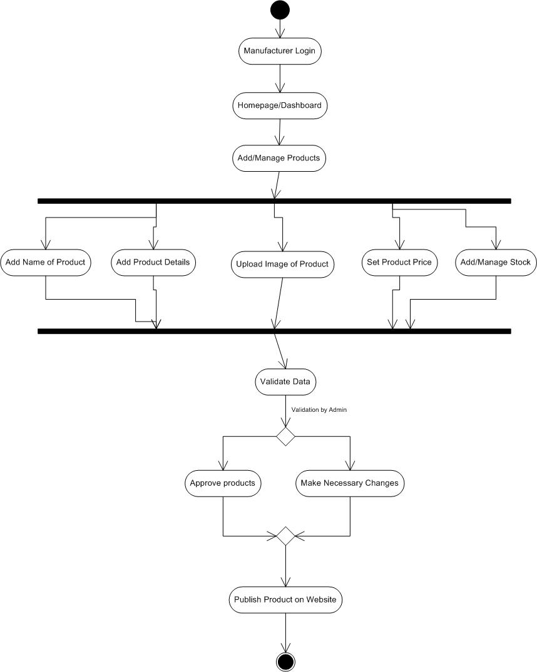
- Place Order - Activity Drawing 5 - Place Order.vsd
