Capstone Project 1 – Part 3
Question 01 – Functional Requirements - 15 Marks
Identify minimum 20 functional requirements Prepared by: V.Niharika
Batch Date :05/05/2025
Answer 01–
Req ID | Req Name | Requirement Description | Priority
FR001 | Farmer Registration | Farmers should be able to register with the application | 9
FR002 | Farmer Search for Products | Farmer should be able to search for available products fertilizers, seeds, pesticides | 9
FR003 | Manufacturer Registration | Manufacturers should be able to register with the application | 8
FR004 | Manufacturer Product Listing | Manufacturers should be able to list their products in the catalogue | 8
FR005 | Product Details Display | The application should display detailed information about each product, including descriptions, specifications, and pricing | 7
FR006 | Filter | Farmer should be able to filter and select the product as per Brands and Price | 6
FR007 | Add to Cart | Users should be able to add products to their shopping cart for purchase | 9
FR008 | Cart Management | Users should be able to view and manage the contents of their shopping cart, including adding or removing products | 8
FR009 | Wish list Management | Users should be able to manage their wish list or buy-later list, including adding or removing products | 10
FR010 | Multiple Payment Gateways | The platform should integrate with multiple payment gateways to facilitate secure and convenient transactions | 6
FR011 | Order Placement | Users should be able to place orders for selected products, specifying quantity and delivery address | 9
FR012 | Order Confirmation | Users should receive an order confirmation with details such as order number, products, quantities, total amount, and estimated delivery date | 7
FR013 | Order Tracking | Users should be able to track the status and location of their orders in real-time | 6
FR014 | Order History | Users should be able to view their order history, including past orders, order details, and statuses | 7
FR015 | Customer Support | Users should have access to customer support, either through live chat, email, or phone, for assistance with their orders or inquiries | 8
FR016 | User Ratings and Reviews | Users should be able to provide ratings and reviews for products they have purchased | 7
FR016 | Product Recommendations | The platform should provide personalized product recommendations based on user preferences and browsing history | 7
FR017 | Social Sharing | Users should have the option to share products or their purchase experience on social media platforms | 7
FR018 | Secure Transactions | The platform should ensure secure transactions by implementing appropriate encryption and security measures | 9
FR019 | Product Filtering | Users should be able to filter products based on various criteria such as price range, brand, or product type | 8
FR020 | Account Management | Users should be able to manage their account settings, including profile information, password changes, and email preferences | 7
Non Functional Requirements
Req ID | Req Name | Requirement Description | Priority
NFR001 | Page Loading Time | Each Page should load within 2 seconds time | 10
NFR002 | Technical Supported System | Application can be used on any OS (Android/IOS) | 6
NFR003 | Time Limit for OTP | OTP time limit should be given maximum of 5 minutes for Login and Registration process | 10
NFR004 | Logout System | If the page is not accessed for more for 5 minutes, the page should log out automatically | 7
NFR005 | Stock Availability | Stock availability should be updated on a real time basis | 8
NFR006 | SMS & Mail Confirmation | Automated Email and SMS notification should be sent to Users | 6
NFR007 | Backup | All data should get backup automatically | 7
NFR008 | Connectivity | System should be connected with Internet | 8
NFR009 | Stock Alerts | Seller should receive Stock alert notifications when Stock is reduced, every week | 6
NFR010 | Net Banking | Bank account should be active in nature for smooth payment process | 8
NFR011 | Check Stock | Once the Product is sold, the stock of the product should be reduced | 7
NFR012 | Email Address | Email Address should be active to receive Email notifications | 5
NFR013 | Taxation System | All products should be included with additional Tax | 8
NFR014 | Password | User should receive Password change alert every 30 day | 4
NFR015 | Payment Receipt | Generation of payment details on whitepaper receipt of 4” 6 | 5

Question 02 - Minimum 5page designs - 15Marks
Make wireframe and prototypes
Answer 02 –

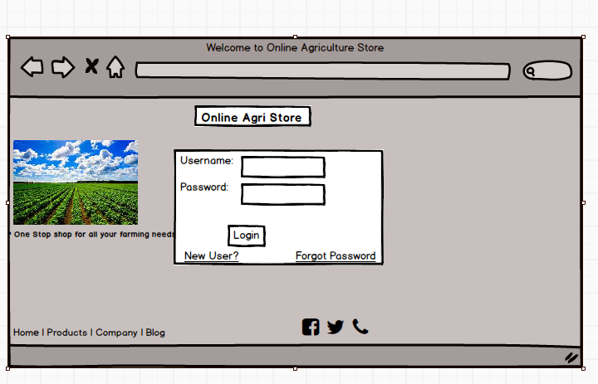

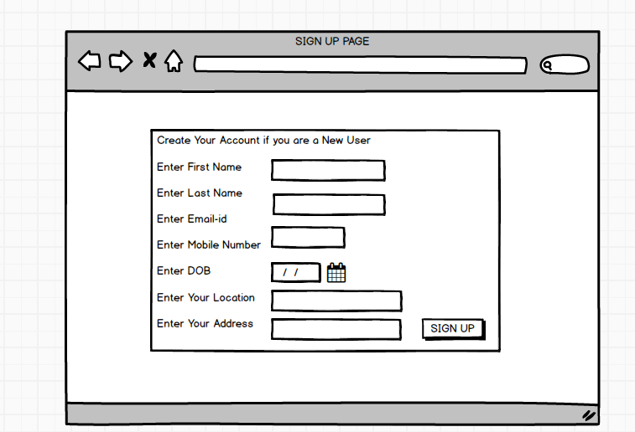

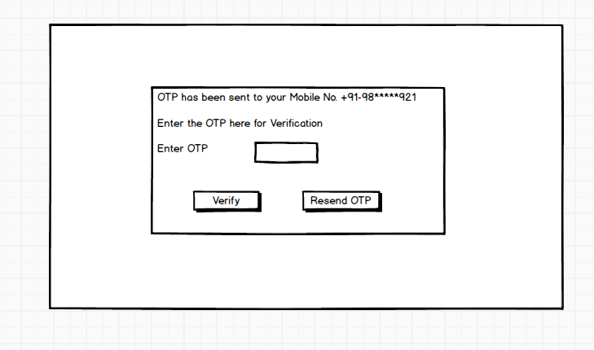

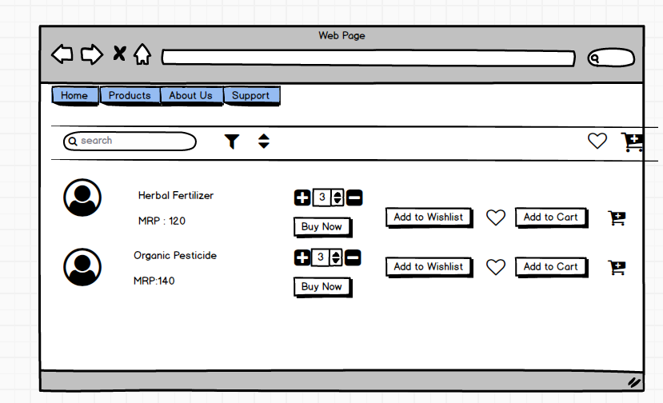

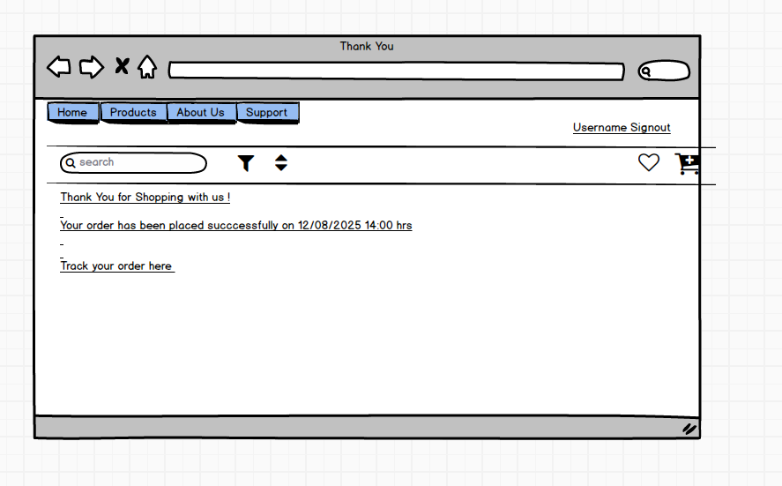
Prototypes:

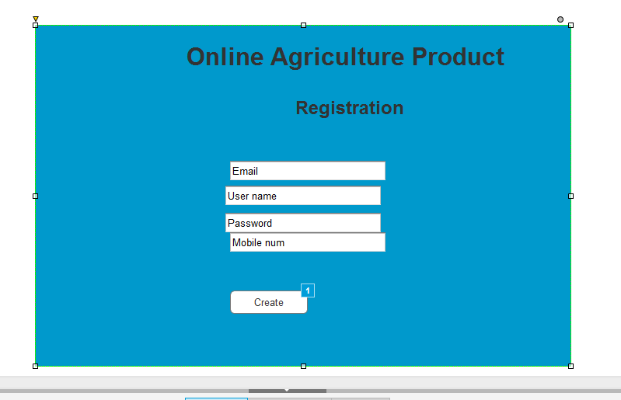

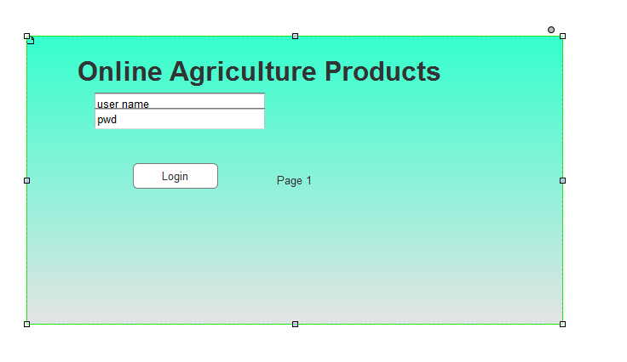

Question 3 – Tools (Visio, Balsamiq) - 15 Marks
Make a note of the Tools, which you are using for above concepts.
Answer 3 –
Microsoft Office Visio

Microsoft Visio is a diagramming and vector graphics application and is part of the Microsoft Office family. It is used to create diagram types such as Flowcharts, Org Charts, Floor Plans, Network Diagrams, UML Diagrams, Mind maps and more. It is also commonly used for scenarios such as Process Mapping and Visual Collaboration. The latest version of Visio also has data visualization that allows users to create diagrams from Excel data and also embed Visio diagrams in Power BI dashboards.

Microsoft Office Visio is a tool that eases the process of making complex diagrams. Especially for business purposes. It can help in the making of presentations, floor plans, org charts, etc. Listed below are some uses of Visio:

Followings things can draw BA by using MS Office Visio.

- Flowchart: A flowchart is helps to show the steps in sequential order. These are steps that need to be taken to complete a certain process. It is effective in conveying information. Thus, it can be used in various other fields too.
- Organization Chart: An org chart displays the roles and reporting relationships in a business organization. It can be used in also any other organization. It depicts the names and positions of employees in a company. In short, we can say it shows the structure of an organization.
- Floor Plan: A floor plan is the structure of a room or a floor. Architects use floor plans to place doors, windows, and other objects. Visio also offers a floor plan template.
- Business Process Modelling Notation: BPMN is a flowchart method of displaying all the processes in a business that is to be taken. In other words, it helps in give a clear understanding of the processes in a particular business through visual representation.

Axure RP:

Prototyping Tool: Axure RP is used for UX/UI prototyping.
UX/UI: Used for user experience and interface design.
Interactive prototypes : create clickable prototypes for testing
UX/UI design: Used design experiences.
Testing Interactions: test how prototypes work.

Balsamiq

Balsamiq Mock ups is an effective tool for presenting the software requirements in the form of wireframes. This helps the software development team to visualize how the software project will look like in the very early stages of development. This is a small tutorial where we will cover all the basic steps needed to start with Balsamiq Mock ups.
Question 4 – RTM - 6Marks
A business analyst’s key responsibilities are to keep track of the requirements and make sure that
no requirement is missed.
Mr. Henry and peter have approached you regarding the current status of the project. How will you tackle this situation?
Prepare RTM

Answer 4 –
Req ID | Req Name | Req Description | Design | D1 | D2 | T1 | T2 | T3 | T4 | UAT
FR0001 | Farmer Registration | Farmers should be able to register with the application | ✓ | ✓ | ✓ | ✓ |  |  |  | ✓
FR0002 | Farmer Search for Products | Farmers should be able to search for available products in fertilizers, seeds, pesticides | ✓ | ✓ | ✓ |  |  |  |  | ✓
FR0003 | Quality & quantity | Seek the quality and quantity of the production an online hotel and make the decision as well their budget and requirement | ✓ | ✓ | ✓ | ✓ | ✓ |  |  | ✓
FR0004 | Pricing for the product | Compare the price of one product to a different product in the app itself | ✓ | ✓ | ✓ | ✓ |  |  |  | ✓
FR0005 | Online ordering | After deciding the product farmer directly buys the product online from the many tires | ✓ | ✓ | ✓ | ✓ | ✓ | ✓ | ✓ | ✓
FR0006 | Get advice from website online | Get advice from an online portal about the agriculture doing farming in an advanced manner for that certain video is there in farmer preferred language | ✓ | ✓ | ✓ |  |  |  |  | ✓
FR0007 | Payment gateway | Get the payment credit facility where they have the different mood of payments are their net banking COD, debit& credit card, etc | ✓ | ✓ | ✓ | ✓ | ✓ | ✓ | ✓ | ✓
FR0008 | Tracking order | After ordering products online they can track the order and time of delivery | ✓ | ✓ | ✓ | ✓ |  |  |  | ✓
FR0009 | Refund & replacement | Customers can make replacement & refund requests from the app online if the product is not good at the time of delivery | ✓ | ✓ | ✓ | ✓ | ✓ | ✓ | ✓ | ✓
FR0010 | Help & Support | Customers can also take the option of help& support from the app online where theirissue solves in a shorter period | ✓ | ✓ | ✓ | ✓ |  |  |  | ✓
NFR0101 | Page Loading Time | Seconds | ✓ | ✓ | ✓ | ✓ | ✓ | ✓ | ✓ | ✓
NFR0102 | WCAG 2.1 | T softy of stem must meet Web Content Accessibility Guidelines WCAG2.1 | ✓ | ✓ | ✓ | ✓ | ✓ |  |  | ✓
NFR0103 | Manufacturing | FAQ for farming product | ✓ | ✓ | ✓ | ✓ |  |  |  | ✓
NFR0104 | Pricing lower | The pricing meter methodology takes time for ordering the seeds and pesticides | ✓ | ✓ | ✓ | ✓ | ✓ | ✓ | ✓ | ✓
NFR0105 | Website lode | Online portal lode to the website takes time to confirmation | ✓ | ✓ | ✓ | ✓ | ✓ | ✓ | ✓ | ✓
NFR0106 | Internet issue | For advance need a multi-video and picture need to upload where server issues and internet connectivity problems may be happening | ✓ | ✓ | ✓ |  |  |  |  | ✓
NFR0107 | Bank server support | Banking channel partners need to support the payment gateway and need support to handle the function of the guidebook and confirmation of payment. | ✓ | ✓ | ✓ | ✓ | ✓ | ✓ | ✓ | ✓
NFR0108 | Delivery channel | Delivery partner channels need a regular update which takes time to update on the website | ✓ | ✓ | ✓ | ✓ |  |  |  | ✓
NFR0109 | Refund process | Refund and replacement take a larger process time where delivery partner collects the product then only the refund instant from the bank server site | ✓ | ✓ | ✓ | ✓ | ✓ | ✓ | ✓ | ✓

Question 5 – 10 Test Case Documents - 10 Marks
Prepare 10 Test Case Documents
Answer 5 –

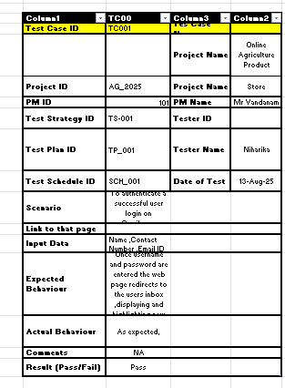

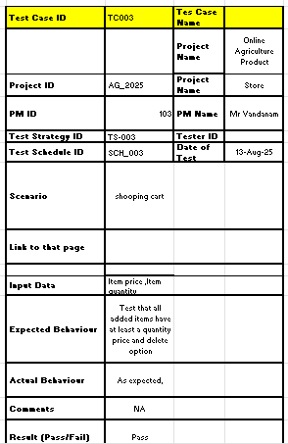

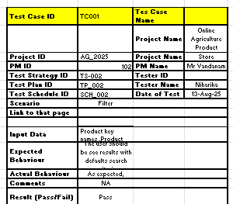

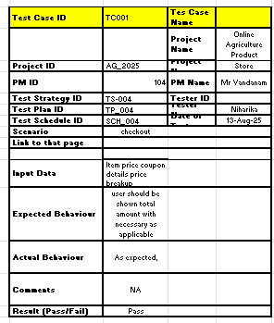
Column2
Question 6 – DB Design - 8 Marks
After the requirements are thoroughly explained to the entire project team by business analyst, the Database architects have decided to do the database design and also to represent the in-flow and out-flow of data.
Draw database schema and ER diagram
Answer 6 –
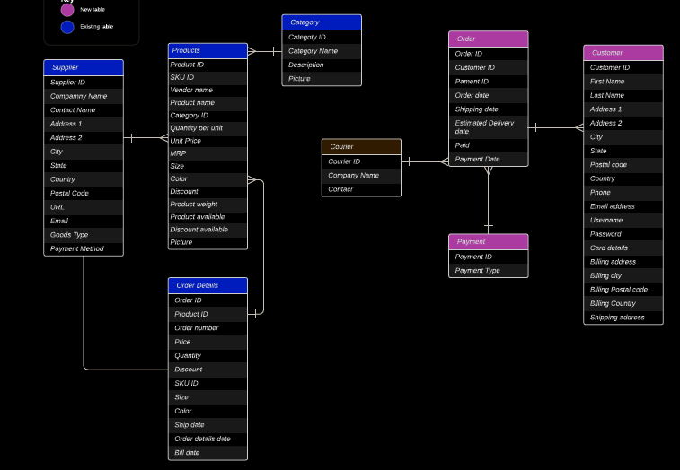
Question 7 – Data Flow Diagram - 3 Marks
What is a data flow diagram? Draw a data flow diagram to represent the in-flow and out-flow of data when a Farmer is placing an order for the product
Answer 7 –
A data-flow diagram is a way of representing a flow of data through a process or a system (usually an information system). The DFD also provides information about the outputs and inputs of each entity and the process itself.
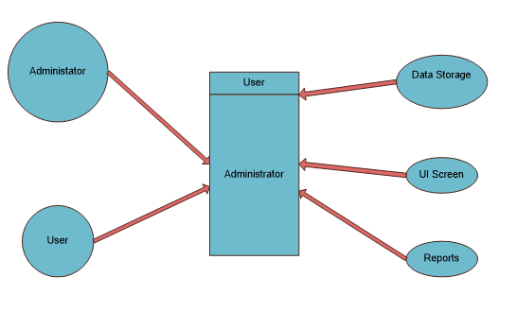
Question 8 – Change Request – 10 Marks
Due to change in the Government Taxation structure. we should change the Tax structure
How do you handle change requests in a project?
Answer 8 – Change requests are when a stakeholder, either a client or an internal team or department, requests a change to the processes or deliverables that had already been decided upon in the project scope.
However, in this scenario, this changes request has come up due to change in the Govt. Taxation structure. As a BA, I would analyse the request and clarify the stakeholders exactly what the request is asking us to do in the Online Agriculture Product Store. In a normal scenario, as a BA, I would first do the Feasibility Test, to check, how feasible it is to change the current ongoing project with the new change request.
However, in this case, Feasibility study is not required, as it’s a Govt structure which needs to be updated and followed. Therefore, I will follow the below steps to change the project as per the client’s requirements.
- Document the Change request.
- Look for any Supporting materials to help in adding this Change.
- Need to assess, whether the Change is an Inside or Outside scope. As its an outside scope, the Budget and time will get impacted.
- BA and PM should ensure whether the change is a minor or a major change. Policy changes by Govt is a major change request and we need to ensure that the change should be done according to the Govt. instruction.
- Fill the Change request Form and get the approval from the Project Manager.
- We also need to ensure that our Team understands the priority of this change request.
- We also need to discuss the change with Change Control Board who will recommend the necessary change on the Project.
- Once this change is approved, the project deliverables will need to be updated. This can include plans and schedules, business process documents, and the requirements documents.
- Once these updates have been made, the project manager can communicate the new course of action to everyone who will be impacted. Now you can delegate the necessary tasks to the people in charge of implementing these new changes.
Question 9 – Change Request Vs an Enhancement - 5 Marks
As the project is in process, Ben and Kevin have contacted you. The reason is to inform you that they want the Farmers to sell their crop yields through this application i.e. Farmers should be able to add their crop yields or products and display to general public and should be able to sell them. They also want to introduce Auction system for their Crop yields. As a BA, what will be your response?

Is this a change request or an enhancement???
Answer 9 –
The request from Ben and Kevin is an Enhancement request, as they want to add another feature in the Online store, which will also help the Farmers to sell the yields directly in the online store, apart from buying products. Hence my response would a positive response to them.
Therefore as a BA, I should analyze the request and provide a project plan, requirement, design, an testing plans for this request. I must prepare an enhancement request form and decide how much manpower and manhours required for this enhancement request.

Question 10 – Estimations – 6 Marks
Come up with estimations – How many Manhours required
Answer 10 –
Manhours Required = Total hours working per day x Total number of members x Total numbers of days worked over the specific period.
Number of Working Hours a day = 8 hours
Number of Resources = 12
Time period provided = 18 months = 547 days = 78 weeks (Including Weekends and Public Holidays)
Assuming Weekends = 156
Assuming Public Holidays = 10
Total = 166
547-166 = 381 working days
Hence, Estimated Manhours = 8 hours * 12 resources * 381 days = 36,576 hours required.
Question 11 – UAT – 6 Marks
Project has finally completed all the stages i.e., design, development, testing etc. Now, it is the role of a business analyst to contact the client for testing of the final product and have to successfully complete it. How are you going to handle this situation? And once it is done, what will be the process to close the project?
Explain UAT Acceptance process
Answer 11 –
User Acceptance Testing (UAT) is a phase in the software development life cycle where the users of the Online Agriculture Product Store participate in validating that if meets their needs.
As a BA, I will verify all the validations prior to design the UAT Test cases, which will cover the functionality of the product, System environment, any possible defects which could arise and how to deal with these defects.
Steps for UAT
- Analysis of Business Requirements: One of the most important activities in the UAT is to identify and develop test scenarios. These test scenarios are derived from the following documents:
(a) Business Use Cases
(b) Process Flow Diagrams
(c) Business Requirements Document (BRD)
(d) System Requirements Specification (SRS)

- Creation of UAT Plan: The UAT test plan outlines the strategy that will be used to verify and ensure an application meets its business requirements. It documents entry and exit criteria for UAT, Test scenarios and test cases approach and timelines of testing.
- Identify Test Scenarios and Test Cases: Identify the test scenarios with respect to high-level business process and create test cases with clear test steps. Test Cases should sufficiently cover most of the UAT scenarios. Business Use cases are input for creating the test cases.
- Preparation of Test Data: It is best advised to use live data for UAT. Data should be scrambled for privacy and security reasons. Tester should be familiar with the database flow.
- Run and record the results: Execute test cases and report bugs if any. Re-test bugs once fixed. Test Management tools can be used for execution.
- Confirm Business Objectives met: Business Analysts or UAT Testers needs to send a sign off mail after the UAT testing. After sign-off, the product is good to go for production. Deliverables for UAT testing are Test Plan, UAT Scenarios and Test Cases, Test Results and Defect Log.

Question 12 – Project Closure Document - 6 Marks
Explain Project closure document
Answer 12 –
Project Closure
Online Agriculture Product Store
Revision Date: MM/DD/YYYY |  | Version: 1.0
Approver Name | Title/Role |  | Signature | Date
Peter and Ben | Project Stakeholder * |  | Ok | xx/xx/xxxx
Mr. Henry | Exec Sponsor (AVP or Exec. Dir) * |  | Ok | xx/xx/xxxx
Mr. Pandu | Financial Head |  | Ok | xx/xx/xxxx
Mr. Vandanam | Project Manager |  | Ok | xx/xx/xxxx
Mr. Kartik | Delivery head |  | Ok | xx/xx/xxxx
Mr. Dooku | Project Coordinator |  | Ok | xx/xx/xxxx
**By authorizing this Project Closure, the Project Stakeholder(s), and Executive Sponsor agree to all terms within this document.

Revision History
Identify document changes.
Section 1. General Information
Project Activity | Date
Project Start | 13th Feb 2023
Project Closure* | 14th April 2024
**Date of Project Closure refers to the project finish date, meaning all project tasks have been completed
Section 2. Business Objectives (As identified in Business Case Document)
Business Case Ref # |  | Business Objectives |  | Met/Not Met |  |  | Comments
BI0001 |  | Farmer should be able to buy and sell agricultural product online. |  | Yes |  |  | Ok
Section 3. Customer Expectation Management
Item | Question |  |  |  |  | Description | Comments
1 | Were all expected benefits and business outcomes realized? |  |  |  |  | Yes | Ok
2 | Were all expected performance standards satisfied? |  |  |  |  | Yes | Ok
Section 4. Outstanding Actions Items and Issues
Action Item |  |  | Transition and/or Resolution
Section 5. Project Office Checklist
Deliverable |  |  |  |  | Description
Risk Assessment completed and posted on suitable shared storage. |  |  |  |  | ☐Yes |  | ☐No
Business Case completed and posted on suitable shared storage. |  |  |  |  | ☐ Yes |  | ☐ No
Project Charter completed and posted on suitable shared storage. |  |  |  |  | ☐ Yes |  | ☐ No
Meeting Notes completed and posted on suitable shared storage. |  |  |  |  | ☐ Yes |  | ☐ No
Additional project documentation and artifacts posted on suitable shared storage, including Requirements Template, Project Change Requests, Milestone Timeline, Work Breakdown Structure, etc. |  |  |  |  | ☐ Yes |  | ☐ No
Lessons Learned documented. |  |  |  |  | ☐ Yes |  | ☐ No
Project folder moved completed projects on suitable shared storage. |  |  |  |  | ☐ Yes |  | ☐ No
Support Handover Document completed and archived. |  |  |  |  | ☐ Yes |  | ☐ No
Comments
Ok to process. Application running properly.

