AGILE DOCUMENT

Document 1
Definition of Done

- Definition of Done is a technique where the team agrees on a list of checklist which must be met before a backlog item must be considered .
- This team has to create a well defined , measurable , agreed upon and shared to the team .members .
- The best form of Definition of Done representation is a checklist of activity that demonstrate the agreed value and quality of users story and it includes
- Acceptance Criteria ( To satisfy Customer Requirement for a product )
- Quality Criteria ( To satisfy Quality Requirement for a product )
- Definition of Done may be defined on different level or stages such as users story or sprint etc .
Checklist for definition of Done
- Product code for presumed functionality
- Assumption of Users story met
- Project build without error
- Unit test written and passing
- Project Deployed on the test environment
- Test on devices
- Features Ok –ed by UX Designer
- QA Performed and issue resolved
- Feature is tested against acceptance criteria
- Features ok –ed by Product Owner
- Refactoring completed
- Any configuration or build change document
- Documentation updated
- Peer code review performed

Document 2
Product Vision
Scrum Name | CRL Breach Monitoring System
Venue
Date | Start Time | End Time | Duration
Client | Banks
Stakeholder List
 | Scrum Team
Scrum Master
Product Owner
Scrum Developer 1
Scrum Developer 2
Scrum Developer 3
Scrum Developer 4
Scrum Developer 5

Target Group | Needs | Product | Value
Banking System | Product solve the CRL limit breach information details | Adding a feature in finacle which shows the details of cash CRL status their will be three stages once it will update when the CRL is near to breach , second when the CRL is breach and thrid when the CRL is already breach and the amount exceed 10 lacs after crl breach | Once the information of CRL comes all bank staff and RCU team start working on this and try to offload the cash to currecny chest as if the cash is above the limit that cash is not insured so the risk for bank staff increase in case of any theft or roberry . With th help of this software all team come to know about CRL status and start working on it . This system help every staff .
All Private and government sectors banks and NBFCs | Enhance the feature in Finacle software for CRL Breach for Cash in branches | If user get the detail of CRL status on priority via System database so user can work on it and try to maintain the cash in the limt . This will help in branch audit rating also . | By this software if we work on CRL management and keep our CRL with in limt this will help us in Audit as our audit for cash parameter will be perfect and risk will olso minimize . Automatically audit rating will be good and once the audit is good our business will also be good and branch overall parameters are ok . Ranking and rating of branch must be as desired
 |  | Yes this is feasable to develop the product as the we are adding only feature in our existing application | To keep branch Rating and Audit rating on top so overall staff rating will be on top
Document 3
Users Stories

User Story No 01 | Tasks 01 | Priority : Highest
As a User I want to login Finacle So that I can see the updation
BV : 500 | CP 02
ACCEPTANCE CRETERIA
User Should login with his credentials enter correct user id and password and successfully login

User Story No 02 | Tasks 01 | Priority : Highest
As a User I want to check the CRL limt So that I can offload cash
BV : 500 | CP 02
ACCEPTANCE CRETERIA
Always check the amount is in desired limit or not and ready for cash offload if limit exceeds

User Story No 03 | Tasks 01 | Priority : Highest
As a Developer I want to check the updation in software So that I can work on it
BV : 500 | CP 02
ACCEPTANCE CRETERIA
Develpper Team work on project and test before introduce in branches

User Story No 04 | Tasks 01 | Priority : Highest
As a Bank employee I want to check the use the software So that I can manage branch CRL
BV : 200 | CP 02
ACCEPTANCE CRETERIA
Bank Staff use the software so they can manage the CRL

User Story No 05 | Tasks 01 | Priority : Highest
As a RCU I want to check No of instance for CRL Breach So that I can review branch rating
BV : 500 | CP 02
ACCEPTANCE CRETERIA
Check for all instance of CRL and deside the rating of branch

Document 4
Agile PO Experience

The Product Owner has a vision of the product
Responsibility of a PO are
Market Analysis :- Availability of Market demand or need , Availability of similar product in Market Such as Flex cube and other software are also using this type of technique for SRL breach or not and this enhancement work in market or not
Enterprises Analysis :- Due Diligence Work on Market Opportunity
Product vision and Road Map :- Keeping the need Analysis in Mind and timelines
Managing Product Features :- Managing stakeholders expectation and prioritization needs , Prioritization of user stories and Epic .
Managing Over All process :- Sprint Process Review Repriotization of Sprint and epic if needed .

From this project I came to learn how to handle sprint meetings
Sprint Planning Meetings:- This happen in beginning of each Sprint and team decide on what they will be delivering sprint
Daily Scrum Meetings :- This happen each day where team will answer 3 questions
- What did you do today
- What will you do tomorrow?
- And is there any impediment that is slowing or stopping you
Sprint Review Meetings :- This happen at the end of Each Sprints where team will demo the complete story to product owner and get it cleared
Sprints Retrospective Meeting :- This happen at the end of sprint where team answer 3 questions .
- What went well in the sprint
- What did not go well
- What are the required area of improvement in next sprint

Users Stories :- User Story is very small task delivery in a small time period ,in a Unique Way

Tasks :- Small activities developer should do is called Tasks
Priority :- Importance given to a user story , Using MoSCoW
Value Statement: - Description of users story
Acceptance Criteria:- Play a important role in explaining steps , Basic flow , Exceptional flow and alternate flow .
BV and CP Value :- BV is value of the user story to the business Currency Notes “ Depending of the importance “
CP :- Efforts of a developer Planning Pokers 1,2,3,5,8

Document 5

Sprint Burn Down and Sprint Burn Up chart

Sprint Burn Down chart
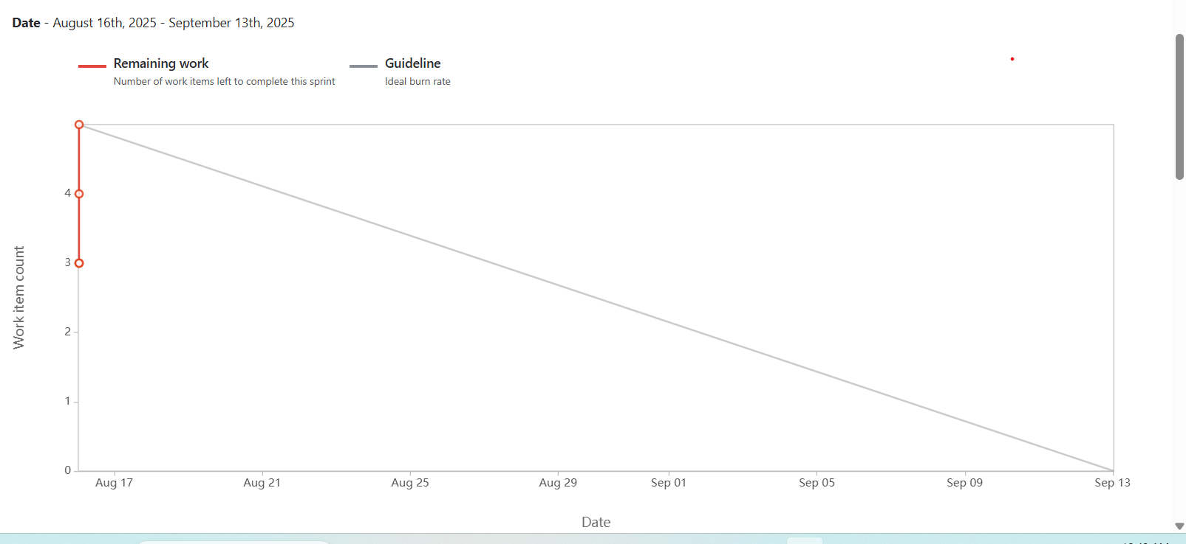

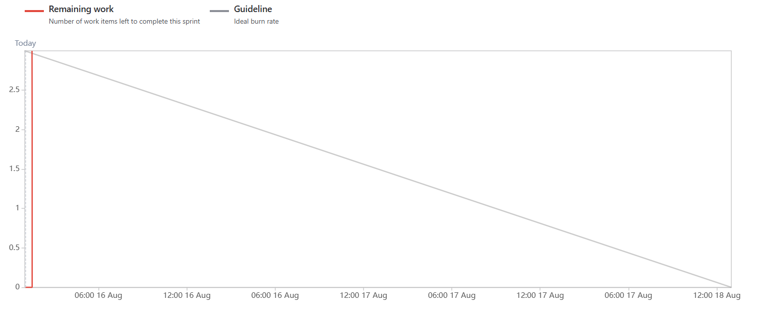

Document 6

Meeting 1 | Sprint Planning Meeting
Date
Time
Location
Prepared By
Attendees
Agenda Topics

Topic | Presenter | Time Alloted

Other Information

Observes
Resourses
Special Notes

Meeting 2 | Sprint Review Meeting

Date
Time
Location
Prepared By
Attendees

Sprint Status | Things to Demo | Quick Updates | What's Next

Meeting 3 | Sprint Retrospective Meetings

Date
Time
Location
Prepared By
Attendees

Agenda | What went well | What didn't go well | Questions | References

Meeting 4 | Daily Stand Up Meeting

Question | Name/Role | Week
 |  | Monday | Tuesday | Wednesday | Thrusday | Friday | Sataurday | Sunday
What did you do yesterday | Developer 1
 | Developer 2
 | Developer 3
What will you do today | Developer 1
 | Developer 2
 | Developer 3
What is blocking your progress | Developer 1
 | Developer 2
 | Developer 3

