Nurturing Process - Capstone Project1 – Part -3/3 V2D2- August 2024
COEPD – Traditional Development
Capstone Project1 – Part -3/3

Online Agriculture Products Store Mr. Henry, after being successful as a businessman and has become one of the wealthiest persons in the city. Now, Mr. Henry wants to help others to fulfil their dreams. One day, Mr. Henry went to meet his childhood friends Peter, Kevin, and Ben. They live in a remote village and do farming. Mr. Henry asked his friends if they are facing any difficulties in their day-to-day work.
Peter told Mr. Henry that he is facing difficulties in procuring fertilizers which are very important for farm. Kevin said that he is also facing the same problem in-case of buying seeds for farming certain crops. Ben raised his concern on lack of pesticides which could help in greatly reducing pests in crops.
After listening to all his friends’ problems, Mr. Henry thought that this is a crucial problem faced not only by his friends but also by so many other farmers. So, Mr. Henry decided to make an online agriculture product store to facilitate remote area farmers to buy agriculture products. Through this Online Web / mobile Application, Farmers and Companies (Fertilizers, seeds and pesticides manufacturing Companies) can communicate directly with each other.
The main purpose to build this online store is to facilitate farmers to buy seeds, pesticides, and fertilizers from anywhere through internet connectivity. Since new users are involved, Application should be user friendly.
This new application should be able to accept the product (fertilizers, seeds, pesticides) details from the manufacturers and should be able to display them to the Farmers. Farmers will browse through these products and select the products what they need and request to buy them and deliver them to farmers location.
Mr. Henry has given this project through his Company SOONY. In SOONY Company, Mr Pandu is Financial Head and Mr Dooku is Project Coordinator. Mr. Henry , Mr Pandu , and Mr Dooku formed one Committee and gave this project to APT IT SOLUTIONS company for Budget 2 Crores INR and 18 months Duration under CSR initiative. Peter, Kevin and Ben are helping the Committee and can be considered as Stakeholders share requirements for the Project.
Mr Karthik is the Delivery Head in APT IT SOLUTIONS company and he reached out to Mr Henry through his connects and Bagged this project. APT IT SOLUTIONS company have Talent pool Available for this Project. Mr Vandanam is project Manager, Ms. Juhi is Senior Java Developer, Mr Teyson, Ms Lucie, Mr Tucker, Mr Bravo are Java Developers. Network Admin is Mr Mike and DB Admin is John. Mr Jason and Ms Alekya are the Tester. And you joined this team as a BA.

Question – 1: Identify minimum 20 functional requirements
Example :
Functional requirement: When an order is fulfilled, the local printer shall print a packing slip.
Non-Functional Requirement: Packing slips shall be printed on both sides of 4”x 6” white paper, the standard size for packing slips used by local printers.
Req ID | Req Name | Req Description | Priority
FR0001 | Farmer Registration | Farmers should be able to register with the application | 8
FR0002 | Farmer Search for Products | Farmers should be able to search for available products in fertilizers, seeds, pesticides | 8
NFR0101 | Page Loading Time | Each Page should load within 2 seconds time | 9
NFR0102 | WCAG 2.1. | The system must meet Web Content Accessibility Guidelines WCAG 2.1. | 8

Functional Requirements for Online Agriculture Products Store
Req ID | Req Name | Req Description | Priority
FR0001 | Farmer Registration | Farmers should be able to register with the application | 8
FR0002 | Farmer Search for Products | Farmers should be able to search for available products in fertilizers, seeds, pesticides | 8
FR0003 | Manufacturer Registration | Manufacturers should be able to register and create a profile | 8
FR0004 | Product Upload | Manufacturers should be able to upload product details including images | 9
FR0005 | Product Approval | Admin should be able to review and approve/reject uploaded products | 9
FR0006 | Product Browsing | Farmers should be able to browse products by category | 8
FR0007 | Add to Cart | Farmers should be able to add products to a shopping cart | 7
FR0008 | Place Order | Farmers should be able to place an order for selected products | 9
FR0009 | Payment Integration | System should support online payment methods (UPI, Net Banking, etc.) | 9
FR0010 | Order Confirmation | System should send order confirmation to farmers | 8
FR0011 | Delivery Tracking | Farmers should be able to track delivery status of their orders | 7
FR0012 | Feedback Submission | Farmers should be able to submit feedback and ratings for products | 6
FR0013 | Admin Dashboard | Admin should have a dashboard to manage users, products, and orders | 9
FR0014 | Notification System | System should notify users about order status, approvals, and updates | 8
FR0015 | Login Functionality | Registered users should be able to log in securely | 9
FR0016 | Password Recovery | Users should be able to recover/reset their password | 8
FR0017 | Multi-language Support | System should support multiple languages for ease of use | 7
FR0018 | Product Filtering | Farmers should be able to filter products by price, category, and rating | 7
FR0019 | Order History | Farmers should be able to view their past orders | 6
FR0020 | Role-Based Access Control | System should provide different access levels for farmers, manufacturers, and admins | 9

Question – 2: Minimum 5 page designs
Make wireframe and prototypes

WireFrames:

User Registration and Login:
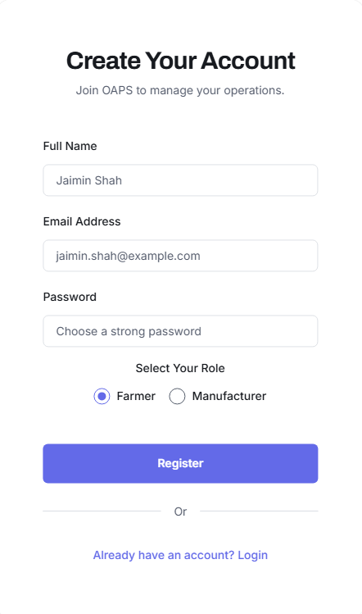
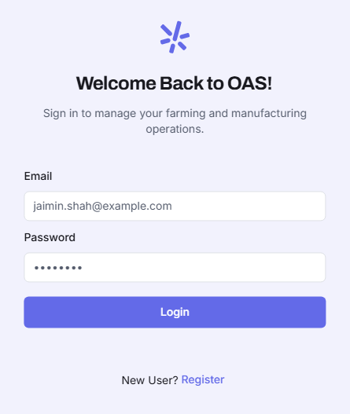

Home Screen:
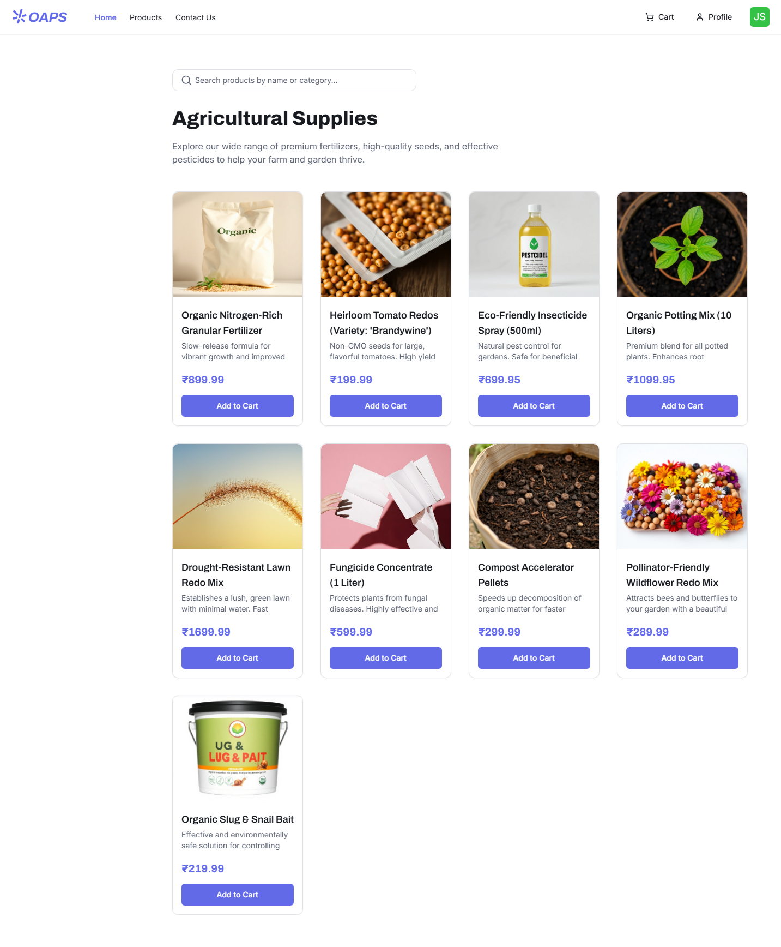

Product Details:
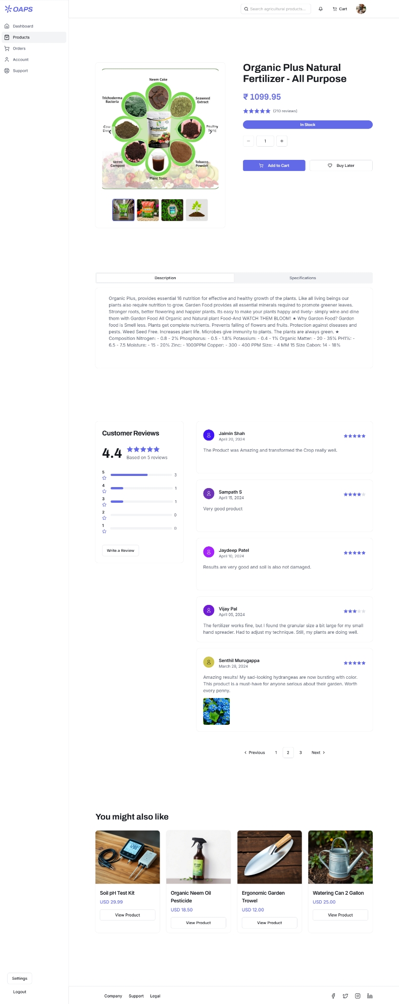

Checkout:
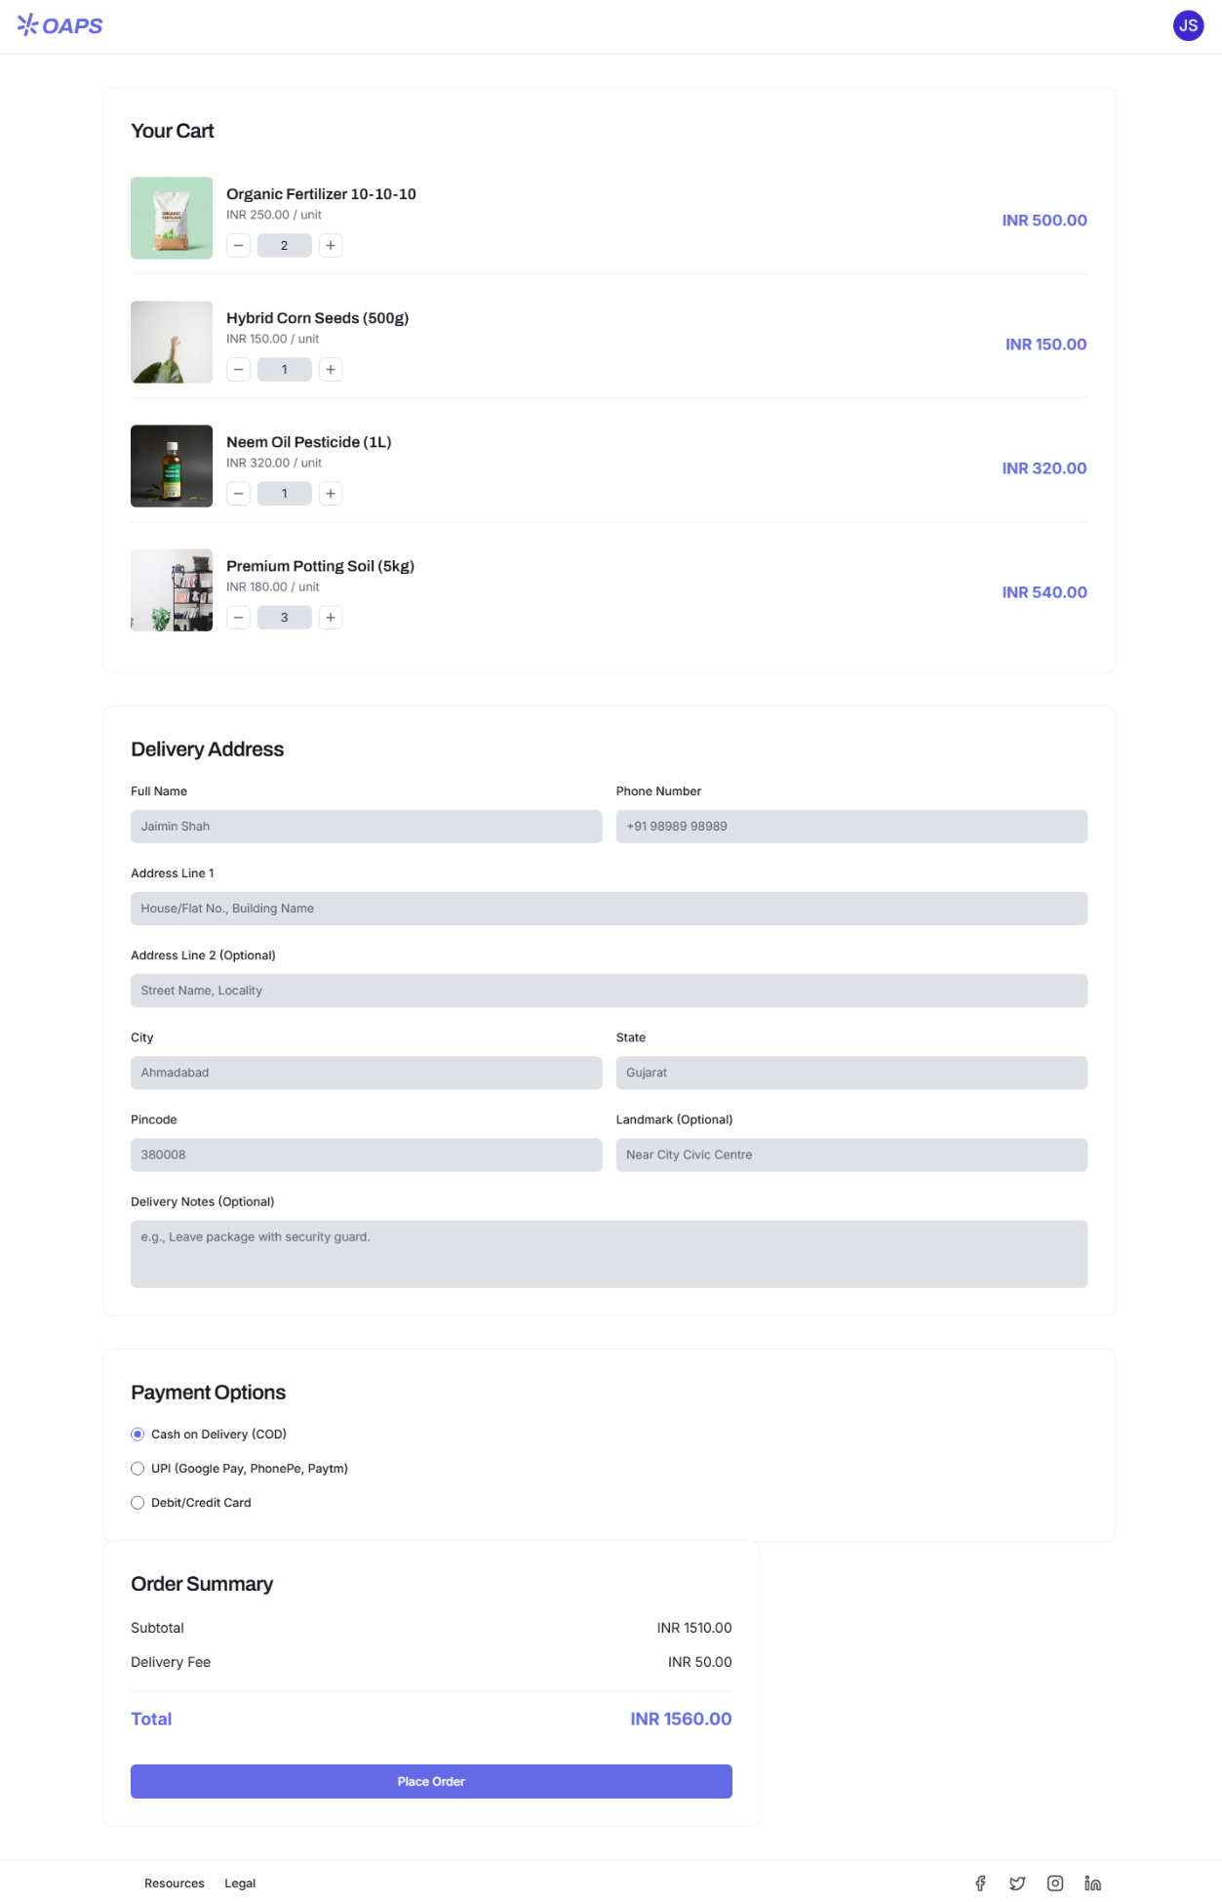
Prototypes:
Please click on following Link to open the Prototype
Functional Flow

Question 3 – Tools (Visio, Balsamiq)
Deliverable Type | Tool Used | Purpose / Justification
Use Case Diagrams & Activity Diagrams | Draw.io (diagrams.net) | Used to create UML diagrams such as Use Case, Activity, and Flow Diagrams with clarity and standard notations.
Wireframes / Prototypes | Balsamiq & Visily.ai | Balsamiq for low-fidelity wireframes to sketch initial layout ideas; Visily.ai for high-fidelity prototypes with interactive and modern UI components.
Requirement Documentation (BRD, SRS, RTM) | Microsoft Word / Excel | Used for maintaining business and functional requirement documents and requirement traceability matrices.

Summary:
- Diagramming Tool: Draw.io
- Wireframe & Prototype Tools: Balsamiq, Visily.ai

Question 4 – RTM
A business analyst’s key responsibilities are to keep track of the requirements and make sure that no requirement is missed.

Mr. Henry and peter have approached you regarding the current status of the project. How will you tackle this situation? Prepare RTM

Comp: Completed
WIP: Work In Progress

Req ID | Req Name | Req Description | Design | D1 | T1 | D2 | T2 | D3 | T3 | D4 | T4 | UAT
FR0001 | Farmer Registration | Farmers should be able to register with the application | Comp. | Comp. | Comp. | Comp. | Comp. | Comp. | Comp. | Comp. | Comp. | Comp.
FR0002 | Farmer Search for Products | Farmers should be able to search for available products in fertilizers, seeds, pesticides | Comp. | Comp. | Comp. | WIP | WIP. | Comp. | Comp. | Comp. | Comp. | WIP
FR0003 | Manufacturer Registration | Manufacturers should be able to register and create a profile | Comp. | Comp. | Comp. | Comp. | Comp. | Comp. | Comp. | Comp. | Comp. | Comp.
FR0004 | Product Upload | Manufacturers should be able to upload product details including images | Comp. | WIP | Comp. | Comp. | Comp. | Comp. | Comp. | Comp. | Comp. | WIP
FR0005 | Product Approval | Admin should be able to review and approve/reject uploaded products | Comp. |  |  | Comp. | Comp. |  |  |  |  | Comp.
FR0006 | Product Browsing | Farmers should be able to browse products by category | Comp. |  |  | Comp. | Comp. |  |  |  |  | Comp.
FR0007 | Add to Cart | Farmers should be able to add products to a shopping cart | Comp. |  |  |  |  | Comp. | Comp. |  |  | Comp.
FR0008 | Place Order | Farmers should be able to place an order for selected products | Comp. |  |  |  |  | Comp. | Comp. |  |  | Comp.
FR0009 | Payment Integration | System should support online payment methods (UPI, Net Banking, etc.) | Comp. |  |  |  |  | Comp. | Comp. |  |  | Comp.
FR0010 | Order Confirmation | System should send order confirmation to farmers | Comp. |  |  |  |  | Comp. | Comp. |  |  | Comp.
FR0011 | Delivery Tracking | Farmers should be able to track delivery status of their orders | Comp. |  |  |  |  | Comp. | Comp. |  |  | Comp.
FR0012 | Feedback Submission | Farmers should be able to submit feedback and ratings for products | Comp. |  |  |  |  |  |  | Comp. | Comp. | Comp.
FR0013 | Admin Dashboard | Admin should have a dashboard to manage users, products, and orders | Comp. |  |  | Comp. | Comp. |  |  |  |  | Comp.
FR0014 | Notification System | System should notify users about order status, approvals, and updates | Comp. |  |  |  |  | Comp. | Comp. |  |  | Comp.
FR0015 | Login Functionality | Registered users should be able to log in securely | Comp. | Comp. | Comp. |  |  |  |  |  |  | Comp.
FR0016 | Password Recovery | Users should be able to recover/reset their password | Comp. | Comp. | Comp. |  |  |  |  |  |  | Comp.
FR0017 | Multi-language Support | System should support multiple languages for ease of use | Comp. |  |  |  |  |  |  | Comp. | Comp. | Comp.
FR0018 | Product Filtering | Farmers should be able to filter products by price, category, and rating | Comp. |  |  | Comp. | Comp. |  |  |  |  | Comp.
FR0019 | Order History | Farmers should be able to view their past orders | Comp. |  |  |  |  | Comp. | Comp. |  |  | Comp.
FR0020 | Role-Based Access Control | System should provide different access levels for farmers, manufacturers, and admins | Comp. | Comp. | Comp. |  |  |  |  |  |  | Comp.

Question 5 – 10 Test Case Documents
Prepare 10 Test Case Documents

Test Case ID | Test Scenario | Test Steps | Expected Result | Actual Result | Status
TC001 | Farmer Registration | 1. Navigate to Registration page  2. Enter Name, Email, Password, select Role = Farmer  3. Click Register | Farmer account is created successfully, confirmation message displayed
TC002 | Manufacturer Registration | 1. Navigate to Registration page  2. Enter Name, Email, Password, select Role = Manufacturer  3. Click Register | Manufacturer account is created successfully
TC003 | Login with Valid Credentials | 1. Navigate to Login page  2. Enter valid Email and Password  3. Click Login | User is redirected to dashboard
TC004 | Login with Invalid Credentials | 1. Enter an invalid Email or Password  2. Click Login | Error message displayed: “Invalid credentials.”
TC005 | Search for Products | 1. Enter keyword in search bar  2. Click Search | Relevant products displayed
TC006 | Add Product to Cart | 1. Browse products  2. Click “Add to Cart” for a product | Product added to cart successfully
TC007 | Place Order | 1. Go to Cart  2. Click “Proceed to Checkout”  3. Enter shipping details and payment info  4. Click “Place Order” | Order confirmation displayed
TC008 | Payment Integration | 1. Select payment method (UPI/Card)  2. Complete payment | Payment successful, confirmation message displayed
TC009 | Product Upload by Manufacturer | 1. Login as Manufacturer  2. Navigate to Product Upload  3. Enter product details and upload image  4. Submit | Product submitted for admin approval
TC010 | Feedback Submission | 1. Navigate to past orders  2. Select delivered product  3. Provide rating and feedback  4. Submit | Feedback saved successfully

Question 6 – DB Design
After the requirements are thoroughly explained to the entire project team by business analyst, the Database architects have decided to do the database design and to represent the in-flow and out-flow of data. Draw database schema and ER diagram.

Entities and Attributes

- Users

Field Name | Data Type | Description
user_id | INT (PK) | Unique ID for each user
name | VARCHAR(100) | User’s full name
email | VARCHAR(100) | Unique email ID
password | VARCHAR(100) | Encrypted password
role | ENUM(‘Farmer’, ‘Manufacturer’, ‘Admin’) | Role type
contact_number | VARCHAR(15) | Mobile number
address | TEXT | Address of user
created_date | DATETIME | Account creation date

- Products

Field Name | Data Type | Description
product_id | INT (PK) | Unique product ID
manufacturer_id | INT (FK → Users.user_id) | Manufacturer who uploaded product
name | VARCHAR(100) | Product name
category | ENUM(‘Fertilizer’, ‘Seed’, ‘Pesticide’) | Product category
description | TEXT | Product description
price | DECIMAL(10,2) | Price of product
stock_quantity | INT | Quantity in stock
image_url | VARCHAR(255) | Product image
status | ENUM(‘Pending’, ‘Approved’, ‘Rejected’) | Admin approval status
created_date | DATETIME | Product upload date

- Orders

Field Name | Data Type | Description
order_id | INT (PK) | Unique order ID
farmer_id | INT (FK → Users.user_id) | Farmer who placed the order
order_date | DATETIME | Date when order was placed
total_amount | DECIMAL(10,2) | Total amount of the order
payment_id | INT (FK → Payments.payment_id) | Linked payment record
status | ENUM(‘Placed’, ‘Shipped’, ‘Delivered’, ‘Cancelled’) | Order status

- Order_Details

Field Name | Data Type | Description
order_detail_id | INT (PK) | Unique order line ID
order_id | INT (FK → Orders.order_id) | Associated order
product_id | INT (FK → Products.product_id) | Product purchased
quantity | INT | Quantity purchased
price | DECIMAL(10,2) | Product price at time of order

- Payments

Field Name | Data Type | Description
payment_id | INT (PK) | Unique payment record
order_id | INT (FK → Orders.order_id) | Associated order
payment_mode | ENUM(‘UPI’, ‘COD’, ‘Card’) | Payment method
payment_status | ENUM(‘Pending’, ‘Successful’, ‘Failed’) | Transaction status
transaction_date | DATETIME | Date/time of payment

- Feedback

Field Name | Data Type | Description
feedback_id | INT (PK) | Unique feedback ID
farmer_id | INT (FK → Users.user_id) | Farmer providing feedback
product_id | INT (FK → Products.product_id) | Product reviewed
rating | INT | Rating (1–5)
comments | TEXT | User comments
feedback_date | DATETIME | Feedback submission date

- Notifications

Field Name | Data Type | Description
notification_id | INT (PK) | Unique notification ID
user_id | INT (FK → Users.user_id) | Recipient user
message | TEXT | Notification content
created_date | DATETIME | Date of notification
is_read | BOOLEAN | Read/unread status

ER Diagram Description (Relationships)

Relationship | Type
User ↔ Product | One manufacturer (User) can upload many Products (1:M).
User ↔ Orders | One farmer (User) can place many Orders (1:M).
Order ↔ Order_Details | One order can contain many products (1:M).
Order ↔ Payments | One order has one payment record (1:1).
User ↔ Feedback | One farmer can give multiple feedbacks (1:M).
Product ↔ Feedback | One product can have multiple feedback entries (1:M).
User ↔ Notifications | One user can receive multiple notifications (1:M).

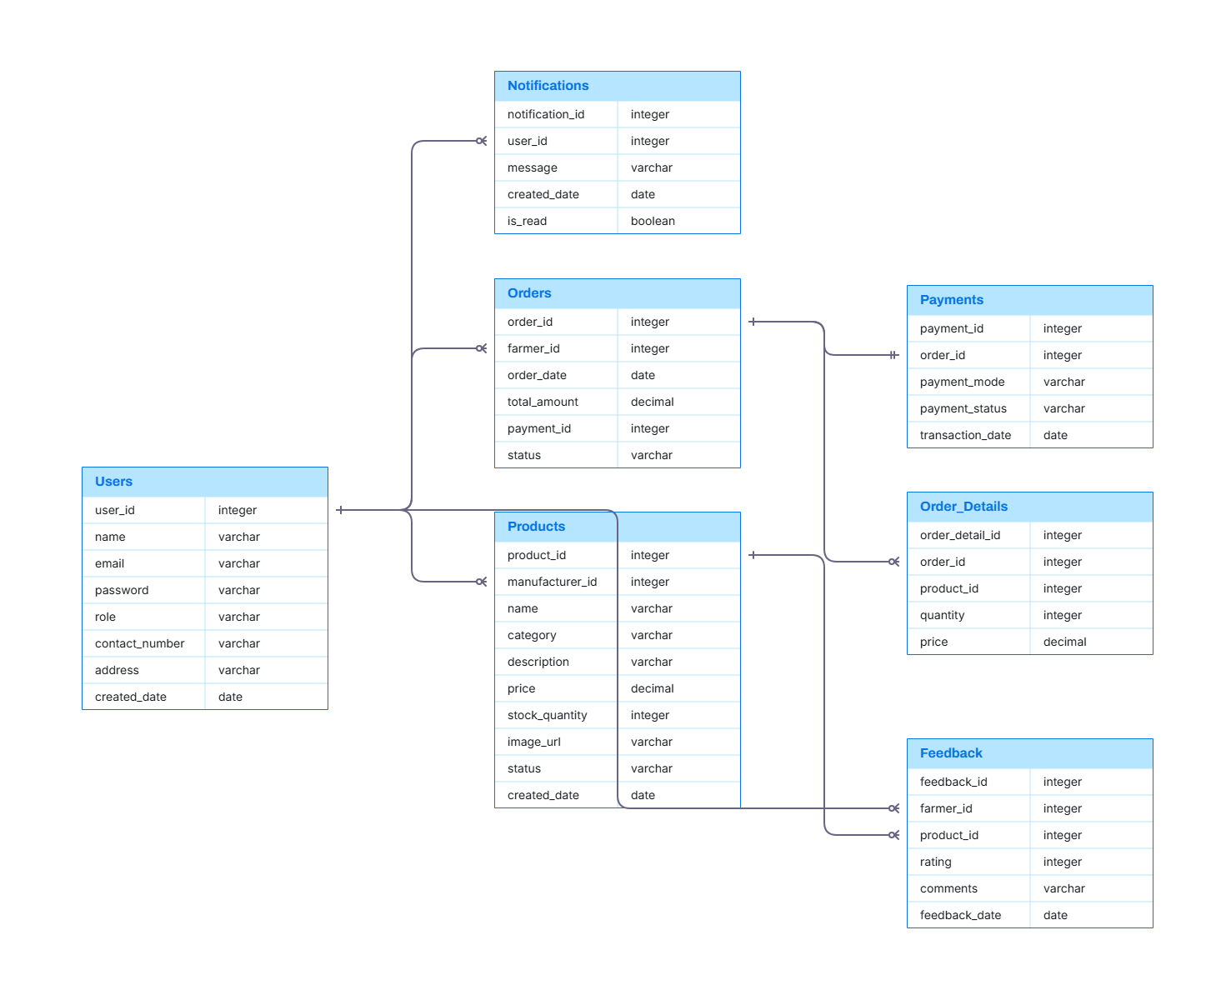

Question 7 – Data Flow Diagram
What is a data flow diagram? Draw a data flow diagram to represent the in-flow and out-flow of data when a Farmer is placing an order for the product.

A Data Flow Diagram (DFD) is a graphical representation that shows how data moves through a system, including:
- Processes (what the system does),
- Data Stores (where data is kept),
- External Entities (who interacts with the system), and
- Data Flows (the movement of information).
In simpler terms — it helps visualize input, process, and output of data.

Farmer Placing an Order
The flow describes what happens when a Farmer browses products and places an order.
We’ll represent this in two levels for clarity:

Level 0 DFD (Context Diagram)
External Entity:
- Farmer (User)
Process:
- Online Agriculture Product Store System
Data Stores:
- Product Database
- Order Database
- Payment Database

Flow Summary:
- Farmer requests to view products.
- System fetches product data.
- Farmer selects products and places an order.
- System stores order and payment details.
- System sends confirmation to farmer.

Level 1 DFD (Detailed View: Farmer Placing Order)
Processes:
- Login / Authentication
- Browse Product Catalog
- Add to Cart
- Confirm Order
- Process Payment
- Generate Confirmation / Update Inventory
Data Stores:
- D1: User Data
- D2: Product Data
- D3: Order Data
- D4: Payment Data
External Entities:
- Farmer (Customer)
- Payment Gateway (External System)

Data Flow Summary

Step | Description | Input | Output
1 | Farmer logs in | Credentials | Access granted
2 | Farmer views catalog | Request | Product list
3 | Farmer adds product to cart | Product ID | Cart data
4 | Farmer confirms order | Cart details | Order record
5 | Payment processed | Payment info | Confirmation/Receipt
6 | System updates stock | Order info | Updated product stock

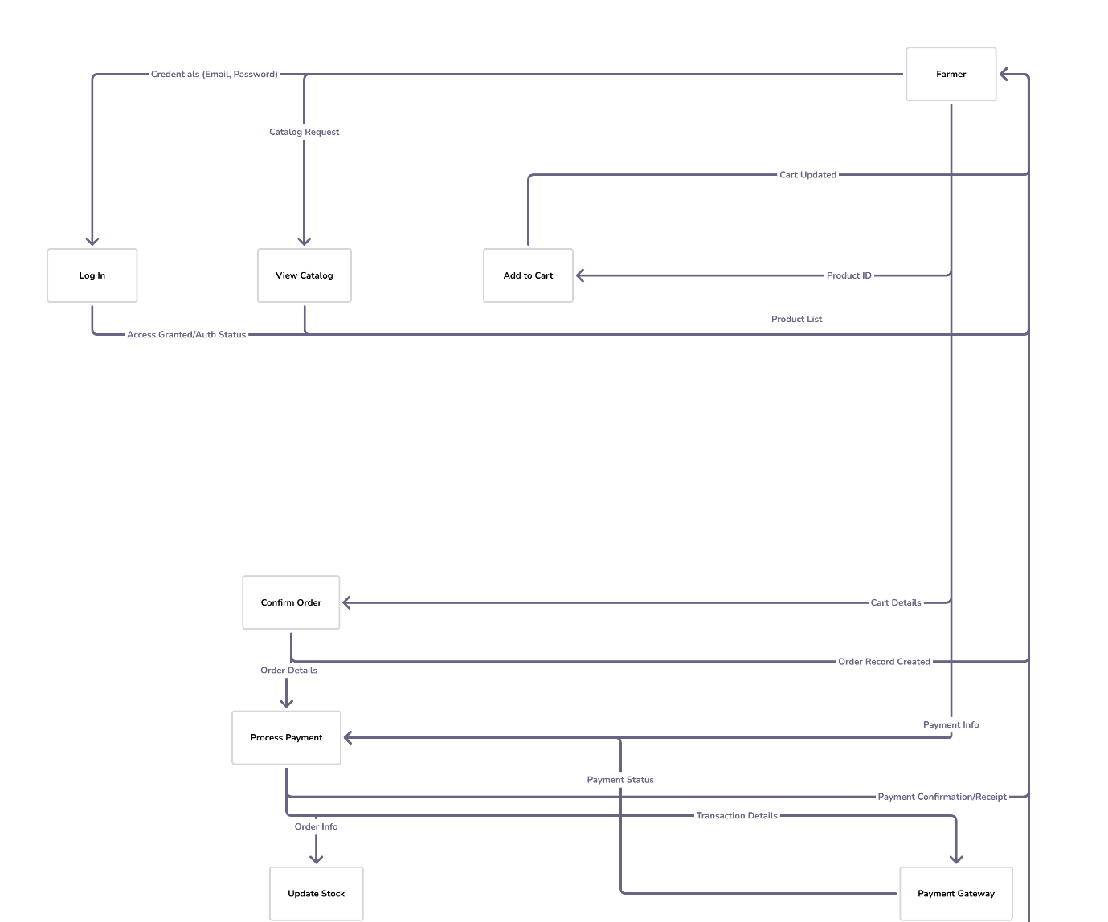
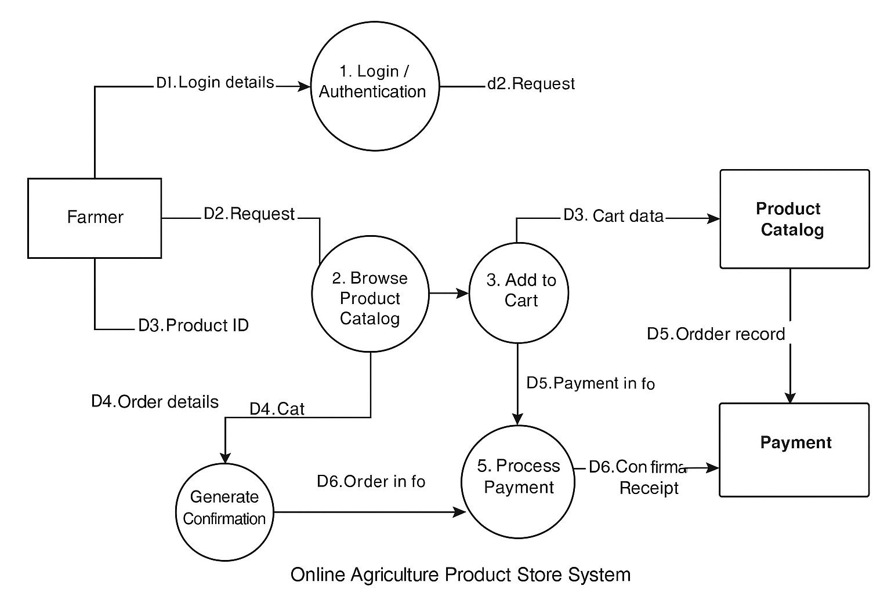

Question 8 – Change Request
Due to change in the Government Taxation structure . we should change the Tax structure How do you handle change requests in a project?

Steps to Handle Change Request

- Log the Change Request
  - Create a Change Request Form detailing:
  - Request ID
  - Description of change (Update Tax Structure)
  - Reason for change (Government policy update)
  - Requested by (Stakeholder name)
  - Date of request

- Impact Analysis (Performed by BA + Technical Team)
- Assess the impact on:

Area | Impact
Functional Requirements | Update pricing, tax fields, and reports
Database | Update tax field structure in Product/Order tables
Code | Update backend tax calculation logic
UI/UX | Update invoice and order confirmation displays
Testing | Regression testing for affected modules
Budget & Schedule | May require 1 additional week and developer/tester effort
Compliance | Ensures legal alignment

- Review and Approval
- Present analysis to Change Control Board (CCB) or key stakeholders (Mr. Henry, Project Manager).
- Obtain formal approval before proceeding.

- Update Documentation
- Prepare a Change Request Form (CRF) detailing:
  - Requestor Name: Mr. Henry / Committee
  - Change Description: Modify tax calculation module to reflect new GST/Tax rules.
  - Reason for Change: Compliance with updated government policy.
  - Affected Modules: Product Pricing, Order Summary, Invoice Generation.
  - Priority: High
  - Requested Date: [Insert Date]

- Implementation
- Developers modify the tax logic.
- Testers perform Unit + Regression Testing.
- BA validates that the change aligns with the updated business rule.
- Deploy changes in UAT for client verification.

- Communicate
- Inform stakeholders about the change implementation and timeline.
- Update user manuals if necessary.

- Testing
- Regression testing for order calculation.
- Validate new tax structure in invoices and payment summaries.

- Sign-off
- Get formal sign-off from client (Mr. Henry or Committee) confirming acceptance.
- Document the CR closure with date, approval, and implementation notes.

Question 9 – Change Request Vs an Enhancement
As the project is in process, Ben and Kevin have contacted you. The reason is to inform you that they want the Farmers to sell their crop yields through this application i.e. Farmers should be able to add their crop yields or products and display to general public and should be able to sell them. They also want to introduce Auction system for their Crop yields. As a BA, what will be your response? Is this a change request or an enhancement?

Change Request:
- A modification to an existing requirement or functionality already agreed upon in the scope.
- Example: Updating tax structure due to government policy change.

Enhancement:
- Adding new functionality that was not part of the original scope.
- Example: Introducing a new feature like auction system or enabling farmers to sell crops.

Original Scope:
The original Online Agriculture Product Store was designed with the core goal:
“To enable farmers to buy agricultural products (fertilizers, seeds, pesticides) from manufacturers.”

New Request from Ben & Kevin:
- Farmers should also be able to sell their own crop yields/products to the general public and have an auction system for crop sales.
- This adds new modules (Farmer Product Upload, Auction Management, Payment for Auction).
- It impacts UI, database design, workflows, and testing.

Business Analysis Evaluation
Aspect | Analysis
Scope Impact | Adds an entirely new business module (selling instead of just buying).
Functional Change | Requires new features: crop upload, bidding/auction logic, buyer registration, payment settlement, etc.
Data Model Impact | New entities (e.g., Crop_Yield, Auction_Bid, Buyer).
UI/UX Impact | New pages: Sell Crop, Auction Dashboard, Bid Interface.
Technical Impact | Major architectural and database expansion.
Timeline Impact | Additional design, development, and testing effort.
Question 10 – Estimations
Come up with estimations – How many Manhours required

Estimation Report – Online Agriculture Product Store

Project Overview:
This document presents the estimation of manhours for the Online Agriculture Product Store Project, developed under the V-Model approach. The estimations cover all phases from requirement gathering to deployment and support, involving multiple roles within the project team.

Phase-wise Estimation
Phase | Description | Estimated Manhours
RG | Requirement Gathering (Stakeholder meetings, BRD creation) | 480
RA | Requirement Analysis (Use cases, UML, SRS preparation) | 384
Design | Design (DB schema, UI mockups, system architecture) | 576
D1-T1 | D1-T1 (Login & Registration module) | 480
D2-T2 | D2-T2 (Product catalog & search module) | 576
D3-T3 | D3-T3 (Order management & payment integration) | 672
D4-T4 | D4-T4 (Notifications, feedback, and admin panel) | 576
UAT | User Acceptance Testing (Client validation & sign-off) | 288
PM & Reviews | Project Management & Reviews (Audits, progress tracking) | 384
Deployment | Deployment & Support (DB migration, setup, production readiness) | 384
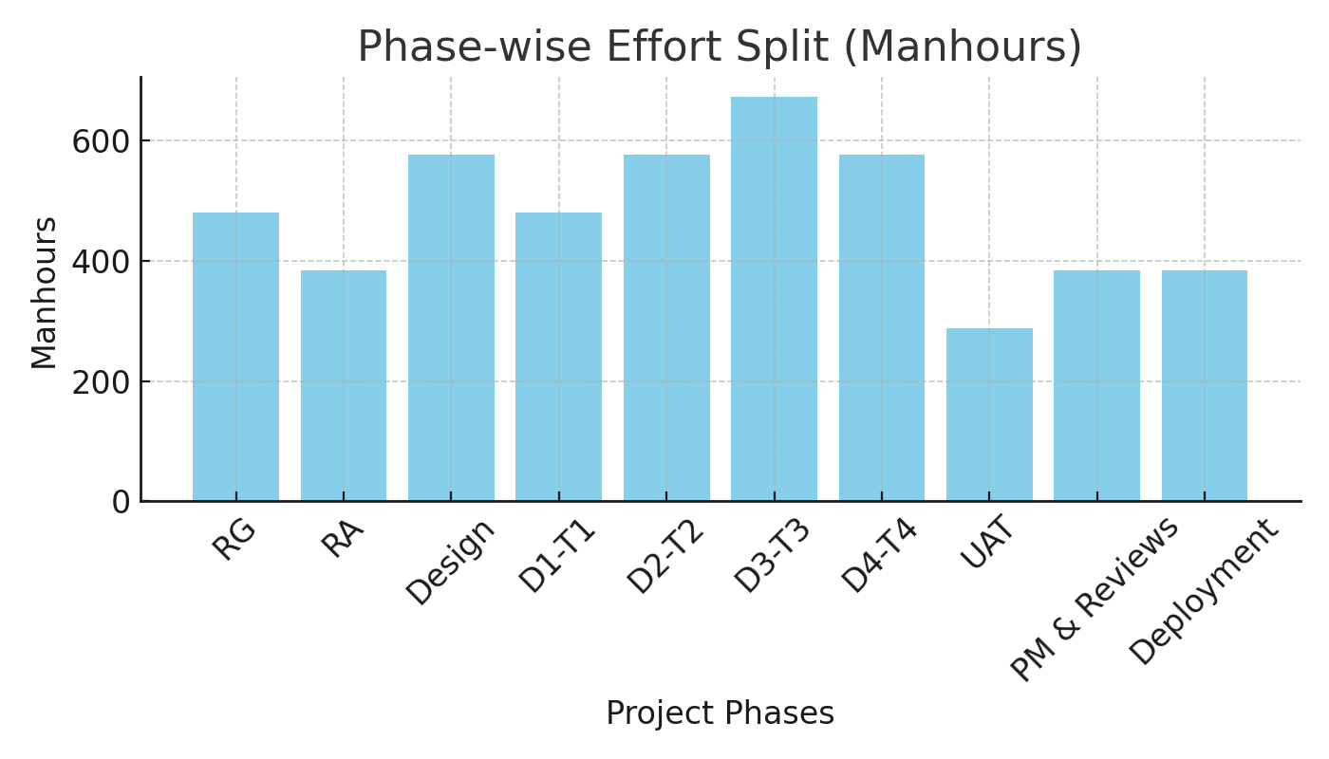

Role-wise Effort Distribution
Role | Headcount | Estimated Manhours
Project Manager | 1 | 480
Business Analyst | 1 | 576
Developers | 4 | 2160
Testers | 2 | 960
DB Admin | 1 | 336
Network Admin | 1 | 288

Assumptions
- Project follows V-Model (Development–Testing parallel phases).
- Includes design, coding, testing, documentation, and review.
- 10% buffer for unplanned changes or rework.
- Effort does not include enhancements (e.g., Auction System).

Conclusion
- The total estimated effort for the Online Agriculture Product Store Project is approximately 4,800–5,300 manhours.
- This estimation includes a 10% contingency buffer for risk and unforeseen changes.
- The breakdown ensures balanced workload distribution among team members, supporting efficient project execution and timely delivery.

Question 11 – UAT
Project has finally completed all the stages i.e., design, development, testing etc. Now, it is the role of a business analyst to contact the client for testing of the final product and have to successfully complete it. How are you going to handle this situation? And once it is done, what will be the process to close the project? Explain UAT Acceptance process.

User Acceptance Testing
User Acceptance Testing (UAT) is the final validation phase where the client verifies that:
- The developed system meets business needs and requirements defined in the BRD/SRS.
- The system is ready for production (Go-Live) use.
- There are no major gaps or defects remaining.
In simple terms: UAT = “Does the system do what the business expected it to do?”

UAT Process
Step | Activity | Responsible | Deliverables
1. UAT Planning | Define UAT scope, timelines, roles, and entry/exit criteria. | BA + PM + Client | UAT Plan Document
2. Environment Setup | Prepare test environment & load final build for client testing. | Technical Team | UAT Environment Ready
3. Test Case Preparation | Prepare UAT test cases mapped to Business Requirements. | BA | UAT Test Case Document
4. Conduct UAT Kickoff Meeting | Walk the client through the UAT scope, schedule, and support process. | BA + PM | Meeting Minutes
5. UAT Execution | Client executes test cases and reports issues (defects). | Client + BA | UAT Result Sheet
6. Defect Tracking & Resolution | Log and fix UAT defects; BA tracks closure status. | Dev + QA + BA | UAT Issue Tracker
7. UAT Sign-off | Once all issues are closed, client provides formal approval. | Client + BA | UAT Sign-off Document

Responsibilities During UAT
- Act as the single point of contact between client and internal team.
- Provide demo and walkthrough to stakeholders.
- Ensure traceability (each test case maps back to a requirement in RTM).
- Document any UAT issues, defects, and resolutions.
- Confirm client satisfaction before sign-off.
- Prepare and circulate the UAT Completion Report.

Entry & Exit Criteria
Type | Criteria
Entry Criteria | - All functional testing completed  - UAT environment ready  - UAT test cases approved by client  - Build deployed in UAT
Exit Criteria | - All critical defects closed  - Client approved all UAT test cases  - UAT sign-off received  - Deployment readiness confirmed

UAT Acceptance Process
- Prepare UAT document (test cases, expected results).
- Conduct UAT with client.
- Log defects and resolve them.
- Retest and confirm fixes.
- Obtain UAT Sign-Off (formal approval).

Sample UAT Sign-off Statement
UAT Sign-off Document
Project: Online Agriculture Product Store
Client: Mr. Henry / SOONY Committee
Date: [Insert Date]
This is to confirm that the Online Agriculture Product Store application has been tested, and all agreed requirements have been verified and accepted.
The product is approved for production deployment.
Signed By:
Mr. Henry – Client Representative
Mr. Vandanam – Project Manager
[Business Analyst Name] – Business Analyst

Project Closure Process
Once UAT is signed off, follow these steps to formally close the project:
Step | Description | Owner
1. Archive Documents | Archive BRD, SRS, RTM, Test Cases, and UAT Sign-off docs. | BA
2. Prepare Closure Report | Discuss lessons learned, challenges, and improvements. | PM + BA
3. Handover to Support Team | Transfer knowledge and documentation to maintenance/support. | PM + Tech Lead
4. Client Closure Meeting | Present final deliverables and formally end project. | BA + PM
5. Release Project Resources | Release team from project; close time and cost tracking. | PM
6. Conduct Retrospective | Discuss improvements for future projects. | BA + PM

Question 12 – Project Closure Document
Explain Project closure document

The Project Closure Document is a formal record that signifies the completion of a project and ensures all deliverables have been met, stakeholders are satisfied, and lessons learned are documented. It is essential for accountability and future reference.

Purpose of the Project Closure Document
- To summarize the project’s overall performance.
- To record acceptance of the final deliverables by the client.
- To document lessons learned and recommendations.
- To release project resources and close financial accounts.
- To ensure all stakeholders are aligned that the project is officially complete.

Key Components of a Project Closure Document
Section | Description
1. Project Overview | - Project name, sponsor, start and end dates.  - Objectives and scope summary.
2. Project Deliverables | - List of all deliverables (BRD, SRS, Design Docs, Test Cases, UAT Report, etc.) that were delivered and approved.
3. Project Performance Summary | - Planned vs actual timeline.  - Budget vs actual cost.  - Quality metrics.
4. UAT Summary & Client Sign-off | Confirmation that User Acceptance Testing is completed and client has approved the system for Go-Live.
5. Lessons Learned | - What worked well.  - Challenges faced and how they were resolved.
6. Risk & Issue Closure | - Documentation that all risks and issues have been mitigated or closed.
7. Knowledge Transfer & Handover | - Confirmation that all technical and functional documentation has been handed over to the maintenance team or client.
8. Resource Release | - List of project resources released from the project after closure.
9. Financial Closure | - Confirmation that project billing, vendor payments, and expenses are settled.
10. Approval & Sign-off | - Formal signatures from the client and project sponsor confirming project completion.
11. Attachments | - UAT report, RTM, final test results, and other key documents.

Project Closure Document(Sample)

Project Overview

Project Name: Online Agriculture Product Store
Client: SOONY Committee (Mr. Henry, Mr. Pandu, Mr. Dooku)
Vendor: APT IT Solutions Pvt. Ltd.
Project Manager: Mr. Vandanam
Business Analyst: [Your Name]
Date: [Insert Date]

This project aimed to develop an Online Agriculture Product Store to enable farmers to buy fertilizers, seeds, and pesticides from manufacturers online.
The project was executed as part of SOONY’s CSR initiative with a budget of ₹2 Crores and an estimated duration of 18 months.

Project Deliverables

Deliverable | Description | Status
BRD | Business Requirement Document | Approved
SRS | System Requirement Specification | Approved
Design Documents | Architecture and UI mockups | Completed
Test Cases | Functional and UAT test cases executed | Completed
UAT Report | User Acceptance Testing completed and signed off | Approved
Final Build | Application deployment and delivery | Delivered

Project Performance Summary

Parameter | Planned | Actual
Duration | 18 months | 18.5 months
Budget | ₹2 Crores | ₹2.05 Crores
Scope | 100% | 100%
Quality | 98% defect-free | Achieved

UAT and Acceptance

User Acceptance Testing (UAT) was successfully completed with the client representatives — Mr. Henry, Mr. Pandu, and Mr. Dooku.
Minor defects identified during UAT were fixed, and the client provided formal acceptance on [Insert Date].
The application is approved for production deployment.

Lessons Learned
- Early stakeholder involvement helped clarify requirements quickly.
- Regular project audits improved quality and schedule adherence.
- Strong communication between BA and developers minimized misunderstandings.
- Change Request handling needs further streamlining to reduce approval delays.

Knowledge Transfer and Handover

All project documents, including BRD, SRS, Design Documents, Test Cases, and UAT Reports,
have been handed over to the maintenance and support teams.
The final application build, database backups, and environment credentials have been shared with the client IT department.

Resource Release and Financial Closure

All project team members have been officially released from the project post client sign-off.
Financial closure activities, including billing and vendor payment settlement, have been completed successfully.

Project Closure Approval

Name | Role | Signature | Date
Mr. Henry | Client / Project Sponsor | __________ | __________
Mr. Vandanam | Project Manager | __________ | __________
[Your Name] | Business Analyst | __________ | __________

Conclusion

The Online Agriculture Product Store Project has been successfully completed and accepted by the client.
All deliverables have been submitted, and the project objectives have been fully met.
This document serves as formal confirmation that the project is closed and has transitioned to the maintenance phase.

