- 4 Quarterly Audits are planned Q1, Q2, Q3, Q4 for this Project What is your knowledge on how these Audits will happen for a BA?
Audit: An audit in a project is a structured review to check the documents complication, solution aligned with requirements, complying with standards.
Internal Audit: It is conducted by own organization
External Audit: Done by client representatives or independent auditors.
Stage | Q1 Requirement Gathering
Completed | Week 1 - 8
Checklist | Stakeholder identification
Checklist | Requirements documented
Checklist | Meeting minutes recorded
Checklist | Sign-offs received
Checklist | Version control maintained

Stage | Q2 Requirement Analysis
Completed | Week 9 - 16
Checklist | Use case diagrams prepared
Checklist | Requirements categorized
Checklist | Feasibility checked
Checklist | Traceability matrix created
Checklist | Conflict resolution documented

Stage | Q3 Design
Completed | Week 17 - 24
Checklist | Functional specs finalized
Checklist | Wireframes/mock-ups created
Checklist | Utilization Tools
Checklist | Validation rules defined
Checklist | Design walkthrough done with stakeholder

Stage | Q4 Development and Testing
Completed | Week 25 - 32
Checklist | Requirements clarifications provided
Checklist | BRD updates if needed
Checklist | BA-JIRA tickets closed with proper remarks
Checklist | Test cases reviewed
Checklist | Defect notes maintained

- Before the Project is going to Kick Start, The Committee asked Mr Karthik to submit BA Approach Strategy Write BA Approach strategy
Write BA Approach strategy (As a business analyst, what are the steps that you would need to follow to complete a project – What Elicitation Techniques to apply, how to do Stakeholder Analysis RACI/ILS, What Documents to Write, What process to follow to Sign off on the Documents, How to take Approvals from the Client, What Communication Channels to establish n implement, How to Handle Change Requests, How to update the progress of the project to the Stakeholders, How to take signoff on the UAT- Client Project Acceptance Form )

- What Elicitation Techniques to apply
It refers to the approach used by business analyst to collect requirements and information from stakeholders to understand what system should do. Purpose of this technique is to understand the expectations of users, identify problems in the existing solution, discover functional and non-functional requirements.
  - Interviews: One-on-one conversions with stakeholder to gather information. It is used in early projects to understand stakeholder expectations and gather domain knowledge. Here, one-on-one discussion is done with farmers and manufacturers to understand their needs.
  - Workshops: Group discussion involving stakeholders from different teams. Early in the project to understand stakeholder expectations and gather domain knowledge. It is done to align multiple stakeholders, resolve conflicts, or brainstorm new ideas collaboratively.
  - Observations: Shadowing users as they perform tasks. It is used to capture real-time behaviours and uncover hidden requirements in existing processes. Observe farmers using traditional methods and transition into app-based buying.
  - Prototyping: Presenting mock UI screens or low/high fidelity models. It is used to validate ideas, clarify unclear requirements, and reduce misunderstandings early.
  - Surveys: Structured set of questions sent to a larger audience. To collect input from many users at once—especially useful for dispersed or remote stakeholders. Get feedback from unregistered user about pain points.

- how to do Stakeholder Analysis RACI/ILS?

Stakeholder analysis: Identifying all parties (stakeholders) affected by the project, understanding their influence, and planning communication with them.
- Internal Stakeholder:
  - Mr. Vandanam – Project manager
  - Ms. Juhi – Sr. Java developer
  - Mr. Teyson, Ms. Lucie, Mr. Tucker, Mr. Bravo – Java Developers
  - Mr. Mike – Network admin
  - Mr. John – DB admin
  - Mr. Jason, Ms. Alekya – Tester
  - Sneha – Business Analyst
- External Stakeholder:
  - Mr. Henry – Businessman
  - Mr. Pandu – Financial head
  - Mr. Dooku – Project coordinator
  - Peter, Kevin and Ben – Stakeholders
RACI Matrix: The RACI matrix is a simple tool used to define roles and responsibilities for tasks in a project. It stands for:
- R – Responsible: The person who does the task.
- A – Accountable: The person who is in charge and makes sure the task is done properly.
- C – Consulted: The people who give advice or help with the task.
- I – Informed: The people who need to be kept updated about the task.
Task | Mr. Henry (Project Sponsor) | Mr. Pandu (Financial head) | Mr. Doku  (Project coordinator) | Mr. Karthik (Delivery head) | Mr. Vandanam  (Project manager) | Ms. Juhi  (Sr. Java developer) | Mr. Teyson, Ms. Lucie  ,Mr. Tucker, Mr. Bravo  (Java Developers) | Mr. Mike (Network Admin) | Mr. John (DB Admin) | Mr. Jason, Ms. Alekya  (Tester) | Peter, Kevin, Ben | Sneha  (Business Analyst)
Requirement  Gathering | A | C | C | I | C | I | I | I | I | I | C | R
Requirement  Analysis | C | I | C | I | C | C | C | C | C | I | C | R
Development | I | I | I | I | A | R | R | C | C | I | I | I
Testing | I | I | I | I | C | I | I | I | I | R | I | I
UAT | A | I | C | I | C | I | I | I | I | C | C | R

- What Documents to Write?
BA creates structured documents to define, track, and approve requirements
- Business Requirement Document (BRD) - High-level business goals and needs
- Functional Requirement Specification (FRS) - Detailed system behaviour & features
- Use Case Specifications- Each use case detailed out.
- Process Flow Diagrams - Visual representation of processes
- Traceability Matrix - Map requirements to test cases

- What process to follow to Sign off on the Documents?
Ensures that stakeholders formally approve the documented requirements before development begins.
Process:
- BA prepares documents and reviews internally.
- Share with stakeholders via email or project portal.
- Conduct review meetings to gather feedback.
- Revise documents based on feedback.
- Obtain written/email confirmation for sign-off.

- How to take Approvals from the Client?
Formal confirmation from clients on scope, documents, and deliverables.
  - Share finalized BRD/FRS via mail or repository.
  - Use a client-specific approval form.
  - Include version control, signature space, and comments section.

6. What Communication Channels to establish n implement
Mediums through which project updates and collaboration happen.
  - Email - Document sharing, formal communication
  - Teams - Daily communication, clarifications
  - Teams call - Discussion & approvals
  - Project Management tools - Task tracking & updates (JIRA)

7. How to Handle Change Requests
Process of managing new requirements or scope changes after sign-off.
- Receive change request via email.
- Analyse impact (cost, time, effort).
- Update FRS/BRD with versioning.
- Get stakeholder/client approval.
- Implement and track the change

8. How to update the progress of the project to the Stakeholder?
Provide regular updates to stakeholders including project manager, technical team. This can be done through status report, daily meetings to ensure transparency and keep stakeholders informed.
- Weekly Reports showing % completion, blockers, status of use cases.
- Monthly summary email to client with risk tracking.
- Daily meeting

  - How to take signoff on the UAT?
Final phase where client checks if solution meets their needs.
Project Sheet Sign off
Version Date: */**/****
Project Name: Online Agriculture Product Store
Project Goals:
1. To help the farmers and manufactures connect with each other
2. To facilitate farmers to buy seeds, fertilizers, pesticides from anywhere and get them delivered in the remote area.
Project Manager: Mr. Vandanam | Sponsor: Mr. Henry
Start Date: April 1st, 2025 | Planned Budget: INR 2 crores
Planned Completion Date: August 15th, 2025 | Actual Budget:
Actual Completion Date: | Variance:
Duration: 18 Months
Days Past the planned completion date:
Project Deliverables
By signing this document, I acknowledge that I have delivered all the stated deliveries per the agreed plan and acceptance criteria.  Project Manager Signature:  Date: **/**/*** | By signing this document, I acknowledge that I have received all the stated deliverables as per the agreed plan and acceptance criteria  Sponsor Signature:  Date: **/**/***
Remarks:

- Explain and illustrate 3-tier architecture?
3 tier architecture: 3-tier architecture is a client-server software architecture pattern that separates the application into three distinct layers:
- Presentation Tier (UI)
- Application Tier (Business Logic)
- Data Tier (Database Layer)
- Presentation Tier (User Interface):
This layer is responsible for the user interface and how users interact with the application. It handles displaying information, receiving user input, and managing navigation.
  - User interacts via website/mobile app.
  - View products, Login/Register, Add to cart, Checkout
- Application Tier (Logic Tier):
This tier contains the core business logic of the application. It processes data, performs calculations, and implements business rules.
Validating login credentials, managing cart sessions, Processing orders
- Data Tier (Database Tier):
This layer manages and stores the application's data. It handles data access, storage, and ensures data integrity.
User data, Product catalogue, Orders and payment history
Benefits:
- Scalability:
Each tier can be scaled independently to handle varying loads and user traffic, according to architectural resources.
- Maintainability:
Changes in one tier can be made without affecting the others, simplifying maintenance and updates.
- Flexibility:
Allows for the use of different technologies and platforms for each tier.
- Security:
Separation of data access from the user interface can improve security, according to software architecture articles.

- Business Analyst should keep What points in his/her mind before he frames a Question to ask to the Stakeholder (5W 1H – SMART – RACI – 3 Tier Architecture – Use Cases, Use case Specs, Activity Diagrams, Models, Page designs)
5W1H: is a problem solving and question framing technique that stands for Who, What, When, Where, Why and How. It is used to gather information, avoid miscommunication and ensure requirement traceability.
  - Who will use the platform?
  - Who is allowed to search for products?
  - What should be searchable?
  - What product categories should be supported?
  - What payment modes should be integrated?
  - When should product delivery be initiated after order placement?
  - Where should the search happen?
  - Where will the feedback or query from a farmer go?
  - Why do we allow search for unregistered users?
  - How will the search logic work?
  - How will payment be processed?
SMART: is a guideline to evaluate if a goal is Specific, Measurable, Achievable, Relevant, Time-bound. Smart helps ensure that the stakeholders’ requirements are actionable. It prevents chasing goals that are unclear.
- Should allow adding quantity, view cart, remove item.
- Measurable: can we track how many times item was added to the cart?
- Achievable: Is it feasible to support all payment types?
- Relevant: Does this improve shopping experience for farmers?
- Time Bound: Can we deliver this feature in 1 week?
RACI: It is a responsibility assignment model that defines roles and responsibilities in a project
- Responsible: This is the person or group who actually performs the task or activity. They are the ones doing the work.
- Accountable: This is the person who is ultimately answerable for the correct and thorough completion of the task or deliverable. This person ensures the work gets done and has the "ownership" of the task.
- Consulted: These are the individuals or groups whose opinions and input are sought before a decision or action is taken. They provide expertise or guidance
- Informed: These are the individuals or groups who need to be kept in the loop about the progress and status of the task or activity, but do not need to be actively involved in the work itself.
For payment gateway module:
Responsible – Development Team – They will integrate payment gateway
Accountable – Project Manager – Signs off on implementation
Consulted – Finance team – For compliance issues
Informed – Stakeholders – To stay updated on progress
3-tier architecture:
- Presentation Tier (User Interface):
This layer is responsible for the user interface and how users interact with the application. It handles displaying information, receiving user input, and managing navigation. UI/Frontend
- Application Tier (Logic Tier):
This tier contains the core business logic of the application. It processes data, performs calculations, and implements business rules. Processes data, logic, validations
- Data Tier (Database Tier):
This layer manages and stores the application's data. It handles data access, storage, and ensures data integrity. Database, data storage and retrieval.

Use Cases
Use Case describes how a user interacts with the system to achieve a goal.
  - Who the actor is?
  - What are their goals?
  - What task or function they would perform?
Use case specs
A Use Case Specification is a detailed document that includes: Actors, Preconditions, Steps/flows (main + alternate), Postconditions
- What are the goals of actor?
- What information does actor desire from system?
- What are the different flows for the use case?
Activity Diagram:
An Activity Diagram is a UML diagram that shows the flow of activities (actions, decisions, parallel tasks) in a system or process. It helps visualize how the process flows, identify forks, joins, decisions, and loops. BAs use this to validate flows with stakeholders.
Model and Page design:
To communicate clearly and confirm UI expectations
- Wireframes: Static visual sketches of UI layout
- Prototypes: Interactive mock-ups showing real flow
- Models: Includes ER models, data models, state diagrams, etc.

- As a Business Analyst, What Elicitation Techniques you are aware of? (BDRFOWJIPQU)
  - Brainstorming: A group activity to quickly share and collect many ideas. Conduct sessions with farmers, the sponsor, and technical teams to gather ideas for features like multiple payment modes, search filters, and seasonal product offers.
  - Document Analysis: Reviewing existing documents, manuals, and records to extract useful information. Study agriculture product catalogues, current manual order processes, and any old online store workflows to identify what should be retained or improved.
  - Reverse Engineering: Analyzing an existing product or system to understand its functionality and requirements. Examine competitor online agriculture stores to see which features work well and adapt them.
  - Focus Group: Structured discussions with a small group of stakeholders to capture their opinions and expectations. Organize focus groups with farmers and manufacturers to discuss usability, preferred payment methods, and language options for the store.
  - Observations: Shadowing users as they perform tasks. It is used to capture real-time behaviours and uncover hidden requirements in existing processes. Observe farmers using traditional methods and transition into app-based buying.
  - Workshops: Group discussion involving stakeholders from different teams. Early in the project to understand stakeholder expectations and gather domain knowledge. It is done to align multiple stakeholders, resolve conflicts, or brainstorm new ideas collaboratively. Host workshops to finalize product search flow, cart process, and payment error-handling steps.
  - JAD (Joint Application Development): Facilitated workshops involving both business stakeholders and IT teams to design and review solutions. Use JAD sessions to agree on the UI layout for search results, cart page, and payment gateway screens.
  - Interviews: One-on-one conversions with stakeholder to gather information. It is used in early projects to understand stakeholder expectations and gather domain knowledge. Here, one-on-one discussion is done with farmers and manufacturers to understand their needs.
  - Prototyping: Presenting mock UI screens or low/high fidelity models. It is used to validate ideas, clarify unclear requirements, and reduce misunderstandings early.
  - Surveys: Structured set of questions sent to a larger audience. To collect input from many users at once—especially useful for dispersed or remote stakeholders. Get feedback from unregistered user about pain points.
  - Use case Specs: A visual method to organize user stories to depict the complete user journey. Create a story map showing how a farmer searches for a product, adds it to the cart, and completes payment — including alternate flows like product unavailability or payment failure.

- Which Elicitation Techniques can be used in this Project and Justify your selection of Elicitation Techniques?
  - Brainstorming: A group activity to quickly share and collect many ideas. Multiple stakeholders (farmers, manufacturers, platform admins) will have unique needs, and brainstorming can capture them in one session before prioritization. Encourages contributions from all groups, even quiet participants. Surfaces innovative ideas. Lays a foundation for requirement prioritization in workshops or follow-up meetings.
  - Use Case Specifications: Detailed documents that describe how a user interacts with the system to achieve a goal, including preconditions, flows, exceptions, and postconditions.
The system has multiple key actions (e.g., login, search product, add to cart, make payment) with different paths for different actors (farmers, manufacturers). Clearly captures step-by-step interactions. Helps developers understand required system responses for normal, alternate, and error cases. Ensures nothing is missed in functional coverage, especially for critical flows like payments.
  - Prototyping: Building a simple working model or mock-up of the system’s interface to help stakeholders visualize requirements.
Many farmers and manufacturers might struggle to express technical requirements in words. A clickable prototype of the homepage, product catalog, cart, and payment flow can help them see what the system will look like. Helps farmers confirm if product categories, filters, and payment screens match their needs. Saves time by identifying missing or misunderstood features early. Reduces rework during development.

- Make suitable Assumptions and identify at least 10 Business Requirements.
Business requirements: Business requirements describe what the business needs to achieve in order to deliver value to its customers, stakeholders, or users. They are goals, objectives, and outcomes that the project or solution must fulfil.
  - BR001 –
Farmers should be able to search for available products in fertilizers, seeds, and pesticides using keywords or filters.
  - BR002 –
Farmers should be able to browse the complete catalog of fertilizers, seeds, and pesticides without logging in.
  - BR003 –
Manufacturers should be able to upload and display their products in the application with product images, details, and prices.
  - BR004 –
The system should provide account registration for new users (Farmers, Manufacturers, Admins) with email ID and secure password creation.
  - BR005 –
The system should provide a secure login for registered users with credential validation.
  - BR006 –
Farmers should be able to add products to a shopping cart for purchase.
  - BR007 –
Farmers should be able to save products in a "buy later" list or Wishlist for future purchase.
  - BR008 –
The system should provide payment through Cash on Delivery (COD), Credit/Debit Card, and UPI.
  - BR009 –
The system should confirm payment success/failure and notify the user immediately.
  - BR010 –The system should send order confirmation emails to Farmers after a successful purchase.
  - BR011 –
The system should provide an order tracking feature to track delivery status and shipment location.
  - BR012 –
Farmers should be able to cancel an order before it is shipped.
  - BR013 –
Manufacturers should have their own dashboard to manage products, prices, and stock levels.
  - BR014 –
Farmers should be able to rate and review purchased products.
  - BR015 –
Admin should be able to monitor all users, orders, payments, and resolve disputes.

- List your assumptions?
  - All users (farmers and manufacturers) have stable internet connectivity to access the application.
  - Manufacturers will provide accurate and updated details (name, price, stock, description) for their products.
  - The platform will be available in a common language understandable to most users (e.g., English or local language).
  - Customer support will be available during working hours for payment or order issues.
  - Order status updates will be sent via email.
  - Product search will be keyword-based.
  - The payment gateway will support UPI, cards, and COD securely with necessary compliance

- Give Priority 1 to 10 numbers (1 being low priority – 10 being high priority) to these Requirements after discussions with the stakeholders
Req ID | Req Name | Req Description | Priority
BR001 | Farmer Search for Products | Farmers should be able to search for available products in fertilizers, seeds, pesticides. | 8
BR002 | Manufacturers Upload their Products | Manufacturers should be able to upload and display their products in the application. | 8
BR003 | User Registration | New users should be able to create an account with email ID and password. | 9
BR004 | User Login | Users should be able to log in using registered email and password. | 9
BR005 | Product Catalog Browsing | Farmers should be able to browse fertilizers, seeds, and pesticides without logging in. | 7
BR006 | Add to Cart | Farmers should be able to add selected products to the cart for purchase. | 9
BR007 | Payment Gateway – UPI | Payment via UPI should be available for farmers. | 10
BR008 | Payment Gateway – Card | Payment via Credit/Debit cards should be available for farmers. | 10
BR009 | Payment Gateway – COD | Cash-on-delivery payment option should be available for farmers. | 9
BR010 | Order Confirmation Email | System should send email confirmation after an order is placed. | 7
BR011 | Delivery Tracking | Farmers should be able to track the status and location of their delivery. | 9
BR012 | Product Details Page | Product details page should display description, price, manufacturer name, and availability. | 8
BR013 | Search Filter & Sorting | Farmers should be able to filter products by category, price, and manufacturer. | 6
BR014 | Manufacturer Verification | Manufacturers must be verified before listing products. | 8
BR015 | Cart Management | Farmers should be able to update quantities or remove products from the cart before payment. | 7

- Draw use case diagram
Use case Diagram:
It is a visual representation of system functionality. It defines the boundaries of the system and its functionality. It shows how user will interact with system to achieve its goals. Its key elements are actors who are users who will interact with the system, use cases are the tasks actors will perform on the system, relationships denote which actor performs which use case, system boundary is a box that represent the system.
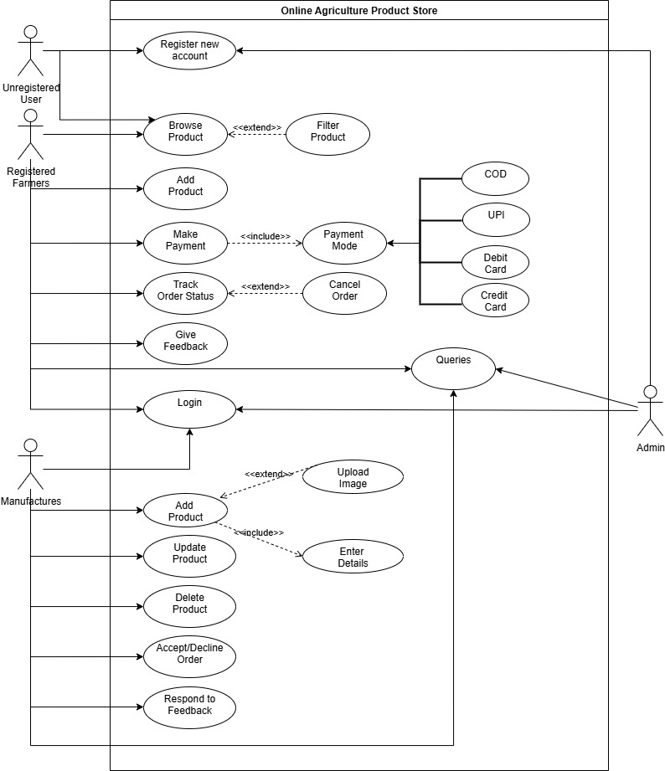

- Prepare use case specs for all use cases
It is a textual representation of how user interacts with the use cases. It outlines the steps involved in a use case, including different scenarios (main flow, alternative flows) and pre/post-conditions, to ensure the system behaves as expected from the user's perspective. It helps bridge the gap between business needs and technical implementation. It includes sections like
- Use Case ID and Name: Unique identifier and descriptive title.
- Description: A brief overview of the use case.
- Actors: Entities that interact with the system.
- Pre-conditions: Conditions that must be met before the use case can begin.
- Main flow: A step-by-step description of the typical interaction.
- Alternative Flows: Possible deviations from the main flow, including error handling.
- Post-conditions: Conditions that are true after the use case is completed successfully.
- Use case document to “Register New Account”
Use case ID | UC001
Use Case Name | Register New Account
Created By | Sneha | Last Updated By | July 10th, 2025
Date Created | May 1st, 2025 | Last Revision Date | July 30th,2025
Actor | Farmers, Manufacturers, Admin
Description | This use case describes how unregistered user registers on the website.
Pre-Condition | 1. Network Stability  2. Valid Email Id/Mobile Number
Post-Condition | The user is successfully registered and redirected to the login page.
Normal Flow of events | 1. User clicks on Register New option.  2. Registration form opens.  3. User fills all mandatory details (Personal details, email/mobile number, password) and submit the form.  4. System verifies and stores data.  5. A message is shown as registration successful  6. User is directed to login page.
Alternate Flow | 1. If email/mobile number already exist then a message is shown  2. If password is weak a message is displayed.
Exceptions | 1. Server downtime or internet failure.  2. Form submission error due to validation failure.
Frequency of Use | Moderate
Assumptions | User has not registered before

- Use case document to “Login” the website
Use case ID | UC002
Use Case Name | Login
Created By | Sneha | Last Updated By | July 10th, 2025
Date Created | May 1st, 2025 | Last Revision Date | July 30th,2025
Actor | Farmers, Manufacturers, Admin
Description | This use case allows user to login on the website.
Pre-Condition | 1. User must be registered  2. User should have valid credentials
Post-Condition | User is logged in and redirected to their dashboard.
Normal Flow of events | 1. User accesses login page  2. User enters email and password  3. Click Login.  4. System validates credentials  5. Upon success, user is redirected to dashboard
Alternate Flow | 1. Forgot password flow is triggered.  2. OTP can be used during login.
Exceptions | 1. Server downtime or internet failure.  2. Invalid credentials.
Frequency of Use | High
Assumptions | User is already registered and have valid credentials.

- Use Case document for “searching product” on the website
Use case ID | UC003
Use Case Name | Browse Product
Created By | Sneha | Last Updated By | July 10th, 2025
Date Created | May 1st, 2025 | Last Revision Date | July 30th,2025
Actor | Farmers, Unregistered Users
Description | This use case allows user browse for the list of agricultural products.
Pre-Condition | None
Post-Condition | List of agricultural products is displayed
Normal Flow of events | 1. User clicks on 'Browse Product'.  2. System shows product catalogue.  3. User can optionally filter products
Alternate Flow | If no products available, system shows "no results found".
Exceptions | Product catalogue not loading due to system error
Frequency of Use | High
Assumptions | 1. Products exist in the catalogue.  2. User knows how to apply filter and search for products.

- Use Case document for “Add product to cart” on the website
Use case ID | UC004
Use Case Name | Add Product
Created By | Sneha | Last Updated By | July 10th, 2025
Date Created | May 1st, 2025 | Last Revision Date | July 30th,2025
Actor | Farmers
Description | This use case allows user to add the product to the cart
Pre-Condition | 1. User must be logged in.  2. User already have looked for the product
Post-Condition | Product is successfully added to the cart.
Normal Flow of events | 1. Farmer selects a product from the catalogue.  2. Clicks 'Add to Cart' button.  3. System confirms product is added.
Alternate Flow | Product is already in cart (increase quantity).
Exceptions | 1. System error while adding to cart.  2. Product is out of stock.
Frequency of Use | High
Assumptions | Product is available and in stock.

- Use Case document for “Payment”
Use case ID | UC005
Use Case Name | Make Payment
Created By | Sneha | Last Updated By | July 10th, 2025
Date Created | May 1st, 2025 | Last Revision Date | July 30th,2025
Actor | Farmers
Description | This use case describes how the user makes a payment for selected products.
Pre-Condition | 1. User must be logged in.  2. Cart should have at least 1 product.
Post-Condition | Payment confirmation and order placed.
Normal Flow of events | 1. User selects 'Make Payment'.  2. System shows available payment modes (<> Payment Mode).  3. User selects UPI / Card / Net Banking.  4. Payment is processed and confirmed.
Alternate Flow | 1. User cancels payment midway.  2. Retry payment after failure.
Exceptions | 1. Payment gateway timeout.  2. Card declined.
Frequency of Use | High
Assumptions | 1. User has knowledge of making Payments online  2. User has sufficient bank balance.

- Use Case document for “Payment”
Use case ID | UC006
Use Case Name | Track Order Status
Created By | Sneha | Last Updated By | July 10th, 2025
Date Created | May 1st, 2025 | Last Revision Date | July 30th,2025
Actor | Farmers
Description | This use case describes how a user can track the delivery status of their order.
Pre-Condition | The user must have placed an order.
Post-Condition | Order status must be displayed
Normal Flow of events | 1. User selects 'Track Order'.  2. System shows current delivery status.  3. Option to cancel is available (<> Cancel Order).
Alternate Flow | Order ID not found
Exceptions | System downtime
Frequency of Use | Medium
Assumptions | Order status info is updated by the system.

- Use Case document for “Adding Product”
Use case ID | UC007
Use Case Name | Add Product
Created By | Sneha | Last Updated By | July 10th, 2025
Date Created | May 1st, 2025 | Last Revision Date | July 30th,2025
Actor | Manufactures
Description | This use case describes how a user adds their product.
Pre-Condition | Manufacturer must be logged in.
Post-Condition | Product is successfully added.
Normal Flow of events | 1. Manufacturer chooses "Add Product".  2. System shows form to enter product details (<<include>> Enter Details).  3. Optionally, manufacturer can upload images (<<extend>> Upload Image).  4. System saves the data.
Alternate Flow | Missing mandatory fields show validation error.
Exceptions | 1. Image file too large.  2. Invalid data type.
Frequency of Use | Medium
Assumptions | Product complies with listing policy.

- Use Case document to “Accept or decline order”
Use case ID | UC008
Use Case Name | Accept/Decline order
Created By | Sneha | Last Updated By | July 10th, 2025
Date Created | May 1st, 2025 | Last Revision Date | July 30th,2025
Actor | Manufactures
Description | This use case describes how a user can accept or reject incoming orders.
Pre-Condition | Order must be placed by user.
Post-Condition | Order status is updated.
Normal Flow of events | 1. Manufacturer sees new order.  2. Selects to Accept or Decline.  3. System updates order state.
Alternate Flow | If manufacturer take no action system sends remainder
Exceptions | 1. Server issue.  2. Order already expired.
Frequency of Use | Medium
Assumptions | Manufacturer is actively managing products.

- Use case document to “Respond to feedback”
Use case ID | UC009
Use Case Name | Respond to feedback
Created By | Sneha | Last Updated By | July 10th, 2025
Date Created | May 1st, 2025 | Last Revision Date | July 30th,2025
Actor | Manufactures
Description | This use case describes how a user responds to feedback.
Pre-Condition | Feedback exists.
Post-Condition | Manufacturer's response saved.
Normal Flow of events | 1. Manufacturer accesses Feedback section.  2. Reads comments.  3. Posts response.  4. System stores and shows to other users.
Alternate Flow | Manufacturer chooses not to respond.
Exceptions | 1. Network failure
Frequency of Use | Low
Assumptions | Feedback is enabled in platform.

- Activity diagrams
  - Registration Page
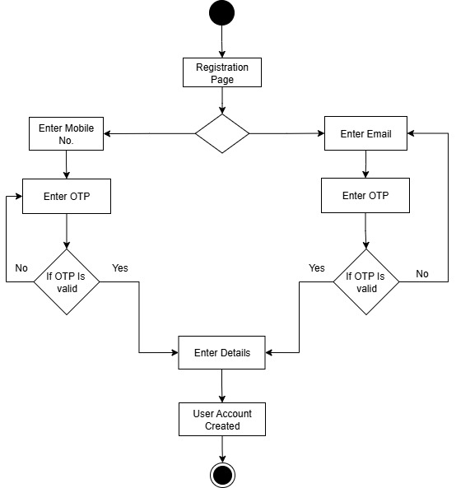
  - Login Page
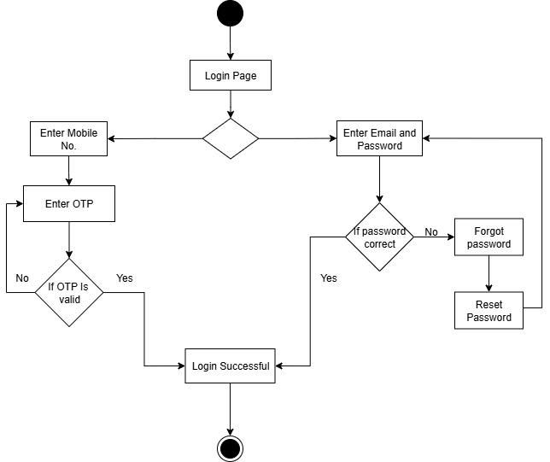

  - Search and Order
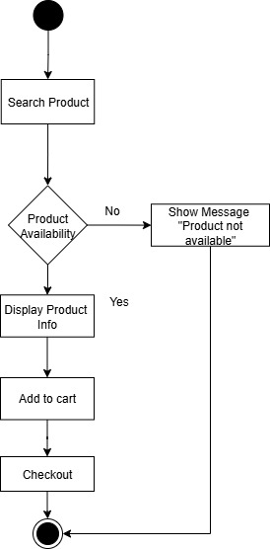

  - Make Payment
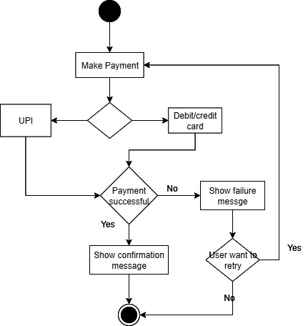

  - Manufacturer adds the item
