Q1) Functional Requirements - 15 Marks
Identify minimum 20 functional requirements
Example:
Functional requirement: When an order is fulfilled, the local printer shall print a packing slip.
Non-Functional Requirement: Packing slips shall be printed on both sides of 4”x 6” white paper, the standard size for packing slips used by local printers.
Ans:
Functional requirements:
Req ID | Req Name | Req Description
FR001 | User Registration | Users should be able to register with the application.
FR002 | Search for Products | Users should be able to search for the available products.
FR003 | Adding Products to the Cart | Users should be able to add products to the cart.
FR004 | Payment with Different Modes | Users should be able to make a payment with different modes.
FR005 | Login | Users should be able to log in using email ID and password.
FR006 | Forgot Password | Users should be able to reset forgotten passwords securely.
FR007 | Browse Product Catalogue | Users should be able to browse the catalogue by category or keyword.
FR008 | Product Image Display | Each product must display at least one image.
FR009 | Track Order | Users should be able to track their order status.
FR010 | Email Confirmation | Users should receive an email confirmation after placing an order.
FR011 | Admin Product Approval | Admin should be able to approve products before they go live.
FR012 | Product Upload by Manufacturer | Manufacturers should be able to upload products with details.
FR013 | Add to Buy Later List | Users should be able to add products to a “Buy Later” list.
FR014 | Update Product Info | Manufacturers should be able to update their product details.
FR015 | Delivery Status Notification | System should notify the user about delivery status via email/SMS.
FR016 | Order History | Users should be able to view past orders.
FR017 | Filter Products | Users should be able to filter products by category, price, or stock.
FR018 | Logout | Users should be able to log out of their account.
FR019 | Session Timeout | System should log out users after a fixed period of inactivity.
FR020 | Adding Products to Wishlist | Users should be able to add products to the Wishlist.

NON- FUNCTIONAL REQUIREMENTS:
Req ID | Req Name | Req Description
NFR001 | Usability | The application should have a simple, intuitive, and user-friendly interface.
NFR002 | Performance | Each page should load within 3 seconds even in low bandwidth conditions.
NFR003 | Security | The system must support secure login and encrypt sensitive user data.
NFR004 | Availability | The application must be available 24/7 with minimum downtime.
NFR005 | Scalability | The system must support scaling up to handle 10,000+ concurrent users.
NFR006 | Compatibility | The application should work across all major web browsers and mobile platforms.
NFR007 | Accessibility | The system should meet WCAG 2.1 guidelines to support users with disabilities.
NFR008 | Response Time | The system should respond to user input within 2 seconds on all pages.
NFR009 | Maintainability | The system should allow easy updates, bug fixes, and content changes.
NFR010 | Backup & Recovery | The system should perform daily backups and enable recovery in case of failure.

Q2) Make wireframe and prototypes
Ans: Wireframes

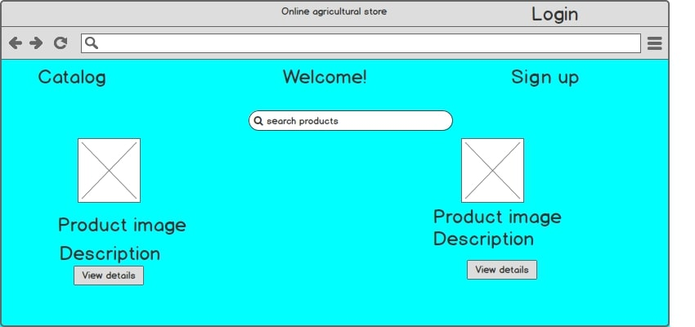

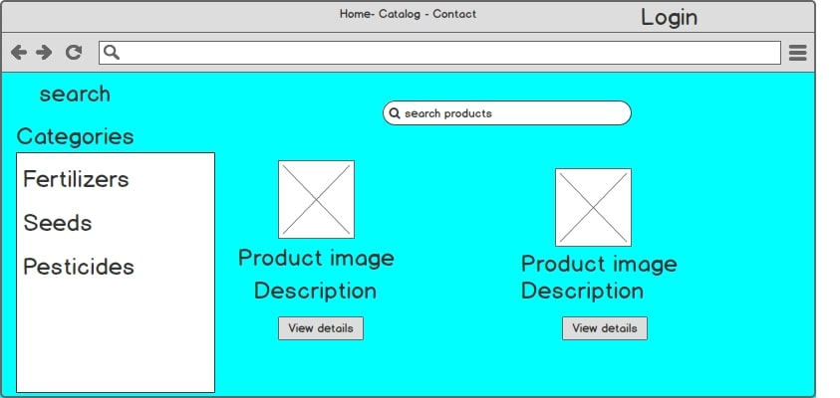

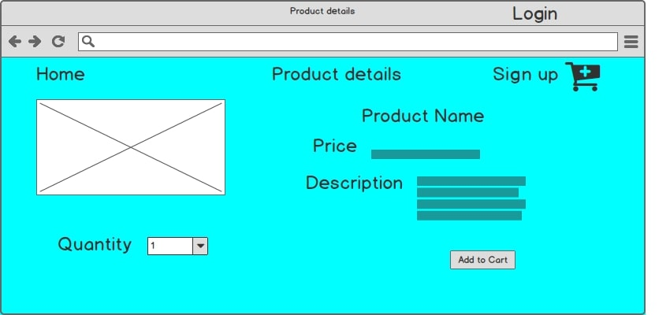

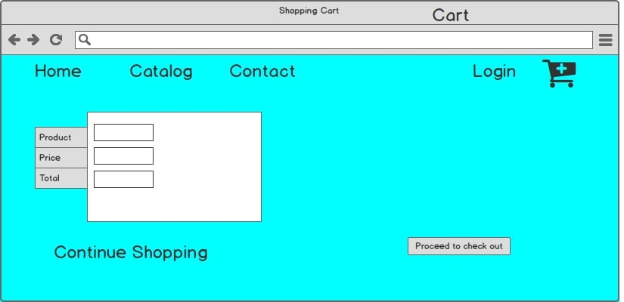
2,Prototypes
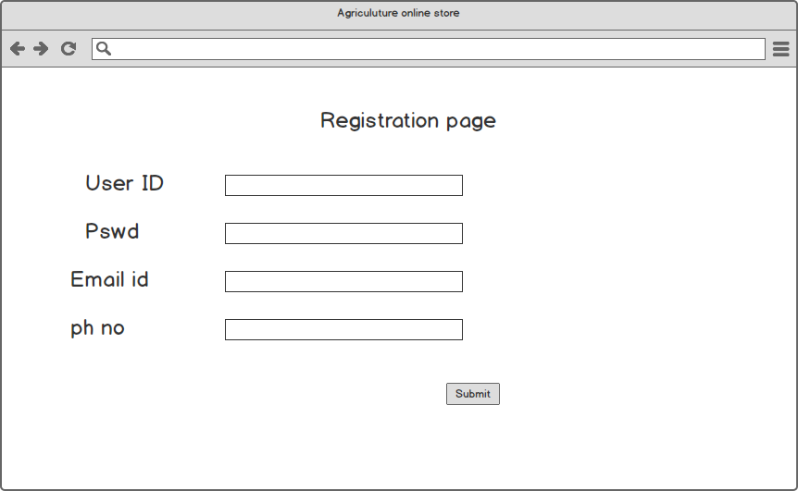

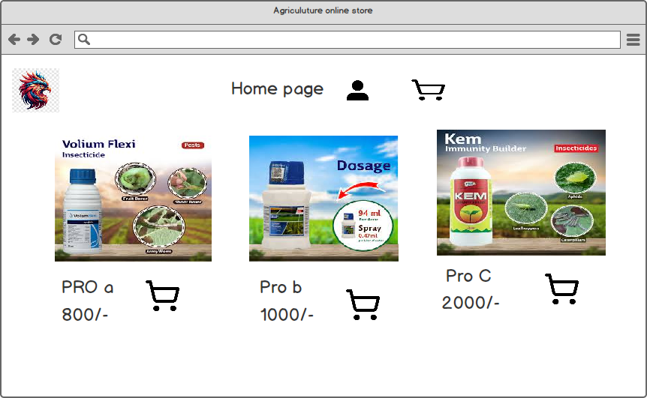
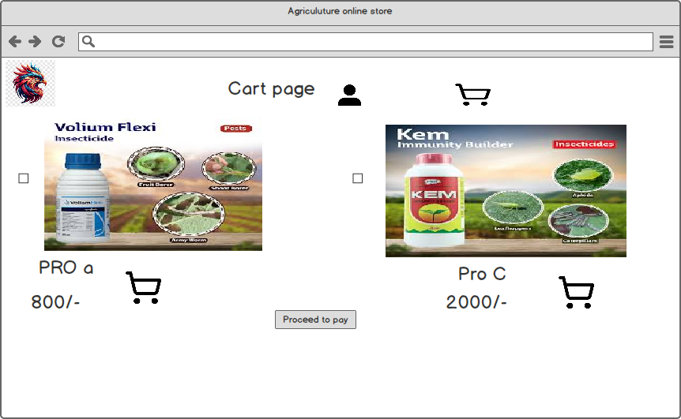

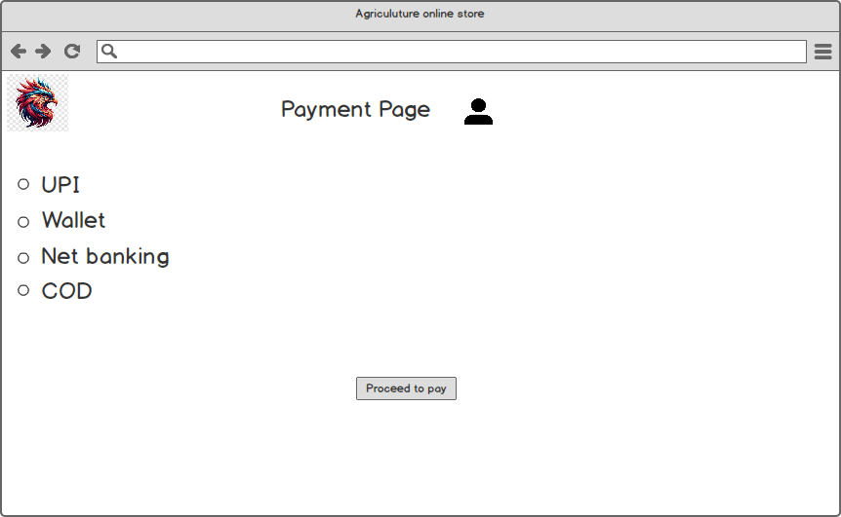

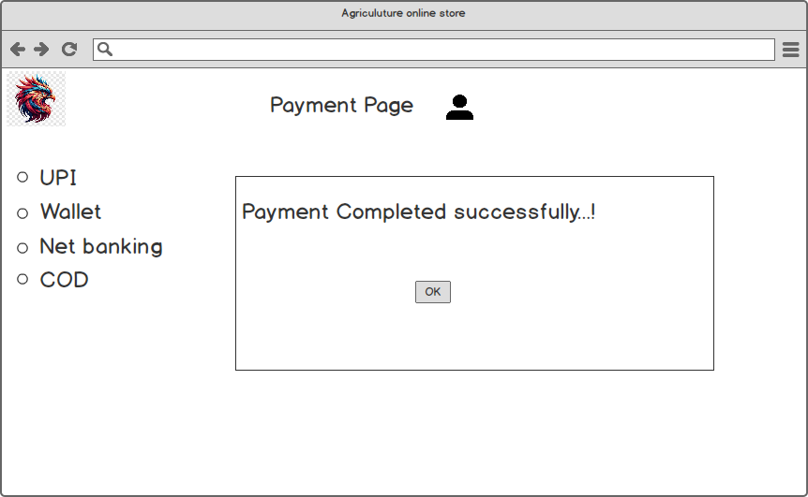

3, Make a note of the Tools, which you are using for above concepts.

Ans: Here's a brief explanation of Microsoft Visio and Balsamiq, including why each tool is useful and when it is best to use them, especially in a Business Analyst role (BA)
Microsoft Visio
Microsoft Visio is a professional diagramming tool that helps create a wide range of diagrams including:
Use Case Diagrams
Activity Diagrams
Sequence Diagrams
Flowcharts
Process Models (BPMN)

Why Visio is Useful:
It offers precise control over diagramming elements.
Suitable for technical documentation and formal presentations.
It is integrated with Microsoft Office, so it's easy to share within a corporate environment.
Ideal for creating UML and system architecture diagrams.

Use in Project:
In this project, Visio was used to create Use Case Diagrams, Activity Diagrams, and System Flowcharts to clearly represent how different actors interact with the system and to visualize the process from registration to product delivery.

Balsamiq
Balsamiq is a low-fidelity wireframing tool used primarily for UI/UX design. It helps design the layout and structure of web or mobile interfaces.

Why Balsamiq is Useful:
Designed for rapid prototyping.
Easy-to-use drag-and-drop interface.
Mimics hand-drawn wireframes, making it easier for stakeholders to give feedback.
Helps to visualize and plan the front-end user interface without needing coding.

Use in Project:
In this project, Balsamiq was used to create wireframes and prototypes for the online agricultural product store. Key screens such as login, product catalogue, search interface, cart, and payment were modelled to give a clear picture of the user experience (UX). This helped in validating requirements and expectations before development began.

Q4) A business analyst’s key responsibilities are to keep track of the requirements and make sure that no requirement is missed. Mr. Henry and peter have approached you regarding the curEDUEEU31the project. How will you tackle this situation?
Ans:
Req ID | Req Name | Req  Descriptn | Design | Code | UT (UNIT TESTING) | CIT(COMPONENT TESTING) | SIT(SYSTEM TESTING) | UAT(USER ACCEPTANCE TEST)
FR001 | User Registration | Users should be able to register themselves | complete | complete | complete | complete | complete
FR002 | User login | Users should be able to login using email and password | complete | complete | complete | complete | complete
FR003 | Search products | Users should be able to search for products  (seeds/fertilizers/pesticides) | complete | complete | complete | complete | complete
FR004 | Product catalog | Users should be able to view all available products | complete | complete | complete | complete | complete
FR005 | Add to cart | Users should be able to add products to the shopping cart | complete | complete | complete | complete | complete
FR006 | Wishlist | Users should be able to add products to a wishlist | complete | complete | complete | complete | complete
FR007 | Payment gateway | Users should be able to make payment using card,COD,UPI | complete | complete | complete | complete | complete
FR008 | Order confirmation | Users should be able to get email confirmation after placing a order | complete | complete | complete | complete | complete
FR009 | Delivery tracking | Users should be able to track their order delivery status | complete | complete | complete | complete | complete
FR010 | Manufacturer upload | Manufacturers should be able to upload and manage their products | complete | complete | complete | complete | complete

Q5) Prepare 10 Test case documents?
Ans:
Test case id | TC001 | Test case Name | Farmer Registration
Project ID | AGRI_01 | Project Name | Online Agri
PM ID | P_001 | PM Name | Mr. Vandanam
Test strategy ID | TS01 | Tester ID | T001
Test plan ID | TP01 | Tester name | Mr. Jason
Test Schedule ID | SCH01 | Date of test | 15-Aug-24
Scenario | Register new farmer user
Link to that page | Registration page
Input data | Name, Email, Password, Phone
Expected behavior | User should be registered and redirected to login
Actual behavior | As expected,
Comments

Results (pass/fail) | pass

Test case id | TC002 | Test case Name | Login for existing user
Project ID | AGRI_02 | Project Name | Online Agri
PM ID | P_002 | PM Name | Mr. Vandanam
Test strategy ID | TS02 | Tester ID | T001
Test plan ID | TP02 | Tester name | Mr. Jason
Test Schedule ID | SCH001 | Date of test | 15-Aug-24
Scenario | Farmer logs in with valid credentials
Link to that page | Login page
Input data | Email, Password
Expected behavior | Login successful, directed to home page
Actual behavior | As expected,
Comments

Results (pass/fail) | pass

Test case id | TC001 | Test case Name | Product search
Project ID | AGRI_01 | Project Name | Online Agri
PM ID | P_004 | PM Name | Mr. Alekya
Test strategy ID | TS04 | Tester ID | T001
Test plan ID | TP01 | Tester name | Mr. Jason
Test Schedule ID | SCH01 | Date of test | 15-Aug-24
Scenario | Search fertilizer “urea”
Link to that page | Home/search page
Input data | Search = “urea”
Expected behavior | Search results display 15 matching fertilizers
Actual behavior | As expected,
Comments

Results (pass/fail) | pass

Test case id | TC003 | Test case Name | Browse Catalog
Project ID | AGRI_03 | Project Name | Online Agri
PM ID | P_003 | PM Name | Mr. Vandanam
Test strategy ID | TS03 | Tester ID | T002
Test plan ID | TP03 | Tester name | Ms. Alekya
Test Schedule ID | SCH001 | Date of test | 16-Aug-24
Scenario | Browse category “seeds”
Link to that page | Catalog page
Input data | Click on “seeds”
Expected behavior | Seeds section loads with available products
Actual behavior | As expected,
Comments

Results (pass/fail) | pass

Test case id | TC001 | Test case Name | Add to cart
Project ID | AGRI_01 | Project Name | Online Agri
PM ID | P_001 | PM Name | Mr. Vandanam
Test strategy ID | TS05 | Tester ID | T001
Test plan ID | TP01 | Tester name | Mr. Jason
Test Schedule ID | SCH05 | Date of test | 17-Aug-24
Scenario | Add pesticide to cart
Link to that page | Product detail page
Input data | Click “add to cart”
Expected behavior | Item appears in cart list
Actual behavior | As expected,
Comments

Results (pass/fail) | pass

Test case id | TC001 | Test case Name | UPI PAYMENT
Project ID | AGRI_01 | Project Name | Online Agri
PM ID | P_006 | PM Name | Mr. Vandanam
Test strategy ID | TS06 | Tester ID | T001
Test plan ID | TP01 | Tester name | Mr. Jason
Test Schedule ID | SCH01 | Date of test | 17-Aug-24
Scenario | Complete payment via UPI
Link to that page | Check out page
Input data | UPI ID, pin
Expected behavior | Payment completed, confirmation recieved
Actual behavior | As expected,
Comments

Results (pass/fail) | pass

Test case id | TC001 | Test case Name | Upload product
u | AGRI_01 | Project Name | Online Agri
PM ID | P_007 | PM Name | Mr. Vandanam
Test strategy ID | TS01 | Tester ID | T001
Test plan ID | TP07 | Tester name | Mr. Jason
Test Schedule ID | SCH01 | Date of test | 19-Aug-24
Scenario | Manufacturer upload product
Link to that page | Manufacturer upload page
Input data | Product name, price, image, stock
Expected behavior | Product listed in catalog
Actual behavior | As expected,
Comments

Results (pass/fail) | pass

Test case id | TC001 | Test case Name | Forget password
Project ID | AGRI_01 | Project Name | Online Agri
PM ID | P_008 | PM Name | Mr. Vandanam
Test strategy ID | TS01 | Tester ID | T001
Test plan ID | TP08 | Tester name | Mr. Alekya
Test Schedule ID | SCH01 | Date of test | 19-Aug-24
Scenario | Trigger password resets link
Link to that page | Login page
Input data | Registered email
Expected behavior | Email sent with password reset instructions
Actual behavior | As expected,
Comments

Results (pass/fail) | pass

Test case id | TC001 | Test case Name | Order confirmation email
Project ID | AGRI_01 | Project Name | Online Agri
PM ID | P_009 | PM Name | Mr. Vandanam
Test strategy ID | TS01 | Tester ID | T001
Test plan ID | TP09 | Tester name | Mr. Alekya
Test Schedule ID | SCH01 | Date of test | 20-Aug-24
Scenario | Confirm purchase and email
Link to that page | Order summary page
Input data | Click “place order”
Expected behavior | Confirmation email received
Actual behavior | As expected,
Comments

Results (pass/fail) | pass

Test case id | TC001 | Test case Name | Delivery tracker
Project ID | AGRI_01 | Project Name | Online Agri
PM ID | P_010 | PM Name | Mr. Vandanam
Test strategy ID | TS01 | Tester ID | T001
Test plan ID | TP10 | Tester name | Mr. Alekya
Test Schedule ID | SCH01 | Date of test | 20-Aug-24
Scenario | Track delivery status
Link to that page | Track order page
Input data | Order ID
Expected behavior | Delivery status and ETA Displayed.
Actual behavior | As expected,.
Comments

Results (pass/fail) | pass

Q6) After the requirements are thoroughly explained to the entire project team by business analyst, Database architects have decided to do the database design and also to represent the in-flow and out flow out-flow of data.
Draw database schema and ER diagram.

Ans:

Inflow and outflow data:

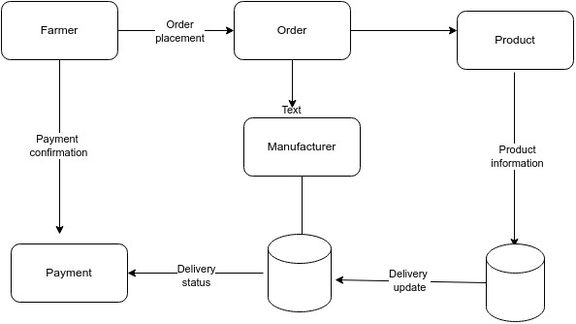

Database schema and ER diagram:

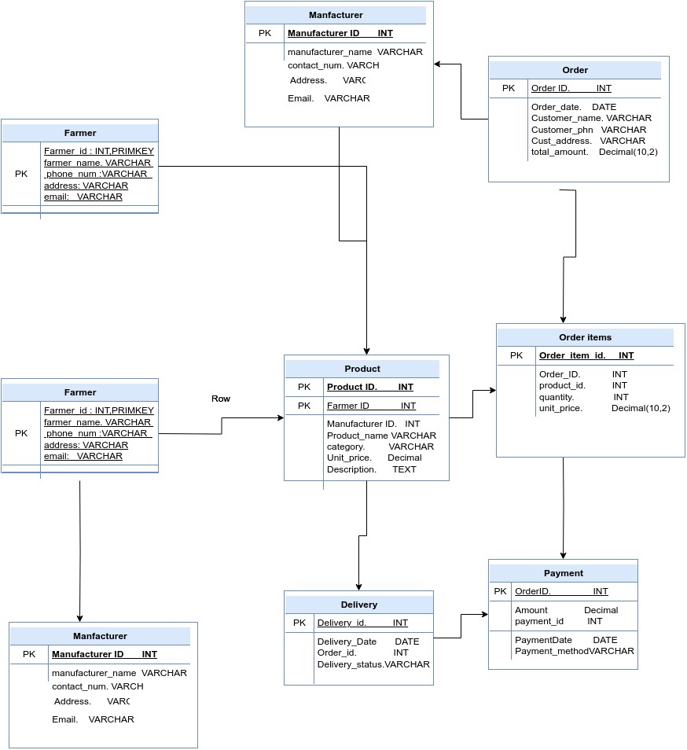

Q7) What is a data flow diagram? Draw a data flow diagram to represent the in-flow and out-flow of data when a Farmer is placing an order for the product?
Ans:
Data flow diagram:
A Data Flow Diagram (DFD) is a graphical representation of the flow of data within a system. It visually shows how data moves from one process to another, how it’s stored, and where it ends up. It helps analysts and designers to understand the flow of data within a system, identify potential bottlenecks or inefficiencies, and communicate system requirements to stakeholders.

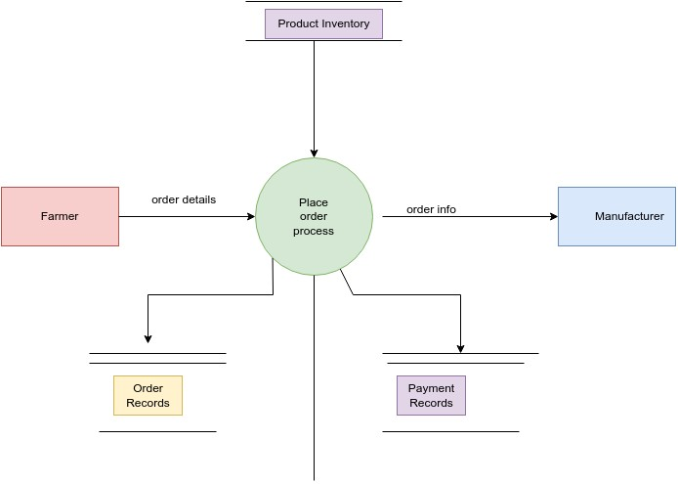

Q8) Due to change in the Government Taxation structure. we should change the Tax structure. How do you handle change requests in a project?

Ans:

A change request is a formal proposal to modify an aspect of the project—for example, updating the taxation structure due to new government rules.
Understand and Document the Change Request
Carefully review the new government taxation guidelines. Document the exact changes required in our agriculture platform; this may impact modules for product pricing, invoicing, farmer/manufacturer payments, and tax reporting.
Conduct Impact Analysis
Analyze how updating the taxation structure will affect the overall system, including order processing, payment gateways, reports, and accounting integrations. Consider the impact on project timelines, required developer or accountant resources, any budget changes, and compliance risks.
Prioritize the Change Request
Since taxation compliance is critical and mandatory, prioritize this change request over other non-essential updates. Assess urgency based on legal deadlines and the risk of penalties for non-compliance.
Seek Approval from Project Sponsor or Leadership
Present the change request and analysis to project sponsors or management. Ensure the leadership team reviews, approves, and allocates resources for updating the relevant taxation modules.
Communicate and Implement the Change
Notify all teams and stakeholders developers, finance/accounting, farmers, manufacturers—about the upcoming changes. Provide clear timelines, training (if needed), and support for adapting to the new tax processes in the agriculture platform. Update all documentation to reflect the new rules and confirm correct implementation through testing.
Summary:
For our online agriculture project, systematic handling of the change request—specifically updating the taxation structure—ensures legal compliance, platform reliability, and stakeholder clarity. This approach keeps our project adaptable and protects farmers, manufacturers, and administrators from regulatory risks while supporting seamless financial operations.

Q9) As the project is in process, Ben and Kevin have contacted you. The reason is to inform you that they want the Farmers to sell their crop yields through this application i.e. Farmers should be able to add their crop yields or products and display to public and should be able to sell them. They also want to introduce Auction system for their Crop yields. As a BA, what will be your response? Is this a change request or an enhancement???

Ans:
Ben and Kevin’s proposal to enable farmers to sell their crop yields via the application including adding products, showcasing them publicly, and introducing an auction system constitutes a significant expansion of project scope.
Key Points:
- Scope Expansion
The original project focused on allowing farmers to purchase agricultural inputs (e.g., fertilizers, seeds, pesticides). The new request transforms the platform into a two-sided marketplace, permitting farmers not only to buy but also to sell their produce, and introduces complex auction functionality.
2.Change Request versus Enhancement
This is a change request, not a minor enhancement, because it introduces core new capabilities, alters the business model, impacts system design, and may require substantial infrastructure updates. Minor tweaks to existing features are classified as enhancements; this proposal is beyond existing scope
3. Formal Change Management Process
The request needs thorough requirements gathering, technical feasibility study, UI/UX redesign, changes to payment and transaction systems, and analysis of legal/regulatory compliance. It must be formally documented, evaluated, and submitted for approval to the project sponsor and major stakeholders (e.g., Mr. Henry). Consider impacts on budget, timeline, prioritization, and overall project objectives.
Recommendation Such a substantial new feature is best considered for a future phase or version, after ensuring successful delivery of the current project scope and platform stability.
Conclusion:
Ben and Kevin’s request is correctly classified as a formal change request due to its broad impact on business processes and technical architecture. Handling it through the established change management process ensures project control, transparency, and successful outcomes. This approach also keeps stakeholders aligned and supports strategic planning for future enhancements.

Q10) Come up with estimations – How many Manhours required?
Ans:
Man-hours are the total required effort of all resources to complete a project. According to industry standards, projects are classified as:
Small: Up to 500 hours
Medium: Up to 1000 hours
Large: Up to 1500 hours
Analysis: Based on the project scenario, the duration is 18 months and the current team size is around 15. The requested functionality (enable farmers to sell crops, manage public listings, implement an auction system) involves substantial new modules, integration, and user support, making it complex but manageable. As the structure of the existing system is flexible and scalable, new infrastructure investments are not required. All necessary team members are experienced and available, so extra training is not needed.
Estimation: Considering the scope and resources, the project aligns with a medium-sized classification. Total Estimated Man-hours: 850 hours
Justification: The feature is a sizeable addition requiring new core modules, technical design, UI/UX updates, and integration, but benefits from an existing team and infrastructure.850 hours fit within the medium project benchmark and is appropriate for the anticipated complexity and team size.

Q11) Project has finally completed all the stages i.e., design, development, testing etc. Now, it is the role of a business analyst to contact the client for testing of the final product and have to successfully complete it. How are you going to handle this situation? And once it is done, what will be the process to close the project? Explain UAT Acceptance process
Ans:
Planning:
As a Business Analyst, the initial step is to create a blueprint for UAT. This involves identifying all the functionalities that need to be tested, setting clear acceptance criteria, and defining the minimum standards required for the client to accept the product. The BA is responsible for coordinating with stakeholders to ensure comprehensive coverage.

Designing:
The BA drafts detailed test cases to encompass all possible user scenarios of the system in a realistic environment. The test cases are designed to verify whether each requirement and workflow behaves as expected from an end-user perspective.

UAT Testers:
A group of end users or client representatives is selected to serve as UAT testers. The BA ensures that testers understand how to execute the test cases and provides guidance on what functionalities and processes need to be validated. The BA acts as the bridge between testers and the development team.

Bug Fixing:
If any issues, defects, or bugs are identified during UAT, the BA logs them and communicates effectively with the development team for resolution. Once fixed, the BA facilitates retesting to confirm all issues have been corrected before progressing.

Sign Off:
Once all bugs are resolved and all requirements are validated, the BA leads the process of obtaining formal acceptance from the client and stakeholders. Successful sign-off means the software is ready for production deployment ("Go Live"), and the BA documents the acceptance and communicates the result to all relevant parties.

Project Closure:
With UAT complete and sign-off secured, the BA oversees project closure activities including: finalizing documentation, handing over deliverables, archiving project assets, releasing project resources, and communicating successful deployment to all stakeholders.

Q12) Explain project closure document?
Ans: A project closure document (also called a project closure report) is a formal record that marks the official completion of a project. It summarizes all major outcomes, key achievements, lessons learned, final metrics, and provides a comprehensive view of project performance for stakeholders and future reference.

Project Overview
A brief summary of the project’s purpose, scope, objectives, and stakeholders.

Sign-off and Acceptance
Details of client/user acceptance—such as the date of UAT sign-off and confirmation that all deliverables meet agreed requirements.

Achievements
Key goals accomplished (e.g., new features, categories added, performance improvement, infrastructure upgrades).

Performance & Satisfaction
Metrics like user satisfaction, customer ROI, number of escalations, and overall value to the company (e.g., “Positive—90%”, gained edge over competitors, trained employees).

Financial Information
Final cost, budget utilization, and any approved/expended funds.

Resource Utilization
Summary of how resources like manpower, hardware, and finances were used.

Quality Assurance
Verification that quality standards and requirements have been met.

Lessons Learned
Key takeaways, improvements, and major insights gained during the project execution.

Risk Management & Challenges
Challenges faced, solutions implemented, and how risks were addressed.

Documentation & References
Links to supporting documents (e.g., business scope, requirements traceability, finance breakdown, user/training documentation).

A well-prepared project closure document ensures all stakeholders have a clear record of what was delivered, how success was measured, what was learned, and the overall value added to the organization. It provides closure, transparency, and knowledge for future initiatives.

S.NO | Points to include | Details | Reference link
1 | Did the client sign off on the UAT Testing | Yes
2 | Date of Sign off | 15th Sep 2025
3 | Name of the resource | Ms. Neha Singh | Projectscope.docx
4 | Objectives of the project | Enable farmers to order& manage agri-inputs online
 | User friendliness | Achieved
 | Customer Satisfaction | Positive feedback (Survey:92%)
 | More categories | Seeds, Fertilizers, Equipment, Crop Insurance
5 | Functionalities worked on | Product ordering, track delivering, payments, dash board
6 | Funding/Amount spent | Amount approved 1CR/spent 92 lakhs | Financebreakdown.xls
7 | Overall project information | On-time, within budget 3 escalations resolved
8 | Customer Satisfaction | High(Repeat orders and referrals increased)

