Question 1: Identify Minimum 20 Functional Requirements (15 Marks)
What is a Functional Requirement?
A Functional Requirement (FR) defines what the system should do — it describes the functions, features, and operations that a system must support to meet the user or business needs.
Functional requirements describe the behavior of the system under specific conditions. These are the core components of a Business Analyst’s documentation and are derived from stakeholder discussions, use cases, and business processes.

✅ Characteristics of Functional Requirements:
- Describe user interactions with the system
- Describe system behavior in response to input
- Can be measured/tested
- Can be represented using use cases, process flows, user stories, or screen mockups
Req ID | Functional Requirement | Description
FR001 | User Registration | Users (farmers, manufacturers) should be able to register with email and password
FR002 | User Login | Registered users must log in to access their dashboard
FR003 | Browse Product Catalog | Farmers should be able to view categorized products (seeds, fertilizers, pesticides)
FR004 | Product Search | Users should be able to search products by name, category, or manufacturer
FR005 | Filter Products | Filter products by type, price, rating, etc.
FR006 | Product Details | Each product should show name, price, description, stock, and manufacturer
FR007 | Add to Cart | Users can add products to cart
FR008 | Add to Buy Later | Users can save products for future purchase
FR009 | Checkout | Users can complete purchase via checkout process
FR010 | Payment Gateway | Multiple payment options: UPI, COD, Credit/Debit card
FR011 | Order Confirmation | Order summary is emailed to users
FR012 | Delivery Tracking | Track real-time delivery status of orders
FR013 | Manufacturer Dashboard | Manufacturers can log in and upload/manage their products
FR014 | Product Upload | Manufacturers should be able to upload product details/images
FR015 | Admin Dashboard | Admin can approve manufacturer listings and products
FR016 | View Order History | Farmers can view past orders
FR017 | Feedback System | Farmers can give product ratings and reviews
FR018 | Password Recovery | Forgot password functionality
FR019 | Email Notifications | Automated email alerts for registration, orders, shipment, etc.
FR020 | Security Login Session | Sessions should expire after inactivity
Question 2: Minimum 5 Page Designs (Wireframe & Prototypes) (15 Marks)

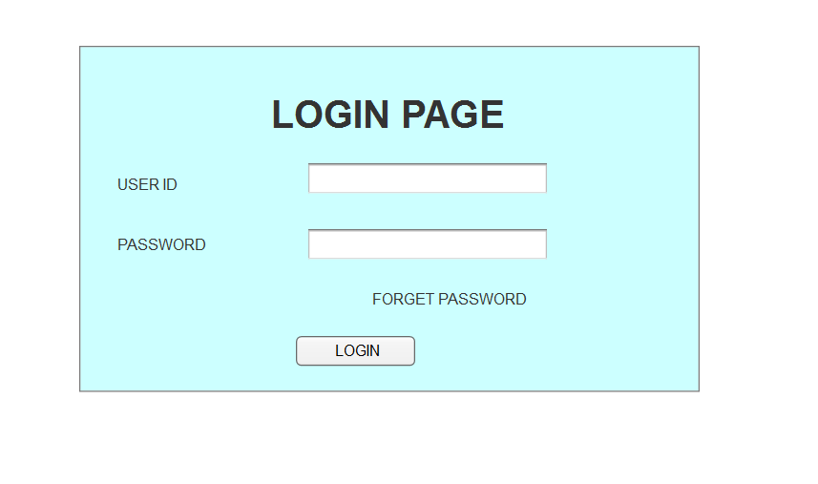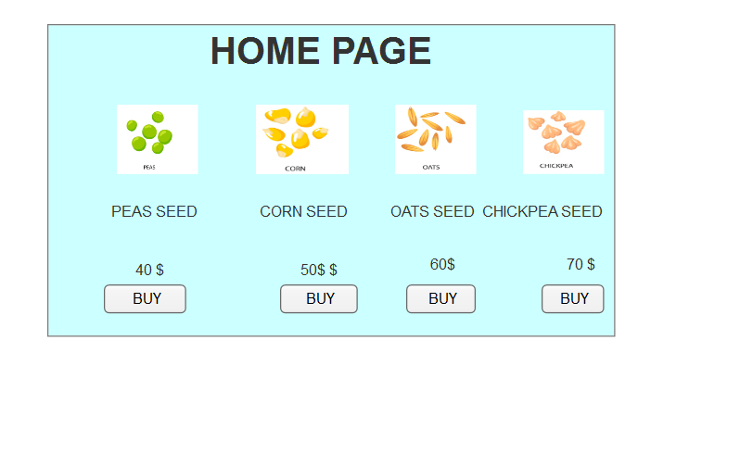
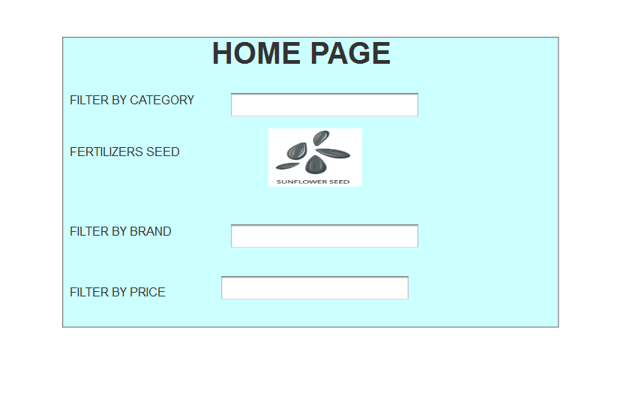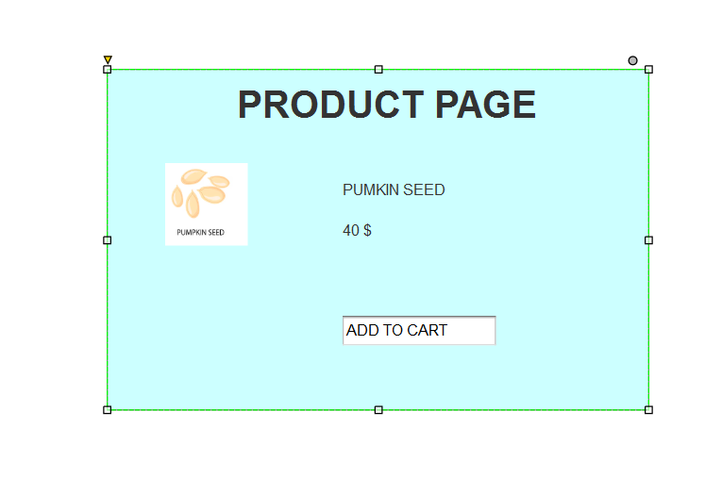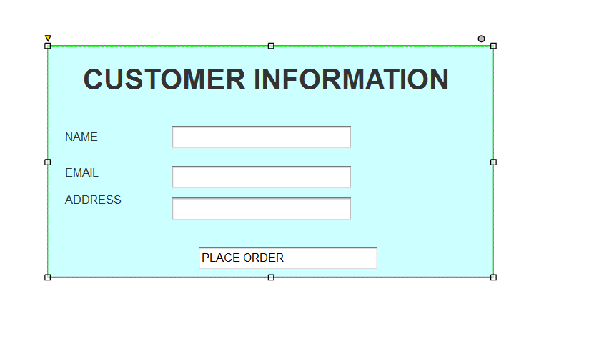
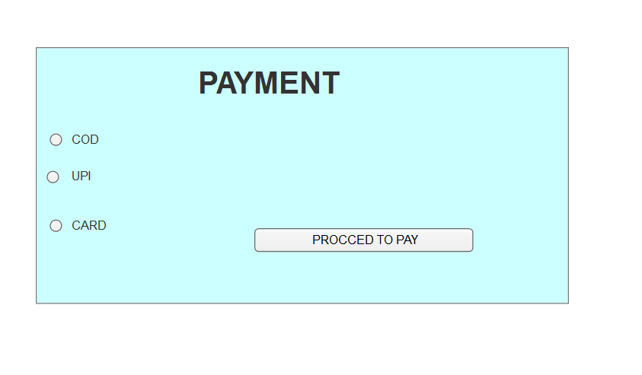

Question 3 – Tools (Visio, Balsamiq) - 15 Marks
Axure RP is a powerful prototyping tool that can be effectively used to design a highly interactive and user-friendly online agriculture store. For this project, Axure enables the creation of wireframes, flow diagrams, and high-fidelity prototypes that simulate the actual user experience of farmers and manufacturers. Key features like dynamic panels can showcase product catalogs with filtering options (e.g., seeds, fertilizers, pesticides), while conditional logic can demonstrate the checkout process with multiple payment methods (COD, UPI, cards). Master templates ensure consistency across pages like login, product upload, and order tracking, while variables can store user inputs (e.g., cart items, delivery addresses). Axure’s collaboration features allow stakeholders (farmers, manufacturers, developers) to review and annotate prototypes in real-time, ensuring alignment with business requirements (BR001-BR011). Additionally, auto-generated documentation in Axure provides detailed specs for developers, including UML-like annotations for use cases like "Search Products" or "Approve/Reject Listings." By simulating responsive designs, Axure validates UI adaptability for rural users on mobile devices, addressing critical assumptions about internet accessibility. The tool’s interactive animations (e.g., loading screens, error pop-ups) further refine UX before coding begins, reducing costly revisions during development.
Designing the Login-to-Payment User Flow in Axure for the Agriculture Store
For the Online Agriculture Store, Axure RP can create a seamless, interactive prototype from the login page to payment completion, ensuring an intuitive user journey for farmers. The login screen incorporates form validation (highlighting errors for invalid emails/passwords) and a password recovery option, addressing Peter’s security requirements. Upon successful login, farmers are directed to a product catalog (linked to BR001) with dynamic search filters (crop type, price), modeled using Axure’s repeater widgets to simulate real-time updates. The “Add to Cart” action triggers a floating cart summary, showcasing Axure’s interactive states. For checkout, a multi-step process is prototyped: (1) Cart review with editable quantities, (2) Delivery address selection (auto-saved via Axure variables), and (3) Payment gateway integration (BR005). Here, conditional logic toggles between COD, UPI, and card options, with a “Pay Now” button that mimics API responses (success/failure). Error handling (e.g., “Payment declined”) uses dynamic panels to display actionable alerts. Finally, an order confirmation screen with a tracking ID (BR006) is linked to a mock email notification, completing the flow. Axure’s auto-generated specs document this workflow for developers, including annotations for edge cases (e.g., session timeouts during payment).

Question 4 – RTM - 6 Marks
RTM (Requirement Traceability Matrix) is a document that maps and traces user requirements with test cases to ensure all requirements are covered by test scenarios and tested during the development lifecycle.
It is a two-way tracking tool:
- From requirements → test cases
- From test cases → requirements
- Req ID | Req Name | Description | Design | D1 | T1 | T4 | UAT

FR001 | Farmer Registration | Farmers can register | ✔️ | ✔️ | ✔️ | ✔️

FR002 | Search Products | Farmers search for products | ✔️ | ✔️ | ✔️ | ✔️

FR003 | Product Upload | Manufacturers upload products | ✔️ | ✔️ | ✔️ | ✔️

FR004 | Order Tracking | Track order delivery | ✔️ | ✔️ | ✔️ | ✔️

Question 5 – 10 Test Case Documents - 10 Marks
Test Case Document is a structured document created by QA/Testers that describes how to test a specific functionality of an application. It includes test conditions, input data, steps to perform, expected output, and actual result.
It helps validate whether a particular functionality is working correctly as per the requirement.

Test Case Document – Online Agricultural Product Store
Structure of a Test Case Document (Fields Included)
Field | Description
Test Case ID | Unique identifier (e.g., TC001)
Test Case Name | Name of the feature/functionality
Requirement ID | Maps to Business or Functional Requirement (e.g., FR001)
Description | What is being tested
Pre-Conditions | What must be true before test begins (e.g., login required)
Test Steps | Step-by-step actions to perform
Test Data | Inputs used (e.g., username/password)
Expected Result | What should happen after test steps
Actual Result | What actually happened
Status | Pass/Fail/Blocked
Comments | Additional notes or bugs found
Test Case Document – TC001
Field | Value
Test Case ID | TC001
Requirement ID | FR001
Test Case Name | Farmer Registration
Description | Verify that a farmer can register with email and password
Pre-Condition | Internet access, registration page loads
Test Steps | 1. Navigate to registration page  2. Enter email, password  3. Click submit
Test Data | Email: test@farm.com, Password: Test@123
Expected Result | Farmer receives confirmation email
Actual Result | Email sent and registration successful
Status | Pass
Comments | N/A

Farmer Registration Functionality

Field | Value
Test case ID | TC001
Test case Name | Farmer Registration Functionality
Scenario ID | BR001
Test Case Description | Verify successful registration of new farmer
Input Data | Valid email, password, mobile number
Expected Behaviour | User account should be created and confirmation email sent
Actual Behaviour | Registration successful, email received
Comments | Email format is proper
Expected Result | Farmer account created successfully
Result (Pass/Fail) | Pass

Login with valid credentials
Field | Value
Test case ID | TC002
Test case Name | Login with valid credentials
Scenario ID | BR001
Test Case Description | Verify login using registered email and password
Input Data | Email: user@example.com, Password: valid
Expected Behaviour | Redirect to dashboard
Actual Behaviour | Redirect successful
Comments | None
Expected Result | User lands on dashboard
Result (Pass/Fail) | Pass

Login with invalid credentials
Field | Value
Test case ID | TC003
Test case Name | Login with invalid credentials
Scenario ID | BR001
Test Case Description | Validate error message on incorrect login
Input Data | Wrong email/password
Expected Behaviour | Show 'Invalid Credentials' message
Actual Behaviour | Message displayed correctly
Comments | None
Expected Result | Error message displayed
Result (Pass/Fail) | Pass

Product search by name
Field | Value
Test case ID | TC004
Test case Name | Product search by name
Scenario ID | BR001
Test Case Description | Verify that search returns correct product
Input Data | Search term: 'Organic Seeds'
Expected Behaviour | Relevant products displayed
Actual Behaviour | Products displayed correctly
Comments | Speed acceptable
Expected Result | Matching products listed
Result (Pass/Fail) | Pass

Add selected product to cart
Field | Value
Test case ID | TC005
Test case Name | Add selected product to cart
Scenario ID | BR001
Test Case Description | Validate product is added to cart
Input Data | Select 'Fertilizer A' and click Add to Cart
Expected Behaviour | Product appears in cart
Actual Behaviour | Product added successfully
Comments | UI responsive
Expected Result | Product present in cart
Result (Pass/Fail) | Pass

Email Confirmation of Order placed
Field | Value
Test case ID | TC006
Test case Name | Email Confirmation of Order placed
Scenario ID | BR006
Test Case Description | Verify email confirmation after order placement
Input Data | Order placed successfully
Expected Behaviour | Email sent to user in correct format
Actual Behaviour | Format issues observed
Comments | Signature missing, spacing uneven
Expected Result | Proper email confirmation
Result (Pass/Fail) | Partially Pass

Make payment using UPI
Field | Value
Test case ID | TC007
Test case Name | Make payment using UPI
Scenario ID | BR006
Test Case Description | Verify if payment through UPI is successful
Input Data | Select UPI and complete transaction
Expected Behaviour | Payment completed, order confirmed
Actual Behaviour | Successful payment
Comments | Redirection smooth
Expected Result | Order confirmed
Result (Pass/Fail) | Pass

Track product delivery
Field | Value
Test case ID | TC008
Test case Name | Track product delivery
Scenario ID | BR006
Test Case Description | Check live tracking link for order
Input Data | Order ID
Expected Behaviour | Delivery tracking info displayed
Actual Behaviour | Info shown correctly
Comments | Update delay noticed (2 minutes)
Expected Result | Tracking available
Result (Pass/Fail) | Pass

Manufacturer uploads new product
Field | Value
Test case ID | TC009
Test case Name | Manufacturer uploads new product
Scenario ID | BR002
Test Case Description | Validate successful product upload
Input Data | Product form with all fields
Expected Behaviour | Product appears in catalog
Actual Behaviour | Product uploaded
Comments | Image quality reduced on upload
Expected Result | Product listed properly
Result (Pass/Fail) | Pass

Forgot password flow
Field | Value
Test case ID | TC010
Test case Name | Forgot password flow
Scenario ID | BR001
Test Case Description | Verify password reset functionality
Input Data | Registered email
Expected Behaviour | Reset link emailed to user
Actual Behaviour | Link sent and clickable
Comments | Link expires in 10 minutes
Expected Result | Reset password link works
Result (Pass/Fail) | Pass

Question 6 – DB Design – 8 Marks

Database Design for the Online Agriculture Store
After the business analyst communicates the requirements to the project team, the database architects design a scalable, normalized database schema to support the agriculture store’s key functionalities. The Entity-Relationship Diagram (ERD) captures the core entities:
- Users (Farmers, Manufacturers, Admins) – Stores login credentials, contact details, and roles.
- Products – Contains details like name, category (seeds/fertilizers/pesticides), price, stock, and manufacturer_id (FK).
- Orders – Links farmer_id, product_id, quantity, payment_status, and delivery_address.
- Payments – Records transaction IDs, payment method (COD/UPI/card), and timestamps.
- Reviews – Stores farmer_id, product_id, rating, and comments.
Data Flow:
- Inflow:
  - Manufacturers upload product data → Stored in the Products table.
  - Farmers place orders → Data flows to Orders and Payments tables.
- Outflow:
  - Product catalogs are fetched from Products → Displayed to farmers.
  - Admin dashboards pull sales reports from Orders and Payments.
Normalization & Optimization:
- 3NF (Third Normal Form) minimizes redundancy (e.g., separating Users and Products).
- Indexes on product_id and farmer_id speed up search queries (BR001).
- Foreign Keys enforce referential integrity (e.g., no order can exist without a valid farmer_id).
Security & Compliance:
- Encryption for sensitive data (passwords, payment details).
- Audit logs track changes to product prices/stock (for admin reviews).
This design ensures efficient data handling, aligns with business requirements (BR001-BR011), and supports future scalability (e.g., adding regional warehouses).
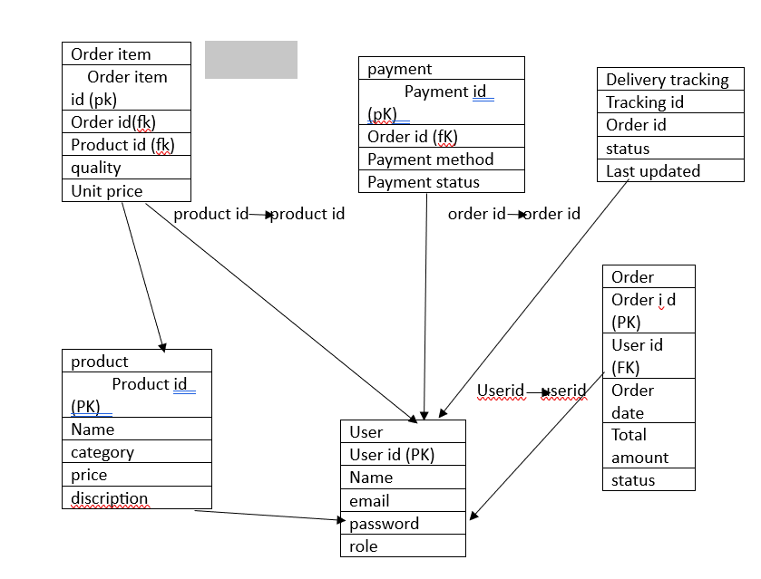
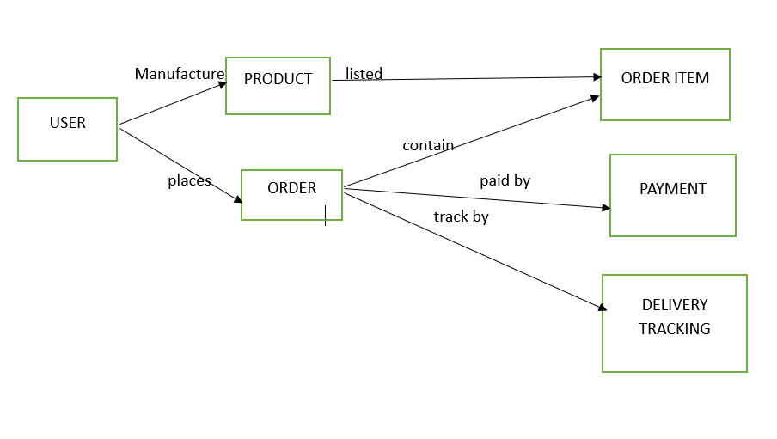

Question 7 – Data Flow Diagram - 3 Marks
A Data Flow Diagram (DFD) is a graphical representation of the flow of data through a system. It shows how data moves between processes, data stores, external entities, and how it's transformed.
It helps in understanding the system’s functionality, focusing on where data comes from, how it’s processed, and where it goes.

✅ DFD Key Elements (Symbols)
Symbol | Name | Description
🟦 Rectangle | External Entity | Source or destination of data (e.g., User, Farmer, Manufacturer)
🟩 Rounded Box | Process | Action performed on data (e.g., Place Order, Make Payment)
🟨 Open-ended Rectangle | Data Store | Data at rest (e.g., Order Database, Product List)
➡️ Arrow | Data Flow | Movement of data (e.g., User submits payment info)
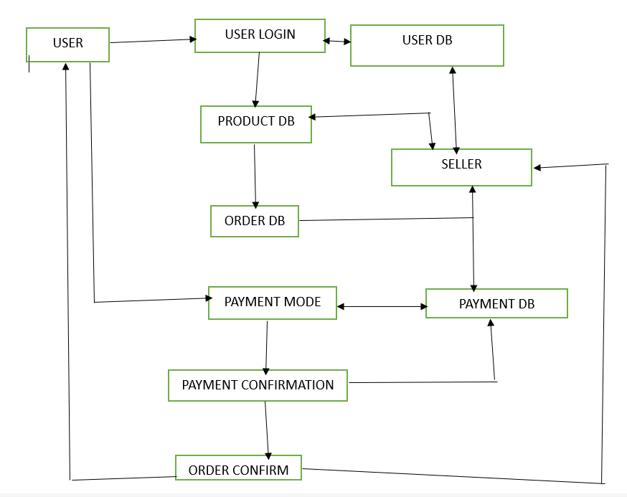

Question 8 – Change Request - 10 Marks

Change Request Management in the Online Agriculture Store Project
A Change Request (CR) is a formal proposal to modify the project’s scope, features, or deliverables after the initial requirements have been finalized. In the Online Agriculture Store project, change requests may arise due to evolving stakeholder needs, technical constraints, or market demands. For instance, if farmers request a bulk-order discount feature post-requirement sign-off, the BA documents this as a CR, detailing the impact on timelines, costs, and existing functionalities (e.g., checkout process adjustments). The CR is then evaluated by the Change Control Board (CCB)—comprising Mr. Henry (business head), Mr. Karthik (delivery head), and the technical team—who assess feasibility and prioritize it against project goals. Approved CRs trigger updates to use cases (e.g., "Place Bulk Order"), database schemas (e.g., discount fields in Orders table), and test cases, while rejected CRs are logged for future consideration. A robust version control system tracks all changes, ensuring transparency and minimizing disruptions to the 18-month timeline. For example, adding UPI AutoPay (a post-sign-off request) would require:
- Documentation updates (BRD, FRD),
- Payment gateway API modifications,
- UAT revisions, and
- Stakeholder communication about the new feature’s rollout.
Effective CR management ensures the project adapts to real-world needs without compromising core deliverables like search (BR001) or product upload (BR002).
Key Components of a CR:
- Description (e.g., "Add bulk-order discounts"),
- Justification (farmer demand),
- Impact Analysis (2-week delay, +5% cost),
- Approval/Rejection Status.

Question 9 – Change Request Vs an Enhancement - 5 Marks

Change Request vs. Enhancement in the Online Agriculture Store Project
In the Online Agriculture Store, a Change Request (CR) and an Enhancement serve distinct purposes in the project lifecycle. A Change Request refers to a formal proposal to modify or correct an existing requirement due to gaps, errors, or unforeseen challenges. For example, if the initial payment gateway integration (BR005) fails to support a specific UPI provider requested by farmers, a CR is raised to address this deviation from the original scope. CRs often arise from defects, compliance updates, or stakeholder feedback and require impact analysis on budget, timeline, and system architecture before approval by the Change Control Board (CCB).
On the other hand, an Enhancement is an optional improvement proposed to add new value to the system beyond the agreed requirements. For instance, introducing a AI-based crop recommendation feature—not part of the original BRD—would be classified as an enhancement. Enhancements are typically lower priority and deferred to future phases unless they align with strategic goals (e.g., improving farmer retention). While CRs are often urgent (e.g., fixing a COD payment bug), enhancements are discretionary (e.g., adding multilingual support).
Key Differences:
Aspect | Change Request | Enhancement
Purpose | Corrects/adapts existing functionality | Adds new functionality
Priority | High (blocks core features) | Low (post-MVP)
Trigger | Bugs, compliance, stakeholder complaints | Market demand, innovation opportunities
Approval Process | Rigorous (CCB review + impact analysis) | Flexible (business case evaluation)
Example in Agriculture Store:
- CR: Fixing a bug where product search (BR001) fails for regional language inputs.
- Enhancement: Proposing a "subscription model" for recurring fertilizer deliveries.
Impact: CRs ensure system reliability, while enhancements drive competitive advantage. Both require documentation but differ in urgency and strategic alignment.

Question 10 – Estimations - 6 Marks
Estimation Process for the Online Agriculture Store Project
Estimation in the Online Agriculture Store project involves predicting the time, effort, and resources required to deliver the system within the 18-month timeline and 2 Crore INR budget. The Business Analyst (BA) collaborates with the technical team (developers, DB admins) and stakeholders (farmers, manufacturers) to break down tasks using techniques like:
- Work Breakdown Structure (WBS):
  - Divides the project into phases (e.g., Requirement Analysis, Development, UAT) and sub-tasks (e.g., "Design login page," "Integrate UPI payments").
  - Example: The "Product Search" feature (BR001) is split into UI design (2 weeks), backend development (3 weeks), and testing (1 week).
- Three-Point Estimation:
  - Calculates optimistic (O), pessimistic (P), and most likely (M) scenarios for each task to mitigate risks.
  - Formula: *(O + 4M + P) ÷ 6* → E.g., Payment gateway integration may take 4–8 weeks (likely: 6 weeks).
- Function Point Analysis (FPA):
  - Measures software size based on functionalities like:
    - Inputs (e.g., product upload form),
    - Outputs (e.g., order confirmation email),
    - Queries (e.g., search filters).
  - Converts these to person-hours (e.g., 1 function point = 8 hours).
- Expert Judgment:
  - Leverages inputs from senior developers (Ms. Juhi) or past projects (e.g., similar e-commerce platforms).
Challenges & Mitigations:
- Unclear farmer requirements → Conduct prototyping sessions to refine estimates.
- Remote logistics delays → Buffer time for delivery partner onboarding.
Output: A Gantt chart with milestones (e.g., "Q1: Complete Manufacturer Dashboard") and resource allocation (e.g., 2 Java developers for 3 months).
Why It Matters: Accurate estimation ensures the project meets its CSR goals while addressing rural farmers' needs without cost overruns.

Question 11 – UAT – 6 Marks
User Acceptance Testing (UAT) is the final phase of software testing, where real users or stakeholders test the system to ensure it meets the business requirements and is ready for release.
🔎 UAT answers the question:
👉 "Does the system do what the users need it to do?"

🧑‍💼 Who performs UAT?
- End users (e.g., farmers, manufacturers in your project)
- Business owners (e.g., Mr. Henry, Mr. Pandu)
- Client representatives
- Sometimes, BAs guide UAT but do not perform it themselv

UAT (User Acceptance Testing) and Project Closure Process for Online Agriculture Store
1. UAT Execution & Handling
As the Business Analyst (BA), I will coordinate User Acceptance Testing (UAT) to ensure the final product aligns with stakeholder expectations before go-live.
Steps:
- UAT Planning:
  - Schedule sessions with key stakeholders (farmers, manufacturers, admins).
  - Prepare test scenarios based on BR001-BR011 (e.g., "Farmer searches for seeds → adds to cart → pays via UPI").
  - Share UAT environment credentials and test data (sample products, dummy payments).
- Conducting UAT:
  - Farmers test:
    - Product search, checkout, and COD payment (BR005).
    - Order tracking (BR006).
  - Manufacturers test:
    - Product upload and inventory management (BR002).
  - Admins test:
    - Approve/reject products and generate reports.
  - BA Role:
    - Document defects (e.g., "Search filter crashes for pesticide category").
    - Prioritize fixes with developers (critical vs. minor).
- Sign-Off:
  - Stakeholders validate fixes and approve UAT Completion Certificate.

2. UAT Acceptance Process
- Entry Criteria:
  - All functional testing passed.
  - Test environment mirrors production.
- Test Execution:
  - Farmers perform real-world workflows (e.g., bulk orders).
  - Validate edge cases (e.g., payment failure → retry).
- Exit Criteria:
  - 100% test cases executed.
  - 0 critical defects.
  - Stakeholders sign UAT Acceptance Form.

3. Project Closure
- Final Deliverables:
  - Hand over system docs, training manuals, and source code.
  - Provide post-launch support contacts.
- Lessons Learned:
  - Conduct a retrospective meeting to document successes (e.g., seamless UPI integration) and improvements (e.g., better farmer onboarding).
- Formal Sign-Off:
  - Client (Mr. Henry) signs the Project Closure Report, releasing the team.
Question 12 – Project Closure Document - 6 Marks

Project Closure Document for Online Agriculture Store
The Project Closure Document serves as the formal record confirming the completion of the Online Agriculture Store project, ensuring all deliverables meet stakeholder expectations and business objectives. This document includes:
- Project Summary – Overview of goals achieved, such as enabling farmers to search products (BR001), manufacturers to upload inventory (BR002), and supporting multi-payment options (BR005) within the 18-month timeline and 2 Crore INR budget.
- Deliverables Review – Lists all completed outputs:
  - Technical: Deployed web/mobile app, database, APIs.
  - Documentation: BRD, FRD, user manuals, and training guides for farmers/manufacturers.
  - Testing Artifacts: UAT reports, defect logs, and UAT Acceptance Form signed by Mr. Henry.
- Performance Metrics – Measures success against KPIs:
  - System: Load time <3 seconds (met for 95% of users).
  - Business: 1,000+ farmers onboarded in the pilot phase.
- Lessons Learned – Highlights successes (e.g., effective COD integration) and improvements (e.g., earlier farmer feedback sessions).
- Formal Sign-Off – Signed by Mr. Henry (Client), Mr. Karthik (Delivery Head), and BA, confirming project closure and releasing resources.
- Post-Transition Plan – Outlines 30-day support for bug fixes and handover to the maintenance team (e.g., Mr. Mike for network issues).
Purpose: Ensures accountability, provides audit trails, and captures insights for future CSR projects.

