Document 6- Please prepare a use case diagram, activity diagram and a use case specification document.
Use case Name : clients seeking immigration services
- Use Case Description
The use case “Clients Seeking Immigration Services” describes how a client interacts with TrueNorth Immigration Consultants to request immigration-related support. The process begins when the client logs into the system and submits an immigration service request. The client uploads required documents, makes necessary payments, and communicates with consultants for advice and guidance. The consultant then validates the documents, provides consultation, and initiates the visa application process with the respective embassy/government system. The system allows the client to track the progress of their application until completion.

3.Actors
- Client (Primary Actor)
  - The individual seeking immigration services.
  - Initiates the request, uploads documents, makes payments, and tracks status.
- Consultant (Supporting Actor)
  - Provides immigration advice and guidance.
  - Reviews client’s request and documents, submits visa applications, and updates status.
- Admin Staff (Supporting Actor)
  - Manages client and consultant accounts.
  - Handles payment confirmations and generates internal reports.
- Embassy / Government System (External Actor)
  - Receives visa applications from consultants.
  - Sends application status updates (approved, rejected, pending).

Use Case Diagram

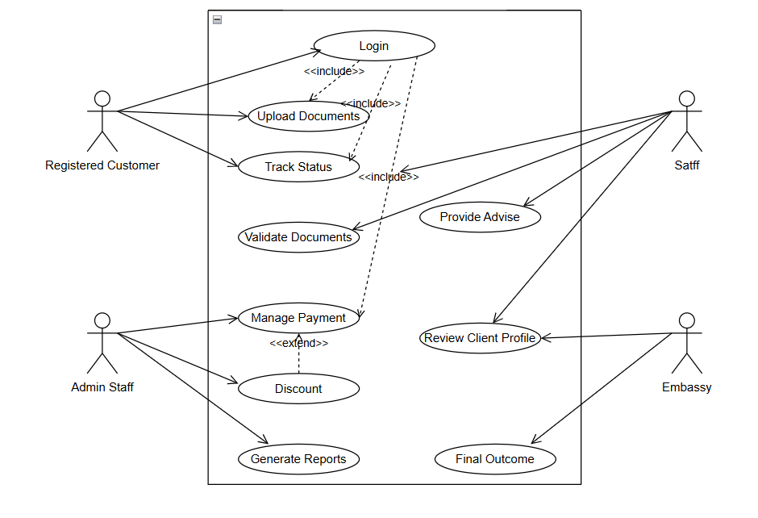
ACTIVITY DIAGRAM
Login Page
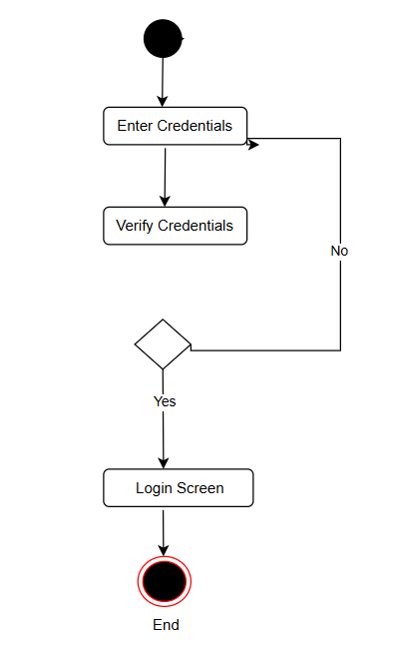

Upload Document
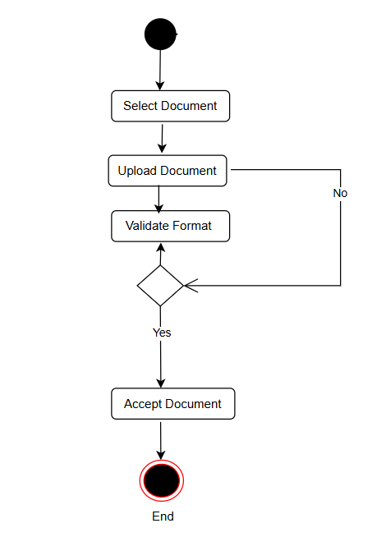
Verify Documents
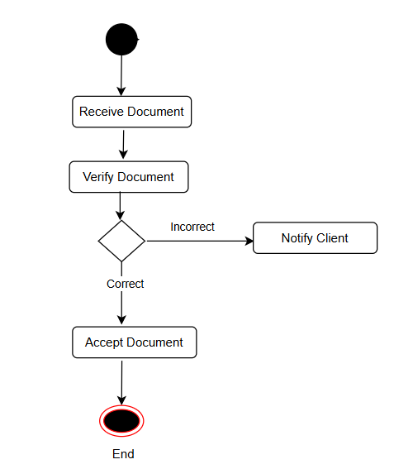
Track Application Status
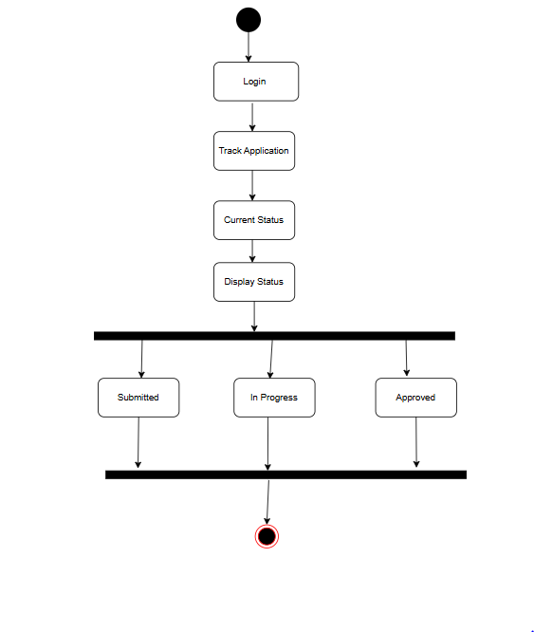
Use Case Specification
Use Case Name: Submit Immigration Service Request
Primary Actor(s): Applicant / Immigration Applicant
Supporting Actors: Immigration Agency Staff, System Admin, External Verification Systems (if needed)
Preconditions: Applicant must be authenticated / registered; Relevant immigration category identified; Applicant must have necessary documentation; System available and service request feature enabled.
Postconditions: Request is submitted; Applicant receives acknowledgement; Internal case/request ticket is created; immigration staff notified; further workflow initiated (e.g. review, verification).

Use Case Name: Upload Documents
Primary Actor(s): Applicant
Supporting Actors: System / Document Management Module, Immigration Agency Staff, External Storage/Verification Systems (if needed)
Preconditions: User is authenticated / logged in; user has an active case/application; user has the documents in digital form; system is available; user has permission to upload documents for this case.
Postconditions: Documents are stored; linked to user’s case; user gets confirmation; documents are available for staff review; versioning, if applicable, is maintained; any metadata stored.

Use Case Name: Track Application Status
Primary Actor(s): Applicant / Immigration Applicant
Supporting Actors: Immigration Agency Staff, System Administrator
Preconditions: Applicant has submitted an immigration application / request; Applicant has credentials / identifier(s) required to track status (e.g. case number, login account). System stores application status and updates it at stages.
Postconditions: Applicant can view the current status of their application; relevant status history / timeline visible; any next steps or outstanding items shown.

Use Case Name: Make Payment
Primary Actor(s): Applicant /Payer
Supporting Actors: Payment Gateway / External Payment Processor, Bank / Card Network, System Administrator, Notification System
Preconditions: Applicant is logged in / authenticated; Applicant has an application or transaction pending requiring payment; The amount due is known; Payment module is enabled and functional; Applicant has valid payment instrument (card, bank account, digital wallet, etc.).
Postconditions: Payment is captured or scheduled; System updates transaction/application status; Receipt or confirmation generated; Applicant is notified; Accounting records updated.

4. Basic Flow
- Client logs into the TrueNorth Immigration system.
- Client navigates to the “Immigration Services” section.
- Client submits a request for immigration services by filling in required details.
- Client uploads necessary supporting documents.
- System validates the request and stores all submitted information.
- Consultant receives notification of the client’s request.
- Consultant reviews the client’s profile and documents.
- Consultant provides initial advice and outlines next steps.
- Client makes the required payment (if applicable).
- Consultant prepares and submits the visa application to the embassy/government system.
- Embassy/government system sends application status updates.
- Client logs in to track the progress of their application through the system.
5. Alternate Flow
- Missing/Invalid Documents
  - Client submits the request but does not upload all required documents.
  - System notifies the client about missing/invalid documents.
  - Client re-uploads the correct documents before the request can proceed.
- Payment Issues
  - Client attempts payment, but the transaction fails (e.g., insufficient funds, network issue).
  - System displays an error message and prompts the client to retry or use another payment method.
- Consultant Unavailable
  - Consultant is temporarily unavailable to review the client’s request.
  - System queues the request and assigns it when a consultant is available.
  - Client is notified of potential delays.
- Embassy/Government System Delay
  - Consultant submits the visa application, but the external system does not respond.
  - System marks the application as “Pending Submission Confirmation.”
  - Consultant and client are notified about the delay.
- Incorrect Login / Authentication Failure
  - If the client enters invalid credentials, system denies access.
  - Client is prompted to recover password or retry login.
6. Exceptional Flows
- System Unavailable
  - If the TrueNorth system is down during request submission, the client cannot proceed.
  - System displays a “Service Temporarily Unavailable” message.
- Document Upload Failure
  - If the document format/size is not supported or upload fails due to a network issue,
the system displays an error and prompts the client to retry.
- Payment Gateway Timeout
  - If the payment gateway fails to respond within the specified time,
the system cancels the transaction and prompts the client to try again.
- Session Timeout
  - If the client remains inactive for too long, the session expires.
  - The client is logged out automatically and must log in again to continue.
- Government/Embassy API Failure
  - If the external government system rejects the submission due to technical errors,
the consultant and client are notified, and the case is flagged for manual intervention.

7. Pre-Conditions
- The client must have access to the TrueNorth Immigration Consultants system (web portal or application).
- The client must be a registered user and logged into the system.
- The system must be operational and connected to the database.
- The consultant and admin accounts should already be set up in the system.
- The payment gateway and document upload module must be available.
8. Post-Conditions
- The client’s immigration service request is successfully recorded in the system.
- All uploaded documents are securely stored in the system repository.
- Payment (if applicable) is processed and transaction details are saved.
- Consultant is notified to review and proceed with the client’s request.
- The client can track the status of their application through the system.
- An application record is created, linked to the client’s profile for future reference.
9. Assumptions
- Clients have reliable internet access to use the TrueNorth system.
- Clients provide accurate and truthful information while submitting requests.
- Clients have the necessary supporting documents ready in acceptable formats (PDF, JPEG, etc.).
- Payment gateway services are available and functioning correctly.
- Consultants are qualified and authorized to provide immigration guidance.
- The government/embassy system is accessible for submitting and tracking visa applications.
- All communications between system and external services (embassy, payment gateway) are secure.
10. Constraints
- Regulatory Compliance – The system must comply with immigration laws, data protection, and confidentiality regulations (e.g., GDPR).
- Document Format Limitations – Only specific file formats (e.g., PDF, JPG, PNG) and file sizes are allowed for uploads.
- Authentication & Security – Clients must log in with valid credentials; system enforces role-based access control.
- System Availability – The portal should be available 24/7, but downtime may occur for maintenance.
- Payment Restrictions – Only supported currencies and payment methods (credit/debit cards, net banking, etc.) can be used.
- Dependency on External Systems – Visa application processing is dependent on embassy/government system availability.
- Performance Constraints – The system must handle multiple client requests simultaneously without significant delay.
- Language Support – Services may only be available in English (or limited languages), restricting accessibility for some clients.
11. Dependencies
- User Registration & Authentication Module – Clients must be registered and logged in before accessing immigration services.
- Document Management Module – Depends on secure upload, validation, and storage of client documents.
- Payment Gateway – Required for processing service/consultation fees before submission.
- Consultant Assignment Module – Ensures that client requests are routed to available consultants.
- Notification/Communication Module – Sends alerts/updates between client and consultant (e.g., email/SMS/portal messages).
- Embassy/Government System Integration – Visa applications rely on external system connectivity for submission and status updates.
- Database Services – All client profiles, applications, and transaction records must be stored and retrievable.
- Reporting Module – Admin staff depends on system reports for monitoring cases and payments.
12. Inputs and Outputs
Inputs (from Client / System):
- Login credentials (username, password).
- Immigration service request form details (personal info, service type, country, purpose).
- Uploaded documents (passport, ID proofs, financial statements, etc.).
- Payment details (card info, net banking, UPI, etc.).
- Client queries/messages for consultant.
Inputs (from Consultant):
6. Review comments or advice notes.
7. Validated documents and application preparation.
Inputs (from Embassy/Government System):
8. Acknowledgement of application submission.
9. Status updates (Pending, Approved, Rejected).

Outputs (to Client):
- Confirmation of successful login.
- Acknowledgement of service request submission.
- Notifications about missing/invalid documents.
- Payment receipt/confirmation.
- Real-time application status updates.
- Consultant’s advice or feedback.
Outputs (to Consultant/Admin):
7. Client request details for review.
8. Alerts for new client requests or missing data.
9. Reports on client services and payments.
Outputs (to Embassy/Government System):
10. Submitted visa application data.
13. Business Rules
- Registration Requirement – A client must be registered and authenticated before requesting immigration services.
- Mandatory Information – Service requests will not be accepted unless all required fields (personal details, service type, etc.) are completed.
- Document Validation – Only accepted formats (PDF, JPG, PNG) within the defined size limit (e.g., max 10 MB) can be uploaded.
- Payment Confirmation – Immigration service requests will only be processed after successful payment confirmation (if applicable).
- Consultant Assignment – Each client request must be assigned to an available consultant within a defined SLA (e.g., 24 hours).
- Status Tracking – Clients must be able to track their application status in real-time once submitted.
- Communication Log – All communications between client and consultant must be recorded in the system for reference.
- Confidentiality – Client data and documents must remain confidential and accessible only to authorized roles.
- Embassy Dependency – Visa decisions are subject to government/embassy rules; TrueNorth cannot guarantee approvals.
- Time-bound Updates – Consultants must update application status within the system whenever there is a change.
14. Miscellaneous Information
- System Usability – The portal should be user-friendly, with multilingual support planned for future releases.
- Scalability – The system must handle increasing numbers of clients and consultants as TrueNorth grows.
- Audit Trails – Every action (login, request submission, document upload, payment, consultant updates) should be logged for audit and compliance.
- Notifications – System should support email, SMS, and in-app notifications for client updates.
- Data Backup & Recovery – All data should be backed up daily and recoverable in case of system failure.
- Mobile Accessibility – The platform should be accessible on both desktop and mobile devices.
- Future Enhancements – Potential to integrate AI for document verification and chatbot support for client FAQs.
- Legal Disclaimer – The company provides consultation services only; final visa decisions rest with the embassy/government authorities.
Document 7- Screens and pages
TrueNorth Immigration Consultants – Wireframes
Login / Sign Up Page
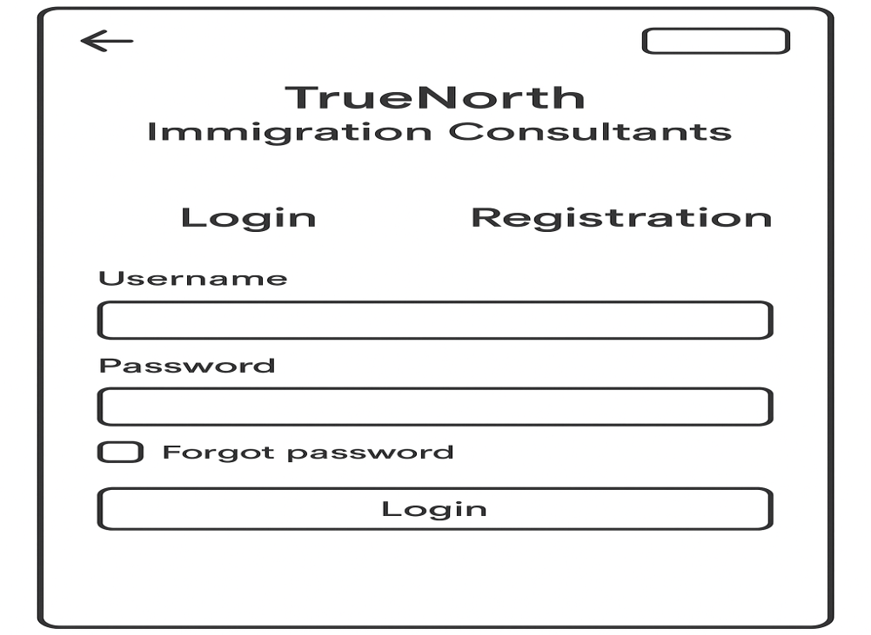
Home Page
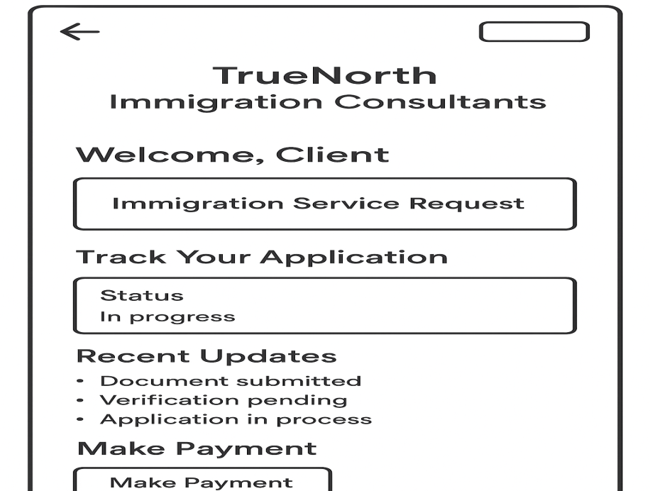
Services Page
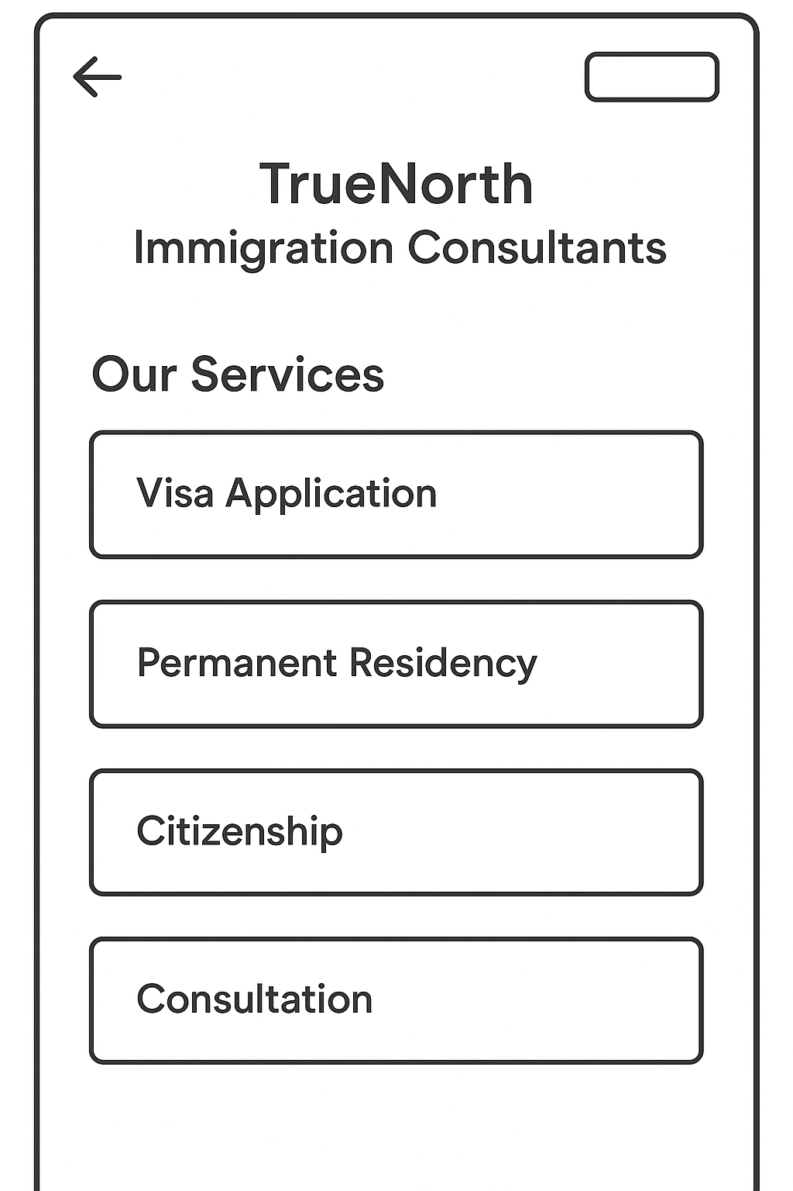

Upload Documents Page
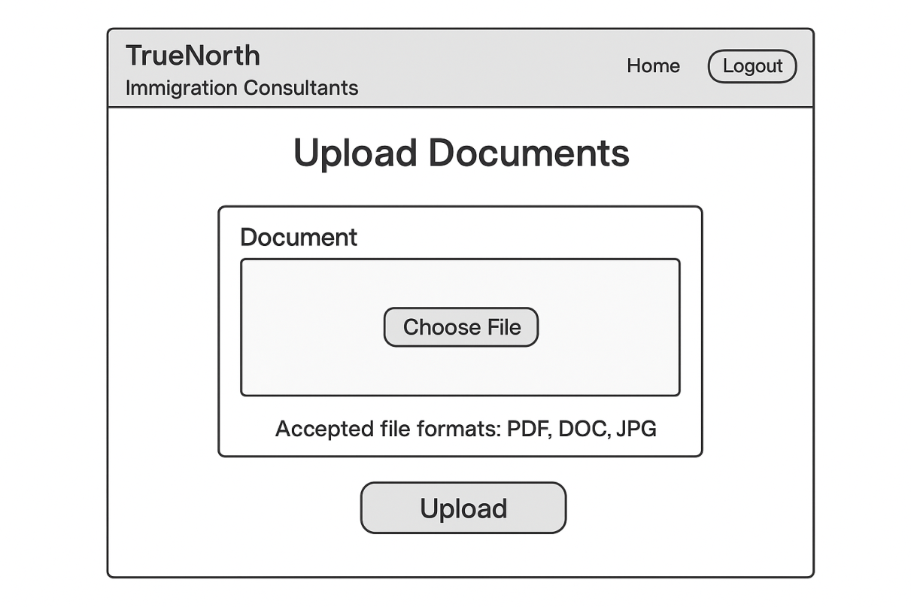
Make Payment Page
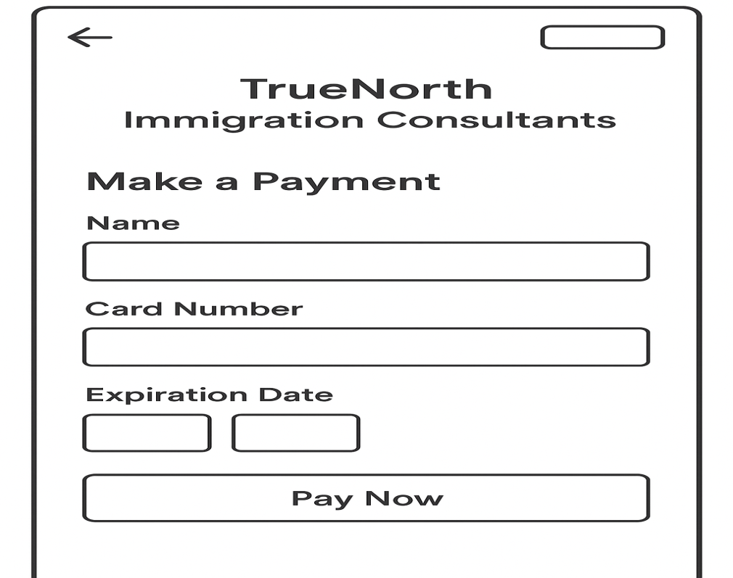

Document 8- Tools-Visio and Axure
Using Visio for the project was a straightforward experience. Its intuitive interface allowed me to quickly create diagrams and flowcharts to visualize the project's architecture and processes. I found it easy to drag and drop shapes, connect them with arrows, and add text to explain each step. Visio's templates also helped me get started quickly, saving time and effort. Overall, Visio proved to be a reliable tool for creating clear and detailed diagrams and enhancing communication and understanding among team members.

Using Axure for the project was a game-changer. Its powerful prototyping capabilities allowed me to create interactive mock-ups of the project's user interface with ease. Axure's drag-and-drop interface made it simple to design each screen and add interactive elements such as buttons, forms, and navigation links. Testing the prototypes in Axure helped identify usability issues early in the development process, leading to smoother user experiences. Overall, Axure proved to be an invaluable tool for designing and refining the project's user interface, ultimately improving its usability and functionality.
Document 9- BA experience
My experience as a BA in the following phases:
- Requirement gathering:
- To gather requirements, we used the MOSCOW technique.
- Engaged stakeholders through interviews, surveys, and workshops.
- Captured comprehensive requirements to align with business goals.
- Ensured clarity and understanding of stakeholder needs and objectives.
- I validate the requirements using the FURPS technique.
- There are many requirements, which are duplicated or repeated. We need to remove them immediately.

- Requirement Analysis:
- We need to draw UML diagrams to visually describe the requirements.
- Activity diagrams are also used to describe the process flow
- Identified dependencies, priorities, and potential challenges.
- Established traceability between requirements and business objectives.
- Prepare BRS and SRS.

- Design:
- From the use case diagrams, we prepare test cases.
- Communicate with the client on design and solution documents
- Created mock-ups and prototypes using tools like Axure and Visio.
- Iteratively refined designs based on stakeholder feedback.
- Ensured designs were user-friendly, intuitive, and aligned with business goals.
- Documented design decisions and rationale for future reference.

- Development:
- Organized JAD sessions
- Worked closely with the development team to provide clear documentation.
- Ensured accurate implementation of design specifications.
- Addressed any questions or concerns from the development team.
- Collaborated on technical solutions to meet project requirements.
- Monitored progress and guided throughout the development process.
- Conduct regular meetings with the technical team and client, which is challenging. Some team members might not be available for the meeting. Recording the session providing that to the missed one and having to one-on-one discussion later with that missed person is all we need to do.
- Testing:
- Developed test plans and scenarios in collaboration with QA teams.
- Conducted regression testing to verify fixes and changes.
- Identified and reported defects, ensuring timely resolution.
- Worked closely with QA teams to prioritize and address issues.
- Updated RTM.
- Take signoff from the client.
- Prepare client for UAT.

- Deployment:
- Coordinated the rollout of the project to ensure a smooth transition.
- Conducted user-training sessions to facilitate the adoption of the solution.
- Communicated updates and progress to stakeholders.
- Ensured project documentation and knowledge transfer for ongoing support and maintenance.
- Make sure all the candidates attend the meeting.
- Coordinates to complete and share end user manuals.

