Business Requirement Document (BRD)
Project Title: COEPD Ice Cream
Smart Inventory & Delivery Optimization System for Ice-Cream and Dairy Manufacturer

1. Executive Summary:
The client is a leading manufacturer of ice-cream and milk products with multiple manufacturing plants and warehouses across the country. They want to build an integrated software system to manage inventory levels in real-time and enable quickest delivery to customers, reducing product spoilage and improving customer satisfaction.

2. Business Objectives:
- Real-time inventory tracking at plants and warehouses
- Enable automatic stock reordering and stock transfers
- Implement smart delivery routing to minimize delivery times
- Provide dashboard and reports for supply chain performance
- Ensure traceability of product batches (for compliance and recalls)

3. Scope of Work:
In-Scope:
- Inventory management system for raw materials and finished goods
- Delivery route optimization tool with customer order tracking
- Integration with existing ERP (if any)
- Web & mobile dashboards for supply chain stakeholders
Out-of-Scope:
- Cold storage hardware integration
- External delivery vendor tracking (unless API provided)

4. Functional Requirements:
Module | Requirement
Inventory Management | Track stock at plant & warehouse level, batch-level tracking, expiry alerts
Auto Reorder | Trigger stock reorder when reaching threshold levels
Inter-Warehouse Transfer | Route-based transfer requests and approvals
Order Management | Capture customer orders from app/portal
Delivery Optimization | Auto-assign orders to routes based on location, traffic, stock availability
Alerts & Notifications | Email/SMS for low stock, delayed delivery, and order status
Reporting Dashboard | Real-time data for stock, sales, spoilage, route KPIs

5. Non-Functional Requirements:
- Performance: System should support 1000+ concurrent users
- Scalability: Should scale as business expands to more locations
- Security: Role-based access, secure API integration
- Availability: 99.9% uptime with cloud hosting

6. Stakeholders:
Role | Responsibility
Plant Managers | Update production and inventory levels
Warehouse Supervisors | Monitor stock and trigger reorders
Logistics Coordinators | Manage routing and delivery scheduling
IT Admin | Manage user access, system performance
Customers | Place and track orders

7. Assumptions & Constraints:
- Internet availability at all plants and warehouses
- GPS data available for delivery routing
- Customer order data available via portal or mobile app

8. Development Plan:
Phase | Deliverables | Timeline
Requirement Analysis | BRD, Use Cases, Workflow Diagrams | Week 1–2
Design & Prototyping | UI Mockups, Architecture Design | Week 3–4
Development – Phase I | Inventory Module | Week 5–7
Development – Phase II | Delivery Module, Routing Logic | Week 8–10
Testing & QA | UAT, Performance Testing | Week 11–12
Deployment | Go-live on cloud infrastructure | Week 13

9. Resource Plan:
Role | Count | Duration
Business Analyst | 1 | Full Project
Project Manager | 1 | Full Project
UI/UX Designer | 1 | 2 Weeks
Frontend Dev | 2 | 8 Weeks
Backend Dev | 2 | 8 Weeks
QA Engineer | 1 | 3 Weeks
DevOps Engineer | 1 | 2 Weeks

2. Process Flow Diagram (Descriptive)
Here’s a step-by-step flow that you can visualize in a diagram using standard flowchart symbols:

  - Inventory Management Flow
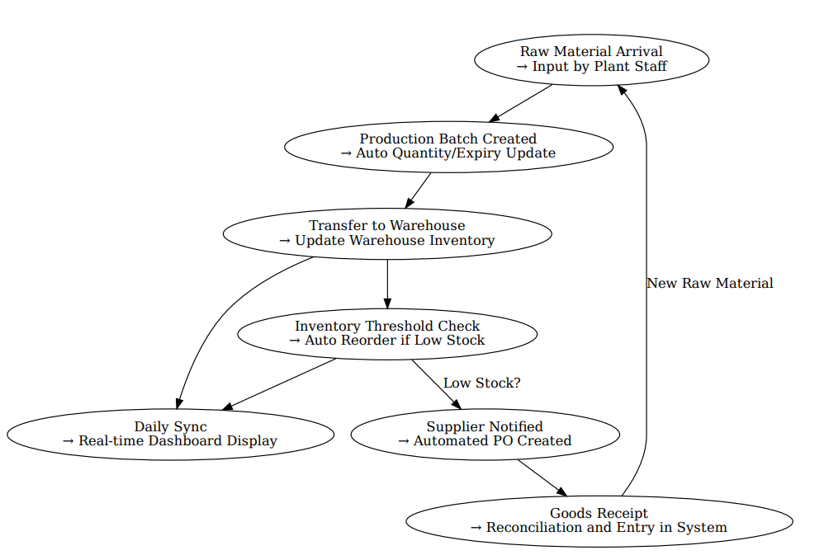

1. Introduction Letter to Client (as a Business Analyst)
Subject: Business Analyst Introduction – Project Kickoff & Collaboration
Dear [Client Name],
I hope this message finds you well.
My name is Aamir, and I will be serving as the Business Analyst for your upcoming project. I am excited to collaborate closely with you and your team to understand your business objectives, gather requirements, and ensure that the final solution aligns perfectly with your vision.
Over the next few days, I will initiate discovery sessions to capture your expectations, analyze current workflows, identify pain points, and translate them into clear, actionable requirements. I will serve as the communication bridge between your business stakeholders and our technical team to ensure clarity, alignment, and traceability throughout the project.
I look forward to a productive partnership and am confident that, together, we will deliver a solution that drives real value.
Warm regards,
Aamir
Axia Womens health
Email: aamir@axia.com | Phone: 9966577563

2. Brief BRD and SRS – (Project: Online Store)
Business Requirement Document (BRD) – Online Store
Project Title: Digital Retail Storefront for Fashion & Electronics
Objective:
To develop an online store that allows users to browse products, place orders, track deliveries, and manage returns seamlessly through a web and mobile interface.
Stakeholders:
- Product Manager
- Marketing Team
- IT & Development Team
- End Users (Customers)
Business Requirements:
- Users should be able to browse products by category and filter them.
- The system should allow secure user registration/login.
- Customers can add products to cart and complete checkout.
- Support multiple payment options (credit card, UPI, COD).
- Admins can add/update/delete products.
- Users can track orders, manage returns, and give feedback.

Software Requirement Specification (SRS)
Functional Requirements:
- User Authentication (Sign Up/Login with email & OTP)
- Product Listing with search and filters (brand, price, size)
- Shopping Cart management (add/edit/delete items)
- Checkout system (with payment gateway integration)
- Order Management: View status, history, cancel/return
- Admin Panel: Inventory control, price update, view orders
- Notification: Email/SMS updates on orders and offers
Non-Functional Requirements:
- System uptime: 99.9%
- Response time: < 3 seconds
- Mobile responsive design
- Data privacy and security (HTTPS, encrypted payments)

3. ERD – Support Ticket Lifecycle (Ticketing System)
Here’s the Entity Relationship Diagram (ERD) conceptually described:
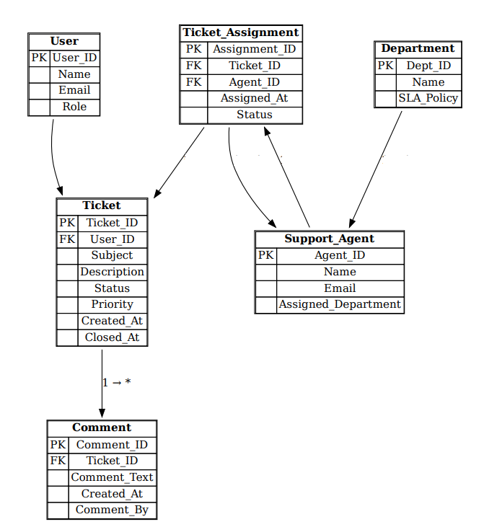
4. User Story – Shopping from E-commerce Site
User Story 1 – Add to Cart & Checkout
As a registered user,
I want to browse products by category,
So that I can add my desired items to the cart and checkout easily.
Acceptance Criteria:
- User can browse by category (e.g., Fashion, Electronics)
- Filter by price, brand, size
- Add product to cart with quantity
- View cart and edit quantities
- Proceed to checkout and pay via preferred method
- Receive confirmation email on successful order

