WATERFALL DELIVERABLES
Document 6

Activity Diagram for Login in SFDC
Activity Diagram for Login

Activity Diagram for Search Customer Record

Activity Diagram for Offer Notification when we approve or reject the offer

Activity Diagram for updating Interaction or Meeting

Use Case Specification
Login
Description | User Name , Password
Actors | Users
Pre Conditions | Active Internet Condition
Post Conditions | Home page of SFDC will be display
Basic Flow | User Name and Password are correct
Alternative flow | User Name or Password is wrong
Exceptional Flow | Forget Username or Password
Assumptions | User have basis knowledge
Constraints | User name can not be name
Dependency | User Should be register
Input Output | Input User Name and password output :- Error code
Business Rules | User name should be unigue
Mis Info | Interative design browser compatable

Search
Description | User Enter the details for search
Actors | Users
Pre Conditions | User have CRN , Mobile no or Pan no to Enter
Post Conditions | User Search the details for particular customer
Basic Flow | Customer details should be correct
Alternative flow | Wrong detail given by customer
Exceptional Flow | Detail provided didn't match
Assumptions | Customer cone with proper details
Constraints | CRN should be unique
Dependency | Cusomter belongs to our bank
Input Output | Input correct details so out put will be correct otherwise debug error
Business Rules | CRN shoukd be unique
Mis Info | Come up with propoer result

Offers
Description | User Enter the details
Actors | Users
Pre Conditions | Enter Customer CRN
Post Conditions | Display the offer in his account
Basic Flow | Customer details should be correct
Alternative flow | Wrong detail given by customer
Exceptional Flow | Detail provided didn't match
Assumptions | Customer come with proper details
Constraints | CRN should be unique
Dependency | offer dependrsTransaction in account
Input Output | Input correct details so out put will be correct otherwise debug error
Business Rules | CRN shoukd be unique
Mis Info | Come up with propoer result

Meeting
Description | User Enter the details for search
Actors | Users
Pre Conditions | Enter Correct CRN
Post Conditions | Enter interaction of meeting
Basic Flow | Customer details should be correct
Alternative flow | Wrong detail given by customer
Exceptional Flow | Detail provided didn't match
Assumptions | Customer come with proper details
Constraints | CRN should be unique
Dependency | Cusomter belongs to our bank
Input Output | Input correct details so out put will be correct otherwise debug error
Business Rules | CRN shoukd be unique
Mis Info | Come up with propoer result

Document 7
Screen and Pages

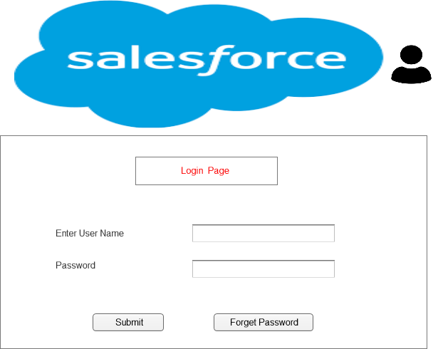

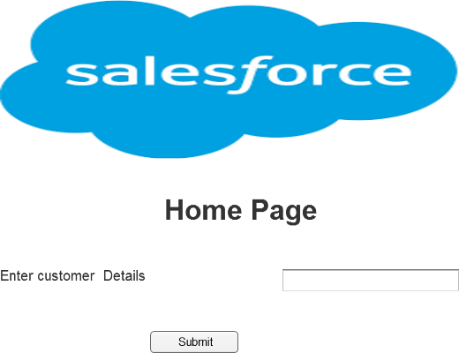

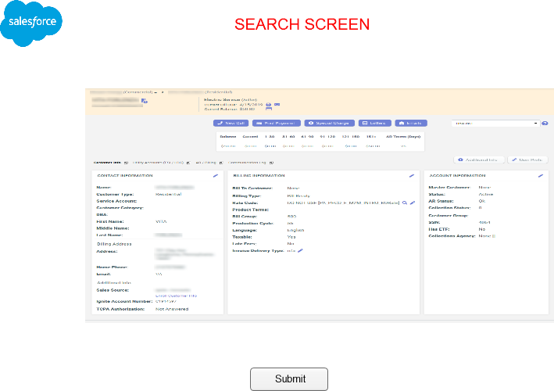

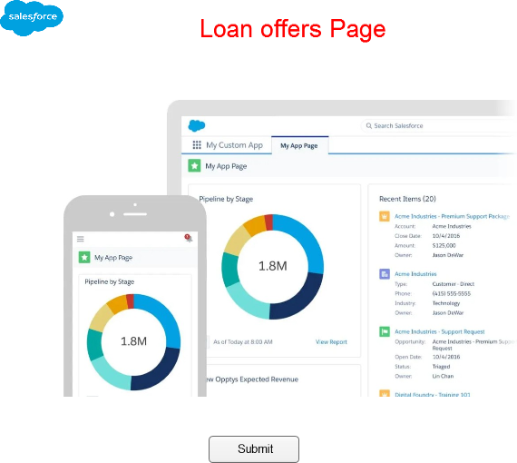

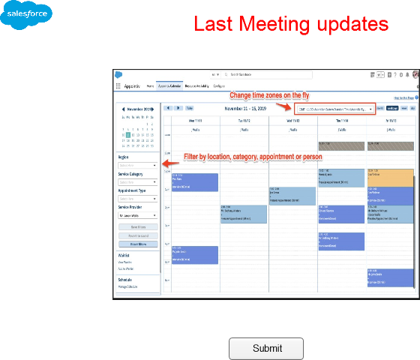

Link for the document

Document 8
Tools Visio and Axure

AXURE
Axure is a powerful design tool used for creating highly interactive prototypes for web, mobile and desktop application with the screen navigation .it has clickable button , input output and other buttons .
Axure is used for creating high fidelity graphical , interface wireframes and prototypes for web and mobile application .
This is use in the starting of project during both design and research phase of a project
Features
- More Advanced
- Require more time to learn
- More powerful
- Advanced prototype features
- Its pricing is Subscription based
- Support a wide range of output

VISIO
- Ms Visio is digramatical and vector Graphical Application used to create flow charts , use case and activity diagram
- MS visio is a tool use to create UML ( Unified Modeling Language ) diagram , There are two type of UML Digram
- UML has 9 Diagrams ( 5 Static and 4 Dynamic )
- AS a BA we prepare Use case Diagram and Activity Diagram
- Use Case Diagram :- User Perspective
- Activity Diagram :- System Perspective

Document 9
My Experience as a BA in following phases
- Requirement Gathering :-
- To Gather the requirement we use MOSCOW Technique
MoSCoW Stands for Must Should Could and Would

Must :- Must have the requirement to meet the business needs ( 100 % Complete )

Should :- Should have this requirement if Possible but Project success does not rely on it (Important , Pre Requites)

Could :- -Could have this requirement if it does not affect anything else in the project (Important they are contradict )

Would :- Would like to have this requirement later , but it won’t be delivered this time ( Low priority requirement )

- Client is not available for some period of time during this phase so as a BA I need to source point of contact from his side and get the information ASAP
- Then as a BA I validate the requirement using FURBS . It stands for

Functionality
Usability
Reliability
Performance
Supportable
- In this phase we remove the duplicate requirement or repeated requirement immediately
- Prototyping

- Requirement Analysis :-

- In this phase we Draw UML diagram and Activity Diagram and communicate the same to team , if they are not agree and they wants some changes then they we will modify the same immediately
- We Prepare BRS Business Requirement Specification and SRS Software Requirement Specification in this Phase

- Design :-

- In this Phase we create Test Cases UML Diagram
- Communiccate the client design and solution document
- Update RTM ( Requirement Tracibility Matrix )
- From use case diagram solution Architect recommend Architect of the IT Solution
- DB Architect come up with ER Diagram or DB Schema
- GUI Designer will look in to Boundary Classes and design all possible screen
- We prepare HDD Hign level design document and ADD Application design Document
Coding
- In this phase BA organize JAD Sessions
- BA Clarify Queries of technical team during coding
- Their might be some team members who are not agree with with the concept during JAD Sessions so as a BA I handle the situation and had one to one discussion with the members and set up a healthy environment .
- Update RTM
- Conduct Regular meetings with technical team and client which are challenging some members are not available in the meeting so keep recording of all meeting and share to them Who missed the meeting
- Create LDD and CDD Low level design document and component design Document

- Testing

- BA Prepare Test Cases from use Cases
- BA Prepare high level testing
- Ba Prepare Client for UAT
- Update RTM
- Take Sign off from client

- Deployment and Implementation

- Provide RTM to client or PM which should attach Project closure document
- Plan and organize training sessions
- Prepare lesson learn from this project
- Make sure all candidate attend the meetings

