Waterfall Model Documents - Part -2/2

Document 6 - Please prepare a use case diagram, activity diagram and a use case specification document.

Use case diagram for Auditors

Here's a detailed Use Case Specification for each use case in the system:
Use Case ID | UC01
Use Case Name | Sign Up / Login
Actor(s) | - Primary Actor: Auditors  - Secondary Actor: IT Admin
Description | Allows users to sign up or log in to the system.
Precondition | User must have valid credentials (for login) or provide required information (for sign-up).
Basic Flow | - User accesses the login or sign-up interface.  - Enters credentials or required details.  - System verifies information.  - If valid, user is logged in; else, an error is shown.
Alternate Flow | If signing up, request is sent to the IT Admin for approval.
Postcondition | User is logged in or pending approval.
Exceptional Flow | Invalid credentials → Error message displayed
Assumptions | Auditor already has or is requesting access.
Constraints | Limited attempts, password policy enforced.
Dependencies | Approval by IT Admin.
Inputs and Outputs | Login credentials / Access token or error message
Business Rules | Password complexity, 2FA if enabled.
Miscellaneous | Account lockout after 5 failed attempts.

Use Case ID | UC02
Use Case Name | Approves or Rejects User Login or Sign Up
Actor(s) | IT Admin
Description | IT Admin reviews and approves or rejects new user registration or login attempts.
Precondition | A new registration or suspicious login request is received.
Basic Flow | - IT Admin reviews request.  - Validates credentials or information.  - Approves or rejects the request.  - Notification is sent to the user.
Alternate Flow | No pending requests → No action taken.
Postcondition | User is authenticated and granted access to the system.
Exceptional Flow | System fails to retrieve request → IT Admin prompted to retry.
Assumptions | Only authorized IT Admins can make approval decisions.
Constraints | System must log every approval or rejection for audit purposes.
Dependencies | Login and Sign-up modules must be functional.
Inputs and Outputs | - Inputs: User registration or login request data (name, role, credentials, documents)  - Outputs: Approval/rejection status, audit logs, notifications
Business Rules | IT Admin can only approve users belonging to their assigned region or department.
Miscellaneous | Approvals are tracked for compliance audits.

Use Case ID | UC03
Use Case Name | Go to Entity
Actor(s) | Auditor
Description | Allows auditors to access specific entities for audit work.
Precondition | Auditor must be logged in and authorized.
Basic Flow | - Auditor selects an entity from the system.  - System displays relevant information for the selected entity.
Alternate Flow | No entities assigned → Display “No entity found” message.
Postcondition | Auditor views selected entity’s details.
Exceptional Flow | Database error → Error message displayed.
Assumptions | Auditor has permissions for multiple entities.
Constraints | Entity list may be given page numbers.
Dependencies | System’s entity master data.
Inputs and Outputs | - Input: Entity selection  - Output: Confirmation
Business Rules | Auditor must be assigned to entity.
Miscellaneous | Recently used entities may be auto-suggested.

Use Case ID | UC04
Use Case Name | Go to Dashboard
Actor(s) | Auditor
Description | Displays a dashboard with tools and updates related to audit work.
Precondition | Auditor must be authenticated.
Basic Flow | - Auditor selects Dashboard.  - Dashboard with widgets, metrics, and links is shown.
Alternate Flow | Personalized dashboard options shown based on role.
Postcondition | Auditor is able to monitor tasks and navigate efficiently.
Exceptional Flow | Dashboard fails to load → Error with retry option.
Assumptions | Data is available and up to date.
Constraints | Dashboard widgets limited by screen size.
Dependencies | Data from audit module, planning, entity.
Inputs and Outputs | - Input: None  - Output: Dashboard UI
Business Rules | Display based on role and permissions.
Miscellaneous | UI caching enabled for performance.

Use Case ID | UC05
Use Case Name | Audit Planning and Execution
Actor(s) | Auditor
Description | Supports planning audit activities and executing them within the platform.
Precondition | Auditor must be given access to an entity.
Basic Flow | - Auditor sets up audit objectives and checklists.  - Performs audit tasks.  - Records findings.
Alternate Flow | Auditor can modify the plan based on findings.
Postcondition | Audit process is initiated or completed.
Exceptional Flow | Task not saved due to session timeout → Prompt user to retry.
Assumptions | Sufficient access to entity records.
Constraints | Must follow firm’s methodology.
Dependencies | Audit templates, role assignments.
Inputs and Outputs | - Input : Audit scope, evidence  - Output : Status updates
Business Rules | Risk-based approach must be followed.
Miscellaneous | Time tracking may be enabled.

Use Case ID | UC06
Use Case Name | Data Analysis
Actor(s) | Auditor
Description | Enables analysis of audit data to detect patterns, risks, and insights.
Precondition | Audit data (financial statements) must be available.
Basic Flow | - Auditor selects data sets for analysis.  - Uses built-in tools to filter and analyse.  - Saves or exports insights.
Alternate Flow | Custom scripts or tools may be used if supported.
Postcondition | Insights are generated and documented.
Exceptional Flow | Corrupted data → Display error, request clean data.
Assumptions | Auditor understands the data.
Constraints | Large files may be rejected
Dependencies | Audit data and processing engine.
Inputs and Outputs | - Input : Raw data  - Output : Analysis results
Business Rules | Standard analysis types must be used.
Miscellaneous | Results can be saved or exported.

Use Case ID | UC07
Use Case Name | Report Generation for Deliverable
Actor(s) | Auditor
Description | Compiles audit findings into a formal report for stakeholders.
Precondition | Audit and analysis must be completed.
Basic Flow | - Auditor selects report format.  - Populates data.  - Reviews and finalizes report.
Alternate Flow | Auditor collaborates with others for peer review.
Postcondition | Report is generated and stored/shared.
Exceptional Flow | System crash during generation → Recovery prompt and auto-save.
Assumptions | Auditor has access to templates.
Constraints | Only certain formats allowed (e.g., PDF, DOCX).
Dependencies | Analysis and audit data must be complete.
Inputs and Outputs | - Input : Report parameters  - Output : Final Report
Business Rules | Reports must meet audit standards
Miscellaneous | Reports are logged and archived.

Use Case Diagram for Clients or Engagement Teams (ETs)

Use Case ID | UC01
Use Case Name | Access Request Status
Actor(s) | Clients / Engagement Team
Description | Allows users to track the status of submitted access or service requests..
Precondition | User must be logged into the system.
Basic Flow | - User logs in.  - Navigates to the "Access Status" section.  - System displays request history and current statuses.
Alternate Flow | User filters or sorts requests by type, date, or status.
Postcondition | User is informed about current request statuses.
Exceptional Flow | Status not available → System shows pending message or escalation option.
Assumptions | Requests were previously submitted.
Constraints | Users can view only their own requests.
Dependencies | Backend request management system.
Inputs and Outputs | - Input: User ID  - Output: List of request statuses
Business Rules | Only IT Admin can modify request status.
Miscellaneous | Interface should support status filtering.

Use Case ID | UC02
Use Case Name | Maintain Platform Security
Actor(s) | IT Admin
Description | Ensures platform integrity and data protection through security operations.
Precondition | System must be operational.
Basic Flow | - IT Admin logs in to the admin panel.  - Reviews security logs and access activities.  - Applies updates, patches, and monitors for breaches.
Alternate Flow | IT Admin performs routine maintenance checks.
Postcondition | Platform remains secure and compliant.
Exceptional Flow | Security breach detected → Escalation and resolution workflow initiated.
Assumptions | - IT Admin has the necessary expertise.  - The system includes integrated security tools.
Constraints | Updates may require downtime or scheduled maintenance
Dependencies | User Access Management Module
Inputs and Outputs | - Inputs: Admin credentials, threat intelligence feeds, access logs  - Outputs: System status reports, access control settings, audit logs
Business Rules | - All admin actions must be logged.  - Minimum password complexity and 2FA are enforced.
Miscellaneous | IT Admins are required to attend annual cybersecurity training.

Use Case ID | UC03
Use Case Name | Collaborate with Offshore Teams in Real-Time
Actor(s) | Clients / Engagement Team
Description | Facilitates real-time communication and collaboration with offshore audit teams.
Precondition | Both parties must be online and authorized.
Basic Flow | - User accesses collaboration tools (chat, call, shared documents).  - Initiates session with offshore team.  - Exchanges information or coordinates tasks.
Alternate Flow | Scheduled meetings or use of asynchronous channels.
Postcondition | Tasks are aligned and clarified in real-time.
Exceptional Flow | Connectivity issue → Retry mechanism or offline message queue.
Assumptions | Secure channels are in place.
Constraints | Connectivity must be stable.
Dependencies | Integrated collaboration tools (chat, video).
Inputs and Outputs | - Input: User credentials, message content  - Output: Message logs, file transfers
Business Rules | All communication must be logged.
Miscellaneous | Use time zone conversion for scheduling.

Use Case ID | UC04
Use Case Name | Discuss About Any Discrepancies
Actor(s) | Clients / Engagement Team
Description | Allows users to raise and discuss issues or mismatches found during audits.
Precondition | Audit findings must be visible to the user.
Basic Flow | - User identifies a discrepancy.  - Raises a discussion or query in the platform.  - Auditor or relevant team responds with clarification or correction.
Alternate Flow | Discussion forwarded to a higher-level reviewer.
Postcondition | Discrepancy is resolved or escalated.
Exceptional Flow | No response received → User sends follow-up or flags the item.
Assumptions | Communication channels are working.
Constraints | Only authorized users can escalate.
Dependencies | Ticketing/discussion system.
Inputs and Outputs | - Input: Report ID, issue description  - Output: Resolved status or comments
Business Rules | SLAs for response times apply.
Miscellaneous | All discussions should be archived.

Use Case ID | UC05
Use Case Name | Provide Necessary Documents and Information
Actor(s) | Clients / Engagement Team
Description | Upload and share required documentation for audit processing.
Precondition | User must know the required documentation.
Basic Flow | - User navigates to document upload section.  - Selects and uploads files.  - System verifies format and stores the documents.
Alternate Flow | User uses drag-and-drop or batch upload features.
Postcondition | Documents are uploaded and available for audit team.
Exceptional Flow | Invalid file format or size → User receives an error and retries.
Assumptions | User knows what documents are needed.
Constraints | Only authorized formats and size allowed.
Dependencies | Secure file storage backend.
Inputs and Outputs | - Input: Uploaded files, metadata  - Output: Upload confirmation
Business Rules | Audit documents must be retained for compliance.
Miscellaneous | Support drag-and-drop and batch uploads.

Use Case ID | UC06
Use Case Name | Check with the Deliverables Provided
Actor(s) | Clients / Engagement Team
Description | View and confirm deliverables (audit results, reports, etc.) provided by auditors.
Precondition | Deliverables must be finalized and uploaded.
Basic Flow | - User logs in and accesses the “Deliverables” section.  - Views the list of completed items.  - Downloads or reviews online.
Alternate Flow | User provides feedback or signs off on the deliverable.
Postcondition | Deliverables are confirmed or followed up for revision.
Exceptional Flow | Deliverable missing → User raises a request for clarification.
Assumptions | User has permissions to access the report.
Constraints | Deliverables are read-only.
Dependencies | Report generation and document upload systems.
Inputs and Outputs | - Input: User access  - Output: Report files, review confirmation
Business Rules | All deliverables must be version-controlled.
Miscellaneous | System may track read/download status.

Activity Diagram

Document 7- Screens and pages

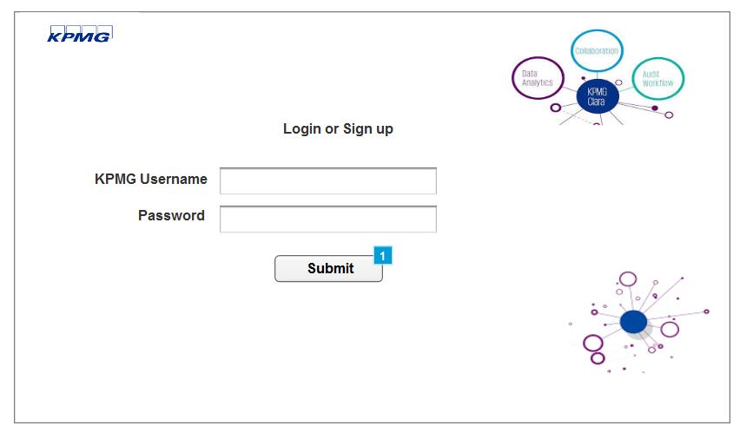

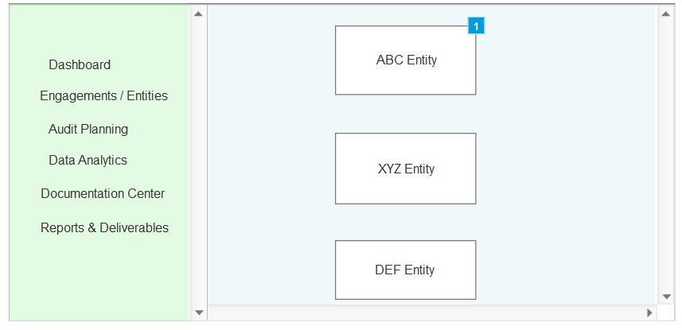

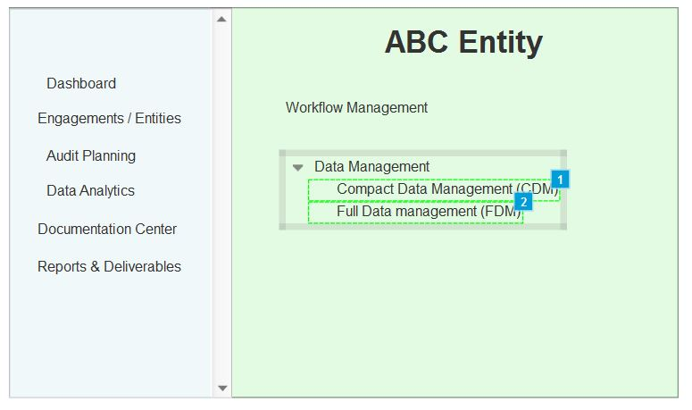

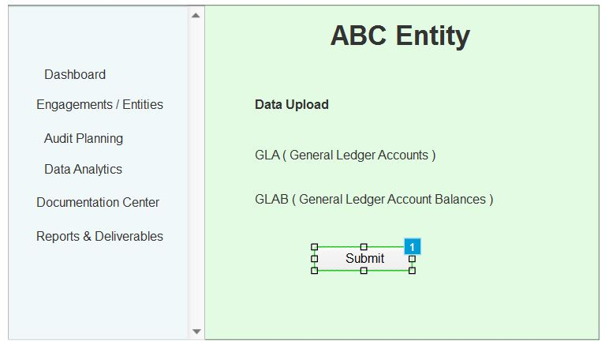

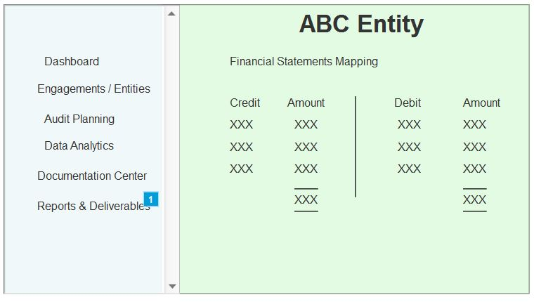

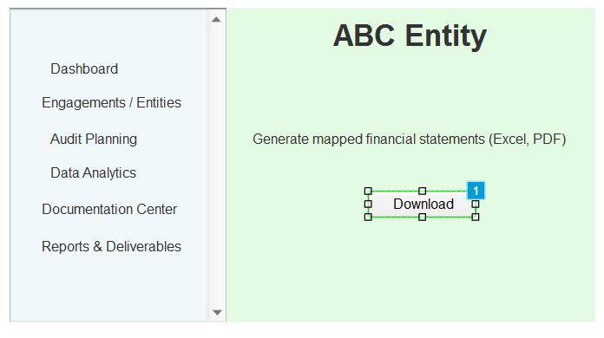

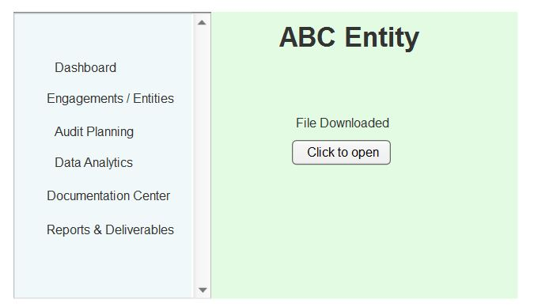

Document 8- Tools-Visio and Axure
Using Visio and Axure for modelling the KPMG Clara system was a highly productive experience. Visio proved particularly effective for creating clear and structured use case and activity diagrams, enabling a visual representation of system functionalities and user interactions with precision and ease. It allowed for smooth collaboration and standardized formatting, which is essential for professional documentation. On the other hand, Axure was instrumental in designing interactive wireframes and prototypes, helping bring KPMG Clara’s interface to life. It offered dynamic elements and real-time simulations, allowing stakeholders to visualize user journeys and identify usability improvements early in the process. Together, these tools supported a comprehensive and efficient approach to system analysis and design for KPMG Clara.

Document 9 - BA experience

My Experience as a Business Analyst for KPMG Clara Works
As a Business Analyst on the KPMG Clara Works project, I was involved in end-to-end lifecycle management, contributing to every critical phase with a structured and detail-oriented approach.

  - Requirement Gathering:
In this phase, I employed the MoSCoW technique to prioritize requirements effectively. Due to limited client availability, I proactively identified alternate points of contact to ensure uninterrupted information flow. I validated the gathered requirements using the FURPS model (functionality, usability, reliability, performance, and security) to ensure completeness and quality. Duplicates and redundancies in requirements were carefully identified and removed to avoid ambiguity. Additionally, I utilized prototyping techniques to help stakeholders better articulate their expectations, resulting in more precise and agreed-upon requirements
2. Requirement Analysis:
To visualize and clarify the requirements, I created UML diagrams, including activity diagrams to illustrate process flows. These diagrams were shared with the development and testing teams for review. When there were disagreements or alternative views, I facilitated discussions and incorporated feedback to refine the models. I also prepared the Business Requirements Specification (BRS) and Software Requirements Specification (SRS) documents to formally capture and communicate the scope.
3. Design:
During the design phase, I derived test cases directly from the use case diagrams, covering both positive and negative scenarios. I maintained continuous communication with the client regarding design and solution documents. Given the importance of complete test coverage, I ensured no test case was overlooked, as even a small omission could impact downstream development. I prepared realistic test data for the QA team and updated the Requirements Traceability Matrix (RTM) to ensure every requirement was accounted for in the test plan.
4. Development:
I organized Joint Application Development (JAD) sessions to foster collaboration between technical teams and stakeholders. During development, I addressed queries from the development team promptly. Where resistance or lack of cooperation was observed, I handled it diplomatically through one-on-one discussions, emphasizing the importance of collaboration and the potential impact of delays. I also referred to the visual models to support developers in understanding complex requirements and maintained regular coordination meetings. For those who missed sessions, I ensured continuity by sharing recorded discussions and conducting follow-ups individually.
5. Testing:
I created detailed test cases from use cases and supported high-level functional testing. I also facilitated the procurement of test data from the client and ensured that the RTM was kept up to date to maintain traceability. After testing, I obtained formal signoff from the client and played a key role in preparing the client for User Acceptance Testing (UAT), ensuring they understood the expected outcomes and system behaviour.
6. Deployment:
In the final phase, I forwarded the updated RTM to the client as part of the project closure documentation. I also coordinated the creation and distribution of end-user manuals, ensuring they were tailored to the specific needs of different user roles. To ensure adoption, I organized and led training sessions, taking care to confirm full attendance and address any last-minute questions or issues.

This comprehensive involvement across all phases enhanced my understanding of the project lifecycle, improved my stakeholder communication skills, and reinforced my ability to ensure project alignment with business goals at every stage.

