Case study 1 – customer can make a payment either by card or wallet or by cash or by net banking
Question 1: Draw a use case diagram
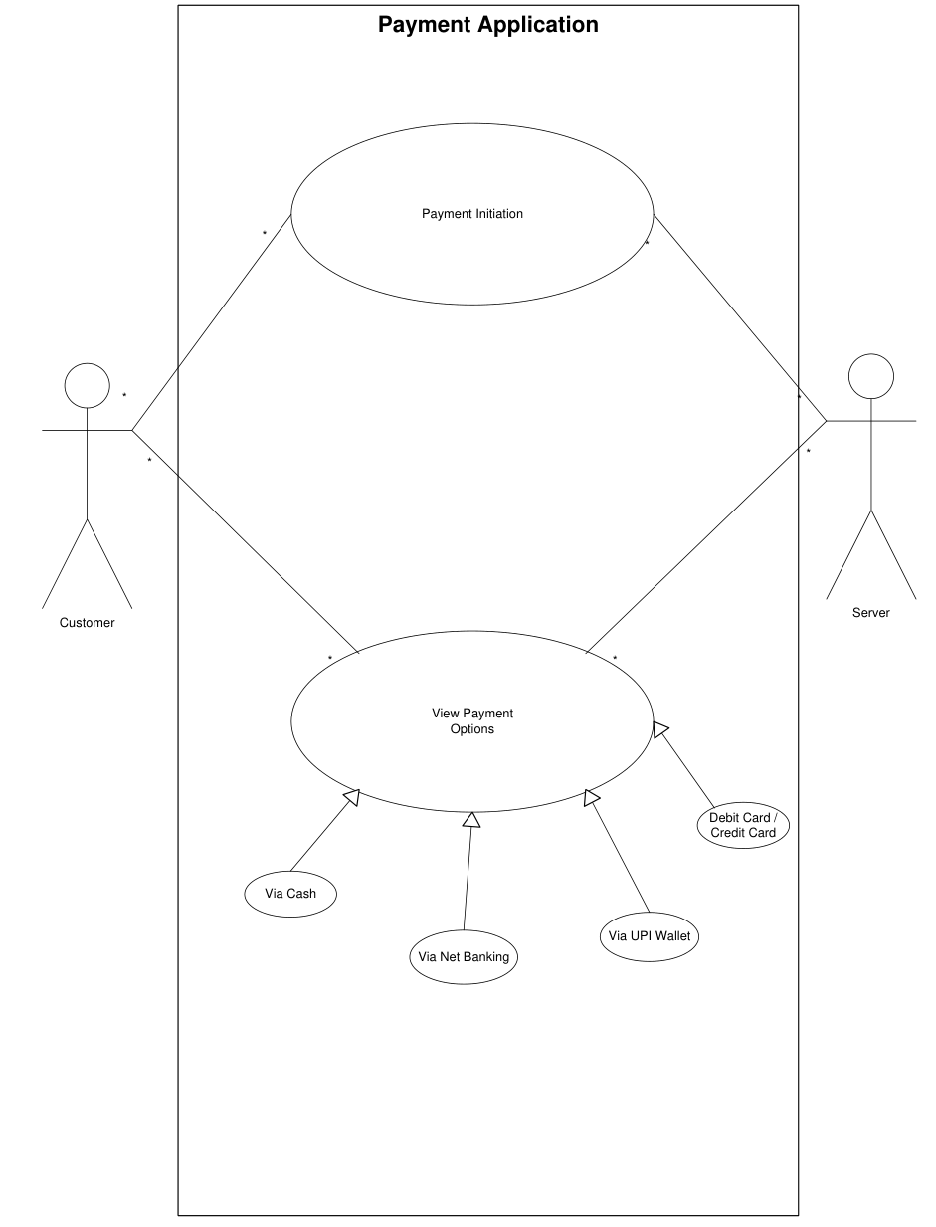

Question 2: Derive Boundary Classes, Controller classes, Entity Classes.
Boundary Classes:  These classes interact with the customer to receive input or provide output:  - PaymentUI or PaymentScreen: Interface through which the customer selects the payment method.  - CardInputForm: Interface through which the customer selects the payment method.  - WalletLoginScreen: For wallet authentication.  - CashConfirmationScreen: Confirms cash receipt.  - NetBankingPortal: Handles bank login & transaction confirmation. | 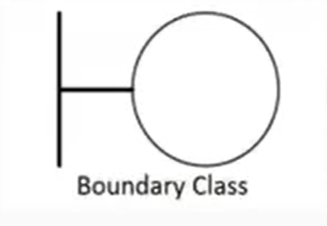
Controller Classes:  Controllers interpret user actions and invoke appropriate entity class methods:  - PaymentController – Main controller to process payment.  - CardPaymentController – Handles logic specific to card payment.  - WalletPaymentController – Handles logic specific to wallet payment.  - CashPaymentController – Handles logic specific to cash payment.  - NetBankingPaymentController – Handles logic specific to net banking. | 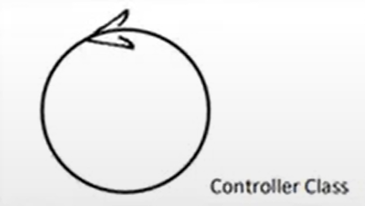
Entity Classes:  These classes deal with core data and processes:  - Payment – Base entity for all payment types (amount, date, status).  - CardDetails – Stores card number, expiry, CVV.  - WalletAccount – Contains wallet ID, balance, and provider info.  - BankAccount – Contains account number, bank name, IFSC.  - Customer – Contains customer profile, preferred payment methods. | 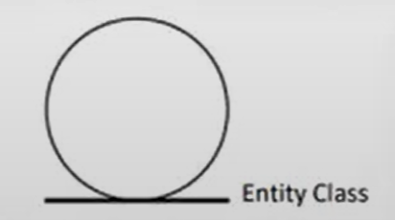

Question 3: Place these classes on a three tier Architecture. – 4 Marks
User layer:
- Responsible for user interaction.
- Contains Boundary Classes that capture input/output.
Classes in this Layer:
- PaymentUI
- CardInputForm
- WalletLoginScreen
- CashConfirmationScreen
- NetBankingPortal
Business Logic Layer:
- Coordinates user actions and enforces business rules.
- Contains Controller Classes that handle logic and workflow.
Classes in this Layer:
- PaymentController
- CardPaymentController
- WalletPaymentController
- CashPaymentController
- NetBankingPaymentController
Data Tier:
- Manages data, entities, and persistence.
- Contains Entity Classes that represent core business objects.
Classes in this Layer:
- Payment
- CardDetails
- WalletAccount
- BankAccount
- Customer

Question 4: Explain Domain Model for Customer making payment through Net Banking - 4 Marks
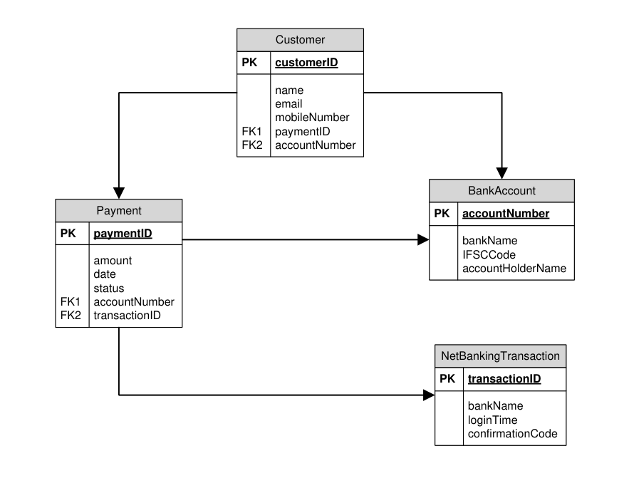

Question 5: Draw a sequence diagram for payment done by Customer Net Banking - 4 Marks
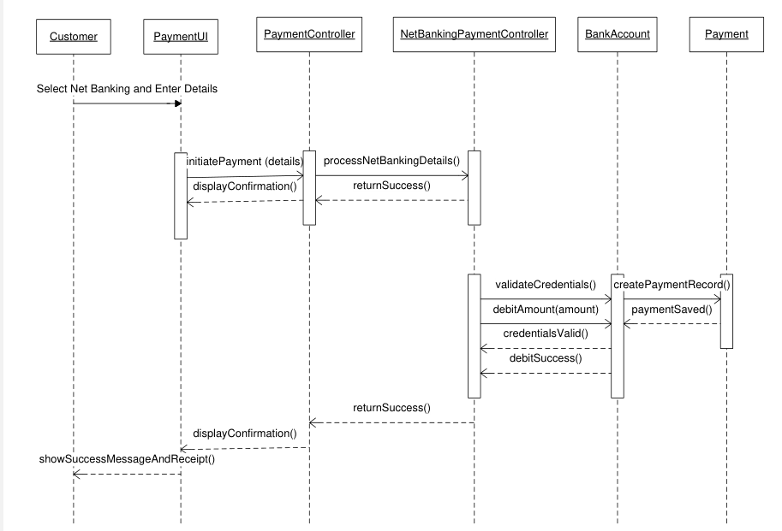

Question 6: Explain Conceptual Model for this Case – 4 Marks
Customer
- Attributes: customerID, name, mobile, email
- Description: Represents the individual initiating the payment.
Payment
- Attributes: paymentID, amount, date, status
- Description: Represents the payment action triggered by the customer.
NetBankingAccount
- Attributes: accountNumber, IFSCCode, linkedMobile
- Description: The bank account used by the customer for Net Banking.
Bank
- Attributes: bankID, bankName, branchCode
- Description: The financial institution that hosts the Net Banking service.
Transaction
- Attributes: transactionID, timestamp, status
- Description: The actual Net Banking transaction event linked to the payment.
Confirmation
- Attributes: confirmationID, message, timeSent, deliveryStatus
- Description: The message or notification sent to the customer after successful payment.
From Entity | Relationship | To Entity | Cardinality
Customer | Initiates | Payment | 1 to many
Payment | Uses | NetBankingAccount | 1 to 1
NetBankingAccount | belongs to | Bank | 1 to 1
Payment | Generates | Transaction | 1 to 1
Transaction | results in | Confirmation | 1 to 1

Question 7: What is MVC architecture? Explain MVC rules to derive classes from use case diagram and guidelines to place classes in 3-tier architecture - 8 Marks
1. What is MVC Architecture?
MVC (Model-View-Controller) is a software architectural pattern used to separate the application into three main components, each with distinct responsibilities:
- Model:
  - Manages data, business logic, and rules of the application.
  - Represents the real-world entity (e.g., Customer, Payment).
- View:
  - Represents the user interface.
  - Displays data from the model and sends user actions to the controller.
- Controller:
  - Acts as an intermediary between View and Model.
  - Receives user input, processes it (e.g., via business logic), and updates the model or view.
2. MVC Rules to Derive Classes from Use Case Diagram
When analysing a Use Case Diagram, follow these rules to derive classes:
- Identify Entity Classes (Model Layer)
  - From nouns in use case descriptions (e.g., Customer, Order, Payment).
  - These represent persistent data or real-world entities.
- Identify Control Classes (Controller Layer)
  - From verbs/activities in the use case (e.g., ProcessPayment, GenerateInvoice).
  - These control the flow of use case execution.
- Identify Boundary Classes (View Layer)
  - From the interaction between the system and actors (e.g., LoginForm, PaymentScreen).
  - These are interfaces for user input and output.
3. Guidelines to Place Classes in 3-Tier Architecture
In a Three-Tier Architecture, application logic is divided into:
- Presentation Tier (UI Layer)
  - Place Boundary/View Classes here.
  - Responsible for user interaction and displaying results.
  - Example: PaymentForm, CustomerScreen.
- Business Logic Tier (Application Layer)
  - Place Control Classes here.
  - Implements business rules, coordinates between UI and data.
  - Example: PaymentController, OrderManager.
- Data Access Tier (Data Layer)
  - Place Entity/Model Classes here.
  - Manages data storage, retrieval, and persistence.
  - Example: Customer, Transaction, DatabaseHandler.

Question 8: Explain BA contributions in project (Waterfall Model – all Stages) – 8 Marks
Stage | BA Contribution | Artifacts & Resources
Pre-Project | Business case preparation, stakeholder identification | Business Case, Feasibility Report, Stakeholder List
Planning | Define scope, estimation support, stakeholder plan | Project Charter, Scope Document, Estimation Sheet
Project Initiation | Goals, success criteria, define BA plan | Kick-off PPT, RACI Matrix, Communication Plan
Requirements Gathering | Elicit and document functional/non-functional requirements | Requirement Document (BRD), MoMs, Interview Notes
Requirements Analysis | Analyze, model, and validate requirements | Use Case Diagrams, Process Flows, Requirement Traceability Matrix (RTM)
Design | Review design documents, ensure business alignment | Design Specs, Wireframes, Solution Review Comments
Development | Clarify requirements, update docs if changes arise | Change Request Log, Updated BRD/RTM
Testing | Review test cases, ensure requirement coverage | Test Case Review Sheet, Defect Log, Requirement Coverage Matrix
UAT | Coordinate UAT, gather feedback, ensure sign-off | UAT Plan, UAT Scenarios, UAT Sign-off Document

Question 9: What is conflict management? Explain using Thomas – Kilmann technique – 6 Marks
What is Conflict Management?
Conflict Management is the process of identifying, addressing, and resolving conflicts between individuals or groups in a constructive way. It aims to minimize negative outcomes and ensure effective collaboration and communication.
Conflicts may arise due to differences in opinions, priorities, values, or goals, especially in teams or project environments. Proper conflict management leads to better decision-making, innovation, and team cohesion.
Five steps for conflict management:
  - Identify the conflict.
  - Discuss the details.
  - Agree with the root problem.
  - Check for every possible solution for the conflict.
  - Negotiate the solutions to avoid conflicts.
Thomas–Kilmann Conflict Management Technique:
The Thomas–Kilmann Conflict Mode Instrument (TKI) is a model that identifies five conflict-handling styles, based on two dimensions:
- Assertiveness – the extent to which a person tries to satisfy their own concerns.
- Cooperativeness – the extent to which a person tries to satisfy others’ concerns.
Competing (High Assertiveness, Low Cooperativeness): A person pursues their own goals at the expense of others.
Collaborating (High Assertiveness, High Cooperativeness): Both parties work together to find a win-win solution.
Compromising (Moderate Assertiveness & Cooperativeness): Each party gives up something to reach a middle ground.
Avoiding (Low Assertiveness & Cooperativeness): The person sidesteps the conflict or postpones it.
Accommodating (Low Assertiveness, High Cooperativeness): One party gives in to the other's demands.
The Thomas–Kilmann technique helps BAs and project managers understand different conflict-handling approaches and choose the best one depending on the situation, promoting smoother collaboration and project success.

Question 10: List down the reasons for project failure – 6 Marks
  - Poor Planning
    - Lack of detailed project planning leads to missed deadlines, underestimated budgets, and resource misallocation.
    - Incomplete or unrealistic timelines can cause the project to derail early.
  - Unclear Objectives and Requirements
    - When project goals and requirements are not well-defined, teams do not understand what needs to be delivered.
    - This leads to confusion, frequent rework, and dissatisfaction from stakeholders.
  - Inadequate Risk Management
    - Failure to identify, assess, and mitigate risks can lead to unexpected disruptions.
    - For example, ignoring risks like vendor delays or technology failures can impact project timelines and costs.
  - Poor Communication
    - Miscommunication between stakeholders, developers, and users can lead to misunderstood requirements or incorrect deliverables.
    - Lack of regular updates or feedback loops also reduces transparency and trust.
  - Scope Creep
    - Uncontrolled or unauthorized changes to the project scope lead to delays, cost overruns, and quality issues.
    - It often results from not having a strict change control process in place.
  - Lack of Stakeholder Engagement
    - When key stakeholders are not involved or informed, the project may move in the wrong direction or lose support.
    - Engagement is critical for requirement validation, feedback, and user acceptance.
  - Resource Constraints
    - Insufficient or misallocated resources (manpower, budget, tools) hinder project execution.
    - Overburdened team members may also reduce productivity and increase errors.
  - Technical Challenges
    - Adoption of new, unstable, or incompatible technologies can cause integration issues or project delays.
    - Poor system architecture or technical debt may also result in product failure.

Question 11: List the Challenges faced in projects for BA – 6 Marks
  - Unclear and Changing Requirements:
    - Stakeholders may provide vague or incomplete inputs.
    - Requirements may change frequently due to evolving business needs, making it difficult to maintain consistency and traceability.
    - This leads to rework, delays, and cost overruns.
  - Managing Stakeholder Expectations:
    - Stakeholders may have conflicting priorities or unrealistic expectations.
    - The BA must ensure clear communication, requirement negotiation, and alignment with the project scope.
    - Failure to manage expectations can result in discontent or non-acceptance of the final product.
  - Scope Creep and Scope Management:
    - Uncontrolled addition of features without formal approval leads to scope creep.
    - BAs must implement a change control process and ensure all changes are documented and evaluated for impact.
    - Poor scope management causes project delays and budget issues.
  - Time and Resource Constraints:
    - Limited availability of time, skilled manpower, or budget affects requirement gathering and validation.
    - BAs often have to prioritize requirements under pressure and ensure optimal use of available resources.
  - Quality Assurance and Testing:
    - Ensuring that the delivered solution meets all functional and non-functional requirements is a major challenge.
    - BAs must work closely with QA teams to validate test cases and ensure thorough testing.
    - Inadequate testing leads to defects and end-user dissatisfaction.
  - Documentation and Knowledge Management:
    - Creating and maintaining clear, concise, and up-to-date documents is essential.
    - BAs often face challenges due to lack of standard templates, version control issues, or missing historical data.
    - Poor documentation leads to miscommunication and knowledge gaps during handovers or future changes.
  - Technology Constraints and Complexity:
    - BAs may have limited understanding of new or complex technologies.
    - Integration with legacy systems or platform limitations may restrict the implementation of desired features.
    - Collaboration with technical teams is critical to translate business needs into feasible solutions.

Question 12: Write about Document Naming Standards – 4 Marks
Document Naming Standards:
Document Naming Standards are a set of rules and conventions used to create consistent, meaningful, and organized file names in a project or organization. These standards help ensure that documents are:
- Easily identifiable
- Searchable
- Version-controlled
- Accessible to all stakeholders
Benefits of Using Document Naming Standards:
- Promotes consistency and clarity across teams
- Helps in quick identification and retrieval
- Reduces duplication and confusion
- Enables effective version control and collaboration
Example:
Suppose we have a project with IF PROJ123, we are working with requirements specification document:
- ProjectID: PROJ123
- Document type: REQ
- Version: 1.0
- Date: 22/6/2025
The document identifier is: PROJ123-REQ-1.0-22-6-2025

Question 13: What are the Do’s and Don’ts of a Business analyst – 6 Marks
Do’s | Don’ts
Consult and SME for clarifications in requirements | Never say no to the client
Go to the client with a plain mind and no assumptions. Listen carefully and completely until the client is done, and then you can make queries. | There is no word as By Default
Try to extract maximum leads to the solution from the client himself | Never imagine anything in terms of GUI
Concentrate on the important requirements | Don’t interrupt the client when he is giving you the problem
Question the existence of existence, question everything | Never try to give solutions to the clients straight away with your previous experience and assumptions.

Question 14: Write the difference between packages and sub-systems – 4 Marks
 | Packages | Sub-systems
Definition | A package is a grouping of related classes, interfaces, or components to organize a system logically. | A sub-system is a self-contained unit of the system that performs a specific function and may contain multiple packages.
Purpose | Used to improve modularity and code organization. | Used to divide the system into larger, manageable functional units.
Level of Abstraction | Low-level grouping of elements like classes or use cases. | High-level grouping representing major functionalities of the system.
Example | PaymentPackage (contains Card, NetBanking, UPI classes) | BillingSystem (includes Payment, Invoice, and Tax submodules)

Question 15: What is camel-casing and explain where it will be used- 6 Marks
Camel-casing is a naming convention in which multiple words are joined together without spaces, and each word starts with a capital letter (except possibly the first word in lower camel case).
There are two types of camel-casing:
  - Lower Camel Case
    - The first word starts with a lowercase letter, and subsequent words begin with a capital letter.
    - Example: employeeName, orderTotal, getCustomerDetails()
  - Upper Camel Case (Pascal Case)
    - All words, including the first one, begin with a capital letter.
    - Example: EmployeeDetails, OrderSummary, CalculateSalary()
Camel-casing is commonly used in programming, documentation, and naming conventions across various software development practices:
- Variable Naming (Lower Camel Case)
  - Improves readability and standardization in code.
  - Example: customerId, invoiceAmount
- Method or Function Naming (Lower Camel Case)
  - Helps distinguish functions from classes and constants.
  - Example: calculateTax(), fetchDataFromAPI()
- Class and Object Naming (Upper Camel Case)
  - Used to define classes, structures, or object types.
  - Example: Product, UserProfile, TransactionHistory
- File or Document Naming (optional use)
  - When spaces are not allowed or discouraged, camel casing ensures readability.
  - Example: RequirementDocument, TestCaseSummary
- Database Fields or API Fields
  - Common in JSON, XML, and REST API field naming.
  - Example: { "userName": "John", "accountBalance": 5000 }
Benefits of Camel-Casing:
- Enhances code readability
- Encourages naming consistency
- Avoids ambiguity and supports standard coding guidelines

Question 16: Illustrate Development server and what are the accesses does business analyst has? – 6 marks
A Development Server is a dedicated environment used by the development team to build, test, and integrate code before it is moved to staging or production. It replicates the application’s structure and provides a controlled space for development activities.
Key Characteristics of a Development Server:
  - Contains in-progress features and early versions of the software.
  - Frequently updated with new code from developers.
  - Supports unit testing, integration testing, and debugging.
  - Usually connected to a test database with dummy/test data.
  - Not accessible to end-users; strictly for internal use.
Accesses a Business Analyst Has on Development Server:
While a Business Analyst (BA) is not directly involved in coding, they often need limited access to the development server for various purposes:
- Read-Only Access to Front-End Screens:
  - To review and validate UI implementations against requirements.
  - Helps in early identification of mismatches or UI issues.
- Access to Logs or Test Data (Optional)
  - To trace issues, validate data flow, or assist QA in understanding errors.
- Access to Requirement-Related Tools
  - BA may use tools integrated into the dev server (e.g., Swagger for API testing, Postman for validation) to verify if functional flows meet documented requirements.
- Bug/Defect Tracking Integration
  - BAs might have access to tools like JIRA, Bugzilla, or TestRail connected to the dev environment for raising and tracking defects or clarifying requirement gaps.
- Support for QA/Dev Teams
  - BAs provide clarifications to developers and testers by referring to how the requirement behaves in the development build.
What Access BAs Usually Don’t Have:
- No code-level access (no ability to edit or deploy code).
- No administrative rights (e.g., changing environment configs or database schemas).

Question 17: What is Data Mapping – 6 Marks
Data Mapping is the process of matching fields from one data source to another to ensure correct data transformation and integration. It is used in scenarios where data needs to move between systems, databases, or formats.
  - The source data fields are mapped to corresponding destination fields to ensure accuracy, consistency, and compatibility.
  - It acts as a blueprint for data migration, data integration, ETL processes, and API development.
Purpose of Data Mapping:
- To enable seamless data flow between systems.
- To ensure that correct values are transferred to the right fields.
- To support data standardization during system upgrades or migrations.
Key Components:
- Source Field:
  - The original data field from the source system.
- Target Field:
  - The destination field in the target system.
- Transformation Rule:
  - Logic used to convert or clean data during transfer.

Question 18: What is API. Explain how you would use API integration in the case of your application Date format is dd-mm-yyyy and it is accepting some data from Other Application from US whose Date Format is mm-dd-yyyy 10 Marks
An API (Application Programming Interface) is a set of protocols, tools, and definitions that allow different software systems to communicate with each other.
- It enables data exchange between applications securely and in real-time.
- APIs can be RESTful, SOAP, or use GraphQL, etc.
- APIs expose certain endpoints (URLs) that accept or return data in structured formats like JSON or XML.
Example: A weather application calls a weather API to fetch live temperature and humidity data.
API Integration refers to the process of connecting two or more systems via APIs to exchange data and perform operations in sync.
In business applications, API integration is used for:
- Connecting CRM with ERP
- Syncing with payment gateways
- Sending/receiving data between client and third-party apps
Scenario-Based Explanation: Handling Date Format Differences:
- Your application uses dd-mm-yyyy format (e.g., 22-06-2025).
- A third-party US-based system sends data using mm-dd-yyyy format (e.g., 06-22-2025) via API.
Solution – How to Handle Using API Integration:
- Step 1: API Request Reception
- Step 2: Data Validation & Parsing
- Step 3: Store or Display in Local Format
- Step 4: Send Back Data (if needed)
Best Practices:
- Use ISO 8601 format (YYYY-MM-DD) in APIs to avoid ambiguity.
- Add date format standardization in API documentation.
- Perform data validation and transformation during integration to ensure compatibility.
API integration allows your system to seamlessly interact with external systems. When working across different regions (like India and the US), it’s crucial to handle data format differences (especially for dates) using conversion logic within the API layer or middleware to ensure data integrity and user clarity.

