MOCKUP 4
A company is having manufacturing plants and warehouses in various parts of the country. They manufacture ice-cream and milk products. They want to build software to achieve two goals.
- Manage the inventory
- Quickest delivery to the customers

Assignment 1
1. Please make a BRD which can be presented to the client along with complete development and resource plan.

BRD which can be presented to the client along with complete development and resource plan.
Table of Contents
Section No. | Section Title | Page No.
1 | Document Revisions | 2
2 | Approvals | 2
3 | RASCI Chart for This Document | 2
4 | Introduction | 2
4.1 | Business Goals | 2
4.2 | Business Objectives | 2
4.3 | Business Rules | 2
4.4 | Background | 2
4.5 | Project Objective | 2
4.6 | Project Scope | 3
4.6.1 | In Scope Functionality | 3
4.6.2 | Out Scope Functionality | 3
5 | Assumptions | 3
6 | Constraints | 3
7 | Risks | 3
8 | Business Process Overview | 3
8.1 | Legacy System (AS-IS) | 3
8.2 | Proposed Recommendations (TO-BE) | 3
9 | Business Requirements | 3,4
10 | Development and Resource Plan | 4
10.1 | Project Timeline (Waterfall Model) | 4
10.2 | Resource Plan | 4
10.3 | Cost Estimate | 4
11 | Appendices | 5
11.1 | List of Acronyms | 5
11.2 | Glossary of Terms | 5
11.3 | Related Documents | 5

Business Requirements Document (BRD)

1. Document Revisions
Version | Date | Description | Author
1.0 | 25-Jun-2025 | Initial Draft | BA Team
1.1 | 27-Jun-2025 | Feedback Incorporated | PMO Team
1.2 | 28-Jun-2025 | Development and Resource Plan Added | PMO Team

2. Approvals
Approved by Project Sponsor, IT Head, Logistics Head, and Operations Head.

3. RASCI Chart for This Document
Stakeholder | Responsible (R) | Accountable (A) | Consulted (C) | Informed (I)
Business Analyst | R |  |  | I
Project Manager | R | A | C | I
IT/Tech Team | R |  | C | I
Manufacturing Heads |  |  | C | I
Warehouse Managers |  |  | C | I
QA Testers | R |  | C | I
Logistics Team | R |  | C | I
Senior Management |  | A | C | I

4. Introduction
This BRD outlines the requirement for implementing an integrated software system for inventory management and optimized delivery for a national ice-cream and milk product manufacturing company.

4.1. Business Goals
- Achieve real-time inventory visibility across all plants and warehouses.
- Optimize product delivery times and routes.

4.2. Business Objectives
- Develop a centralized platform for inventory monitoring.
- Implement route optimization for customer deliveries.
- Ensure temperature-sensitive product compliance.

4.3. Business Rules
- Inventory data must update in real-time.
- Orders should be assigned to the nearest warehouse with available stock.
- Delivery routes must minimize time and cost while maintaining product integrity.

4.4. Background
Currently, the company relies on fragmented systems and manual processes to manage stock and assign deliveries. This results in delays, overstocking, wastage, and inefficiencies in delivery.

4.5. Project Objective
To build and deploy a software system that unifies inventory management and ensures timely and efficient delivery of perishable dairy products to end-customers.

4.6. Project Scope
4.6.1. In Scope Functionality
- Real-time stock management and alerts
- Automated routing and delivery scheduling
- Temperature tracking integration
- Dashboard views for operations, logistics, and management
- Role-based user access
4.6.2. Out Scope Functionality
- Financial reporting and invoicing modules
- CRM features not related to inventory or logistics

5. Assumptions
- Internet connectivity is available at all plant and warehouse locations.
- Users will receive adequate training.
- GPS devices or smartphones are available with delivery personnel.

6. Constraints
- Budget limited to ₹60 lakhs
- Solution must work with minimal latency even on 3G networks
- Initial deployment limited to five pilot locations

7. Risks
Technological Risks - Legacy hardware or OS incompatibility
Skills Risks - Field staff may resist or struggle with new system interfaces
Political Risks - Delayed decision-making from regional operations heads
Business Risks - Product spoilage due to tech failure or delayed deliveries
Requirements Risks - Change in delivery model mid-project (e.g., D2C rollout)
Other Risks - Temperature monitoring devices may malfunction

8. Business Process Overview
Covers entire flow from production at plant, stock transfer to warehouse, order placement, assignment to nearest dispatch point, and delivery to customer.

8.1. Legacy System (AS-IS)
- Plants and warehouses maintain inventory using Excel sheets or ERP modules that do not sync in real-time.
- Deliveries are manually coordinated by regional dispatch teams.

8.2. Proposed Recommendations (TO-BE)
- Implement centralized software with real-time inventory synchronization
- Integrate GPS-enabled route optimizer
- Deploy live dashboards and notification systems for logistics and stock managers

9. Business Requirements
Req ID | Requirement | Description | Priority
BRD001 | Real-Time Inventory Update | System must reflect current stock at each location in real-time. | High
BRD002 | Auto Order Assignment | Orders to be routed to nearest warehouse with available stock. | High
BRD003 | Route Optimization | System must generate best delivery route based on distance and traffic. | High
BRD004 | Expiry Tracking | Alert before product expiry at plant/warehouse level. | High
BRD005 | Temperature Control Monitor | Integrate temperature sensor data to ensure compliance during transit. | High
BRD006 | Role-Based Access | Provide different access levels to plant staff, warehouse managers, and delivery agents. | High
BRD007 | Order Status Dashboard | Allow all stakeholders to track order progress and inventory changes. | Medium
BRD008 | Offline Data Sync | System must cache data offline and sync automatically when reconnected. | Medium
BRD009 | Notification System | Real-time alerts on low stock, late deliveries, and deviations in route/temperature. | Medium
BRD010 | Performance Reports | Weekly and monthly inventory turnover and delivery SLA reports. | Medium

10. Development and Resource Plan

10.1. Project Timeline (Waterfall Model)
Phase | Duration | Key Deliverables
Requirements Phase | 2 weeks | BRD, Use Cases, Process Flows
Design Phase | 3 weeks | System Architecture, UI/UX Prototypes
Development Phase | 6 weeks | Functional Modules, Backend Logic
Testing Phase | 2 weeks | Unit, Integration, and UAT Reports
Deployment Phase | 1 week | Deployed system, Admin Training
Support Phase | Ongoing | Bug fixes, Optimization, Updates

Total Duration: 14 weeks (excluding support)

10.2. Resource Plan
Role | Count | Responsibility
Project Manager | 1 | Overall execution and stakeholder coordination
Business Analyst | 1 | Requirement gathering and documentation
UI/UX Designer | 1 | Interface and dashboard design
Backend Developers | 2 | Inventory and logistics module coding
Frontend Developer | 1 | UI implementation and integration
QA Tester | 1 | Functional and performance testing
DevOps Engineer | 1 | Deployment and maintenance
Trainer/Support Staff | 1 | End-user training and post-go-live support

10.3. Cost Estimate (in ₹)
Item | Estimated Cost (₹)
Software Development | 30,00,000
Hardware and Sensors | 10,00,000
Project Management & QA | 5,00,000
Training & Documentation | 3,00,000
Contingency & Support (10%) | 6,00,000
Total | 54,00,000

11. Appendices

11.1. List of Acronyms
Acronym | Description
ERP | Enterprise Resource Planning
SLA | Service Level Agreement
GPS | Global Positioning System

11.2. Glossary of Terms
Term | Definition
Inventory | Stock of goods at any given location
Route Optimizer | Algorithm/system used to identify fastest delivery paths
Dispatch | Process of sending out goods for delivery
11.3. Related Documents
- Feasibility Study
- Stakeholder Elicitation Notes
- Route Planning Prototype Screens
- Integration Strategy Document
2. Prepare process flow diagram using your imagination.
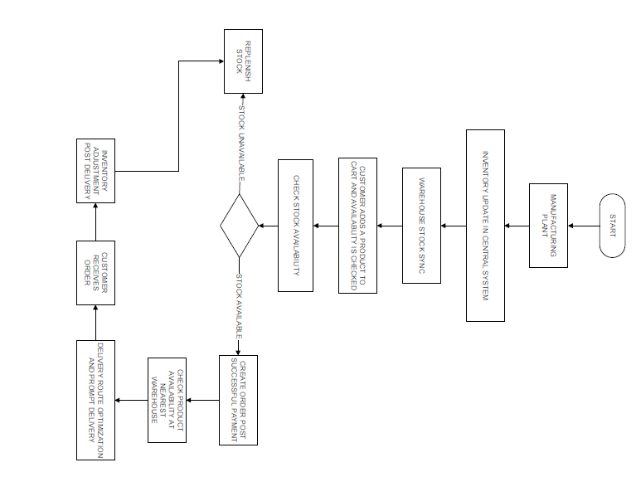

Assignment 2

1. Write an introduction letter to a client introducing yourself as a business analyst in charge of working with the client and his team to start the business understanding process.
Answer :

To,

Mr.Shah,
ABC limited
Gurugram.

Subject: Introduction – Business Analyst for Your Project

Dear Mr.Shah,

I hope you're doing well.

My name is Ritesh Nigam, and I’ll be your Business Analyst for the upcoming project. I’ll be working closely with you and your team to understand your business needs, define clear requirements, and ensure our solution aligns with your goals.

We’ll begin with the business understanding phase, where I’ll gather key inputs from stakeholders to shape the project roadmap effectively.

Looking forward to collaborating with you. Please feel free to share any documents or availability for a quick discussion.

Best regards,
Ritesh Nigam
Business Analyst
HDFC Bank Ltd.
ritesh.nigam@hdfcbank.com | +91-9977888894

2. Prepare a brief BRD and SRS for a project- Horoscope or Ticketing system or online store.
Answer :

Business Requirement Document (BRD)

Project: Online Store

1. Purpose:
This BRD outlines the business needs and expectations for the development of an Online Store. The system will enable customers to browse, search, and purchase products online.

2. Business Objectives:
• Offer a seamless online shopping experience
• Increase sales through digital channels
• Manage inventory and customer orders efficiently

3. Stakeholders:
• Customers
• Admin
• Warehouse Staff
• Management Team

4. Scope:
In Scope:
• Product catalog management
• Shopping cart and checkout
• User registration and login
• Payment integration
• Order tracking
Out of Scope:
• In-store purchases
• Loyalty programs

5. Assumptions:
• Users have access to the internet
• Payment gateways are operational
• Inventory data is maintained accurately

6. Constraints:
• Integration limited to specified payment gateways
• Delivery limited to selected geographies

System Requirements Specification (SRS)

Project: Online Store

1. Functional Requirements:
• User registration, login, and profile management
• Product search, filter, and view
• Add to cart, edit cart, and checkout
• Payment processing
• Order history and tracking
• Admin panel for managing products, users, and orders

2. Non-Functional Requirements:
• System availability: 99.9%
• Response time: < 2 seconds
• Scalability to handle peak loads
• Data encryption for sensitive information

3. System Interfaces:
• Payment Gateway (e.g., Stripe, PayPal)
• Email Notification System
• Inventory Management System

4. User Roles:
• Customer
• Administrator
• Warehouse Staff

5. Technical Requirements:
• Web-based platform
• Mobile-responsive design
• Hosted on cloud infrastructure
• Database: MySQL

3. Make an ERD of creating a support ticket/Ticketing life cycle.
Answer :
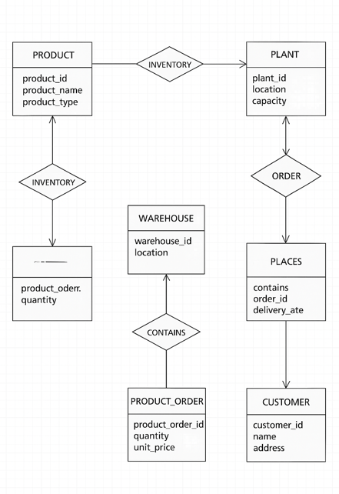

4. User story of shopping from ecommerce.
Answer

Project
User Story No: 1 | Tasks: 3 Priority: Highest
AS A CUSTOMER I
WANT TO BROWSE PRODUCTS
SO THAT I CAN VIEW AVAILABLE ITEMS TO PURCHASE
BV: 600 | CP: 03
ACCEPTANCE CRITERIA
Browse product categories
Display product list with name, price, and image
Filter products by category and price range

User Story No: 2 | Tasks: 2 Priority: High
AS A CUSTOMER I
WANT TO ADD PRODUCTS TO MY CART
SO THAT I CAN PURCHASE THEM IN ONE GO
BV: 500 | CP: 02
ACCEPTANCE CRITERIA
Add product to cart
Display updated cart with total items and price

User Story No: 3 | Tasks: 2 Priority: Highest
AS A CUSTOMER I
WANT TO PLACE AN ORDER
SO THAT I CAN COMPLETE THE PURCHASE OF SELECTED PRODUCTS
BV: 700 | CP: 04
ACCEPTANCE CRITERIA
Place order with selected cart items
Display order confirmation and order number

User Story No: 4 | Tasks: 2 Priority: Medium
AS A CUSTOMER I
WANT TO TRACK MY ORDERS
SO THAT I CAN KNOW THE DELIVERY STATUS
BV: 400 | CP: 02
ACCEPTANCE CRITERIA
View list of placed orders
Display order status like "Processing", "Shipped", "Delivered"

User Story No: 5 | Tasks: 3 Priority: High
AS A CUSTOMER I
WANT TO MAKE ONLINE PAYMENTS
SO THAT I CAN COMPLETE MY PURCHASE SECURELY
BV: 650 | CP: 03
ACCEPTANCE CRITERIA
Provide multiple payment options (Credit Card, UPI, Net Banking)
Process payment securely
Display payment success/failure message

