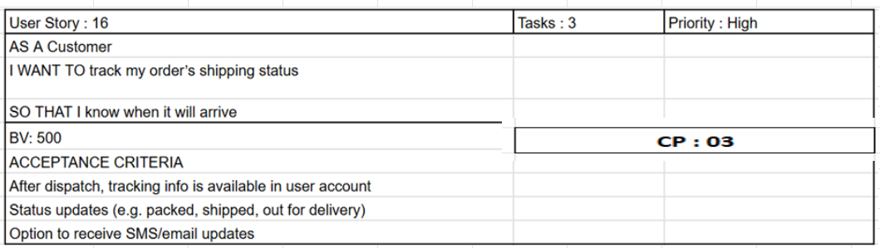Assignment 1 — Inventory + Fast Delivery System (BRD + Development & Resource Plan + Process Flow)
1. Business Requirements Document (BRD)
Project Name: Inventory & Distribution Management System (IDMS)
Project ID: 002
Version ID: 01
Author: Mr. Sourav Banerjee
A business requirements document (BRD) is an official document that provides a comprehensive overview of a project, including its objectives, key stakeholders, timeline, budget, constraints, and more. This document outlines what's needed to reach the intended project objectives.
1. Document Revisions
Version | Date | Author | Description
01 | 18/09/2025 | Mr. Sourav Banerjee | Initial Draft
2. Approvals
Name | Role | Signature | Date
Client Representative | Business Stakeholder
IT Project Manager | Technical Stakeholder
QA Manager | Quality Assurance
3. RACI Chart for This Document
IT Side (Project Stakeholders):
Role | Responsible | Accountable | Consulted | Informed
Project Manager | X
Business Analyst |  | X
Developers | X
QA Team | X
Infrastructure Team |  |  | X
Client Side (Business Stakeholders):
Role | Responsible | Accountable | Consulted | Informed
Operations Head |  | X
Plant Managers | X
Warehouse Managers | X
Distribution Head | X
Customer Service |  |  | X
4. Introduction
4.1 Business Goals
The project is initiated to streamline inventory management and ensure faster delivery to customers. By integrating manufacturing plants, warehouses, and logistics into a centralized system, the company can reduce inefficiencies, minimize stockouts, optimize delivery routes, and improve customer satisfaction.
4.2 Business Objectives
- Provide an IT solution for managing inventory across plants and warehouses.
- Enable real-time tracking of stock levels, demand, and delivery.
- Optimize logistics to ensure the quickest delivery.
4.3 Business Rules
- Each plant and warehouse must update inventory in real-time.
- Stock movement must be tracked from production to delivery.
- Deliveries must be prioritized based on location, urgency, and freshness of the product.
- Compliance with food safety and cold chain regulations is mandatory.
4.4 Background
- Manual stock management has led to delays, wastage, and mismanagement.
- Delivery timelines are inconsistent due to lack of route optimization.
- Communication gaps exist between plants, warehouses, and distributors.
4.5 Project Objective
To develop a centralized inventory and distribution management system to manage stock efficiently and ensure faster deliveries to customers.
4.6 Project Scope
4.6.1 In-Scope Functionality
- Real-time inventory management across plants and warehouses.
- Automated stock alerts for low inventory and expiry tracking.
- Route optimization for deliveries.
- Integration with suppliers and distributors.
- Analytics dashboard for sales, wastage, and delivery timelines.
- User-friendly interface for both operations team and management.
4.6.2 Out-of-Scope Functionality
- Expansion to non-dairy product categories.
- Integration with third-party e-commerce platforms.
- Advanced AI demand forecasting (future phase).
- Additional features beyond initial scope of inventory and delivery.

5. Assumptions
- Complete requirement gathering can be finalized before development.
- All plants and warehouses will have stable internet connectivity for system updates.
- The company will provide necessary access to existing operational data.
- Users will be trained to adopt the new system.

6. Constraints
- Fixed budget and timeline as per agreed contract.
- Limited flexibility for scope change once development begins.
- Dependence on existing infrastructure and hardware at plants/warehouses.
- Compliance with food safety and IT security regulations.

7. Risks
- Risk of user resistance to adopting new software.
- Delays if real-time data integration with warehouses fails.
- Cost overrun due to scope creep.
- Possible downtime in production if system implementation faces technical issues.
- Dependency on logistics partners for actual delivery execution.

8. Business Process Overview
The waterfall project methodology will be followed, with sequential phases:
- Requirements: Detailed requirement gathering with stakeholders.
- Design: System architecture, database design, and process workflows.
- Implementation: Development of inventory, logistics, and reporting modules.
- Testing: Functional, integration, and user acceptance testing.
- Maintenance: Post-deployment support and system updates.

9. Business Requirements
- Ability to track raw materials, finished goods, and stock levels in real-time.
- Role-based access for plant managers, warehouse managers, and distributors.
- Automated alerts for stock expiry, replenishment needs, and delays.
- Route planning system to optimize delivery based on distance and load.
- Dashboard for real-time monitoring of production, warehouse, and delivery metrics.
- Secure integration with accounting and billing systems.

10. Appendices
- Initial notes from client discussion.
- Process flow diagrams for inventory and delivery management.
- Sample reports and dashboards.

2. Process Flow Diagram
Feedback/ Return waste
Transport & Cold- Chain Monitoring
Fulfilment: Pick & Pack (cold pack)
Delivery to Customer & Proof of Delivery / Quality
Route & Logistics Plan → Which warehouse, best route, vehicle, time
Check warehouse with available stock & good / expiry / cold history
If low stock → trigger replenishment
Order received from customer
Stock monitoring & Expiry
Warehousing / Cold- Chain Storage
Production (Batch + QC + Pack)
Raw Material Procurement & QC
Forecast & Demand Planning

Assignment 2
1. Introduction letter (as Business Analyst)
Subject: Introduction — Business Analyst for IDMS Project
Dear ABC Team,
I’m Sourav Banerjee Business Analyst assigned to work with you on the Inventory & Rapid Delivery Management System. I will be your primary point of contact to capture business requirements, align stakeholders, and translate needs into a pragmatic technical solution.
Over the next 2–4 weeks I’ll:
- Run discovery workshops with operations, warehouse, logistics, sales, and IT.
- Document current processes (as-is) and map future processes (to-be).
- Produce a prioritized requirements backlog and acceptance criteria.
- Support vendor/integration assessment and pilot planning.
Please let me know your preferred times for a 60-minute kick off workshop in the coming week and the names of 2–3 SME participants from operations and IT. I look forward to working closely with your team and delivering a solution that reduces waste and accelerates deliveries.
Best regards,
Sourav Banerjee
Business Analyst — IDMS Project
srv@gmail.com
8250443132

2. Brief BRD and SRS — choose Online Store
Project Name – Online Store Project
Project ID – 002
Version ID – 01
Author – Mr Sourav Banerjee
A business requirements document (BRD) is an official document that provides a comprehensive overview of a project, including its objectives, key stakeholders, timeline, budget, constraints, and more. This document outlines what’s needed to reach the intended project objectives.
1. Document Revisions
Version | Date | Author |  | Summary of Changes
0.1 | 20-Sep-2025 | Mr Sourav Banerjee |  | Initial draft
1.0 | TBD | Mr Sourav Banerjee |  | Final version after review
2. Approvals
Role | Name | Date | Signature / Approval
Project Sponsor | ____________________ | __________
Business Lead | ____________________ | __________
IT Architect | ____________________ | __________
Quality Assurance | ____________________ | __________

3. RACI Chart for This Document
This RACI chart identifies who is responsible, accountable, consulted, and informed for changes to this BRD.
Role | Responsible | Accountable | Consulted | Informed
BRD Creation & Drafting | Business Analyst | Project Manager | Subject Matter Experts | Stakeholders
Requirement Changes | Business Analyst | Project Manager | Client / Business Lead | Development Team
Final Approval | Project Manager | Project Sponsor | Business Lead | All Stakeholders
4. Introduction
4.1 Business Goals
The project is initiated to build a robust online store platform that enables the business to sell products directly to customers via the web and mobile. It will allow growth in sales, improve customer reach, and enhance customer experience through smooth shopping, efficient checkout, and reliable logistics.
4.2 Business Objectives
- Increase online sales revenue by 30% in the first 12 months of launch.
- Reduce cart abandonment rate from 70% to 45% within 6 months.
- Improve user satisfaction (measured via surveys) to at least 85% positive feedback.
- Enable scalable product catalogue, supporting up to 10,000 SKUs initially.
4.3 Business Rules
- Customers must register or login to place an order.
- All prices displayed must include applicable taxes and shipping charges (if known).
- Payment processing must comply with PCI-DSS standards.
- Orders can be cancelled by customers up to 1 hour before dispatch; rest follow business policy.
- Returns must be permitted within 14 days of delivery, subject to condition.
4.4 Background
- Currently, the business operates only through physical store(s) and phone orders; there is no online presence.
- Manual processing of orders causes frequent delays and errors.
- Customer reach is limited to local area; many potential customers cannot access store.
- Competition already has several online stores offering similar products with faster delivery.
4.5 Project Objective
To deliver an online store platform that supports product listings, search, user registration, shopping cart, online payments, order tracking, and logistics integration, thereby increasing sales, reducing operational friction, and improving customer satisfaction.
4.6 Project Scope
4.6.1 In Scope Functionality
- Product catalogue with categories, product pages (images, descriptions, variants).
- Customer registration, login, profile management.
- Search and filtering of products.
- Shopping cart and checkout process including payment gateway integration.
- Order management for customer and admin (order status, history).
- Shipping options calculation and integration.
- Inventory tracking and alerts.
- Responsive design (web and mobile).
- Customer reviews and ratings.
- Admin dashboard to manage products, orders, customers.
4.6.2 Out of Scope Functionality
- Multi-vendor marketplace (only single vendor initially).
- Advanced AI-based recommendation engine (deferred to future release).
- Social commerce/live streaming features.
- Offline POS integration.
- Multi-language support beyond English initially.

5. Assumptions
- All product data (images, descriptions, variants) will be provided by business before system design begins.
- Third-party shipping and payment providers are reliable and have accessible APIs.
- The technology stack chosen supports scaling to expected user base.
- Stakeholders will provide timely feedback during reviews.

6. Constraints
- Fixed budget for initial launch: INR 200,000.
- Time to market target: 6 months from project kick-off.
- Scope must be limited to features in “In Scope” to avoid delays.
- Hosting and infrastructure cost must not exceed allocated hosting budget.
7. Risks
Risk | Likelihood | Impact | Mitigation Strategy
Delayed delivery of product assets (images, descriptions) | Medium | High | Establish deadlines, regular follow-up, assign accountability
Payment gateway integration delays or regulatory issues | Low-Medium | High | Evaluate multiple gateways, begin integration early
Unforeseen technical issues (scaling, performance) | Medium | Medium | Perform load testing, choose scalable infrastructure
Customer acceptance issues (poor UX, slow site) | Medium | Medium | Engage UX testing, user feedback loops before launch
Scope creep (adding features beyond original plan) | High | High | Strict change control, freeze scope at launch, plan for versions
8. Business Process Overview
The project will follow a Waterfall model with the following phases:
- Requirements: Gather full requirements from business, customers, stakeholders.
- Design: UI/UX design, architectural design, data design.
- Implementation: Development of front-end, back-end, integrations.
- Testing: Unit-testing, integration testing, performance testing, user acceptance testing.
- Deployment: Launch to production environment.
- Maintenance: Post-launch support, bug fixes, small enhancements.

9. Business Requirements
Here is a non-exhaustive list of business requirements (high level):
- The system must allow customers to browse products by category and search using keywords and filters (e.g., price, brand).
- System must support user registration, login/logout, profile management (address, order history).
- Cart must allow adding/removing items, adjusting quantities, view totals (including tax/shipping).
- Checkout must support secure payment via at least two payment gateways.
- After ordering, customer must receive email confirmation and be able to track order status.
- Admin must be able to add/update/delete products, manage inventory.
- Reporting: sales reports (daily, monthly), product popularity, order fulfilment metrics.
- System must handle at least 500 concurrent users without performance degradation.

10. Appendices
- Appendix A: Sample product catalogue spreadsheet (to be provided by business).
- Appendix B: List of competitor online stores reviewed.
- Appendix C: Glossary of terms (SKU, UI, UX, etc.).
SRS
<<Client Name>>
<<Project Name: Ticketing System>>
Software Requirement Specification
<<Date (September 18, 2025)>>
Table of Contents
- 1.0 Introduction 3
1.1 Overview 3
1.2 Acronyms and Definitions 3
1.3 Operational Requirements 4
1.3.1 Software Requirements 4
1.3.2 Hardware Requirements 4
1.4 References 4
1.5 Design and Implementation Constraints 4
1.6 Assumed Factors That Could Affect the Requirements Stated In the SRS 5
2.0 System Overview 5
2.1 Current System 5
2.2 Proposed System 5
2.3 Benefits of the Proposed System 6
3.0 UI Requirements 6
3.1 Project Contents 6
4.0 Other Parameters 7
4.1 Acceptance 7

- 1.0 Introduction
- 1.1 Overview
- The Ticketing System is intended to automate the process of issuing, managing, and resolving support tickets. This system will serve clients (end-users) who submit tickets, support agents/technicians who manage and resolve them, and administrators who oversee operations and reporting. The aim is to streamline support workflows, reduce resolution times, ensure accountability, provide transparency to users, and generate analytics for continual improvement.
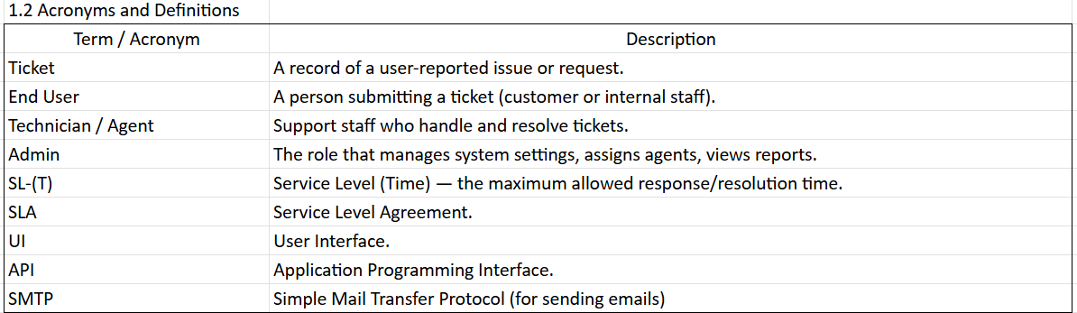
1.3 Operational Requirements
1.3.1 Software Requirements
- Web application framework (e.g., React, Angular, Vue for front-end; Node.js, Django, Laravel for backend).
- Database (relational, e.g., PostgreSQL / MySQL).
- Authentication & authorization module.
- Email service for notifications (SMTP or third-party API like SendGrid).
- Logging and audit trail capabilities.
- Reporting tools for dashboard and analytics.
1.3.2 Hardware Requirements
- Web server(s) for front end and back end (cloud or on-premise).
- Database server with backup capability.
- Sufficient CPU, RAM, storage to handle concurrent users (e.g. 1000 simultaneous sessions initially).
- Reliable network connectivity.
- SSL certificate for encrypted communication.
1.4 References
- Project Proposal Document
- Business Requirements Document (BRD)
- Stakeholder Interview Notes
- Applicable regulations / policies (e.g., data protection, privacy)
1.5 Design and Implementation Constraints
- The system must be web-based, accessible via major browsers.
- Use HTTPS for all traffic.
- Must support role-based access control (agent, user, admin).
- The email notification system should integrate with external SMTP or email API provider.
- Response/resolution SLAs must be configurable.
- System must support multi-tenant or departmental segregation if required in future.
- Must follow any internal coding standards / security guidelines of client.
1.6 Assumed Factors That Could Affect the Requirements Stated In the SRS
- Timely availability of feedback from stakeholders.
- Availability of stable email service for sending notifications.
- Third-party dependencies (if integrating with external systems) will deliver as per schedule.
- Users have basic proficiency with computers & internet.
- The organization’s infrastructure (servers, network) will be capable and maintained.

2.0 System Overview
2.1 Current System
- Currently, ticketing is done manually via email and spreadsheet tracking.
- Lack of formal SLA tracking.
- No centralized dashboard for tracking ticket status, response/resolve times.
- Communication (between user and agent) is fragmented; history often gets lost.
2.2 Proposed System
The proposed Ticketing System will be a unified web application to allow end users to submit tickets through a portal, track status, communicate with agents, and receive notifications. Support agents will have tools to view/prioritize/assign tickets, escalate issues, respond, and close tickets. Administrators will have visibility into metrics, dashboards, SLAs, user management, and system configuration.
2.3 Benefits of the Proposed System
- Faster response & resolution times due to structured workflows.
- Improved accountability: who did what and when is recorded.
- Transparency for end users: ticket submission, status, communication all in one place.
- Better reporting & analytics for continuous improvement.
- Reduction in manual effort and errors.
- Consistency in handling issues.

3.0 UI Requirements
3.1 Project Contents
Each module in this system shall have a user interface that meets the following:
Modules / Functionalities:
- User Portal:
• Submit ticket (subject, description, category, attachment)
• View ticket status and history
• Reply/comment on ticket communications
- Agent/Technician Interface:
• View queue of tickets (sorted by priority/status)
• Assign tickets to self or others
• Update status and progress
• Communicate with user (comments)
• Close/resolve tickets
- Admin Interface:
• User/agent management (create, disable, assign roles)
• Configure ticket categories, priorities, SLA rules
• Dashboard: ticket volume, pending vs resolved, average resolution times, agent performance
• Reports export (CSV / PDF)
UI Design and Behaviour:
- Clean and intuitive layout with navigation menu.
- Responsive design (desktop, tablet, mobile).
- Form validation (required fields, file size/type constraints for attachments).
- Notification indicators (e.g. when there is an update).
- Search & filter functionality (by status, category, date, agent).

4.0 Other Parameters
4.1 Acceptance
The client will review and accept the application on receiving the following deliverables:
- Prototypes / UI mock-ups of key flows (ticket submission, agent dashboard, admin dashboard).
- Fully functional web application deployed in a staging environment.
- Documentation including:
  - User manual (for end users)
  - Agent manual
  - Admin manual
  - Installation / Deployment guide
- Test reports / QA testing summary (unit tests, integration tests, user acceptance testing).
- Final production deployment.

3. ERD: Support Ticket / Ticketing Life Cycle
Designing an ER (Entity-Relationship) diagram for online ticketing and event management systems is important for organizing and visualizing the database structure. It involves identifying the entities (such as users, events, and tickets) and their relationships to ensure data integrity and efficient management.
An ER diagram for online ticketing and event management systems typically includes entities such as users, events, tickets, venues, and payments, along with their attributes and relationships. The diagram helps visualize how these entities are connected and how data flows between them.
Online Ticketing and Event Management Features
- User Registration: Allow users to create accounts and manage their profiles and User Authentication implements secure login mechanisms to authenticate users.
- Event Creation: Enable event organizers to create and manage events. It also, provides users with the ability to search for events based on criteria such as location, date, category, and keywords.
- Ticket Booking: Allow users to book tickets for events. Also, Ticket Printing and Delivery provide options for users to print tickets or receive them electronically.
- Payment Processing: Process payments securely for ticket bookings. Also, Payment Confirmation provides users with confirmation of their ticket purchases and payment status.
- Event Management: Provide tools for event organizers to manage event details, such as dates, venues, and ticket prices.
Entities and Attributes of Online Ticketing and Event Management
1. Event: This table stores information about events.
- event_id: This is a unique identifier for each event, often an auto-incrementing integer value.
- name: The name of the event.
- description: A detailed description of the event, including its purpose, agenda, etc.
- date: The date on which the event occurs.
- time: The time of the event.
- location: The venue where the event takes place (reference to Venue table using a foreign key).
2. User: This table stores user information.
- user_id: This is a unique identifier for each user, often an auto-incrementing integer value.
- name: The user's full name.
- email: It is an user’s email address which is used for login and communication purposes.
- password: The user's password for secure login (needs to be hashed and stored securely).
- user_type: This specifies the type of user (e.g., organizer, attendee, administrator).
3. Venue: This table stores information about event venues.
- venue_id: This is a unique identifier for each venue, often an auto-incrementing integer value.
- name: The name of the venue.
- address: The full address of the venue.
- capacity: The maximum number of people the venue can hold.
- city: It is a name of city where the venue is located.
- state: It is a name of state where the venue is located.
- zip_code: The zip code of the venue's location.
4. Ticket: This table stores information about individual tickets for attending events.
- ticket_id: This is a unique identifier for each ticket, often an auto-incrementing integer value.
- event_id: The event this ticket is associated with (foreign key referencing the Event table).
- order_id: The order this ticket belongs to (foreign key referencing the Order table).
- price: The price paid for the ticket.
- type: It shows the type of ticket for examples: "General Admission", "VIP".
- seat_number: The seat number associated with this ticket (may be null for general admission).
5. Order: This table stores information about ticket orders placed by users.
- order_id: This is a unique identifier for each order, often an auto-incrementing integer value.
- user_id: The user who placed the order (foreign key referencing the User table).
- date: The date the order was placed.
- total_price: The total price of all tickets in the order.
- payment_id: The payment method used for the order (foreign key referencing the Payment table).
6. Payment: This table stores information about payments made for orders.
- payment_id: This is a unique identifier for each payment, often an auto-incrementing integer value.
- order_id: The order associated with the payment (foreign key referencing the Order table).
- payment_method: The method used for payment (e.g., "Credit Card", "PayPal").
- transaction_id: The unique identifier provided by the payment gateway for the transaction.
7. Speaker: This table stores information about speakers participating in events.
- speaker_id: This is a unique identifier for each speaker, often an auto-incrementing integer value.
- name: The speaker's full name.
- bio: A brief biography or description of the speaker.
- event_id: The event the speaker is participating in (foreign key referencing the Event table).
Relationships Between These Entities
1. Event - Venue Relationship:
- It Represents One to Many Relationship.
- One event can occur at one venue, but a venue can host many events.
2. Event - Ticket Relationship:
- It Represents One to Many Relationship.
- One event can have many tickets, but a ticket belongs to only one event.
3. User - Order Relationship:
- It Represents One to Many Relationship.
- One user can place many orders, but an order belongs to only one user.
4. Order - Ticket Relationship:
- It Represents One to Many Relationship.
- One order can contain multiple tickets, while a ticket belongs to a single order.
5. Order - Payment Relationship:
- It Represents One to One Relationship.
- 1:1 - One order is associated with only one payment, and vice versa.
6. Event - Speaker Relationship:
- It Represents Many to Many Relationship.
- An event can have multiple speakers and a speaker can participate in multiple events. This is a many-to-many relationship, which is typically implemented using a separate junction table in practice.

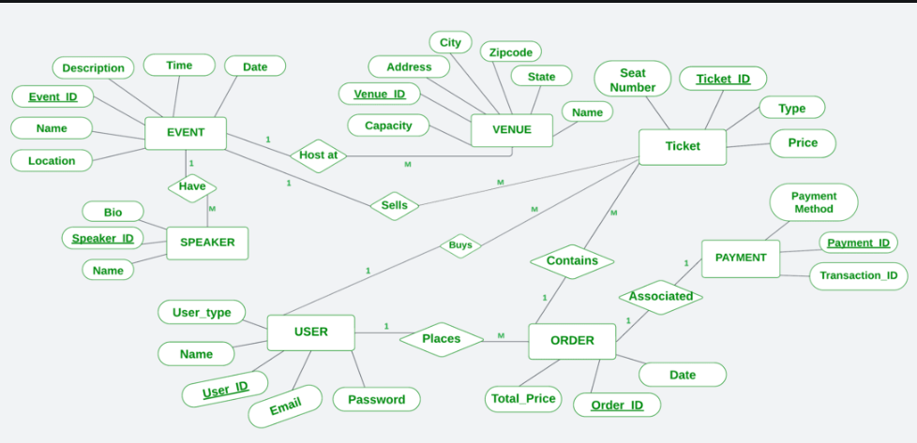

4. User story: Shopping from e-commerce (detailed with acceptance criteria)
Epic
As a customer, I want to order refrigerated dairy and ice-cream products online so that I receive them fresh at my doorstep within a chosen delivery slot.
User story
