Nurturing Process - Capstone Project1 – Part -3/3 V2D2 Aug 2024
Question 1 – Functional Requirements - Identify minimum 20 functional requirements
Answer 1 : Functional requirements define the specific behaviors, functions, or operations of a system. They describe what the system should do, outlining the necessary tasks, actions, or activities it must perform to achieve its objectives.
Req ID | Req Name | Req Description | Priority
FR0001 | Farmer Registration | Farmers should be able to register with the application using email and password. | 8
FR0002 | Manufacturer Registration | Manufacturers should be able to register to upload product details. | 8
FR0003 | Farmer Login | Farmers must be able to log in using their credentials. | 9
FR0004 | Manufacturer Login | Manufacturers must be able to log in to manage their products. | 9
FR0005 | Product Catalog | Farmers should be able to browse categorized product listings (fertilizers, seeds, pesticides). | 10
FR0006 | Product Search | Farmers should be able to search for specific products by name or category. | 9
FR0007 | Add to Cart | Farmers can add products to a shopping cart for purchase. | 8
FR0008 | Buy Later List | Farmers can add products to a “buy-later” list for future consideration. | 7
FR0009 | Product Detail View | Farmers can view full details of a selected product. | 8
FR0010 | Payment Gateway Integration | The application must support payment via COD, Credit/Debit card, and UPI. | 10
FR0011 | Place Order | Farmers can place orders for selected products. | 10
FR0012 | Order Confirmation Email | An email should be sent to the user after a successful order placement. | 9
FR0013 | Delivery Tracking | Users should be able to track their order delivery status in real-time. | 9
FR0014 | Product Upload by Manufacturer | Manufacturers can upload and manage product listings. | 9
FR0015 | Product Approval (Admin) | Admin should be able to review and approve uploaded products before display. | 8
FR0016 | Forgot Password | Users can reset their password via email link if they forget it. | 7
FR0017 | Edit Profile | Users can view and update their profile details. | 7
FR0018 | Order History | Farmers should be able to view their past orders. | 7
FR0019 | Product Ratings/Reviews | Farmers should be able to rate and review purchased products. | 6
FR0020 | Logout | All users must be able to log out securely from the system. | 10

Non-functional Requirements will describe the qualities and attributes of a system, focusing on how the system perform rather than specific behaviors or functions.
Req ID | Req Name | Req Description | Priority
NFR0101 | Page Loading Time | Each page of the application should load within 2 seconds under standard internet conditions. | 9
NFR0102 | WCAG 2.1 Compliance | The application must comply with Web Content Accessibility Guidelines (WCAG) 2.1 for accessibility. | 8
NFR0103 | Mobile Responsiveness | The application should be responsive and usable on all mobile devices and tablets. | 9
NFR0104 | Uptime | The application should be available 99.9% of the time (excluding planned maintenance). | 10
NFR0105 | Data Security | All user data should be encrypted during transmission and storage (SSL, HTTPS, etc.). | 10
NFR0106 | Scalability | The system should be scalable to support an increasing number of users and products. | 8
NFR0107 | User Load | The system should be able to support at least 10,000 concurrent users without performance degradation. | 9
NFR0108 | Backup and Recovery | The system should automatically back up data daily and provide recovery options in case of failure. | 8
NFR0109 | Browser Compatibility | The application should work properly on all major browsers (Chrome, Firefox, Safari, Edge). | 7
NFR0110 | Localization Support | The system should support multiple regional languages for rural accessibility. | 7

Question 2–Minimum 5 page designs
Make wireframe and prototypes
Answer 2 :
- Login / Registration Page : This page allows users farmers to login or register.
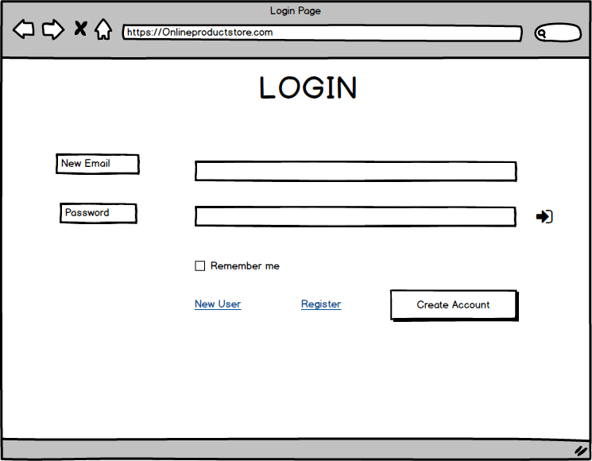

- Home / Dashboard Page: After Logging in, users land on this dashboard to navigate the platform.

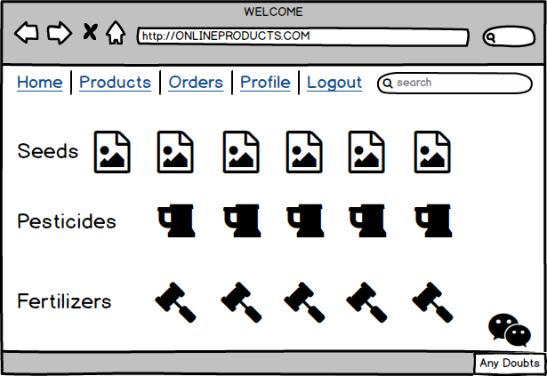
In this I have given links for Seeds, Pesticides and Fertilizer mockup pages.
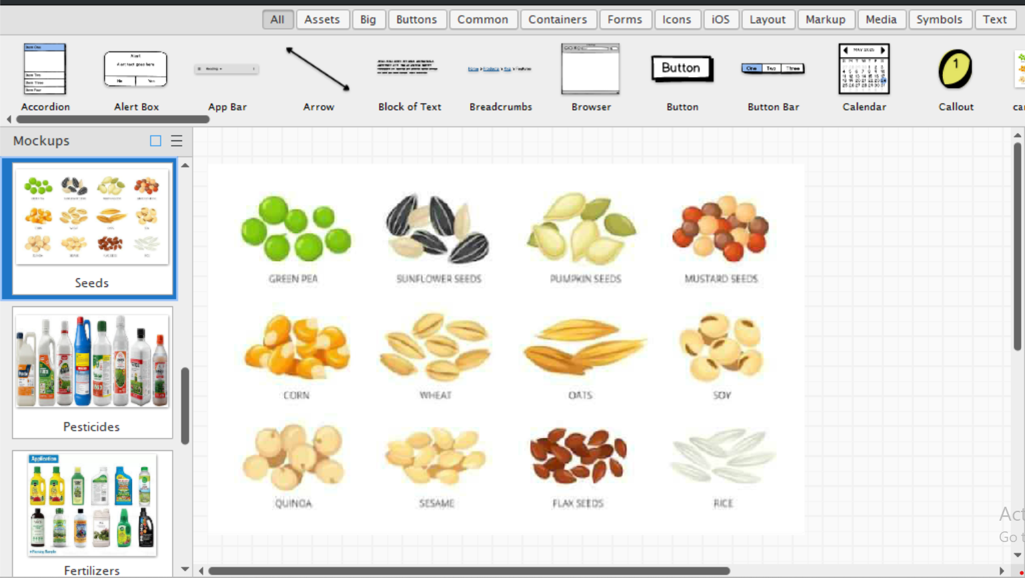

- Product Catalog Page Purpose: To browse and view products in detail.
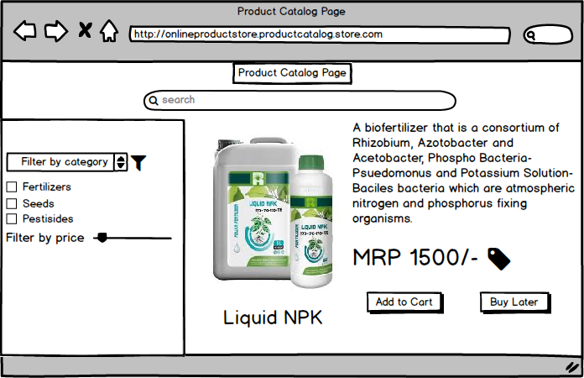
- Payment Gateway Page: To complete the transaction.
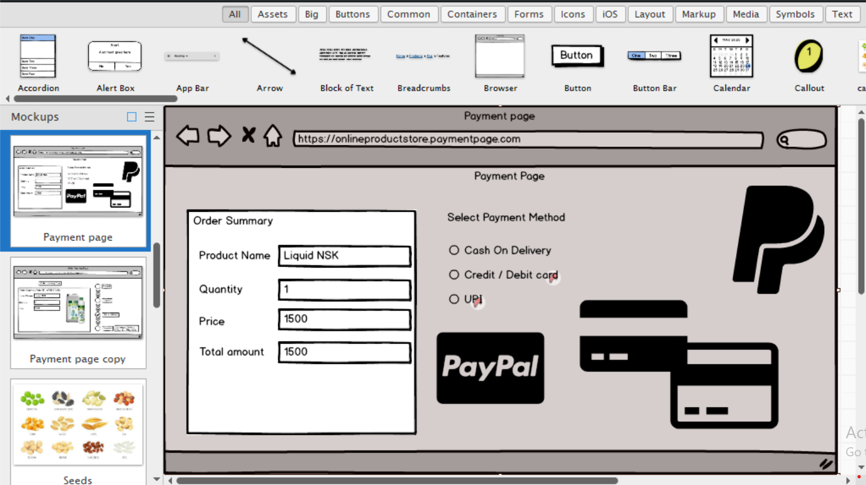

Here, If end user selects type of payment it takes to relevant mock pages as below
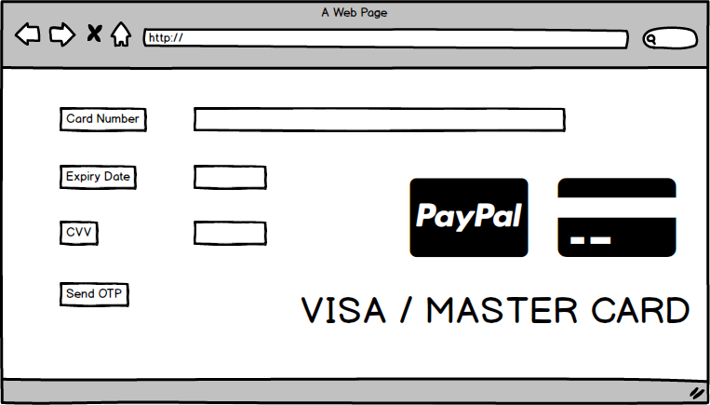

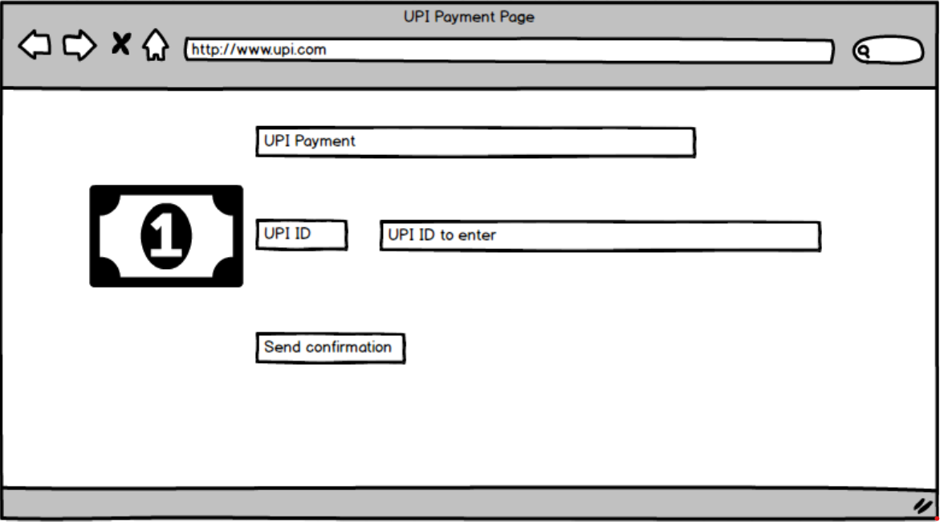

- Order Tracking Page: To track the delivery status of orders.
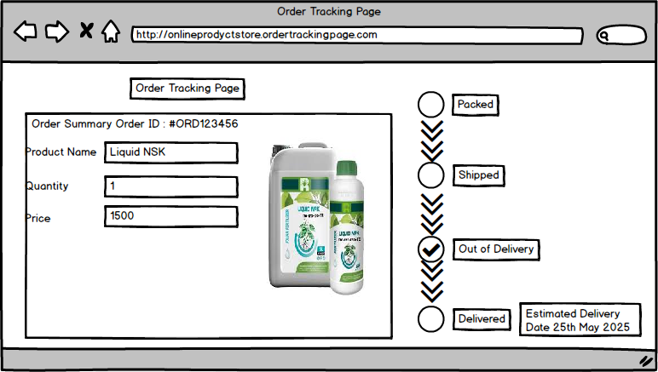

Question 3 – Tools (Visio, Balsamiq)
Make a note of the Tools, which you are using for above concepts.
Answer 3 :
Microsoft Visio: To create flowcharts and detailed system diagrams (like use-case, process flow).
1. Professional-Grade Diagramming Tool: It offers a wide variety of pre-built templates and stencils for different use cases like flowcharts, network diagrams, UML diagrams, and more.
2. Ease of Use: Visio provides a drag-and-drop interface which makes it easy to use even for non-technical users.
3. Support for Complex Diagrams: You can easily create complex diagrams like Entity Relationship Diagrams (ERDs), Data Flow Diagrams (DFDs), and Process Flows with clear relationships and layers.
4. Integration with Microsoft Office Suite: Seamlessly integrates with tools like Word, Excel, Outlook, and Teams. This is useful for documentation and collaboration in corporate environments.
5. Customization and Flexibility: You can customize shapes, connectors, and styles to match specific requirements or organizational standards.
6. Data Linking Capability: Visio can link to real-time data from external sources (like Excel or databases) to create dynamic diagrams.
7. Standardization: Many organizations prefer Visio because it supports industry-standard notations (e.g., BPMN, UML, ERD).
8. Collaboration Support: With Visio Online, teams can collaborate in real time on diagrams.
Balsamiq Wireframes: To design low-fidelity wireframes of the application screens.
1. Rapid Wireframing : Balsamiq allows for quick creation of low-fidelity wireframes, which helps teams visualize and iterate on user interface designs early in the development process.
2. User-Friendly Interface: It uses a drag-and-drop approach with a sketch-like style, making it intuitive even for non-designers such as Business Analysts and Product Managers.
3. Focus on Structure Over Visual Design : The hand-drawn style intentionally avoids detailed visuals so stakeholders focus on layout, flow, and functionality, not fonts or colors.
4. Reusable Components :Common UI elements like buttons, input fields, dropdowns, modals, and navigation bars are prebuilt and reusable, speeding up design.
5. Great for Collaboration:Supports collaboration between designers, developers, and stakeholders, making it easy to gather feedback and iterate quickly.
6. Export and Share Easily:Wireframes can be exported as PDFs or PNGs or shared through Balsamiq Cloud, making it easier to present or include in documentation.
7. Supports Agile Development: Ideal for agile teams where prototypes and iterations are needed quickly and frequently during sprints.
Question 4 – RTM
A business analyst’s key responsibilities are to keep track of the requirements and make sure that no requirement is missed.
Mr. Henry and peter have approached you regarding the current status of the project. How will you tackle this situation? Prepare RTM
Answer 4 : To respond to Mr. Henry and Peter’s inquiry about the current status of the project, as a Business Analyst, you will use the Requirement Traceability Matrix (RTM). The RTM helps track the life cycle of each requirement across design, development (T1 to T4), and testing (UAT), ensuring nothing is missed.
Req ID | Req Name | Req Description | Design | D1 | T1 | T2 | T3 | T4 | UAT
FR0001 | Farmer Registration | Farmers should be able to register with the application | Done | Done | Done | - | - | - | In Progress
FR0002 | Farmer Search for Products | Farmers should be able to search for available products in fertilizers, seeds, pesticides | Done | Done | Done | In Progress | - | - | Not Started
FR0003 | User Login | Login for users using email & password (Farmers & Manufacturers) | Done | Done | Done | Done | - | - | In Progress
FR0004 | Product Catalog | Display categorized products (fertilizers, seeds, pesticides) | Done | Done | In Progress | - | - | - | Not Started
FR0005 | Add to Buy-Later List | Users can add products to a “Buy Later” list | In Progress | In Progress | - | - | - | - | Not Started
FR0006 | Payment Gateway | COD, Credit/Debit Card, and UPI payment options | Planned | - | - | - | - | - | Not Started
FR0007 | Email Confirmation | Email updates to users for order status | Planned | - | - | - | - | - | Not Started
FR0008 | Delivery Tracking | Users can track delivery status of orders | Planned | - | - | - | - | - | Not Started
NFR0101 | Page Loading Time | Each page should load within 2 seconds | Done | Done | In Testing | - | - | - | Not Started
NFR0102 | WCAG 2.1 Compliance | Web accessibility compliance with WCAG 2.1 standards | Done | Done | In Testing | - | - | - | Not Started
NFR0103 | Cross-Browser Compatibility | Application should work on all modern browsers (Chrome, Firefox, Safari, Edge) | Done | Done | In Testing | - | - | - | Not Started
NFR0104 | Mobile Responsiveness | Responsive design for use on mobile and tablet devices | Done | Done | In Testing | - | - | - | Not Started
NFR0105 | Security | All user data and transactions should be secure (HTTPS, encrypted passwords, etc.) | In Progress | In Progress | - | - | - | - | Not Started
NFR0106 | Scalability | System should support up to 10,000 concurrent users | Planned | - | - | - | - | - | Not Started
NFR0107 | Availability | Application should have 99.5% uptime | Planned | - | - | - | - | - | Not Started
NFR0108 | Maintainability | Code should be modular and easy to maintain by development team | Planned | - | - | - | - | - | Not Started
NFR0109 | Data Backup & Recovery | Daily backup of user and product data; recovery in case of failure | Planned | - | - | - | - | - | Not Started
NFR01010 | Performance Testing | Application performance under load should be tested before deployment | Planned | - | - | - | - | - | Not Started

Question 5– Prepare 10 Test Case Documents
Answer 5 :
Test Case Document 1
• Test Case ID: TC001
• Test Case Name: Farmer Registration
• Precondition: Farmer is on the registration page
• Test Steps:
1. Enter valid email ID
2. Enter a secure password
3. Confirm password
4. Click on “Register” button
• Expected Result:
Farmer account should be created and confirmation message displayed
• Status: Pass/Fail
Test Case Document 2
• Test Case ID: TC002
• Test Case Name: Farmer Login
• Precondition: Farmer has already registered
• Test Steps:
1. Enter registered email ID
2. Enter password
3. Click on “Login”
• Expected Result:
User should be logged in and redirected to dashboard/homepage
• Status: Pass/Fail
Test Case Document 3
• Test Case ID: TC003
• Test Case Name: Search for Products
• Precondition: User is logged in
• Test Steps:
1. Enter product name in search bar (e.g., “urea”)
2. Click search icon or press Enter
• Expected Result:
List of matching products should be displayed
• Status: Pass/Fail
Test Case Document 4
• Test Case ID: TC004
• Test Case Name: Browse Product Catalog
• Precondition: User is logged in
• Test Steps:
1. Navigate to product section
2. Select category (Fertilizers / Seeds / Pesticides)
• Expected Result:
All products under the selected category should be listed
• Status: Pass/Fail
Test Case Document 5
• Test Case ID: TC005
• Test Case Name: Add to Buy Later List
• Precondition: User is logged in and browsing products
• Test Steps:
1. Click on “Add to Buy Later” button beside a product
• Expected Result:
Product should be added to the user’s Buy Later list
• Status: Pass/Fail
Test Case Document 6
• Test Case ID: TC006
• Test Case Name: Payment Gateway - UPI
• Precondition: User has selected products and moved to checkout
• Test Steps:
1. Choose UPI as payment method
2. Enter UPI ID and authenticate
• Expected Result:
Payment should be processed and success message shown
• Status: Pass/Fail
Test Case Document 7
• Test Case ID: TC007
• Test Case Name: Payment Gateway - Credit/Debit Card
• Precondition: User is at checkout page
• Test Steps:
1. Choose Credit/Debit card option
2. Enter valid card details and proceed
• Expected Result:
Payment should be successful and confirmation message should be shown
• Status: Pass/Fail
Test Case Document 8
• Test Case ID: TC008
• Test Case Name: Order Confirmation Email
• Precondition: User has successfully placed an order
• Test Steps:
1. Place an order
2. Check registered email inbox
• Expected Result:
Email confirmation with order details should be received
• Status: Pass/Fail
Test Case Document 9
• Test Case ID: TC009
• Test Case Name: Delivery Tracking
• Precondition: Order is placed and dispatched
• Test Steps:
1. Go to “My Orders” section
2. Click “Track Order”
• Expected Result:
Order tracking details should be displayed
• Status: Pass/Fail
Test Case Document 10
• Test Case ID: TC010
• Test Case Name: Manufacturer Product Upload
• Precondition: Manufacturer is logged in
• Test Steps:
1. Click on “Add Product”
2. Enter product name, type, description, price, quantity
3. Click “Submit”
• Expected Result:
Product should be added to the catalog and visible to farmers
• Status: Pass/Fail

Question 6 – DB Design
After the requirements are thoroughly explained to the entire project team by business analyst, the Database architects have decided to do the database design and also to represent the in-flow and out-flow of data.
Draw database schema and ER diagram
Answer 6 :
Database schema: It is a blue print that outlines the structure of a database, including its tables fields, relationships, Constraints, and other characteristics.
Data Base Schema for Online Agriculture product Store
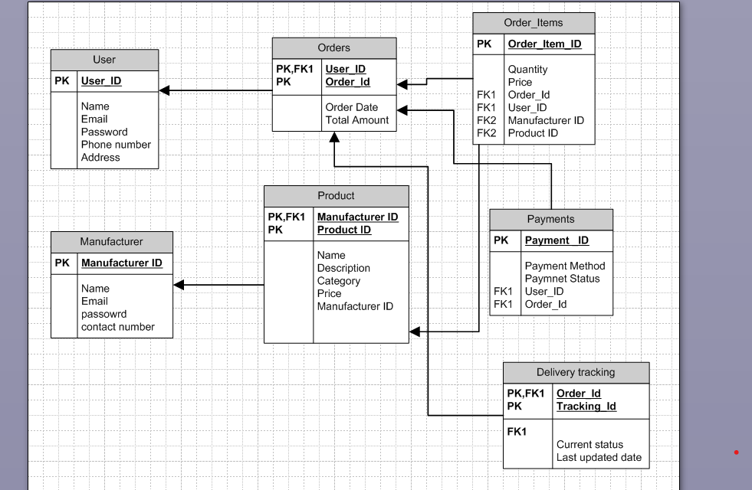
ER Diagram: It is a visual representation of the relationships b/w entities in a database .It depicts the entities , attributes, and relationships b/w them.
ER Diagram for Online Agriculture product Store:
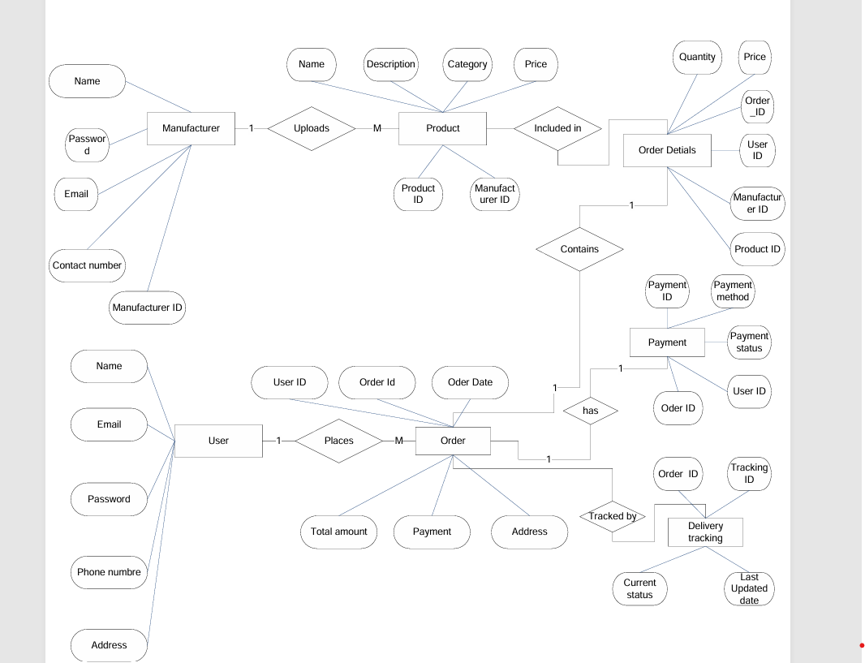

Question 7 : Data Flow Diagram
What is a data flow diagram? Draw a data flow diagram to represent the in-flow and out-flow of data when a Farmer is placing an order for the product
Answer 7 :
A Data Flow Diagram (DFD) is a graphical representation of the flow of data within a system. It visually shows how data moves from one process to another, how it's stored, and where it ends up.
• It help analysts and designers to understand the flow of data within a system, identify potential bottlenecks or inefficiencies, and communicate system requirements to stakeholders.
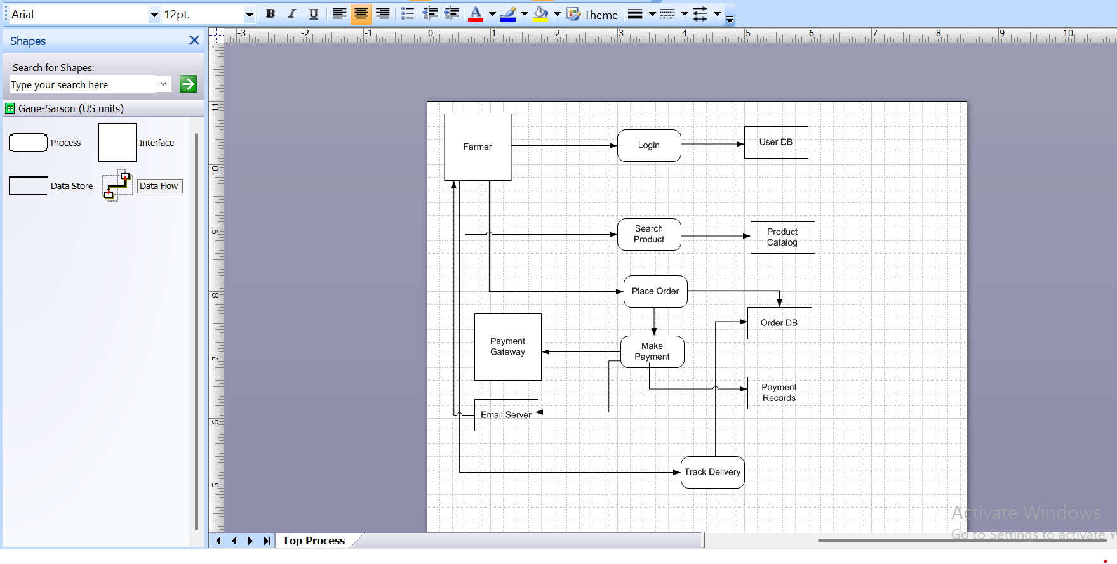
Question 8 : Change Request
Due to change in the Government Taxation structure .
we should change the Tax structure How do you handle change requests in a project?

Answer 8
Handling a Change Request (CR)—such as a change in Government Taxation Structure—requires a structured approach to ensure that the change is evaluated, approved, and implemented efficiently without disrupting the project scope, timeline, or budget. Here’s how you, as a Business Analyst, can handle such a change request:
Steps to Handle a Change Request (CR):
1. Receive and Record the Change Request
• Initiator: The change request may come from a client (e.g., Mr. Henry, Mr. Dooku) or regulatory authority.
• Documentation: Record the CR formally using a Change Request Form including:
• CR ID
• Requested By
• Date of Request
• Description (e.g., “Update tax calculation module to support revised government tax structure”)
2. Analyze the Impact
Conduct an impact analysis in collaboration with relevant team members:
Area | Impact
Scope | Will it change the current scope of the taxation logic in the system?
Schedule | Will it delay the delivery? Estimate additional time.
Cost | Will extra budget or effort be needed?
Resources | Will developers/testers need to reallocate?
Risk | Will it introduce compliance risks or integration issues?
3. Conduct Feasibility Assessment
• Discuss with: Developers (e.g., Ms. Juhi, Mr. Teyson), DB Admin (Mr. John), Testers (Ms. Alekya)
• Evaluate if the new tax rules can be accommodated without affecting ongoing builds.
• Assess any required changes in backend logic, UI, reports, or invoices.
4. Update Requirements / Specifications
• Modify the SRS (Software Requirements Specification) or BRD (Business Requirements Document) to reflect the new tax structure.
• Update use cases and user stories related to:
• Product Pricing
• Checkout Process
• Invoice generation
• Tax Report modules
5. Get Approval from the Change Control Board (CCB)
• Present the impact assessment and revised documentation to the CCB (Committee: Mr. Henry, Mr. Pandu, Mr. Dooku).
• Obtain formal sign-off before making any changes.
6. Implement the Change
• Assign the task to developers and testers.
• Update relevant modules (pricing engine, tax logic, invoice generation).
• Involve DB Admin (John) for any DB schema modifications related to taxes.
7. Testing
• Regression Testing: Ensure existing functionality works as expected.
• UAT (User Acceptance Testing): Involve key stakeholders (Peter, Kevin, Ben) to validate.
• Check:
• Correct tax is applied.
• Invoice reflects correct breakdown.
• Reports are updated as per compliance.
8. Update Project Artifacts
• Update:
• Project Plan
• Test Cases
• User Manuals / Help Files
• Training materials
9. Deploy and Monitor
• Deploy the updated version.
• Monitor for any post-release issues.
• Send communication to users about tax change impact.
Example:
The GST rate was updated from 5% to 12%. You coordinate with developers to update tax calculation logic in the backend, update UI labels, ensure invoices reflect the new rate, and inform all stakeholders through a project status update.
Question 9– Change Request Vs an Enhancement
As the project is in process, Ben and Kevin have contacted you. The reason is to inform you that they want the Farmers to sell their crop yields through this application i.e. Farmers should be able to add their crop yields or products and display to general public and should be able to sell them. They also want to introduce Auction system for their Crop yields. As a BA, what will be your response? Is this a change request or an enhancement???
Answer 9 : Ben and Kevin now want to extend the platform’s functionality by allowing farmers to sell their crop yields and introduce an auction system for selling. This feature was not mentioned in the original scope, which focused only on buying agricultural products (fertilizers, seeds, pesticides) by farmers from manufacturers.
This is clearly an Enhancement, not just a simple change request.
Difference Between Change Request and Enhancement:
Aspect | Change Request | Enhancement
Definition | A modification to an existing feature or agreed scope | Introduction of new features or modules not originally planned
Original Scope? | Yes | No
Impact | Usually moderate | Usually high impact on scope, budget, timeline, and resources
Example | Updating tax structure due to government change | Adding a whole new module for crop selling & auction functionality
A. Acknowledge the Request
“Thank you, Ben and Kevin, for sharing this idea. Enabling farmers to sell their crop yields and adding an auction feature can be highly beneficial to the farming community.”
B. Categorize the Request
“Based on the current scope of our application—which is designed to help farmers buy agricultural products—this is considered an enhancement since it introduces new business functionality not included in the original requirements.”
C. Initiate Enhancement Handling Process
“To proceed, I will document this enhancement request and conduct an impact analysis to evaluate the effect on:
• Project scope
• Timeline (currently 18 months)
• Budget (currently ₹2 Crores)
• Resource allocation”
D. Present to the Committee
“Once the analysis is done, I will share it with the project stakeholders and the SOONY committee (Mr. Henry, Mr. Pandu, Mr. Dooku) to seek approval or to defer it as part of a Phase 2.”
E. Next Steps
• Document new use cases and functional requirements
• Update the Business Requirement Document (BRD)
• Coordinate with the Project Manager to assess schedule and cost impact
• Communicate implications to development and testing teams
Question 10: Estimations
Come up with estimations – How many Manhours required
Answer 10:
To estimate manhours for this agriculture product store project, we’ll use Work Breakdown Structure (WBS) and effort estimation techniques like expert judgment and analogous estimation based on the scope described.
Project Scope Summary
The application will include:
• User Registration & Login (Farmers & Manufacturers)
• Product Catalog (Fertilizers, Seeds, Pesticides)
• Product Search
• Shopping Cart / Wishlist
• Order Placement & Payment Gateway
• Delivery Tracking
• Email Notifications
• Admin Interfaces (optional scope)
• Web + Mobile Application (assuming hybrid or responsive design)
High-Level Work Breakdown & Estimations
Module / Task | Role | Estimated Hours
1. Requirements Gathering & Analysis | BA | 80 hrs
Stakeholder meetings, documentation (BRD, SRS), walkthroughs
2. UI/UX Design (Wireframes + Prototypes) | BA + UI Designer | 60 hrs
3. Application Architecture & Planning | Project Manager, Senior Dev | 40 hrs
4. Backend Development | Java Developers
- User Login/Registration |  | 40 hrs
- Product Catalog Management |  | 60 hrs
- Shopping Cart & Wishlist |  | 40 hrs
- Order Management |  | 50 hrs
- Payment Integration (COD/UPI/Card) |  | 60 hrs
- Delivery Tracking |  | 40 hrs
Subtotal (Backend) |  | 290 hrs
5. Frontend Development | Java Developers
- Web Pages (Forms, Catalog, Cart) |  | 120 hrs
- Mobile App (Responsive/Hybrid) |  | 100 hrs
Subtotal (Frontend) |  | 220 hrs
6. Database Design & Setup | DB Admin (John) | 40 hrs
7. Network & Deployment Setup | Network Admin (Mike) | 30 hrs
8. Testing (Functional, UAT) | Testers (Jason, Alekya)
- Test Case Writing |  | 40 hrs
- Functional Testing |  | 60 hrs
- UAT Support |  | 30 hrs
Subtotal (Testing) |  | 130 hrs
9. Project Management | PM (Mr. Vandanam) | 60 hrs
10. Buffer (15% Risk & Contingency) | - | ~145 hrs
Total Estimated Manhours
Activity | Total Hours
Requirements & Design | 180 hrs
Development (Backend + Frontend) | 510 hrs
Testing | 130 hrs
Infra (DB + Network) | 70 hrs
Project Management | 60 hrs
Buffer (15%) | 145 hrs
Grand Total | 1,095 Manhours
Assumption on Team Capacity
Role | Number of People | Avg. Daily Hours
Developers | 5 | 6 hrs/day
Testers | 2 | 6 hrs/day
BA | 1 | 6 hrs/day
PM | 1 | 2 hrs/day
With this Setup, and about 20-22 working days/month, the project can be realistically completed within 5-6 calendar months with parallel activities-well within the 18 month allocated timeline.
Question 11 – UAT
Project has finally completed all the stages i.e., design, development, testing etc. Now, it is the role of a business analyst to contact the client for testing of the final product and have to successfully complete it. How are you going to handle this situation? And once it is done, what will be the process to close the project? Explain UAT Acceptance process
Answer 11 : User Acceptance Testing (UAT) is a critical responsibility in ensuring that the solution meets the client’s expectations and business requirements. Here’s how I would manage this phase and lead the process toward project closure.
UAT (User Acceptance Testing) Handling Process
1. Prepare for UAT
• Create UAT Plan
•Define objectives, scope, testing schedule, entry & exit criteria, and responsibilities.
• Identify UAT Participants
• Coordinate with key stakeholders: Mr. Henry, Peter, Kevin, Ben, and relevant users from SOONY (they act as end users).
• Test Environment Setup
• Coordinate with QA, DevOps, and Network Admin (Mr. Mike) to deploy the UAT build in a controlled environment.
2. Prepare UAT Test Cases / Scenarios
• Create business scenario–based test cases (real-life usage cases).
• Share with client for feedback and approval before starting testing.
Example scenarios:
• Register/Login as a farmer
• Search for a seed product and place order
• Make payment via UPI
• Receive order confirmation email
• Track delivery status
3. Conduct UAT
• Schedule UAT sessions with client stakeholders (onsite or remote).
• Provide walkthrough or training if needed (especially as users may not be tech-savvy).
• Observe and document feedback/issues.
• Track issues in a defect tracker (can use Excel or tools like JIRA).
4. Collect UAT Sign-off
• Once all major issues are fixed and the system behaves as expected:
• Share a UAT Summary Report.
• Obtain formal UAT Sign-off from Mr. Henry and the committee (Mr. Pandu, Mr. Dooku).
UAT Acceptance Criteria
To be accepted, the system must:
• Meet all business requirements (as per BRD/SRS)
• Pass all critical test cases without high/medium severity bugs
• Provide acceptable user experience (especially for farmers)
• Have confirmation from stakeholders that they’re satisfied
Project Closure Process (Post-UAT)
1. Final Documentation:
• Update BRD/SRS, user manuals, technical documentation.
• Provide client with a complete documentation kit.
2. Knowledge Transfer:
• Conduct KT sessions for SOONY support staff (if they will manage post-go-live support).
• Share admin manuals or training material.
3. Project Closure Meeting:
• Include all stakeholders: SOONY Committee, APT IT team.
4. Obtain Project Closure Sign-off:
• Formal email or document acknowledging
• Delivery completion
• UAT acceptance
• Budget compliance
• Project objectives met
5. Archive Project Artifacts:
• Store all project files, communication, reports securely for future reference.
Question 12 – Project Closure Document
Explain Project closure document
Answer 12:
Project Name:
Online Agriculture Product Store for Farmers
Client:
SOONY (CSR Initiative by Mr. Henry)
Executing Company:
APT IT SOLUTIONS
Project Duration:
18 Months
Project Budget:
₹2 Crores INR
1. Project Overview
This project aimed to develop a user-friendly online platform (web/mobile) that enables farmers from remote areas to purchase agricultural products such as fertilizers, seeds, and pesticides directly from manufacturing companies. The system includes product catalog browsing, login/registration, search functionality, a secure payment gateway, email order confirmation, and delivery tracking.
2. Achievements
• Successfully developed a web and mobile responsive platform for both farmers and manufacturers.
• User-friendly login/registration functionality.
• Product catalog with filtering and searching.
• Payment gateway: UPI, COD, Credit/Debit Cards.
• Email confirmation system.
• Real-time delivery tracking.
• Manufacturer dashboard for product management.
• On-time and on-budget delivery.
3. Lessons Learned
Positive Learnings:
- Early stakeholder involvement helped define clear requirements.
- Agile iterations allowed rapid feedback integration.
- Collaboration ensured early defect detection.
Improvement Areas:
- UAT required additional training for rural users.
- Delays in third-party API testing (payment gateway).
- Involve UX design earlier for better usability.
4. Quality Assurance
• All test cases passed in System and UAT phases.
• Functional, usability, performance, and security testing completed.
• UAT sign-off received from all stakeholders.
• No critical or major defects outstanding.
5. Resource Utilization
• All allocated resources were efficiently utilized.
• Effective collaboration across roles (Development, Testing, Admin, BA).
• Minimal idle time during project execution.
6. Risk Management
• Connectivity issues resolved via lightweight design.
• Farmers’ digital literacy gaps bridged with support.
• Payment gateway API delays handled with parallel planning.
• Scope creep managed by freezing after change request approvals.
7. Challenges
• Connectivity issues in rural areas delayed field UAT.
• Farmers required training to use digital features.
• Payment integration needed repeated coordination.
• Aligning stakeholder expectations required frequent demos.

