Document 1: Definition of Done
- DOD is criteria which shows when product is complete. DOD ensures about consistency and quality of product.
- DOD means a list of things that must be finished before we say task is done.
- It is an exit criterion agreed by product owner and development team to consider a Product Backlog Item (PBI) done and product is ready to deliver.
- Ex. Coded, Reviewed, Bugs Fixed, Packaged, Test Cases automated, Test case written, Integrated, Deployed, Accepted by product owner.
- Purpose of DoD:
  - Define completion criteria: It provides a clear understanding of what needs to be achieved to complete a piece of work.
  - Ensure Quality: It helps to ensure that product meets required quality standards.
  - Minimize Risk: It helps to identify and mitigate risks at early stage.

Document 2- Product Vision
Scrum Project Name: | Yara Banking
Venue:
Date: 12/05/2025 | Start Time: 10.00 | End Time:18.00 | Duration: 6:00 hrs
Client:
Stakeholder List: | Developer, Testers, Product Manager, Customer, Business Analyst, Designers
Scrum Team
Scrum Master: | Mr. Hrishikesh
Product Owner: | Mr.Krishna
Scrum Developer 1: | Mrs.Arati
Scrum Developer 2: | Miss.Anuja
Scrum Developer 3: | Miss. Radhika
Scrum Developer 4: | Mr. Ved
Scrum Developer 5: | Mr. Adwik
Vision:
To increase company’s profit, increase customer base.

Target group  Which market segment does the product address?  Answer: Product will helpful for Users who are Bank Account Holders and who wants to be account Holder.  Who are the target users and customers?  Answer: All Account Holders of bank and all who wants to be a part of it. | Needs  What problem does the product solve?  Answer: Product will solve complexity issue and will save the time.  Which benefit does it provide?  Answer: User will save his time and need not to worry about Login Complexity. | Product  What product is it?  Answer: This is a Banking Application. One resort for all purpose.  What makes it desirable and special?  Answer: Login is easy with single level authentication. Passbook history is visible up to a year. User will be able to generate Debit card Pin with this.  Is it feasible to develop the product?  Answer: Yes, it is feasible. | Value  How is the product going to benefit the company?  Answer: Company will get a large number of users.  What are the business goals?  Answer: Product will help company to enhance reputation and financial status.  What is the business model?  Answer: Basic model for business is to make company profitable.

Document 3: User stories
User Story No: 1 | Tasks: Login |  | Priority: High
Value Statement:
As a User,
I should be able to do login,
So that,
I can see home page.
BV: 1000 |  | CP: 5
Acceptance Criteria: Login Screen, User Id, Password

User Story No: 2 | Tasks: Login |  | Priority: High
Value Statement:
As a Banker,
I Should be able to login,
So that,
I can see home page.
BV: 500 |  | CP: 21
Acceptance Criteria: Login Screen, User Id, Password

User Story No: 3 | Tasks: Debit card pin generation |  | Priority: High
Value Statement:
As a user,
I should be able to generate debit card Pin via application,
So that,
I can use my ATM and save time.
BV: 500 |  | CP: 5
Acceptance Criteria: Debit card, Login, User Id, Password

User Story No: 4 | Tasks: Login |  | Priority: High
Value Statement:
As a user,
I should be able to login in single step,
So that I can save my time.
BV: 200 |  | CP: 13
Acceptance Criteria: Login Screen, User Id, Password

User Story No: 5 | Tasks: Passbook |  | Priority: High
Value Statement:
As a user,
I should be able to see transaction history up to 1 yr,
So that,
I can generate one year statement.
BV: 500 |  | CP: 34
Acceptance Criteria: Login Screen, User Id, Password, Account with bank

User Story No: 6 | Tasks: Payment |  | Priority: High
Value Statement:
As a user,
I should be able to make payment from application,
So that,
I can transfer my money.
BV: 1000 |  | CP: 5
Acceptance Criteria: Login Screen, User Id, Password, Account with bank

Document 4: Agile PO Experience.
Answer:
- As a product owner of this project, I have completed some basic responsibilities. First I did the market analysis to know the need and demand of this project and also searched for similar products in the market.
- Then I did an enterprise analysis by doing SWOT ANALYSIS to know its strengths, weaknesses, opportunities in the project and threads we will be facing in the project. Gap analysis also helped me to understand the current situation and desired situation of the project.
- Then I created A roadmap by keeping in mind the vision of the Project to focus only on the requirements of the project and to understand the timeline.
- I made a list of all features and tasks that are needed which is product backlog. Then I broke the big ideas- epics into smaller user stories and distributed the work in teams.
- I created sprint charts with jeera tool.
- I decided what is more important should be delivered first.
- I work closely with the team to plan each sprint. We all attended daily standup meetings to answer the questions in clarify the requirements

- According to the needs of the project we created the epics then user stories and distributed them to the development team and they started working on them.
- The sprint meetings helped me to track the development of the project.
- Sprint meetings like -
            - Sprint planning meeting which happened at the beginning of each sprint helped me to understand what the team is delivering in the sprint.
            - Daily Scrum meeting which happened daily for team members where they answer three questions daily what they did today? What will do tomorrow and what impediments are stopping you?
            - Sprint review meeting which happened at the end of sprint where the team gives demo to PO and get it cleared.
            - Sprint retrospective meeting which happened at the end of sprint where team answers what went well in the sprint? What did not go well? And what are the required areas for improvement.

Document 5: Product and sprint backlog and product and sprint burndown charts
- Product backlog:
- It is list of all item that need to complete so product can be developed.
- Product owner is responsible for product backlog items.
- Product backlog specific to entire goal of product.
- It not dependent on sprint backlog.
- Until new product developed, product backlog remains same i.e. unchanged.

User Story ID | User Story | Tasks | Priority | BV | CP | Sprint
1 | Login | Login | High | 500 | 5
2 | Passbook | Passbook | High | 500 | 5
3 | Debit card Pin | Debit card Pin | High | 500 | 5

- Sprint backlog:
- It is list of items taken from product backlog and completed to complete sprint.
- The developer is responsible for sprint backlog items.
- Sprint backlog specific for particular sprint.
- Sprint backlog dependent on product backlog.
- For every new sprint, a new sprint backlog prepared.

User Story ID | User Story | Tasks | Owner | Status | Estimated Effort
1 | Login | Login | PO | Completed
2 | Passbook | Passbook | PO | Completed
3 | Debit card Pin | Debit card Pin | PO | Completed

- Sprint burnup
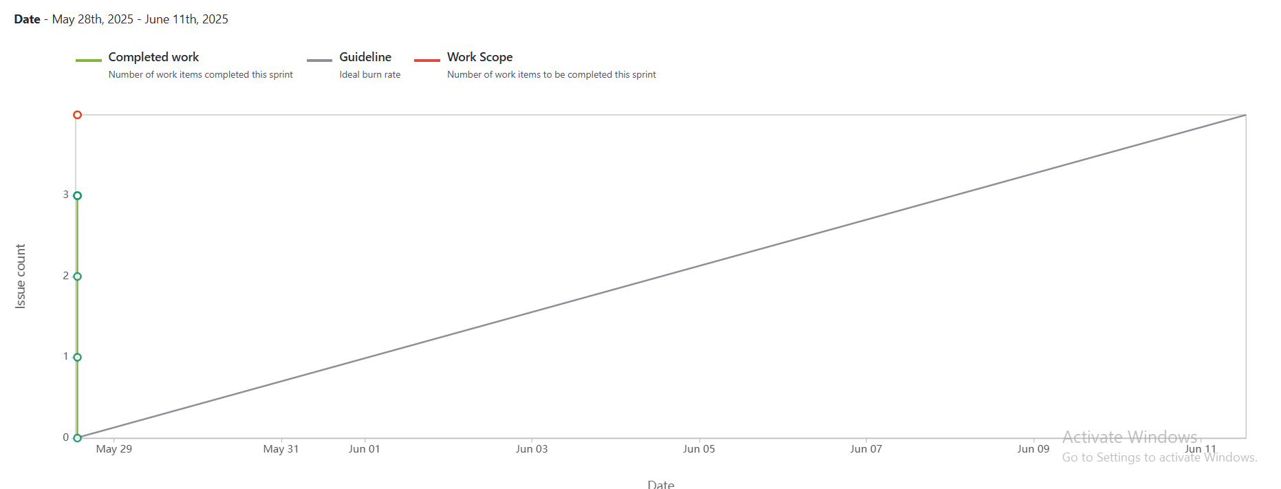
- Sprint burndown

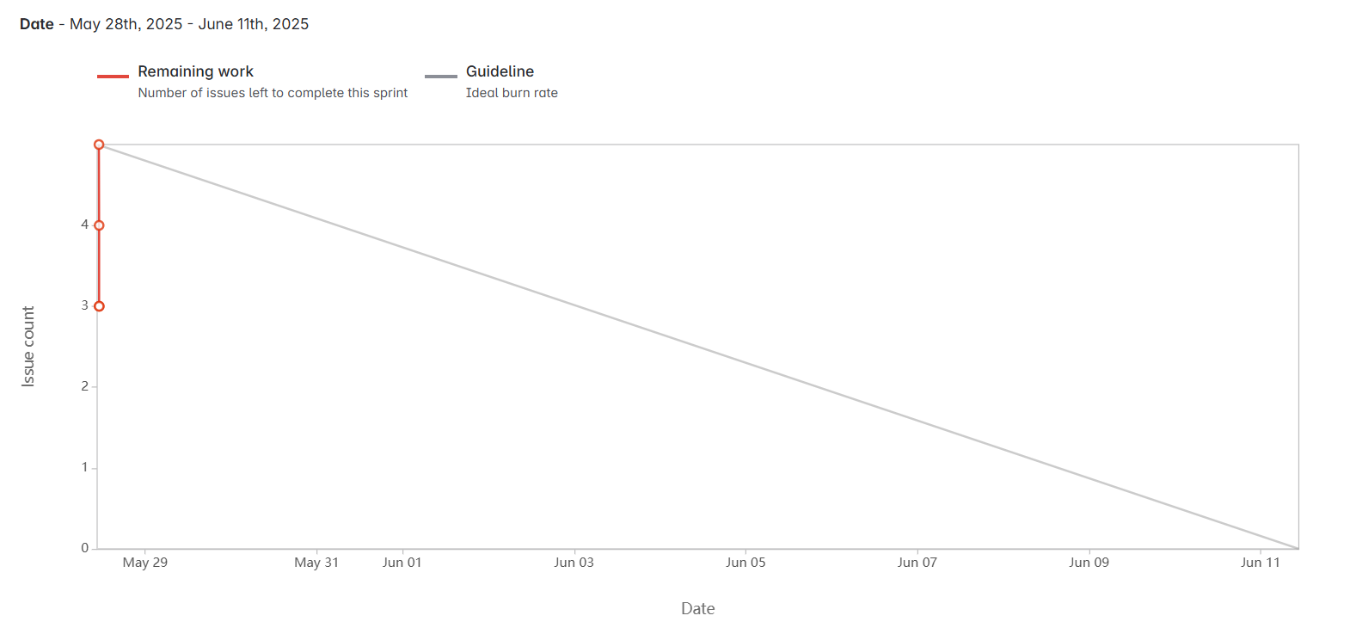
Document 6: Sprint meetings
Meeting Type 1: Sprint Planning meeting
Date | 15.05.2025
Time | 10:00
Location | Pune
Prepared By | Miss. Kalyani
Attendees | PO, Scrum Team, PM, BA

Agenda Topics
Topic | Presenter | Time Allotted
Login Complexity | PO | 2 weeks
Passbook Transactions | PO | 2 weeks
Debit card PIN | PO | 2 weeks

Other Information
Observers | Scrum master, Product owner, Business Analyst
Resources | Hardware, Software, Team
Special Notes

Meeting Type 2: Sprint review meeting
Date | 29.05.2025
Time | 10:00 am
Location | Pune
Prepared By | Miss. Kalyani
Attendees | PO, Scrum Team, PM, BA

Sprint Status | Things to Demo | Quick Updates | What’s Next
Completed | Login Functionality | Able to Login | Able to see home page.
Completed | Passbook transactions | Able to view Transactions up to 1 year | Able to download statement.
Completed | Debit Card PIN | Ale to generate Debit card PIN in application. | Able to use Debit Card.

Meeting Type 3: Sprint retrospective meeting
Date | 29.05.2025
Time | 10:00 am
Location | Pune
Prepared By | Miss. Kalyani
Attendees | PO, Scrum Team, PM, BA

Agenda | What went well | What didn’t go well | Questions | Reference
Login | Everyone supported | Unable to take help from other application’s functionality.
Passbook Transactions | Everyone supported | Unable to take help from other application’s functionality.

Meeting Type 4: Daily Stand-up meeting

Question | Name/Role | Week “X” (from dd-mm-yyyy to dd-mm-yyyy)
Question | Name/Role | Monday | Tuesday | Wednesday | Thursday | Friday | Saturday | Sunday
What did you do yesterday? | Developer 1 | User single level authentication login. | User single level authentication login. | User single level authentication login. | User single level authentication login. | User single level authentication login. | User single level authentication login. | -
What did you do yesterday? | Developer 2
What did you do yesterday? | Developer 3
What will you do today? | Developer 1 | Passbook transaction history visible up to 1 Yr. | Passbook transaction history visible up to 1 Yr. | Passbook transaction history visible up to 1 Yr. | Passbook transaction history visible up to 1 Yr. | Passbook transaction history visible up to 1 Yr. | Passbook transaction history visible up to 1 Yr. | -
What will you do today? | Developer 2
What will you do today? | Developer 3
What (if any) is blocking your progress? | Developer 1 | System Downtime. | System Downtime. | System Downtime. | System Downtime. | System Downtime. | System Downtime. | -
What (if any) is blocking your progress? | Developer 2
What (if any) is blocking your progress? | Developer 3

