Use case diagram:

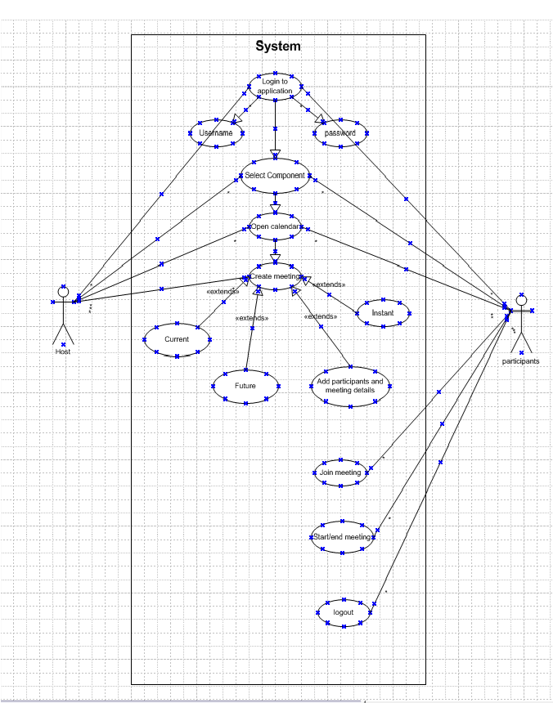

Activity Diagram:
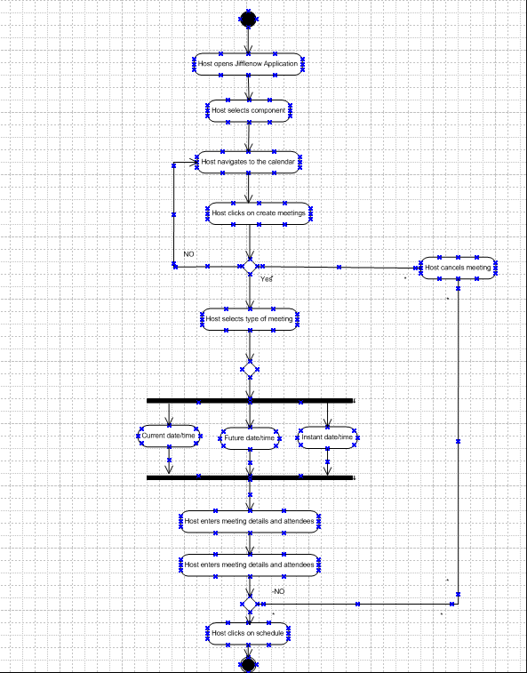

Use case specification 1 :

UC Name | Schedule meetings
UC # | 1.00
Primary Actor | Meeting host
Use Case Story | This use case enables the user to login create meeting by adding the participants and required details
Trigger | Host clicks on create meeting
Pre-Condition | User needs to have access to create meetings
Post-Condition | User should be able to schedule meetings and run it

Assumption Create meeting button should be available in the meeting calendar page
Constraints Attendees should only be able to join the meeting

Primary Flow (PF) | Title: Host is able to schedule the meeting
Primary Flow (PF) | Actor Action | System Response
Primary Flow (PF) | 1) User enters User ID
Primary Flow (PF) | 2) User enters password
Primary Flow (PF) | 3) User clicks on login button | 4) System validates User ID and password  If valid, go to next step  If invalid, go to Alternate Flow 1 (AF1)
Primary Flow (PF) | 5) User select a component
Primary Flow (PF) | 6) user clicks on the calendar icon | 7) user will be navigated to the meeting creation page
Primary Flow (PF) | 8) user clicks on the create meeting button | 9) User will be taken to the meeting creation page where the user selects participants and time slot
 | 10) User clicks on schedule button | 11) user will be redirected back to the calendar view with the meeting slot being created
Alternate Flow 1(AF1) | Title: Invalid credentials
Alternate Flow 1(AF1) | Actor Action | System Response
Alternate Flow 1(AF1) |  | 1) System displays the following error message: Invalid User ID and password. Please Re-try
Alternate Flow 1(AF1) | 2) Go to Step 1 of PF
Exception Flow 1 (EF1) | Title: Password failure count=3
Exception Flow 1 (EF1) | Actor Action | System Response
Exception Flow 1 (EF1) |  | 1) System locks the account the displays the following error message: Your account is locked. Please contact 1-800-XXX-XXXX to unlock the account.

Use case specification 2:

UC Name | Join meeting
UC # | 2.00
Primary Actor | participants
Use Case Story | This use case enables the user to login and join the meeting created
Trigger | User click on join meeting button
Pre-Condition | User needs to see the join meeting button
Post-Condition | User should be able to join meeting by clicking on join meeting
Assumption Join meeting link should be displayed on the calendar page

Primary Flow (PF) | Title: Host is able to schedule the meeting
Primary Flow (PF) | Actor Action | System Response
Primary Flow (PF) | 1) User enters User ID
Primary Flow (PF) | 2) User enters password
Primary Flow (PF) | 3) User clicks on login button | 4) System validates User ID and password  If valid, go to next step  If invalid, go to Alternate Flow 1 (AF1)
Primary Flow (PF) | 5) User select a component
Primary Flow (PF) | 6) user clicks on the calendar icon | 7) user will be navigated to the meeting creation page
Primary Flow (PF) | 8) user clicks on join button | 9) User will be taken to the join meeting page
 | 10) User joins the meetings
Alternate Flow 1(AF1) | Title: Invalid credentials
Alternate Flow 1(AF1) | Actor Action | System Response
Alternate Flow 1(AF1) |  | 1) System displays the following error message: Invalid User ID and password. Please Re-try
Alternate Flow 1(AF1) | 2) Go to Step 1 of PF

Screencomps

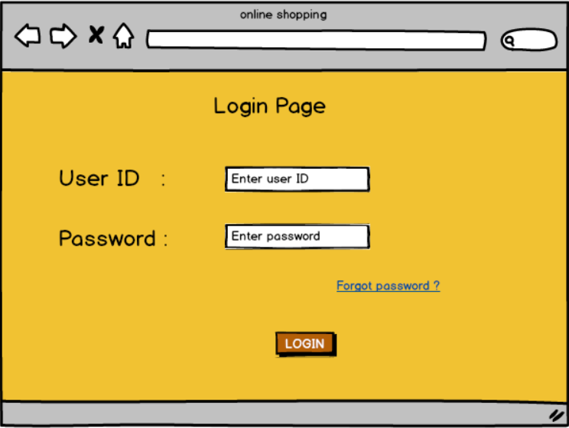
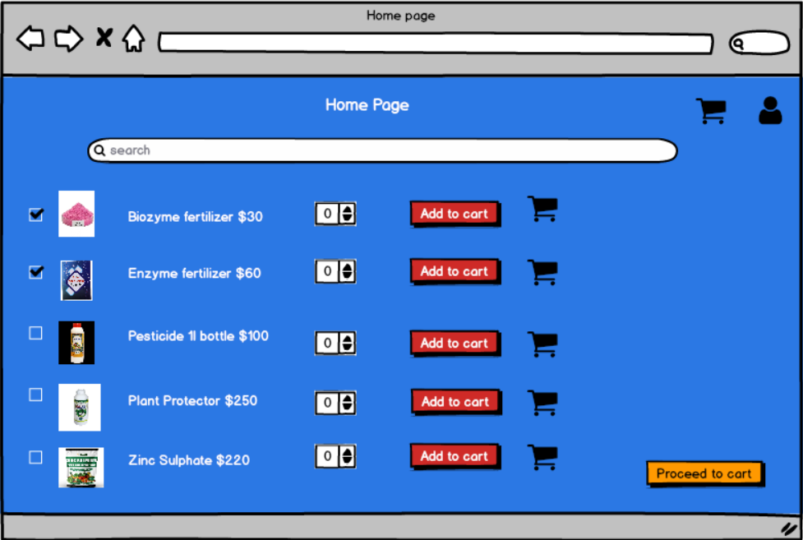
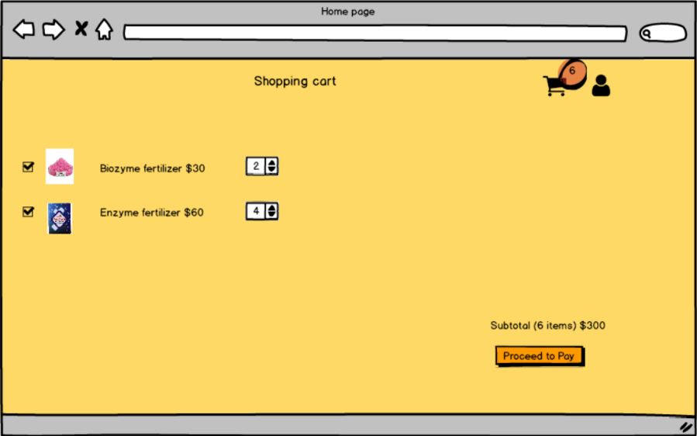
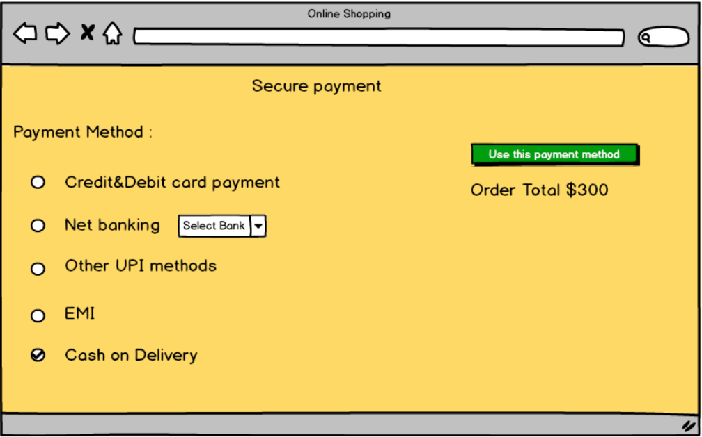
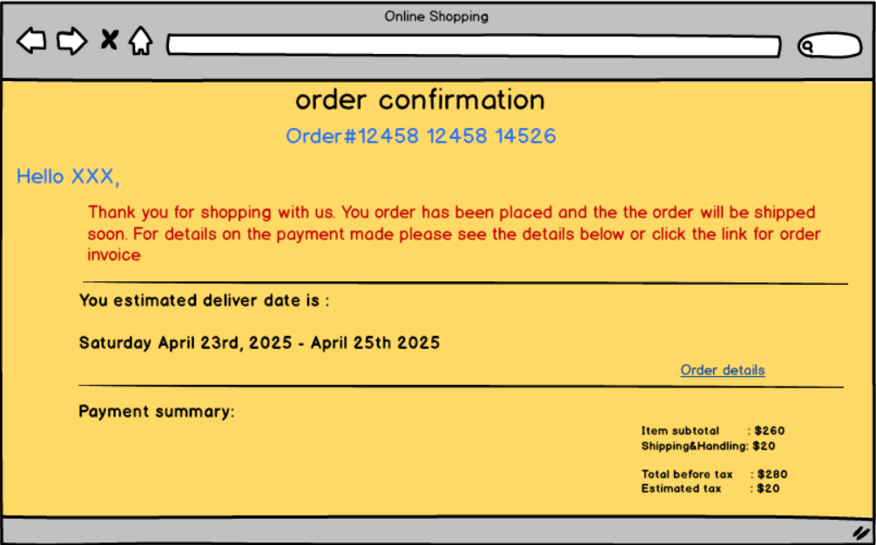

Tools used:
Tools used for preparing above pages was balasmiq. Where we can actually create a link to pages and see the slideshow. The main drawback of Balasmiq is that you cannot give inputs. Other than that there are so many options available. I find Balasmiq as the most comfortable tool for creating screencomps. There are lot of options available in the tool

My experience as BA in the following fields
1. Requirement Gathering
- Role: Elicit, document, and validate business needs.
- Activities: Conduct stakeholder interviews, workshops, and surveys.
- Deliverables: Create documents like user stories and requirement specifications, ensuring alignment with business objectives.

2. Requirement Analysis
- Role:
Understand and organize gathered requirements, identifying conflicts or gaps.
- Activities:
Analyze requirements for feasibility, business value, and potential conflicts.
- Deliverables:
Develop detailed Business Requirements Documents (BRDs) and Software Requirements Specifications (SRSs)

3. Design
- Role: Provide business and user perspectives to the design team.
- Activities: Collaborate on wireframes and user interface (UI) mockups, ensuring designs align with business goals and user expectations.
- Deliverables: Input on user experience (UX) and functional design documents

4. Development
- Role: Act as a liaison, translating requirements and providing clarity to developers.
- Activities: Support the development team by answering questions and ensuring the solution being built aligns with the specifications.
- Deliverables: Clarifications and ongoing support to ensure requirements are met.

5. Testing
- Role: Facilitate testing efforts, verifying that the developed solution meets requirements and user needs.
- Activities: Define acceptance criteria, help create test cases, and participate in User Acceptance Testing (UAT).
- Deliverables: Validated software that meets defined criteria.

6. Deployment
- Role: Support the transition of the software to the production environment and monitor its performance.
- Activities: Assist with the deployment process and monitor the system's performance post-deployment.
- Deliverables: A successfully deployed system and ongoing feedback for maintenance

