Business Goals.
1. Increased Efficiency and Productivity:
- Streamlining Processes:
Automation tools can automate repetitive tasks like data entry, report generation, freeing up human resources for more strategic work.
- Reduced Manual Effort:
By automating tasks, businesses can significantly reduce the amount of manual labour required, leading to cost savings and increased output.
- Minimizing Errors:
Automated processes are less prone to human error, resulting in more accurate and reliable outcomes.
- Faster Turnaround Times:
Automation can speed up processes, leading to quicker delivery of products and services, and faster response times to customer inquiries.
- Improved Scalability:
Automation allows businesses to handle increased workload and growth more efficiently, without needing to proportionally increase headcount.
2. Cost Reduction:
- Lower Labor Costs:
Automating tasks reduces the need for manual labour.
3. Enhanced Customer Experience:
- Faster Response Times:
Automated systems can provide instant responses to customer inquiries, leading to higher customer satisfaction.
- Improved Customer Service:
Automation can improve the overall customer service experience by streamlining processes and providing faster, more efficient service.
4. Improved Employee Satisfaction:
- Reduced Workload:
Automation can reduce the burden of repetitive tasks, allowing employees to focus on more engaging and challenging work.

BUSINESS OBJECTIVES
- Automation replaces manual, repetitive tasks with automated processes, reducing the time and effort required to complete them.
- Manual processes are prone to human error, while automated systems ensure tasks are performed consistently and accurately every time. For example, automating data validation ensures data is entered correctly and consistently across systems.
- This leads to faster turnaround times for tasks, improve customer service by providing faster response and increase overall productivity.
- By automating routine tasks, businesses can free up employees to focus on more strategic and value-added activities.
BUSINESS RULES
Business rules are conditional statements that define how a system should behave based on specific criteria.
- Clearly documented the rules that govern these processes, including any constraints, conditions, or actions that must be followed.
- Only authorised operator can login to the Tool.
- Data integrity and security must be maintained.
- Validated the tool's behaviour aligns with the documented business rules and that it produces the intended results.
- Automation requires collaboration between business users, IT teams, and the operator. This ensures that the operator can only handle tool upon completion of appropriate training.
BACKGROUND
The automation tool is developed to reduce manual work process steps, human error, and to eliminate resources by identifying inefficiencies.
The proposed Automation tool streamlines processes, minimizes human error, allowing for faster task completion, freeing up human resources for more strategic work, and improving overall productivity leading to greater accuracy and consistency in operations.
Automated systems can easily handle increased workloads and growing business demands, making it easier to scale operations without significant increases in resource.
PROJECT OBJECTIVES
- To develop an automation tool that automate payment release.
- To integrate a better work platform for better operational efficiency.
- Automated processes are generally faster than manual ones, leading to quicker completion of tasks and faster delivery.
- Automation helps optimize resource allocation by identifying inefficiencies and bottlenecks in workflows.
PROJECT SCOPE
The scope of the automation tool focuses on enhancing and streamline the process by improving overall operational efficiency by shifting the manual process to automated process.

INSCOPE FUNCTIONALITY
- Increased Efficiency: Reducing the time and effort required to complete tasks.
- Improved Accuracy: Minimizing errors and inconsistencies.
- Enhanced Quality: Ensuring that the process meets the required standards.
- Cost Reduction: Optimizing resource allocation and reducing operational costs.
OUTSCOPE FUNCTIONALITY
- Features or functionalities that are not frequently accessed or tested might be excluded to focus on more frequently used areas.
- Areas where automation scripts require constant maintenance due to frequent code changes might be deemed out of scope.
- Complex or highly dynamic UI elements might be excluded because automation is too difficult, time-consuming and need high maintenance costs.
ASSUPMTIONS
- The project will follow the Waterfall model without major changes.
- The processes and requirements being automated should be relatively stable and unlikely to change frequently.
- The tool will be used only by the authorized operators.
- VPN connection is stable and reliable for tool access.
- Operator will ensure each payment is done by the automated tool not by any manual procedure.
- Data security policies will be followed.
- The organization will provide the necessary access and user manual for the tool user.
- Regulatory compliance related to data privacy and security will be added.
CONSTRAITS
- The system must comply with existing IT security and compliance standard.
- The project must be completed with predefined budget and time.
- Only predefined user roles will be given permission for tool access.
- No major hardware upgrades will be considered during this project.
- The tool will only support desktop or laptop no other device will supported.
- Any changes in requirements after approval will require a formal change request process.
RISKS
TECHNOLOGICAL RISKS
RISK | STRATEGY
Integration issues with existing CRM & internal systems | Mitigate-Conduct early system compatibility testing and API validations
Potential data security vulnerabilities | Avoid-Implement encryption, access control, and security audits
System performance issues due to high concurrent users | Mitigate-Optimize database queries and conduct load testing
Bugs or system failure | Mitigate-Set up monitoring tools for error detection and quick resolution

SKILLS RISKS
RISK | STRATEGY
Lack of experience developers for tool implementation | Mitigate- Allocation experienced personnel
Delay in user training leading to adaptation issues | Mitigate-Schedule multiple training sessions and provide user manuals.

POLITICAL RISKS
RISKS | STRATEGY
Change in organizational priorities affecting project funding | Secure executive sponsorship and align project goals with business objectives.
Conflicts or difference in opinion among stakeholders regarding project scope | Define clear requirements and involve key stake holders in decision making
Regulatory changes impacting lead management policies | Mitigate-Regulatory review compliance policies and adjust functionalities

BUSINESS RISKS
RISK | STRATEGY
System failure impacting process and SLA and overall operational loss | Avoid- Implement redundancy and failover mechanisms
Resistance from employee in adopting the new system | Mitigate- Conduct early training and obtain feedback for necessary adjustments

REQUIREMENT RISKS
RISK | STRATEGY
Scope creep due to evolving business demands | Itigate-Enforce a strict change control process & impact analysis.
Ambiguous or incomplete requirements affecting system design | Mitigate-Refine requirements through detailed documentation and validation with end -users

OTHER RISKS
RISK | STRATEGY
Data migration issues leading to loss of historical lead data | Mitigate- Conduct backup and validation check before migration
Vendor dependency for certain software components | Mitigate-Ensure vendor support agreement and identify alternative solutions
Network outage affecting productivity | Ensure backup plans like Cross Train people

BUSINESS PROCESS REVIEW
By automating repetitive tasks, organizations can streamline the process enhancing productivity and allow employees to focus on more strategic and value-added work. The enhancement leads to better compliance, improved customer satisfaction, and increased overall business performance.
LEGACY SYSTEM(AS-IS)
Existing Challenges in the Legacy Manual System:
- Scalability: Manual processes struggle to adapt to growing business needs, becoming inefficient as the volume of work increases as each and every transaction has to pull from work platform have to filter them manually, causing delays.
- Inaccuracy: Manual customer data input, especially when dealing with large volumes of information , is susceptible to errors, leading to inaccurate insights.
- Human error: Manual processing, prone to mistakes, leading to inaccuracies, delays, and potential financial losses or reputational damage.
- Manual processes require more labour, time, and resources, leading to higher operational costs and reduced efficiency.

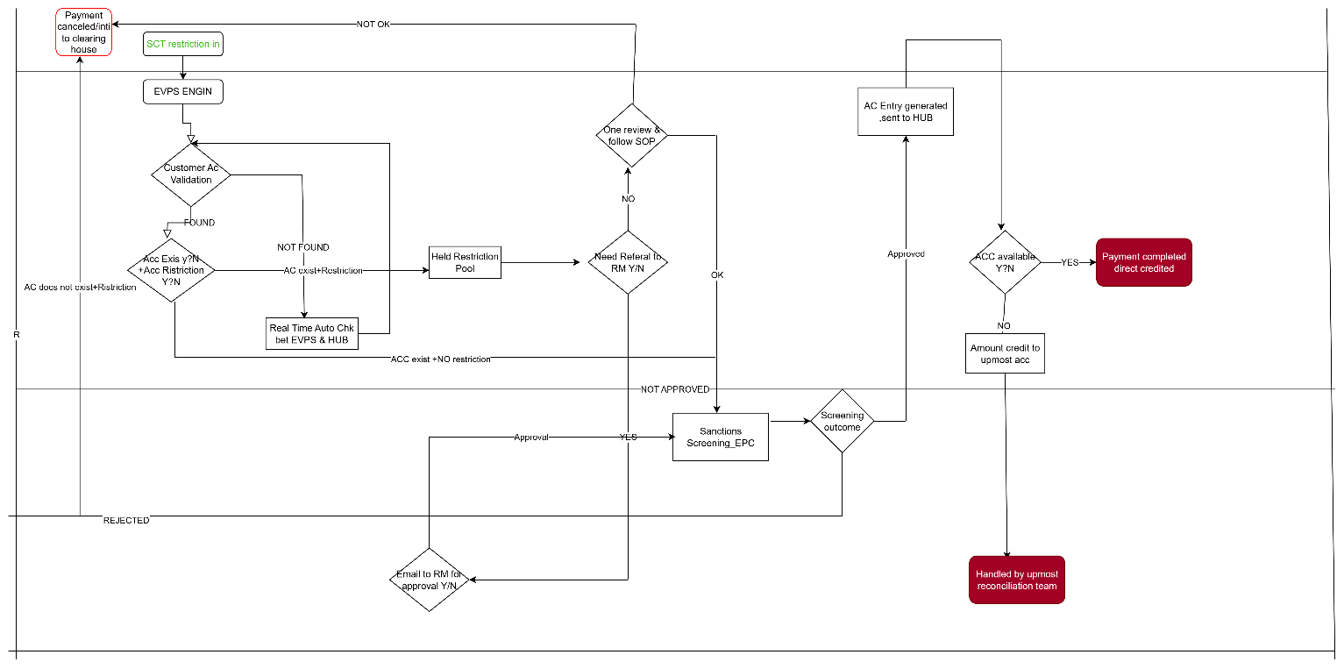

PROPOSED RECOMMENDATION(TO-BE)
1. Identify and Define the Process:
Tool Identify repetitive task, thus can avoid delay in processing, and human error.
No need of multiple approvals, or frequent handoffs.
2. No Work allocation is needed
No need of work allocation by Supervisor, the operators itself can segregate the work.
3.Map the current process: Visualize the existing workflow, including all steps.
4.Monitor and Optimize the Workflow:
- Continuously monitor the performance of the automated workflow.
- Identify areas for improvement and make necessary adjustments to optimize the workflow.
5.Continuous Integration/Continuous Delivery (CI/CD): Automation facilitates faster feedback loops and quicker payment releases
. 6.: Drafting mail
Upon successful completion of auto release of payment an auto drafted mail delivered to RM .
7. Reporting and Analysis Error Handling:
Tool generates reports or logs detailing the execution, including any successes, failures, or significant events. When errors or unexpected conditions occur, automation tools will handle them in a defined manner, such as retrying an operation, logging the error, or triggering alerts. They typically generate reports on the success or failure of their tasks.

BUSINESS REQUITREMNTS
1.The tool should be accessed only by the authorised person.
2.The tool should allow operator to categorize payment and filter the payment for execution from the payment platform.
3.The operator should be able to manually add the value date, customer id and country.
4.The tool should be able to check payment which in progress, already done payment or future payment cases.
5.The tool should be able to diaries the payment if the value date is in future.
6.The tool should be able to eliminate duplicate payment.
7. QA analyst should be assigned manually if needed.
8. Payment Id, Customer Id should be recorded by operator after releasing the payment.
9.If any payment fails or undelivered for any situation the operator should investigate the reason, notify the RM by drafting mail.
10.The EOD report should be generated to check the volume in flow, volume completed or to track any left-out payment.
11.The tool should be designed to handle a large volume
12.The system should maintain a history of all transactions history, including follow ups,redo and status changes for tracking purposes.

13.The tool should allow operators to add comments or notes for better tracking of conversations or for any corrections in future.
14.Audit logs should be maintained to track any changes made by whom and when and why
15. The tool should allow manual data exports for reporting and analysis without integrating with third -party tools.
16.A back up and recovery mechanism should be in place to ensure data protection in case of system failure.
17.The system should provide search and filter capabilities to help operator quickly find history payment on different criteria.
18. The system should trigger or notify if any payment is within TAT.
19. The system will filter large value payment urgently.
20. If any action has not been taken within the TAT the tool will auto release the payment.
21. The auto drafted mail should include RM name, Company name, Account number, Amount, Tr Id number.
22. Tool should ensure data security by identifying sanction country.
23. Tool should deliver out of office reply from RM.
APPENDICES
LIT OF ACRONYMS
Acronym | Description
HUB | HSBC Universal Banking
HFE | HSBC Front End
FVQ | Folders View Queues
DPWS | Direct Participant Workstation
GSD | Global Service Desk
EVPS | European Payments Volume System

GLOSSAERY TERMS
Term | Definition
GMG | Group Messaging Gateway is the centralized message store-and-transfer application of the HSBC group with external payment gateways for SWIFT
DPWS | It’s a remote workstation to a number of services provided by EBA (European Banking Authority) which acts as clearing house for all SEPA transactions.
HUB | Core back office and accounting system which maintains the majority of banking records, including customer accounts, balances special instructions and more

RELATED DOCUMENTS
Document Name | Description | Reference Links
Functional Specification Document FSD | Defines detailed functional requirements of Lite Automation Tool | FSD Document
Business Requirements Document BRD | Captures overall business needs & objectives | BRD Document
Requirements Traceability Matrix RTM | Maps business requirements to functional & non-functional Spes | RTM Document
Security & Compliance Guidelines | Details security policies, compliance, and data handling | Security Document
Process Flow Diagram | Illustrate As-is & To-Be workflows for Tool Implementation | Process Diagrams

