Question 1 – Audits - 5 Marks
Quarterly audits (Q1, Q2, Q3, Q4) are performance and process reviews to ensure project compliance, documentation accuracy, and continuous improvement for Business Analysts.
Objectives of Quarterly Audits: - Ensure alignment with project standards and timelines. - Verify organizational and regulatory compliance. - Check documentation accuracy and quality of deliverables.
Q1 – Planning & Requirement Audit: -
- Review of BRD, FRD, and User Stories.
- Validation and sign-off of requirements.
- Verification of requirement elicitation techniques.
Q2 – Design & Change Management Audit: -
- Review of Change Requests and impact analysis.
- Verification of design documentation and collaboration.
- Check adherence to change management procedures.
Q3 – Testing & UAT Audit: -
- Review of Test Case mapping with requirements.
- Verification of BA’s involvement in UAT and defect analysis.
- Assessment of traceability and issue resolution.
Q4 – Post-Implementation & Continuous Improvement Audit: -
- Review of post-go-live and lessons learned documents.
- Evaluation of benefit realization and performance tracking.
- Confirmation of knowledge transfer and process improvement
Audit Evidence & Documents Checked: -
- BRD / FRD / SRS
- Requirement Traceability Matrix (RTM)
- Meeting minutes & sign-offs - Change request logs
- UAT feedback and defect reports
- Post-implementation reports
Audit Outcome: -
- Audit scores or compliance rating.
- Findings and improvement areas.
- Action items for next quarter
Question 2 – BA Approach Strategy
- Understanding Project Objectives –
Before starting the project, As a BA I will first understand the business goals, scope, objectives, and high-level requirements. This will include reviewing the Project Charter and Business Case Document, conducting initial meetings with key stakeholders and sponsors, and identifying project constraints, assumptions, and success criteria.

- Stakeholder Analysis-
To ensure all key people are identified and engaged, prepare a Stakeholder Register listing their roles, responsibilities, and influence. Categorize stakeholders based on interest and impact. Use tools such as RACI Matrix to clarify roles: Responsible, Accountable, Consulted, and Informed.

- Elicitation Techniques-
To gather requirements effectively, I will apply suitable elicitation techniques based on project type and stakeholder availability like Interviews, Workshops/JAD sessions, Surveys/Questionnaires, Observation, Brainstorming, and Prototyping.

- Requirement Analysis and Documentation
Once requirements are gathered, I will analyze and prioritize them using MoSCoW (Must have, Should have, Could have, Won’t have). Key documents include BRD, FRS, NFR, Process Flow Diagrams, Use Case Diagrams, and Data Flow Diagrams.

- Document Review and Sign-Off Process
Conduct walkthrough sessions to explain requirements, record feedback, and update documents. Obtain formal sign-off from stakeholders and sponsors through email . Store all signed documents in a version-controlled repository.

- Communication and Reporting Strategy
Establish communication channels such as Email, Teams/Zoom Meetings, Define a Communication Plan including frequency, format, and responsible person for each update.

- Change Request (CR) Management
If any new requirement arises after sign-off, document the CR, analyze its impact on scope, cost, and timeline, and present it to the Change Control Board (CCB) for approval. Update requirement documents and project plan after approval.

- Tracking Progress and Status Reporting
Conduct regular progress meetings and send Weekly/Monthly BA Reports. Use tools like JIRA to track requirements and maintain a Requirements Traceability Matrix (RTM).

- User Acceptance Testing (UAT) and Client Sign-off –
Prepare UAT Scenarios and Test Cases mapped to each requirement. Support the client during UAT, resolve issues, and obtain UAT Sign-off and Client Project Acceptance Form .
- Post-Implementation Review
Conduct a Lessons Learned session, document best practices, challenges.
Question 3 – 3-Tier Architecture
Layer 1 – Presentation Layer (Front-End)
Team Members: Project Manager – Mr. Vandanam Senior, Java Developer – Ms. Juhi

Role: This is the user interface layer where users interact with the system. It displays data and
collects input.

Example: In an agriculture online store, this layer displays product listings, login pages, and order
forms.
Layer 2 – Application Layer (Business Logic)
Team Members: Java Developers – Mr. Teyson, Ms. Lucie, Mr. Tucker Role:
This is the heart of the system where business rules are applied and processed. It connects the front-end and the database. Example: When a user places an order, this layer checks product availability, calculates price, and confirms payment
Layer 3 – Database Layer (Data Layer) Team Members:
DB Admin – Mr. John, Testers – Mr. Jason and Ms. Alekya, Business Analyst – Vaishnavi
Role: This layer stores, retrieves, and manages data. Testers ensure data flow accuracy, and the BA validates business requirements. Example: Product details, customer info, and order records are stored here.

Question 4 – BA Approach Strategy for Framing Questions
- Apply the 5W & 1H Technique
1 Who – Who are the main users (farmers, wholesalers, buyers, delivery partners)? 2 What – What products will be sold (seeds, fertilizers, tools, crops, etc.)?
3 When – When will products be listed, delivered, or payments made?
4 Where – Where will the platform operate (rural areas, cities, or across regions)?
5 Why – Why is this platform needed (to connect farmers directly to buyers, reduce middlemen)?
6 How – How will users register, buy/sell, and track their orders?
- SMART Approach
1 Specific: What crops should be available seasonally on the platform?
2 Measurable: How many users or products can the system support per day?
3 Achievable: Is the farmer login process easy for low-tech users?
4 Relevant: Does the payment method suit farmers and rural users?
5 Time-bound: What is the expected go-live date for each module?

- Consider RACI Analysis
1 Responsible – Developers designing the store and payment features.
2 Accountable – Project Manager ensuring on-time delivery.
3 Consulted – Farmers, buyers, and logistics partners for feedback.
4 Informed – Senior management and regulatory authorities

- Align with 3-Tier Architecture
Frame questions based on each tier of the system:
1 Presentation Tier – What should the homepage or product listing look like? Do we need regional language support for farmers?
2 Application Tier – What business rules apply for pricing, discounts, and stock updates?
3 Data Tier – What details should be stored—farmer profiles, product categories, order history.

- Use Case & Activity-Based Questioning

1 Use Cases: How does a farmer upload a new product? What happens when a buyer places an order?
2 Use Case Specifications: What data fields are needed for registration or product upload?
3 Activity Diagrams/Models: What is the complete flow from order placement to delivery?

- Page Design & Prototype
Questions 1 How should the product page or cart appear to buyers?
2 Should we display farmer ratings and reviews?
3 Do we need a mobile-friendly layout for rural accessibility?

Question 5 – Elicitation Techniques – ( BDRFOWJIPQU)
B- Brainstorming – A group discussion technique to Generate ideas from stakeholders in free-flowing session
D-Document analysis- Reviewing existing documentation like business like reports, manuals, policies
R-Requirement workshop –structure meeting with stakeholders to collaboratively define and prioritize requirements
F-Focus group- small groups of stakeholders or users are interviewed to gather opinions and feedback.
O-Observation- Direct watching users perform tasks in their environment.
W- workshop –similar to requirements workshops but may involve broader collaboration, including brainstorming , process modelling and solution design.
J –JAD (joint application development) session- Facilitate sessions where stakeholders and developers collaborate to define and refine requirements.
Help to quick decision making and aligning requirements with business goals.
I-Interviews –one on one or group discussion with stakeholders to gather detailed requirements
P-prototyping –creating mockups , wireframes, helps stakeholders visualize requirements, and reduce misunderstanding
Q- Questionnaires/survey- Distributing structured forms to collect information from many users efficiently
U- Use case- Defining sequences of actions that users take to achieve goals in the system.

Question 6 – This project Elicitation Techniques.
Prototyping is the most suitable elicitation technique for the Agricultural Online Product Store.
Justification-
- project because it allows stakeholders to visualize the system before actual development. It helps in collecting clear and accurate requirements through visual representation of screens and system flow.
- Most stakeholders such as farmers and suppliers are non-technical, so they can easily understand the system by viewing the prototype instead of reading documents.
- It encourages early feedback, helps identify missing features, and reduces the chances of misunderstanding.
- Through prototypes, the Business Analyst can validate requirements, confirm user needs, and make necessary changes at an early stage, saving time and cost.
- It also increases stakeholder confidence and satisfaction, as they can see their ideas being implemented visually.
- Hence, Prototyping is the best technique as it ensures a clear understanding, fewer errors, and a user-friendly system design suitable for agricultural stakeholders.
Question 7 – 10 Business Requirements
BR001- User Registration and login via email id and password.
BR002- showcase product catalogue of fertilizer, seed, pesticides.
BR003- Search option available for product searching
BR004-Buy later option should be available so buyer can add product into wish list.
BR005- Before buying or adding to buy later option user should register them.
BR006- User friendly payment gateway and credit/debit card , COD, UPI payment option should be there.
BR006- Buyer can track ordered product delivery.
BR007- Buyer should get order confirmation on email id.
BR008- Buyer can give rating and product review and feedback.
BR009- Buyer should get delivery details via message or email before reaching to destination.
BR010- In case of defect in product buyer can return the product within specific period
BR011- Before buying the product customer can check estimate delivery date by submitting pin code number.

Question 8 –Assumptions

1. The platform will be user friendly.
2. It will connect farmers directly to sellers.
3. Due to limited network access in remote village area application will be lightweight and simple.
4. The platform will support multiple languages.
5. The admin will manage users, categories and product information.
6. logistics will be handled by third party delivery partners.
7. Forget password option will be available in case of users forgot password.
8.Customer support option will be available.

Question 9 – This project Requirements Priority –
REQ ID | Req. Description | priority
BR001 | User Registration and login | 10
BR002 | showcase product catalogue | 8
BR003 | Search option | 10
BR004 | Buy later option | 5
BR005 | User friendly payment gateway | 9
BR006 | ordered product delivery | 8
BR007 | rating and product review | 5

BR008 | Return the product in case of defect | 3
BR009 | check estimate delivery before ordering product | 3
BR010 | order confirmation on email id. | 8

Question 10 – Use Case Diagram

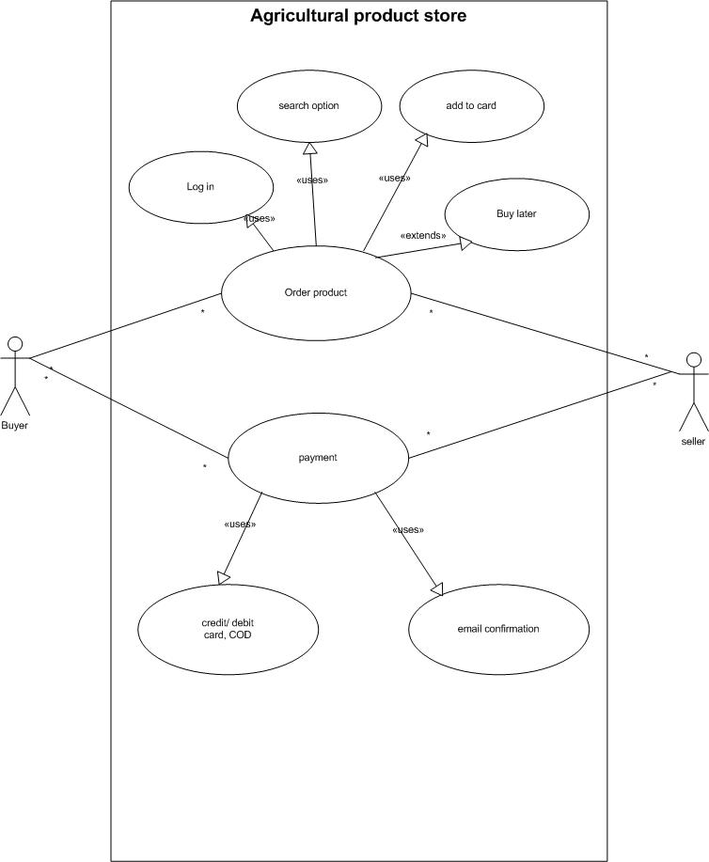

Question 11 –Use Case Specs
1.USE Case spec- Login
Description – This use case will allow to enter into the application using valid username and password.
Actor – Buyer and seller
Pre condition-
- For log in user should have user id and password.
- Network connectivity.
- User have technical knowledge .
Post condition-
- The users is successfully logged into the system and entered into homepage
- In case of invalid user id and password, error page will showcase.
Basic flow –
- The user open log in page.
- Enter user id and password
- User will enter the log in button
- In case of correct credentials system will take to homepage
- In case of incorrect credentials system will show error page
Alternate flow-
- In case of invalid user id or password system will show case error page
- User will re- enter the correct credentials
Exception flow
- Forget password
- Power failure
- Account locked
Assumptions-
- The log in page is accessible from both webs and mobile interface.
Dependencies
- User should already have register to application
- User should have user ID and password.
Input- Output
- Input user name and password
- Output successfully log in to the portal
- In case of incorrect credential error page will occure
Business Rule-
- User name – valid and unique email id
- Password- at least 1 small cap, 1 large cap and 1 number
- Password should be at least 8 character

2.USE Case spec – Register new user
Description- This use case will help to Register to new user to platform
Actor – Buyer and sellers
Pre condition –
- User should have application
- User have unique mail id
Post condition-
- By using unique email id and password user is registered.
- In case of unavailability of email id user should first have to create new email ID
Basic flow-
- User will download the application or browse the link on computer
- Click on register
- Enter unique email and password
- User will get successful registration confirmation
Alternate flow
- In case of non-availability of email id then user will first create email id
- Improper password created.
- Error will get popup to create correct user id and password.
Exceptional flow-
- Power failure
- Server down
Assumptions-
- User have smartphone
- User have network availability
- Basic technical knowledge about how to use application
Dependencies-
- User should install the application in phone.
Input –Output
- Enter unique email id and password
- Output is user is register to application
Business Rule-
- One email id should have only one account , user cannot repeat user id for multiple account open for same application.

3.Use case specs- payment
Description – This use case allow user to select a payment mode pay the charges
Actor
- BUYER
- Third party app
Pre-condition-
- Buyer log in to the portal
- Select the expected product with quantity
- Check payment amount correctly.
Post-condition-
- Buyer will get order confirmation status via email.
- Now buyer can track the delivery of product.
Basic flow
- User enter on payment button
- User will get multiple option for selection i.e. credit card,debit card or cod
- User select appropriate option
- If its credit card or debit card user will enter card number ,cvv number user will get otp on register mobile number
- Then user will confirm the payment amount and click on payment confirm
- In case of COD user will select COD option and user will pay he cash at the delivery of product
AlterNet flow-
- In case failure of network connectivity while processing payment user will get error of payment failure.
- User can re-enter the amount and card number to process the payment again.
Exceptional case-
- If due to network issue or server error if payment got debited from users account and not reflect in application then user can contact customer care of respected bank.
Assumption-
- If Buyer is selecting credit or debit card then card then user have credit or debit card number and register mobile number where user will get OPT
- User have good network connectivity.
Dependencies-
- User must have log in before payment.
- Add to card must be processed before selecting payment.
Input and output-
- User should enter correct card number and opt they payment get processed
- Output is payment get successful now user can get order confirmation mail and user can track order.
Business Rule-
- Total payment amount must be equal to card amount.

4.USES CASE SPECS – Add to card.
Description- This use case will allow user to add product for buying.
Actor- Buyer
Pre- condition-
- User should have registered themselves on application user should have login id and password.
Post condition-
- user can process for payment once they have add the product in card
Basic flow-
- user will browse the expected product
- select the quantity.
- Add the product to cart
Alternate flow-
- User will browse the product and if the product is currently unavailable then user cannot add the product to card
- Then user will select the option notify me so once the product is restored then buyer will get notification about product availability.
Exceptional flow
- Even after product is available and then user can select the product to cart then there must be network issue or server error.
Assumption-
- Product is in stock
- Customer has checked all the necessary details like price , quality and quantity.
Dependency-
- In case of unavailability of network connect user cannot add to cart the product
Input –Output-
- User select expected quantity of product and select add to card.
- Output is add to card products are ready for payment.
Business Rule- User should register themselves before add to card the product.

5.USE CASE SPECS- Buy later
Description- This use case will help the user to add the product in wish list so user can buy that product later.
Actor- Buyer
Pre-condition-
- User should log in to the portal.
- User has selected expected quantity.
- Network availability
Post condition-
- User can back to home page without any further option selection
- User can add the product in to card which they have selected in buy later option
Basic Flow-
- User will browse the product
- Check the details
- Add to buy later option
- Buyer can later add the product into add to cart
Alternate flow-
- In case of selected buy later product is got unavailable then user can browse the product again and add that product into cart.
Exceptional flow-
- In case of out of stock of expected product user cannot add in buy later optiom
Assumption
- Product is in stock
- User already log in to the portal
Dependency
- user can select the product as buy later only if product is available.
Input and output-
- user select the product and add into buy later option.
- user can add to cart the product later .
Business Rule-
- Only register user can add the product into buy later option.

Question 12 –Activity Diagrams

