Case Study 1 (Q1-Q6 ◊ 24 Marks) A customer can make a payment either by Card or by Wallet or by Cash or by Net banking.
Q1. Draw a Use Case Diagram - 4 Marks
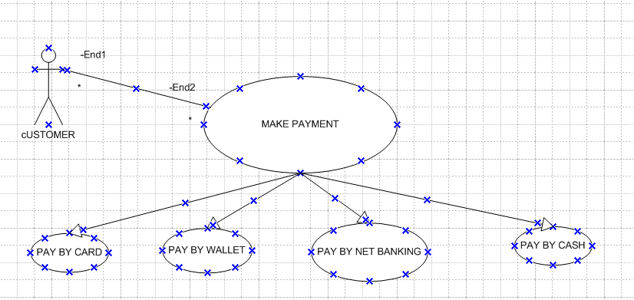

Q2. Derive Boundary Classes, Controller classes, Entity Classes. - 4 Marks
Based on the use case "A customer can make a payment either by Card or by Wallet or by Cash or by Net banking", here’s how you derive the Boundary, Controller, and Entity classes using UML design principles:

✅ 1. Boundary Classes (UI interaction points)
These represent interfaces between the system and external actors (like the customer).
- PaymentPage
- CardPaymentForm
- WalletPaymentForm
- CashPaymentForm
- NetBankingPaymentForm

2. Controller Classes (Process user input and coordinate between UI and business logic)
- PaymentController
  - Handles the logic of selecting payment mode
  - Validates payment method inputs
  - Initiates transaction request

3. Entity Classes (Contain business data and logic)
- Customer
- Payment
  - Attributes: amount, date, paymentMode, status
- Card
  - Attributes: cardNumber, expiryDate, CVV
- Wallet
  - Attributes: walletID, balance
- BankAccount
  - Attributes: accountNumber, bankName, IFSC
- Transaction
  - Attributes: transactionID, status, timestamp

Summary Table (for clarity):
Class Type | Class Names
Boundary | PaymentPage, CardPaymentForm, WalletPaymentForm, CashPaymentForm, NetBankingPaymentForm
Controller | PaymentController
Entity | Customer, Payment, Card, Wallet, BankAccount, Transaction

Q3. Place these classes on a three tier Architecture. - 4 Marks

1. Presentation Layer (UI Layer)
Handles interaction with the user (customer).
Classes:
- PaymentPage
- CardPaymentForm
- WalletPaymentForm
- CashPaymentForm
- NetBankingPaymentForm

2. Application Layer (Business Logic / Controller Layer)
Coordinates between UI and data, applies business rules.
Class:
- PaymentController

3. Data Layer (Persistence / Entity Layer)
Represents the data and business entities.
Classes:
- Customer
- Payment
- Card
- Wallet
- BankAccount
- Transaction

Visual Table Format:
Layer | Classes
Presentation | PaymentPage, CardPaymentForm, WalletPaymentForm, CashPaymentForm, NetBankingPaymentForm
Application | PaymentController
Data (Entity) | Customer, Payment, Card, Wallet, BankAccount, Transaction

Q4. Explain Domain Model for Customer making payment through Net Banking - 4 Marks

A Domain Model represents real-world conceptual classes and their relationships for a specific business scenario.

Domain: Customer Payment via Net Banking
✅ Key Conceptual Classes:
Class | Description
Customer | Represents the person initiating the payment.
Payment | Represents a generic payment made by the customer.
NetBanking | Contains bank details for Net Banking transaction.
Transaction | Records the status, timestamp, and outcome of the payment process.
BankAccount | Represents the customer's bank account used in the Net Banking payment.

Relationships:
- A Customer initiates a Payment.
- A Payment is processed via NetBanking (paymentMode = "Net Banking").
- NetBanking uses a BankAccount.
- A Payment results in a Transaction.

Domain Model Diagram (Textual Representation)
Customer --------> Payment --------> Transaction
|
|
uses NetBanking
|
links to BankAccount

Attributes (Example)
- Customer: customerID, name, email
- Payment: paymentID, amount, date, paymentMode
- NetBanking: netBankingID, bankName, IFSC
- BankAccount: accountNumber, accountHolderName
- Transaction: transactionID, status, timestamp

Q5. Draw a sequence diagram for payment done by Customer Net Banking - 4 Marks

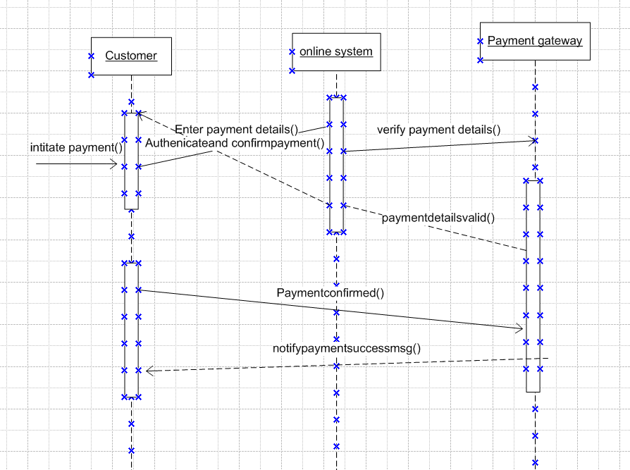

Q6. Explain Conceptual Model for this Case - 4 Marks
A Conceptual Model is a high-level, abstract representation of the system that defines the main entities, their attributes, and relationships, without considering how the system will be implemented technically.
In this case, the conceptual model focuses on the payment process and how a customer interacts with different payment methods.
Key Entities:
- Customer
  - Attributes: CustomerID, Name, Email, Phone
- Payment
  - Attributes: PaymentID, Amount, PaymentDate, PaymentType
- Payment Methods (can be modeled as subtypes or types of Payment)
  - Card: CardNumber, CardType, ExpiryDate
  - Wallet: WalletName, WalletID
  - Cash: (No additional attributes)
  - NetBanking: BankName, TransactionID
Relationships:
- A Customer can make one or more Payments.
- Each Payment is made using one Payment Method (Card, Wallet, Cash, or NetBanking).
Purpose:
This conceptual model helps in visualizing:
- The interaction between customer and payment system.
- The variety of payment options available.
- The structure of data needed to support the payment process.
It acts as a communication tool between business users and developers to ensure a shared understanding of the system.

Q7. What is MVC architecture? Explain MVC rules to derive classes from use case diagram and guidelines to place classes in 3-tier architecture - 8 Marks
1. MVC Architecture (Model-View-Controller)
MVC is a design pattern used in software engineering to separate an application into three interconnected components:
- Model:
  - Represents the business logic and data.
  - Manages rules, calculations, and data persistence.
  - Example: Payment, Customer, Order, etc.
- View:
  - Handles the presentation layer (UI/UX).
  - Displays data from the model to the user.
  - Example: Payment Page, Confirmation Screen.
- Controller:
  - Acts as an intermediary between Model and View.
  - Handles user inputs, processes requests, and updates the Model and View accordingly.
  - Example: PaymentController, OrderController.
This separation improves modularity, maintainability, and scalability.

2. MVC Rules to Derive Classes from Use Case Diagram
To derive classes from a Use Case Diagram, follow these rules:
- Identify Model Classes from nouns in use cases (e.g., Customer, Payment, Product).
- Derive Controller Classes from system events or actions (verbs) in use cases (e.g., "Make Payment" → PaymentController).
- View Classes are derived based on user interaction screens or UI components mentioned in use cases.
Example:
Use Case: "Customer makes payment"
- Model: Customer, Payment
- Controller: PaymentController
- View: PaymentPage, ConfirmationPage

The 3-tier architecture consists of:
- Presentation Tier (UI Layer):
  - Includes View Classes.
  - Responsible for displaying data and collecting user input.
  - Example: PaymentPage, OrderForm
- Business Logic Tier (Application Layer):
  - Includes Controller and Service Classes.
  - Coordinates data flow between UI and database.
  - Example: PaymentController, OrderService
- Data Access Tier (Data Layer):
  - Includes Model Classes and Database Access Components (DAOs).
  - Manages data storage, retrieval, and database communication.
  - Example: Payment, Customer, PaymentDAO

Q8. Explain BA contributions in project (Waterfall Model – all Stages) – 8 Marks

A Business Analyst (BA) plays a crucial role in each stage of the Waterfall Model, which is a linear and sequential software development process. The BA ensures that business requirements are correctly captured, communicated, and validated across all phases.

1. Requirement Gathering & Analysis
- Main Contribution:
  - Interacts with stakeholders to elicit, analyze, and document business requirements.
- Activities:
  - Conducts interviews, surveys, workshops.
  - Creates artifacts like Business Requirement Document (BRD) and Use Case Diagrams.
- Outcome:
  - A clearly defined and signed-off requirements document.

2. System Design
- Main Contribution:
  - Supports the design team by clarifying requirements.
  - Ensures functional requirements are accurately translated into system architecture.
- Activities:
  - Validates design documents (DFD, ER diagrams, screen mockups).
  - Provides business logic rules and constraints.

3. Implementation
- Main Contribution:
  - Acts as a liaison between developers and stakeholders.
  - Clarifies any ambiguous requirements during development.
- Activities:
  - Reviews user stories or development progress.
  - Ensures developers are aligned with business goals.

4. Testing
- Main Contribution:
  - Supports the QA team in understanding the business perspective.
- Activities:
  - Prepares or reviews test cases and test scenarios.
  - Helps in User Acceptance Testing (UAT).
  - Ensures the system meets the original business requirements.

5. Deployment
- Main Contribution:
  - Ensures stakeholders are ready for system rollout.
- Activities:
  - Assists with training, user manuals, and change management.
  - Coordinates with users for a smooth transition.

6. Maintenance
- Main Contribution:
  - Monitors system usage and gathers feedback for future improvements.
- Activities:
  - Logs enhancement requests, tracks issues, and updates documentation.

Summary:
The BA ensures requirement clarity, supports design and development teams, and bridges the gap between technical teams and business stakeholders throughout the Waterfall model lifecycle, ensuring delivery of a system that meets business needs.
Q9. What is conflict management? Explain using Thomas – Kilmann technique – 6 Marks
1. Conflict Management
Conflict management is the process of identifying and handling conflicts in a sensible, fair, and efficient manner. In a project or team environment, conflicts can arise due to differences in opinions, priorities, communication styles, or resource constraints.
Objective of conflict management:
To minimize negative impacts of conflict and enhance team collaboration and productivity through resolution strategies.

2. Thomas–Kilmann Conflict Management Technique
The Thomas–Kilmann Conflict Mode Instrument (TKI) identifies five main styles of handling conflict, based on two dimensions:
- Assertiveness (focus on your own needs)
- Cooperativeness (focus on others' needs)
Five Conflict-Handling Modes:
Style | Description | When to Use
1. Competing (High assertiveness, Low cooperativeness) | A win-lose approach. You pursue your own concerns at the expense of others. | In emergencies or quick decisions needed.
2. Collaborating (High assertiveness, High cooperativeness) | A win-win approach. Both parties work together to find a mutually beneficial solution. | Best for long-term problem solving.
3. Compromising (Medium assertiveness, Medium cooperativeness) | A give-and-take approach. Each party gives up something to reach a middle ground. | When a quick, temporary solution is acceptable.
4. Avoiding (Low assertiveness, Low cooperativeness) | You withdraw or postpone dealing with the conflict. | When the issue is trivial or emotions need to cool down.
5. Accommodating (Low assertiveness, High cooperativeness) | You yield to others’ needs while ignoring your own. | Useful to preserve harmony or when the issue matters more to the other person.

Q10. List down the reasons for project failure
- Unclear or Changing Requirements
– Poorly defined scope or frequent scope changes without control.
- Lack of Stakeholder Involvement
– Inadequate communication or feedback from users or sponsors.
- Poor Project Planning
– Weak timelines, unrealistic estimates, and lack of risk assessment.
- Inadequate Resources
– Insufficient budget, tools, or skilled team members.
- Lack of Leadership or Poor Management
– Weak project leadership, unclear roles, or misaligned priorities.
- Ineffective Communication
– Gaps in sharing updates, decisions, or requirements among team members.
- Technical Failures
– Integration issues, technology limitations, or poor-quality deliverables.
- Unmanaged Risks
– Ignoring or improperly handling known or unknown project risks.
- Low User Adoption or Resistance to Change
– End users not accepting the system due to lack of training or involvement.
- Failure in Testing & Quality Assurance
– Defects discovered too late due to insufficient testing efforts.

Q11. List the Challenges Faced in Projects for a Business Analyst (BA) – 6 Marks

A Business Analyst (BA) plays a key role in bridging business needs and technical solutions. However, they often face several challenges during a project:

Common Challenges Faced by a BA:
- Unclear or Evolving Requirements
– Stakeholders may not fully understand or agree on what they want.
- Lack of Stakeholder Engagement
– Difficulty in getting timely feedback or decisions from clients/users.
- Communication Gaps
– Misunderstandings between business users and technical teams.
- Changing Scope (Scope Creep)
– Continuous addition of new requirements without impact analysis.
- Conflicting Stakeholder Priorities
– Different departments or users may have opposing goals or needs.
- Time Constraints
– Limited time to gather requirements, validate them, or support development.
- Inadequate Domain Knowledge
– Lack of familiarity with the business area can slow down requirement gathering.
- Resistance to Change
– Users may resist new systems or processes the BA is helping design.
- Tool or Technology Limitations
– Restrictions in tools may affect documentation, modeling, or communication.
- Difficulty in Validating Requirements
– Ensuring that captured requirements are accurate and testable.
Q12. Write about Document Naming Standards

Document Naming Standards refer to a set of rules or guidelines used to consistently name project documents. They help ensure documents are easily identifiable, organized, and retrievable by all stakeholders throughout the project lifecycle.

Purpose of Document Naming Standards:
- Improve consistency and clarity.
- Enable easy search and access to documents.
- Avoid duplication and confusion.
- Support version control and project tracking.

Common Elements in a Document Naming Standard:
- Project Name or Code
  - E.g., AGRO, HRMS, SCRM
- Document Type or Abbreviation
  - E.g., BRD (Business Requirements Document), SRS, UAT, MTG (Meeting Minutes)
- Date (in YYYYMMDD format)
  - Ensures chronological sorting.
  - E.g., 20250616
- Version Number
  - Helps track document revisions.
  - E.g., v1.0, v2.1
- Description or Module Name (Optional)
  - Clarifies purpose of the document.
  - E.g., LoginModule, PaymentFlow

Example of a Standard Naming Format:
css
CopyEdit
[ProjectCode]_[DocType]_[Module]_[Date]_v[Version].ext
Example:
CopyEdit
SCRM_BRD_Payment_20250616_v1.0.docx

Q13. What are the Do’s and Don’ts of a Business analyst

Do’s of a Business Analyst:
- Listen Actively to Stakeholders
– Understand their needs, pain points, and expectations thoroughly.
- Document Requirements Clearly
– Use standard formats (e.g., BRD, Use Case, User Stories) that are easy to understand.
- Validate Requirements Frequently
– Confirm with stakeholders to ensure accuracy and completeness.
- Communicate Effectively
– Bridge the gap between business and technical teams with clear, consistent communication.
- Ask Questions and Clarify
– Never assume. Clarify ambiguities early to avoid future issues.
- Understand the Business Domain
– Gain domain knowledge to provide relevant and valuable solutions.
- Be Solution-Oriented
– Focus on adding value and solving real business problems.

❌ Don’ts of a Business Analyst:
- Don’t Assume Stakeholders Are Always Clear
– Misunderstood needs lead to wrong solutions.
- Don’t Ignore Non-Functional Requirements
– Performance, security, and usability are just as important.
- Don’t Rely Only on Documentation
– Continuous communication is key; documents support, not replace, discussion.
- Don’t Overcomplicate Requirements
– Keep it simple, structured, and relevant.
- Don’t Delay Clarifications
– Unresolved doubts can cause major project delays or rework.
- Don’t Take Sides in Conflicts
– Stay neutral and facilitate resolution based on facts and business value.

Summary:
A Business Analyst must be a good communicator, active listener, clear documenter, and neutral facilitator. Avoid assumptions, unclear documentation, and lack of stakeholder engagement to ensure project success.
Let me know if you want this framed as a poster or checklist!

Q14. Write the difference between packages and sub-systems
Aspect | Packages | Sub-systems
Definition | A package is a logical grouping of related classes, interfaces, or components. | A sub-system is a self-contained, independent module or part of a system.
Purpose | Organizes and simplifies the structure of models and code. | Represents a complete functional unit within the system.
Scope | More granular – used to group elements like use cases or classes. | Broader – may contain multiple packages, use cases, or components.
Dependency | Packages can depend on or relate to other packages. | Sub-systems can interact with other sub-systems via interfaces.
Modeling Tool | Represented in UML as a folder symbol. | Represented in UML as a component with interfaces.
Example | Authentication, Payment, UserManagement (packages) | Order Management System, Inventory System (sub-systems)

✅ Summary:
- Packages help organize and group related elements within a system.
- Sub-systems represent larger, functional components of the system, often combining multiple packages or modules.

Q15. What is camel-casing and explain where it will be used- 6 Marks

What is Camel-Casing?
Camel-casing is a naming convention in programming and documentation where multiple words are joined without spaces, and each word (except the first) starts with a capital letter.
- It’s called "camel case" because the capital letters resemble the humps of a camel.
- Examples:
  - customerName
  - totalAmount
  - processPayment

✅ Types of Camel-Casing:
- Lower Camel Case:
  - First letter is lowercase; used for variables, function names, etc.
  - Example: orderNumber, calculateTotal
- Upper Camel Case (Pascal Case):
  - Every word starts with a capital letter; used for class names, objects.
  - Example: CustomerDetails, PaymentMethod

✅ Where Is Camel-Casing Used?
Camel-casing is commonly used in:
- Programming Languages:
  - Used in Java, C#, JavaScript, Python, etc., for naming:
    - Variables: itemCount
    - Methods: getCustomerData()
    - Classes: InvoiceManager
- Database Fields (in some cases):
  - Field names in code mapping to DB columns: userEmail, orderDate
- API Naming (JSON, XML):
  - JSON keys often follow camel-case: { "userId": 101, "userName": "John" }
- UML and Modeling Standards:
  - Naming of attributes or operations in UML diagrams.

✅ Summary:
Camel-casing is a best practice for naming variables, methods, and classes in programming to make names readable and consistent. It improves code clarity and maintainability across teams
Q16. Illustrate Development server and what are the accesses does business analyst has? -6
Development Server?
A Development Server is a dedicated environment where developers build, test, and integrate code during the software development lifecycle. It mimics the production setup but is used only for internal development and testing purposes.

Key Features of a Development Server:
- Contains early versions of the application/code.
- Used by developers, testers, and BAs for functional verification.
- Supports unit testing, integration testing, and requirement validation.
- Not customer-facing – strictly internal.

Illustration (Simple Text Diagram):
pgsql
CopyEdit
+--------------------------+
| Development Server |
+--------------------------+
| - Source Code Repository |
| - Application Build |
| - Database (Test Data) |
| - Logs & Error Tracking |
+--------------------------+

Business Analyst's Access in Development Server:
A Business Analyst (BA) typically has limited but essential access to the development server for the purpose of validation, testing, and requirement alignment.

BA Access Rights Include:
- Read-Only Access to Application
– To review new features and confirm they align with requirements.
- Test Environment Access
– To assist QA in verifying user stories or business rules.
- Log Access (View Only)
– For reviewing error logs or debugging information with developers.
- Requirement Traceability Checks
– To ensure all requirements are being correctly implemented.
- No Code Access (Typically)
– BAs do not modify or deploy code – that’s the developer’s responsibility.

Summary:
A Development Server is a safe zone for building and testing software. Business Analysts have read/test access, enabling them to validate functionality, support QA, and ensure alignment with business requirements, but not to change code or deploy updates.

Q17. What is Data Mapping 6 Marks

Definition of Data Mapping (2 Marks)
Data Mapping is the process of matching fields or elements from one data source to another. It defines how data from the source system corresponds to data in the target system, ensuring correct transformation, migration, or integration of data.

✅ Purpose of Data Mapping (1 Mark)
- To enable data migration, data integration, and data transformation between systems.
- Ensures data accuracy, consistency, and compatibility between applications or databases.

✅ Where It Is Used (1 Mark)
Data Mapping is commonly used in:
- System Integration (e.g., CRM to ERP)
- Database Migration
- ETL Processes (Extract, Transform, Load)
- API Data Exchange
- Reporting and BI tools

Example of Data Mapping
Source Field (System A) | Target Field (System B)
cust_name | customerFullName
dob | dateOfBirth
mobile_no | phoneNumber
This shows how fields from one system align with another system’s structure.

Types of Mapping (Optional Mention for Depth)
- 1-to-1 Mapping: One field to one field.
- Many-to-One Mapping: Multiple source fields combined into one.
- One-to-Many Mapping: One source field split into multiple target fields.

Summary:
Data Mapping is a critical process that ensures the correct flow and transformation of data between systems. It is essential for system integration, migrations, and maintaining data integrity across platforms.

Q18. What is API. Explain how you would use API integration in the case of your application Date format is dd-mm-yyyy and it is accepting some data from Other Application from US whose Date Format is mm-dd-yyyy 10 Marks

API
API (Application Programming Interface) is a set of protocols, rules, and tools that allow different software applications to communicate with each other.
- APIs enable data exchange between two systems.
- They can be RESTful, SOAP, or GraphQL, commonly used in modern web applications.
- Example: When a payment gateway is integrated into an e-commerce site, it uses APIs to send payment information and receive responses.

2. API Integration in the Given Case
Case Description:
- Your application accepts date input in dd-mm-yyyy format (e.g., 16-06-2025).
- The external application (from the US) sends date in mm-dd-yyyy format (e.g., 06-16-2025).
- Integration is needed via API to ensure data is received and stored correctly.

Steps to Handle API Integration with Date Format Differences:
a. API Endpoint Setup
- Your application exposes or consumes an API endpoint for receiving data.
- Example: POST /api/customerData
b. Parsing and Validation Logic
- When the US system sends the date (mm-dd-yyyy), your application must:
  - Parse the incoming date
  - Convert it into dd-mm-yyyy format before saving or processing
- This can be done using date handling libraries in most languages (e.g., JavaScript, Python, Java).
Example in Python:
python
CopyEdit
from datetime import datetime

us_date = "06-16-2025"
converted_date = datetime.strptime(us_date, "%m-%d-%Y").strftime("%d-%m-%Y")
print(converted_date) # Output: 16-06-2025
c. Data Mapping
- Ensure API documentation clearly defines the expected date format on both sides.
- Use data transformation logic in the middleware layer or controller before saving to DB.
d. Testing & Error Handling
- Validate incorrect formats and return meaningful error messages like:
  - "Invalid date format. Expected mm-dd-yyyy."
- Implement unit and integration tests to ensure dates are handled correctly.
e. Logging and Monitoring
- Log incoming requests and converted data for traceability.

Summary:
- API is used to integrate your application with external systems to exchange data automatically.
- In this scenario, date format mismatch is a key challenge.
- Use parsing and format conversion logic during API processing to ensure data consistency.
- Proper error handling, validation, and documentation are critical for successful API integration.

