Question 1 – Audits, 4 Quarterly Audits are planned Q1, Q2, Q3, Q4 for this Project
Ans:
Quarter 1:
Stage | Quarter 1 Audit Report(Requirement gathering phase)
Completed | 10 weeks (Week 1 to Week 10)
Check list | BRD template
 | Elicitation results report
 | Grouping of functionalities/ features-client signoff
 | Email communication To: Client stakeholders, CC: project Manager, BCC: Delivery Head

Stage | Quarter 1 Audit Report (Requirement analysis phase)
Completed | 10 weeks (Week 1 to Week 10)
Check list | UML diagrams
 | Business to functional requirements mapping
 | Client signoff- documents
 | RTM document version control
 | Email communication To: Client stakeholders, CC: project Manager, BCC: Delivery Head

Quarter 2:

Stage | Quarter 2 Audit Report (Design)
Completed | 7 weeks (Week 11 to Week 18)
Check list | Utilization of tools: Balsmiq, axure, ms-visio
 | Stakeholder MOM
 | Client signoff- documents
 | Email communication To: Client stakeholders, CC: project Manager & Project Team, BCC: Delivery Head

Quarter 3:
Stage | Quarter 3 Audit Report(Development)
Completed | 20 weeks (Week 19 to 39)
Check list | JAD session report
 | End user manual preparation document
 | BA and developer MOM
 | Email communication To: Client stakeholders, CC: project Manager & Project Team, BCC: Delivery Head

Stage | Quarter 3 Audit Report(Testing)
Completed | 20 weeks (Week 19 to 39)
Check list | Test case summary
 | Training report to end users
 | Email communication To: Client stakeholders, CC: project Manager & Project Team, BCC: Delivery Head

Quarter 4:

Stage | Quarter 4 Audit Report(Deployment & Implementation)
Completed | 4 weeks (Week 79 to Week 82)
Check list | Document of deployment plan including timelines, resources, and rollback procedures.
 | Record of Validate deployment environment matches testing environments.
 | Loging Monitor deployment for issues and unexpected behaviours.
 | Document of Validate deployment success through smoke testing or sanity checks.
 | Email communication to: Client stakeholders, CC: project Manager & Project Team, BCC: Delivery Head

--------------------------------------------------------------------------------------------------------------------------------------

Question 2: BA Approach Strategy
Ans:
- What Elicitation Techniques to apply: We have many elicitation techniques to apply used to gather requirements. Some of them used in this project are: Brainstorming, Document Analysis, Prototyping, use case spec, etc…
- How to do Stakeholder Analysis RACI: Stakeholder analysis can be done by using the RACI matrix involves identifying stakeholders and defining their roles and responsibilities within a project. - Identify Stakeholders, Define Roles and Responsibilities, Create the RACI Matrix, Assign RACI Roles (Responsible, Accountable, Consulted and Informed)
Responsible: Mr. Karthik (Delivery Head), Mr. Vandanam (project Manager), Ms. Juhi(Senior Java Developer), Mr Mouleeshwaran V (Business Analyst)
Accountable: Mr. Henry, Mr. Pandu, Mr. Dooku (Client SPOC)
Consulted: Mr Teyson, Ms. Lucie, Mr. Tucker and Mr Bravo (Java Developers), Mr Mike (Network Admin), Mr John (DB Admin), Mr Jason and Ms Alekya (Testers)
Informed: Mr. Peter, Mr. Kevin, Mr. Ben (Client SPOC)
- What Documents to Write: BRD(Stake holder analysis, Elicitation techniques, requirements sorting, prioritize requirements and validate requirements) , FRD(Documents contains functions and features(use case and activity diagrams)), Use Case Documentation(Use case name, description, conditions, basic flow, alternate flow, Exceptional flow, Assumption), Test Case Documents(the document which have the input data, expected behaviour, actual behaviour, comments and results) & etc..
- What process to follow to Sign off on the Documents: Sign Off to be taken on SRS (Which contains functional and non-functional requirements) as this is the primary and important document. Sign off can be taken by using E-mail confirmation from Client.
- How to take Approvals from the Client: Establish a formal meeting with the clients to keep them informed and get continuous feedback.
- What Communication Channels to establish n implement: Regular Meetings - Weekly status meetings, reviews, and monthly stakeholder updates.
- How to Handle Change Requests: Initially BA should check the change request whether it is a defect from previous installations or not. If it is a defect then it is assigned to the technical team else BA should be do the following

1. Impact Analysis
2. Feasibility Study
3. Effort Estimation
- How to update the progress of the project to the Stakeholders: Weekly Status Reports, Monthly Review Meetings.
- How to take signoff on the UAT- Client Project Acceptance Form: UAT Preparation, Conduct UAT, Fix Issues, Acceptance Form, Final Review Meeting, Obtain Sign-off.

Question 3 – Explain and illustrate 3-tier architecture?
Ans:
Layers | Information
Application Layer | Screens, Pages, Validations on Page,  Company Specific logic, Functionality
Business Logic Layer | All Re-usable components (Third party plugin), Frequently changing components,  Governing Body Rules & Regulations, Compliances
Data Layer | Database components connecting to Databases

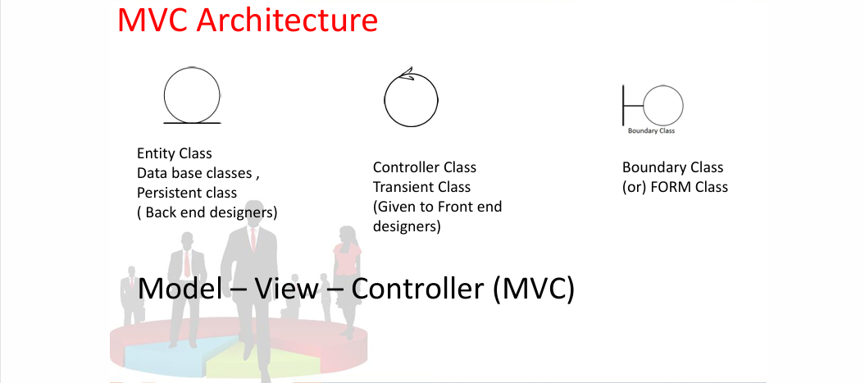

Guidelines to place identified MVC Classes in a 3 Tier Architecture
- Place all Entity Classes in DB Layer
- Place Primary Actor associated Boundary Class in Application Layer
- Place Controller Class in Application Layer
- If governing Body influence or Reusability is there with any of remaining Boundary Classes , place them in Business Logic Layer else place them in Application Layer

Question 4 – BA Approach Strategy for Framing Questions
Ans:
- The 5W1H framework is a tool is used for extracting requirement form client like Why, What, Where, Who, When & How
Example: In the Login feature we check with 5w1h framework:
Why: To Authenticate the users to the application
What: To Track the user behaviour in the application
Where: Home page of Agro e-commerce application
Who: Farmers and manufacturers have to login for the activity of purchase and updating the product catalogue
When: Farmers (Buy the product or buy later options), Manufacturer (Update the product catalogue)
How: Both farmers and manufacturers login with (email and password)
- The SMART technique can help in Validating the requirements and it’s used to confirm the requirement before accepting for the development:
(Specific, Measurable, Attainable, Relevant & Time Bound)
Example:
Specific: The login feature is must for all the users to track their behaviours and activities
Measurable: This feature impacts to analysis most listed product in the financial year and most purchase product and high user in geographic place.
Attainable: This feature can be developed in technologies like (Java and sql)
Realistic: The third-party plugin can be used to login with google account or any social media account
Time Bound: To develop and test the feature will take 3 hrs – 4 hrs
- RACI charts help define and clarify roles and responsibilities within a team by outlining who is responsible, accountable, consulted, and informed for each task.
Responsible: Mr. Karthik (Delivery Head), Mr. Vandanam (project Manager), Ms. Juhi (Senior Java Developer), Mr Mouleeshwaran V (Business Analyst)

Accountable: Mr. Henry, Mr. Pandu, Mr. Dooku (Client SPOC)

Consulted: Mr Teyson, Ms. Lucie, Mr. Tucker and Mr Bravo (Java Developers), Mr Mike (Network Admin), Mr John (DB Admin), Mr Jason and Ms Alekya (Testers)

Informed: Mr. Peter, Mr. Kevin, Mr. Ben (Client SPOC)
- 3-tier Architecture:
Layers | Information
Application Layer | Farmer loginBC, loginCC
Business Logic Layer | Login with login serverBC
Data Layer | FarmerEC, login serverEC
- Use case:
    - A Use case is a high-level diagram.
    - The main purpose of the diagram is to identify the requirement.
    - A use case diagram is an actor specific.
    - Essential Use Cases: Makes sense and completeness to the end user (Create Account, Login, Search Option, Payment, Order and delivery status)
    - Supporting Use Cases: Makes sense and supports Essential Use case (Buy product, Buy later, Product catalogue, Cod, Card payment, UPI)
    - Actors: Primary Actor directly interacts with the system (Farmer and manufacturer) and Secondary Actor supports the system (E-commerce app, login server, bank and FCH)
- Use case Specs: Every Use case will have it’s own use case Description Document or Use case Specification
- Activity Diagram: An activity diagram is drawn to model how the system should function in order to achieve Business Logic, Business Functionality and Business Objectives.Activity diagram is basically a flow chart to represent the flow form one activity to another activity.

--------------------------------------------------------------------------------------------------------------------------------------
Question 5 – What Elicitation Techniques you are aware of?
Ans:
Requirement Elicitation Techniques are classified into different types they are:
  - Document Analysis
  - Reverse Engineering
  - Focus Groups
  - Observations
  - Workshops
  - JAD
  - Interview
  - Prototyping
  - Questionnaire
  - Brainstorming
  - Use case Specs
Document Analysis
Document analysis is done through reading a document and understanding the product, process and project.
Reverse Engineering
- Reverse engineering, also called back engineering, is the processes of extracting knowledge or design information from anything man-made and re producing it or re-producing anything based on the extracted information.
- The process often involves disassembling something and analysing its components and workings in detail. Majorly used in migration projects.
Focus Groups
A focus group is a means to elicit ideas and attitudes about a specific product, service or opportunity in an interactive group environment.
Observations
Observing, shadowing users or doing a part of their job, can provide information of existing processes, inputs and outputs.
Workshop
A requirement workshop is a structured approach to capture requirements. A workshop may be used to scope, discover, define, prioritize and reach closure on requirements for the target system.
JAD (Joint Application Development)
Application developed through JAD has higher customer satisfaction and less number of errors as user is directly involved in the development process.
Interview
Interview of a user and stakeholders are important in creating software.
An interview is a systematic approach where interviewee is going to ask relevant questions related to software and documenting the responses.
Prototyping
Prototyping is an attractive idea for complicated and large systems for which there is no manual process or existing system to help determining the requirements
Questionnaire
Questionnaire can be useful for obtaining limited system requirements details form the users/ stakeholders, who have minor input or are geographically remote.
Brainstorming
- Brainstorming can be done either individually or in groups. The ideas collected during the brainstorming session are reviewed or analysed.
- Brainstorming is an effective way to generate lots of ideas on a specific issue and then determine which idea is the best solution.
Use case specifications:
Every Use case will have it’s own use case Description Document or Use case Specification
1. Use case Name
2. Use case Description
3. Actors Primary Actors Secondary actors
4. Basic Flow
5. ALTERNATE FLOW
6. Exceptional flows
7. Pre- Conditions
8. Post- conditions
9. Assumptions
10. Constraints
11. Dependencies
12. Inputs and Outputs
13. Business Rules
14.Miscellaneous Information

Question 6 – This project Elicitation Techniques
Ans: In this Project we have chosen the below elicitation techniques to Gather the requirements
Prototyping: In this stage we use all the business requirements in to UI design to give demo to the client how our application will look like after development Eg: (Login page, search products, payment page, etc…). Which help us to get the approval from the client.
Use case Specs: In the Use case specification stage we take all the business requirements we build the use case description, conditions, basic flow, alternate flow, exceptional flow and Assumptions, it is used to have the clear understanding of each business requirements.
Document Analysis: In this Project, Document analysis is Used to understand the project goal and its process.
Brainstorming: Brainstorming is Used to conduct the sessions with SME’s and project team, to address the complicated problem in the project. Solutions and suggestions will be rated and it helps to implement in the current blocker of a project.

--------------------------------------------------------------------------------------------------------------------------------------

Question 7 – 10 Business Requirements
Ans:
Business requirements are the specific needs or conditions that a business must meet to achieve it objectives, Every Business Requirements will have project id with business requirement ID
Business Requirement ID | Requirements
PQ1BR001 | Farmers should be able to search for available products in fertilizers, seeds, pesticides
PQ1BR002 | Manufacturers should be able to upload and display their products in the application
PQ1BR003 | Farmers should be able to create a new account using their email ID and set a secure password.
PQ1BR004 | All users (Farmers and Manufacturers) must have a login feature to access role-specific application functionalities.
PQ1BR005 | Farmers should be able to add products to a “Buy Later” list (Wishlist) after logging in.
PQ1BR006 | The application must support secure payment options including Credit/Debit card, UPI, and Cash on Delivery (COD).
PQ1BR007 | Farmers should receive email confirmation upon order placement, including order details and estimated delivery.
PQ1BR008 | The system must include a delivery tracking feature that enables farmers to monitor the status of their orders in real-time.
PQ1BR009 | The application must be user-friendly and accessible to users with limited technical expertise, including those from remote areas
PQ1BR010 | The system should allow farmers to leave feedback or ratings for products after delivery.

Question 8 –Assumptions
Assumption 1: User can sign in with their google accounts or any social media accounts
Assumption 2: The farmers and manufacturers have access to a stable internet connection in their remote locations.
Assumption 3: Farmers are familiar with basic online shopping processes or will be provided with necessary training or help materials.
Assumption 4: Manufacturers are willing to regularly update product availability and stock status
Assumption 5: The payment gateway partners and COD facility are available and can service remote village locations
--------------------------------------------------------------------------------------------------------------------------------------

Question 9 – This project Requirements Priority
Ans: Priority Points are given based on the based on the business value and taking help of software developers, we will be giving those priority
Business Requirement ID | Requirements | Priority
PQ1BR001 | Farmers should be able to search for available products in fertilizers, seeds, pesticides | 10
PQ1BR002 | Manufacturers should be able to upload and display their products in the application | 9
PQ1BR003 | Farmers should be able to create a new account using their email ID and set a secure password. | 7
PQ1BR004 | All users (Farmers and Manufacturers) must have a login feature to access role-specific application functionalities. | 9
PQ1BR005 | Farmers should be able to add products to a “Buy Later” list (Wishlist) after logging in. | 8
PQ1BR006 | The application must support secure payment options including Credit/Debit card, UPI, and Cash on Delivery (COD). | 10
PQ1BR007 | Farmers should receive email confirmation upon order placement, including order details and estimated delivery. | 6
PQ1BR008 | The system must include a delivery tracking feature that enables farmers to monitor the status of their orders in real-time. | 9
PQ1BR009 | The application must be user-friendly and accessible to users with limited technical expertise, including those from remote areas | 10
PQ1BR010 | The system should allow farmers to leave feedback or ratings for products after delivery. | 5

--------------------------------------------------------------------------------------------------------------------------------------

Question 10 – Use Case Diagram
Ans:
- A Use case is a high-level diagram.
- The main purpose of the diagram is to identify the requirement.
- A use case diagram is an actor specific.
- Essential Use Cases: Makes sense and completeness to the end user (Create Account, Login, Search Option, Payment, Order and delivery status)
- Supporting Use Cases: Makes sense and supports Essential Use case (Buy product, Buy later, Product catalogue, Cod, Card payment, UPI)
- Actors: Primary Actor directly interacts with the system (Farmer and manufacturer) and Secondary Actor supports the system (E-commerce app, login server, bank and FCH)
- Generalization: is a kind of Parent Class exist through one (or more) of Child Classes
- Include – Compulsory: Parent Class is NOT complete without Child Classes, Direction of Arrow – based on dependency Not information flow
- Extend – Optional: Parent Class exist without Child Classes

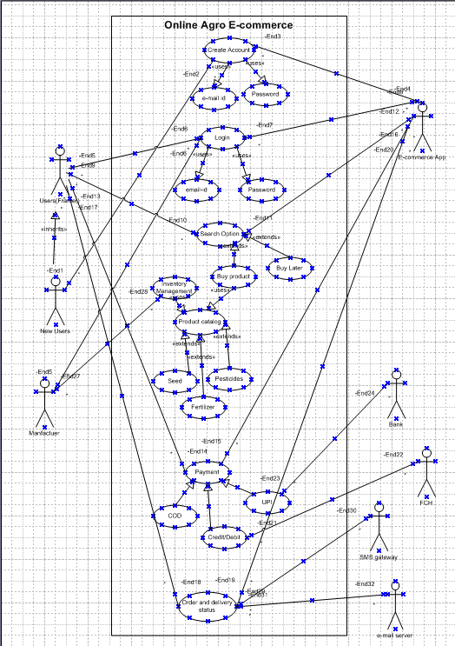

Question 11 – Use Case Specs
Ans:
Use case specifications:
Every Use case will have it’s own use case Description Document or Use case Specification
- Use case Name
- Use Case Description
- Actors Primary Actors Secondary actors
- Basic Flow
- ALTERNATE FLOW
- Exceptional flows
- Pre-Conditions
- Assumptions
Login:
Use case id: | UC 001
Use case Name: | Login
Created by | Mouleeshwaran V | Last Updated by | 23/08/25
Date Created | 23-08-2025 | Last revision Date | 26-08-2025
Actor | User and Login Server
Description | User has to log in to the Page
Precondition | User Need to have email id and password
Normal Flow | 1) User enter the email address  2) User enters the correct Password  3) If both are successful, the user can log into a home page
Alternate Flow | 1) If it is a wrong email ID, they can sign in again by typing the correct email ID  2) If the password is wrong, they can type the correct password again  3) If the Password is forgotten, they can click forgot password option they can type their email address, the temporary password will be sent to their email-id.
Exception | Without a Login User can search, browse the product catalogue
Frequency of use | High
Assumptions | User can sign in with their google accounts or any social media accounts

Create Account:
Use case id: | UC 002
Use case Name: | Create Account
Created by | Mouleeshwaran V | Last Updated by | 23/08/25
Date Created | 23-08-2025 | Last revision Date | 26-08-2025
Actor | New User and Login Server
Description | New User has to create a credential account
Precondition | User must have a Valid email ID
Normal Flow | 1) Creating an account with valid email-id  2) Creating password with special characters and numbers  3) verification email will be sent to your registered email-id  4) After clicking the verification link  5) User can login to app
Alternate Flow | 1) User can search the product catalogue with login into the ap  2) User can select the products into catalogue
Exception | 1) User can search the product catalogue with login into the app  2) User can select the products into catalogue
Frequency of use | Low
Assumptions | User can create account with google account or any social media account

Search:
Use case id: | UC 003
Use case Name: | Search the products
Created by | Mouleeshwaran V | Last Updated by | 23/08/25
Date Created | 23-08-2025 | Last revision Date | 26-08-2025
Actor | User and e-commerce app
Description | Search the products catalogue to browse and select the products
Precondition | No perquisites
Normal Flow | 1) In the search option, the Product catalogue is visible  2) In the product catalogue, we have products like(Seeds, pesticides, fertiliser)  3) Farmer can browse the products and select the products what they want
Alternate Flow | 1) In the search option, the Product catalogue is visible  2) In the product catalogue, we have products like(Seeds, pesticides, fertiliser)  3) Farmer can browse the products
Exception | Farmer can browse the product
Frequency of use | High
Assumptions | No Assumptions

Manufacturer Upload:

Use case id: | UC 004
Use case Name: | Manufacturer Upload Information
Created by | Mouleeshwaran V | Last Updated by | 23/08/25
Date Created | 23-08-2025 | Last revision Date | 26-08-2025
Actor | Manufacturer and e-commerce application
Description | Manufacturer can upload information of the product
Precondition | manufacturer has to log in
Normal Flow | 1) The manufacturer has a login  2) In their Product catalogue session, they need to add the product list, quantity and their price.  3) Update the stock on regular basis.
Alternate Flow | 1) The manufacturer has a login  2) In their Product catalogue session, they need to add the product list, quantity and their price.  3) Update the stock on regular basis.
Exception | Manufacturer has upload the product information in the product catalogue
Frequency of use | Medium
Assumptions | Manufacturer updates the products on a Daily Basis

Buy Products and Buy later:
Use case id: | UC 005
Use case Name: | Buy Products and Buy later
Created by | Mouleeshwaran V | Last Updated by | 23/08/25
Date Created | 23-08-2025 | Last revision Date | 26-08-2025
Actor | User, E-commerce App, bank and fch
Description | To Buy Product, we need to login and access the payment gateway, and to buy later we need login
Precondition | Login is a must for buying the product and buying later products
Normal Flow | 1) To buy the product, the User has to log in  2) The user should have selected the products  3) Then the user has to select the payment gateway  4) User selects the Payment mode  5) Then Paying the product  6) For Buy Later User has login
Alternate Flow | 1) To buy the product, the User has to log in  2) The user should have selected the products  3) Then the user has to select the payment gateway  4) User selects the Payment mode  5) Then Paying the product  6) For Buy Later User has login
Exception | Login is a must for buying the product and buying later products
Frequency of use | Medium
Assumptions | Login is must

--------------------------------------------------------------------------------------------------------------------------------------

Question 12 – Activity Diagrams
Ans:
Activity Diagram:
An activity diagram is drawn to model how the system should function in order to achieve Business Logic, Business Functionality and Business Objectives.
Activity diagram is basically a flow chart to represent the flow form one activity to another activity.
Decision Box: A diamond symbol, indicating a choice. Workflow will proceed along one of a number of possible paths, according to the guard conditions.
Start Node: Indicates where the workflow begins.
Final node: Indicate that the workflow is completed.
Activity: Indicates a step in the process. It is a unit of work done by the system.
Branch And Merge: Between a Branch n Merge, we can have n number of paths. For the control to pass from branch to merge at least 1 path should execute. The condition between the paths will be “OR”.
Fork and Join: Between a Fork n Join, we can have n number of paths. For the control to pass from
Fork to Join all the paths should execute. The condition between the paths will be “AND”.

Create Account:

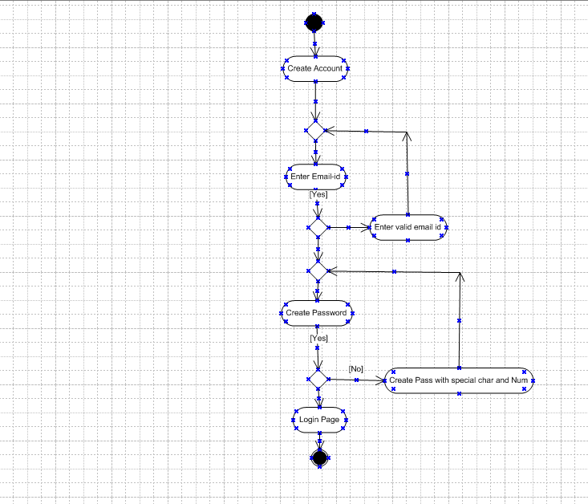

Login:
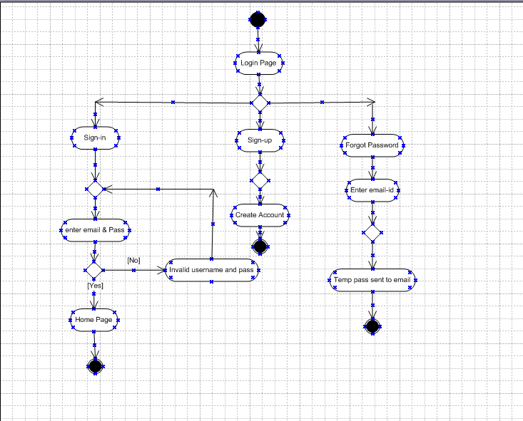

Search Option:
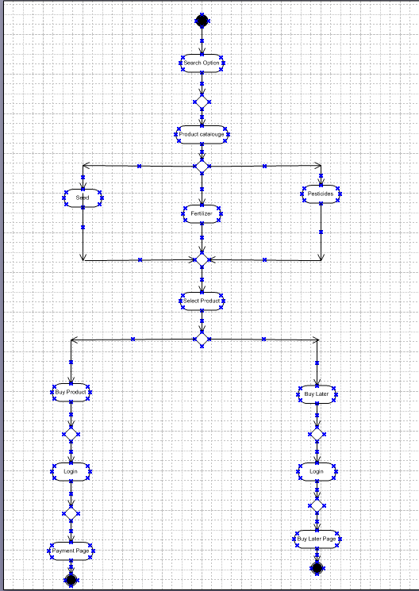

Payment:
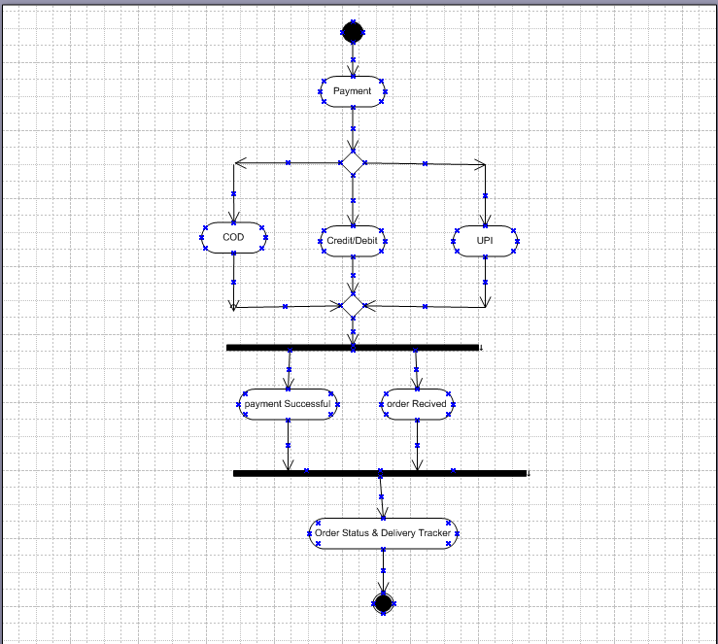

Complete Flow:
