BA Mock 4
Prepared By
Aswitha Thoppay Chandrasekaran
2025

BA Mock-4
A company is having manufacturing plants and warehouses in various parts of the country. They manufacture ice-cream and milk products. They want to build software to achieve two goals.
- Manage the inventory
- Quickest delivery to the customers

Assignment 1:
1. Please make a BRD which can be presented to the client along with complete development and resource plan.
2. Prepare process flow diagram using your imagination.

Assignment 2:
1. Write an introduction letter to a client introducing yourself as a business analyst in charge of working with the client and his team to start the business understanding process.
2. Prepare a brief BRD and SRS for a project- Horoscope or Ticketing system or online store.
3. Make an ERD of creating a support ticket/Ticketing life cycle.
4. User story of shopping from ecommerce

Assignment 1:
1. Please make a BRD which can be presented to the client along with complete development and resource plan.

Part 1 BRD – BUSINESS REQUIREMENT DOCUMENT
Project: Integrated Inventory & Delivery Management System (IIDOS)
Client: ABC Dairy Foods Pvt. Ltd.
Prepared BY:Aswitha Thoppay Chandrasekaran
Version: 1.0

Document Revisions
Version | Date | Author | Description
1.0 | 11/20/2025 | Aswitha Thoppay Chandrasekaran | Initial draft for client review

Approvals
Role / Title | Name | Signature | Date
Project Sponsor – Head of Supply Chain | Mr. Ramesh Kumar | Ramesh | 11/20/2025
Business Owner – Operations Director | Ms. Priya Sharma | Priya | 11/20/2025
IT Manager – Technology & Systems | Mr. Anil Mehta | Anil | 11/20/2025
Project Manager – Implementation Lead | Ms. Kavya Reddy | Kavya | 11/20/2025
Business Analyst – Requirements Lead | Ms. Aswitha Thoppay Chandrasekaran | Aswitha | 11/20/2025
System Architect | Bhuvi Iyer | Bhuvi | 11/20/2025
Development Lead | Anjali | Anjali | 11/20/2025
UX Lead | Srinivas | Srini | 11/20/2025
Quality Lead | Jayaprakash | Jp | 11/20/2025
Documentation Lead | Aksara | Aksara | 11/20/2025

RACI Chart (With Names & Titles)

Codes Used in RACI Chart
- R – Responsible (person doing the task)
- A – Accountable (owner of the task/approver)
- C – Consulted (provides input)
- I – Informed (kept updated)

RACI Chart
Project Phase | Business Analyst(Aswitha Chandrasekaran) | Project Manager(Kavya Reddy) | IT Manager(Anil Mehta) | Development Lead(Anjali) | Business Owner(Priya Sharma) | Project Sponsor(Ramesh Kumar)
Planning | C | A | C | I | C | I
Project Initiation | I | A | C | I | C | R
Requirements Gathering | R | A | C | I | C | I
Analysis | R | A | C | I | C | I
Design | C | A | R | C | C | I
Development | I | C | C | R | I | I
Testing | C | A | C | R | I | I
UAT | R | A | I | C | C | I

Introduction

4.1 Business Goals
ABC Dairy Foods Pvt. Ltd. operates multiple manufacturing plants and distribution warehouses across the country, producing ice-cream and milk-based products. As the company continues to grow, it faces increasing operational challenges including manual inventory tracking, delays in dispatch planning, and lack of real-time visibility across locations.
Business Need:
The organization needs a centralized, technology-driven system to streamline inventory management and ensure the quickest possible delivery of perishable products while maintaining quality and reducing wastage.
Business Goals:
- Establish a unified, real-time inventory management system across all plants and warehouses.
- Improve delivery speed and reduce turnaround time through optimized routing and fulfillment.
- Minimize wastage of perishable goods by ensuring timely stock rotation (FEFO).
- Enable data-driven planning for production, forecasting, and distribution.
- Improve customer satisfaction through accurate stock availability and timely deliveries.

4.2 Business Objectives
To provide an IT solution that will:
- Capture and maintain real-time stock information for raw materials and finished goods across all locations.
- Automate the stock allocation process based on availability, demand, and proximity to the delivery destination.
- Implement FEFO for ice-cream and milk products to reduce expiry-related wastage.
- Provide an order management module to receive, validate, allocate, and track orders end-to-end.
- Offer delivery route optimization for quickest and most cost-effective distribution.
- Provide dashboards and reports for supply chain monitoring, forecasting, and performance analysis.
- Maintain audit trails of all inventory movements and user activities.

4.3 Business Rules
- All inventory must be tracked at batch/lot level with manufacturing and expiry dates.
- FEFO (First Expired, First Out) must be applied for all product dispatches.
- Only authorized users can create or edit master data (SKU, warehouse details, user roles).
- Orders must be fulfilled from the nearest location with available stock unless overridden by management.
- Every dispatch, transfer, or return must be logged with timestamp and user ID.
- Drivers must update delivery status (In Transit → Delivered) through the designated interface/mobile device.
- Temperature-controlled goods must follow predefined cold-chain handling rules.
- Daily stock reconciliation is mandatory across all warehouses.

4.4 Background
ABC Dairy currently manages its inventory through spreadsheets and manual communication between warehouses and manufacturing units. Because of this fragmented process, the company faces recurring challenges:
- Inaccurate or delayed stock updates
- Difficulty identifying the nearest warehouse with available stock
- Increased wastage due to poor expiry tracking
- Delayed deliveries caused by manual route planning
- Lack of central dashboards for decision-making
To address these issues, the leadership team proposed developing an Integrated Inventory & Quick Delivery Management System. This system will automate major operational processes, increase visibility across the supply chain, and ensure on-time delivery of dairy products across the country.

4.5 Project Objective
The objective of the project is to design and implement a centralized software solution that streamlines inventory operations, optimizes distribution planning, and supports real-time decision-making. This system will:
- Centralize all stock information across plants and warehouses.
- Automate the order fulfillment process based on availability and delivery timelines.
- Optimize delivery routes using distance, stock levels, and priority parameters.
- Support seamless interaction with existing operational systems, if any.
- Reduce manual effort and errors through digital workflows and automated validations.
- Align with the organization’s goal of faster delivery, reduced wastage, and improved supply chain transparency.

4.6 Project Scope
The current project will focus on developing a complete Inventory & Delivery Management System for ABC Dairy. This includes digitalizing inventory handling, order processing, and delivery planning. The project will also include reporting, dashboards, and role-based access control.

4.6.1 In Scope Functionality
- Real-time inventory management for plants and warehouses
- SKU master management (product details, batch, expiry)
- Goods receipt, stock adjustment, transfers, and returns
- Order capture and validation
- Automated stock reservation and allocation
- FEFO-based dispatch management
- Delivery and route optimization module
- Pick list and loading sheet generation
- Order tracking and delivery status updates
- Alerts for low stock, near-expiry items, and SLA delays
- Dashboard and reporting for stock, dispatch, wastage, and delivery performance
- User management and role-based access

4.6.2 Out of Scope Functionality
- Integration with external ERP/finance systems (Phase 2)
- Mobile application for retail customers (B2C ordering)
- IoT-based cold-chain temperature sensors
- AI-based demand forecasting (future enhancement)
- HR and payroll functionalities
- Vendor procurement management

Assumptions
- All master data (SKU list, warehouse details, plant details, customer list) will be provided by the client before development begins.
- All warehouses and plants have stable internet connectivity to support real-time data updates.
- Users have basic computer knowledge and will be available for required training sessions.
- The client will allocate SMEs (warehouse managers, plant supervisors, logistics coordinators) for requirement workshops and UAT.
- Existing manual records will be accurate enough to migrate into the new system.
- All required hardware (computers, barcode scanners, printers) will be procured by the client.
- The delivery fleet (vehicles) already exists and does not require GPS/IoT integration for Phase 1.
- Any changes to business policies or rules will be communicated promptly to the project team.
- The solution will be deployed on the client’s preferred environment (cloud or on-premise) without major architectural changes.
- Integration with external ERP/Finance systems is not required in Phase 1.

Constraints
- Time Constraints:
  - The project must be completed within a fixed timeline of 6 months.
- Budget Constraints:
  - Client has a predefined budget for development, testing, and deployment.
- Operational Constraints:
  - Cold chain logistics limitations may affect the ability to automate certain delivery processes.
  - Warehouses may operate on different schedules and staffing levels.
- Technical Constraints:
  - Legacy systems do not have APIs for integration (Phase 1 is standalone).
  - Limited IT infrastructure in some remote warehouse locations.
- Resource Constraints:
  - Availability of SMEs for continuous requirement validation.
  - Limited internal IT staff for parallel projects.
- Regulatory Constraints:
  - Dairy and food safety regulations (expiry dates, storage temperature, FEFO).
- Geographical Constraints:
  - Warehouses spread across remote regions may face network or connectivity delays.

Risks

Technological Risks
Risk | Likelihood | Impact | Strategy | Description
Compatibility issues with existing legacy processes | Medium | High | Mitigate | Conduct detailed technical feasibility before development.
System downtime due to infrastructure failures | Low | High | Mitigate | Implement backups, redundancy, and system monitoring.
Performance issues under high transactional load | Medium | Medium | Mitigate | Load testing and scalable architecture.

Skills Risks
Risk | Likelihood | Impact | Strategy | Description
Lack of trained internal IT staff to support the system | Medium | Medium | Mitigate | Provide training & knowledge transfer sessions.
Warehouse staff resistance to new technology | High | High | Mitigate | Conduct user training and phased onboarding.

Political Risks
Risk | Likelihood | Impact | Strategy | Description
Internal resistance from management or departments | Low | Medium | Accept/Mitigate | Ensure stakeholder alignment through regular reviews.
Leadership changes affecting priorities | Low | High | Transfer | Escalate to project sponsor for re-alignment.

Business Risks
Risk | Likelihood | Impact | Strategy | Description
Project delays leading to high operational costs | Medium | High | Mitigate | Strong project governance and monitoring.
System not used properly after deployment | Medium | High | Mitigate | Adoption training and pilot rollout.
Inaccurate data migration impacting operations | High | High | Mitigate | Data cleansing and verification before go-live.

Requirements Risks
Risk | Likelihood | Impact | Strategy | Description
Requirements not fully understood | High | High | Avoid/Mitigate | Conduct multiple workshops and prototyping.
Scope creep during development | High | Medium | Mitigate | Formal change request (CR) process.
Missing business rules due to incomplete SME inputs | Medium | High | Mitigate | Detailed AS-IS/TO-BE sessions & validations.

Other Risks
Risk | Likelihood | Impact | Strategy | Description
Natural disruptions (weather, transport issues) | Low | Medium | Accept | Operational-only impact.
Vendor delays | Medium | Medium | Mitigate | Contractual SLAs and escalation matrix.
Security vulnerabilities | Low | High | Mitigate | Perform penetration testing & strong access controls.

Business Process Overview
This section describes how the business currently operates (AS-IS) and how the proposed system will improve operations (TO-BE).

8.1 Legacy System (AS-IS)
The existing process is manual and decentralized:
- Manufacturing plants send production updates via email/phone.
- Warehouse stock is updated in Excel sheets at end of day.
- Orders from distributors/retailers are received via phone calls or WhatsApp.
- Warehouse staff manually check stock and allocate orders.
- Delivery routing is done by experience or phone coordination.
- No real-time visibility exists across locations.
- Expiry management is manual, leading to wastage and returns.

8.2 Proposed Recommendations (TO-BE)
The new system will automate and centralize the entire process:
- Real-time inventory updates from plants and warehouses.
- Automated FEFO-based batch selection for dispatch.
- System-driven order allocation using nearest warehouse logic.
- Optimized delivery routes based on distance, SLA, and stock.
- Live tracking of orders, deliveries, and stock movements.
- Dashboards for management visibility.
- Reduced manual work and errors.
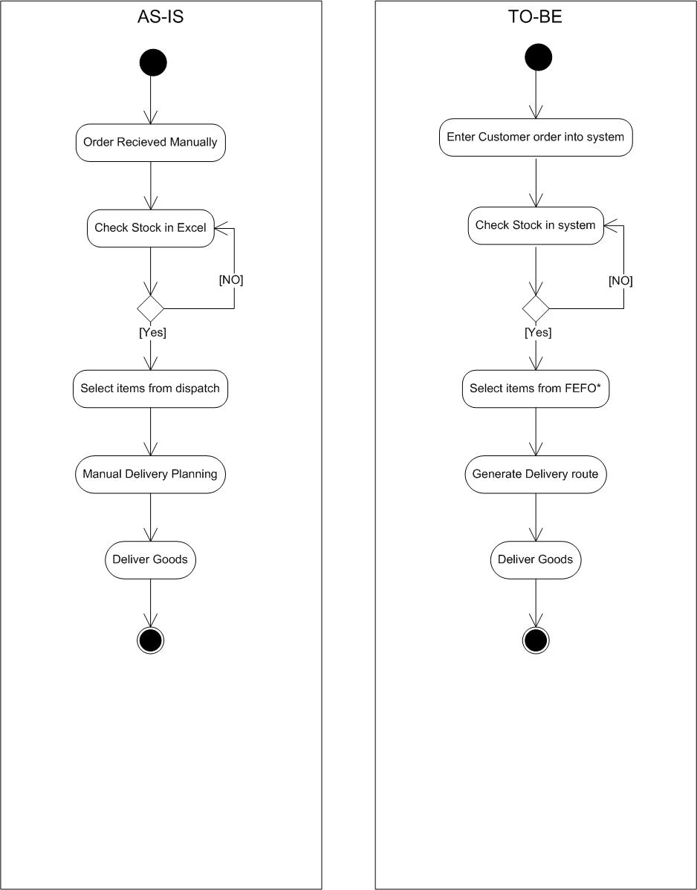

Business Requirements
ID | Requirement Description | Category | Priority | Notes
BR-01 | System must allow real-time tracking of stock at plant and warehouse levels. | Inventory Management | High | Critical for visibility and supply chain operations.
BR-02 | System must support batch & expiry-based tracking. | Inventory Management | High | Required due to perishable nature of dairy products.
BR-03 | System must support FEFO (First Expired, First Out) based dispatch selection. | Inventory Management | High | Ensures minimal wastage and compliance with dairy standards.
BR-04 | System must maintain audit trails for all stock movements. | Inventory Management | Medium | Needed for accuracy, accountability, and audits.
BR-05 | System must capture customer orders from multiple channels (phone, portal, sales team). | Order Management | High | Multi-channel support ensures operational flexibility.
BR-06 | System must validate stock availability before confirming an order. | Order Management | High | Prevents stock-outs and ensures customer commitment is feasible.
BR-07 | System must automatically allocate orders to the nearest warehouse with sufficient stock. | Order Management | High | Reduces delivery time; core objective of the project.
BR-08 | System must generate optimized delivery routes. | Delivery & Routing | High | Achieves goal of quickest delivery; uses distance/time logic.
BR-09 | System must provide real-time delivery tracking features. | Delivery & Routing | Medium | Enables monitoring, SLA tracking, and customer updates.
BR-10 | System must generate pick lists and loading sheets for dispatch teams. | Delivery & Routing | Medium | Supports warehouse operations and reduces manual errors.
BR-11 | System must generate inventory summary reports. | Reporting & Dashboard | Medium | Used for daily operational decisions.
BR-12 | System must generate near-expiry stock alerts. | Reporting & Dashboard | High | Prevents wastage; connected to FEFO management.
BR-13 | System must generate daily dispatch and delivery performance reports. | Reporting & Dashboard | Medium | For performance evaluation and continuous improvement.

Non-Functional Requirements
ID | Requirement
NFR-01 | System must provide 99% uptime during business hours.
NFR-02 | Screens must load within 3 seconds.
NFR-03 | System must support role-based access.

Appendices

10.1 List of Acronyms
Acronym | Meaning
BRD | Business Requirements Document
SKU | Stock Keeping Unit
FEFO | First Expired, First Out
UAT | User Acceptance Testing
SLA | Service Level Agreement

10.2 Glossary of Terms
- Inventory: Products or materials stored in warehouses/plants.
- Batch: A group of items produced together with same expiry date.
- Dispatch: Sending goods to customers.
- Route Optimization: Identifying the best route for delivery.
- Order Allocation: Assigning order to the best warehouse.

10.3 Related Documents
- SRS (Software Requirements Specification)
- Functional Specification Document (FSD)
- AS-IS and TO-BE Diagrams
- RTM (Requirements Traceability Matrix)
- Stakeholder Analysis Document

Assignment 1 — Part 2: Development & Resource Plan (High-level)

High-level Development Plan
Phase | Activities | Duration | Resources Required
1. Requirement Gathering (Sprint 0 – Part 1) | • Conduct stakeholder interviews  • MVP definition for pilot (Inventory + Order-to-Delivery)  • Document AS-IS & TO-BE workflows  • Business rules gathering  • Create BRD / User Story Epics | 3 weeks (Month 1) | Business Analyst (BA), Project Manager (PM), Product Owner (Client), Client SMEs
2. System Design (Sprint 0 – Part 2) | • UI/UX prototypes (Web + Mobile)  • System architecture + database schema (PostgreSQL + Redis)  • Story grooming & acceptance criteria  • Sprint roadmap & release planning  • Environment provisioning (Cloud + DevOps) | 3 weeks (Month 1–2) | Solution Architect, BA, UX/UI Designer, PM, DevOps Engineer, DBA
3. Development (Agile Sprints 1–4) | Sprint 1 (2 Weeks): Inventory Core, SKU Master, Batch + Expiry  Sprint 2 (2 Weeks): FEFO Dispatch, Stock Movement (GRN/Issue/Transfer)  Sprint 3 (2 Weeks): Order Capture, Validation, Allocation (Nearest Warehouse)  Sprint 4 (2 Weeks): Routing Engine, Route Planning, Driver App (Mobile), Warehouse App (Mobile Scanning)  • Incremental releases, daily stand-ups, sprint reviews | 8–10 weeks (Month 2–4) | Backend Developers (2–3), Frontend Developers (2), Mobile Developers (2), Tech Lead, QA Engineers (parallel), BA
4. Testing (QA + UAT) | • Functional testing  • Integration testing  • Mobile testing (Driver & Warehouse apps)  • Bug reporting & fixes  • Client UAT & sign-off | 4 weeks (Month 4–5) | QA Engineers, BA, Developers, Client UAT Team
5. Reporting & Dashboard Sprint | • Inventory dashboards (Stock, Batch, Expiry)  • SLA dashboards (Delivery time, Route KPIs)  • Management reports  • Basic BI layer setup (Power BI/Metabase) | 2 weeks (Month 5) | Developer, QA, BA, UX/UI Designer
6. Pilot Deployment (MVP) | • Deploy to 1 Plant + 1 Warehouse + 1 Delivery Route  • Configure cloud infra (AWS/Azure/GCP)  • Conduct end-user training (warehouse + driver teams)  • Hypercare support | 2 weeks (Month 5–6) | BA, Developers, DevOps Engineer, Client Ops Team, Training & Change Manager
7. Regional Rollout (Staged) | • Rollout per region based on success of pilot  • Data migration & environment config  • Training sessions  • Minor enhancements  • Rollout monitoring | 4–12 weeks (optional beyond Month 6) | BA, Developers, QA, Client Regional Teams, Training Manager
8. Post-Deployment Support | • Stabilization period  • Performance tuning  • Bug fixes & small enhancements  • Knowledge Transfer (KT) | 2 weeks (Month 6) | BA, Developer, QA, DevOps

High-Level Resource Plan
1. Core Project Team Overview
This project will be delivered by a cross-functional Agile team consisting of business, technical, QA, and deployment resources.
The allocation below is based on a 6-month delivery timeline with Agile sprints.
Core Roles Involved:
- Product Owner (Client)
- Business Analyst
- Project Manager / Scrum Master
- Solution Architect
- Developers (Backend, Frontend, Mobile)
- QA/Test Engineers
- DevOps / Deployment Engineer
- Database Administrator
- UX/UI Designer
- Change & Training Lead
- Client SMEs (Warehouse, Plant, Logistics)
2. Resource Summary Table (High-Level)
Role | Headcount | Key Responsibilities | Allocation (Approx.)
Product Owner (Client) | 1 | Requirements prioritization, approvals, UAT | 20% across project
Business Analyst (BA) | 1 | Requirements, user stories, AS-IS/TO-BE, UAT | 60% first 3 months, 40% later
Project Manager / Scrum Master | 1 | Planning, sprint ceremonies, tracking, reporting | 40–50%
Solution Architect | 1 | Architecture, design, review | 25% early phases, 10% later
Backend Developers | 2 | API, business logic, integration | 100% during development sprints
Frontend Developers | 2 | UI screens, dashboards | 100% during development sprints
Mobile Developers | 1–2 | Develop on mobile application | 100% during Sprint 3–4
QA/Test Engineers | 2 | Test cases, execution, defect tracking | 20% early, 100% in final 2 months
DevOps Engineer | 1 | Environments, CI/CD, deployment | 20% ongoing, 50% during deployment
Database Administrator (DBA) | 1 | Data models, performance tuning | 20% early, 10% later
UX/UI Designer | 1 | Wireframes, prototypes | 50% early, on-demand later
Training & Change Manager | 1 | Training materials, rollout support | 20% in final month
Client SMEs (Warehouse/Plant) | 2–3 | Domain input, UAT, rollout support | On-demand throughout
4. Resource Deployment by Project Phase
Phase | Resources Engaged
Requirements & Design | BA, PM, Architect, UX Designer, Client SMEs
Sprint 1–2 (Inventory + FEFO) | Backend Devs, Frontend Devs, QA, BA, Tech Lead
Sprint 3–4 (Orders + Routing) | Backend Devs, Mobile Devs, QA, BA
Sprint 5 (Dashboards) | Frontend Devs, QA, BA
Testing & UAT | QA, BA, Developers, SMEs
Deployment & Training | DevOps, BA, Training Lead, Client Ops
Post-Go-Live Support | Developers, QA, BA
5. Notes / Assumptions
- Team members may be shared across parallel workstreams.
- Certain roles (UX, Architect, DBA) are part-time engagement roles.
- Mobile developers can be optional if warehouse & driver apps are web-based.
- Additional resources may be added based on rollout phase requirements.

Assignment 1 Q2: Prepare process flow diagram using your imagination. 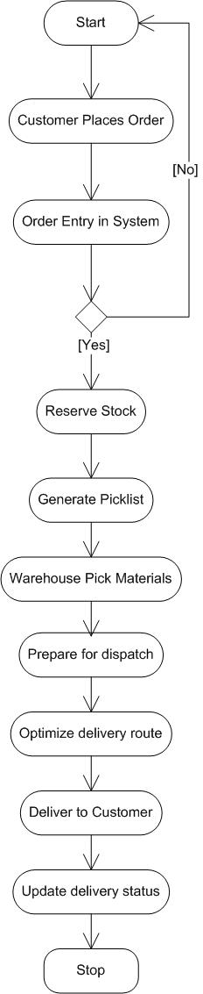

Assignment 2:
1. Write an introduction letter to a client introducing yourself as a business analyst in charge of working with the client and his team to start the business understanding process.
2. Prepare a brief BRD and SRS for a project- Horoscope or Ticketing system or online store.
3. Make an ERD of creating a support ticket/Ticketing life cycle.
4. User story of shopping from ecommerce

BA Introduction Letter
Subject: Introduction – Business Analyst for Online Ticketing System Initiative
Date:11/20/2025
Dear Henry,
I hope you are doing well. My name is Aswitha Thoppay Chandrasekaran, and I will be working with you as the Business Analyst for the Online Ticketing System initiative.
My role is to work closely with you and your team to understand your business processes, pain points, and expectations, and to translate them into clear requirements for our technical team. Over the next few days, I will be scheduling workshops, interviews, and walkthroughs with your stakeholders so that we can:
- Document the current (“AS-IS”) process,
- Define the future (“TO-BE”) process, and
- Prioritize the requirements for phased implementation.
- Map end-to-end user journeys
- Identify key user groups such as customers, administrators, operations, and logistics teams
- Document all functional and non-functional requirements in a structured and clear manner
My focus will be to ensure smooth communication, complete requirement clarity, and alignment between your business goals and the final solution. I will coordinate with the development, QA, design, and architecture teams to ensure that all requirements are implemented as expected and validated thoroughly during each stage
I look forward to your guidance and support in identifying the right stakeholders and providing access to existing documents or systems that will help us start the business understanding process.
Please feel free to share any initial questions, concerns, or expectations you may already have about the project.
Thank you, and I am excited to collaborate with you on this engagement.
Warm regards,
Aswitha Thoppay Chandrasekaran
Business Analyst – COEPD
aswithac@coepd.com

Prepare a brief BRD and SRS for a project- Ticketing system

BRD – BUSINESS REQUIREMENT DOCUMENT
Project: Ticketing & Support Management System (TSMS)
Client: Online Ticketing System initiative
Date:11/20/2025
Version: 1.0

1. Document Revisions
Version | Date | Author | Description
1.0 | 20-Nov-2025 | Aswitha Thoppay Chandrasekaran | Initial draft for client review

2. Approvals
Role / Title | Name | Signature | Date
Project Sponsor – Head of Operations | Mr. Rajesh Verma
Business Owner – Customer Support Manager | Ms. Neha Gupta
IT Manager – Technology & Applications | Mr. Arvind Rao
Project Manager – Implementation Lead | Ms. Kavya Reddy
Business Analyst – Requirements Lead | Ms. Aswitha Thoppay Chandrasekaran

3. RACI Chart for This Document

Codes Used
- R – Responsible: Creates document
- A – Accountable: Approves final document
- C – Consulted: Provides inputs
- I – Informed: Notified of updates

RACI Chart
Project Phase | BA (Aswitha) | PM (Kavya) | IT Manager (Arvind) | Dev Lead (Rahul) | Business Owner (Neha) | Sponsor (Rajesh)
Planning | C | A | C | I | C | I
Project Initiation | I | A | C | I | C | R
Requirements Gathering | R | A | C | I | C | I
Analysis | R | A | C | I | C | I
Design | C | A | R | C | C | I
Development | I | C | I | R | I | I
Testing | C | A | C | R | I | I
UAT | R | A | I | C | C | I

4. Introduction

4.1 Business Goals
Online Ticketing System initiative Organization receives support queries through emails, phone calls, and manual logs. Tracking issues is difficult, leading to delays, escalations, and customer dissatisfaction.
Goal:
To establish a unified ticketing system that centralizes all support requests and improves efficiency, transparency, and resolution time.

4.2 Business Objectives
To provide an IT solution for:
- Logging and tracking customer issues through a web portal & mobile app
- Automatic ticket assignment based on department, skill, & availability
- SLA-based tracking and escalation
- Real-time visibility of ticket status
- Communication between customer & support agent
- Dashboard for management reports
- User authentication & role-based access
- Integration support for future modules (e-learning, HRMS, etc.)

4.3 Business Rules
- Each ticket must have a unique ID.
- Users must log in or register before booking tickets.
- Payment must be completed to confirm booking.
- Booking cannot exceed the available seat count.
- Tickets cannot be canceled after a defined cutoff time.
- Only admins can add, edit, or remove event listings.
- Confirmation must be sent via SMS/Email after payment.
- Only approved payment methods (UPI, Card, Wallet) can be used.
- Each user can book only the allowed number of tickets per event.

4.4 Background
The customer support team currently uses emails, spreadsheets, and manual methods to track service requests. This leads to:
- Manual bookings cause long queues, errors, and overbooking.
- Customers expect quick, digital, paperless ticket booking.
- Businesses require real-time tracking of bookings and seat availability.
- A digital platform reduces operational overhead and improves accuracy.
- Online ticketing increases reach and overall revenue
To improve customer experience and streamline operations, XYZ Organization has initiated a Ticketing System project.

4.5 Project Objective
To develop a centralized Ticketing & Support Management System that:
- Build an easy-to-use online platform for booking tickets.
- Integrate secure payment gateways.
- Generate digital tickets and confirmations instantly.
- Show live seat availability and pricing.
- Provide a strong admin dashboard for management.
- Ensure accurate booking reports and payment records.
- Reduce manual handling by automating end-to-end booking flow.
- Support both mobile and desktop users.
- Ensure data security and prevent unauthorized access

4.6 Project Scope

4.6.1 In Scope Functionality
- User login & authentication
- Ticket creation & submission
- Ticket assignment & workflow
- Ticket prioritization (Low/Medium/High/Urgent)
- SLA tracking & escalation
- Commenting & chat between user and agent
- Email/SMS notifications
- Role management (Admin, Support Agent, Customer)
- Mobile app (Android & iOS) – basic functionality
- Cancellation option

4.6.2 Out of Scope Functionality
- Payroll or HRMS processing
- Finance, billing, invoicing
- Chatbot automation (future phase)
- Integration with CRM/ERP (future phase)
- E-learning or training modules (separate system)

5. Assumptions
- Users will provide accurate information during ticket creation.
- All required data (user list, department list) will be provided before development.
- Internet connectivity is available for web & mobile access.
- Mobile app will support only Android & iOS.
- Integration features will be handled in Phase 2.

6. Constraints
- The system must be delivered within a fixed 3–4 month timeline.
- Budget availability may limit advanced automation features.
- Mobile app must support limited offline mode.
- Hosting platform must comply with IT security policies.
- Support team availability for UAT may be limited.

7. Risks

Technological Risks
Risk | Likelihood | Impact | Strategy
Server downtime | Medium | High | Mitigate – backup & monitoring
Mobile app compatibility issues | Low | Medium | Mitigate – device testing

Skills Risks
Risk | Likelihood | Impact | Strategy
Lack of trained support staff | Medium | High | Mitigate – training & KT

Political Risks
Risk | Likelihood | Impact | Strategy
Resistance to new system | Medium | Medium | Mitigate – change management

Business Risks
Risk | Likelihood | Impact | Strategy
System not adopted by staff | Medium | High | Mitigate – training, pilot rollout

Requirements Risks
Risk | Likelihood | Impact | Strategy
Incomplete requirement inputs | Medium | High | Avoid – detailed workshops

Other Risks
Risk | Likelihood | Impact | Strategy
Security breach | Low | High | Mitigate – strong authentication

8. Business Process Overview

8.1 Legacy System (AS-IS)
- Users stand in long queues at physical ticket counters to book tickets.
- Booking confirmations are issued only through printed paper tickets.
- Seat availability is updated manually, increasing the chances of overbooking.
- Payments are mostly handled in cash, with no digital tracking or automated records.
- Admins maintain booking logs, seat status, and revenue information manually, making the process time-consuming and error-prone

8.2 Proposed System (TO-BE)
- Instant digital ticket generation and confirmation via SMS/Email after successful payment.
- Seat availability will update automatically and in real time after every booking to avoid overbooking.
- A secure online payment gateway will ensure safe transactions with proper digital records.
- A centralized Admin Dashboard will display live booking updates, seat status, pricing, schedules, and real-time revenue analytics.
- Automation will significantly reduce manual work, eliminate human errors, and improve overall booking speed and accuracy
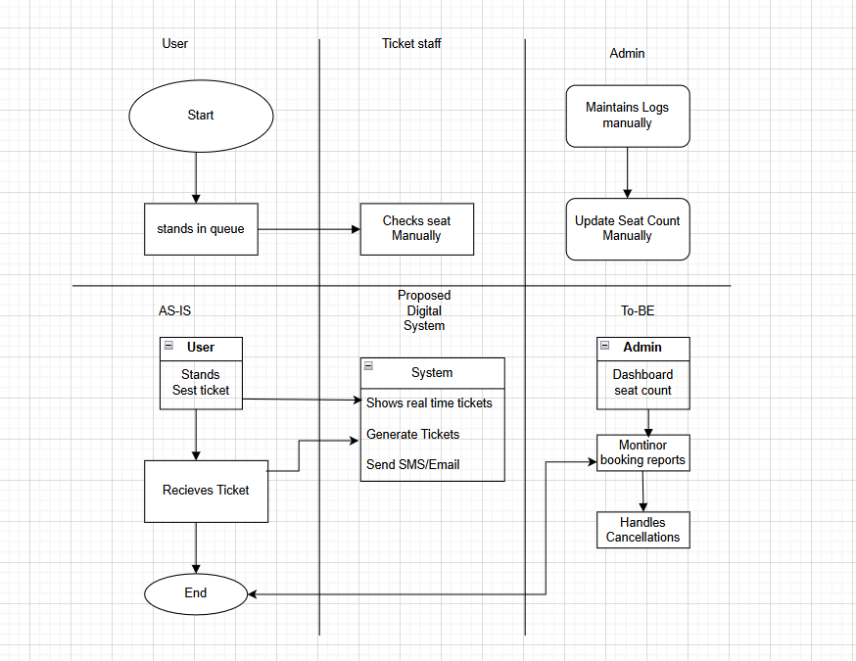

Business Requirements
BR ID | Business Requirement Description | Category | Priority | Notes
BR-01 | The system must provide a unified online platform (web & mobile) for users to book tickets digitally instead of standing in physical queues. | Customer Experience | High | Core goal: replace manual booking with online self-service.
BR-02 | The system must allow registered users to securely log in before booking tickets. | Access & Security | High | Ensures user identity and personalized booking history.
BR-03 | The system must allow users to view events/shows with details like date, time, location, pricing, and seat categories. | Event & Catalog Management | High | Enables informed decision-making before booking.
BR-04 | The system must show real-time seat availability to prevent overbooking. | Inventory / Seat Management | High | Directly addresses manual errors and overbooking issues.
BR-05 | The system must enforce business rules such as maximum tickets per user per event. | Policy & Compliance | High | Controls abuse, ensures fair usage.
BR-06 | The system must prevent bookings beyond available seats and ensure consistent seat allocation. | Inventory / Seat Management | High | Critical for accuracy and customer trust.
BR-07 | The system must support secure online payments using approved methods (UPI, Card, Wallet, etc.). | Payment & Revenue | High | Required for digital monetization and convenience.
BR-08 | The system must confirm a booking only after successful payment and generate a digital ticket with a unique Booking ID. | Booking & Confirmation | High | Ensures financial + booking integrity.
BR-09 | The system must send booking confirmations and digital tickets via SMS and/or Email. | Communication | High | Replaces paper tickets; supports “anywhere access.”
BR-10 | The system must allow users to view their past and upcoming bookings from their account. | Customer Self-Service | Medium | Enhances transparency and self-service.
BR-11 | The system must provide a cancellation option (only within defined cutoff time) and update seat availability and refund status accordingly. | Cancellation & Policy | Medium | Aligns with business rules on cancellation.
BR-12 | Only Admin users must be able to add, edit, or remove event listings, schedules, prices, and seat capacity. | Admin Control | High | Prevents unauthorized changes to business data.
BR-13 | The system must offer an Admin Dashboard showing real-time bookings, occupancy, cancellations, and revenue analytics. | Management & Analytics | High | Supports management decisions and performance tracking.
BR-14 | The system must maintain accurate booking, payment, and cancellation records for audit and reporting purposes. | Audit & Compliance | High | Important for finance, compliance, and reconciliation.
BR-15 | The system must be scalable to support higher user loads during peak booking periods (e.g., popular events, weekends). | Scalability | Medium | Ensures consistent performance during peak usage.
BR-16 | The system must support access from both desktop browsers and mobile devices (web + mobile app). | Channel & Accessibility | High | Directly supports “digital, paperless, anytime” goal.
BR-17 | The system must be designed to support future integrations (e.g., HRMS, e-learning, CRM/ERP) with minimal rework. | Future Integration | Medium | Aligns with objective of integration support in future phases.

10. Appendices

10.1 List of Acronyms
- BRD – Business Requirements Document
- SLA – Service Level Agreement
- UAT – User Acceptance Testing
- FAQ – Frequently Asked Questions

10.2 Glossary of Terms
- Ticket: A record of customer issue
- SLA: Time within which a ticket must be resolved
- Agent: Support staff handling the ticket

10.3 Related Documents
- SRS
- Use Case Documents
- RTM
- Process Flow Diagrams

Software Requirements Specification (SRS)
Project: Ticketing & Support Management System (TSMS)
Client: Online Ticketing System initiative
Version: 1.0
Author: Aswitha Thoppay Chandrasekaran

1. Introduction

1.1 Purpose
The purpose of this SRS is to define and document the functional, technical, and system requirements for the Ticketing & Support Management System. This document acts as a formal agreement between:
- Client (Business Stakeholders)
- Technical Team (Development, QA, Architecture)
It is the first legally binding document confirming what the system will deliver.

1.2 Scope
The system will enable users to:
- Create and track support tickets
- Assign tickets automatically based on rules
- Track SLA, priority, and ticket progress
- Communicate with support agents
- View dashboards and manage reports
- Use a mobile app (Android/iOS) for logging tickets
- Enable managers to monitor workloads and escalations

1.3 Intended Users
- End Users / Customers
- Support Agents
- Support Manager
- System Administrator
- IT Team

1.4 Definitions & Acronyms
Term | Meaning
Ticket | A support request logged by a user
SLA | Service Level Agreement
UAT | User Acceptance Testing
Priority | Severity of the ticket
Agent | Support team member

2. Overall System Description

2.1 System Overview
The Ticketing System is a web & mobile-based application that centralizes support requests. It automates ticket assignment, tracks SLAs, sends notifications, and provides dashboards for management.

2.2 User Roles
Role | Permissions
Customer/User | Create tickets, view status, add comments
Support Agent | View assigned tickets, update progress, resolve tickets
Support Manager | Manage agents, view dashboards, override assignments
System Admin | Manage users, settings, categories, SLAs

2.3 System Constraints
- Mobile app supported on Android & iOS
- Web application responsive for all screen sizes
- Internet connection required
- Hosted on cloud/on-prem as per IT policy

3. Functional Requirements
FR ID | Functional Requirement Description | Priority
FR-01 | System must allow users to create tickets via web & mobile app. | High
FR-02 | System must auto-generate a unique Ticket ID for every new ticket. | High
FR-03 | Users must be able to attach files/screenshots while creating a ticket. | Medium
FR-04 | System must auto-assign tickets based on department, skill, or availability. | High
FR-05 | Support Manager must be able to manually reassign tickets. | High
FR-06 | Ticket workflow must follow: New → Assigned → In Progress → On Hold → Resolved → Closed. | High
FR-07 | Only support agents should update ticket statuses. | High
FR-08 | System must allow reopening of closed tickets with manager approval. | Medium
FR-09 | System must track SLA timers for each ticket based on priority. | High
FR-10 | System must send escalation alerts for SLA breach. | High
FR-11 | Users & agents must communicate through ticket comments. | High
FR-12 | System must allow internal (agent-only) and public comments. | Medium
FR-13 | System must send notifications (email/SMS) for ticket updates. | High
FR-14 | Support Manager must have dashboards for workload, SLA, and agent performance. | Medium
FR-15 | System must generate downloadable reports (CSV/PDF). | Medium
FR-16 | Knowledge base must be available for users to search common issues. | Medium
FR-17 | Admin must manage users, roles, and permissions. | High
FR-18 | System must maintain full ticket history and audit logs. | High

4. Technical Requirements
TR ID | Technical Requirement Description | Category
TR-01 | System must follow a 3-tier architecture (UI → API → Database). | Architecture
TR-02 | Backend must be built using Node.js or Java Spring Boot. | Technology Stack
TR-03 | Frontend must use React / Angular (responsive UI). | Technology Stack
TR-04 | Mobile app must be developed using Flutter or React Native. | Technology Stack
TR-05 | Database must be MySQL / PostgreSQL with optimized indexing. | Database
TR-06 | All communication must be encrypted using HTTPS/TLS 1.2+. | Security
TR-07 | Passwords must be hashed and salted using industry standards. | Security
TR-08 | System must use role-based access control. | Security
TR-09 | The system must support up to 5,000 concurrent users. | Performance
TR-10 | Page loading time must not exceed 3 seconds. | Performance
TR-11 | System must maintain 99% uptime. | Availability
TR-12 | Daily automated backups must be maintained. | Backup & Recovery
TR-13 | System must be able to restore data within 4 hours of failure. | Backup & Recovery
TR-14 | Alerts & notifications must integrate with SMTP/SMS gateways. | Integrations
TR-15 | System must support future integration with CRM/ERP modules. | Scalability
TR-16 | Logging & monitoring must be enabled using tools like ELK/Grafana. | Monitoring

5. Signoff
This SRS is considered final and approved when signed by authorized parties.
This document becomes the binding agreement between the business and the technical team.
Role | Name | Signature | Date
Business Owner | Neha Gupta
IT Manager | Arvind Rao
Project Manager | Kavya Reddy
Business Analyst | Aswitha Thoppay Chandrasekaran

Entity-Relationship (ERD) for a support ticket/Ticketing life cycle
Here a Customer (User) faces an issue and creates a Ticket. The ticket is assigned to a Support Agent, who works on it.Every status change or update is recorded in Ticket_History. The Customer and Agent can add Comments, and sometimes upload Attachments to explain the issue better
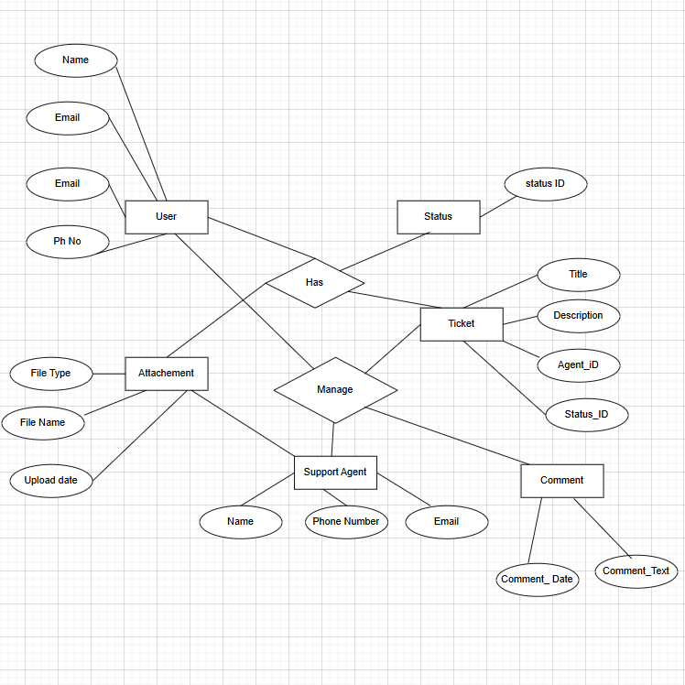
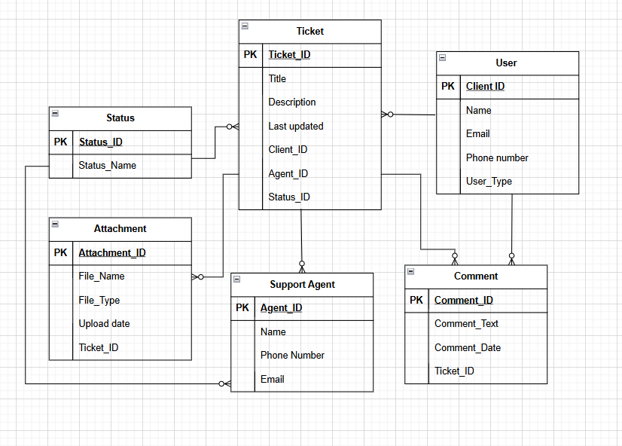

E-Commerce User Stories with BV & CP
S.No | User Story | Acceptance Criteria | Priority | BV | CP | Task
1 | As a user, I want to register so that I can create an account. | Registration succeeds with valid details; sends OTP/email. | High | 500 | 5 | Design registration form, validation, OTP/email service, and DB user creation.
2 | As a user, I want to log in so that I can access my account. | User can log in with valid credentials. | High | 500 | 3 | Implement login API, session/JWT handling, and error messages.
3 | As a user, I want to reset my password so that I can regain access. | Password reset email/SMS is sent; reset works. | High | 200 | 3 | Build “forgot password” flow with token link/OTP and update password logic.
4 | As a user, I want to browse products by category so that I can find items easily. | Category filter loads correct items. | High | 1000 | 5 | Create category model, listing page filters, and backend category filter query.
5 | As a user, I want to search for products so that I can find what I need quickly. | Search returns relevant results. | High | 1000 | 5 | Implement search API (by name/keywords) and search bar UI.
6 | As a user, I want to view product details so that I can make informed decisions. | Product page shows title, price, images, specs. | High | 500 | 3 | Build product detail page, API endpoint, and image gallery.
7 | As a user, I want to see product reviews so that I can evaluate quality. | Reviews + ratings visible; sort by date/rating. | Medium | 200 | 5 | Create review model, API, UI section with sorting options.
8 | As a user, I want to add items to the cart so that I can purchase later. | Cart shows added items instantly. | High | 1000 | 5 | Implement cart service (session/user-based), add-to-cart button, and mini-cart UI.
9 | As a user, I want to update item quantity in the cart so that I can adjust my order. | Qty updates reflect price change. | High | 200 | 3 | Add quantity controls, update cart totals, and validate stock on change.
10 | As a user, I want to remove items from cart so that I can control my purchase. | Item removed instantly; total recalculated. | Medium | 50 | 2 | Implement remove-from-cart action and recalc cart totals.
11 | As a user, I want to apply coupon codes so that I can get discounts. | Valid coupons apply; invalid codes give warnings. | Medium | 200 | 5 | Build coupon validation logic, discount calculation, and error handling.
12 | As a user, I want to checkout securely so that I can complete my purchase. | Checkout loads address + payment steps. | High | 1000 | 8 | Implement multi-step checkout flow, order summary, and address selection.
13 | As a user, I want to save multiple addresses so that I can reuse them during checkout. | User can add/edit/delete addresses. | Medium | 200 | 3 | Create address book screens, CRUD APIs, and link to user profile.
14 | As a user, I want to choose delivery options so that I can get items on my schedule. | Standard/Express options available. | Medium | 50 | 3 | Add delivery options in checkout, pricing rules, and selection storage.
15 | As a user, I want to pay using cards/UPI/wallet so that I can complete payment. | Payment gateway integration works. | High | 1000 | 8 | Integrate payment gateway, handle callbacks, and manage success/failure states.
16 | As a user, I want to receive order confirmation so that I know my order is placed. | SMS/Email confirmation sent. | High | 500 | 2 | Trigger email/SMS template after successful order creation.
17 | As a user, I want to track my order so that I know where it is. | Shows shipped, in-transit, delivered status. | High | 500 | 5 | Implement order status model, tracking page, and status updates.
18 | As a user, I want to reorder past items so that I can buy easily again. | One-click reorder works. | Medium | 200 | 3 | Add “Reorder” button in order history and reuse existing cart/checkout logic.
19 | As a user, I want to see my order history so that I can review past purchases. | Shows list with status + items. | Medium | 200 | 3 | Create orders list page and API to fetch orders by user.
20 | As a user, I want to cancel orders so that I can change my mind. | Cancel works only before packing/shipping. | Medium | 50 | 3 | Implement cancellation rules, update order status, and process refund trigger.
21 | As a user, I want to add items to wishlist so that I can save products. | Items saved under wishlist. | Low | 20 | 2 | Build wishlist model, add-to-wishlist button, and wishlist page.
22 | As a user, I want to remove wishlist items so that I can manage saved items. | Remove updates instantly. | Low | 10 | 1 | Add remove-from-wishlist action and UI refresh.
23 | As a user, I want product recommendations so that I can discover relevant items. | Recommendations load correctly. | Medium | 200 | 5 | Implement basic recommendation logic (similar items / popular items) and UI section.
24 | As a user, I want to filter products (price, size, brand) so that I can refine results. | Filters update product listing. | High | 500 | 5 | Add filter controls, backend query filters, and reload list dynamically.
25 | As a user, I want to see delivery estimates so that I know when items arrive. | ETA shown on product + checkout pages. | Medium | 50 | 2 | Calculate ETA based on location/method and display on UI.
26 | As a user, I want to contact support so that I can resolve purchase issues. | Chat/email/phone support accessible. | Medium | 50 | 2 | Add “Contact support” entry points and link to chat/form/phone info.
27 | As a user, I want guest checkout so that I can order without registration. | Checkout without login works. | Medium | 500 | 5 | Adjust checkout to allow guest orders and capture minimal details.
28 | As a user, I want notifications for order updates so that I stay informed. | SMS/email/push sent on status changes. | Medium | 200 | 3 | Hook notifications to order status changes using event/queue or triggers.
29 | As a user, I want secure login with OTP so that my account is protected. | OTP verification required. | High | 200 | 5 | Implement OTP generation, delivery, and verification in login flow.
30 | As an admin, I want to manage product inventory so that stock stays accurate. | Add/edit/delete inventory; auto-decrement on orders. | High | 1000 | 8 | Build admin inventory screens, stock APIs, and stock decrement/update logic on orders.

