Question 1 – Functional Requirements - 15 Marks

Req ID | Req Name | Req Description | Priority
NFR0001 | Farmer Registration | Farmers should be able to register  with the application | 8
NFR0002 | Farmer Search for  Products | Farmers should be  able to search for available products in fertilizers,  seeds, pesticides | 8
NFR0003 | Farmer Login | Farmers should be able to log in using  their credentials. | 9
NFR0004 | Product Catalog Browsing | Farmers should be able to browse through the product catalog with categories  and filters. | 8
NFR0005 | Add to Cart | Farmers should be able to add products to their shopping cart for  future purchase. | 9
NFR0006 | Buy Now Option | Farmers should have the option to immediately purchase a product without adding it to the  cart. | 8
NFR0007 | Payment via Credit/Debit Card | The system should support payments through credit and  debit cards. | 9
NFR0008 | Payment via UPI | The system should support payments through Unified Payments  Interface (UPI). | 9
NFR0009 | Order Confirmation Notification with invoice | Upon successful order placement, Farmers should receive confirmation via email and SMS with invoice  details. | 9

NFR0010 | Order Tracking delivery | Farmers should be able to track the status of their orders in real-time  for delivery. | 8

Req ID | Req Name | Req Description | Priority
NFR0101 | Page Loading Time | Each Page should load within 2  seconds times | 9
NFR0102 | WCAG 2.1 | . The system must meet Web Content Accessibility  Guidelines WCAG 2.1 | 8
NFR0103 | System Availability | The system should have an uptime of 99.9% to ensure  high availability. | 9
NFR0104 | Data Security | User data should be encrypted and stored securely to prevent unauthorized  access. | 10
NFR0105 | Responsive Design | The application should be accessible and usable across various devices  and screen sizes. | 8
NFR0106 | Scalability | The system should be able to handle increased load during peak shopping times without performance  degradation. | 8
NFR0107 | Backup and Recovery | Regular backups should be taken, and the system should support  data recovery in case of failures. | 9
NFR0108 | Compliance with PCI DSS | The payment  system should comply with Payment Card  Industry Data | 10

 |  | Security Standards.
NFR0109 | Localization Support | The application should support multiple languages  and regional settings. | 7
NFR0110 | SEO Optimization | The website should be optimized for  search engines to enhance visibility. | 6

Question 2–Minimum 5 pages designs - 15 Marks
- REGISTRATION :

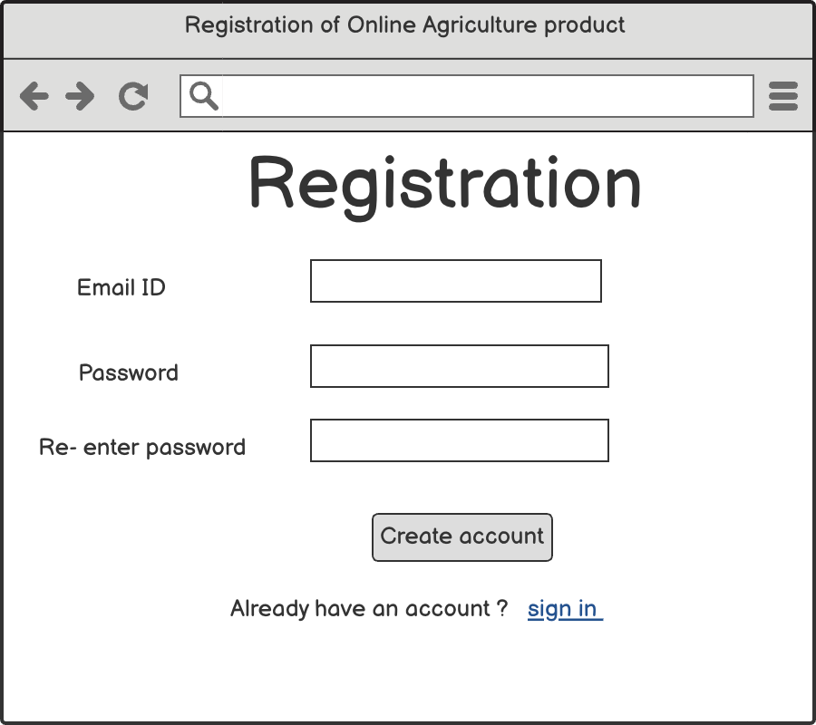

- SIGN IN :

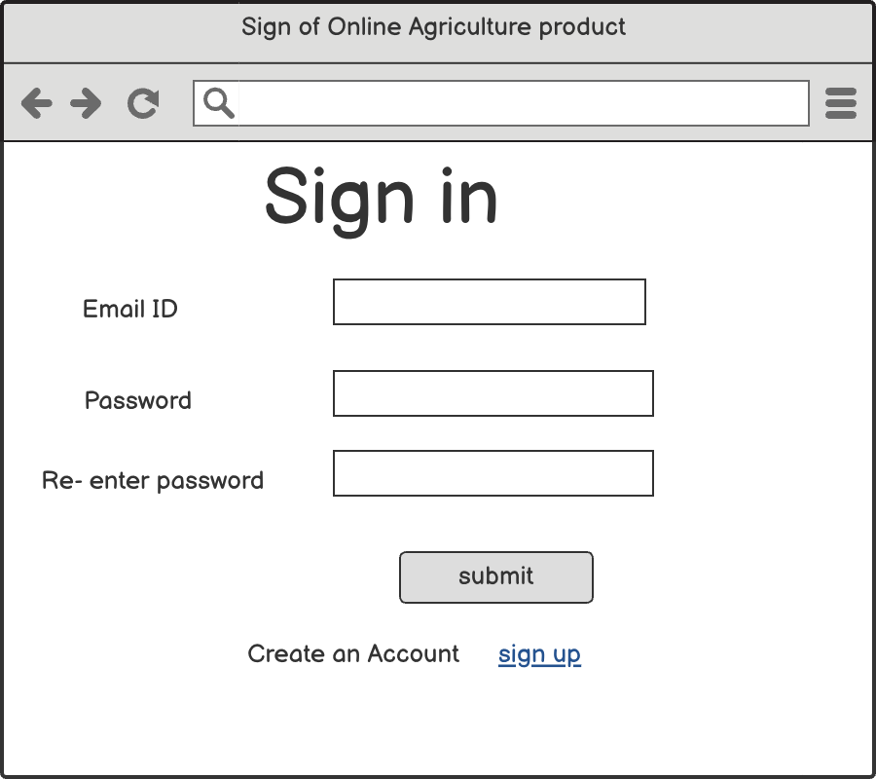

- SEARCH PRODUCT

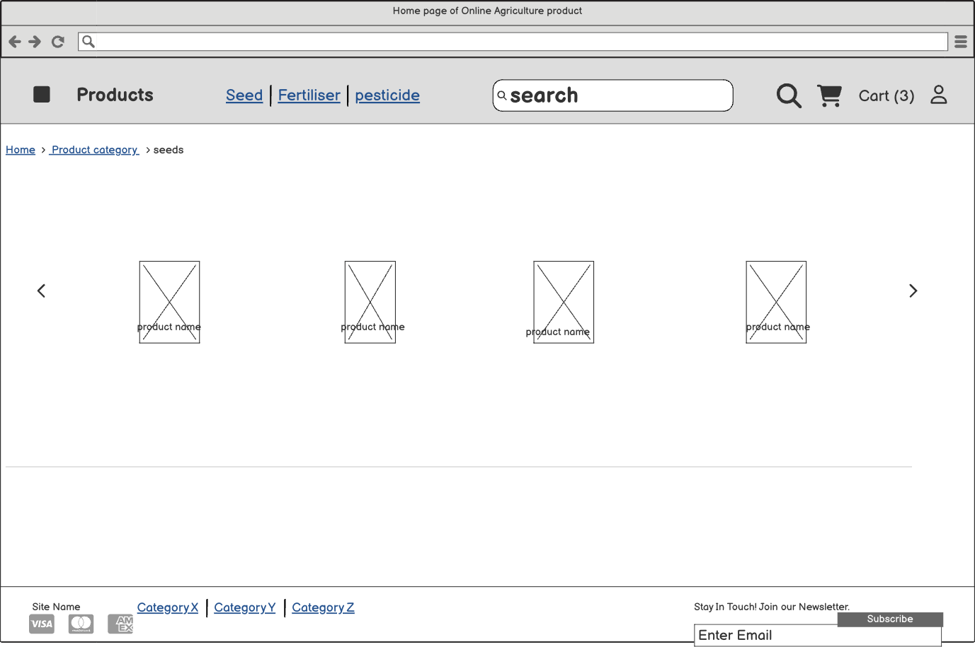

- ADD TO CART
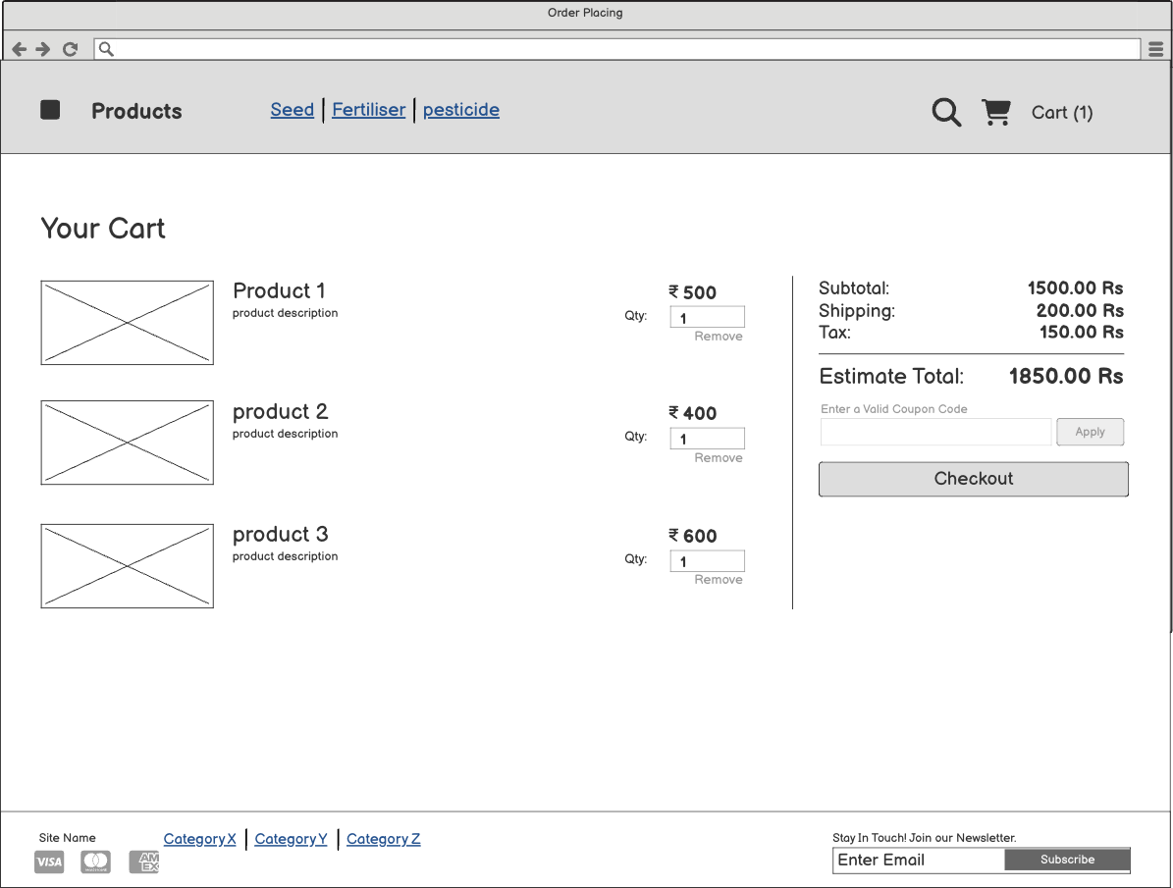

- PAYMENT PROCESS

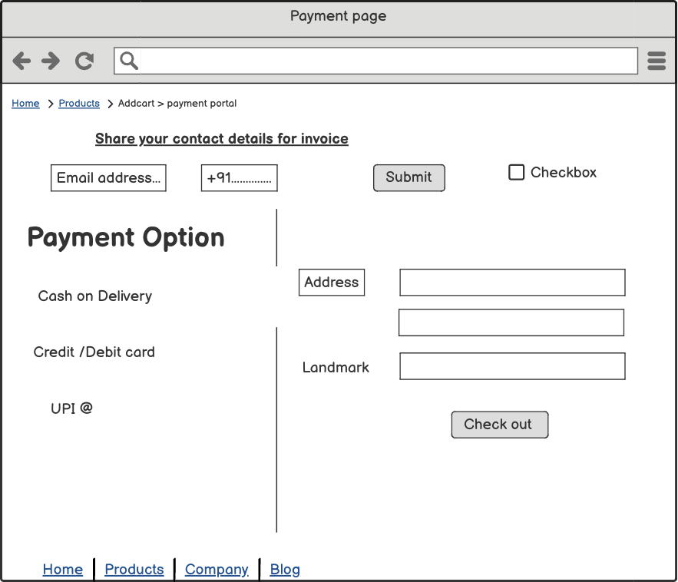

Question 3 – Tools (Visio, Balsamiq) - 15 Marks
Make a note of the Tools, which you are using for above concepts.
  - MS Visio

Purpose: A diagramming tool designed to create a wide range of visual representations, such as flowcharts, organizational charts, and network diagrams.
Key Features:

    - Versatile Diagramming: Supports creation of flowcharts, org charts, network diagrams, floor plans, and more.
    - Data Integration: Integrates with Microsoft Excel and other Office applications for data-linked diagrams.
    - Templates and Shapes: Offers a vast library of templates and shapes to expedite diagram creation.
    - Collaboration: Enables real-time collaboration through Microsoft Teams and
cloud services.
    - Accessibility: Available as both a desktop application and a web-based tool within Microsoft 365.
Ideal For:

    - Business professionals needing to visualize complex information.
    - IT specialists designing network infrastructures.
    - Project managers outlining workflows and processes.

Balsamiq
Purpose: A wireframing tool that enables rapid creation of low-fidelity mockups for user interfaces, focusing on structure and content over detailed design.
Key Features:

    - Sketch-Style Wireframes: Emulates hand-drawn designs to emphasize layout and functionality.
    - Drag-and-Drop Interface: Simplifies the process of assembling UI components.
    - Pre-built UI Elements: Provides a library of common interface elements for
quick mockup creation.
    - Collaboration: Facilitates team collaboration with easy sharing and feedback mechanisms.
    - Integration: Integrates with tools like Slack and Trello for streamlined workflows.
Ideal For:

    - Product managers and UX designers in the early stages of design.
    - Teams requiring quick iteration on UI concepts.
    - Stakeholder presentations to convey initial ideas.

  - Axure
Purpose: A comprehensive prototyping tool for creating interactive, high -fidelity prototypes and specifications, allowing simulation of real-world application behavior.
Key Features:

    - Interactive Prototypes: Supports dynamic content, conditional logic, and adaptive views without coding.
    - Specification Documentation: Generates detailed specifications and annotations for development handoff.
    - Widget Libraries: Offers a vast collection of UI components to build complex interfaces.

    - Collaboration Tools: Includes version control, commenting, and sharing features for team collaboration.
    - Responsive Design: Allows creation of prototypes that adapt to various screen sizes and devices.
Ideal For:

    - UX designers and business analysts requiring advanced prototyping capabilities.
    - Development teams needing detailed specifications for implementation.
    - Projects involving complex user interactions and workflows.

Summary

Microsoft Visio is best suited for creating detailed diagrams to represent processes, systems, and organizational structures.
Balsamiq is ideal for quickly sketching and iterating on user interface layouts during the early stages of design.
Axure RP is tailored for developing interactive prototypes that closely mimic the functionality of the final product.

Question 4 – RTM - 6 Marks

Req ID | Req Name | Req Description | Design | Code | UT | CT | ST | SIT | UAT
NFR 0001 | Farmer Registratio n | Farmers should be able to  register | C | C | C | C | C | C | C

 |  | with the application
NFR 0002 | Farmer Search for Products | Farmers should be able to search for available products in fertilizers, seeds,  pesticides | C | C | C | C | IC | IC | IC
NFR 0003 | Farmer Login | Farmers should be able to log in using their  credentials. | C | C | C | C | C | C | C
NFR 0004 | Product Catalog Browsing | Farmers should be able to browse through the product catalog with  categories and filters. | C | C | C | IC | IC | IC | IC
NFR 0005 | Add to Cart | Farmers should be able to add products to their shopping cart for future  purchase. | C | C | C | IC | IC | IC | IC
NFR 0006 | Buy Now Option | Farmers should have the option to immediatel y purchase a product without adding it to  the cart. | C | C | C | IC | IC | IC | IC
NFR 0007 | Payment via Credit/Debit Card | The system should support  payments through | C | C | C | C | C | C | IC

 |  | credit and debit cards.
NFR 0008 | Payment via UPI | The system should support payments through Unified Payments Interface  (UPI). | C | C | C | C | C | C | IC
NFR 0009 | Order Confirmatio n Notification with invoice | Upon successful order placement, Farmers should receive confirmatio n via email and SMS with invoice  details. | C | C | C | IC | IC | IC | IC
NFR 0010 | Order Tracking delivery | Farmers should be able to track the status of their orders  in real-time for delivery. | C | C | C | IC | IC | IC | IC

Req ID | Req Name | Req Description | Design | Code | UT | CT | ST | SIT | UAT
NFR 0101 | Page Loading Time | Each Page should load within 2  seconds times | C | C | C | C | C | C | C
NFR 0102 | WCAG 2.1 | . The system must meet Web Content Accessibility Guidelines  WCAG 2.1 | C | C | C | C | IC | IC | IC

NFR 0103 | System Availability | The system should have an uptime of 99.9% to  ensure high availability. | C | C | C | C | C | C | C
NFR 0104 | Data Security | User data  should be encrypted and stored securely to prevent  unauthorize d access. | C | C | C | IC | IC | IC | IC
NFR 0105 | Responsiv e Design | The application should be accessible and usable across various devices and screen  sizes. | C | C | C | IC | IC | IC | IC
NFR 0106 | Scalability | The system should be able to handle increased load during peak shopping times without performanc e  degradation. | C | C | C | IC | IC | IC | IC
NFR 0107 | Backup and Recovery | Regular backups should be taken, and the system should support data recovery in  case of failures. | C | C | C | C | C | C | IC
NFR 0108 | Complianc e with PCI DSS | The payment system  should | C | C | C | C | C | C | IC

comply with Payment Card Industry Data Security
Standards.
NFR 0109 | Localizatio n Support | The application should support multiple languages  and regional settings. | C | C | C | IC | IC | IC | IC
NFR 0110 | SEO  Optimizati on | The website should be optimized for search engines to enhance  visibility. | C | C | C | IC | IC | IC | IC

Question 5 – 10 Test Case Documents - 10 Marks

Registration

Test case ID | TC_REG_001 | Test Case Name | User Registration. With valid data
Project ID | PRJ_KM_001 | Project Name | KISANMANDI
PM ID | PM_001 | PM Name | SAI
Test Strategy ID | TS_001 | Tester ID | QA_001
Test Plan ID | TP_001 | Tester Name | GOKUL
Test Schedule ID | TSCH_001 | Date of Text | 02-05-2024
Scenario | Register a new user with valid  credentials.
Link to that page
Input Data | Set 1:  Full Name : XYZ Email : XYZ@GMAIL.CO M  Password:XYZ12  Confirm pswd: XYZ12

Expected Behaviour | User is successfully registered and redirected to the  Home page.
Actual behaviour | As Expected
comments | N/A
Result( Pass /Fail) | Pass
- Login

Test case ID | TC_LOGIN_002 | Test Case Name | User Lgin With  valid data
Project ID | PRJ_KM_001 | Project Name | KISANMANDI
PM ID | PM_001 | PM Name | SAI
Test Strategy ID | TS_001 | Tester ID | QA_002
Test Plan ID | TP_001 | Tester Name | GOKUL
Test Schedule ID | TSCH_002 | Date of Text | 05-05-2024
Scenario | Existing user with valid credentials.
Link to that page
Input Data | Set 1:  Full Name : XYZ Email : XYZ@GMAIL.CO M  Password:XYZ12
Expected Behaviour | User is successfully Login  and redirected to the Home page.
Actual behaviour | As Expected
comments | N/A
Result( Pass /Fail) | Pass

- Product Catalog Browsing

Test case ID | TC_PRDCTBRWS  _003 | Test Case Name | User Lgin With  valid data
Project ID | PRJ_KM_001 | Project Name | KISANMANDI
PM ID | PM_001 | PM Name | SAI
Test Strategy ID | TS_001 | Tester ID | QA_002

Test Plan ID | TP_001 | Tester Name | GOKUL
Test Schedule ID | TSCH_003 | Date of Text | 10-05-2024
Scenario | Navigate through product categories and view product  listings.
Link to that page
Input Data | Set 1: Product Categorize Seed , pesticide , Fertilizer.
Expected Behaviour | Products are displayed with images, prices,  and descriptions.
Actual behaviour | As Expected
comments | N/A
Result( Pass /Fail) | Pass

- Product Search :

Test case ID | TC_SEARCH_003 | Test Case Name | User Search product
Project ID | PRJ_KM_001 | Project Name | KISANMANDI

PM ID | PM_001 | PM Name | SAI
Test Strategy ID | TS_001 | Tester ID | QA_002
Test Plan ID | TP_001 | Tester Name | GOKUL
Test Schedule ID | TSCH_004 | Date of Text | 18-05-2024
Scenario | Search for a specific product  using the search bar.
Link to that page
Input Data | Set 1:  Product variety Qty, price, weigh
Expected Behaviour | Relevant products are displayed based on the  search .
Actual behaviour | As Expected
comments | N/A
Result( Pass /Fail) | Pass

- Add to cart

Test case ID | TC_ADDCART_00 4 | Test Case Name | ADD CART
Project ID | PRJ_KM_001 | Project Name | KISANMANDI
PM ID | PM_001 | PM Name | SAI
Test Strategy ID | TS_001 | Tester ID | QA_002
Test Plan ID | TP_001 | Tester Name | GOKUL
Test Schedule ID | TSCH_005 | Date of Text | 25-05-2024
Scenario | Add a selected  product to the shopping cart.
Link to that page
Input Data | N/A
Expected Behaviour | Product is added to the cart, and cart count is  updated.
Actual behaviour | As Expected
comments | N/A
Result( Pass /Fail) | Pass

- BUY LATER FEATURE

Test case ID | TC_BYLTR_004 | Test Case Name | BUYLATER
Project ID | PRJ_KM_001 | Project Name | KISANMANDI
PM ID | PM_001 | PM Name | SAI
Test Strategy ID | TS_001 | Tester ID | QA_002
Test Plan ID | TP_001 | Tester Name | GOKUL
Test Schedule ID | TSCH_006 | Date of Text | 30-05-2024
Scenario | Add a selected  product to the shopping cart.
Link to that page
Input Data | N/A
Expected Behaviour | Product is added to the 'Buy Later' list, accessible  from the user account
Actual behaviour | As Expected
comments | N/A
Result( Pass /Fail) | Pass

- PAYMENT PROCESSING :

Test case ID | TC_PMP_004 | Test Case Name | PAYMENT PROCESSING
Project ID | PRJ_KM_001 | Project Name | KISANMANDI
PM ID | PM_001 | PM Name | SAI
Test Strategy ID | TS_001 | Tester ID | QA_002
Test Plan ID | TP_001 | Tester Name | GOKUL
Test Schedule ID | TSCH_007 | Date of Text | 7-06-2024
Scenario | Complete a purchase using a  valid mode of payment
Link to that page
Input Data | N/A
Expected Behaviour | Payment is processed

successfully, and order confirmation
is displayed.
Actual behaviour | As Expected
comments | N/A
Result( Pass /Fail) | Pass

- Order placed with mail confirmation

Test case ID | TC_OP_004 | Test Case Name | Order placed
Project ID | PRJ_KM_001 | Project Name | KISANMANDI
PM ID | PM_001 | PM Name | SAI
Test Strategy ID | TS_001 | Tester ID | QA_002
Test Plan ID | TP_001 | Tester Name | GOKUL
Test Schedule ID | TSCH_008 | Date of Text | 7-06-2024
Scenario | Place an order and verify that an email confirmation with  invoice is received
Link to that page
Input Data | N/A
Expected Behaviour | Order is placed successfully, and confirmation email with invoice is  received
Actual behaviour | As Expected
comments | N/A
Result( Pass /Fail) | Pass

- Order tracking

Test case ID | TC_OT_004 | Test Case Name | Order Tracking
Project ID | PRJ_KM_001 | Project Name | KISANMANDI
PM ID | PM_001 | PM Name | SAI
Test Strategy ID | TS_001 | Tester ID | QA_002
Test Plan ID | TP_001 | Tester Name | GOKUL
Test Schedule ID | TSCH_009 | Date of Text | 15-06-2024
Scenario | Track the status of a placed order using the order  tracking feature.
Link to that page
Input Data | N/A

Expected Behaviour | Order status is displayed accurately with current location  and estimated
Actual behaviour | As Expected
comments | N/A
Result( Pass /Fail) | Pass

10 Order Delivery confirmation:

Test case ID | TC_ODC_004 | Test Case Name | Order Delivery Confirmation
Project ID | PRJ_KM_001 | Project Name | KISANMANDI
PM ID | PM_001 | PM Name | SAI
Test Strategy ID | TS_001 | Tester ID | QA_002
Test Plan ID | TP_001 | Tester Name | GOKUL
Test Schedule ID | TSCH_010 | Date of Text | 25-06-2024
Scenario | Verify that the order delivery is confirmed and  notification is received.
Link to that page
Input Data | N/A
Expected Behaviour | Order status is updated to  'Delivered', and

confirmation notification is
received.
Actual behaviour | As Expected
comments | N/A
Result( Pass /Fail) | Pass

Question 6 – DB Design – 8 Marks DB SCHEMA DAIGRAM

Is blueprint that outline structure of database including its table, field, relationship, constrain another characteristic

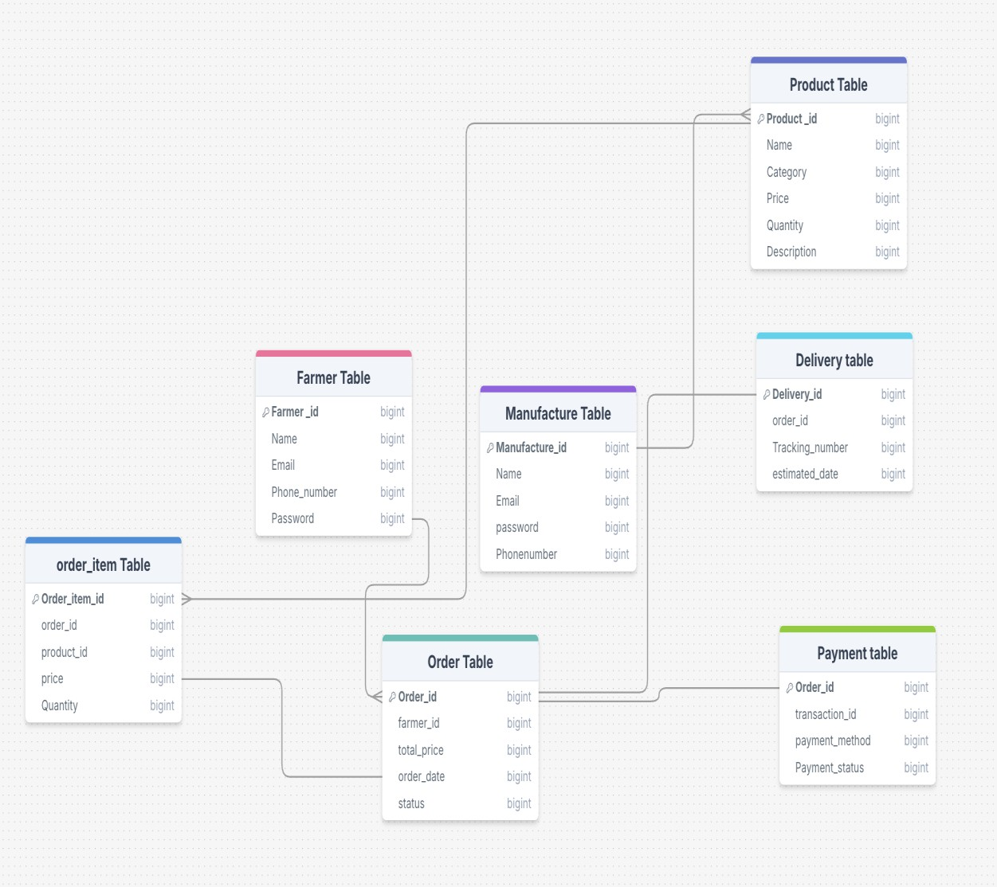

Entity Relationship Diagram : Visual representation of Relationship between in database.

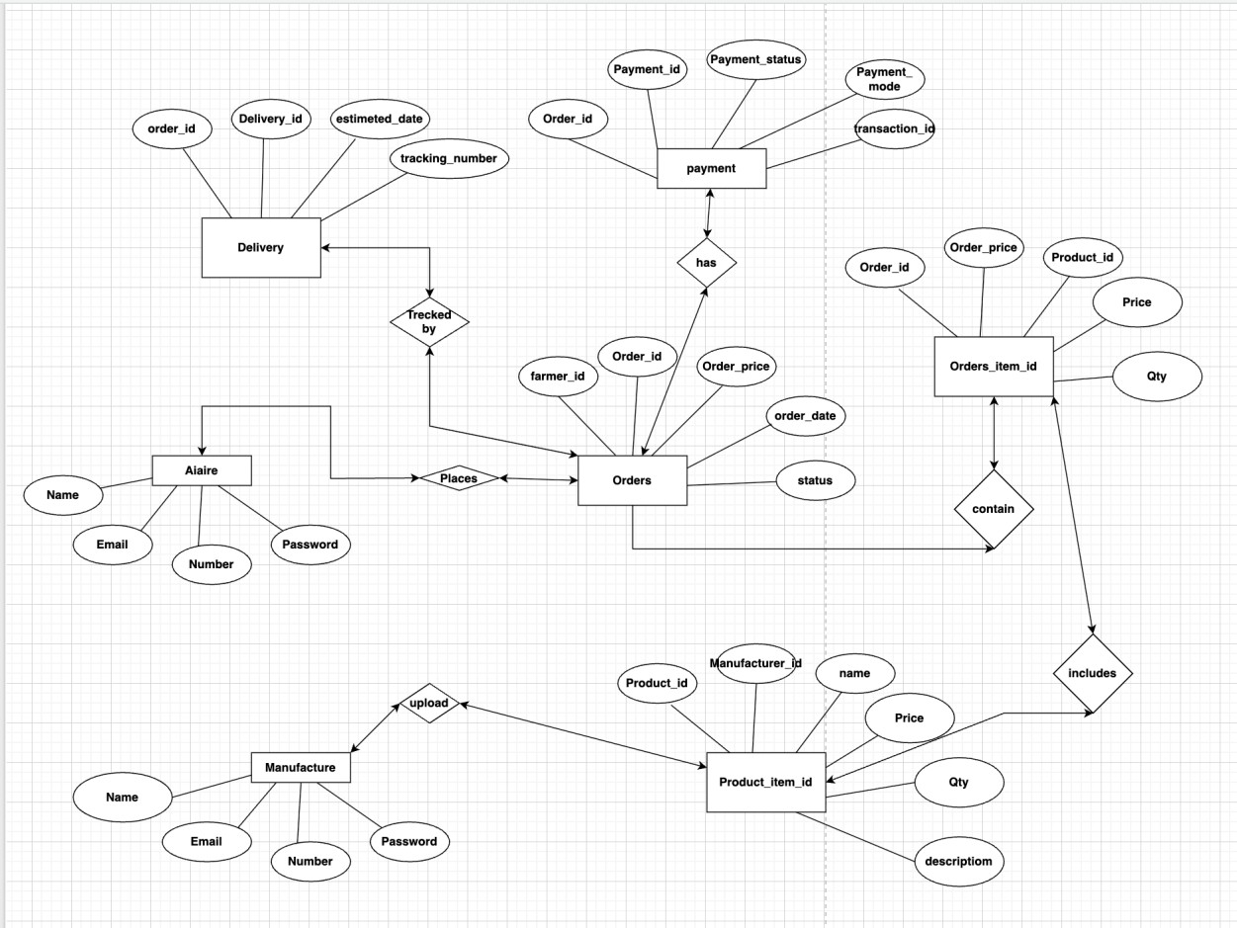

Question 7 – Data Flow Diagram - 3 Marks
What is a data flow diagram? Draw a data flow diagram to represent the in-flow and out- flow of data when a Farmer is placing an order for the product

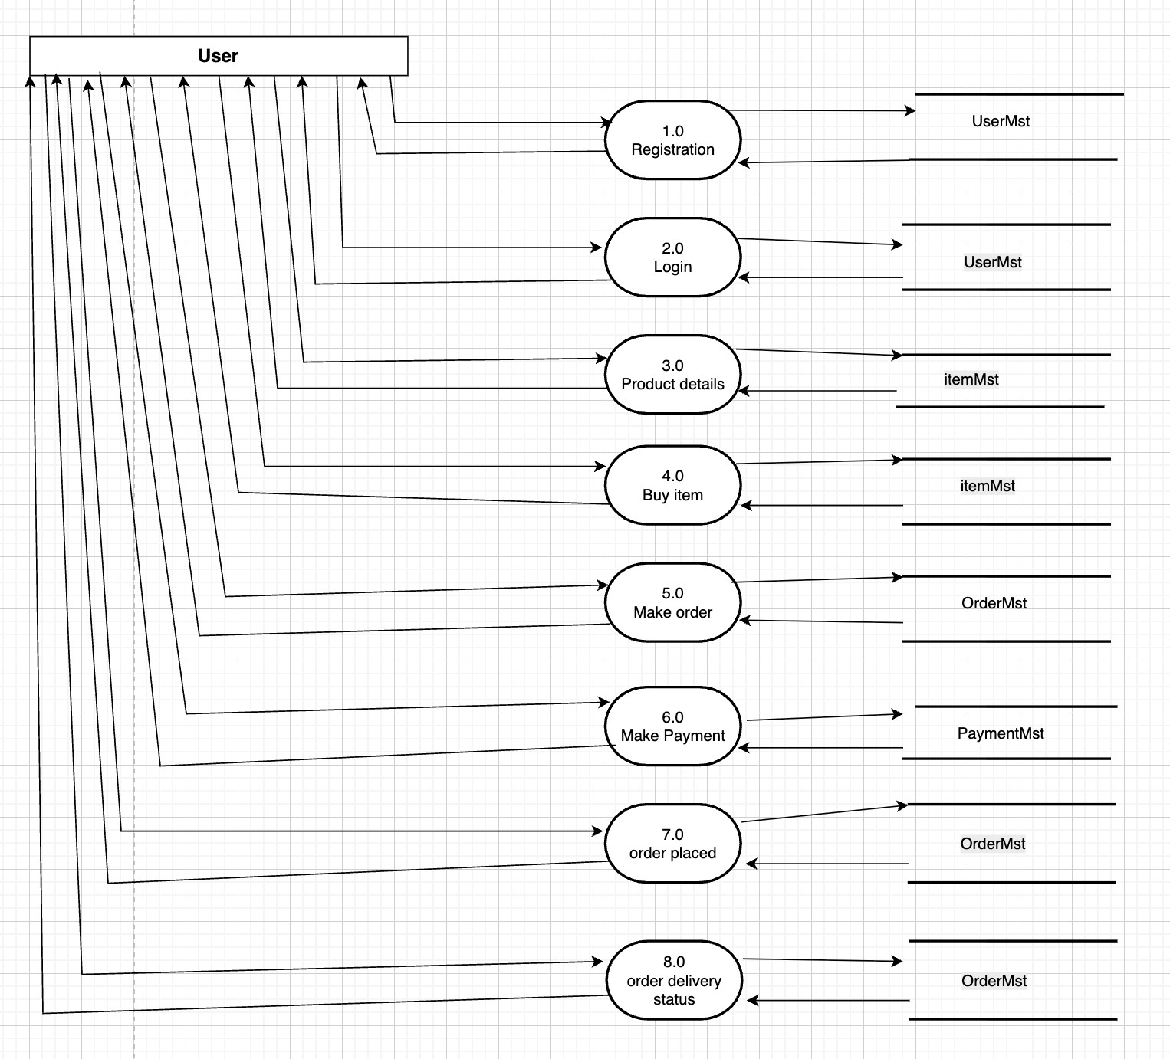

Question 8 – Change Request - 10 Marks
Due to change in the Government Taxation structure . we should change the Tax structure How do you handle change requests in a project?
A change request is a formal proposal to alter a system, product, or project.
- Understand the scope of change request and document the change request
- Do the impact analysis - project scope, schedule, budget, resources, and risks
- Prioritize change requests based on its urgency, importance, impact on project
- Seek approval from the project sponsor for the change request.
- Communicate the change request and its potential impacts to all relevant stakeholders, including the project team.

Question 9 – Change Request Vs an Enhancement - 5 Marks
A change request is a formal proposal to alter a system, product, or project.
- Understand the scope of change request and document the change request
- Do the impact analysis - project scope, schedule, budget, resources, and risks
- Prioritize change requests based on its urgency, importance, impact on project
- Seek approval from the project sponsor for the change request.
- Communicate the change request and its potential impacts to all relevant stakeholders, including the project team.

In this case, adding their crop yields or products and display to public and should be able to sell them to the application would be considered an enhancement as it involves adding new features to the system.
As a Business Analyst, should document the requirements and work with the development team to determine the feasibility and impact of the new features. BA should also consider the potential benefits, risks, and costs associated with the enhancements before making any recommendations to the client.

Question 10 – Estimations - 6
Marks Come up with estimations – How many Manhours required

Man hours are the required effort of the resources to complete a project. There are 3 types of projects:
Small: Upto 500 hours Medium: Upto 1000 hours Large: Upto 1500 hours Analysis
As per the case study, the duration of the project is 18 months and the current team size is around 15. This will come under medium project.
As the trained resources are available, trainers are not required.
As the structure of the project is available, New and enhanced infrastructure is not required.

Estimation: (18 months, 15 members, 5 days a week) Per day: 8hrs*15members = 120 hrs
Per week: 120hrs * 5days = 600hrs
Per month: 120 hrs * 22days = 2640 hrs
Leaves SL/CL 10 days = 2520 hrs (2640 hrs –120 hrs)
Question 11 – UAT – 6 Marks
Project has finally completed all the stages i.e., design, development, testing etc. Now, it is the role of a business analyst to contact the client for testing of the final product and must successfully complete it. How are you going to handle this situation? And once it is done, what will be the process to close the project? Explain UAT Acceptance process ?

Planning : In this step, Blue Prints are made to implement UAT testing for every feature that needs to test and minimum standards for accepting the test.
Designing Here the Test cases ate designed to hide all the possibilities of software packages in a real world environment.
UAT Testers : A Testing team consists of a end users that meet the criteria for implementing testing.
They should know the test cases to run and understand the functionalities.
Bug Fixing: Whatever Bugs are tound in the UAT Testing, the development team should work on them and make it software error free.
Sign Off: After removing all the bugs, the testing team indicates acceptance of the completion of the bugs. In this phase, all the stakeholders come to a conclusion that the software is ready to GO LIVE and sign it off.

Question 12 – Project Closure Document - 6 Marks
Explain Project closure document

- A project closure document, also known as a project closure report - is a formal document that summarizes the key outcomes, lessons learned, and final details of a completed project.
- It serves as a comprehensive record of the project's accomplishments, challenges, and overall performance, providing valuable insights for stakeholders and future projects.
Points to be included in the Project closure document are:

Project Overview: Developed an e-commerce platform for agricultural products, completed on time and budget.
Achievements: Launched platform, integrated secure payments, enabled order tracking, and vendor onboarding.

Lessons Learned: Early stakeholder involvement and agile sprints improved delivery and quality

Quality Assurance: Rigorous testing ensured high reliability and user satisfaction. Resource Utilization: Efficient use of team and budget; minimal overtime.
Risk Management: Addressed payment, logistics, and onboarding risks proactively

Challenges: Overcame integration delays and vendor adoption issues through training and planning

S.No | Points to include | Details | Reference  link

1 | Did the client signed off on  the UAT Testing
 | Date of the signoff: | 5th June 2025
 | Name of the resource: | Mr. Arjun Sharma | Business scope  document.docx
2 | Objectives of the project
 | User friendliness | Achieved
 | Customer satisfaction | ROI in 4 months
 | More categories | Achieved
3 | Functionalities worked on
 | Secure payment processing | Achieved
 | Product catalog and search | Achieved
 | Add to cart, order confirmation, invoice to email  & phone | Achieved
 | Order tracking & delivery | Achieved
4 | Infrastructure
 | Software Installed | Achieved
 | Laptops purchased | Achieved
5 | Funding
 | Amount approved | Rs. 1.2 crore | Finance breakdown.  docx
 | Amount used | Rs. 1.15 crore
6 | Overall project Information
 | Escalations | 30
 | Customer satisfaction | High
7 | Value to the company
 | Positive/Negative | Positive – 95%
 | Positive/Negative | - Expanded reach to rural and urban customers
 | Positive/Negative | - Increased farmer and  vendor participation
 | Positive/Negative | - Improved brand presence

- New partnerships with
logistics providers
- New project in pipeline

