Waterfall Model Documents

Document 6- Please prepare a use case diagram, activity diagram and a use case specification document.
Use Case Diagram
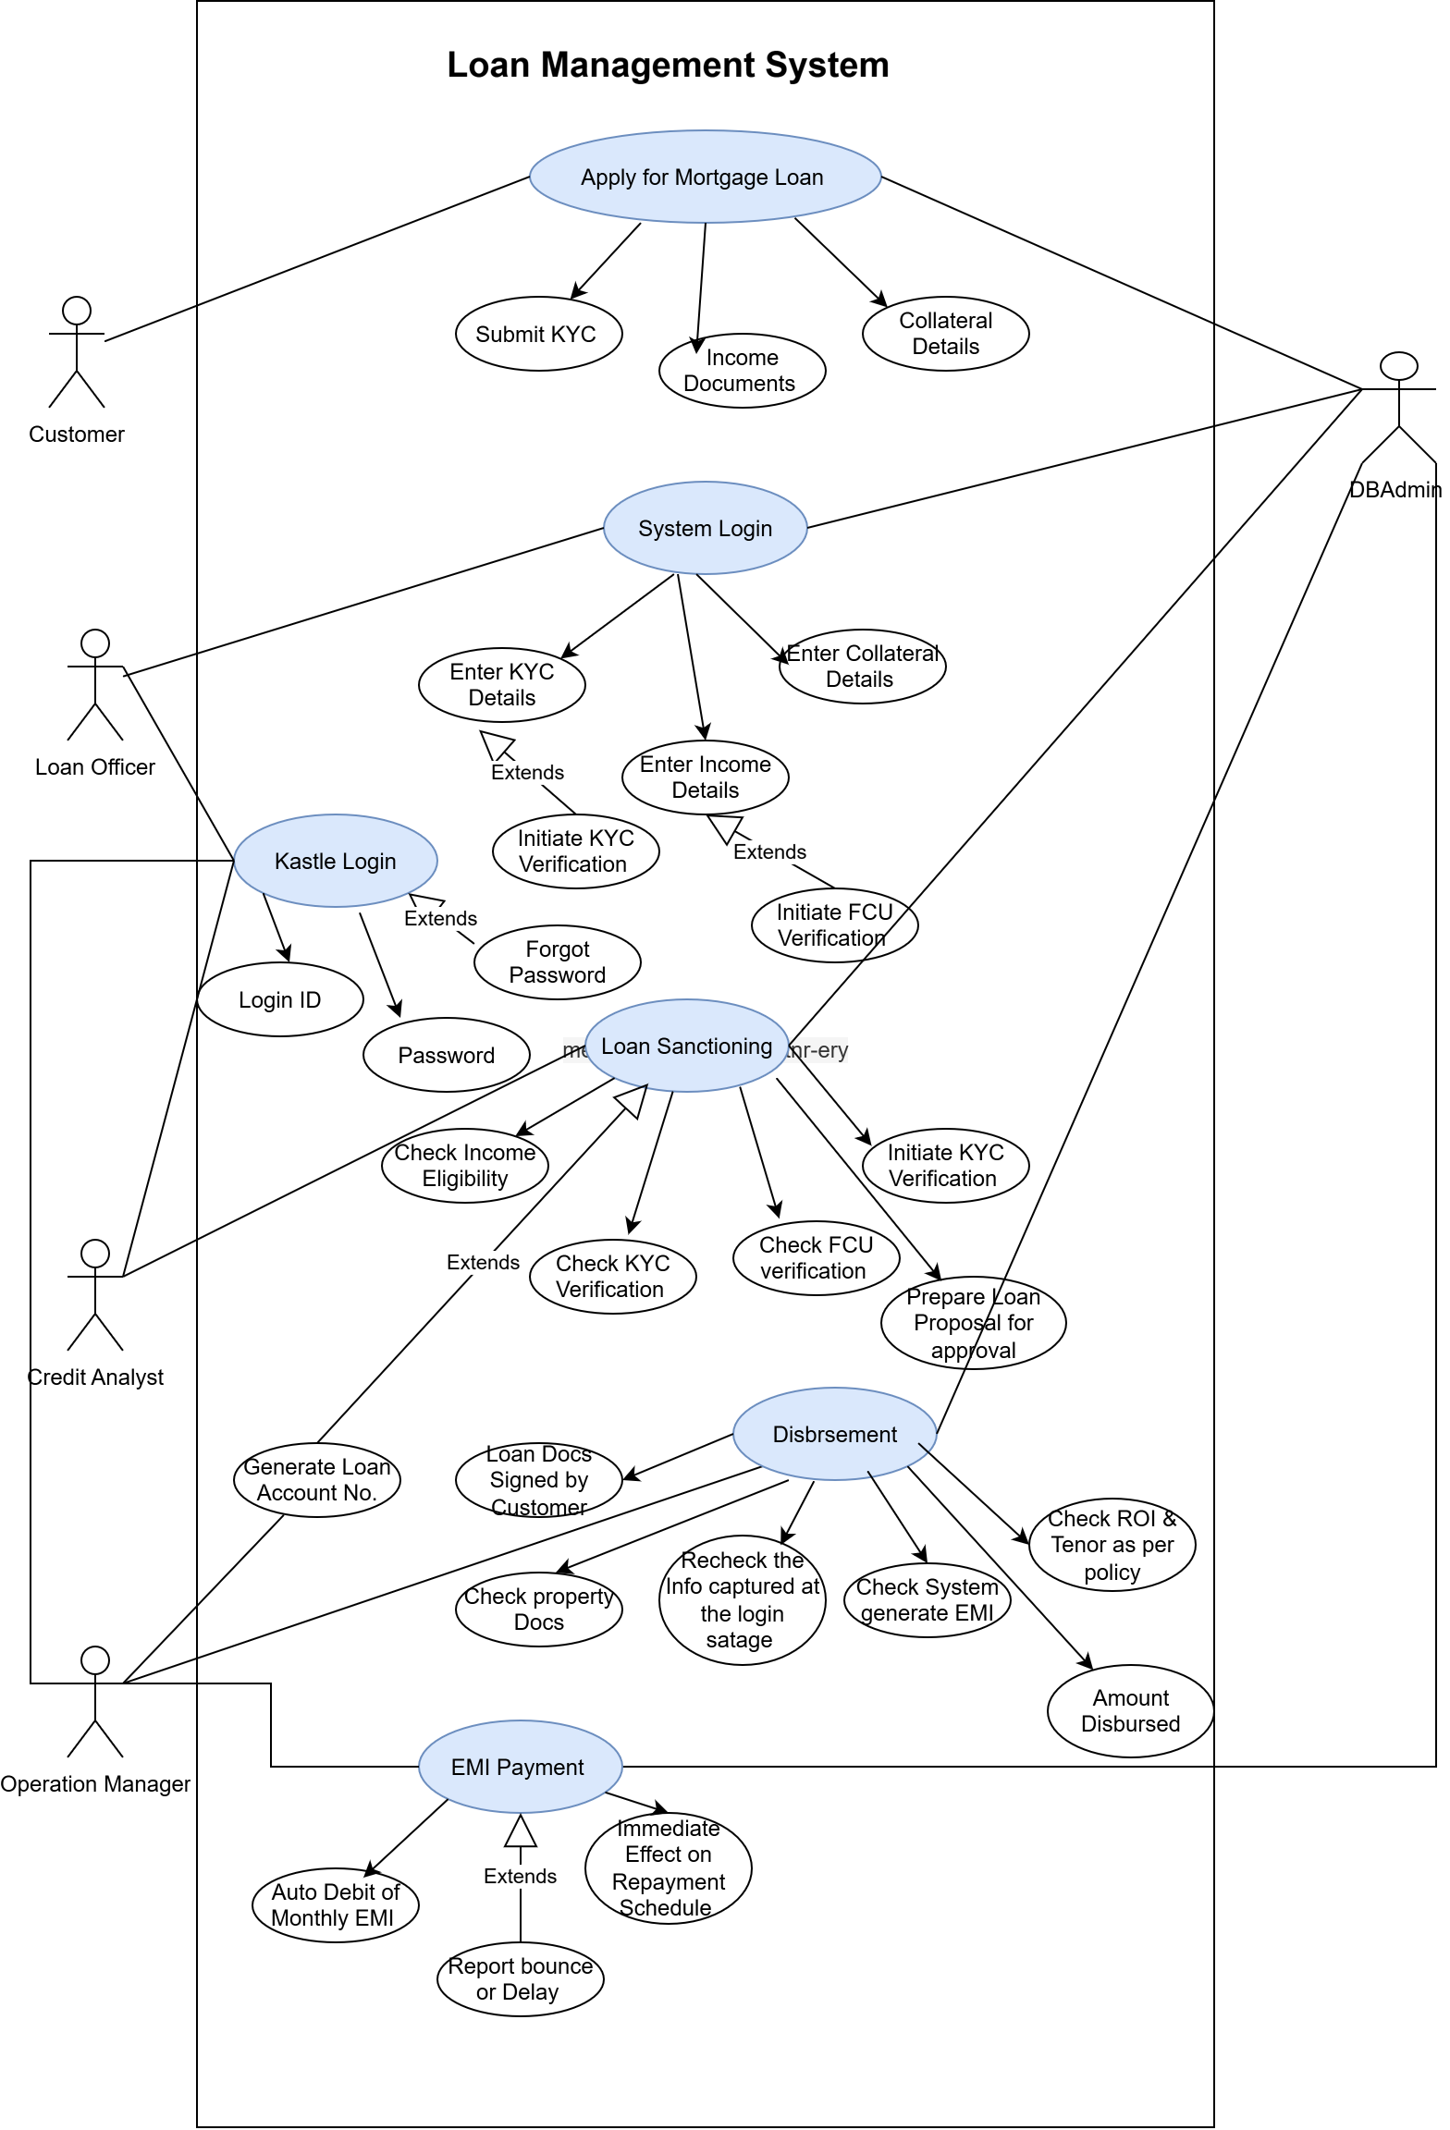
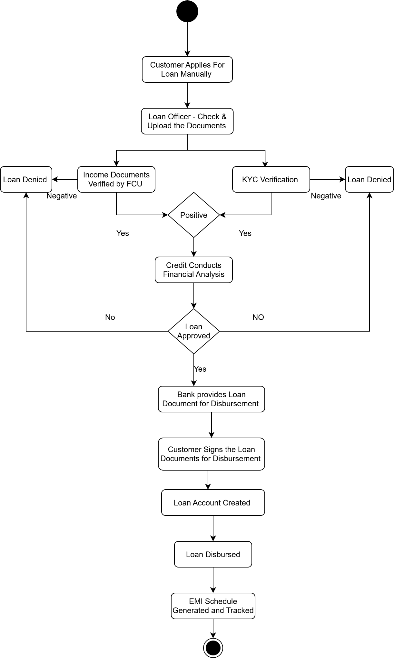
Use Case Specifications
Use Case ID | 1.0
Use case Name | Loan Disbursement
Created by | BA | Last updated BY | BA
Date of Creation | 12-09-2025 | Last Revision date | 13-09-2025
Actor | Primary Actor: Loan Officer (Operations Team)  Secondary Actors:  - Core Banking System (GL Posting)  - Document Management System (DMS)  - Payment Gateway/NACH System  - Compliance Officer
Description | This use case describes the process of disbursing approved loans to customers after successful sanction, verification, and compliance checks. It covers tranche-wise disbursement, builder payments, and customer notifications.
Pre- condition | Loan must be sanctioned and boarded in LMS.  All KYC, compliance, and risk checks must be completed.  Sufficient sanction balance must be available.
Post Condition | Loan account is updated with disbursed amount.  Repayment schedule is generated/updated.  Payment successfully transferred to designated beneficiary.
Normal Flow of events | 1) Loan Officer selects the sanctioned loan account from the system.  2) System validates sanction details, KYC, and compliance requirements.  3) Loan Officer enters disbursement amount and tranche details.  4) System validates available sanction limit and disbursement eligibility.  5)System triggers maker-checker approval workflow.  6) Upon approval, system interfaces with Payment Gateway/Bank for fund transfer.  7) Funds are transferred to builder/borrower account.  8) System updates loan account balance and repayment schedule.  9) Disbursement confirmation is sent via SMS/Email to the borrower.
Alternate Flow | 1) If partial disbursement is required, the Loan Officer selects "Partial Disbursement".  2)The system recalculates outstanding sanction limit and adjusts repayment schedule accordingly.
Exceptions | 1) If sanction validity has expired → System blocks disbursement.  2) If compliance/KYC verification fails → Disbursement request rejected.  3) If payment gateway fails → System retries, moves transaction to pending queue, and alerts the Loan Officer.
Frequency of Use | High
Assumptions | Payment systems (NACH/NEFT/PG) are available and online.  Sanctioned amount data is accurate and reconciled with LOS.  Compliance policies are updated in the LMS.
Constraints | Disbursement can only be done within business hours.  Subject to regulatory compliance (RBI/NHB rules).  Maker-checker mandatory for all disbursements.
Dependencies | Loan Origination System (LOS) for sanction details.  Core Banking System for GL postings.  Payment Gateway for fund transfers.  DMS for compliance documents.
Inputs and Outputs | Inputs:  - Loan Account Number  - Disbursement Amount  - Beneficiary Details  - Approval Workflow  Outputs:  - Fund Transfer Confirmation  - Updated Loan Account & Schedule  - Notifications to Customer and Loan Officer
Business Rules | Disbursement cannot exceed sanctioned loan amount.  Maker-checker approval required for every disbursement.  Only authorized Loan Officers can initiate disbursement.  GST/charges auto-calculated where applicable.
Miscellaneous Information | Audit logs must be maintained for each disbursement.  Reports generated for Finance, Risk, and Compliance teams.  System must ensure data encryption for payment details.

Use Case ID | 2.0
Use case Name | Loan Boarding
Created by | BA | Last updated BY | BA
Date of Creation | 12-09-2025 | Last Revision date | 13-09-2025
Actor | Primary Actor: Loan Operations Officer  Secondary Actors: LOS System, Credit Bureau, Compliance Officer
Description | Capturing and onboarding loan details into the LMS from LOS (Loan Origination System) or manual inputs for exceptions.
Pre- condition | Customer wants to apply for loan online
Post Condition | Loan created and visible in LMS with account number
Normal Flow of events | 1)Officer selects “New Loan Boarding.”  2) System fetches sanctioned data from LOS.  3) Officer validates sanction terms, Income Documents, borrower KYC, and collateral.  4) Officer enters/updates additional data.  5)System generates unique loan account number and schedules.  6)Confirmation sent to LOS and stored in LMS.
Alternate Flow | Manual boarding for exceptions if LOS is unavailable.
Exceptions | Missing KYC documents → system halts process.  Duplicate CIF detected → error message.
Frequency of Use | High
Assumptions | LOS integration is stable
Constraints | Must comply with KYC/RBI norms.
Dependencies | Loan Origination System (LOS) for sanction details.  DMS for compliance documents.  KYC details
Inputs and Outputs | Input – borrower, loan sanction data. Output – loan account number, schedule.
Business Rules | Maker-checker required for approvals.  PAN/Aadhaar validation mandatory.
Miscellaneous Information | Audit trail must capture all actions

Use Case ID | 3.0
Use case Name | Repayment Processing
Created by | BA | Last updated BY | BA
Date of Creation | 12-09-2025 | Last Revision date | 13-09-2025
Actor | Primary Actor: Customer  Secondary Actors: Payment Gateway, NACH System, Finance Officer
Description | Handling borrower repayments via NACH, UPI, IMPS.
Pre- condition | Loan account active.
Post Condition | Payment reflected in GL and schedule updated.
Normal Flow of events | Customer initiates repayment Via Auto debit  Payment received via channel.  LMS applies funds as per hierarchy (penal → charges → interest → principal).  System updates schedules and balances.  Receipt generated and sent to customer.
Alternate Flow | Partial payment accepted, system recalculates dues
Exceptions | Payment failure (insufficient funds, network issues).  Suspense posting if details mismatch.
Frequency of Use | High
Assumptions | Payment systems are integrated.
Constraints | Must process within SLA (< 2 hours for bulk NACH).
Dependencies | Payment Gateway, NACH, Core Banking.
Inputs and Outputs | Input – payment instruction. Output – receipt, updated schedule
Business Rules | Priority of allocation configurable by business rules.  Suspense must be cleared within 2 days
Miscellaneous Information | Payment retries allowed

Use Case ID | 4.0
Use case Name | Collections & Delinquency
Created by | BA | Last updated BY | BA
Date of Creation | 12-09-2025 | Last Revision date | 13-09-2025
Actor | Primary Actor: Collections Officer  Secondary Actors: Customer, Legal Officer, Agency
Description | Managing overdue accounts, tracking DPD (days past due), and collection activities.
Pre- condition | Loan account overdue.
Post Condition | Dues updated, collection status tracked.
Normal Flow of events | System identifies overdue accounts at EoD.  DPD bucket movement occurs automatically.  Collections officer contacts customer, records PTP (Promise To Pay).  Payment collected and updated in LMS.
Alternate Flow | Legal case initiation if PTP broken multiple times.
Exceptions | Wrong contact info → flagged to CRM.  Payment received but not reconciled.
Frequency of Use | High
Assumptions | Agency contracts already in place.
Constraints | Legal escalation per RBI guidelines
Dependencies | CRM, Legal, Payment Systems.
Inputs and Outputs | Input – overdue report. Output – PTP records, legal notices.
Business Rules | PTP tracking mandatory.  Legal escalation only post-threshold DPD.
Miscellaneous Information | All activities must be timestamped

Use Case ID | 5.0
Use case Name | Foreclosure / Prepayment
Created by | BA | Last updated BY | BA
Date of Creation | 12-09-2025 | Last Revision date | 13-09-2025
Actor | Primary Actor: Customer  Secondary Actors: Loan Officer, Finance System
Description | Handling early closure or partial prepayment of loans.
Pre- condition | Loan must be active.
Post Condition | Loan account closed or updated.
Normal Flow of events | Customer requests foreclosure or prepayment.  Officer calculates outstanding balance + charges.  System generates statement and prepayment penalty (if applicable).  Customer pays dues.  System closes loan / adjusts schedule.
Alternate Flow | Waiver of penalty (if approved by Risk)
Exceptions | Payment mismatch.  Waiver request denied.
Frequency of Use | High
Assumptions | Customer settles dues in one transaction
Constraints | RBI guidelines on foreclosure charges apply
Dependencies | Finance, Risk approvals
Inputs and Outputs | Input – closure request. Output – statement, NOC/NDC.
Business Rules | Penalty as per product policy.  Waivers only via maker-checker.
Miscellaneous Information | DMS triggers lien release

Use Case ID | 6.0
Use case Name | Data Migration
Created by | BA | Last updated BY | BA
Date of Creation | 12-09-2025 | Last Revision date | 13-09-2025
Actor | Primary Actor: Data Migration Lead  Secondary Actors: Finance Officer, IT Team
Description | Migrating accounts, balances, and history from Kastle to new LMS
Pre- condition | Legacy system data should be frozen
Post Condition | Data available in new LMS
Normal Flow of events | Extract data from Kastle.  Transform data into LMS format.  Load into LMS staging.  Reconcile account balances.  Run mock migration & verify.
Alternate Flow | Manual correction of exceptions
Exceptions | Data mismatch in balances.  Missing unique identifiers.
Frequency of Use | High
Assumptions | Source data is clean and reconciled.
Constraints | Mock migration variance ≤0.05%.
Dependencies | Kastle system, Finance, Audit.
Inputs and Outputs | Input – legacy data. Output – migrated data, reconciliation reports.
Business Rules | All accounts must tie out with GL.  Audit approval required.
Miscellaneous Information | Maintain full migration audit logs

Document 7- Screens and pages
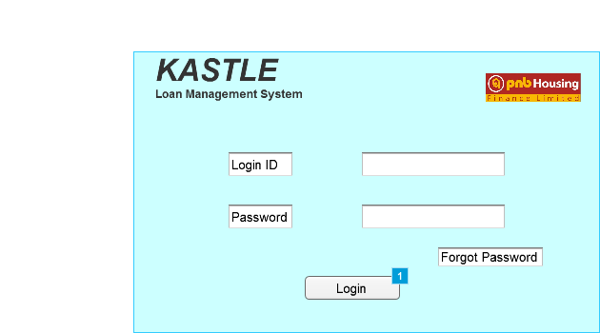

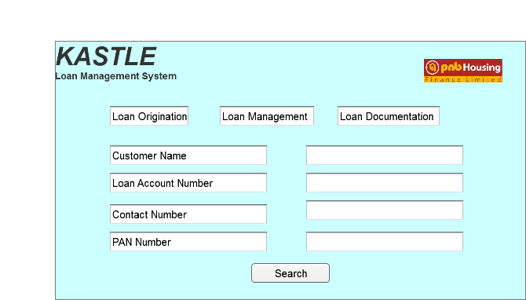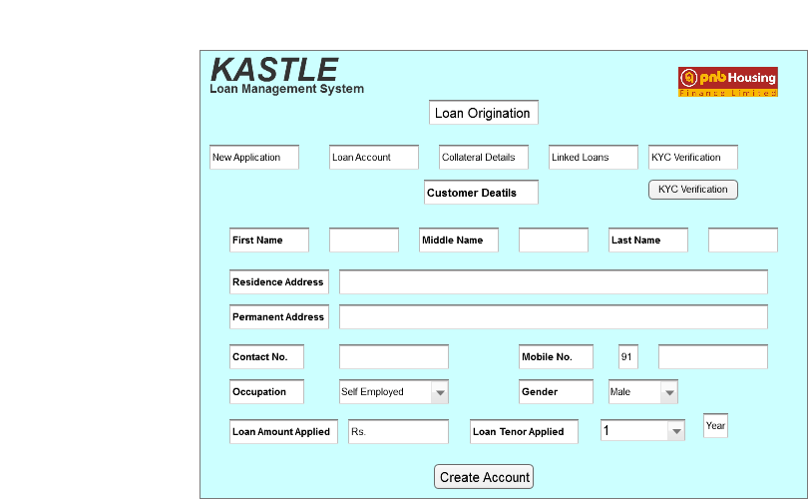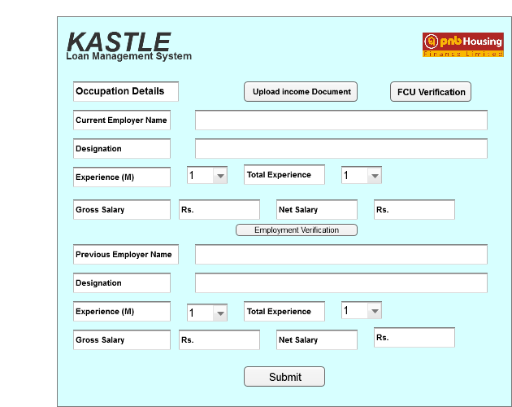

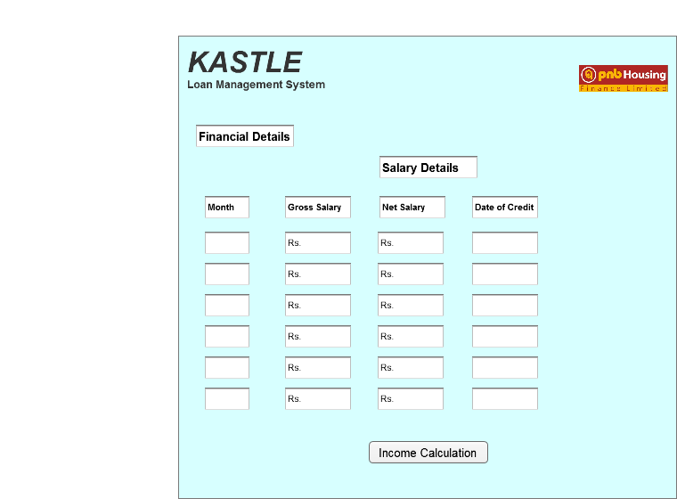

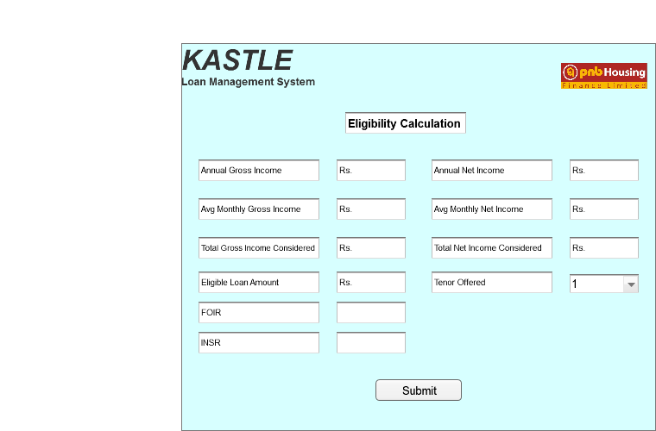
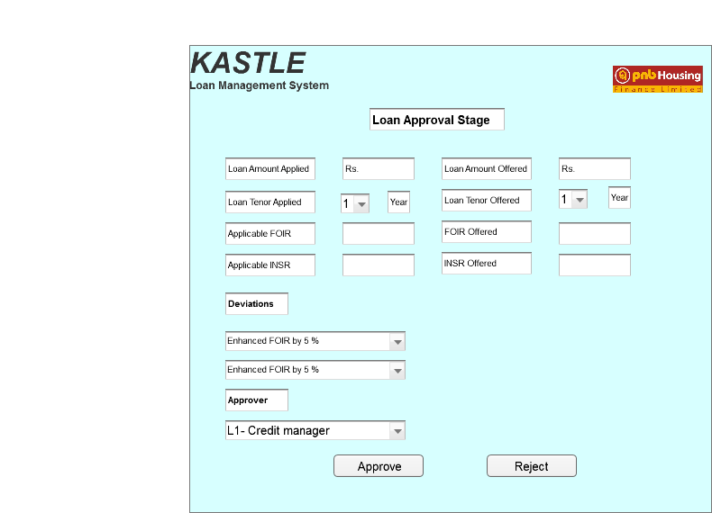

Document 8- Tools-Visio and Axure

MS Visio- It’s a diagramming and vector graphics application that allows users to create a wide range of visual representations, including flowcharts, network diagrams and other visual representation of complex information.
During this project, I tried to use Microsoft Visio for creating UML diagrams, including use case diagrams, Activity and data flow diagrams, which helped in visually representing system workflows and ensuring all stakeholders had a clear understanding of the functional requirements. Visio’s templates and drag-and-drop interface made it easier to maintain consistency across artifacts and document the system in a structured way.
Azure RP- It is more advanced prototyping tool used to create high fidelity, interactive wireframes and prototypes for web and mobile applications. Axure allows users to build prototypes without needing to write code, making it easier to test and refine designs before development begins. Axure is used mostly at research and design phase of the project.
Additionally, I leveraged Axure RP for prototyping user interfaces and simulating user journeys. Axure’s interactive wireframes provided stakeholders with a near-real experience of the system before development, helping to gather feedback early and reduce rework later. The combined use of Visio for system design and Axure for UI/UX prototypes ensured both the technical and business teams had a comprehensive view of the proposed Loan Management System.

Document 9- BA experience
1. Requirement Gathering:
- To gather requirements, we used MOSCOW technique.
- Actively engaged with stakeholders, including business users and department heads, to elicit requirements through interviews, workshops, and document analysis
- Client is not available for some period of time during this phase. So as a BA i need to source out point of contacts from his side and get the information ASAP.
- Ensured all business needs were captured clearly, prioritized them, and documented them in a structured format like BRD. There were many requirements which are duplicated or repeated which was removed.
2. Requirement Analysis:
- Analyzed gathered requirements to identify gaps, conflicts, and dependencies
- Created models such as use case diagrams, process flows, and data flow diagrams to validate requirements with stakeholders and ensure alignment with business objectives.
- Communicate the diagrams to team. Some team members might not agree with them and might make changes. As a BA we need to consider the points and make modifications
- Prepare BRS and SRS
3. Design:
- Collaborated with solution architects and UX designers to translate business requirements into functional specifications and wireframes. From the use case diagrams, we prepare test cases and communicate with client on design and solution documents
- Ensured the proposed system design aligned with the requirements, addressing both functional and non-functional needs.
- Ensured not a single test case was missed as it might have huge impact on project development in later stages
- Prepare test data for testing
- Update RTM. This is just as we need to make sure that all the requirements are met.
4. Development:
- During development, supported the technical team by clarifying requirements, resolving queries, and ensuring that the implementation followed the documented specifications.
- Organized JAD sessions- There might be some team members who doesn't agree with the concept or who doesn’t cooperate during JAD sessions. As a BA i handle the situation gently and had one on one discussion with them. Explained how their actions are going to affect the project. Setup healthy environment within the team.
- Conduct regular meetings with technical team and client which is challenging. Some team members might not be available for the meeting. Recording the session and providing that to missed one and having one to one discussion later with that missed person
- Referred diagrams to code the Unit

5. Testing:
- Assisted in preparing test scenarios and cases based on requirements from use cases
- To be actively involved in User Acceptance Testing (UAT), validating that delivered functionalities met business expectations
- Any defects or mismatches were logged, prioritized, and tracked until closure.
- Perform high level testing
- Updated RTM and Taken signoff from client
6. Deployment:
- Coordinated with stakeholders during deployment, ensuring proper training, user manuals, and transition support were provided.
- Validated that the solution was deployed successfully in the production environment and supported post-deployment activities, including feedback collection and change requests
- Forwarded RTM to client which should be attached to project closure document.
- Make sure all the candidates attend the meeting.

