Capstone Project 2
Prepared by :Niharika.
Batch : 05-05-2025

Question 1 – Write Agile Manifesto – 8 Marks

AGILE MANIFESTO:
  - Agile Manifesto is what are the values and Principles to be considered while working in Agile.
  - It is nothing but a document that outlines the 4 basic Values of Agile and 12 Principles of Agile.
It’s not only for Scrum but also for all the frameworks that come under Agile like Scrum, XP, Kanban etc.
Four main Values
- Individuals and interactions over processes and tools
- Working software over comprehensive documentation
- Customer collaboration over contract negotiation
- Responding to change over following a plan

Twelve Principles of Agile Software
- Satisfy the customer through early and continuous delivery of valuable software.
- Welcome changing requirements, even late in development. Agile processes harness change for the customer's competitive advantage.
- Deliver working software frequently, from a couple of weeks to a couple of months, with a preference to the shorter timescale.
- Business people and developers must work together daily throughout the project.
- Build projects around motivated individuals. Give them the environment and support they need and trust them to get the job done.
- The most efficient and effective method of conveying information to and within a
- development team is face-to-face conversation.
- Working software is the primary measure of progress.
- Agile processes promote sustainable development. The sponsors, developers, and users should be able to maintain a constant pace indefinitely.
- Continuous attention to technical excellence and good design enhances agility.
- Simplicity--the art of maximizing the amount of work not done--is essential.
- The best architectures, requirements, and designs emerge from self-organizingteams.
- At regular intervals, the team reflects on how to become more effective, then tunes and adjusts its behavior accordingly.

Question 2 – User Stories- Acceptance Criteria-BV-CP – 40 Marks
User Story No: 1 | Tasks: 2 | Priority: Highest
AS A DELIVERY BOY
I WANT TO REGISTER IN SCRUM FOODS SO THAT I CAN DELIVER ORDERS
BV: 500 | CP: 08
ACCEPTANCE CRITERIA

Registration Screen
Text Boxes for User Name, Password, Nation ID, Mobile No, Email, Address, Phone Number.
Click on Register Button.
Send Successful Notification to the user
Write minimum 40 User stories and their Acceptance Criteria along with their BV and CP

User Story No: 2 | Tasks: 2 | Priority: Highest
AS A RESTAURANT OWNER I WANT TO VIEW ORDERS
SO THAT I CAN VIEW THE LIST OF ORDERS
BV: 500 | CP: 08
ACCEPTANCE CRITERIA
---

View Order, Display List of orders in the tabular Form

User Story No: 3 | Tasks: 2 | Priority: Highest
AS A CUSTOMER
I WANT TO ADD THE ADDRESS
SO THAT I CAN GET THE ORDER TO MY ADDRESS
BV: 500 | CP: 08
ACCEPTANCE CRITERIA

Text Box to enter.

Business Rules: Within the radius of 5 km

User Story No: 4 | Tasks: 2 | Priority: Highest
AS A CUSTOMER
I WANT TO SELECT THE PAYMENT MODE
SO THAT I CAN MAKE PAYMENT OF MY CHOICE
BV: 500 | CP: 8
ACCEPTANCE CRITERIA

Display payment modes, radio buttons to select payment modes, payments button.

Business Rule. Can select only one payment mode

User Story No: 5 | Tasks: 1 | Priority: Highest
AS AN ADMIN
I WANT TO VIEW THE RESTAURANTS
SO THAT I CAN APPROVE THEIR REGISTRATION
BV: 500 | CP: 8
ACCEPTANCE CRITERIA

Register in the platform with the details

User Story No: 6 | Tasks: 1 | Priority: Low
AS A CUSTOMER
I WANT TO VIEW THE PRICE
SO THAT I CAN ORDER THE FOOD
BV: 50 | CP: 1
ACCEPTANCE CRITERIA
Display price in the list of menu items

User Story No: 7 | Tasks: 2 | Priority: Low
AS A CUSTOMER
I WANT TO VIEW THE CONTACT NUMBER OF DELIVERY BOY
SO THAT I CAN CONTACT DELIVERY BOY FOR THE STATUS
BV: 50 | CP: 1
ACCEPTANCE CRITERIA

- Display delivery boy mobile number
- Display delivery boy name in tracking field
- Display delivery boy picture

User Story No: 8 | Tasks: 2 | Priority: Medium
AS A RESTAURANT OWNER
I WANT TO PROVIDE TIME SLOTS
SO THAT CUSTOMER CAN CHECK OPENING AND CLOSING HOURS
BV: 100 | CP:
ACCEPTANCE CRITERIA
- Click on restaurant dashboard
- Add from time to time
- Click on submit
- Display updated successfully
User Story No: 9 | Tasks: 2 | Priority: High
AS A Business OWNER
I WANT TO VIEW RESTAURANT REVENUE REPORT SO THAT I CAN VIEW THE RESTAURANT’S REVENUE
BV: 200 | CP: 3
ACCEPTANCE CRITERIA
Select Reports
Select Revenue Reports Select to and from date Select Region (can select all) Generate Report
Download Report in EXCEL

User Story No: 10 | Tasks: 3 | Priority: High
AS A REG ADMIN
I WANT TO MANAGE REGIONAL RESTAURANTS SO THAT, I CAN TRACK THE PERFORMANCE OF REGIONAL RESTAURANTS.
BV: 200 | CP: 3
ACCEPTANCE CRITERIA
CLICK ON PERFORMANCE OF RESTAURANTS SELECT FROM DATE TO DATE
CLICK ON GENERATE REPORT WHICH INCLUDES RESTAURANTS ID, NAME, REVENUE
CLICK ON DOWNLOAD REPORT SHOULD BE IN EXCEL

User Story No: 11
AS ADMIN
I WANT TO SEE THE REGIONAL REVENUE REPORTS, SO THAT I CAN VIEW THE REGIONAL PERFORMANCE
BV: 100 CP:05
ACCEPTANCE CRITERIA
Select regional dropdown
View performance of each rest of that region in tabular form which includes rest name, revenue, generated Download in excel or PD

User Story No: 12 | Tasks: 2 | Priority: High
AS A CUSTOMER
I WANT TO CHAT WITH REG ADMIN
SO THAT I CAN REQUEST FOR REFUND
BV: 200 | CP: 5
ACCEPTANCE CRITERIA
- BR-ALL MANDATORY
- TEXT BOX FIELDS
- DISPLAY ORDER ID
- TEXT BOX,FOR DESCRIPTION
- SUBMIT BUTTON
- GENERATE ISSUE ID
- DISPLAY SUCCESSFUL

User Story No: 13 | Tasks: 2 | Priority: High
AS A HUNGRY USER
I WANT TO BROWSE NEARBY RESTAURANTS SO THAT I CAN ORDER THE FOOD
BV: 200 | CP: 3
ACCEPTANCE CRITERIA
- Each restaurant entry displays its name, cuisine type, and rating
- This list can be sorted by distance or rating

User Story No: 14 | Tasks: 2 | Priority: High
AS A CUSTOMER
I WANT TO BROWSE DIFFERENT RESTAURANTS AND MENUS
SO THAT I CAN FIND A PLACE TO ORDER FOOD
BV: 200 | CP: 2
ACCEPTANCE CRITERIA
- The menu includes dishes, prices and descriptions
- Show the restaurant is open or closed

User Story No: 15 | Tasks: 1 | Priority: High
AS A CUSTOMER
I WANT TO BROWSE FOR SPECIFIC DISHES AND CUISINES
SO THAT I CAN FIND A PLACE TO ORDER FOOD
BV: 200 | CP: 2
ACCEPTANCE CRITERIA
1)App displays relevant restaurant and dishes matching the query

User Story No: 16 | Tasks: 1 | Priority: High
AS A CUSTOMER
I WANT TO FILTER RESTAURANTS
SO THAT I CAN FIND A PLACE TO ORDER FOOD
BV: 200 | CP: 2
ACCEPTANCE CRITERIA
1)Filter restaurants by cuisine type and dietary options (vegan, veg, nonveg, egg)
User Story No: 17 | Tasks: 2 | Priority: High
AS A CUSTOMER
I WANT TO TRACK MY ORDER
SO THAT I KNOW THE TIME OF DELIVERY
BV: 200 | CP: 2
ACCEPTANCE CRITERIA
- App shows real time update on the order status
- Display estimated delivery time

User Story No: 18 | Tasks: 1 | Priority: High
AS A USER
I WANT TO SAVE FAVOURITE RESTAURANTS AND DISHES
SO THAT I CAN ORDER FROM MY FAVOURITES
BV: 200 | CP: 2
ACCEPTANCE CRITERIA
1)Access my list of favorites easily for future orders

User Story No: 19 | Tasks: 1 | Priority: High
AS A USER
I WANT TO VIEW PAST ORDER HISTORY SO THAT I CAN ORDER AGAIN
BV: 200 | CP: 2
ACCEPTANCE CRITERIA
1)Can see the details such as order items, total cost and order date

User Story No:20 | Tasks: 3 | Priority: High
AS A USER
I WANT TO RECEIVE NOTIFICATIONS SO THAT I CAN RECEIVE UPDATES
BV: 200 | CP: 2
ACCEPTANCE CRITERIA
1)Notifications for order confirmation 2) Notification for dispatch 3) Notification for delivery

User Story No:22 | Tasks: 2 | Priority: High
AS A CUSTOMER
I WANT TO CONTACT CUSTOMER SUPPORT SO THAT I CAN SUBMIT QUERIES OR ISSUES
BV: 200 | CP: 2
ACCEPTANCE CRITERIA
1)Customer support section with contact information

User Story No:22 | Tasks: 2 | Priority: High
AS A RESTAURANT OWNER
I WANT TO RECEIVE AND MANAGE ORDERS SO THAT I CAN UPDATE ORDER STATUS
BV: 200 | CP: 5
ACCEPTANCE CRITERIA
1) Manage order status
2) Notify restaurants about incoming orders
User Story No:23 | Tasks: 2 | Priority: High
AS A RESTAURANT OWNER
I WANT TO ACCESS TO CUSTOMER REVIEWS
SO THAT I CAN VIEW AND RESPOND TO CUSTOMER REVIEWS
BV: 200 | CP: 2
ACCEPTANCE CRITERIA
- Owners can address feedback
- Owners can improve their services

User Story No:24 | Tasks: 1 | Priority: Medium
AS A CUSTOMER
I WANT TO VIEW PROMOCODES AND DISCOUNTS SO THAT I CAN ORDER AT LOWER PRICE
BV: 100 | CP: 4
ACCEPTANCE CRITERIA
1)Active Promo codes

User Story No:25 | Tasks: 1 | Priority: Medium
AS A CUSTOMER
I WANT TO APPLY PROMOCODES AND DISCOUNTS SO THAT I CAN ORDER AT LOWER PRICE
BV: 100 | CP: 4
ACCEPTANCE CRITERIA
1)Active Promo codes

User Story No:26 | Tasks: 7 | Priority: HIGH
AS A DELIVERY BOY
I WANT TO VIEW THE ORDERS SO THAT I CAN ACCEPT THE ORDERS
BV: 200 | CP: 4
ACCEPTANCE CRITERIA
1)Order visibility 2) Real-time updates
3) Order details 4) Order filtering and sorting
5) Order map view 6) Order navigation
7) Order completion and confirmation

User Story No:27 | Tasks: 5 | Priority: HIGH
AS A DELIVERY BOY I WANT TO LOGIN SO THAT I CAN ACCEPT THE ORDER
BV: 200 | CP: 4
ACCEPTANCE CRITERIA
- User Authentication
- Error Handling
- Password security
- Multi-factor Authentication 5) Compatibility and Usability

User Story No:28 | Tasks: 5 | Priority: MEDIUM
AS A DELIVERY BOY
I WANT TO VIEW FEEDBACK SO THAT I CAN KNOW
THE CUSTOMER FEEDBACK
BV: 200 | CP: 4
ACCEPTANCE CRITERIA
1) Access to feedback system 2) Feedback Visibility
3) Feedback sorting and filtering 4) Response Mechanism
5) User Support

User Story No:29 | Tasks: 5 | Priority: MEDIUM
AS AN ADMIN
I WANT TO VIEW FEEDBACK SO THAT I CAN KNOW THE CUSTOMERS FEEDBACK
BV: 200 | CP: 4
ACCEPTANCE CRITERIA
1) Access to feedback system 2) Feedback Visibility
3) Feedback sorting and filtering 4) Response Mechanism
5) User Support

User Story No:30 | Tasks: 5 | Priority: MEDIUM
AS A RESTAURANT OWNER I WANT TO VIEW FEEDBACK SO THAT I CAN KNOW THE CUSTOMERS FEEDBACK
BV: 200 | CP: 4
ACCEPTANCE CRITERIA
1) Access to feedback system 2) Feedback Visibility
3) Feedback sorting and filtering 4) Response Mechanism
5) User Support
User Story No:31 | Tasks: 3 | Priority: HIGH
AS AN ADMIN
I WANT TO KNOW THE ISSUES SO THAT I CAN RESOLVE THEM
BV:100 | CP: 3
ACCEPTANCE CRITERIA
1) Display issue section
2) Sorting and filtering of issues list
3) Editing and modifying the issues

User Story No:32 | Tasks: 3 | Priority: HIGH
AS A REGIONAL ADMIN
I WANT TO KNOW THE ISSUES SO THAT I CAN RESOLVE THEM
BV: 200 | CP: 4
ACCEPTANCE CRITERIA
1) Display issue section
2) Sorting and filtering of issues list
3) Editing and modifying the issues

User Story No:33 | Tasks: 6 | Priority: HIGH
AS A RESTAURANT OWNER
I WANT TO VIEW REVENUE GENERATED SO THAT I CAN VIEW RESTAURANTS REVENUE
BV: 200 | CP: 4
ACCEPTANCE CRITERIA
Select Reports
Select Revenue Reports Select to and from date Select Region (can select all) Generate Report
Download Report in EXCEL

User Story No:34 | Tasks: 2 | Priority: HIGH
AS A RESTAURANT OWNER
I WANT TO KNOW DELIVERY BOY SO THAT I CAN VERIFY THE DELIVERY BOY
BV: 200 | CP: 4
ACCEPTANCE CRITERIA
ID proof
Punctuality and reliability

User Story No: 35
AS A CUSTOMER
I WANT TO VIEW THE CONTACT NUMBER OF DELIVERY BOY SO THAT I CAN CONTACT DELIVERY BOY FOR THE STATUS
BV: 50
ACCEPTANCE CRITERIA
1. Display delivery boy mobile number
2. Display delivery boy name in tracking field
3. Display delivery boy picture

User Story No: 36 | Tasks: 2 | Priority: Medium
AS A RESTAURANT OWNER
I WANT TO PROVIDE TIME SLOTS SO THAT CUSTOMER CAN CHECK OPENING AND CLOSING HOURS
BV: 100 | CP: 2
ACCEPTANCE CRITERIA
1. Click on restaurant dashboard
2. Add from time to time
3. Click on submit
4. Display updated successfully

User Story No:37 | Tasks: 3 | Priority: High
AS A USER
I WANT TO RECEIVE NOTIFICATIONS SO THAT I CAN RECEIVE UPDATES
BV: 200 | CP: 2
ACCEPTANCE CRITERIA
1)Notifications for order confirmation 2) Notification for dispatch 3) Notification for delivery

User Story No:38 | Tasks: 1 | Priority: MEDIUM
AS A CUSTOMER
I WANT TO CONTACT CUSTOMER SUPPORT SO THAT I CAN SUBMIT QUERIES OR ISSUES
BV: 200 | CP: 2
ACCEPTANCE CRITERIA
1)Customer support section with contact information

User Story No:39 | Tasks: 4 | Priority: MEDIUM
AS A CUSTOMER
I WANT TO VIEW THE ORDER SO THAT I CAN CANCEL IT
BV: 100 | CP: 3
ACCEPTANCE CRITERIA
Order status
Method of cancellation Refund policy
Time frame

User Story No:40 | Tasks: 4 | Priority: HIGH
AS A REGIONAL ADMIN
I WANT TO TRACK THE DELIVERY SO THAT I CAN VIEW THE STATUS OF THE DELIVERY
BV: 100 | CP: 3
ACCEPTANCE CRITERIA
Real time tracking Security and data privacy User friendly Interface
Question 3– What is epic? Write 2 epics – 5 Marks

Epic is a large user story or a collection of related user stories that represents a significant feature or functionality. Epics are high level, often spanning multiple sprints or iterations, and they provide a way to organize and prioritize work in a product backlog.

Epic No.1: Ratings and reviews:
As a user, I want to view ratings and reviews for restaurants on scrum foods, so that I can make informed decisions about where to order food from.
As a user, I want to provide ratings and reviews for restaurants on scrum foods, so that I can share my experiences with other users and contribute to the community.

Acceptance Criteria
  - Users can view average ratings and reviews for each restaurant on the restaurant details page
  - Users can read detailed reviews and comments left by the other customers
  - Users can sort and filter reviews based on criteria such as rating and relevance
  - Users can rate the restaurants and leave a review after placing the order
  - User can edit or delete their own reviews within a specified timeframe
  - Reviews are displayed in a way that provides helpful insights to other users
  - The rating and review system maintains the integrity and authenticity of user feedback
Epic No.2: Real-Time Order Tracking for Food Delivery App
Description:
The real-time order tracking epic aims to provide users with a seamless and transparent experience by allowing them to track the status and location of their food orders in
real-time. This feature enhances customer satisfaction, reduces support inquiries, and improves overall user engagement.

User Stories:
As a customer, I want to see the live status of my order.
  - Display the current status of the order, such as "order confirmed," "preparing," "out for delivery," and "delivered."
  - Provide real-time updates as the order progresses through various stages.
As a customer, I want to track the location of my delivery.
  - Integrate GPS or location services to show the delivery partner's real-time location on a map.

  - Allow customers to view the estimated time of arrival (ETA) based on the delivery partner's location.
As a customer, I want to receive notifications for order updates.
  - Send push notifications or SMS updates to inform customers about order confirmation, preparation, and delivery status changes.
  - Provide delivery partner details, including name, contact information, and a profile picture.
As a customer, I want to contact the delivery partner directly.
  - Enable in-app chat or call functionality to allow customers to communicate with the assigned delivery partner.
  - Ensure privacy by using masked phone numbers or secure messaging channels.
As a customer, I want to view the delivery route.
  - Display the delivery route on the map, showing the path the delivery partner will take to reach the destination.
  - Allow customers to track the progress of the delivery in real-time along the route.
As a customer, I want to provide feedback on the delivery experience.
  - Allow customers to rate the delivery partner and overall delivery experience after the order is delivered.
  - Implement a feedback system with written comments to gather valuable insights.
As a customer, I want to see estimated delivery time adjustments.
  - Account for real-time traffic conditions and other factors that may affect the delivery time.
  - Update the estimated delivery time accordingly and inform the customer promptly.
As a customer, I want to have a seamless tracking experience across platforms.
  - Ensure the real-time order tracking feature is available and consistent on all supported platforms (e.g., mobile app, web).
As an admin, I want to monitor order tracking performance.
  - Provide analytics and reporting on order tracking metrics, such as average delivery time and customer satisfaction ratings.
  - Use data to identify areas for improvement and optimize the delivery process.

Acceptance Criteria:

Real-Time Order Updates:

  - The app should provide real-time updates on the status of the user's order, such as "Order received," "Preparing," "Out for delivery," and "Delivered."
Order Location Tracking:

  - The app should display the live location of the delivery driver while en route to the user's address.
  - The map should update at regular intervals to reflect the driver's movement accurately.
Estimated Delivery Time:

  - The app should provide an accurate estimated time of delivery (ETA) based on the driver's current location, distance to the delivery address, and traffic conditions.
Delivery Notifications:

  - Users should receive push notifications or in-app alerts for significant order updates, such as when the order is dispatched for delivery or when it is near the delivery address.
Map Zoom and Interaction:

  - Users should be able to zoom in and out on the map to view the delivery driver's route more closely.
  - The map should support standard interactions, such as panning and rotating, to improve the user experience.
Delivery Status History:

  - Users should have access to the delivery status history, allowing them to see the timeline of their order from placement to delivery completion.
Accuracy and Reliability:

  - The real-time tracking information should be accurate and reliable, providing users with the most up-to-date data available.
The system should handle location updates efficiently, minimizing delays or inaccuracie
Privacy and Security:

  - The real-time tracking feature should adhere to data privacy regulations and ensure that user location data is handled securely and used only for order tracking purposes.
Compatibility:

  - The real-time order tracking should work smoothly across various platforms, including iOS and Android devices, as well as web browsers.
Opt-Out Option:

- Users should have the option to disable real-time order tracking if they prefer not to share their location information.
User Education:

- Provide clear instructions or tooltips to educate users on how to use the real-time order tracking feature effectively.
Support for Multiple Orders:

- If a user places multiple orders, the app should allow them to track each order individually with its own status and location updates.
By meeting these acceptance criteria, the food delivery app can successfully implement real-time order tracking, providing users with a transparent and convenient way to monitor their orders from the moment they are placed until they are delivered to their doorstep.

Question 4 –What is the difference between BV and CP – 2 Marks

- Business Value (BV):
  - Business Value refers to the perceived or quantifiable worth or benefit that a specific task, feature, or requirement brings to the business or project.
  - It is typically determined based on factors such as revenue generation, cost savings, customer satisfaction, market competitiveness, strategic alignment, and other business-related criteria.
  - Business Value helps prioritize tasks or features based on their importance to the overall project goals and objectives.

  - Examples of Business Value considerations: Increased revenue, improved user experience, compliance with industry regulations, competitive advantage.

Techniques used: Moscow, Currency notes technique MOSCOW:
The MOSCOW technique is a prioritization and requirements management technique used in project management and software development. It helps stakeholders and project teams prioritize and categorize requirements or tasks based on their importance and urgency. The acronym "MOSCOW" stands for the four categories into which requirements or tasks are typically classified:
- Must Have: These are critical requirements or tasks that are essential for the project's success. Without these, the project would likely fail to meet its objectives.
- Should Have: These are important requirements or tasks that are not absolutely critical but significantly contribute to the project's value. They are high-priority items that should be included if possible.
- Could Have: These are desirable requirements or tasks that would enhance the project but are not essential. They are often considered nice-to-have features that can be addressed if time and resources allow.
- Won't Have (this time): These are requirements or tasks that are deliberately deprioritized and will not be included in the current phase of the project. They may be considered for future iterations or versions.
The MOSCOW technique helps project teams and stakeholders make informed decisions about what should be included in a project based on the available resources, constraints, and objectives. It facilitates open communication between stakeholders, ensures that the most critical aspects are addressed first, and allows for flexibility in project scope as priorities change.
Here's an example of how the MOSCOW technique might be used in a software development project:
- Must Have: User authentication, basic user profile management, core functionality of the application.
- Should Have: Advanced user settings, integration with third-party services, improved user interface design.
- Could Have: Additional language support, social media sharing features, enhanced search functionality.
- Won't Have (this time): Gamification features, integration with legacy systems, complex data visualization.

By categorizing requirements or tasks using the MOSCOW technique, project teams can focus on delivering the most critical and valuable components of a project while providing a clear framework for managing priorities and expectations.

Complexity Points (CP):
  - Complexity Points, also known as story points or function points, are a measure of the relative complexity or effort required to complete a task, feature, or requirement.
  - They are used to estimate the effort, time, and resources needed to implement a specific item.
  - Complexity Points are often assigned based on factors such as technical difficulty, development effort, integration challenges, and other technical or development-related criteria.
  - Complexity Points help in assessing the workload and resource allocation needed for different tasks or features.
  - Examples of Complexity Points considerations: Integration with legacy systems, technical dependencies, data migration, algorithmic complexity.
Techniques used: Planning poker
Planning poker:
Planning Poker is a consensus-based technique commonly used in Agile and Scrum methodologies for estimating the effort or complexity of user stories or tasks. It helps teams collaborate and arrive at a shared understanding of the work involved in a particular item. The term "CP" in your question likely stands for "Complexity Points," which are used in Planning Poker to represent the relative effort or complexity of a task. Here's how the Planning Poker technique works:

Preparation:

. The team gathers to estimate the effort or complexity of user stories or tasks that need to be completed in a sprint or iteration.

Estimation Cards:

Estimation cards are used, each containing a number representing a predefined range of Complexity Points (e.g., 0, 1, 2, 3, 5, 8, 13, 20, 40,100).
- The cards are often designed such that the numbers increase non-linearly, reflecting that as tasks become more complex, the uncertainty in estimates also increases.

Facilitator:
A facilitator (often the Scrum Master or Agile Coach) leads the session and explains the process to the team.
Estimation Process:

- For each user story or task, the team discusses the requirements, assumptions, and any relevant information.
- Each team member selects an estimation card representing their individual view of the Complexity Points required to complete the task. The card is kept face down.

Reveal and Discussion:

- After everyone has selected a card, all team members reveal their chosen cards simultaneously.
- If there's a wide variation in estimates, team members have a discussion to share their reasoning and insights. This helps clarify assumptions and leads to a shared understanding.

Re-Estimation and Consensus:
After the discussion, team members may revise their estimates by selecting a different card based on the insights gained.
The process of discussion and re-estimation continues until a consensus is reached. The goal is to align the team's estimates.

Repeat for Each Task:
The process is repeated for each user story or task in the backlog.

Final Estimate:
The final estimate for each user story or task is often determined by the mode or median of the estimates chosen by the team members.
Planning Poker helps mitigate individual biases and provides a collaborative and transparent way to estimate work. It encourages discussions, helps identify potential challenges, and allows the team to make informed decisions about how much work can be taken on in a sprint or iteration

In summary, Business Value focuses on the business impact and significance of tasks or features, while Complexity Points focus on the technical effort and complexity involved in implementing those tasks or features. Both concepts are valuable in project management and software development, as they help prioritize and plan work based on both business goals and technical constraints.

Question 5 –Explain about Sprint– 5 Marks
SPRINT:

In the context of software development and project management, a Sprint is an Time-boxed, iterative development period during which a specific set of tasks and goals are worked on by a development team. Sprint is a core concept in Agile methodologies, such as Scrum, which emphasizes flexibility, collaboration, and delivering value to the customer in shorter cycles.
Here are the key characteristics and components of a sprint:

- Time Frame: A sprint typically has a fixed duration, often ranging from 1 to 4 weeks. The duration is consistent across all sprints to provide a predictable cadence for development and planning.
- Goals and Objectives: At the beginning of each sprint, the development team, along with stakeholders, selects a set of user stories, features, or tasks to work on during that sprint. These items are collectively referred to as the sprint backlog.
- Planning: During sprint planning, the development team breaks down the selected items from the product backlog into smaller tasks and estimates the effort required for each task. The team commits to completing these tasks within the sprint duration.
- Daily Stand-ups: Throughout the sprint, the team holds daily stand-up meetings (also known as daily scrums) to discuss progress, obstacles, and plans. Each team member shares what they've accomplished, what they're working on, and any challenges they're facing. These meetings foster communication and collaboration.
- Development: The development team works on the tasks identified in the sprint backlog. They collaborate closely, often using techniques like pair programming and frequent code reviews to ensure high-quality work.
- Continuous Integration: Developers integrate their code changes into the main codebase regularly, ensuring that the software remains functional and stable throughout the sprint.
- Testing: Testing is an integral part of a sprint. Automated tests are run to validate code changes, and manual testing may be conducted to ensure the quality of the software.
- Review and Demo: At the end of the sprint, the development team conducts a sprint review and demo. They showcase the completed work to stakeholders, gathering feedback and validation. This helps ensure that the delivered features align with expectations.
- Retrospective: Following the review and demo, the team holds a sprint retrospective. They reflect on what went well during the sprint, what could be improved, and actions to take in the next sprint. The retrospective encourages continuous improvement.

- Incremental Development: Each sprint results in a potentially shippable product increment, meaning that at the end of each sprint, a new version of the software is available with additional features or improvements.

- Adaptability: Agile methodologies emphasize adaptability and the ability to respond to changing requirements. If new priorities or insights emerge, adjustments can be made in subsequent sprints.
Sprints allow development teams to iteratively deliver value to customers and stakeholders in a controlled and predictable manner. By breaking down the work into manageable chunks and continuously seeking feedback, Agile teams can enhance collaboration, reduce risk, and improve the overall quality of the software being developed.

Question 6 – Explain Product backlog and sprint back log– 5 Marks

Product Backlog and Sprint backlog:

The Product Backlog is a dynamic, prioritized list of all the features, user stories, enhancements, bug fixes, and other work items that need to be addressed over the course of a project. It represents the entire scope of the product's development and is managed by the Product Owner. The Product Backlog is continually refined and updated based on feedback, changing requirements, and new insights.

The Sprint Backlog is a subset of the Product Backlog that represents the work that the development team commits to completing during a specific time period called a "Sprint." A Sprint is a fixed-duration iteration, usually lasting two to four weeks, in which the team
works on a set of items from the Product Backlog. The Sprint Backlog is created during the Sprint Planning meeting, where the development team selects a set of items to work on based on their capacity and the priorities set by the Product Owner.
S.No. | Product Backlog | Sprint Backlog
1 | Anything that needed to accomplish the project vision | Anything that needed to fulfill the sprint goal
2 | Product owner owns | Development team owns
3 | Contains requirements, tasks, and defects. | A subset of product backlog items defined as a priority by the product owner
4 | Everyone contributes to the product catalog | Sprint planning meeting is to refine the sprint backlog items
5 | Product backlog evolves and changes will be done by the PO through the product life cycle | No changes are allowed to the sprint backlog items once the sprint has started
6 | Product backlog refinement meeting is to refine the product backlog | Sprint planning meeting is to refine the sprint backlog items
7 | Release burn down metric is used | Sprint burn down metric is used
8 | Estimation is done at a user story level | Estimation is done at activity or task level
9 | Daily standup meeting does not discuss product backlog items | Daily standup meeting discusses the sprint backlog in accordance with sprint goal
Question 7 – What is impediments log? write 2 impediments – 5 Marks
Impediments Log: An impediment log, also known as an issue log or obstacle log, is a document or tool used in Agile software development to track and manage obstacles, bottlenecks, or any factors that impede the progress of a project or team.
Example of Two Impediments are as follows:
Delivery partner shortage in a specific region
Technical issue causing intermittent order processing failure a.
Delivery partner shortage in a specific region:
Login ID | 1
Description | Delivery partner storage in specific region
Impact | Delays in order deliveries and increases customer dissatisfaction
Priority | High (due to its impact on customer experience)
Assigned to | Operations team and HR team
Status | Open
Action taken | The operations team is actively recruiting new delivery partners in the region. The HR team is working on fast-tracking the onboarding process.
Resolution | Delivery partner recruitment efforts are ongoing and the HR team is streamlining the onboarding process to expedite new hires. Regular updates are being provided in team meetings.
b. Technical issue causing intermittent order processing failure

Login ID | 2
Description | Technical issue causing intermittent order processing failures
Impact | Delays in order processing and potential revenue loss
Priority | High (due to its impact on revenue and customer experience)
Assigned to | Tech team and QA team
Status | In progress
Action taken | The tech team has identified the root cause and is working on a fix. The QA team is conducting extensive testing to ensure the issue is resolved
Resolution | The tech team has implemented a fix and conducted thorough testing. The issue has been resolved, and orders are now processing smoothly.

Question 8 – Explain Velocity of the Team – 1 Marks

VELOCITY OF THE TEAM:

Velocity refers to the measure of the amount of work a development team can complete during a sprint.
The calculation of velocity is performed by the development team itself, as they are responsible for estimating the effort required to complete each user story or backlog item.
Story point estimation:
Story point estimation is a technique used in agile software development to estimate the effort required for a specific task or user story. It's a relative measure of complexity rather than a fixed time unit. Team members assign story points based on their understanding of the work involved, considering factors like complexity, effort, and uncertainty.
The actual time a story point represents can vary from team to team. For some, it might equate to hours, while for others, it might represent days. It's important to establish a consistent baseline within the team so that story point estimates can be used effectively for planning and prioritization.

Tracking completed work:
Tracking completed work in Agile development typically involves calculating the total story points completed by the team over a specific time frame, usually a sprint or iteration. Here's how you can calculate completed work:
- Identify Completed Stories: At the end of the sprint or iteration, review the user stories or tasks that were completed and accepted as done.
- Sum Story Points: Add up the story points assigned to all the completed user stories. Exclude any story points that were not fully finished or accepted during the sprint.
- Calculate Total Completed Work: The sum of story points completed represents the total completed work for that sprint.
This completed work can be used to calculate the team's velocity for that specific sprint, as mentioned in the previous response. It provides insights into the team's capacity and helps with
future sprint planning and estimation.

Summing story points:
Summing story points involves adding up the numerical values assigned to individual user stories or tasks during the estimation process in Agile development. Story points are used to represent the effort, complexity, and size of a piece of work relative to other items on the backlog. Here's how you can sum story points:
- List Completed User Stories: Gather a list of user stories or tasks that have been completed during a specific sprint or iteration.

- Identify Story Point Values: Each user story or task should have a story point value assigned to it during the estimation process. These values are usually relative, such as 1, 2, 3, 5, 8, 13, etc., representing increasing levels of complexity or effort.
- Add Up Story Point Values: Sum up the story point values for all the completed user stories or tasks. For example, if you completed user stories with story point values of 3, 5, and 8, the sum would be 16.
The sum of story points provides a quantitative measure of the work completed by the team during a sprint. This sum is often used to calculate the team's velocity, which helps in future sprint planning and estimation.
Average velocity:
Average velocity in Agile development refers to the average amount of work, measured in story points, that a team completes during a series of sprints or iterations. It's a key metric used for planning and estimating future work. Here's how to calculate average velocity:
- Select a Time Frame: Choose a specific number of past sprints or iterations for which you want to calculate the average velocity. For example, you might choose the last 5 sprints.
- Sum Completed Story Points: Add up the total story points completed by the team in each of the selected sprints. This will give you the total completed work for the chosen time frame.
- Calculate Average: Divide the total completed story points by the number of sprints or iterations you selected. This will give you the average velocity for that period.
Formula: Average Velocity = Total Completed Story Points / Number of Sprints
Use for Planning: The average velocity can serve as a guideline for future sprint planning. It helps the team estimate how much work they can commit to in upcoming iterations based on their historical performance.
Keep in mind that average velocity is a rough estimate and can fluctuate based on various factors. It's important to consider the team's capacity, any changes in team composition, and improvements in estimation accuracy over time.
Question 9 – Draw Sprint Burn Charts n Product Burn Down Charts– 3 Marks

SPRINT BURNDOWN CHART:

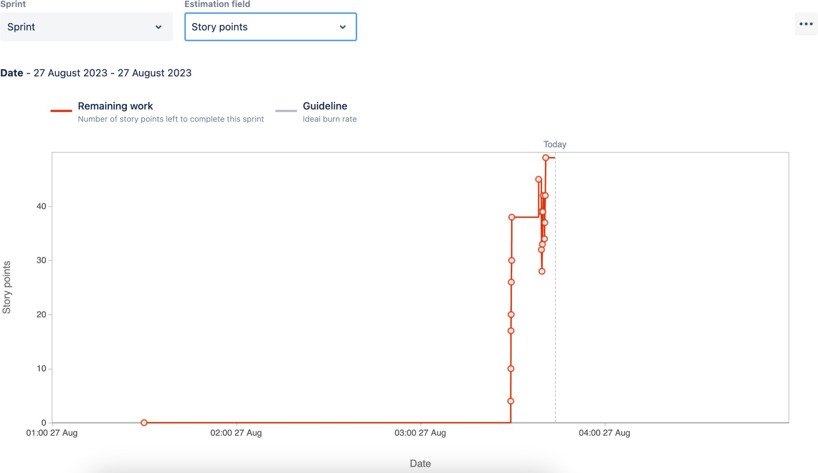
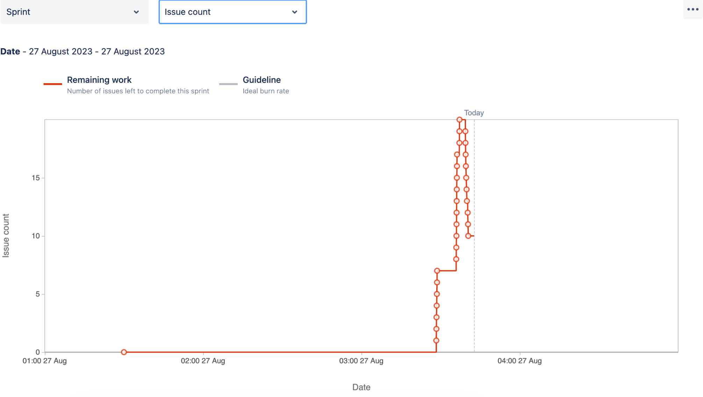
PRODUCT BURNDOWN CHART
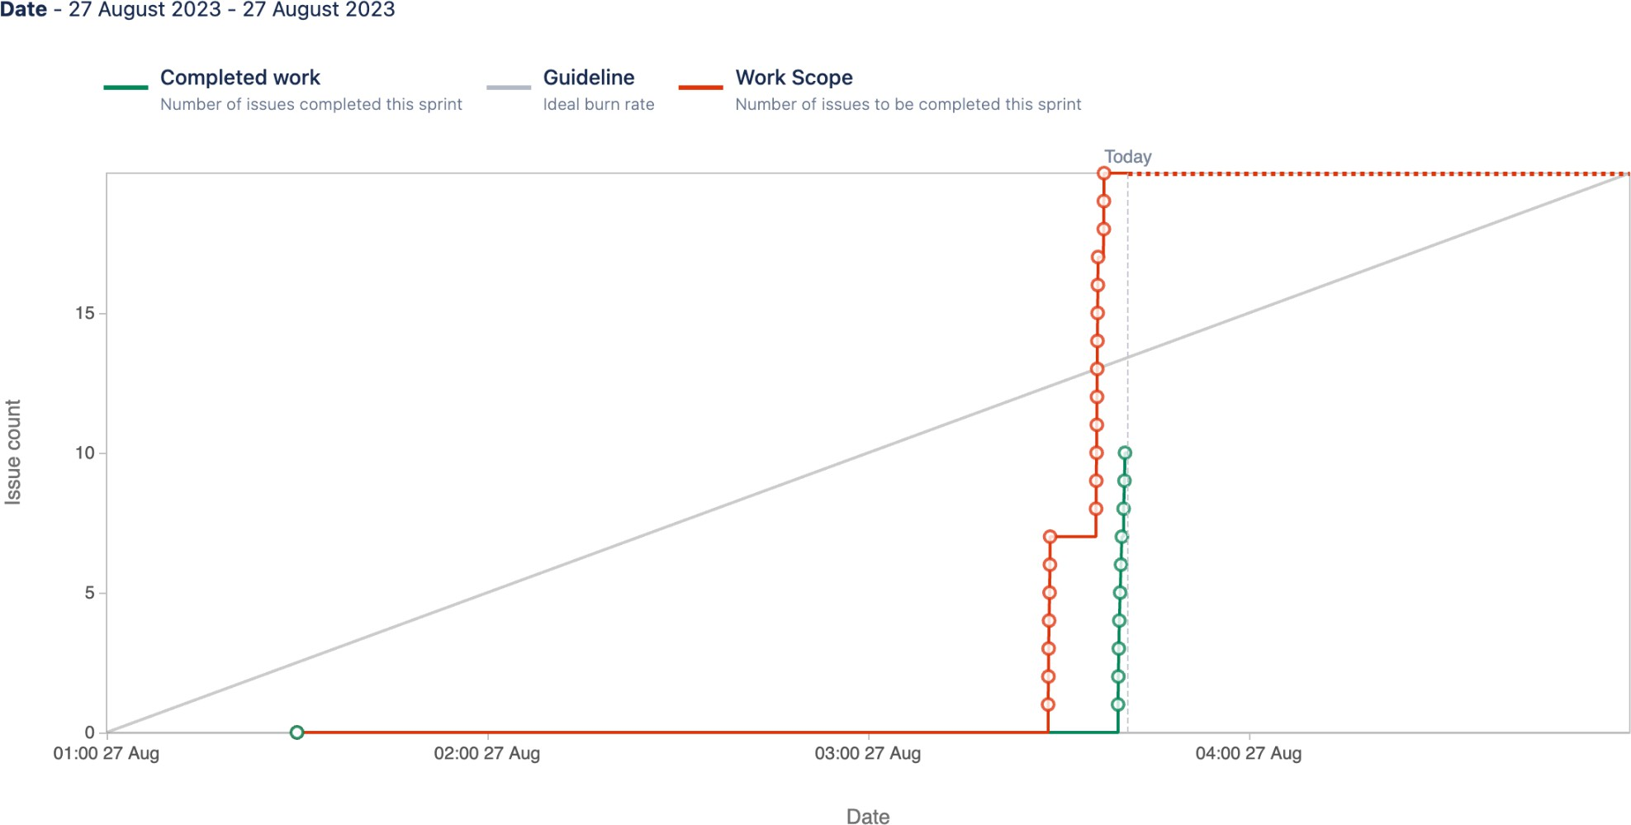
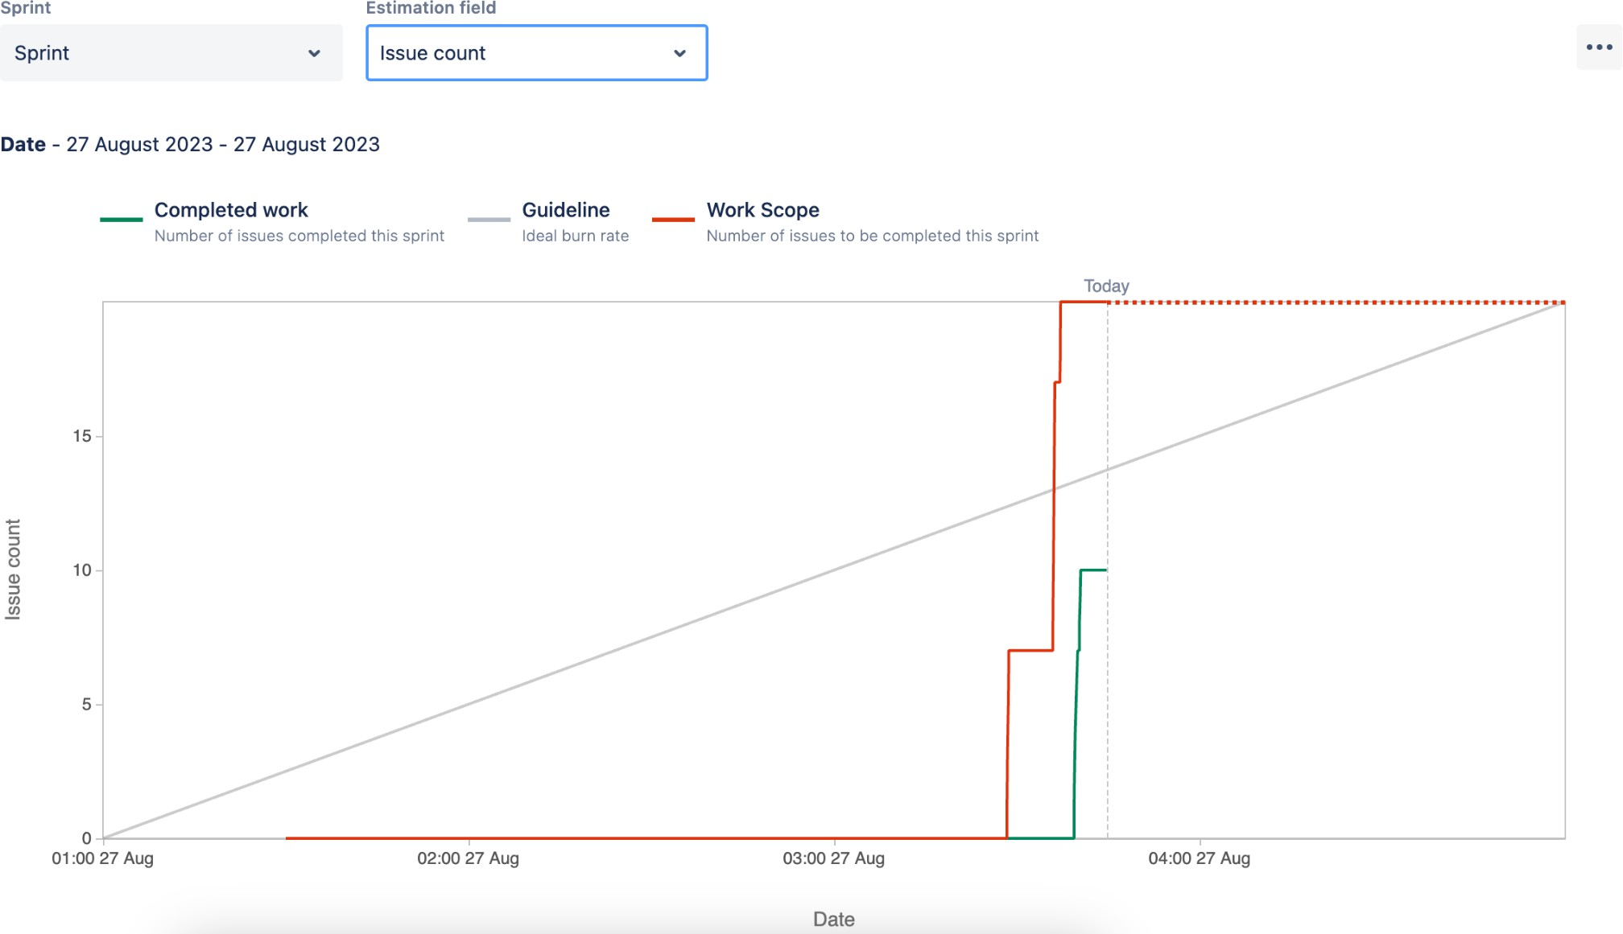

Question 10 – Explain about Product Grooming – 2 Marks

Product grooming
Product grooming, also known as backlog grooming or refinement, is a crucial activity in Agile development that involves preparing and refining items in the product backlog to ensure they are well-understood, prioritized, and ready for development. Let's break down the process step by step:
- Setting the Context: At the beginning of the backlog grooming process, the team and relevant stakeholders come together to understand the overall goals and objectives of the project. This helps set the context for the work to be done and aligns everyone's understanding.
- Backlog Review: The product owner and the development team review the items in the product backlog. This involves assessing the user stories, tasks, and other items to ensure they are accurate, up-to-date, and still relevant to the project's goals.
- Prioritization: During backlog grooming, the team collaboratively prioritizes the backlog items based on their value to the product and the needs of the users or customers. This helps ensure that the most important and valuable work is addressed first.
- Refinement and Estimation: In this step, the backlog items are refined to provide clear and detailed descriptions. The team breaks down user stories into smaller tasks and discusses the technical requirements. Estimation involves assigning story points or other sizing metrics to each item, indicating the relative effort needed for implementation.
- Dependency Analysis: The team examines potential dependencies between backlog items. Identifying and understanding dependencies helps in planning the order of implementation and managing potential bottlenecks.
- Acceptance Criteria: Well-defined acceptance criteria are established for each backlog item. These criteria outline the conditions that must be met for the item to be considered complete and ready for delivery. Clear acceptance criteria help prevent misunderstandings and ensure a shared understanding of what is expected.
- Backlog Grooming Meetings: These are recurring meetings where the product owner and the development team come together to perform the activities mentioned above. These meetings often occur before sprint planning sessions to ensure that the upcoming sprint backlog is well-prepared.

Backlog grooming is an iterative process that helps maintain a healthy and
well-organized product backlog. It ensures that the development team always has a prioritized list of well-defined, estimated, and ready-to-develop items. This, in turn, supports the efficient planning and execution of sprints and helps the team deliver value to customers in a more predictable and effective manner.

Question 11 – Explain the roles of Scrum Master and Product Owner – 3 Marks

Criteria | Product Owner | Scrum Master
Nature of Work | Collaborates with all the stakeholders and brings the vision of a product into the product backlog | Acts as a team coach and is responsible for maintaining the quality of the product
Responsibilities | Responsible for completing the project on time. Acts as an intermediary between development team and the customers | Ensures the scrum framework is followed and helps the development team create a quality product
Accountability | Responsible for project backlog and the timely completion of the product and for providing updates to the clients and stakeholders | Accountable for the quality of the entire project and for giving updates to the management about the completion of the product
Reporting | Reports to top management and clients | Reports to top management about the efficiency of the team and the quality of the product
Qualities | Communication and the leadership skills, creativity, critical thinking and a sharp mind are key assets for any product owner | Thorough knowledge of scrum theory and practices. Being able to lead the team but without the sense of authority

Product grooming, also known as backlog grooming or refinement, is a crucial activity in Agile development that involves preparing and refining items in the product backlog to ensure they are well-understood, prioritized, and ready for development. Let's break down the process step by step:
- Setting the Context: At the beginning of the backlog grooming process, the team and relevant stakeholders come together to understand the overall goals and objectives of the project. This helps set the context for the work to be done and aligns everyone's understanding.
- Backlog Review: The product owner and the development team review the items in the product backlog. This involves assessing the user stories, tasks, and other items to ensure they are accurate, up-to-date, and still relevant to the project's goals.
- Prioritization: During backlog grooming, the team collaboratively prioritizes the backlog items based on their value to the product and the needs of the users or customers. This helps ensure that the most important and valuable work is addressed first.
- Refinement and Estimation: In this step, the backlog items are refined to provide clear and detailed descriptions. The team breaks down user stories into smaller tasks and discusses the technical requirements. Estimation involves assigning story points or other sizing metrics to each item, indicating the relative effort needed for implementation.
- Dependency Analysis: The team examines potential dependencies between backlog items. Identifying and understanding dependencies helps in planning the order of implementation and managing potential bottlenecks.
- Acceptance Criteria: Well-defined acceptance criteria are established for each backlog item. These criteria outline the conditions that must be met for the item to be considered complete and ready for delivery. Clear acceptance criteria help prevent misunderstandings and ensure a shared understanding of what is expected.
- Backlog Grooming Meetings: These are recurring meetings where the product owner and the development team come together to perform the activities mentioned above. These meetings often occur before sprint planning sessions to ensure that the upcoming sprint backlog is well-prepared.
Backlog grooming is an iterative process that helps maintain a healthy and
well-organized product backlog. It ensures that the development team always has a prioritized list of well-defined, estimated, and ready-to-develop items. This, in turn, supports the efficient planning and execution of sprints and helps the team deliver value to customers in a more predictable and effective manner.

Question 12 – Explain all Meetings Conducted in Scrum Project – 8 Marks

Sprint Planning: This meeting kicks off each sprint, which is a time-boxed iteration of work, usually spanning 2-4 weeks. During this meeting, the Scrum team, including the Product Owner, Scrum Master, and Development Team, collaborates to determine which backlog items (user stories, features, etc.) will be worked on in the upcoming sprint. The team also breaks down these items into tasks and estimates the effort required.
Daily Stand-up (Daily Scrum): Held daily during the sprint, this short meeting aims to facilitate quick and focused communication among team members. Each team member answers three key questions: What did I accomplish since the last stand-up? What will I work on until the next stand-up? Are there any obstacles or impediments in my way? This meeting helps keep everyone aligned and informed about the progress and challenges.
Sprint Review: At the end of each sprint, the team holds a review meeting to showcase the work completed during the sprint to stakeholders, customers, and the Product Owner. The team demonstrates the potentially shippable product increment and gathers feedback. Based on this feedback, the Product Owner can update the backlog.
Sprint Retrospective: Also held at the end of each sprint, the retrospective is a dedicated time for the team to reflect on their processes and practices. The team discusses what went well, what could be improved, and any potential changes they'd like to make in the next sprint to enhance their efficiency and effectiveness.
Backlog Refinement (Grooming): While not officially part of the Scrum events, backlog refinement is an important ongoing activity. During these sessions, the team and the Product Owner review and refine backlog items, adding details, clarifications, and estimates to make them ready for inclusion in future sprints.
Product Backlog Refinement: This meeting focuses on refining the product backlog items. The team and the Product Owner discuss and clarify requirements, priorities, and any changes needed in the backlog items. This ensures that the backlog is well-prepared for upcoming sprints.

Release planning: This meeting occurs at the start of the project or major release and involves the product owner, development team, and stakeholders. It aims to discuss and plan the high level scope, timeline, and goals for the project.
Ad hoc meetings: These meetings may be schedules as needed to address specific topics or issues, such as resolving impediments, discuss technical challenges, or conducting additional planning or collaboration sessions
Question 13 – Explain Sprint Size and Scrum Size– 2 Marks

Sprint Size:
In Scrum, a "sprint" is a time-boxed iteration during which the development team works to deliver a potentially shippable product increment. The length of a sprint is referred to as the "sprint duration" and is usually fixed throughout the project. Common sprint durations are 1 to 4 weeks. The choice of sprint duration depends on factors such as team velocity, project complexity, and business needs. A shorter sprint encourages more frequent opportunities for feedback and adaptation, while a longer sprint provides more time for development.

Scrum Team Size:

The Scrum team size refers to the number of individuals who collectively contribute to the development of the product. A Scrum team consists of three key roles: the Product Owner, the Scrum Master, and the Development Team. The Development Team, in particular, is responsible for creating the product increment. Scrum recommends that the Development Team size be kept small, typically between 3 to 9 members, to facilitate effective communication, collaboration, and decision-making.

Question 14 – Explain DOR and DOD – 2 Marks

Definition of Ready (DOR):

The Definition of Ready outlines the criteria that a product backlog item (user story, feature, task, etc.) should meet before it is considered ready to be taken into a sprint for development. The DOR ensures that the item is well-defined, understood, and prepared for efficient development. The specific criteria in the DOR can vary from team to team, but commonly include elements such as:
- Clear description and acceptance criteria: The item's requirements are clearly stated, and the conditions for its successful completion are
well-defined.
- Dependencies identified: Any dependencies on external factors, teams, or resources are identified and addressed.
- Estimable: The team has enough information to provide a reasonable estimate of the effort required.
- Testable: It's possible to determine whether the item has been successfully implemented through testing.
- Minimal ambiguity: The item's details are clear, and any uncertainties are resolved.

Definition of Done (DOD):

The Definition of Done outlines the criteria that must be met for a product increment or backlog item to be considered complete and potentially shippable. The DOD ensures that the team maintains a consistent level of quality and completeness in their work. The specific criteria in the DOD can vary based on the team's standards, the nature of the project, and the industry, but commonly include elements such as:
- Code complete: All development work is finished, including coding, testing, and integration.
- Peer-reviewed: Code has been reviewed by other team members for quality and adherence to coding standards.
- Automated tests passed: Automated tests (unit tests, integration tests, etc.) have been successfully executed and passed.
- Functional requirements met: The item meets all specified acceptance criteria and functional requirements.
Document updating: Any necessary documents, user guides, or technical documentation has been updated.

Question 15 – Explain Prioritization Techniques and MVP – 3 Marks

Prioritization Techniques:
Prioritization techniques are methods used to determine the order in which tasks, features, or items should be addressed in a project. These techniques help teams allocate resources effectively and focus on delivering the most valuable work first. Some common prioritization techniques include:
MOSCOW: This technique categorizes items into Must have, Should have, Could have, and won’t have categories. It helps clarify essential features from those that are optional or lower priority.
Weighted Shortest Job First (WSJF): WSJF assigns a priority score to each item based on factors like business value, time sensitivity, and risk. Items with higher scores are considered more important to work on.
Kano Model: This model categorizes features into Basic Needs, Performance Needs, and Delighters. It helps prioritize based on how features impact user satisfaction.
Value vs. Effort Matrix: Items are plotted on a matrix based on their potential value and effort required. This helps identify quick wins and high-value tasks.
Relative Prioritization: Teams compare items pairwise to determine which is more important. This helps create a relative ranking of items.
Buy a Feature: Stakeholders are given a budget to 'buy' features, which helps prioritize features based on how much value they see in them.

Minimum Viable Product (MVP):
An MVP is the smallest version of a product that includes just enough features to provide value to early adopters and gather feedback. The MVP approach helps validate assumptions, learn from users, and iteratively build upon a product's foundation. It involves:
- Core Functionality: An MVP focuses on delivering the core functionalities that address the primary needs or pain points of the target users.
- Minimal Features: The MVP omits non-essential features to avoid unnecessary complexity and expedite development.
- Testing Hypotheses: The MVP tests assumptions and hypotheses about user behavior, market demand, and product viability.
- Iterative Development: Based on user feedback, the product is refined and expanded in subsequent iterations, gradually adding more features.
- Early Value: The MVP allows the product to be released faster, gaining valuable insights and attracting early adopters.

Question 16 – Difference between Business Analyst n Product Owner – 3 Marks

Aspect | Business analyst | Product owner
Role focus | Understand business needs, processes, and requirements. | Define, prioritize, and convey requirements for the product.
Requirement gathering | Gathers and documents detailed business requirements. | Creates user stories and defines product features.
Problem solving | Identifies problems, inefficiencies, and suggests improvements. | Drives the product vision, strategy, and value proposition.
Communication | Acts as a liaison between business stakeholders and development teams. | Collaborates with stakeholders, customers, and the development team.
Documentation | Creates documentation of business rules, workflows, | Manages the product backlog and maintains

 | and requirements. | clear user stories.
Scope Definition | Helps define the scope of projects based on business needs. | Defines the scope of product features and enhancements.
Vision and strategy | Focuses on specific project or process improvements. | Has a holistic vision for the product and its strategic direction.
Backlog management | Not typically responsible for managing a product backlog. | Manages and prioritizes the product backlog items.
Prioritization | Does not have a primary role in prioritizing features. | Prioritizes features based on business value, user needs, and market trends.
Decision making | Provides input but not responsible for final product decisions. | Makes final decisions on product features, enhancements, and priorities.
Iterative Development | May or may not be involved in iterative development cycles. | Actively participates in sprint planning, reviews, and retrospectives.
Acceptance | Ensures business requirements are met. | Ensures user stories meet acceptance criteria and align with product vision.
Leadership and Strategy | Focuses on tactical solutions and improvements. | Focuses on strategic leadership and product direction.
Continuous improvement | Contributes to process improvements and business efficiency. | Incorporates user feedback for ongoing product enhancement.

Question 17 – Prepare a sample Resume of 3yrs exp Product Owner – 3 Marks

Niharika Varaganti
Address : Gudimalkapur, Hyderabad . Phone - +91-9849912322

EXPERIENCE:

COGNIZANT Technologies, Hyderabad – Jan 2019 to Feb 2021
- Work directly with end users to capture and analyze challenges to their workflow.
- Provide key performance metrics to the Head of IT on the deliveries and benefits realization of change implementations.
- Prioritizes work within an agile team and maintain a backlog of future work for consideration/prioritization.
- Take responsibility for the development of on-going enhancements, create and prioritize user stores with the agile teams
- Own and drive backlog grooming and management, prioritize user stories, create acceptance criteria and drive testing and delivery.
- Work with Program Management and Battelle leadership to support new business.
- Maximizing the work of the development team.
Amazon, hyderabad – Mar 2022 to Present
- Work directly with other product owners, system engineers, program managers, developers, testers, and customers to define features and technical user stories
- Support an Agile Software Development process, working in conjunction with end users / stakeholders and technical delivery team
- Work closely with counterparts in Product Management to align on the vision, program backlog, and roadmap
- Acting as stakeholder of specific product backlog items, work closely with development teams to ensure the output to be aligned with expectations
- Being the voice of the customer and providing a business perspective on value during day-to-day development
- Work with a diverse set of contractor and government personnel to track, manage, and resolve technical issues
- Assist in customer workshops and strategic RFX
EDUCATION:

jawaharlal nehru Technological university ,Hyderabad
-Bachelor’s Degree in Information Technology.

SKILLS
- Strong communication and technical skills with the ability to quickly grasp technical issues/concepts
- Dissect high-level information into details and is able to communicate details in a manner understood by relevant audiences
- Your ability to drill down into the details of a delivery request without losing sight of the big picture
- Should have good functional knowledge of Investment Banking/Capital markets or Wealth and Investment Management
- Fast learner; able to learn new software solutions, business processes and design techniques quickly and efficiently
- Ability to make critical judgement decisions and solid organization skills
- Excellent written and verbal communication skills, including the ability to understand, work with, and shape the vision of customers and stakeholders
- Proven ability to quickly learn new business domains and technical applications
- Prepare agreed deliverables in line with standards, to meet agreed quality standards and timelines
- Excellent written and verbal communication skills, including the ability to understand, work with, and shape the vision of customers and stakeholders.

