Waterfall Deliverables part 2/2
Document 6: Use case Diagram for the project.

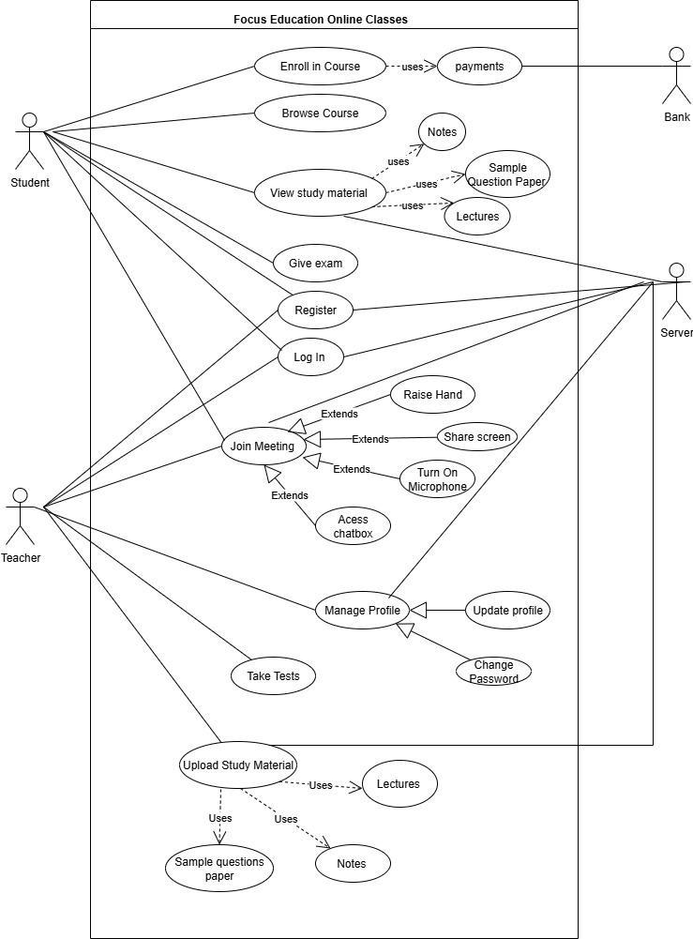

Activity Diagram

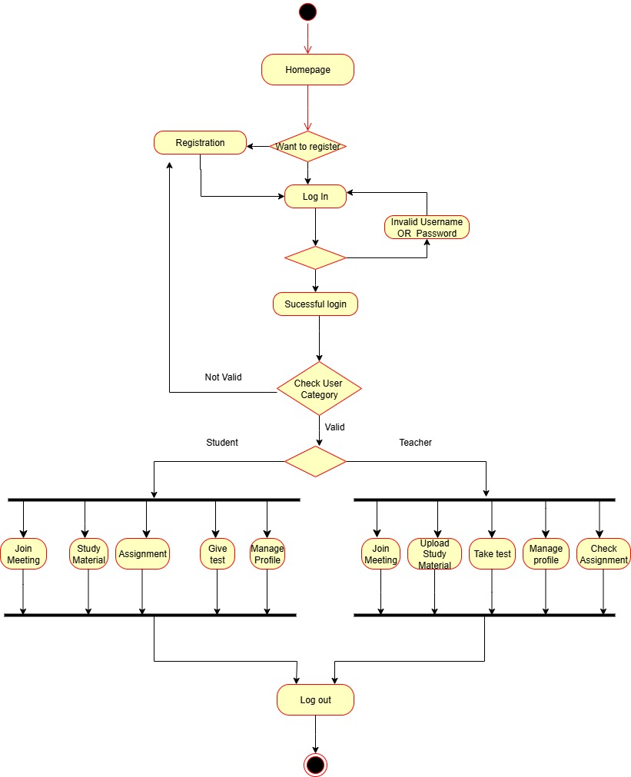
Student login

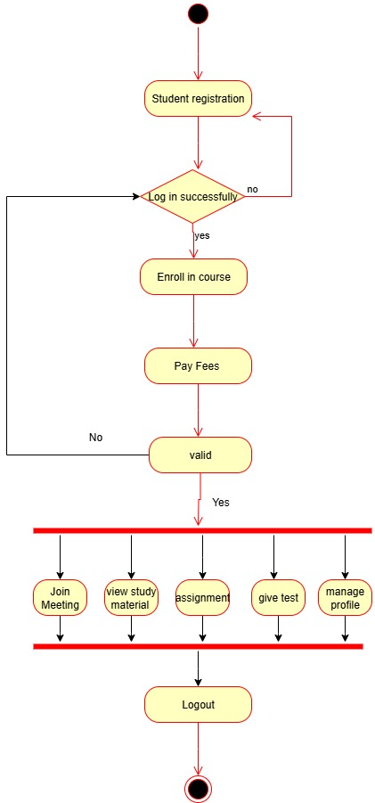

Teacher Login:

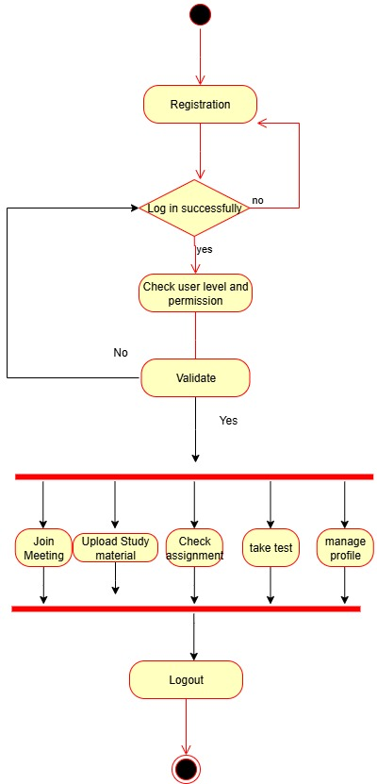

Use Case Specifications:
Use case Name | Registration
Use case ID | 01
Actors | Teachers, Students
Pre-Condition | The user must be new user
Flow of Events | - The user navigates the homepage.  - clicks on register button  - the system presents a registration form  - the user fill outs the form with required information  - the system validate the input data  - the system creates new user account  - the system logs the user into the system
Post-Condition | The User Registered to the system successfully and logged in  The user can access user specific feature
Alternate Course of Action | If the input data is invalid , the system displays an error message and prompts the user to reenter the information  If the email address is already registered, the system informs the user and suggest logging in

Use case Name | Log In
Use case ID | 02
Actors | Students , teachers
Pre-Condition | All users must have username and password
Flow of Events | 1.The user clicks the Login link  2. the system displays the login page for user  3.The user enters username and password  4. the system checks the validity of username and password  5.The user logs in to the system
Post-Condition | The user is successfully logged in
Alternate Course of Action | The user didn’t type the correct username and password do not have an account.  The system displays incorrect username and /or password message

Use case Name | Browse course
Use case ID | 03
Actors | New users, registered students
Pre-Condition | All the users must be registered
Flow of Events | - The actor initiate the Browse Course use case.  - The system displays available courses  - the actor select the course from the  list  - the system displays detailed about the selected course
Post-Condition | The actor has either browsed course
Alternate Course of Action | Error Display:  - the system encounters error while retrieving or displaying course information  - the system displays an error message to the actor  - the system may offer options for actors to try again or contact support

Use case Name | Enroll in course
Use case ID | 04
Actors | students
Pre-Condition | Student must be registered and should have valid us an active account
Flow of Events | 1.the student successfully logged in  2.student browse the course  3.student select a course  4. student confirm the enrollment by depositing the fees  5. system register the student  6.system sends the confirmation message or notification to the student about successful enrollment
Post-Condition | The student is successfully enrolled in the selected course
Alternate Course of Action | Course full:  If the course is full the system displays a course full message and may offer get notified message when the course is available.

Use case Name | Upload Study Material
Use case ID | 05
Actors | student
Pre-Condition | The student should be logged in the system  The student should be enrolled in the course
Flow of Events | - The student clicks view study material link  - System displays the list of available study material  - The student select the type of study material to view  - the system displays content of selected material  - The student can navigate the material and download it  - the student can close the study material view
Post-Condition | The student viewed the selected study material and can downloaded it
Alternate Course of Action | Restricted Material:  If the material is restricted ( due to access permission or time limitations) the system displays an appropriate message

Use case Name | Join Meeting
Use case ID | 06
Actors | Students, teachers
Pre-Condition | The teacher and student should have accounts on the online meeting platform  The teacher and student should have an access to the device with a camera, microphone and internet connect  The system should have scheduled the online class
Flow of Events | For Teacher:  1.The teacher logged in the online meeting platform  2.The teacher initiate the meeting  3.Teacher waits for the student to join  For Student:  1.student receives the meeting link  2. Student click on the link.  3. student logs in to the online meeting platform  4. student joins the meeting by clicking join button  5. student waits for the teacher to start meeting  6.student confirm audio and video  7. student participate in the class session
Post-Condition | The student and teacher are successfully connected in the online meeting platform  The online class session can begin
Alternate Course of Action | If teachers and student internet connection is unstable, they may experience delays in initiating the meeting, the teacher need to retry and troubleshoot their connection.

Use case Name | Give Exam
Use case ID | 07
Actors | students
Pre-Condition | Student must be logged in  Student should be enrolled in the course  Student should be informed about exam date and time via message
Flow of Events | - student receives the test link  - student clicks on test link  - student give the test  - student clicks on submit button when completed the test
Post-Condition | Student has successfully given the test
Alternate Course of Action | If the student click the submit button before answering all the question, then system displays please complete the exam first and then submit message.

Use case Name | Submit Assignment
Use case ID | 08
Actors | student
Pre-Condition | Student must be logged in  Student should have enrolled in course  Student should have completed the assignment
Flow of Events | - the student logs into the system  - the student uploads the assignment file by click on submit assignment button  - student confirm submission  - the system saves the submitted assignment  - the system provide confirmation to the student that assignment has been submitted
Post-Condition | The assignment is successfully submitted  Teacher can assess the assignment
Alternate Course of Action | File size limit exceeded:  If the uploaded file exceeded the allowed size, the system will notify the student and prevent submission until a smaller file size is uploaded

Use case Name | Manage Profile
Use case ID | 09
Actors | Teachers, student
Pre-Condition | The users should be logged in  The profile data should exist
Flow of Events | - the user log into the system  - navigates to the profile section  - view their current information  - makes the changes like update personal information or change password  - once changes are done user receives a success message
Post-Condition | The profile data is updated
Alternate Course of Action | If the user enter an invalid format, the system displays an error message and allow them to reenter the information.

Use case Name | Take test
Use case ID | 10
Actors | Teachers
Pre-Condition | The teacher must be logged in  Teacher should have prepared a test for students
Flow of Events | - the teacher should log in  - teacher should navigate to the take exam link  - specify the class, subject and chapter name  - click on upload test paper  - click on submit button  - system should successfully store the test  - system should show a successfully submitted test paper message
Post-Condition | The teacher successfully submitted the test  Student can give the test
Alternate Course of Action | If the teacher enter an invalid format, the system displays an error message and allow them to reenter the information.

Use case Name | Upload Study material
Use case ID | 11
Actors | Teachers
Pre-Condition | The teacher should be logged in  The format of the uploading file should be within the mentioned size
Flow of Events | 1.the teacher logs in  2. navigate to the upload study material  3. select the upload button  4.choose file to be uploaded  5.the system should validate the file  6.the system should confirm the upload message  7.the system should saves the material
Post-Condition | The teacher successfully uploaded the study material  Student can access the study material within the course
Alternate Course of Action | The system should show the teacher a message if the file size is not appropriate  If the upload is interrupted the system should allow the teacher to resume upload from where it was left off.

Document 7: Screens and pages
- Homepage


- Log in Page

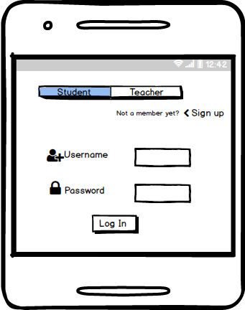
- Browse course


- Student Dashboard
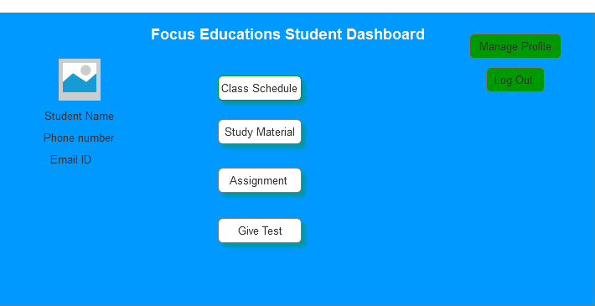

- Teachers Dashboard

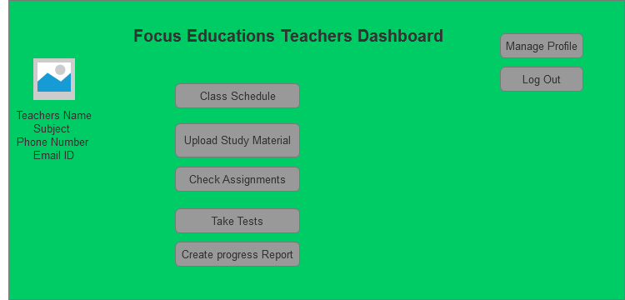

Document 8- MS Visio, Balsamic and Azure

As a BA I have used
MS Visio Tool – To draw UML Diagram (use case, activity, sequence) which will help the technical team to understand the features of the system, functionality of system and flow of the system.
Balsamic – I used this tool for wireframe of my project that how the structure of the product/application will look like.
Azure RP Pro – I used this tool to draw prototype of my project as it will allow client to see and interact with dummy type of the project that how the application and a few specification will look like.

Document 9 – BA experience
My experience as a BA in the following phases:
- Requirement Gathering:
- To gather requirement we used Moscow technique.
- Client was not available for some period of time during this phase. So as a BA I need to source out point of contact from his side and get the information asap.
- I validate the requirement using FURP’s technique.
- There were many requirements which were duplicate or repeated. We need to remove them immediately
- Prototypes were used to give more specific requirements.

- Requirement Analysis:
- We need to draw UML diagrams to visually describe the requirements
- Activity diagrams were used to describe the process flow.
- Communicate the diagram to the team, some team members might not agree with them and might make changes. As a BA we need to consider the points and make modifications.
- Prepare BRS and SRS.

- Designs:
- From use case diagram we help to prepare test cases.
- Communicate with client on design and solution document.
- Write negative test cases along with positive test cases.
- Do not miss a single Test case. It might have huge impact on the project development in later stages.
- Prepare test data for testing.
- Update RTM it is must as it will help us to make sure that all the requirements are met.

- Development:
- Organize JAD sessions.
- Clarify queries of technical team during coding.
- There might be some team member who might not agree with concept or who don’t agree during JAD sessions. As a BA I have to handle the situation with patience and had to have one on one discussion with them. Explain how their actions are going to affect the project. Set up healthy environment within the team.
- Referred Diagram to code the unit.
- Conduct regular meeting with technical team and client which is challenging, some team members might not be available for the meeting.
- Record the sessions and provide them to the missed ones and have to have one on one discussion with the missed one is all I need to do.

- Testing:
- Prepare test cases from use cases.
- Perform high level testing.
- Test data is requested by BA from client.
- Update RTM.
- Take signoff from client.
- Prepare client for UAT.

- Deployment:
- Forward RTM to client which should be attached to Project Closure Document.
- Coordinate to complete and share end user manuals.
- Plans and organize training sessions.

