- Identify minimum 20 functional requirements?
- Functional Requirements define the specific behaviors, functions, or operations of a system. They describe what the system should do, outlining the necessary tasks, actions, or activities it must perform to achieve its objectives
Req ID | Req Name | Req Description
FR0001 | Farmer Registration | Farmers should be able to register with the application using email ID and password
FR0002 | Farmer Search for Products | Farmers should be able to search for available products in fertilizers, seeds, and pesticides
FR0003 | Manufacturer Registration | Manufacturers should be able to register to list their products
FR0004 | User Login/Logout | All users (Farmers & Manufacturers) should be able to log in and log out securely
FR0005 | Add Product to Catalog | Manufacturers should be able to add product details (name, category, price, etc.) to the catalog
FR0006 | Product Catalog Browsing | Farmers should be able to browse the product catalog without needing to log in initially
FR0007 | Product Details View | Farmers should be able to view detailed product information before purchasing
FR0008 | Add to Cart | Farmers should be able to add selected products to their shopping cart
FR0009 | Add to Wish list | Farmers should be able to save products to a "Buy Later" wish list after logging in
FR0010 | Checkout Process | Farmers should be able to checkout and review order summary before payment
FR0011 | Payment – COD | Payment option for Cash on Delivery (COD) should be available
FR0012 | Payment – UPI | Payment option through UPI should be supported
FR0013 | Payment – Credit/Debit Card | Payment via Credit/Debit Card should be supported
FR0014 | Order Confirmation Email | An order confirmation email should be sent to farmers after successful order placement
FR0015 | Order History | Farmers should be able to view their order history and past purchases
FR0016 | Order Tracking | Farmers should be able to track the status and location of their delivery
FR0017 | Admin Product Approval | Admin should be able to approve or reject products submitted by manufacturers
FR0018 | Review & Rating | Farmers should be able to provide product reviews and ratings after delivery
FR0019 | Forgot Password | Users should be able to recover their account via a "Forgot Password" link
FR0020 | Multi-Category Navigation | Products should be organized by categories: fertilizers, seeds, and pesticides for easy browsing

Non – Functional Requirements will describe the Qualities and attributes of a system, focusing on how the system performs rather than specific behaviors or functions
Req ID | Req Name | Req Description
NFR0001 | Usability | The Application should have an Initiative and User Friendly
NFR0002 | Performance | The Application must load pages within 3 seconds
NFR0003 | Security | The Application must ensure secure user authentication
NFR0004 | Compatibility | The Application should be compatible with major web browsers
NFR0005 | Response Time | The Application should respond to user inputs within 2 seconds
NFR0006 | System Availability | The application should be available “24x7 with 99.5% uptime” (excluding maintenance windows)
NFR0007 | Mobile Responsiveness | The application must be “mobile-friendly” and function seamlessly on all standard screen sizes
NFR0008 | Data Encryption | All user data, especially passwords and payment information, should be stored and transmitted “securely” using encryption
NFR0009 | User Capacity | The system should support “at least 10,000 concurrent users” without performance degradation
NFR0010 | Scalability | The system must be scalable to accommodate growing user base and catalog size over time
NFR0011 | Email Delivery SLA | All transactional emails (e.g., order confirmation) should be delivered within “60 seconds” of action
NFR0012 | Backup & Disaster Recovery | System data must be backed up ”daily” and have a disaster recovery plan with “< 24 hours” recovery time

- Make wireframe and prototypes?
- Below are some of the Wire Frames
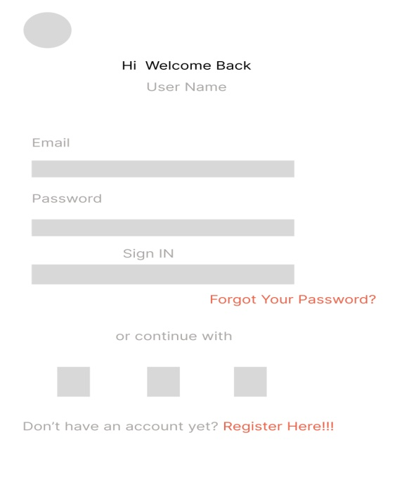
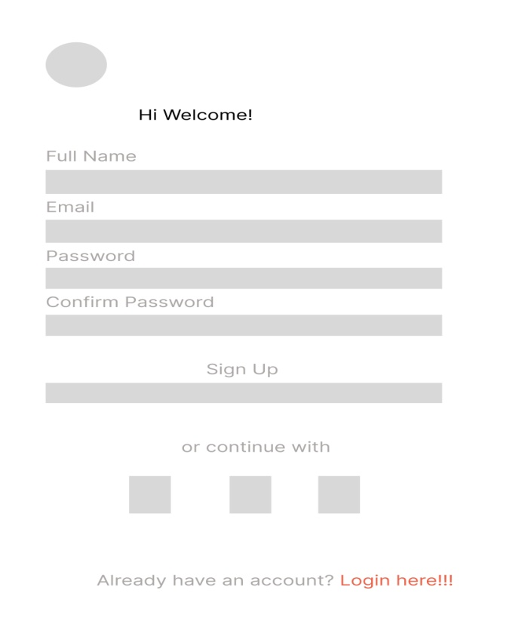

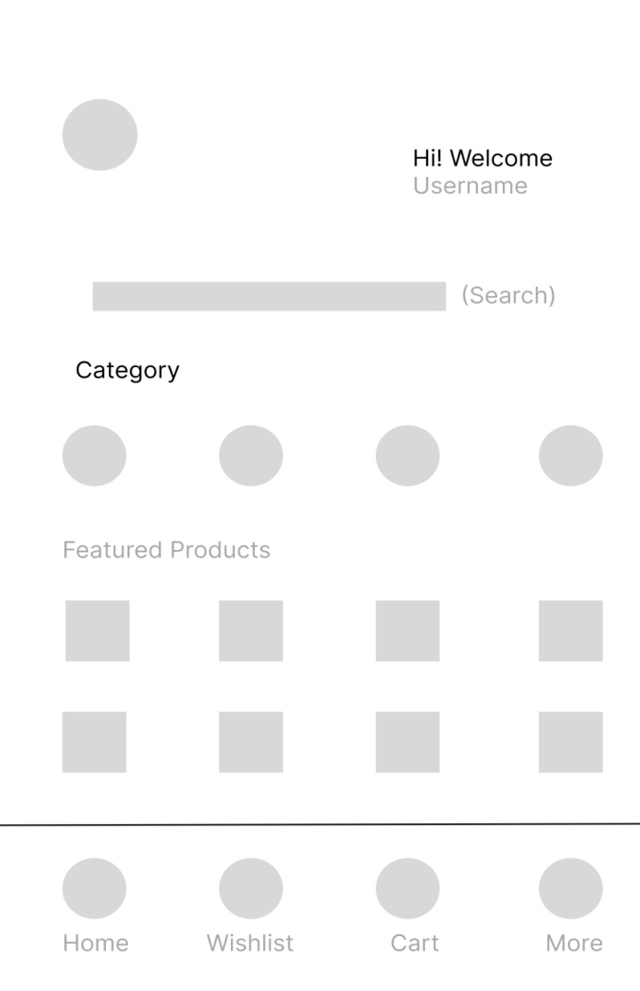

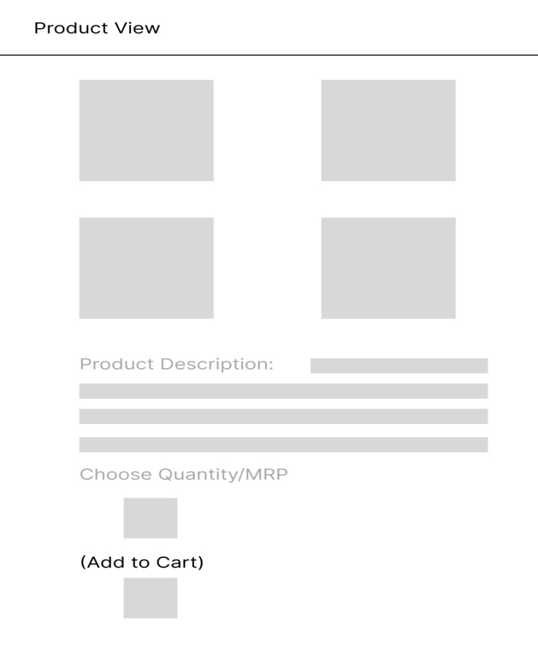

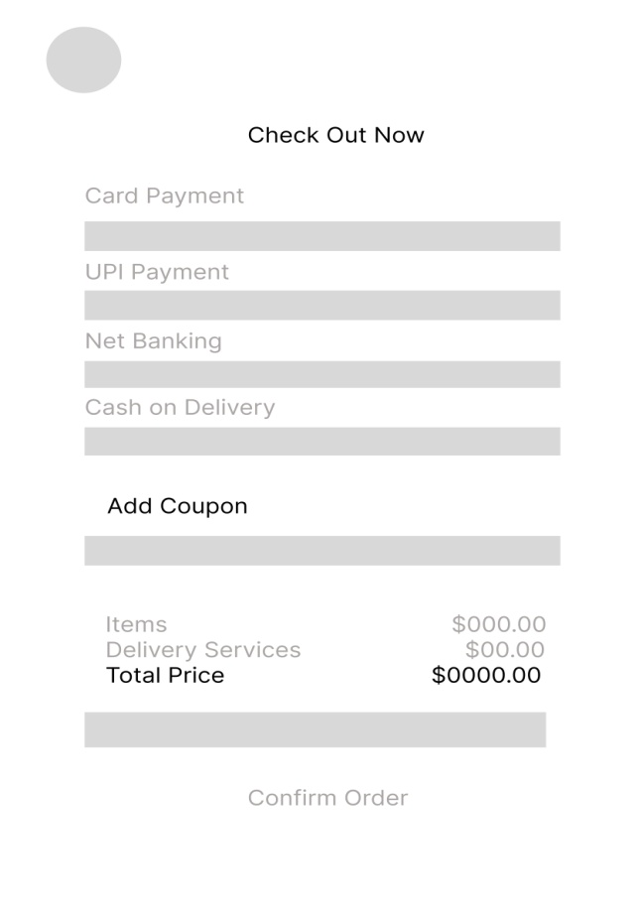
Below are some of the Proto Types
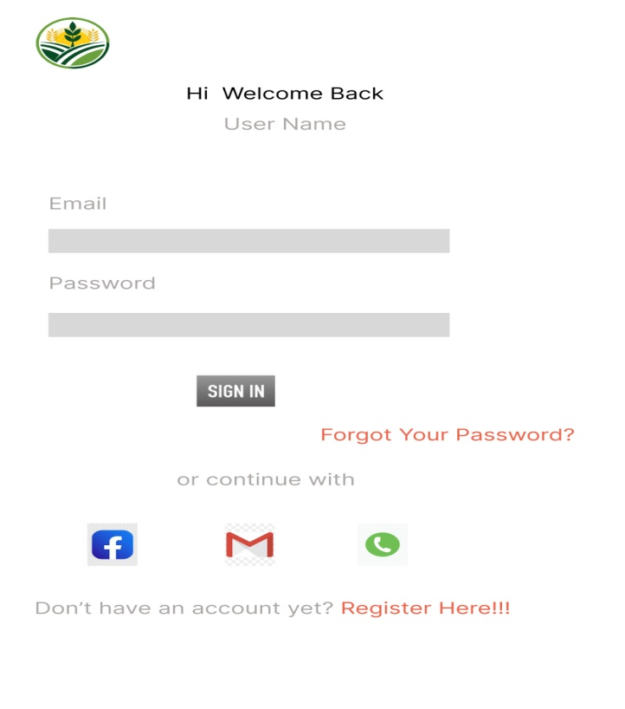

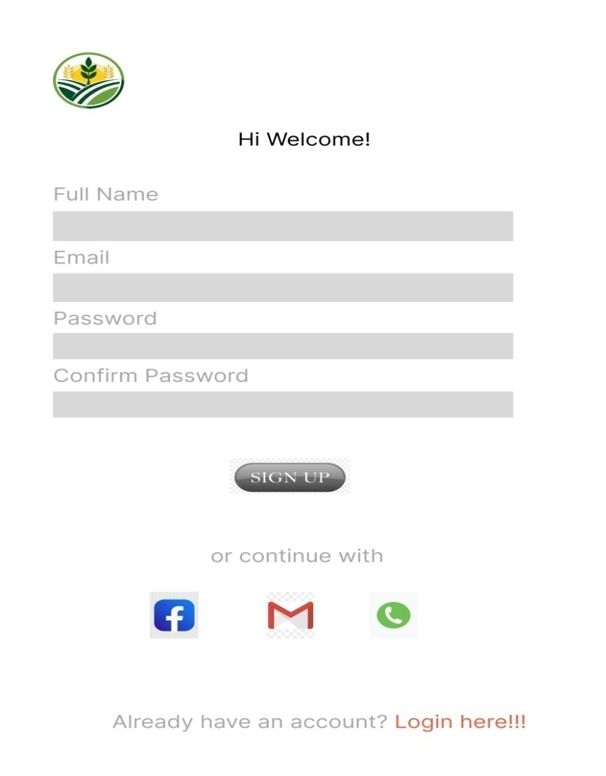
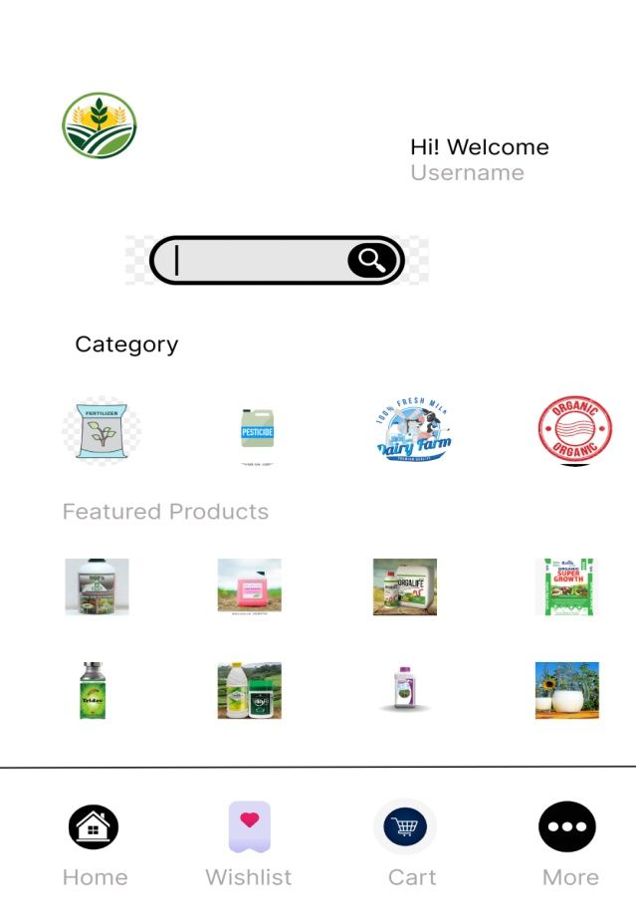

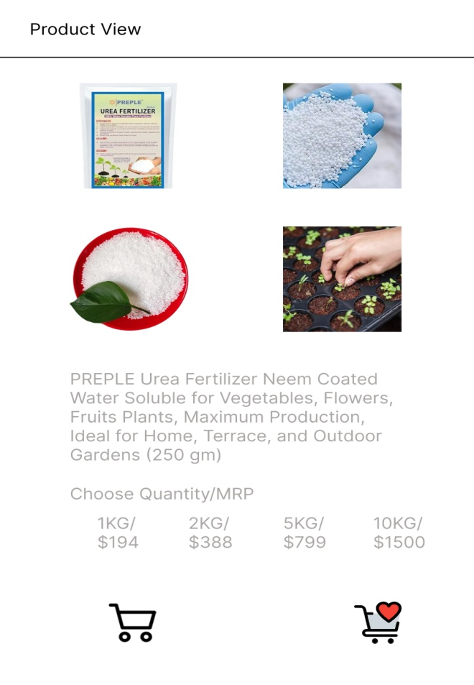
- Make a note of the Tools, which you are using for above concepts?
- Microsoft Visio: It is a Diagramming and Vector Graphics Application used to create diagrams, flow charts and other visual representation of complex information.
Use: To create process flow diagrams, such as:
- User Journey (Farmer/Manufacturer login → Browse → Purchase → Track)
- System architecture for the online agriculture product store
- Data flow diagrams between components like UI, database, and payment gateway
- Helps stakeholders (like Mr. Henry and Mr. Dooku) understand the logical flow of the system
Example Use Cases in This Project:
- Visualize how a Farmer interacts with the platform step-by-step
- Show backend integrations (e.g., manufacturer product uploads → display → order placement)

Balsamiq: It is a rapid Wire Framing tool used to create mockups and prototypes of user interfaces.
Use: To create early-stage UI layouts for example:
- Home Page
- Login/Registration screens
- Product catalog
- Cart and payment pages
- Order tracking screens
- Easy to use during requirement discussions with stakeholders like Peter, Kevin, and Ben
- Keeps focus on functionality, not visual design
Example Use Cases in This Project: Demonstrate what the Product Catalog page looks like
- Show how search and filter options would appear to the farmer
- Layout of Payment Gateway screen including UPI, COD, and card options

- A business analyst’s key responsibilities are to keep track of the requirements and make sure that no requirement is missed Mr. Henry and peter have approached you regarding the current status of the project. How will you tackle this situation? Prepare RTM?
- It is a document to track the requirement throughout the project life cycle, ensuring that they are met and that no requirements are overloaded
Req ID | Req Name | Req Description | Design | Code | UT( Unit Testing) | CT(Component Testing) | ST( System Testing) | SIT | UAT( User Accepting Testing)
FR001 | User Registration | User should register themselves | Complete | Complete | Complete | Complete | Complete | Complete | In Complete
FR002 | Search Product | User should be able to search product | Complete | Complete | Complete | Complete | In Complete | In Complete | In Complete
FR003 | User request for detailed products | User should be able to request for details of the product | Complete | Complete | Complete | Complete | In Complete | In Complete | In Complete
FR004 | Add product to Cart | User should be able to add the products to the cart | Complete | Complete | Complete | Complete | In Complete | In Complete | Complete
FR005 | Buys the Product | User should be able to buy the products | Complete | Complete | Complete | Complete | In Complete | In Complete | In Complete

- Prepare 10 Test Case Documents?
- A Test Case Document is a detailed outline used by testers to ensure that a Software Application or system is working as expected.
Test Case 1:
- Test Case ID:TC001
- Test Case Name: Farmer Registration
- Description: Verify that a farmer can successfully register using a valid email and password
- Pre-Condition: User is on registration page
- Test Steps:
Enter valid email
Enter password
Click “Register”
- Test Data:
Email: testfarmer@example.com
New Password: Test\@1234
Confirm Password: Test\@1234
- Expected Result: User is registered and redirected to dashboard
- Actual Result: As expected
- Status: Pass
- Remarks: N/A
Test Case 2:
- Test Case ID: TC002
- Test Case Name: Login for Existing Farmer
- Description: Verify that existing farmer can log in with correct credential
- Pre-Condition: Farmer account already exists
- Test Steps:
Enter valid email and password
Click Login
- Test Data:
Email: testfarmer@example.com
Password: Test\@1234
- Expected Result: Redirected to farmer dashboard
- Actual Result: As expected
- Status: Pass
- Remarks: Nil
Test Case 3:
- Test Case ID: TC003
- Test Case Name: Product Search Functionality
- Description: Verify farmer can search for “fertilizer” in the product catalog
- Pre-Condition: User logged in
- Test Steps:
Enter “fertilizer” in search bar
Click search
- Test Data:
Search Term: Fertilizer
- Expected Result: All fertilizer products should be displayed
- Actual Result: As expected
- Status: Pass
- Remarks: Nil
Test Case 4:
- Test Case ID: TC004
- Test Case Name: Add Product to Cart
- Description: Verify user can add product to cart
- Pre-Condition: User logged in and on product catalog
- Test Steps:
Select product
Click “Add to Cart”
- Test Data:
Product: Fertilizer A
- Expected Result: Product appears in cart
- Actual Result: As expected
- Status: Pass
- Remarks: Nil
Test Case 5:
- Test Case ID: TC005
- Test Case Name: Buy Later Function
- Description: Verify user can save product in "Buy Later" list
- Pre-Condition: User logged in
- Test Steps:
Select product
Click “Buy Later”
- Test Data:
Product: Seed X
- Expected Result: Product appears in Buy Later list
- Actual Result: As expected
- Status: Pass
- Remarks: Nil
Test Case 6:
- Test Case ID: TC006
- Test Case Name: Payment Gateway - UPI Option
- Description: Verify successful payment via UPI
- Pre-Condition: Items added to cart
- Test Steps:
Proceed to checkout
Select UPI
Enter UPI ID
Confirm payment
- Test Data:
UPI ID: test\@upi
- Expected Result: Payment successful confirmation
- Actual Result: As expected
- Status: Pass
- Remarks: Nil
Test Case 7:
- Test Case ID: TC007
- Test Case Name: Delivery Tracking
- Description: Verify order tracking using order ID
- Pre-Condition: Order placed
- Test Steps:
Enter order ID
Click “Track”
- Test Data:
Order ID: ORD12345
- Expected Result: Tracking status displayed
- Actual Result: As expected
- Status: Pass
- Remarks: Nil
Test Case 8:
- Test Case ID: TC008
- Test Case Name: Email Confirmation After Order
- Description: Verify confirmation email is sent post-order
- Pre-Condition: Order is placed
- Test Steps:
Place order
Check registered email
- Test Data:
Email: testfarmer@example.com
- Expected Result: Order confirmation email received
- Actual Result: As expected
- Status: Pass
- Remarks: Nil
Test Case 9:
- Test Case ID: TC009
- Test Case Name: Manufacturer Product Upload
- Description: Verify manufacturer can upload product details
- Pre-Condition: Manufacturer logged in
- Test Steps:
Navigate to upload section
Fill product info
Submit
- Test Data:
Product Name: Seed X
Price: $500
- Expected Result: Product listed in catalog
- Actual Result: As expected
- Status: Pass
- Remarks: Nil
Test Case 10:
- Test Case ID: TC010
- Test Case Name: Page Load Time (Non-Functional)
- Description: Verify that catalog page loads within 2 seconds
- Pre-Condition: Application deployed
- Test Steps:
Navigate to catalog page
Measure load time
- Test Data: Nil
- Expected Result: Page loads < 2 seconds
- Actual Result: 1.8 seconds
- Status: Pass
- Remarks: Complies with NFR0101

- After the requirements are thoroughly explained to the entire project team by business analyst, the Database architects have decided to do the database design and also to represent the in-flow and out-flow of data. Draw database schema and ER diagram?
- DB Schema is a Blue Print that outlines the structure of a Database, including its tables, fields, relationships, constraints, and other characteristics.
An Entity – Relationship Diagram (ERD) is a visual representation of the relationships between entities in a database. It depicts the entities ( such as tables), attributes (properties or fields) and relationships between them.
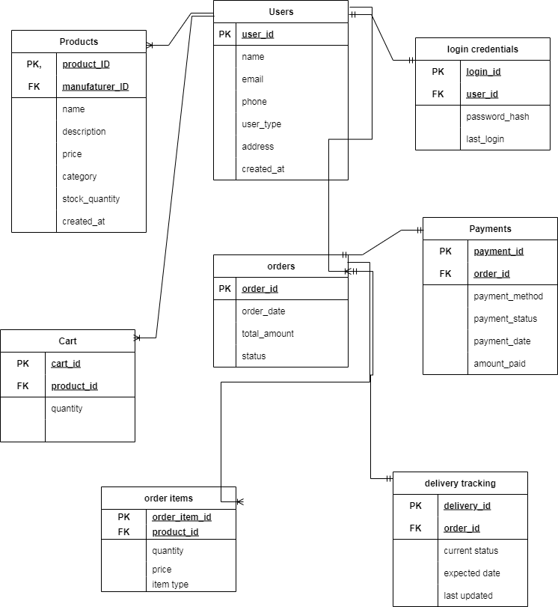
- What is a data flow diagram? Draw a data flow diagram to represent the in-flow and out-flow of data when a Farmer is placing an order for the product?
- A Data Flow Diagram(DFD) is a graphical representation of the flow of data within a system. It visually shows how data moves from one process to another, how it’s stored, and where it ends up.
It helps analysis and designers to understand the flow of data within a system, identify potential bottlenecks or inefficiencies and communicate system requirements to stakeholders
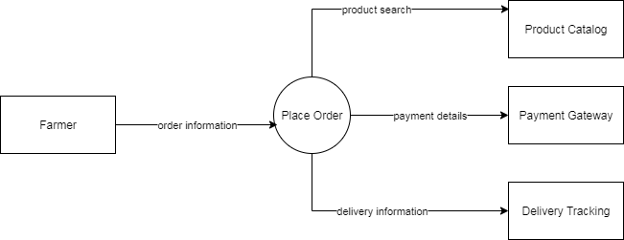

- Due to change in the Government Taxation structure, we should change the Tax structure How do you handle change requests in a project?
- A change request is a formal proposal to alter a system, product or project.
- Initially the BA documents the change requests
- The BA will analyze the change request is really a change or a defect discovered from previous need communication
- The change manager or the project manager must provide an initial approval if the BA needs to move further in analyzing the change requested
- When it comes to change management whether or not to incorporate the changes, depends on yet another important factor which is for the BA as well as Project Manager to ensure whether the requested change is a complex one or just a minor change
- In case the change is complex, it will not only expand the scope of the project drastically which in turn leads to increase the delivery time
- BA will help the stakeholders to understand the impact, the change request will have on the organization and to help minimize negative impact that results from that particular change
- Successful change efforts necessitate the BA to articulate a realistic or convincing vision that appeals to both internal and external stakeholders
- A BA must be able to communicate a sense of urgency among the stakeholders, lead by example, show strong personal commitment and enable stakeholders to contribute to their full potential.
- Successful change management therefore, requires organization to overcome the challenge of bringing all stakeholders to an agreement/consensus about the changes to be incorporated and to avoid conflicts which generally causes delay in the project completion

- As the project is in process, Ben and Kevin have contacted you. The reason is to inform you that they want the Farmers to sell their crop yields through this application i.e. Farmers should be able to add their crop yields or products and display to general public and should be able to sell them. They also want to introduce Auction system for their Crop yields. As a BA, what will be your response? Is this a change request or an enhancement???
- In this case, adding Auction and Crop Yields to the applications would be considered an enhancement as it involves adding new features to the system
As a BA, you should document the requirements and work with the development team to determine the feasibility and impact of the new features, you should also consider the potential benefits, risks and costs associated with the enhancements before making any recommendations to the client

- Come up with estimations – How many Man hours required?
- Man Hours are the required effort of the resources to complete a project. There are 3 types of projects:
- Small: Upto 500 hours
- Medium: Uprto 1000 hours
- Large: Upto 1500 hours
Analysis:
- As per the case study, the duration of the project is 18 months and the current team size is around 15. This will come under medium project
- As the trained resources are available, trainers are not required
- As the structure of the project is available. New and enhanced infrastructure is not required

- Project has finally completed all the stages i.e., design, development, testing etc. Now, it is the role of a business analyst to contact the client for testing of the final product and have to successfully complete it. How are you going to handle this situation? And once it is done, what will be the process to close the project? Explain UAT Acceptance process?
- Planning: In this step, Blue Prints are made to implement UAT testing for each feature that needs to test and minimum standards for accepting the test
Designing: Here the Test cases are designed to hide all the possibilities of software packages in a real world environments
UAT Testers: A Testing team consists of a end users that meet the criteria for implementing testing. They should know the test cases to run and understand the functionalities
Bug Fixing: Whatever Bugs are found in the UAT Testing, the development team should work on them and make it software error free
Sign Off: After removing all the bugs, the testing team indicates acceptance of the completion of the bugs. In this phase, all the stakeholders come to a conclusion that the software is ready to GO LIVE and sign it off

- Explain Project closure document?
- A Project closure document, also known as a Project Closure Report – is a formal document that summarizes the key outcomes, lessons learned and final details of a completed project
It serves as a comprehensive record of the project’s accomplishments, challenges, and overall performance, providing valuable insights for stakeholders and further projects
Points to be in the Project closure document are:
- Project Overview
- Achievements
- Lessons Learned
- Quality Assurance
- Resource Utilization
- Risk Management
- Challenges
Sl. No. | Points to include | Details
1 | Did the client signed off on the UAT Testing
 | Date of the signoff | 25th July 25, 2025
 | Name of the resource
2 | Objectives of the Project
 | User Friendliness | Achieved
 | Customer Satisfaction | RDI in 6 months
 | More Categories | Achieved
3 | Functionalities worked on
 | Secure payment processing | Achieved
 | Categories | Achieved
4 | Infrastructure
 | Software installed | Achieved
 | Laptops purchased | Achieved
5 | Funding
 | Amount Approved | Rs. 1 Crores
 | Amount used | Rs. 95 Lakhs
6 | Overall project information
 | Escalations | 50
 | Customer Satisfaction | High
7 | Value to the company
 | Positive/ Negative | Positive – 90%  - Company has gained an edge over the competitors  - Increased Clients  - Trained Employees  - New Project in Pipeline

