Question 1 – Functional Requirements - 15 Marks
Functional requirements captures the features capabilities that the users need from the system. These requirements are system action -oriented in nature. The action are generally performed by the user to get an output from the system. It provides a direct observable value to the user. The result of performing action on the functional requirement can be directly seen in the system. As in the given situation these actions would generally be performed by the Farmers, Manufacturers, database admin. Some of the important functional requirements that are required in this scenario are described in detail.

FR ID | Requirement Name | Description | Priority (1–10) | Justification
FR001 | Farmer Search for Products | Farmers should be able to search for available products in fertilizers, seeds, pesticides. | 8 | Core to usability and discoverability of products.
FR002 | Manufacturers Upload Products | Manufacturers should be able to upload and display their products in the application. | 8 | Critical for product availability and functioning of catalog.
FR003 | Farmer Account Creation | Farmers should be able to register using email and password. | 9 | Required for user identification and secure transactions.
FR004 | Farmer Login | Farmers should be able to log in securely. | 9 | Key to access personalized features like cart, order history.
FR005 | Manufacturer Account Creation | Manufacturers should be able to create and manage their own seller accounts. | 8 | Needed to onboard suppliers and build catalog.
FR006 | Upload Product Details | Manufacturers can enter name, image, stock, price, etc. | 8 | Essential for clear product presentation.
FR007 | Multiple payment options | Farmers can have the option of paying via multiple channels | 6 | Multiple options can make things easy for the farmers.
FR008 | Add to Cart / Buy Later | Farmers can save products to buy now or later. | 7 | Improves shopping convenience.
FR009 | Secure Payment Options | UPI, cards, net banking, and COD payment options. | 10 | Crucial for transaction completion and user trust.
FR010 | Order Confirmation Email | Email confirmation sent after successful order. | 7 | Good UX and reduces uncertainty in transactions.
FR011 | Delivery Tracking | Real-time order tracking feature for farmers. | 7 | Boosts trust and transparency.
FR012 | Multilingual Support | Interface in English + local/regional languages. | 6 | Important for accessibility but not a blocker for MVP.
FR013 | OTP Verification | OTP sent during registration and critical activities. | 7 | Enhances security and authentication.
FR014 | Farmer Dashboard | View order history, saved items, and recommendations. | 6 | Useful for engagement, not essential for first launch.
FR015 | Update Stock & Product Info | Manufacturers can modify stock and details. | 8 | Maintains product accuracy, avoids selling out-of-stock items.
FR016 | Automated Invoice Generation | Invoices generated post-purchase and sent to both parties. | 6 | Needed for compliance and records.
FR017 | Product Reviews & Ratings | Farmers can review and rate products. | 5 | Useful but not critical for initial go-live.
FR018 | Manufacturer Sales Analytics | Dashboard with sales trends and inventory insights. | 4 | Advanced feature; not essential for MVP.
FR019 | Upcoming Products | Manufacturers can highlight for upcoming products in system | 6 | It helps the farmers to get an idea about the product in advance
FR019 | Notifications (Email/SMS/Push) | Notifications for order status, offers, and confirmations. | 6 | Improves communication but can be phased in later.

Question 2–Minimum 5 page designs - 15 Marks
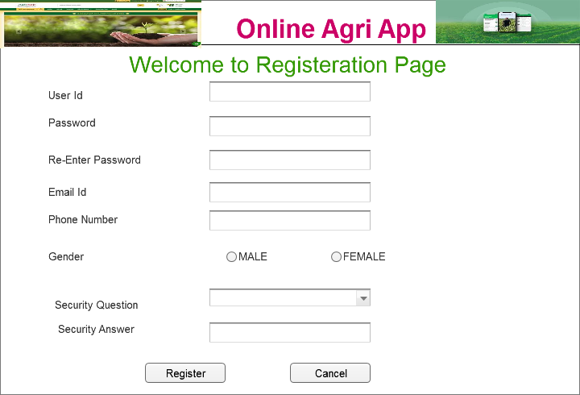

LOG IN PAGE
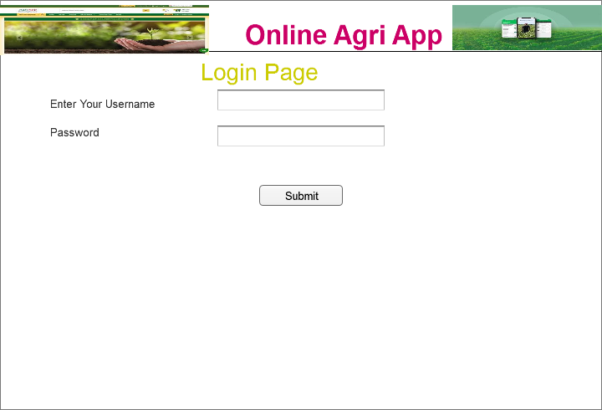

Home Page
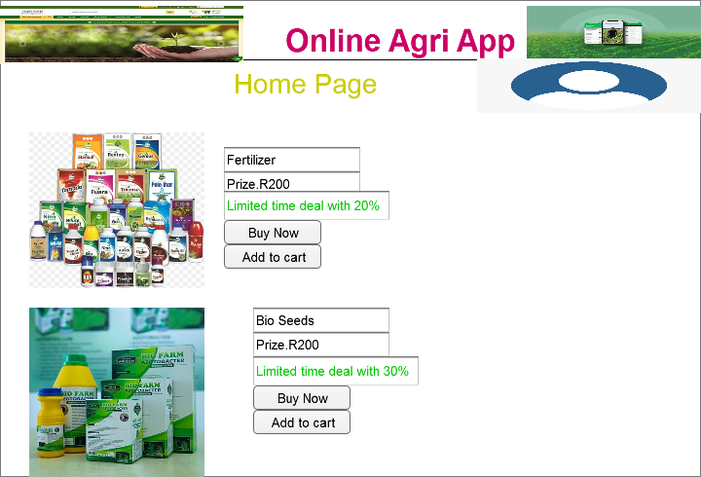

YOUR CART
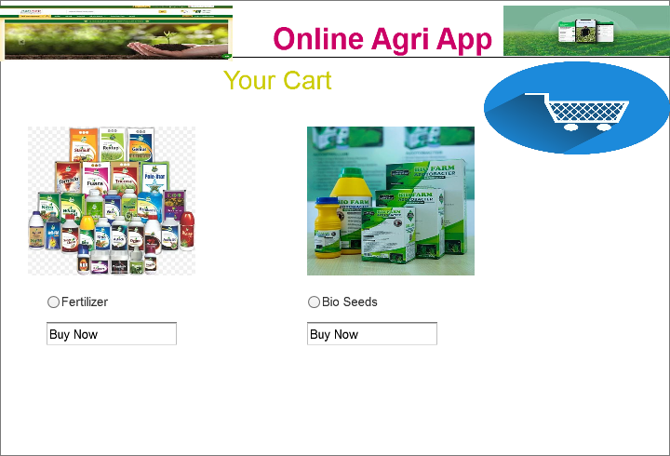

PAYMENT
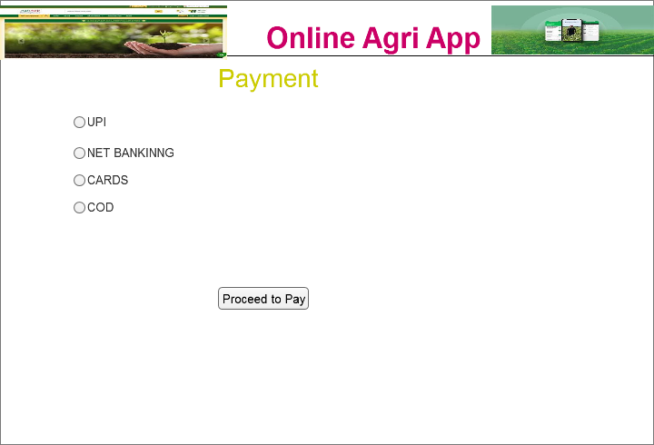

Question 3 – Tools (Visio, Balsamiq) - 15 Marks
Certainly! Here's a detailed comparison and description of Microsoft Visio, Azure (specifically Azure DevOps/Architecture tools), and Balsamiq — all of which are widely used for project planning, UI/UX design, system architecture, and documentation.

🔧 1. Microsoft Visio
Best for: Flowcharts, Network Diagrams, Process Maps, Architecture Designs
🔹 Overview:
Microsoft Visio is a diagramming and vector graphics application used by business analysts, engineers, and architects to visually document systems and workflows.
🔹 Key Features:
- Drag-and-drop shapes for flowcharts, network diagrams, floor plans, and more.
- Built-in templates and stencils for various industries.
- Can be integrated with Microsoft 365 and SharePoint.
- Supports UML, BPMN, and ERD diagrams.
- Option to link diagrams with real-time data from Excel or databases.
🔹 Use Cases:
- Business Process Modeling (BPM)
- System and Network Diagrams
- Organization Charts
- Database Schema Diagrams
🔹 Pros:
- Professional and precise diagrams
- Microsoft ecosystem integration
- Supports complex architecture visualization

2. Axure
Axure RP (Rapid Prototyping) is a professional-grade wireframing, prototyping, and documentation tool used for designing interactive, high-fidelity prototypes for web and mobile applications. It is especially useful for business analysts, UX designers, product managers, and developers to visualize complex systems before development. The major difference between Axure and Balsmiq is that you can get variety of key widgets in the Balsmiq.Some of the key features of the axure are shared below.
1. Advanced Interactivity
- Create clickable wireframes and UI prototypes with:
  - Conditional logic (if-else)
  - Dynamic panels
  - Variables
  - Adaptive views for responsiveness
- You can simulate complex UX flows (e.g., multi-step forms, state changes, error handling).
2. Drag-and-Drop Interface
- Huge library of UI elements (buttons, forms, tabs, menus).
- Allows custom widgets and reusable components (masters).
- Supports mobile and desktop views.
3. Team Collaboration
- Multiple designers can work on the same project (with Axure Cloud).
- Reviewers and stakeholders can add comments and track changes in real time.
- Works with Axure Share (now Axure Cloud) to publish and share prototypes easily.

3. Balsamiq
Best for: Wireframing and early-stage UI/UX design
Overview:
Balsamiq is a rapid wireframing tool that mimics sketch-style user interface design. It focuses on low-fidelity mockups to encourage collaboration and fast iterations.
Key Features:
- Simple drag-and-drop interface with UI components (buttons, forms, icons)
- Focused on structure and flow, not final visual design
- Supports interactive prototypes (linking screens)
- Export to PNG or PDF
- Web-based and desktop versions
Use Cases:
- Early-stage UI/UX mockups
- User flows for mobile/web apps
- Stakeholder feedback on layout and navigation
Pros:
- Very easy to learn and use
- Encourages collaboration without pixel perfection
- Lightweight and fast

Question 4 – RTM - 6 Marks
A requirement traceability matrix is used to check if the current project requirement are being met. It makes sure that it covers all the requirement and all are completed before the end of the project. It is real time monitoring of the progress of the project with respect to the requirments. It helps a BA to make sure that all the requirements have been captured and are being monitored at each and every stage of the SDLC. We have carved some of the requirements as per the case.

S.no | Req Id | Req Des | TC ID | TC Des | TC Designer | Unit Testing | Integration Testing | UAT | Defect | Status
1 | FR001 | Farmer search for products | TC01 | Farmers should be able to search for available products in fertilizers, seeds, pesticides. |  | Completed | Completed | Completed | None | Completed
2 | FR002 | Manufacturers Upload Products | TC02 | Manufacturers should be able to upload and display their products in the application. |  | Completed | Partial Completed | NOT Started | NOT Started | NOT Started
3 | FR003 | Farmer Account Creation | TC03 | Farmers should be able to register using email and password. |  | Completed | Partial Completed | NOT Started | NOT Started | NOT Started
4 | FR004 | Farmer Login | TC04 | Farmers should be able to log in securely. |  | Completed | Partial Completed | NOT Started | NOT Started | NOT Started
5 | FR005 | Manufacturer Account Creation | TC05 | Manufacturers should be able to create and manage their own seller account. |  | Completed | Partial Completed | NOT Started | NOT Started | NOT Started
6 | FR006 | Upload Product Details | TC06 | Manufacturers can enter name, image, stock, price, etc. |  | Completed | Partial Completed | NOT Started | NOT Started | NOT Started
7 | FR007 | Multiple payment options | TC07 | Farmers can have the option of paying via multiple channels |  | Completed | Completed | NOT Started | NOT Started | NOT Started
8 | FR008 | Add to Cart / Buy Later | TC08 | Farmers can save products to buy now or later. |  | Completed | Completed | NOT Started | NOT Started | NOT Started
9 | FR009 | Secure Payment Options | TC09 | UPI, cards, net banking, and COD payment options. |  | Completed | Completed | NOT Started | NOT Started | NOT Started
10 | FR010 | Order Confirmation Email | TC10 | Email confirmation sent after successful order. |  | Completed | Completed | NOT Started | NOT Started | NOT Started

Question 5 – 10 Test Case Documents

A test case document is a detailed set of instructions created to test specific functionality of a software application to ensure it works as expected. It typically includes test scenarios, input data, execution steps, expected outcomes, and actual results. Features are mostly developed by the frontend and backend team. Front end team develops features which are accessed by the users directly while backend team develop features which are used by the organization members only.
The basic layout of a test case document contains information which is shared below.
Project Name: Agriculture Web Application
Module: User Registration / Product Search / Cart / Checkout
Prepared By: Amit Kumar
Role: Business Analyst
Date: 04/07/2025
Version: 1.0
Test Case ID | Requirement ID | Test Scenario | Test Steps | Test Data | Expected Result | Actual Result | Status | Remarks
TC001 | REQ-UR-01 | Validate user registration with valid data | 1. Go to Registration page2. Enter valid Name, Email, Password3. Click Submit | Name: John DoeEmail: john@example.comPassword: Test@123 | User should be registered successfully and receive confirmation email | [To be filled by QA] | [To be filled] | -
TC002 | REQ-UR-02 | Validate error message for existing email | 1. Enter existing email2. Submit form | Email: john@example.com | Error message: “Email already exists” should be shown

Test Case ID | Requirement ID | Test Scenario | Test Steps | Test Data | Expected Result | Actual Result | Status | Remarks
TC010 | REQ-PS-01 | Validate search returns relevant products | 1. Enter keyword in search bar2. Click Search | Keyword: “Shoes” | List of relevant products with keyword "Shoes" displayed
TC011 | REQ-PS-02 | Validate no result message | 1. Enter non-existent product2. Search | Keyword: “Spaceship” | Message “No products found” is shown

Test Case ID | Requirement ID | Test Scenario | Test Steps | Test Data | Expected Result | Actual Result | Status | Remarks
TC020 | REQ-CT-01 | Add a product to cart | 1. View product2. Click “Add to Cart” | Product ID: P123 | Product added to cart with quantity 1
TC021 | REQ-CT-02 | Update quantity in cart | 1. Go to Cart2. Change quantity to 3 | Quantity: 3 | Cart updated, total price reflects change

Test Case ID | Requirement ID | Test Scenario | Test Steps | Test Data | Expected Result | Actual Result | Status | Remarks
TC030 | REQ-CK-01 | Complete checkout with valid payment | 1. Go to checkout2. Fill address3. Choose payment4. Confirm | Address: ValidPayment: Visa | Order placed, confirmation shown
TC031 | REQ-CK-02 | Fail payment with invalid card | 1. Use invalid card | Card: 1234 5678 9012 3456 | Error message shown: “Invalid card details”
Q.6Draw database schema and ER diagram
A database schema defines the structure and organization of data within a database. It outlines how data is logically stored, including the relationships between different tables and other database objects. The schema serves as a blueprint for how data is stored, accessed, and manipulated, ensuring consistency and integrity throughout the system. In this article, we will explore the concept of database schema, its types, and how it plays a crucial role in designing efficient and scalable databases
What is Schema?
A schema is the blueprint or structure that defines how data is organized and stored in a database. It outlines the tables, fields, relationships, views, indexes, and other elements within the database. The schema defines the logical view of the entire database and specifies the rules that govern the data, including its types, constraints, and relationships.

We have created how a database would like in form of tables and alongwith different constraints by using the SQL.
We have classified the database schema into four separate tables which are ( Farmer, Manufacturer, Orders and Product) and the various attributes of the table is created in the SQL show that the logical identification of data in the database can be understood easily.
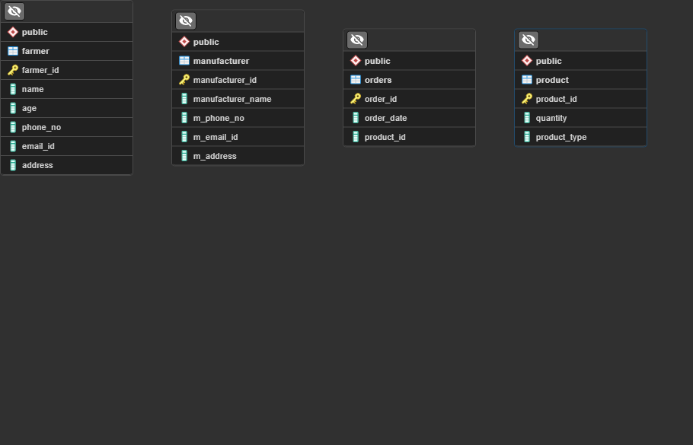
In the above visualization constraints and their data-types is not visible, so in order to make things more understandable we have created another visualization which will define the kind of data we are using and their characters in the below database design.
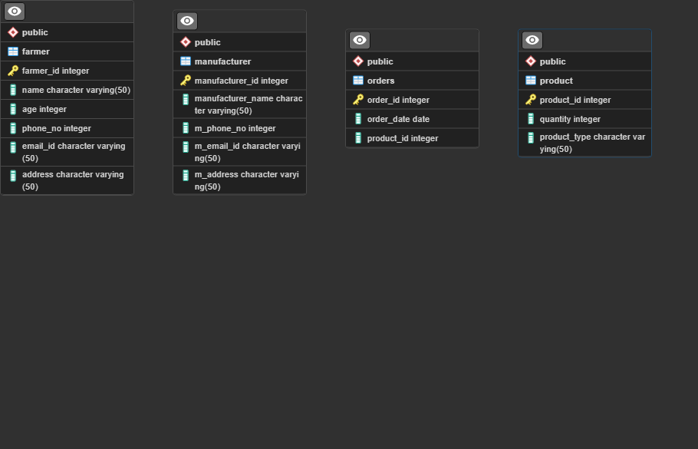
The code that has been used below is share below for more clarity.

ERD- Entity relationship diagram
An ERD (Entity Relationship Diagram) is a visual representation of data entities and their relationships within a system. It is widely used in the design phase of database and system architecture in BFSI projects.

Components of ERD:
- Entities:
Represented by rectangles, they denote objects like Customer, Loan, Account.
- Attributes:
Represented by ellipses, they are properties of entities, like Customer_Name, Loan_Amount.
- Relationships:
Represented by diamonds, they show how entities are connected (e.g., Customer applies for Loan).
- Primary Key (PK):
Uniquely identifies each record in an entity.
- Foreign Key (FK):
Links one entity to another (used to define relationships).
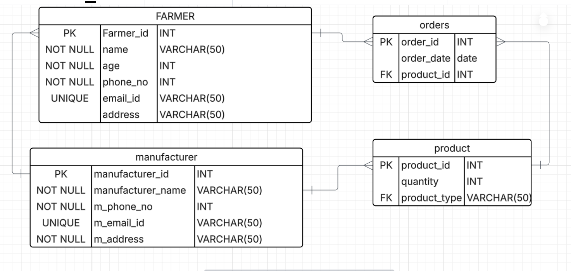

Cardinality Rules (Defines how many instances of one entity relate to another)
Type | Symbol | Meaning
One-to-One | 1 : 1 | Each record in A is related to one in B
One-to-Many | 1 : * | A record in A can relate to many in B
Many-to-Many | * : * | Records in A and B can have multiple matches

Common Constraints Used in ERD / Database Schema
Constraint | Description
PRIMARY KEY | Uniquely identifies a row (e.g., Customer_ID)
FOREIGN KEY | Connects one table to another (Customer_ID in Loan table)
NOT NULL | Prevents NULL values in a column
UNIQUE | Ensures all values in a column are different
CHECK | Enforces a condition (e.g., Loan_Amount > 0)
DEFAULT | Assigns a default value if none is provided
AUTO_INCREMENT / SERIAL | Automatically generates numeric PKs (PostgreSQL, MySQL)

Data Types Used in ERD / Schema
Data Type | Description | Example Values
INT / BIGINT | Whole numbers, for IDs or counts | 1001, 99999
VARCHAR(n) | Variable-length text (max n chars) | 'John Doe', 'IND'
DATE | Stores date | '2025-07-07'
DECIMAL(p,s) | Fixed-point numbers (p=precision, s=scale) | 100000.50
BOOLEAN | True/False values | TRUE, FALSE
TEXT | Long form text | 'Bank branch description'

Q.7What is a data flow diagram? Draw a data flow diagram to represent the in-flow and out-flow of data when a Farmer is placing an order for the product
A Data Flow Diagram (DFD) is a visual representation of how data moves through a system. It shows how input is transformed into output through processes and how data is stored and communicated between different parts of the system. DFDs are widely used in system analysis and design to understand and document the flow of information.

A DFD uses a set of standard symbols:
- Process (Rounded Rectangle):
Process are the actions that are carried out with the data that flows around the system. The process carries out the input data from the source and activity is performed and data flows out of the system.
  - Represents a function or activity where data is processed.
  - Example: Register new user, Validate Sales order
- Data Flow (Arrow):
  - Shows the movement of data between processes, data stores, and external entities.
  - Example: Data moving from a user to a process.
- Data Store (Open-ended Rectangle):
Data stores are places where data is stored. This information may be stored on temporary basis or permanent basis depending on the requirement of the organization. In any system there needs to be some assumption about the extent of storing a data.
  - Represents where data is stored.
  - Example: Customer Database.
- External Entity (Square):
  - Represents external sources or destinations of data.
  - Example: Customers, Vendors, Government Systems.
DFDs are categorized based on levels of detail:
1. Level 0 DFD (Context Diagram):
- The highest level of DFD.
- Represents the entire system as a single process.
- Shows interactions between the system and external entities.
- Purpose: To provide a broad overview of the system.

2. Level 1 DFD
- Breaks down the single process of Level 0 into multiple sub-processes.
- Shows internal data flows between processes and data stores.
- Purpose: To give more detail about the system's inner workings.

3. Level 2
- Further decomposition of Level 1 processes into smaller sub-processes.
- Used for complex systems.
- Purpose: To thoroughly document system logic for development.

Q.8How do you handle change requests in a project?
As a Business Analyst, handling change requests—such as the one for the revised Government Taxation structure—requires a structured approach to ensure the change is assessed, documented, approved, and implemented effectively without impacting the overall project objectives.

Steps to Handle the Change Request:
1. Acknowledge the Change Request
- When the committee (Mr. Henry, Mr. Pandu, and Mr. Dooku) informs us about the tax structure change, I first formally acknowledge the request.
- Record the change request in the Change Request Log or relevant project documentation system.
2. Understand the Change in Detail
- Conduct a stakeholder meeting (including finance head Mr. Pandu) to understand:
  - What exactly has changed in the taxation policy?
  - How does it affect the pricing, billing, and transactions within the application?
  - Does it affect past transactions or only new ones?
  - Will the tax rates be different based on product types (fertilizers, seeds, pesticides) or regions?
3. Document the Change Request
Prepare a Change Request Document (CRD) including:
- Change request ID
- Date of request
- Request originator
- Description of the change
- Reason for change (e.g., Government Taxation Revision)
- Impact areas: product catalog, pricing, invoicing module, reports, etc.
4. Impact Analysis
Work with the Development (Ms. Juhi and team), Database Admin (John), and Testers (Jason, Alekya) to:
- Perform impact analysis on:
  - Data structures (tax-related fields)
  - Business logic (price calculation)
  - UI changes (display of taxes)
  - Reports (invoices, order summaries)
- Assess how much time and cost will be involved.
5. Approval from Steering Committee
Present the CRD and impact assessment to the Project Committee (Mr. Henry, Mr. Pandu, Mr. Dooku).
- Seek formal approval or rejection.
- If approved, communicate the change to the Project Manager (Mr. Vandanam) and update the Project Plan and Scope documents.
6. Coordinate with Development & Testing
- Update the Requirement Specification Document (BRD/FRD).
- Communicate the change clearly to:
  - Developers (Juhi, Teyson, Lucie, Tucker, Bravo)
  - Testers (Jason, Alekya) to prepare new test cases
- Ensure proper version control and traceability.
7. Deployment Plan
- Work with Network Admin (Mike) and DB Admin (John) to ensure smooth deployment.
- Plan for any required data migration or adjustments.
8. Communicate with End Users (Farmers & Manufacturers)
- Update help documentation or UI if necessary to reflect the tax changes.
- Provide in-app tooltips or guides to make the transition user-friendly.
9. Post-Implementation Review
- Monitor the system post-change.
- Capture feedback from users (Peter, Kevin, Ben) and manufacturers.
- Document lessons learned.
Effect of Change Request

1. Scope Impact
- Increased Scope:
  - The project must now include additional features or updates in the system to support new tax rules (e.g., varying tax rates, tax exemptions, region-wise rules).
  - UI/UX changes may be needed to display revised tax calculations to users (farmers and companies).
- Change in Requirements:
  - Existing BRD/FRD needs to be updated.
  - Additional business rules, validations, and workflows must be defined.

2. Timeline Impact
- Delays in Schedule:
  - New analysis, development, and testing phases must be added.
  - The original 18-month timeline might need an extension if the change is significant.
- Rework:
  - Already developed or partially completed modules (like order processing, billing, tax reports) may require rework.

3. Budget Impact
- Cost Increase:
  - Additional effort from developers (Ms. Juhi, Mr. Bravo, etc.), testers (Ms. Alekya, Mr. Jason), and BAs.
  - More testing cycles, database changes, UI redesigns.
  - Possible need for external consultants (e.g., taxation domain expert).
- This may push the budget beyond the initial ₹2 Crore unless re-scoped.

🔹 4. Risk Impact
- Increased Project Risks:
  - Delay in delivery could affect farmer trust and CSR visibility.
  - Misinterpretation of new tax rules may cause incorrect transactions.
  - Government audits may occur if not handled accurately.

5.Resource Impact
- Redistribution or Overallocation:
  - Developers or testers might be pulled from other modules to handle this change.
  - Risk of resource fatigue or dependency on key personnel (e.g., only one Java lead or tester familiar with pricing logic).

6. Documentation Impact
- Need for Updates:
  - Business Requirements Document (BRD)
  - Functional Specifications
  - Test Cases and Acceptance Criteria
  - Training and Help Documentation for farmers/companies

7. Stakeholder Expectations
- Realignment Needed:
  - Stakeholders like Mr. Henry, Mr. Pandu, and Mr. Dooku need to be kept informed of how this impacts delivery and cost.
  - Farmers (Peter, Kevin, Ben) may need onboarding for understanding new pricing.

Impact Area | Effect
Scope | New features, UI changes, revised workflows
Timeline | Possible delay due to rework and extra tasks
Budget | Potential overrun of the ₹2 Cr budget
Risk | Non-compliance or system inaccuracies
QA | More test cycles, complexity in validation
Resources | Overlap, overloading, need for reallocation
Documentation | Updates to BRD, FRD, Test Cases, User Guides
Stakeholder Expectation | Needs realignment, communication

Q.9 Change Request Vs an Enhancement
As a BA we would welcome the change request from the client side and would prepare a change request document so that we can officially register the change request. Allowing farmers to sell their crop yields and adding an auction system could bring great value to the farming community by enabling them to directly reach customers and get competitive prices.
However, this functionality involves entirely new features which were not part of the original agreed-upon project scope. Therefore, I will formally record this request and initiate the process of evaluating its impact on the project scope, timeline, budget, and resources.”
As comparing the requirement from the new one we are almost updating the role of farmers as in earlier scenario the farmers were only buying the product from the application but now they can sell their products through the application hence there is complete change in the functionality of the user. Hence it would require to make new sets of requirements which would impact the entire SDLC cycle.
However, this functionality involves entirely new features which were not part of the original agreed-upon project scope. Therefore, I will formally record this request and initiate the process of evaluating its impact on the project scope, timeline, budget, and resources.”

Reasoning:
Aspect | Explanation
Original Scope | Focused only on buying agriculture inputs (seeds, fertilizers, pesticides)
New Request | Enables farmers to sell their produce and conduct auctions
System Impact | Requires new modules, UI, workflows, database changes
Effort Level | High – involves business logic for auctions, order tracking, payments
Conclusion | Major shift in functionality – This is a Change Request
Change Request = A request to change the scope or nature of the project after it has been baselined.

Aspect | Change Request | Enhancement
Definition | A formal request to modify existing approved project scope | A suggestion to improve or add value after initial delivery
Timing | Usually occurs during project execution | Usually comes after project completion or initial release
Scope Impact | Alters the agreed-upon baseline scope | Adds to the system without changing original scope
Examples | Adding a new module like crop sales during a project | Improving UI, adding filters, speed optimization post-release
Formality | Requires formal approval and change control process | May be handled through backlog or feature roadmap
Impact Level | Can significantly affect budget, timeline, and resources | Usually less disruptive, planned in future phases
Need for Re-planning | Often requires re-scoping, impact analysis, stakeholder approval | May not require major re-planning

Q.10 Come up with estimations – How many Manhours required
To estimate the manhours required for the new Change Request (i.e. enabling farmers to sell their crop yields and introducing an auction system) in the online agriculture store project, we’ll break it down into key functional areas and estimate the time per role.

High-Level Estimation – Manhours (Effort Based)
Assumptions:
- Medium complexity implementation
- Agile/Scrum approach with 2-week sprints
- Existing infrastructure and authentication modules are reusable
- Testing, UI/UX, API integrations, backend logic, and database work are all involved

🔧 Functional Modules to be Added
Module | Description
1. Crop Listing (by Farmers) | Farmers upload crops, details, price, quantity
2. Buyer Interface | Public view, browse, search, filter
3. Cart & Purchase | Add to cart, buy now, checkout, payment
4. Auction System | Start auction, bidding logic, end auction
5. Order Management | For both farmers and buyers
6. Notifications | Email/SMS/app alerts (bids, orders, delivery)
7. Admin Panel | Moderate listings, review users, auction flags
8. DB Changes & Security | Schema updates, role-level access
9. Testing | Unit, Integration, UAT
10. Documentation | User manuals, release notes

👥 Manhour Estimation by Role
Role | Estimated Effort (Manhours)
Business Analyst (You) | 40 hrs (requirement gathering, change doc, UAT)
UI/UX Designer | 40 hrs (screens for crop listing, auctions, orders)
Java Developers (Backend & Frontend) | 160 hrs (core logic, UI, APIs)
DB Admin (John) | 20 hrs (schema design, data migration)
QA/Testers (Jason & Alekya) | 60 hrs (test cases, functional & regression testing)
Project Manager (Vandanam) | 16 hrs (planning, status tracking, coordination)
Network Admin (Mike) | 8 hrs (deployment, firewall checks, hosting changes)
Total Estimated Manhours | 344 hours

Final Summary
- Estimated Manhours: ~344 hours
- Additional Duration: ~4 weeks
- Effort Type: Medium-to-high complexity Change Request
- Team Required: BA, 3–4 devs, 2 testers, 1 DB Admin, 1 PM

Project has finally completed all the stages i.e., design, development, testing etc. Now, it is the role of a business analyst to contact the client for testing of the final product and have to successfully complete it. How are you going to handle this situation? And once it is done, what will be the process to close the project? Explain UAT Acceptance process
User Acceptance Testing (UAT) is a process where the actual users of the software verify that the developed system performs correctly according to the agreed business requirements and is ready for production use.

Purpose of UAT
- To validate the system from the user’s perspective
- To ensure it supports day-to-day business operations
- To confirm that the system is ready for deployment
- To identify any gaps or critical issues that developers or testers may have missed

1. Prepare for UAT
- Review Requirements Traceability Matrix (RTM)
Ensure all functional and non-functional requirements are implemented and traceable.
- Create UAT Test Plan
Outline scope, objectives, roles, environment setup, and timelines.
- Create UAT Test Cases/Scenarios
Based on real-life use cases for:
  - Farmer registration and login
  - Browsing/buying agricultural products
  - Selling crop yields (if included)
  - Auction features
  - Payments and notifications
- Coordinate with Testers (Jason & Alekya) to validate coverage
- Set Up UAT Environment
Coordinate with network (Mike) and DB admin (John) to create a separate, clean UAT instance.

2. Communicate with Client
- Reach out to Mr. Henry, Mr. Pandu, Mr. Dooku, and stakeholders (Peter, Kevin, Ben)
- Share:
  - UAT Plan & Schedule
  - User credentials, instructions, and guides
  - Support contacts in case of issues
- Offer live walkthrough/demo before starting UAT

UAT Acceptance Process
Step | Activity
1 | Plan UAT – Define scope, team, environment, and timeline
2 | Prepare Test Scenarios – Based on BRD, real business cases
3 | Client Execution – Client tests the system themselves
4 | Log Issues – Client reports bugs, gaps, or suggestions
5 | Fix & Retest – Dev and QA team fix issues; BA retests
6 | Final Sign-Off – Client confirms the system is acceptable and signs the UAT Acceptance Document

Key Takeaways from UAT
- Signed UAT Sign-Off Document from the client
- Email confirmation or formal approval from Mr. Henry & committee

Project Closure Process
Once UAT is signed off:
1. Conduct Closure Meeting
- With client and internal team (APT IT SOLUTIONS)
- Review deliverables, performance, pending issues
2. Final Deliverables Handover
- Source code, database schema, admin credentials
- Documentation: BRD, FRD, user manuals, release notes
- Training materials for farmers & company users
3. Client Training
- Organize sessions for client-side admins and end-users
- Provide recorded tutorials or guides
4. Support Handoff
- Set up post-go-live support (if agreed)
- Define SLA, escalation paths
5. Internal Team Debrief
- Lessons learned
- Archive project documents
- Release resources

Final Closure Document Includes:
- Client acceptance
- Deliverables checklist
- Warranty/support agreement (if any)
- Financial closure confirmation
- Lessons learned and performance feedback

As a BA we would make sure that the all the documentation regarding the project has been completed and signed off by the respective heads.
- Client validates the product
- Acceptance is formally signed
- Project closes smoothly with all knowledge transferred

Q.12 Explain Project closure document
What is a Project Closure Document?
A Project Closure Document is a formal document prepared at the end of a project to officially close it and confirm that all project deliverables have been completed, accepted by the client, and all contractual obligations have been met.
It is the final step in the project lifecycle and is critical to ensure that the project is concluded in a controlled and structured way.

Purpose of the Project Closure Document
- Confirm completion of the project scope and deliverables
- Obtain formal client acceptance
- Release project resources (team, infrastructure)
- Document lessons learned
- Close financials and contracts
- Provide a reference for future projects

Key Components of a Project Closure Document
Section | Description
1. Project Overview | Brief description of the project, client, start/end dates, budget, objectives
2. Final Deliverables Summary | List of all deliverables completed and handed over (e.g., application, documentation, source code)
3. Client Acceptance | Formal confirmation that the client has tested and approved the product (usually includes UAT sign-off)
4. Milestones & Completion Dates | A summary of major milestones and their actual completion dates
5. Budget Summary | Final budget status — initial estimate vs actual spent
6. Open Issues & Resolutions | Any known unresolved issues and their resolutions or future handling plan
7. Lessons Learned | What went well, what didn’t, and what can be improved in future projects
8. Resource Release Plan | Statement that project resources (team, hardware, licenses) are being released
9. Support & Maintenance Plan | If applicable, details of post-go-live support or warranty
10. Sign-Off Section | Signatures from key stakeholders (Project Manager, Client, BA, Sponsor)

Example

Section | Content
Project Name | Online Agriculture Product Store
Client | Mr. Henry, SOONY Company
Duration | 18 Months
Budget | ₹2 Crores
Final Deliverables | Web/Mobile App, UAT Signed, Training Docs
UAT Sign-Off | Signed by Mr. Henry, Dooku, and Pandu
Lessons Learned | Mid-scope changes (auction system) should be better managed; agile worked well
Support Plan | 3 months warranty support from APT IT Solutions
Signatures | Mr. Vandanam (PM), Mr. Henry (Client), You (BA)

Benefits of Project Closure Document
- Ensures nothing is left incomplete or undefined
- Protects both client and vendor from future misunderstandings
- Helps in audits and reference for similar future projects
- Encourages organizational learning

📌 Final Tip:
Always review the closure document with the project sponsor and client before getting final signatures to ensure everyone agrees that the project has successfully delivered what was promised.

