COEPD - Scrum Project Implementation – 100 Marks – Pass is 60%
Instructions to follow:
- Copy paste (either image, diagram or text) is not entertained. If done, the document will not be evaluated.
- After submission of the answers of this prep exam, You should be prepared to attend viva and justify your answers in the prep exams. If in Viva, participant is NOT justifying the answers, Viva
- will be repeated until Candidates justify 60% correctness.
- Mentor calls are scheduled only if the participant have submitted their task at least for one time.
(should apply their knowledge in this task first)
- For attempting prep exams participant should be thorough on the topics using their references.
- Please format the document properly (Always have a question no., question and answer).
- Have a consistent format (Font name: Arial/ Calibri -Font size 12, Font Color: Black ).
- Few Questions are related to the case study, check Questions thoroughly before you answer.
- Answers should be elaborated in detail(*not as per the allotted marks).
Please focus on learning and applying the knowledge as this knowledge will be helpful in contributing at your BA job.
- In the evaluation, students must answer all questions and should be able to justify at least 60% content and correctness of each answer.

Question 1 – write Agile Manifesto – 8 Marks

Agile Manifesto We are committed to discovering new ways to better deliver our products. In doing so, we value: Four Main Values
•Individual and Interactions / Over processes and tools.
•Working Products / Over Comprehensive documents
•Customer Collaborations / Over Contract Negotiation.
•Responding to Feedback / Over Following a Plan.

Agile Principles
•Our highest priority is to satisfy the customer through early and continuous delivery.
•welcome changing requirements, even late in development.
•Deliver Working Product frequently.
•Businesspeople and cross-disciplined teams must work together daily.
•Build projects around motivated individuals and trust them to get the job done.
•The most effective and efficient method of conveying information is face-to-face conversation.
•Work products are the primary measure of progress.
•Maintain a sustainable pace indefinitely.
•Give continuous attention to technical excellence.
•Simplicity- the art of maximizing the amount of work done is essential.
Teams self-organize.
Teams regularly reflect and adjust to become more effective.

Scrum Project Name: Scrum Foods (Foods Delivery Applications)

Scrum Project Description:
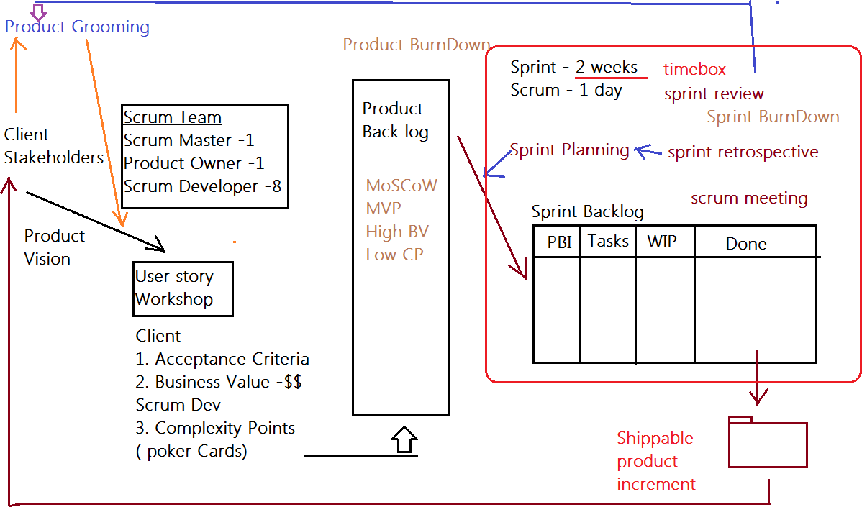
Scrum Foods provides fast, reliable online food delivery application targeting customers of all age group offering 24/7 service along with tracking of the delivery real time.

Client: COEPD IT Solutions
Stakeholder List:
1. Business Owner
2. Administrator
3. Regional Administrator
4. Restaurant
5. Delivery boy
6. Customer

Agile Manifesto We are committed to discovering new ways to better deliver our
Products.

In doing so, we value: Four Main Values
1.Individual and Interactions / Over processes and tools.
2.Working Products / Over Comprehensive documents
3.Customer Collaborations / Over Contract Negotiation.
4.Responding to Feedback / Over Following a Plan.

Agile Principles
1. Our highest priority is to satisfy the customer through early and continuous delivery
2. welcome changing requirements, even late in development
3. Deliver Working Product frequently
4.Businesspeople and cross-discipline teams must work together daily
5. Build projects around motivated individuals and trust them to get the job done
6.The most effective and efficient method of conveying information is face-to-face
conversation
7. Working product is primary measure of progress
8. Maintain a sustainable pace indefinitely
9.Give continuous attention to technical excellence
10. Simplicity- the art of maximizing the amount of work done is essential
11.Teams self-organize
12. Teams regularly reflect and adjust to become more effective

Product Vision

– Meeting – Discussion – Document -

Scrum Project Name: Scrum Foods
Venue:
Date: Start Time: End Time: Duration:
Client: COEPD IT Solutions
Stakeholder List:
1. Business Owner
2. Administrator
3. Regional Administrator
4. Restaurant
5. Delivery boy
6. Customer
Scrum Team
Scrum Master: Satya Rathnakar
Product Owner: YOU
Scrum Developer 1: Linesh Vegad
Scrum Developer 2: Yogender
Scrum Developer 3: Gowri
Scrum Developer 4: A.Lakshmikala
Scrum Developer 5: Madhuri
Scrum Developer 6: Varun
Scrum Developer 7: Rakesh
Scrum Developer 8: Rajesh
You are the Product Owner

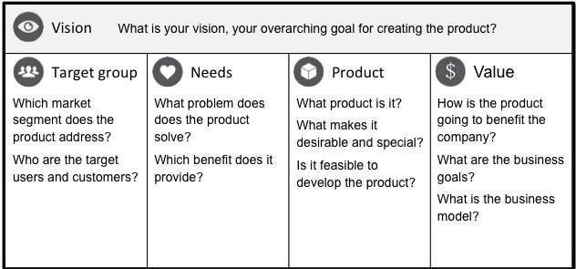

VISION: Customers of any age group who want to have top-rated restaurant’s delicious food in one- go at their doorstep with lighting fast delivery, 24/7 availability and reliable services are SCRUM FOODS. Unlike any other food delivery app in market, our utmost priority is customer need and
customer satisfaction which makes us stand out of any other food delivery app in this industry.
Online food delivery industry is our target segment.  Users/Customers: People who want food deliveries within stipulated time at their required place | Scrum foods provide guaranteed safe food delivery in one-go of top rated licensed restaurants.  Customers can receive with safe packaged food within expected time to clear their hunger. | Scrum foods will be on mobile, tablets and desktop application.  Real time tracking and providing 24/7 services and customer support  Product feasibility can be complex and require attention in every aspect | Open up revenue stream  Be leading online food delivery app in country  Create reputed brand image for other business opportunities.

Product Vision – Description – Notes

Customer: Registration, Login, Search and View restaurants, View restaurant's menu, Order food, Payment, Tracking, Cancel order, Feedback & Rating and Logout.
Delivery Boy: Registration, Login, View orders, Select and accept orders, Order pickup and delivery, Status updates, Payment (COD), View Feedback, Raise Issues, View Deliveries report and revenue generated, Logout.
Restaurants: Registration, Login, View Orders, Delivery Boy Verification, Payment, View Feedback, Raise Issues, View revenue generated through Scrum Food app, Logout.
Regional Admin: Admin Login, Tracking/status, Customer feedback, Managing Regional delivery boys and restaurant, View regional revenue, Issues, Refunds, View payment made to regional restaurant and Logout.
Admin: Login, Managing Regional Admin, Issues, Customer Feedback, Approval/Rejections privileges on restaurants, Delivery boy, Restaurants and Regional Admin requests, Resolve Issues and Logout
Business Owner: Login, Issues, Reports, Update payments for restaurants and delivery boys and Logout

End of Product Vision

User Story Workshop
How to write a User story:
Take a Sticky Note and take a contract color Sketch Pen and write the user story in CAPITAL letters only. Make sure the user story is short, clear and unambiguous and one Scrum Developer can develop in one agreed sprint.
If you come across complex, big User stories… these are called epics. We can divide the epics into Themes and then into User Stories

Finalized User Stories | Count:
USER STORIES
SPRINT-1
User Story No: 1 | Tasks: 2 |  | Priority: HIGHEST
AS A DELIVERY BOY
I WANT TO REGISTER IN SCRUM FOODS SO THAT I CAN DELIVER ORDERS
BV: 500 |  | CP: 02
ACCEPTANCE CRITERIA
Registration Screen
Text Boxes for User Name, Password, Nation ID, Mobile No, Email, Address, Phone Number.
Click on Register Button.
Send Successful Notification to the user

User Story No: 02 | Tasks: 2 |  | Priority: HIGHEST
AS A RESTAURANT OWNER I WANT TO VIEW ORDERS
SO THAT I CAN VIEW THE LIST OF ORDERS
BV: 500 |  | CP: 2
Acceptance Criteria :
View Order, Display List of orders in the tabular Form

User Story No: 3 | Tasks:2 |  | Priority: HIGHEST
AS A CUSTOMER
I WANT TO ADD THE ADDRESS
SO THAT I CAN GET THE ORDER TO MY ADDRESS
BV: 500 |  | CP: 2
Acceptance Criteria :
Text Box to enter.
Business Rules: Within the radius of 5 km

User Story No: 4 | Tasks:2 |  | Priority: HIGHEST
AS A CUSTOMER
I WANT TO SELECT THE PAYMENT MODE
SO THAT I CAN MAKE PAYMENT OF MY CHOICE
BV: 500 |  | CP: 3
Acceptance Criteria :
Display payment modes, radio buttons to select payment modes, payments button.
Business Rule. Can select only one payment mode

User Story No: 5 | Tasks:2 |  | Priority: HIGHEST
AS AN ADMIN
I WANT TO VIEW THE RESTAURANTS
SO THAT I CAN APPROVE THEIR REGISTRATION
BV: 500 |  | CP: 2
ACCEPTANCE CRITERIA
List of restaurant, select Restaurants, verify restaurant details, approve button, reject button, notification to the restaurant.

User Story No: 6 | Tasks:2 |  | Priority: LOW
AS ACUSTOMER
I WANT TO VIEW THE PRICE
SO THAT I CAN ORDER THE FOOD
BV: 50 |  | CP: 1
Acceptance Criteria :
1. Display price in the list of menu items

User Story No:7 | Tasks:2 |  | Priority: LOW
AS A CUSTOMER
I WANT TO VIEW THE CONTACT NUMBER OF DELIVERY BOY SO THAT I CAN CONTACT DELIVERY BOY FOR THE STATUS
BV: 50 |  | CP: 1
Acceptance Criteria :
- Display delivery boy mobile number
- Display delivery boy name in tracking field
- Display delivery boy picture

User Story No: 8 | Tasks:2 |  | Priority: MEDIUM
AS A RESTAURANT OWNER
I WANT TO PROVIDE TIME SLOTS
SO THAT CUSTOMER CAN CHECK OPENING AND CLOSING HOURS
BV: 100 |  | CP: 2
Acceptance Criteria :
- Click on restaurant dashboard
- Add from time to time
- Click on submit
- Display updated successfully

User Story No: 9 | Tasks:2 |  | Priority: HIGH
AS A Business OWNER
I WANT TO VIEW RESTAURANT REVENUE REPORT SO THAT I CAN VIEW THE RESTAURANT’S REVENUE
BV: 200 |  | CP: 3
Acceptance Criteria : Select Reports
Select Revenue Reports Select to and from date Select Region (can select all) Generate Report
Download Report in EXCEL

User Story No: 10 | Tasks: 03 |  | Priority: High
AS A REG ADMIN
I WANT TO MANAGE REGIONAL RESTAURANTS,
SO THAT, I CAN TRACK THE PERFORMANCE OF REGIONAL RESTAURANTS.
BV: 200 |  | CP: 03
Acceptance Criteria :
CLICK ON PERFORMANCE OF RESTAURANTS SELECT FROM DATE TO DATE
CLINCK ON GENERATE REPORT WHICH INCLUSES RESTAURANTS ID, NAME, REVENUE
CLICK ON DOWNLOAD REPORT SHOULD BE IN EXCEL

User Story No: 11 | Tasks: 02 |  | Priority: Medium
AS ADMIN
I WANT TO SEE THE REGIONAL REVENUE REPORTS, SO THAT I CAN VIEW THE REGIONAL PERFORMANCE
BV: 100 |  | CP: 03
Acceptance Criteria :
Select regional dropdown
View performance of each rest of that region in tabular form which includes rest name, revenue, generated
Download in excel or PDF

User Story No: 12 | Tasks: 02 |  | Priority: High
AS A CUSTOMER
I WANT TO CHAT WITH REG ADMIN SO THAT I CAN REQUEST FOR REFUND
BV: 200 |  | CP: 02
Acceptance Criteria :
- BR-ALL MANDATORY
- TEXT BOX FIELDS
- DISPLAY ORDER ID
- TEXT BOX,FOR DESCRIPTION
- SUBMIT BUTTON
- GENERATE ISSUE ID
- DISPLAY SUCCESSFUL

Adding BV and CP to User stories
BV – Business Value
This is not the cost of Development or the complexity of the feature. Business Value is how important is this feature (user Story) to the Business. This is estimated by Scrum Currency Notes. We provide Rs 1000. Rs 500, Rs 100, Rs 50, Rs 20 and Rs 10 Denominations. These estimations are done by the Stakeholders (Clients). If different values are selected by the stakeholders, then discussions will happen, and they agree to one BV value to that user story.

CP – Complexity Points
CP is also known as Story Points (SP). CP is the effort required by the Scrum Developers to develop this feature (user story) using technology. Efforts include time taken to solve the complexity and write the code. CP is estimated by the Scrum Developers by using Poker cards. We provide pokers with values “?”, 1, 2, 3, 5, 8, 13, 20, 40, 100 and BIG. If the entire Project development takes 200 points, then this user
story coding effort will be… how many points? … Thinking in this way, Scrum Developers will give CP to the User story. ). If different values are selected by the Scrum Developers, then discussions will happen, and they agree to one CP value to that user story.

Question 2 – User Stories- Acceptance Criteria-BV-CP – 40 Marks
Write minimum 40 User stories and their Acceptance Criteria along with their BV and CP

User Stories - SPRINT 1
User Story No: 1 | Tasks: 2 | Priority: HIGH
AS A DELIVERY BOY
I WANT TO REGISTER IN SCRUM FOODS
SO THAT I CAN DELIVER ORDERS
BV: 500 | CP: 02
ACCEPTANCE CRITERIA
Registration Screen
Text Boxes for User Name, Password, Nation ID, Mobile No, Email, Address, Phone Number.
Click on Register Button.
Send Successful Notification to the user.
User Story No: 2 | Tasks: 2 | Priority: HIGH
AS A DELIVERY BOY
I WANT TO REGISTER IN SCRUM FOODS
SO THAT I CAN DELIVER ORDERS
BV: 500 | CP: 02
ACCEPTANCE CRITERIA
Registration Screen
Text Boxes for User Name, Password, Nation ID, Mobile No, Email, Address, Phone Number.
Click on Register Button.
Send Successful Notification to the user.
User Story No: 3 | Tasks: 2 | Priority: HIGH
AS A DELIVERY BOY
I WANT TO REGISTER IN SCRUM FOODS
SO THAT I CAN DELIVER ORDERS
BV: 500 | CP: 02
ACCEPTANCE CRITERIA
Registration Screen
Text Boxes for User Name, Password, Nation ID, Mobile No, Email, Address, Phone Number.
Click on Register Button.
Send Successful Notification to the user.
User Story No: 4 | Tasks: 2 | Priority: HIGH
AS A DELIVERY BOY
I WANT TO REGISTER IN SCRUM FOODS
SO THAT I CAN DELIVER ORDERS
BV: 500 | CP: 02
ACCEPTANCE CRITERIA
Registration Screen
Text Boxes for User Name, Password, Nation ID, Mobile No, Email, Address, Phone Number.
Click on Register Button.
Send Successful Notification to the user.
User Story No: 5 | Tasks: 2 | Priority: HIGH
AS A DELIVERY BOY
I WANT TO REGISTER IN SCRUM FOODS
SO THAT I CAN DELIVER ORDERS
BV: 500 | CP: 02
ACCEPTANCE CRITERIA
Registration Screen
Text Boxes for User Name, Password, Nation ID, Mobile No, Email, Address, Phone Number.
Click on Register Button.
Send Successful Notification to the user.
User Story No: 6 | Tasks: 2 | Priority: HIGH
AS A DELIVERY BOY
I WANT TO REGISTER IN SCRUM FOODS
SO THAT I CAN DELIVER ORDERS
BV: 500 | CP: 02
ACCEPTANCE CRITERIA
Registration Screen
Text Boxes for User Name, Password, Nation ID, Mobile No, Email, Address, Phone Number.
Click on Register Button.
Send Successful Notification to the user.
User Story No: 7 | Tasks: 2 | Priority: HIGH
AS A DELIVERY BOY
I WANT TO REGISTER IN SCRUM FOODS
SO THAT I CAN DELIVER ORDERS
BV: 500 | CP: 02
ACCEPTANCE CRITERIA
Registration Screen
Text Boxes for User Name, Password, Nation ID, Mobile No, Email, Address, Phone Number.
Click on Register Button.
Send Successful Notification to the user.
User Story No: 8 | Tasks: 2 | Priority: HIGH
AS A DELIVERY BOY
I WANT TO REGISTER IN SCRUM FOODS
SO THAT I CAN DELIVER ORDERS
BV: 500 | CP: 02
ACCEPTANCE CRITERIA
Registration Screen
Text Boxes for User Name, Password, Nation ID, Mobile No, Email, Address, Phone Number.
Click on Register Button.
Send Successful Notification to the user.
User Story No: 9 | Tasks: 2 | Priority: HIGH
AS A DELIVERY BOY
I WANT TO REGISTER IN SCRUM FOODS
SO THAT I CAN DELIVER ORDERS
BV: 500 | CP: 02
ACCEPTANCE CRITERIA
Registration Screen
Text Boxes for User Name, Password, Nation ID, Mobile No, Email, Address, Phone Number.
Click on Register Button.
Send Successful Notification to the user.
User Story No: 10 | Tasks: 2 | Priority: HIGH
AS A DELIVERY BOY
I WANT TO REGISTER IN SCRUM FOODS
SO THAT I CAN DELIVER ORDERS
BV: 500 | CP: 02
ACCEPTANCE CRITERIA
Registration Screen
Text Boxes for User Name, Password, Nation ID, Mobile No, Email, Address, Phone Number.
Click on Register Button.
Send Successful Notification to the user.
User Story No: 11 | Tasks: 2 | Priority: HIGH
AS A DELIVERY BOY
I WANT TO REGISTER IN SCRUM FOODS
SO THAT I CAN DELIVER ORDERS
BV: 500 | CP: 02
ACCEPTANCE CRITERIA
Registration Screen
Text Boxes for User Name, Password, Nation ID, Mobile No, Email, Address, Phone Number.
Click on Register Button.
Send Successful Notification to the user.
User Story No: 12 | Tasks: 2 | Priority: HIGH
AS A DELIVERY BOY
I WANT TO REGISTER IN SCRUM FOODS
SO THAT I CAN DELIVER ORDERS
BV: 500 | CP: 02
ACCEPTANCE CRITERIA
Registration Screen
Text Boxes for User Name, Password, Nation ID, Mobile No, Email, Address, Phone Number.
Click on Register Button.
Send Successful Notification to the user.
User Story No: 13 | Tasks: 2 | Priority: HIGH
AS A DELIVERY BOY
I WANT TO REGISTER IN SCRUM FOODS
SO THAT I CAN DELIVER ORDERS
BV: 500 | CP: 02
ACCEPTANCE CRITERIA
Registration Screen
Text Boxes for User Name, Password, Nation ID, Mobile No, Email, Address, Phone Number.
Click on Register Button.
Send Successful Notification to the user.
User Story No: 14 | Tasks: 2 | Priority: HIGH
AS A DELIVERY BOY
I WANT TO REGISTER IN SCRUM FOODS
SO THAT I CAN DELIVER ORDERS
BV: 500 | CP: 02
ACCEPTANCE CRITERIA
Registration Screen
Text Boxes for User Name, Password, Nation ID, Mobile No, Email, Address, Phone Number.
Click on Register Button.
Send Successful Notification to the user.
User Story No: 15 | Tasks: 2 | Priority: HIGH
AS A DELIVERY BOY
I WANT TO REGISTER IN SCRUM FOODS
SO THAT I CAN DELIVER ORDERS
BV: 500 | CP: 02
ACCEPTANCE CRITERIA
Registration Screen
Text Boxes for User Name, Password, Nation ID, Mobile No, Email, Address, Phone Number.
Click on Register Button.
Send Successful Notification to the user.
User Story No: 16 | Tasks: 2 | Priority: HIGH
AS A DELIVERY BOY
I WANT TO REGISTER IN SCRUM FOODS
SO THAT I CAN DELIVER ORDERS
BV: 500 | CP: 02
ACCEPTANCE CRITERIA
Registration Screen
Text Boxes for User Name, Password, Nation ID, Mobile No, Email, Address, Phone Number.
Click on Register Button.
Send Successful Notification to the user.
User Story No: 17 | Tasks: 2 | Priority: HIGH
AS A DELIVERY BOY
I WANT TO REGISTER IN SCRUM FOODS
SO THAT I CAN DELIVER ORDERS
BV: 500 | CP: 02
ACCEPTANCE CRITERIA
Registration Screen
Text Boxes for User Name, Password, Nation ID, Mobile No, Email, Address, Phone Number.
Click on Register Button.
Send Successful Notification to the user.
User Story No: 18 | Tasks: 2 | Priority: HIGH
AS A DELIVERY BOY
I WANT TO REGISTER IN SCRUM FOODS
SO THAT I CAN DELIVER ORDERS
BV: 500 | CP: 02
ACCEPTANCE CRITERIA
Registration Screen
Text Boxes for User Name, Password, Nation ID, Mobile No, Email, Address, Phone Number.
Click on Register Button.
Send Successful Notification to the user.
User Story No: 19 | Tasks: 2 | Priority: HIGH
AS A DELIVERY BOY
I WANT TO REGISTER IN SCRUM FOODS
SO THAT I CAN DELIVER ORDERS
BV: 500 | CP: 02
ACCEPTANCE CRITERIA
Registration Screen
Text Boxes for User Name, Password, Nation ID, Mobile No, Email, Address, Phone Number.
Click on Register Button.
Send Successful Notification to the user.
User Story No: 20 | Tasks: 2 | Priority: HIGH
AS A DELIVERY BOY
I WANT TO REGISTER IN SCRUM FOODS
SO THAT I CAN DELIVER ORDERS
BV: 500 | CP: 02
ACCEPTANCE CRITERIA
Registration Screen
Text Boxes for User Name, Password, Nation ID, Mobile No, Email, Address, Phone Number.
Click on Register Button.
Send Successful Notification to the user.
User Story No: 21 | Tasks: 2 | Priority: HIGH
AS A DELIVERY BOY
I WANT TO REGISTER IN SCRUM FOODS
SO THAT I CAN DELIVER ORDERS
BV: 500 | CP: 02
ACCEPTANCE CRITERIA
Registration Screen
Text Boxes for User Name, Password, Nation ID, Mobile No, Email, Address, Phone Number.
Click on Register Button.
Send Successful Notification to the user.
User Story No: 22 | Tasks: 2 | Priority: HIGH
AS A DELIVERY BOY
I WANT TO REGISTER IN SCRUM FOODS
SO THAT I CAN DELIVER ORDERS
BV: 500 | CP: 02
ACCEPTANCE CRITERIA
Registration Screen
Text Boxes for User Name, Password, Nation ID, Mobile No, Email, Address, Phone Number.
Click on Register Button.
Send Successful Notification to the user.
User Story No: 23 | Tasks: 2 | Priority: HIGH
AS A DELIVERY BOY
I WANT TO REGISTER IN SCRUM FOODS
SO THAT I CAN DELIVER ORDERS
BV: 500 | CP: 02
ACCEPTANCE CRITERIA
Registration Screen
Text Boxes for User Name, Password, Nation ID, Mobile No, Email, Address, Phone Number.
Click on Register Button.
Send Successful Notification to the user.
User Story No: 24 | Tasks: 2 | Priority: HIGH
AS A DELIVERY BOY
I WANT TO REGISTER IN SCRUM FOODS
SO THAT I CAN DELIVER ORDERS
BV: 500 | CP: 02
ACCEPTANCE CRITERIA
Registration Screen
Text Boxes for User Name, Password, Nation ID, Mobile No, Email, Address, Phone Number.
Click on Register Button.
Send Successful Notification to the user.
User Story No: 25 | Tasks: 2 | Priority: HIGH
AS A DELIVERY BOY
I WANT TO REGISTER IN SCRUM FOODS
SO THAT I CAN DELIVER ORDERS
BV: 500 | CP: 02
ACCEPTANCE CRITERIA
Registration Screen
Text Boxes for User Name, Password, Nation ID, Mobile No, Email, Address, Phone Number.
Click on Register Button.
Send Successful Notification to the user.
User Story No: 26 | Tasks: 2 | Priority: HIGH
AS A DELIVERY BOY
I WANT TO REGISTER IN SCRUM FOODS
SO THAT I CAN DELIVER ORDERS
BV: 500 | CP: 02
ACCEPTANCE CRITERIA
Registration Screen
Text Boxes for User Name, Password, Nation ID, Mobile No, Email, Address, Phone Number.
Click on Register Button.
Send Successful Notification to the user.
User Story No: 27 | Tasks: 2 | Priority: HIGH
AS A DELIVERY BOY
I WANT TO REGISTER IN SCRUM FOODS
SO THAT I CAN DELIVER ORDERS
BV: 500 | CP: 02
ACCEPTANCE CRITERIA
Registration Screen
Text Boxes for User Name, Password, Nation ID, Mobile No, Email, Address, Phone Number.
Click on Register Button.
Send Successful Notification to the user.
User Story No: 28 | Tasks: 2 | Priority: HIGH
AS A DELIVERY BOY
I WANT TO REGISTER IN SCRUM FOODS
SO THAT I CAN DELIVER ORDERS
BV: 500 | CP: 02
ACCEPTANCE CRITERIA
Registration Screen
Text Boxes for User Name, Password, Nation ID, Mobile No, Email, Address, Phone Number.
Click on Register Button.
Send Successful Notification to the user.
User Story No: 29 | Tasks: 2 | Priority: HIGH
AS A DELIVERY BOY
I WANT TO REGISTER IN SCRUM FOODS
SO THAT I CAN DELIVER ORDERS
BV: 500 | CP: 02
ACCEPTANCE CRITERIA
Registration Screen
Text Boxes for User Name, Password, Nation ID, Mobile No, Email, Address, Phone Number.
Click on Register Button.
Send Successful Notification to the user.
User Story No: 30 | Tasks: 2 | Priority: HIGH
AS A DELIVERY BOY
I WANT TO REGISTER IN SCRUM FOODS
SO THAT I CAN DELIVER ORDERS
BV: 500 | CP: 02
ACCEPTANCE CRITERIA
Registration Screen
Text Boxes for User Name, Password, Nation ID, Mobile No, Email, Address, Phone Number.
Click on Register Button.
Send Successful Notification to the user.
User Story No: 31 | Tasks: 2 | Priority: HIGH
AS A DELIVERY BOY
I WANT TO REGISTER IN SCRUM FOODS
SO THAT I CAN DELIVER ORDERS
BV: 500 | CP: 02
ACCEPTANCE CRITERIA
Registration Screen
Text Boxes for User Name, Password, Nation ID, Mobile No, Email, Address, Phone Number.
Click on Register Button.
Send Successful Notification to the user.
User Story No: 32 | Tasks: 2 | Priority: HIGH
AS A DELIVERY BOY
I WANT TO REGISTER IN SCRUM FOODS
SO THAT I CAN DELIVER ORDERS
BV: 500 | CP: 02
ACCEPTANCE CRITERIA
Registration Screen
Text Boxes for User Name, Password, Nation ID, Mobile No, Email, Address, Phone Number.
Click on Register Button.
Send Successful Notification to the user.
User Story No: 33 | Tasks: 2 | Priority: HIGH
AS A DELIVERY BOY
I WANT TO REGISTER IN SCRUM FOODS
SO THAT I CAN DELIVER ORDERS
BV: 500 | CP: 02
ACCEPTANCE CRITERIA
Registration Screen
Text Boxes for User Name, Password, Nation ID, Mobile No, Email, Address, Phone Number.
Click on Register Button.
Send Successful Notification to the user.
User Story No: 34 | Tasks: 2 | Priority: HIGH
AS A DELIVERY BOY
I WANT TO REGISTER IN SCRUM FOODS
SO THAT I CAN DELIVER ORDERS
BV: 500 | CP: 02
ACCEPTANCE CRITERIA
Registration Screen
Text Boxes for User Name, Password, Nation ID, Mobile No, Email, Address, Phone Number.
Click on Register Button.
Send Successful Notification to the user.
User Story No: 35 | Tasks: 2 | Priority: HIGH
AS A DELIVERY BOY
I WANT TO REGISTER IN SCRUM FOODS
SO THAT I CAN DELIVER ORDERS
BV: 500 | CP: 02
ACCEPTANCE CRITERIA
Registration Screen
Text Boxes for User Name, Password, Nation ID, Mobile No, Email, Address, Phone Number.
Click on Register Button.
Send Successful Notification to the user.
User Story No: 36 | Tasks: 2 | Priority: HIGH
AS A DELIVERY BOY
I WANT TO REGISTER IN SCRUM FOODS
SO THAT I CAN DELIVER ORDERS
BV: 500 | CP: 02
ACCEPTANCE CRITERIA
Registration Screen
Text Boxes for User Name, Password, Nation ID, Mobile No, Email, Address, Phone Number.
Click on Register Button.
Send Successful Notification to the user.
User Story No: 37 | Tasks: 2 | Priority: HIGH
AS A DELIVERY BOY
I WANT TO REGISTER IN SCRUM FOODS
SO THAT I CAN DELIVER ORDERS
BV: 500 | CP: 02
ACCEPTANCE CRITERIA
Registration Screen
Text Boxes for User Name, Password, Nation ID, Mobile No, Email, Address, Phone Number.
Click on Register Button.
Send Successful Notification to the user.
User Story No: 38 | Tasks: 2 | Priority: HIGH
AS A DELIVERY BOY
I WANT TO REGISTER IN SCRUM FOODS
SO THAT I CAN DELIVER ORDERS
BV: 500 | CP: 02
ACCEPTANCE CRITERIA
Registration Screen
Text Boxes for User Name, Password, Nation ID, Mobile No, Email, Address, Phone Number.
Click on Register Button.
Send Successful Notification to the user.
User Story No: 39 | Tasks: 2 | Priority: HIGH
AS A DELIVERY BOY
I WANT TO REGISTER IN SCRUM FOODS
SO THAT I CAN DELIVER ORDERS
BV: 500 | CP: 02
ACCEPTANCE CRITERIA
Registration Screen
Text Boxes for User Name, Password, Nation ID, Mobile No, Email, Address, Phone Number.
Click on Register Button.
Send Successful Notification to the user.
User Story No: 40 | Tasks: 2 | Priority: HIGH
AS A DELIVERY BOY
I WANT TO REGISTER IN SCRUM FOODS
SO THAT I CAN DELIVER ORDERS
BV: 500 | CP: 02
ACCEPTANCE CRITERIA
Registration Screen
Text Boxes for User Name, Password, Nation ID, Mobile No, Email, Address, Phone Number.
Click on Register Button.
Send Successful Notification to the user.

Question 3– What is epic? Write 2 epics – 5 Marks
Business Value and Complexity Points

Ans) Epic typically refers to a large, high-level requirement or initiative that is too broad or
complex to be completed in a single development cycle or iteration. Epics are often broken
down into smaller, more manageable units called user stories.
Epic-1:User Authentication and Profile Management:
This epic focuses on creating a seamless user experience for account creation, login, and
profile management functionalities.
User Stories:
As a new user, I want to create an account using my email or social media credentials.
As a registered user, I want to log in securely with my credentials.
As a user, I want to edit my profile information such as name, contact details, and address.
As a user, I want to view my order history and save favorite restaurants for quicker ordering.
As a user, I want to reset my password in case I forget it.
Acceptance Criteria:
Users can register with valid email addresses or social media accounts.
Login functionality securely authenticates users.
Users can update their profile information and view order history.
Password reset functionality follows security best practices.
Changes to profile information reflect accurately in the app.

2)Epic-2-Ordering and Delivery Management:

This epic involves the core functionality of browsing restaurants, placing orders, and
managing deliveries.
User Stories:
As a user, I want to browse restaurants by cuisine type, location, and ratings.
As a user, I want to view restaurant menus, including item descriptions, prices, and
images.
As a user, I want to add items to my cart and proceed to checkout for payment.
As a user, I want to track the status of my order in real-time, from preparation to delivery.
As a delivery driver, I want to receive notifications for new orders, navigate to the
customer's location, and mark orders as delivered.

Acceptance Criteria:

Users can search and filter restaurants based on various criteria.
Restaurant menus display item details and prices accurately.
Users can add items to their cart, adjust quantities, and proceed to checkout seamlessly.
Real-time order tracking provides updates on order status, estimated delivery time, and
location of the delivery driver.
Delivery drivers receive timely notifications for new orders and can update order status
upon delivery.

Question 4 –What is the difference between BV and CP – 2 Marks

BV (Business Value) and CP (Critical Path) are two important concepts in project
management, particularly in the context of scheduling and prioritization.
Business Value (BV):
BV refers to the quantifiable worth or benefit that a project or task brings to an
organization. It's often expressed in financial terms but can also include non-financial
factors like customer satisfaction, brand reputation, or strategic alignment.
When prioritizing tasks or projects, those with higher BV are typically given precedence
since they contribute more directly to the organization's goals or bottom line.
BV helps stakeholders make informed decisions about resource allocation, project scope,
and risk management by focusing efforts on activities that generate the most value.

Critical Path (CP):
CP refers to the sequence of tasks in a project that determines the minimum amount of
time required to complete the project.
It identifies the longest sequence of dependent tasks and determines the shortest possible
duration for completing the project.
Tasks on the critical path are crucial because any delay in them will directly impact the
overall project timeline. Non-critical tasks can be delayed without affecting the project's
completion date (though they may still impact other aspects like resource utilization or
dependencies).
CP analysis helps project managers identify which tasks are most critical to project
success and where resources should be allocated to ensure timely completion.

Product Backlog
Your User stories will go into Product Back log

Question 5 –Explain about Sprint– 5 Marks

Sprint Understanding
What is sprint Duration: 2 Weeks - Your sprint Value

Scrum is a subunit of Sprint.
What is scrum Duration: 1 day – Your scrum Value ? PBI: Product Backlog Item
Task: Unit of Work done by 1 Developer in 1 Scrum WIP: Work In Progress
Sprint Backlog

PBI | Tasks | WIP | Done
Registration  Login  Add Resturants  Order Food  Make Payment  Track Delivery  Cust Feedback | 3  2  3  3  3  3  3 | 2  2  2  0  3  3  3 | 1  0  1  3  0  0  0

SPRINT:
In the context of software development and project management, a sprint is a time-boxed,
iterative development period during which a specific set of tasks and goals are worked on
by a development team. Sprint is a core concept in Agile methodologies, such as Scrum,
which emphasizes flexibility, collaboration, and delivering value to the customer in shorter
cycles. Here are the key characteristics and components of a sprint:
●Time Frame:
A sprint typically has a fixed duration, often ranging from 1 to 4weeks. The duration is
consistent across all sprints to provide a predictable cadence for development and
planning.
●Goals and Objectives:
At the beginning of each sprint, the development team, along with stakeholders, selects a
set of user stories, features, or tasks to work on during that sprint. These items are
collectively referred to as the sprint backlog.
●Planning:
During sprint planning, the development team breaks down the selected items from the
product backlog into smaller tasks and estimates the effort required for each task. The
team commits to completing these tasks within the sprint duration.
●Daily Stand-ups:
Throughout the sprint, the team holds daily stand-up meetings (also known as daily
scrums) to discuss progress, obstacles, and plans. Each team member shares what
they've accomplished, what they're working on, and any challenges they're facing. These
meetings foster communication and collaboration.
●Development:
The development team works on the tasks identified in the sprint backlog. They
collaborate closely, often using techniques like pair programming and frequent code
reviews to ensure high-quality work.
●Continuous Integration:
Developers integrate their code changes into the main codebase regularly, ensuring that
the software remains functional and stable throughout the sprint.
●Testing:
Testing is an integral part of a sprint. Automated tests are run to validate code changes,
and manual testing may be conducted to ensure the quality of the software.
●Review and Demo:
At the end of the sprint, the development team conducts a sprint review and demo. They
showcase the completed work to stakeholders, gathering feedback and validation. This
helps ensure that the delivered features align with expectations.
●Retrospective:
Following the review and demo, the team holds a sprint retrospective. They reflect on what
went well during the sprint, what could be improved, and actions to take in the next sprint.
The retrospective encourages continuous improvement.
●Incremental Development:
Each sprint results in a potentially shippable product increment, meaning that at the end
of each sprint, a new version of the software is available with additional features or
improvements.
●Adaptability:
Agile methodologies emphasize adaptability and the ability to respond to changing
requirements. If new priorities or insights emerge, adjustments can be made in
subsequent sprints. Sprints allow development teams to iteratively deliver value to
customers and stakeholders in a controlled and predictable manner. By breaking down the
work into manageable chunks and continuously seeking feedback, Agile teams can
enhance collaboration, reduce risk, and improve the overall quality of the software being
developed.

Question 6 – Explain Product backlog and sprint back log– 5 Marks

Sprint Planning Meeting: All 8 Scrum Developers will gather before the sprint starts and understand how many user stories, they can develop in 1 sprint (2 weeks), and move them from the product Backlog to the sprint Backlog. They take inputs from Sprint Retrospective meeting.
Scrum Meeting – Daily Stand-up Meeting
End of every Scrum, Scrum Developers will participate in Scrum meeting. Here they must answer 3 Questions.
- What task did you work in this scrum?
- What task will you work on next scrum?
- Any Challenges/impediments? When you will complete the user story?

Product Backlog:
Definition:
The Product Backlog is a prioritized list of all desired work on the project. It serves as the
single source of requirements for any changes to be made to the product.
It's a dynamic document that evolves as more is learned about the product and customer
needs change.

Ownership:
The Product Backlog is owned and managed by the Product Owner, who is responsible for
maximizing the value of the product and ensuring that the team is working on the most
valuable items.

Content:
The items in the Product Backlog can include new features, enhancements, bug fixes,
technical work, or any other work that adds value to the product.
These items are typically expressed as user stories, epics, or other forms of requirements,
and they are prioritized based on their value to the product and the stakeholders.

Planning Horizon:
The Product Backlog provides a long-term view of the work to be done on the product,
covering multiple releases or iterations.
It helps guide the overall direction and strategy for the product, allowing the team to plan
and adapt as necessary to meet business objectives.

Sprint Backlog:
Definition:
The Sprint Backlog is a subset of the Product Backlog that contains the work selected for
the current sprint.
It represents the plan for how the team will achieve the sprint goal and deliver a potentially
shippable product increment by the end of the sprint.

Ownership:
The Sprint Backlog is owned by the Development Team, who are responsible for selecting
the items from the Product Backlog, breaking them down into tasks, and completing the
work during the sprint.
Content:
The Sprint Backlog typically includes user stories or other Product Backlog items that have
been decomposed into smaller, actionable tasks.
These tasks are estimated, assigned to team members, and tracked throughout the sprint
to ensure progress towards the sprint goal.

Planning Horizon:
The Sprint Backlog provides a short-term view of the work to be done during the current
sprint, typically covering a time frame of one to four weeks.
It helps the team focus on the immediate priorities and commitments for the sprint,
allowing for flexibility and adaptation as they work towards the sprint goal.

Question 7 – What is impediments log? write 2 impediments – 5 Marks
Impediments Log:
The impediments log is typically maintained by the Scrum Master, although it can be
accessible to the entire team.
It contains a list of all obstacles or impediments that are hindering the team's progress in
completing their work.
Each impediment is described briefly, including details such as its impact on the team,
who is affected, and any potential solutions or actions needed to resolve it.
The log is updated regularly during sprint retrospectives, daily stand-up meetings, or
whenever new impediments arise.
The Scrum Master is responsible for facilitating discussions around impediments,
prioritizing them based on their severity and impact, and working with the team to find
solutions.
Impediments for Scrum Food Delivery App:
1)Vendor API Integration Delay:
Description: The development team is facing delays in integrating the vendor's API into the
app, which is essential for real-time menu updates and order processing.
Impact: Without the API integration, the app's functionality is limited, affecting user
experience and potentially leading to customer dissatisfaction.
Resolution: The Scrum Master collaborates with the vendor and development team to
expedite the API integration process, explores alternative solutions, or adjusts the sprint
backlog to focus on other high-priority tasks while awaiting the integration.
2)Network Connectivity Issues for Delivery Drivers:
Description: Delivery drivers using the app report intermittent network connectivity issues,
causing delays in receiving orders and updating order status.
Impact: The network connectivity issues disrupt the smooth operation of the delivery
process, leading to delays in order deliveries and potentially impacting customer
satisfaction.
Resolution: The development team investigates the root cause of the network connectivity
issues, works on optimizing the app's network communication protocols, and implements
offline functionality to allow delivery drivers to continue working even in low or no network
connectivity areas.

Impediments Log:
All challenges faced by the team will be logged in this impediments log
A sick team member
Lack of system knowledge
Lack of management support
Once the Sprint is completed
- From the Done state of the sprint Backlog, we will product Increment and we can deliver it to the client
- Sprint Retrospective meeting: Only the Scrum Developers will participate and will discuss about Challenges faced and come up with lessons learnt. We can use these lessons learnt in Sprint planning meeting to select user stories for the next sprint.
- Sprint Review meeting: All Stakeholders like Scrum Developers, Product owner, Scrum master, Client, 3rd party reviewers will participate. What they discuss is
  - Velocity – How many CP is covered in this sprint
  - Sprint Burn Down Chart

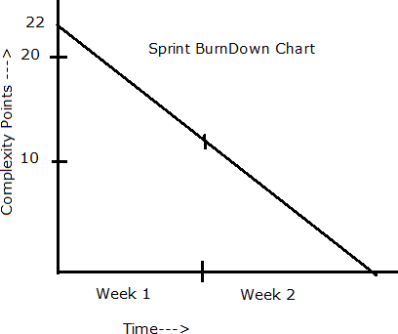

  - Product Burn Down Chart

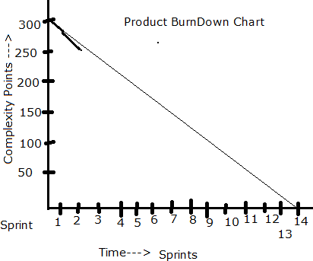

  - Product insights for improvement

Sprint 1
Start Time: 11:00 AM End Time: 13:00 Duration: 2 hrs

Sprint Planning Meeting
Participants
Discussion Points: Discussed on the Sprint Velocity and the BV with the user stories. Discussed with
the associates on resources provided to them and also communicated to the team on sprint duration as well as expectations from the client.
User Stories Selected: 10 (MVP)

Sprint Backlog

PBI | Tasks | WIP | Done
10 | 20 | 0 | 10

Prepare Tasks from PBI
How many Scrums, we will have in this sprint? Allocate Tasks to Developers

Scrum 1
Start Time: End Time: Duration:
Participant and Task Selected

Scrum Meeting
End of every Scrum, Scrum Developers will participate in Scrum meeting. Here they must answer 3 Questions.
- What task did you work in this scrum?
- What task will you work on next scrum?
- Any Challenges/impediments? When you will complete the user story?

Scrum 2
Scrum 3
Scrum 4
Repeat the same activities for all scrums

Sprint 1 – Closing Activities
From the Done state of the sprint Backlog, we will product Increment and we can deliver it to the client What is the Product Increment we made now?
In this sprint, we completed 10 user stories (MVP), meaning we now have a working feature or a set of functionalities that can be used by the client.

Example Product Increment:
- User Registration & Login: Farmers can create accounts and log in.
- Product Listing Page: Farmers can view available fertilizers, seeds, and pesticides.
- Basic Search Functionality: Users can search for agricultural products.
- Cart & Checkout: Farmers can add items to the cart and proceed to checkout.
- Order Summary Page: Users can review orders before purchasing.

Sprint Retrospective meeting: Only the Scrum Developers will participate and will discuss about Challenges faced and come up with lessons learnt. We can use these lessons learnt in Sprint Planning Meeting to select user stories for the next sprint.
Write here Participants: Only Scrum Developers
Purpose: Reflect on Sprint 1, discuss challenges faced, and identify lessons learned for improvement in future sprints.
Challenges Faced:
1️.Delayed API Integration – Some external APIs were not ready, slowing down development.
2️. Unclear Requirements – Some user stories lacked detailed acceptance criteria, leading to confusion.
3️. Environment Issues – Developers faced access issues in the testing environment, causing delays.
4️. Task Overload – Some developers had more tasks than expected, leading to bottlenecks.

Lessons Learned & Action Points for Next Sprint:
- Better Requirement Clarity – Ensure detailed user stories with clear acceptance criteria before development starts.
- Early API Coordination – Align with third-party vendors earlier to avoid delays.
Testing Environment Setup Beforehand – Ensure all required environments are accessible before development begins.
- Balanced Task Allocation – Distribute tasks more evenly among team members.

Sprint Review meeting: All Stakeholders like Scrum Developers, Product owner, Scrum master, Client, 3rd party reviewers will participate. What they discuss is
We as team, 1.Demonstrated the Completed Work – Showed the Product Increment (completed user stories) to stakeholders.
2️.Gathered Feedback from the Client – Discussed whether the completed features meet expectations and if any improvements are needed.
3. Reviewed Business Value Delivered – Explained how the implemented features align with business goals.
4️.Discussed Any Changes Needed – Noted any modifications or enhancements suggested by the client or reviewers.
5️.Planned for Next Steps – Based on feedback, considered changes for future sprints and discussed upcoming priorities.

Key Takeaways for Next Sprint:
- Any new requirements or changes will be added to the Product Backlog.
- Stakeholder feedback will be considered in the next Sprint Planning Meeting.
- The team will focus on improving efficiency based on lessons learned.

Question 8 – Explain Velocity of the Team – 1 Marks
Velocity – How many CP is covered in this sprint
VELOCITY OF THE TEAM:
Velocity refers to the measure of the amount of work a development team can complete
during a sprint. The calculation of velocity is performed by the development team itself, as
they are responsible for estimating the effort required to complete each user story or
backlog item.

Story point estimation:
Story point estimation is a technique used in agile software development to estimate the
effort required for a specific task or user story. It's a relative measure of complexity rather
than a fixed time unit. Team members assign story points based on their understanding of
the work involved, considering factors like complexity, effort, and uncertainty. The actual
time a story point represents can vary from team to team. For some, it might equate to
hours, while for others, it might represent days. It's important to establish a consistent
baseline within the team so that story point estimates can be used effectively for planning
and prioritization.

Tracking completed work:
Tracking completed work in Agile development typically involves calculating the total story
points completed by the team over a specific time frame, usually a sprint or iteration.
Here's how you can calculate completed work:
Identify Completed Stories: At the end of the sprint or iteration, review the user stories or
tasks that were completed and accepted as done.

Sum Story Points: Add up the story points assigned to all the completed user stories.
Exclude any story points that were not fully finished or accepted during the sprint.
Calculate Total Completed Work: The sum of story points completed represents the total
completed work for that sprint. This completed work can be used to calculate the team's
velocity for that specific sprint, as mentioned in the previous response. It provides insights
into the team's capacity and helps with future sprint planning and estimation.

Summing story points:
Summing story points involves adding up the numerical values assigned to individual user
stories or tasks during the estimation process in Agile development. Story points are used
to represent the effort, complexity, and size of a piece of work relative to other items on the
backlog. Here's how you can sum story points:
●List Completed User Stories : Gather a list of user stories or tasks that have been completed during a specific sprint or
iteration.
● Identify Story Point Values : Each user story or task should have a story point value assigned to it during the estimation
process. These values are usually relative, such as 1, 2, 3, 5, 8, 13, etc., representing
increasing levels of complexity or effort.

● Add Up Story Point Values : Sum up the story point values for all the completed user stories or tasks. For example, if
you completed user stories with story point values of 3, 5, and 8, the sum would be 16. The
sum of story points provides a quantitative measure of the work completed by the team
during a sprint. This sum is often used to calculate the team's velocity, which helps in
future sprint planning and estimation.

Average velocity:
Average velocity in Agile development refers to the average amount of work, measured in
story points, that a team completes during a series of sprints or iterations. It's a key metric
used for planning and estimating future work. Here's how to calculate average velocity

● Select a Time Frame : Choose a specific number of past sprints or iterations for which you want to calculate the
average velocity. For example, you might choose the last 5 sprints.

●Sum Completed Story Points : Add up the total story points completed by the team in each of the selected sprints. This
will give you the total completed work for the chosen time frame.
●Calculate Average : Divide the total completed story points by the number of sprints or iterations you
selected. This will give you the average velocity for that period. Formula: Average Velocity =
Total Completed Story Points / Number of Sprints
Use for Planning : The average velocity can serve as a guideline for future sprint planning. It helps the team
estimate how much work they can commit to in upcoming iterations based on their
historical performance. Keep in mind that average velocity is a rough estimate and can
fluctuate based on various factors. It's important to consider the team's capacity, any
changes in team composition, and improvements in estimation accuracy over time

Question 9 – Draw Sprint Burn Charts n Product Burn Down Charts– 3 Marks

Sprint Burn down Chart

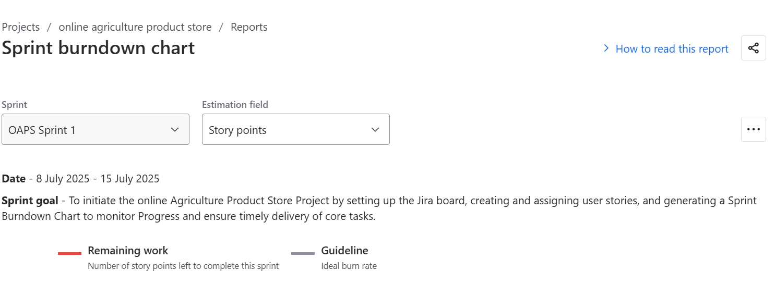

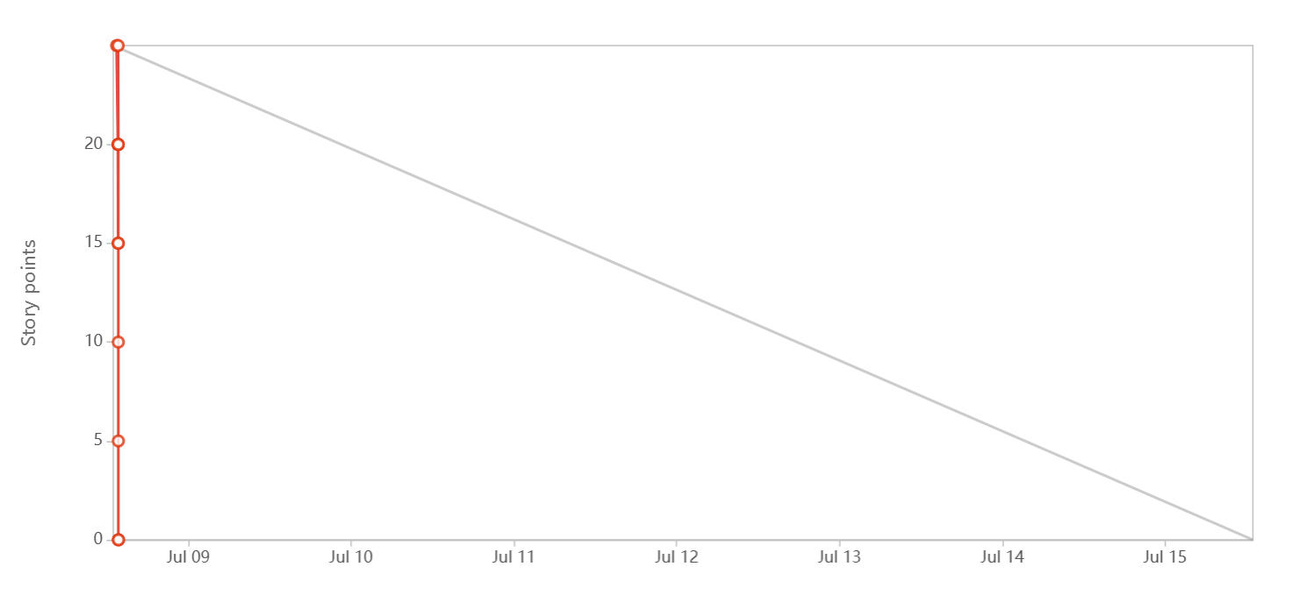

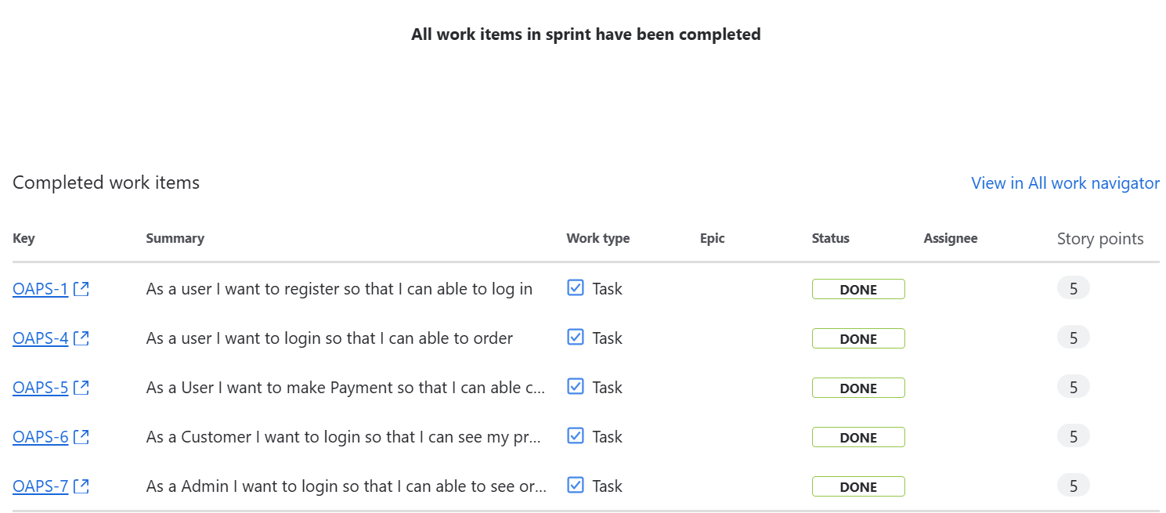

Question 10 – Explain about Product Grooming – 2 Marks

Product grooming, also known as backlog grooming or refinement, is an essential activity
in Agile methodologies like Scrum. It involves preparing the product backlog for upcoming
sprints by refining and prioritizing items to ensure they are ready for implementation.
Here's a detailed explanation of product grooming:

Purpose:
The main goal of product grooming is to ensure that the product backlog contains well-
defined, prioritized, and estimable items that are ready for implementation in future
sprints.
It helps the product owner and development team maintain a clear understanding of the
product vision, user needs, and upcoming work, facilitating effective planning and
execution.

Activities Involved:
Reviewing and Prioritizing: The product owner reviews the items in the product backlog,
considering feedback from stakeholders, market changes, and business priorities. Items
are prioritized based on their value to the product and customers.

Refining User Stories: User stories or backlog items are refined to ensure they are clear,
concise, and actionable. This may involve breaking down large items into smaller ones,
adding acceptance criteria, and clarifying requirements.

Estimation: The development team estimates the effort required to complete each backlog
item, using techniques like story points or hours. This helps in capacity planning and sprint
commitment.

Removing or Archiving Obsolete Items: Outdated or unnecessary items are removed from
the backlog to maintain its relevance and focus on the most valuable work.

Participants:
Product Owner: The product owner leads the grooming sessions, providing guidance on
priorities and requirements.

Development Team: Developers, testers, and other team members actively participate in
grooming sessions to provide input, ask questions, and clarify requirements.
Stakeholders: Relevant stakeholders may be invited to grooming sessions to provide
feedback, share insights, and ensure alignment with business goals.

Frequency:
Product grooming is an ongoing activity that occurs throughout the product development
lifecycle, typically before the start of each sprint.
The frequency of grooming sessions may vary depending on the project's needs, but they
are often scheduled regularly to ensure backlog items remain up-to-date and actionable.

Benefits:
Improved Planning: Well-groomed backlog items help in accurate sprint planning,
resource allocation, and prioritization of work.

Reduced Waste: By refining and prioritizing backlog items in advance, the team can avoid
wasted time and effort on unclear or low-priority tasks.

Enhanced Collaboration: Grooming sessions foster collaboration between the product
owner and development team, leading to shared understanding and ownership of the
product backlog.

Increased Flexibility: A groomed backlog allows the team to respond quickly to changes in
market conditions, customer feedback, or business priorities, adapting their plans
accordingly.

Question 11 – Explain the roles of Scrum Master and Product Owner – 3 Marks
Scrum Master:
Servant Leader: The Scrum Master serves the Scrum Team and the organization by
facilitating Scrum events, removing impediments, and coaching the team on Agile
principles and practices.
Process Facilitator: They ensure that the Scrum framework is understood and enacted
properly. This includes organizing Scrum events (such as Sprint Planning, Daily Standups,
Sprint Review, and Sprint Retrospective) and helping the team follow Scrum practices.
Obstacle Remover: The Scrum Master helps remove any impediments hindering the team's
progress. This might involve addressing issues within the team, coordinating with other
teams or stakeholders, or escalating issues to higher levels of management for resolution.
Protective Shield: They shield the team from external interference, allowing the team to
focus on their work during the Sprint.
Coach: The Scrum Master coaches the team on Agile principles, practices, and values.
They help the team continuously improve by fostering a culture of learning and
experimentation.

Product Owner:
Visionary: The Product Owner is responsible for creating and communicating the vision for
the product. They have a deep understanding of the market, customer needs, and
business goals.
Stakeholder Liaison: They represent the stakeholders and their interests to the Scrum
Team. This involves gathering feedback, managing expectations, and prioritizing
requirements based on business value.
Product Backlog Management: The Product Owner maintains and prioritizes the Product
Backlog, which is a prioritized list of all the work that needs to be done on the project. They
ensure that the Product Backlog is visible, transparent, and understood by everyone
involved.
Requirement Refinement: They work with the Scrum Team to refine the requirements in the
Product Backlog, ensuring that they are clear, feasible, and well-understood by the team.
Decision Maker: The Product Owner makes decisions about what features should be
included in each Sprint and what order they should be developed in. They have the
authority to accept or reject work done by the team based on whether it meets the
acceptance criteria and delivers value to the customer.

Question 12 – Explain all Meetings Conducted in Scrum Project – 8 Marks

Sprint Planning:
This meeting kicks off each sprint, which is a time-boxed iteration of work, usually
spanning 2-4 weeks. During this meeting, the Scrum team, including the Product Owner,
Scrum Master, and Development Team, collaborates to determine which backlog items
(user stories, features, etc.) will be worked on in the upcoming sprint. The team also breaks
down these items into tasks and estimates the effort required.
Daily Stand-up (Daily Scrum):
Held daily during the sprint, this short meeting aims to facilitate quick and focused
communication among team members. Each team member answers three key questions:
What did I accomplish since the last stand-up? What will I work on until the next stand-up?
Are there any obstacles or impediments in my way? This meeting helps keep everyone
aligned and informed about progress and challenges.
Sprint Review
At the end of each sprint, the team holds a review meeting to showcase the work
completed during the sprint to stakeholders, customers, and the Product Owner. The team
demonstrates the potentially shippable product increment and gathers feedback. Based
on this feedback, the Product Owner can update the backlog.
Sprint Retrospective:
Also held at the end of each sprint, the retrospective is a dedicated time for the team to
reflect on their processes and practices. The team discusses what went well, what could
be improved, and any potential changes they'd like to make in the next sprint to enhance
their efficiency and effectiveness.
Backlog Refinement (Grooming):
While not officially part of the Scrum events, backlog refinement is an important ongoing
activity. During these sessions, the team and the Product Owner review and refine backlog
items, adding details, clarifications, and estimates to make them ready for inclusion in
future sprints.
Product Backlog Refinement:
This meeting focuses on refining the product backlog items. The team and the Product
Owner discuss and clarify requirements, priorities, and any changes needed in the backlog
items. This ensures that the backlog is well-prepared for upcoming sprints.
Release planning:
This meeting occurs at the start of the project or major release and involves the product
owner, development team, and stakeholders. It aims to discuss and plan the high level
scope, timeline, and goals for the project.
Adhoc meetings:
These meetings may be schedules as needed to address specific topics or issues, such as
resolving impediments, discuss technical challenges, or conducting additional planning or
collaboration sessions .

Question 13 – Explain Sprint Size and Scrum Size– 2 Marks

Sprint Size: In Scrum, a "sprint" is a time-boxed iteration during which the development Team works to
deliver a potentially shippable product increment. The length of a sprints referred to as the
"sprint duration" and is usually fixed throughout the project. Common sprint durations are
1 to 4 weeks. The choice of sprint duration depends on factors such as team velocity,
project complexity, and business needs. A shorter sprint encourages more frequent
opportunities for feedback and adaptation, while a longer sprint provides more time for
development.
Scrum Team Size:
The Scrum team size refers to the number of individuals who collectively contribute to the
product's development. A Scrum team consists of three keyroles: the Product Owner, the
Scrum Master, and the Development Team. The Development Team, in particular, is
responsible for creating the product increment. Scrum recommends that the Development
Team size be kept small, typically between 3 to 9 members, to facilitate effective
communication, collaboration, and decision-making.

Question 14 – Explain DOR and DOD – 2 Marks
Definition of Ready (DOR):
The Definition of Ready outlines the criteria that a product backlog item (user story,
feature, task, etc.) should meet before it is considered ready to be taken into a sprint for
development. The DOR ensures that the item is well-defined, understood, and prepared for
efficient development. The specific criteria in the DOR can vary from team to team, but
commonly include elements such as:
● Clear description and acceptance criteria: The item's requirements are clearly stated,
and the conditions for its successful completion are well-defined.
● Dependencies identified: Any dependencies on external factors, teams, or resources are
identified and addressed.
● Estimable: The team has enough information to provide a reasonable estimate of the
effort required.
● Testable: It's possible to determine whether the item has been successfully
implemented through testing.
● Minimal ambiguity: The item's details are clear, and any uncertainties are resolved.
Definition of Done (DOD):
The Definition of Done outlines the criteria that must be met for a product increment or
backlog item to be considered complete and potentially shippable. The DOD ensures that
the team maintains a consistent level of quality and completeness in their work. The
specific criteria in the DOD can vary based on the team's standards, the nature of the
project, and the industry, but commonly include elements such as:
● Code complete: All development work is finished, including coding, testing, and
integration.
● Peer-reviewed: Code has been reviewed by other team members for quality and
adherence to coding standards.
● Automated tests passed: Automated tests (unit tests, integration tests, etc.) have been
successfully executed and passed.
Functional requirements met: The item meets all specified acceptance criteria and
functional requirements.
● Documentation updated: Any necessary documentation, user guides, or technical
documentation has been updated.

Question 15 – Explain Prioritization Techniques and MVP – 3 Marks

Prioritization techniques are methods used to determine the order in which tasks,
features, or items should be addressed in a project. These techniques help teams allocate
resources effectively and focus on delivering the most valuable work first. Some common
prioritization techniques include:
MoSCoW:
This technique categorizes items into Must have, Should have, Could have, and Won't
have categories. It helps clarify essential features from those that are optional or lower
priority.
Weighted Shortest Job First (WSJF):
WSJF assigns a priority score to each item based on factors like business value, time
sensitivity, and risk. Items with higher scores are considered more important to work on.
Kano Model:
This model categorizes features into Basic Needs, Performance Needs, and Delighters. It
helps prioritize based on how features impact user satisfaction.
Value vs. Effort Matrix:
Items are plotted on a matrix based on their potential value and effort required. This helps
identify quick wins and high-value tasks.
Relative Prioritization:
Teams compare items pairwise to determine which is more important. This helps create a
relative ranking of items.
Buy a Feature:
Stakeholders are given a budget to 'buy' features, which helps prioritize features based on
how much value they see in them.
Minimum Viable Product (MVP):
An MVP is the smallest version of a product that includes just enough features to provide
value to early adopters and gather feedback. The MVP approach helps validate
assumptions, learn from users, and iteratively build upon a product's foundation
It involves:
Core Functionality:
An MVP focuses on delivering the core functionalities that address the primary needs or
pain points of the target users.
●Minimal Features:
The MVP omits non-essential features to avoid unnecessary complexity and expedite
development.
●Testing Hypotheses:
The MVP tests assumptions and hypotheses about user behavior, market demand, and
product viability.
Iterative Development:
Based on user feedback, the product is refined and expanded in subsequent iterations,
gradually adding more features

Question 16 – Difference between Business Analyst n Product Owner – 3 Marks

Aspect | Business Analyst (BA) | Product Owner (PO)
Role | Analyzes business needs and documents requirements. | Owns the product vision and prioritizes the backlog.
Focus | Ensures requirements align with business goals. | Ensures the product delivers maximum value to users.
Backlog Involvement | Helps gather and refine requirements for the backlog. | Directly manages and prioritizes the product backlog.
Stakeholder Interaction | Works with stakeholders to gather insights. | Acts as a bridge between business and development teams.
Decision Making | Provides recommendations based on analysis. | Makes final decisions on features and priorities.
Output | Requirement documents, process flows, user stories. | Approved backlog items, product roadmap.

Question 17 – Prepare a sample Resume of 3yrs exp Product Owner – 3 Marks

PRODUCT OWNER - 3 YEARS EXPERIENCE
📍 Name: Rahul Sharma
📍 Phone: +91 98765 43210
📍 Email: rahul.sharma@email.com
📍 LinkedIn: linkedin.com/in/rahulsharma

🎯 OBJECTIVE
Results-driven Product Owner with 3 years of experience in Agile environments. Skilled in product backlog management, stakeholder collaboration, and delivering high-value features. Strong expertise in prioritization, sprint planning, and user story refinement to ensure seamless product development.

💼 PROFESSIONAL EXPERIENCE
Product Owner | ABC Tech Solutions | Jan 2022 – Present
📍 Key Responsibilities:
- Managed and prioritized the Product Backlog based on business value.
- Collaborated with stakeholders, development teams, and UX designers to define and refine user stories.
- Led Sprint Planning, Daily Stand-ups, Sprint Reviews, and Retrospectives to ensure smooth execution.
- Defined MVP (Minimum Viable Product) and ensured timely delivery of critical features.
- Used prioritization techniques (MoSCoW, WSJF, and Kano Model) to focus on high-impact features.
- Worked closely with QA to ensure that acceptance criteria were met before release.
📍 Key Achievements:
✅ Successfully launched a customer self-service portal, increasing user engagement by 30%.
✅ Improved sprint velocity by 25% through backlog refinement.
✅ Reduced time-to-market by 20% through effective prioritization.

🛠 SKILLS
✔ Product Backlog Management
✔ User Story Writing & Refinement
✔ Stakeholder Management
✔ Agile & Scrum Methodologies
✔ Sprint Planning & Execution
✔ Data-Driven Decision Making
✔ Jira, Confluence, Trello

🎓 EDUCATION
🎓 Bachelor of Technology (B.Tech) in Computer Science – Delhi University – 2019
📌 Certifications:
- Certified Scrum Product Owner (CSPO) – 2021
- Agile & Scrum Training – Scrum Alliance

