NURTURING PROCESS – CAPSTONE PROJECT – 3

A customer can make a payment either by Card or by Wallet or by Cash or by Net banking.
Q1. Draw a Use Case Diagram
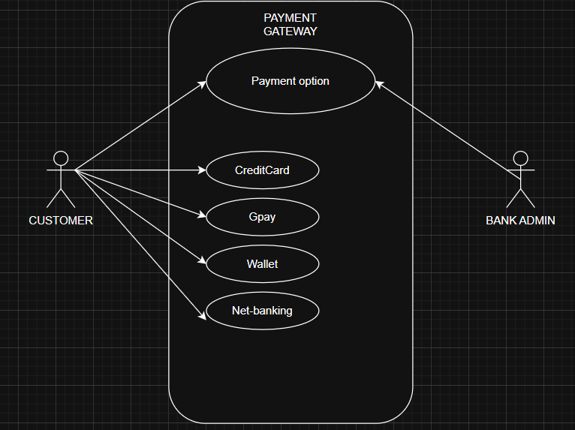

Q2. Derive Boundary Classes, Controller classes, Entity Class
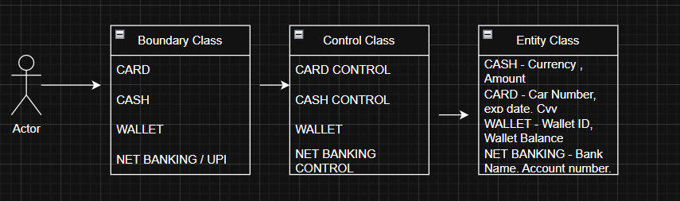

Q3. Place these classes on a three tier Architecture

Client Handles the presentation layer – Application server handles application layer & server system handles database layer
Presentation layer – This is the layer we see when we use a software . By using this we can access the webpages. The core functionality of this layer is to communicate with the application . I mean payment access gateway

Application layer – Is also known as business logic layer. As per the payment gateway option., we selects the payment option. Application layer will interact will the database layer. This acts as a mediator between presentation layer & database layer. It will gather the requirement or the data which we selects
Example – Credit-card? Gpay? Wallet? Net-banking?) & communicate to the presentation layer. It use to perform the operations of the application

Database layer – Data is stored in data layer. Application layer communicate with data layer to retrieve the input & performs required action
Which means API (Application program interface) – using JAVA / PYTHON etc
Example – After selecting the payment option will initiate the process to complete the transaction
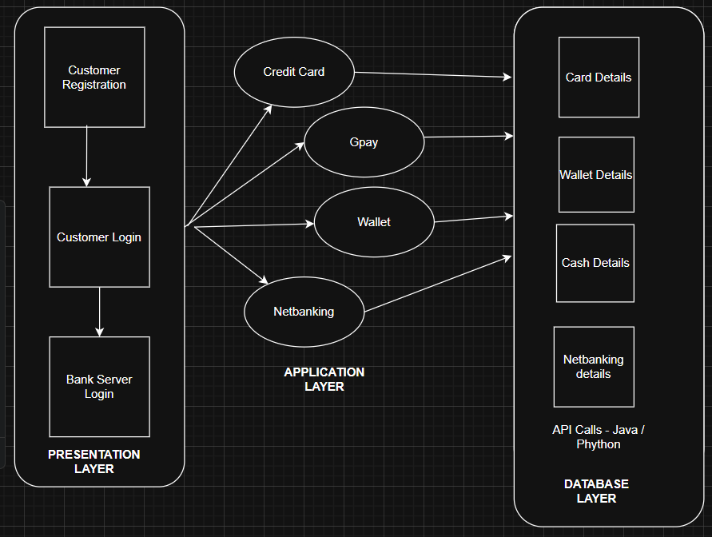

Q4. Explain Domain Model for Customer making payment through Net Banking

Domain Model for Net Banking Payment (Entities + Relationships)
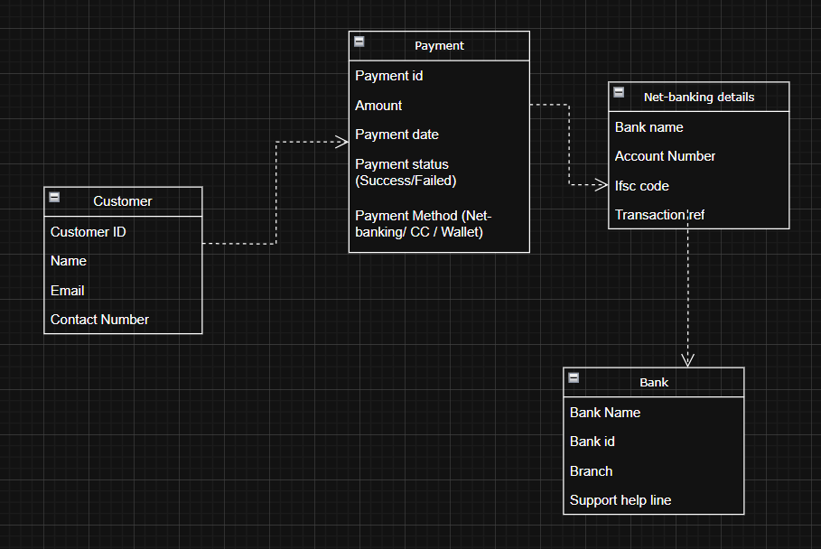

Relationships

- A Customer initiates a Payment.
- A Payment is associated with NetBankingDetails
- NetBankingDetails belongs to a Bank

Q5. Draw a sequence diagram for payment done by Customer Net Banking –

Interaction between classes in the sequential order. It is a step- step process .

It is used to show the flow of message (Event or action)

WHO DRAWS SEQUENTIAL DIG

Creating Sequential diagram is a collaborative effort, but typically led by specific roles
Software Architects / Senior Developers: They often create the initial high-level sequence diagrams to define the flow of interactions

Business Analysts: Might create a "business-level" sequence diagram to validate the process with stakeholders.

Who will be the part ?

Primary Actor - Customer: The user initiating the entire process. They interact with the interface.

High-level sequence diagram (conceptual level).

- Initially customer opens the bank website & then he or she will be entering their credentials to login.

- Once it takes you to the home-screen

- Select for payment (Netbanking)

- Add the details of the person to whom the transfer must be done. (Which includes his Name - account number- branch code- ifsc)

- Enter the amount - Initiate the payment – get otp – transaction done
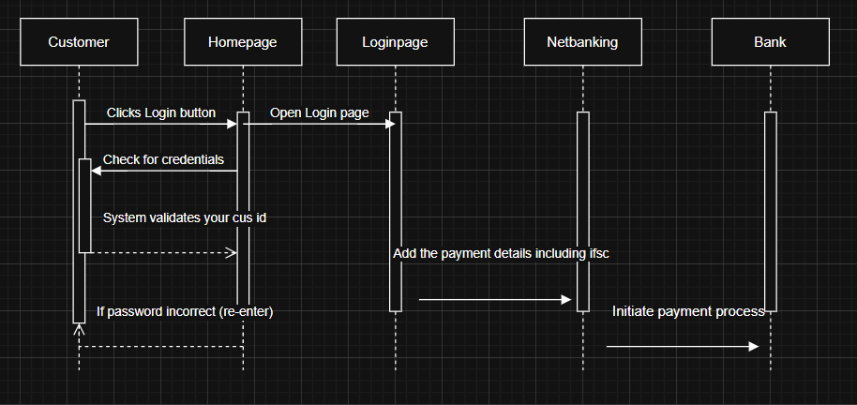

Q6. Explain Conceptual Model for this Case

Conceptual Data means data connected by lines . It represents the entity & the line represents the relationship between the entity

Bank – Represent the service provider who offer services

Security & Privacy – Bank should provide at-most security & privacy for their net-banking users. This should built a trust among customers . It should enable various features under the privacy restriction. The bank should provide strong infrastructure.

Login Credentials – Customers must use their customer id or user id along with password to login to their net-banking page. Adding to that it must have additional features like multi-level authentication like otp to the registered number or virtual authentication

Payment option – Picking the Net-banking as preferred payment option & adding the 3rd party transfer person details along with his IFSC / Account number / Branch code etc

Policies – This includes various policies RBI regulations , netbanking services, ensuring flawless services, & monitoring the compliance
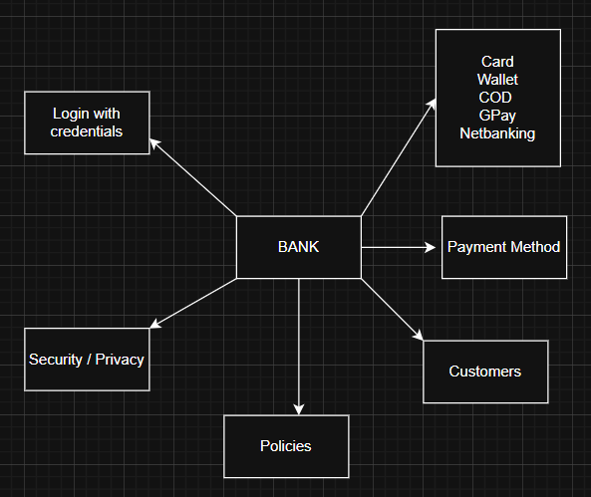

Q7. What is MVC architecture? Explain MVC rules to derive classes from use case diagram and guidelines to place classes in 3-tier architecture

MVC = Model – View – Controller

It is a software design pattern that separates the application into 3 logical components:
With the Real examples I can say customers pay via net-banking

VIEW (Presentation Layer)

Customer opens Payment-Page and selects Net Banking.

CONTROLLER (Application Layer):
Payment Controller receives the request.
It validates user, amount, bank details (IFSC / BANK CODE).
And then calls to the transaction controller to initiate the payment process , I mean the transaction

Model (Data Layer):
Transaction entity created with status = Payment Approved / Pending
Bank Account validated with API

Once it integrates successfully the payment will be done

.

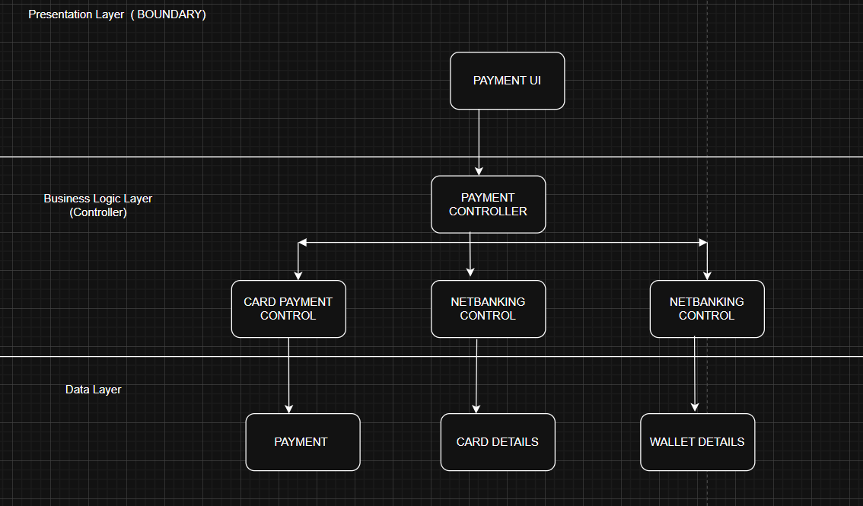

Q8. Explain BA contributions in project (Waterfall Model – all Stages)

- Requirement Gathering & Analysis
- System Design
- Implementation
- Deployment
- Maintenance

In Requirement gathering Stakeholders will be identified & requirement will be gathered from stakeholders
Business analyst will participate & will take all the download .
BRD will be prepared

In system design – Clarify the business rules regarding the payment option (Net banking – Bank reuires account number, branch code, ifsc code) & authentication
Validate that the System Design Document (SDD) aligns with BRD.

Implementation
BA Role - Support developers by clarifying requirements.
Ensure functional flows are aligned with requirements. Also Participate in review meetings.
Answer business logic questions (e.g., What happens if Net Banking fails?).

Deployment
BA Role: Ensure business stakeholders are informed about payment process
Confirm the system supports all payment methods smoothly.
Cross verify with checklist before the go-live

In Maintenance BA Role – Make sure the services are uninterrupted , also ensure Change Request process are also included Updated RTM must be available.

Q9. What is conflict management? Explain using Thomas – Kilmann technique

Conflict can occur due to several reasons. Goals/ Values / Resource .
The process of identifying and addressing the conflict.. Aimed at resolving disputes , or difference of opinion among individuals

By identifying the conflict efficiently , It will really helpful to reduce the negative impact.

Competing / Collaborating / Compromising / Avoiding / Accommodating

- Only Card + Net Banking delivered; Cash & Wallet postponed.
- Phase 1 (Card, Net Banking), Phase 2 (Wallet), Phase 3 (Cash).
- Ignore Cash option discussion until later.
- Accept Business demand to add Wallet spite of challenges and concerns

Resolving disagreements in a way that minimizes disruption and maximizes project success

Q10. List down the reasons for project failure

- Poor Requirement Gathering & Analysis
- Lack of Stakeholder Engagement
- Confusing also frequent Changing Requirements
- Ignoring Prioritization
- Not a effective Documentation or a Improper documentation
- Poor Validation
- Regulatory & Compliance Oversights
- Misalignment between business & technology
- Lack of team co-ordination among team

Q11. List the Challenges faced in projects for BA

Requirement Gathering Challenges

- Difficulty in eliciting clear requirements from stakeholders
- Customers demand “all payment modes” but do not specify about refunds, failed payments,, retry.

Stakeholder Alignment Issues

- Conflicting priorities
- IT Devlopment team says only Card can be delivered in first sprint

Scope Creep & Changing Requirements

- Stakeholder may demand UPI Integration along with the existing payment modes
- Netbanking login attempt should be restricted to 2 times
- There should be 3 layer authentication.whiile login to home page. Initially it was agreed only using the credentials alone. But now client demands , otp & digital face sensor confirmation

Communication Gaps

- Misunderstandings between Business (non-technical language).
- Developers (technical jargon).

Example – If a requirement is explained by the stakeholder differently. But the development team understood incorrectly & start building the feature. (Ex – Refund of wallet)

Technical Complexity & Integration

      - Bank APIs, Wallet providers, integration
      - High dependency on third-party vendors during API Integration
      - BA must constantly update requirements when integration points change.

Change Management

- New payment methods (Ex – UPI, Buy now pay later
- OTP verification must be sent to both mobile & registered email-id
- Forget password / Recovery password

Unrealistic Expectation

- Goals that that cannot be achieved or that are out of scope.

Q12. Write about Document Naming Standards

Good Document Naming Standards (with Payment Case Example)

- A consistent set of rules for naming project documents.
- Ensures clarity and easy retrieval of documents.
- Avoids confusion when multiple versions exist.
- Makes collaboration smoother among Business, Development, QA, and Compliance teams.

Example - Business Requirement Document (BRD) (PAYSYS_BRD_v1.0.docx)
Functional Specification Document (FSD – Wallet Module) PAYSYS_Wallet_FSD_v1.1.docx
Test Scenarios – Card Payment: PAYSYS_Card_TestScenarios_v2.0.docx

Q13. What are the Do’s and Don’ts of a Business analyst

First lets see DO’S

Elicit Clear Requirements
Conduct workshops with Business, Banks, Wallet providers, and Finance teams.
Example: Ensure requirements cover success, failure, timeout, refund flows for Net Banking.

Document Requirements Properly
Maintain BRD, FSD, and Use Case Diagrams with Document Naming Standards.

Prioritize Features Using Techniques
Apply MoSCoW / KANO / MVP.

Bridge the Gap Between Business & Technical Teams
Translate business needs into technical stories.
Example: Convert “Wallet refund” requirement into Clear detail manner without any jargon words

Manage Conflicts Professionally
Example: If Business wants Wallet first but Tech insists on Card → Use “Compromise” to deliver Card in Sprint 1, Wallet in Sprint 2.

Now lets see DONT’S

Don’t assume requirements are obvious
Don’t make any assumption without getting clear concerete update from the stakeholder in regard to the requirement. That should be analysed whether it is within scope.

Don’t Use Vague Language
Incorrect: “System should allow quick payment.”
Right: “System should process Card payment within 5 seconds with 95% success rate.”

Don’t Allow Scope Creep Without Change Control
Example: Suddenly adding UPI without analyzing impact → project delays
Never say “NO” to the client & also don’t accept all the requirement without analysing the challenges and risk.

Q14. Write the difference between packages and sub-systems
Packages is a group of classes or a usecase used to organize model elements
It can be nested within other packages
It is used to represent system architecture
A package is a logical grouping of related classes, interfaces, or use cases in UML. a higher-level unit of the system that provides specific functionality
Example- Payment Methods , WalletPayment , Netbanking, Cash
Packages - Card_Payment_Package ----- > CardUI, CardController, CardEntity
Subsystems - Payment Processing Subsystem → Includes all above packages.

Order Management Subsystem → Handles orders before triggering payment.
Inventory Subsystem → Updates stock after successful payment.
Bank Integration Subsystem → Works with Net Banking & Card payments.

Q15. What is camel-casing and explain where it will be used-
Camel-casing is a naming convention in programming where words are combined without spaces, and each new word starts with a capital letter.

lowerCamelCase – process Payment, validate Card Payment
UpperCamelCase – Payment Controller, Net-Banking Entity

Classes Subsystem & Entities
- Customer
- CardPayment
- WalletPayment
- NetBankingPayment

Q16. Illustrate Development server and production server along with Kamel casing

A Development server is a dedicated environment where software is built, integrated, and tested before moving into QA/ UAT

BA can verify logs/screens → confirm that the transaction status moves from Initiated → Success.

The reason why development server is important - Safe Experimentation / Testing Ground / Bug Fixing / Free from RISK even if any issues happened

Production Server (PROD Server)

The reason why production server is important - Handles Real Customer Transactions / Generates Revenue for the Business / Delivers Customer Experience

Characteristics:
- Purpose: Real transactions for end customers.
- Monitor reports, analyze trends, raise defects
Customer pays with actual Card/Net Banking
Feature | Development Server (DEV) | Production Server (PROD)
Purpose | Build & test system | Real-time customer usage
Data | Fake/test data | Real payment data
Example | Test Net Banking payment | Customer pays ₹1000 via Net Banking – real debit from account

Camel Casing: A naming convention where words are joined without spaces, and each new word begins with a capital letter

Database fields: transactionId, paymentMethod, customerId

Q17. What is Data Mapping / Data Integration

Data Mapping process of connecting data fields from one system to another so that information flows correctly between them.
It shows how “Source Data” corresponds to “Target Data”
Used in API integrations & database migration

Source Field– Customer ID / Payment Method / Transaction Amount
Target Field – Cust_id/ Pay_mode/ Amount

Data Integration - When a customer makes a payment, data comes from different external systems:
Card → Card Network (Visa, MasterCard, Rupay)
Wallet → Paytm, PhonePe, Google Pay
Why Data Integration is Important
Combines all payments (Card, Wallet, Cash, Net Banking) into one account history.

Q18. What is API. Explain how you would use API integration in the case of your application Date format is dd-mm-yyyy and it is accepting some data from Other Application from US whose Date Format is mm-dd-yyyy
API (Application Programming Interface) is a set of rules & endpoints that allow two applications to talk to each other.
APIs help in integration, i.e., connecting your Payment System with external systems like:
Bank Net Banking API
Wallet providers (Paytm, Google Pay, etc.)
When a customer pays via Net Banking, your system must call the Bank’s API to:
Send customer ID, amount, bank account details.
Get response: transaction status (Success / Failure).
When a customer pays via Wallet, your system must call Wallet APIs to deduct money.

Convert the date format from DD/MM/YYYY
Other Application (US) sends API data in → mm-dd-yyyy

