Mock – 4 – Assignment Re-work

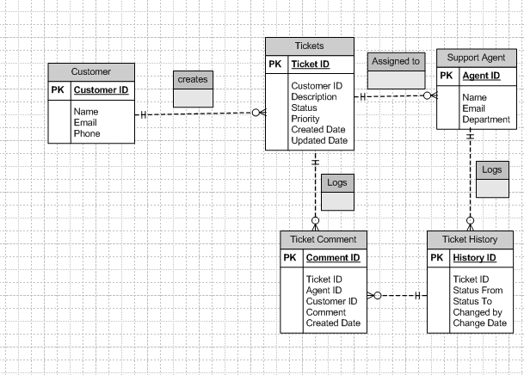

User story of shopping from ecommerce.

User Story no. 1 | Tasks: 2 | Priority: High
As a customer,
I want to browse products by category
so that I can easily find items I want to buy.
BV: 500 | CP: 3
Acceptance Criteria:
- Products are displayed with name, price, and image.
- Customers can filter by category and search by keywords.
- No irrelevant products are shown in search results.

User Story no. 2 | Tasks: 2 | Priority: High
As a customer,
I want to add products to my shopping cart, update quantities, or remove items,
so that I can manage my purchases before checkout.
BV: 50 | CP: 5
Acceptance Criteria:
- Items can be added, updated, or removed from the cart.
- The cart shows total price and quantity.
- Cart data is preserved during the session.

User Story no. 3 | Tasks: 2 | Priority: Medium
As a customer,
I want to checkout securely with payment and delivery details,
so that I can complete my purchase and receive confirmation.
BV: 50 | CP: 8
Acceptance Criteria:
- Payment is processed only after entering valid address and payment information.
- Customers receive an order confirmation.
- Inventory is updated after successful checkout

User Story no. 4 | Tasks: 3 | Priority: High
As a customer,
I want to add products to my shopping cart
so that I can review them before checkout.
BV: 200 | CP: 5
Acceptance Criteria:
Items are added to the cart and reflect quantity adjustments.

User Story no. 5 | Tasks: 2 | Priority: Medium
As a customer,
I want to update or remove items in the cart
so that I can manage my order.
BV: 50 | CP: 3
Acceptance Criteria:
Cart updates immediately after changes.

User Story no. 6 | Tasks: 2 | Priority: High
As a customer,
I want to view product details
so that I can make informed purchase decisions.
BV: 200 | CP: 5
Acceptance Criteria:

All the Details, images are reviewed.
All the reviews are displayed correctly.

User Story no. 7 | Tasks: 2 | Priority: Medium
As a customer,
I want to see product availability in stock
so that I know if I can purchase it.
BV: 50 | CP: 2
Acceptance Criteria:
Stock availability is shown clearly.

User Story no. 8 | Tasks: 2 | Priority: High
As a customer,
I want to apply discount codes during checkout
so that I can apply them while buying the products.
BV: 100 | CP: 3
Acceptance Criteria:
All the Discount codes apply to the related products.
All the products reflect in the final price after discount.

User Story no. 9 | Tasks: 3 | Priority: High
As a customer,
I want to securely enter my payment information
so that I can complete the purchase safely.
BV: 500 | CP: 8
Acceptance Criteria:
All the Payment gateway process is secure and successful.
Notifications from the server is received.

User Story no. 10 | Tasks: 2 | Priority: High
As a customer,
I want to receive order confirmation via email
so that I know it was successful.
BV: 100 | CP: 3
Acceptance Criteria:
Confirmation email is sent without delay.
Order Confirmation is sent to the mobile number.

User Story no. 11 | Tasks: 2 | Priority: Medium
As a customer,
I want to track my order status
so that I know when it will be delivered.
BV: 100 | CP: 5
Acceptance Criteria:
All the Tracking details get updated in real-time.

User Story no. 12 | Tasks: 2 | Priority: Low
As a customer,
I want to view my past orders
so that I can reorder items easily.
BV: 20 | CP: 2
Acceptance Criteria:
Order history is displayed correctly.

User Story no. 13 | Tasks: 2 | Priority: Medium
As a customer,
I want to rate and review products
so that I can share my experience.
BV: 50 | CP: 3
Acceptance Criteria:
Reviews are saved and shown properly.

User Story no. 14 | Tasks: 2 | Priority: Medium
As a customer,
I want personalized recommendations
so that I can discover new items.
BV: 50 | CP: 2
Acceptance Criteria:
Recommendations are relevant based on history.
All the product suggestion are taken from the relevant search history.

User Story no. 15 | Tasks: 3 | Priority: Medium
As a customer,
I want to save items in a wishlist
so that I can purchase them later.
BV: 50 | CP: 3
Acceptance Criteria:
Wishlist retains selected items reliably.

User Story no. 16 | Tasks: 2 | Priority: High
As a customer,
I want to register and log in
so that I can access my profile and orders.
BV: 200 | CP: 5
Acceptance Criteria:
Registration and login work without issues.

User Story no. 17 | Tasks: 3 | Priority: Medium
As a customer,
I want to reset my password if I forget it
so that I can regain access.
BV: 50 | CP: 2
Acceptance Criteria:
Password reset is completed successfully.
Email confirmation is sent before resetting it.

User Story no. 18 | Tasks: 2 | Priority: High
As a customer,
I want to choose shipping options
so that I can control delivery times and costs.
BV: 100 | CP: 3
Acceptance Criteria:
Shipping options are selectable and reflect in checkout.
All the options are displayed at checkout page.

User Story no. 19 | Tasks: 2 | Priority: Medium
As a customer,
I want to view estimated delivery dates
so that I can plan accordingly.
BV: 50 | CP: 2
Acceptance Criteria:
Delivery dates are displayed before checkout.

User Story no. 20 | Tasks: 3 | Priority: High
As a customer,
I want to provide billing and shipping addresses
so that I can receive products at my location.
BV: 100 | CP: 5
Acceptance Criteria:
Addresses are saved and used during checkout.
Suggestions are provided based upon different order locations.

User Story no. 21 | Tasks: 2 | Priority: Medium
As a customer,
I want to receive promotional notifications
so that I can take advantage of offers.
BV: 50 | CP: 3
Acceptance Criteria:
Notifications are sent and accessible.
All the offer related coupon codes are also shown on the page.

User Story no. 22 | Tasks: 2 | Priority: Low
As a customer,
I want to share products on social media
so that I can recommend items to friends.
BV: 20 | CP: 2
Acceptance Criteria:
Share options via different networks work without error.

User Story no. 23 | Tasks: 2 | Priority: Medium
As a customer,
I want to compare products side by side
so that I can choose the best one.
BV: 50 | CP: 3
Acceptance Criteria:
Comparison view loads multiple products.
All the realated products suggestions are shown up during the search

User Story no. 24 | Tasks: 2 | Priority: Medium
As a customer,
I want to contact support from the platform
so that I can get help when needed.
BV: 50 | CP: 2
Acceptance Criteria:
Support contact is visible and accessible.
Support center operates through mail phone etc.

User Story no. 25 | Tasks: 2 | Priority: High
As a customer,
I want the checkout process to be simple and fast
so that I can complete my order without hassle.
BV: 200 | CP: 8
Acceptance Criteria:
Checkout is streamlined,
Error-free
Works efficiently with out delays.

