Document 6:
1. Use case Diagram for My client engagement:
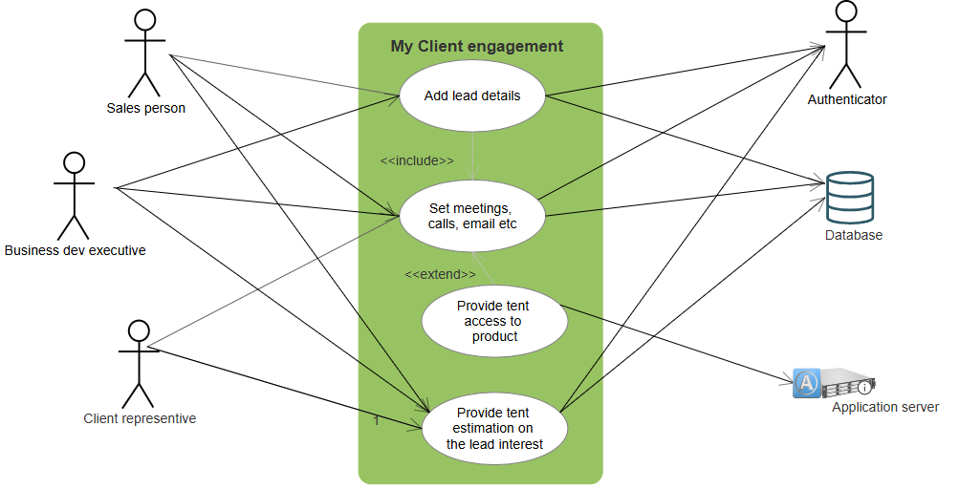
2. Activity Diagram for My client engagement:
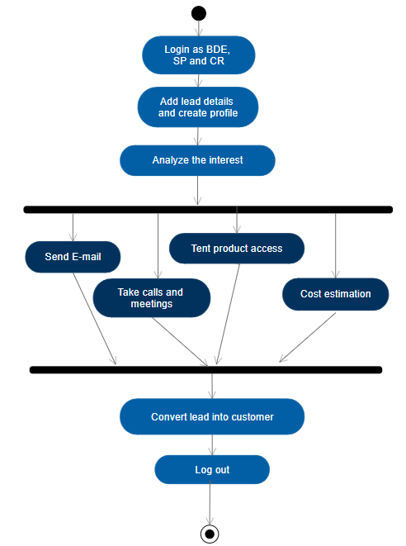
3. Use case specification:
Use case ID | MCE001
Use case name | Business exe, Sales person, Client re-presentative login into the application
Actor | Business exe, Sales person, Client re-presentative
Description | Business exe, Sales person, Client re-presentative wants to login into application
Pre condition | The internet connectivity should be there.  The mobile app or desktop browser should be available  Valid credential
Post condition | User should be successfully logged in.
Basic flow | User search the portal website  Enter the user name & password  Click on submit
Alternate flow | If the user is not logged in, prompt to register or proceed as guest.
Exception flow | Login failed-Display error page
Includes | NA
Extends | Forget password
Business rule | without valid credential cannot login to portal
Priority | High
Frequency of use | Very often
Assumptions | Valid credentials
Notes or issue | Write forget password use case separate

Use case ID | MCE002
Use case name | Business exe, Sales person, Client re-presentative create leads
Actor | Business exe, Sales person, Client re-presentative
Description | Business exe, Sales person, Client re-presentative wants to create new lead
Pre-condition | The internet connectivity should be there.  The mobile app or desktop browser should be available  Valid credential
Post condition | User should be successfully logged in.
Basic flow | Enter the user’s name & password  Click on submit  Add new lead  Fill up the form & submit
Alternate flow | If the user not able to add, throw error message
Exception flow | Failed add lead-Display error page
Includes | Send email, set call and meetings
Extends | Tentative product access
Business rule | without permission do not create lead
Priority | High
Frequency of use | Very often
Assumptions | Valid credentials
Notes or issue | NA

Use case ID | MCE003
Use case name | User set the meeting with Leads
Actor | Business exe, Sales person, Client re-presentative
Description | User wants to sets the meeting with lead and set some agenda
Pre-condition | The internet connectivity should be there.  The mobile app or desktop browser should be available  Valid credential  A lead is already created
Post condition | User should be successfully logged in.
Basic flow | User search the portal website  Enter the user’s name & password  Click on submit  Navigate to the lead
Alternate flow | If the user is not able to set meeting, prompt to try another way
Exception flow | Setting meeting failed -Display error page
Includes | NA
Extends | NA
Business rule | With 30% of conversion confidence move to meeting
Priority | High
Frequency of use | Very often
Assumptions | Valid credentials
Notes or issue | NA

Use case ID | MCE004
Use case name | User should be create dashboard for products
Actor | Business exe, Sales person, Client re-presentative
Description | User wants to create dashboard for product business and ROI
Pre-condition | The internet connectivity should be there.  The mobile app or desktop browser should be available  Valid credential  user should have solid lead confidence
Post condition | User should be successfully logged in.
Basic flow | User search the portal website  Enter the user’s name & password  Click on submit  Add new dashboard and able to add different data set
Alternate flow | If the user is unable to access dashboard creation, prompt to register or proceed as guest.
Exception flow | Dashboard creation failed-Display error page
Includes | NA
Extends | NA
Business rule | without valid credential and expected access right cannot login to portal and cannot create dashboard
Priority | Medium
Frequency of use | often
Assumptions | Valid credentials and Access
Notes or issue | NA

Use case ID | MCE005
Use case name | User gives cost estimation to leads
Actor | Business exe, Sales person, Client re-presentative
Description | Business exe, Sales person, Client re-presentative wants calculate costing
Pre-condition | The mobile app or desktop browser should be available  Valid credential  Navigate to estimation and calculate
Post condition | User should be successfully logged in.
Basic flow | User search the portal website  Enter the user name & password  Click on submit  Navigate to estimation and calculate  prepare cost estimation and share
Alternate flow | If the estimation is unavailable , prompt to register or proceed as guest.
Exception flow | Cost estimation failed-Display error page
Includes | NA
Extends | Lead conversion
Business rule | With 60% confidence go for cost estimation
Priority | High
Frequency of use | often
Assumptions | Valid credentials
Notes or issue | NA
Document 7- Screens and pages:
Login Screen:
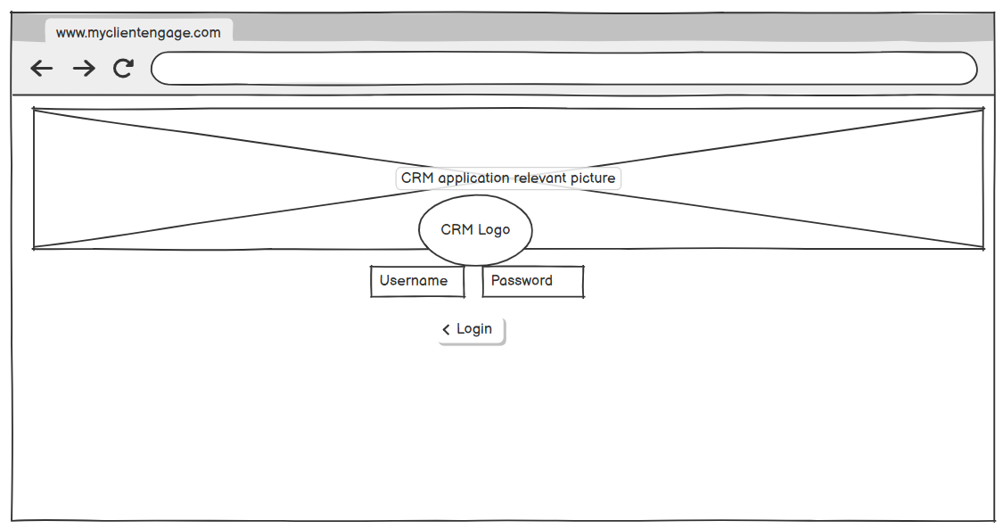
Lead creation page:
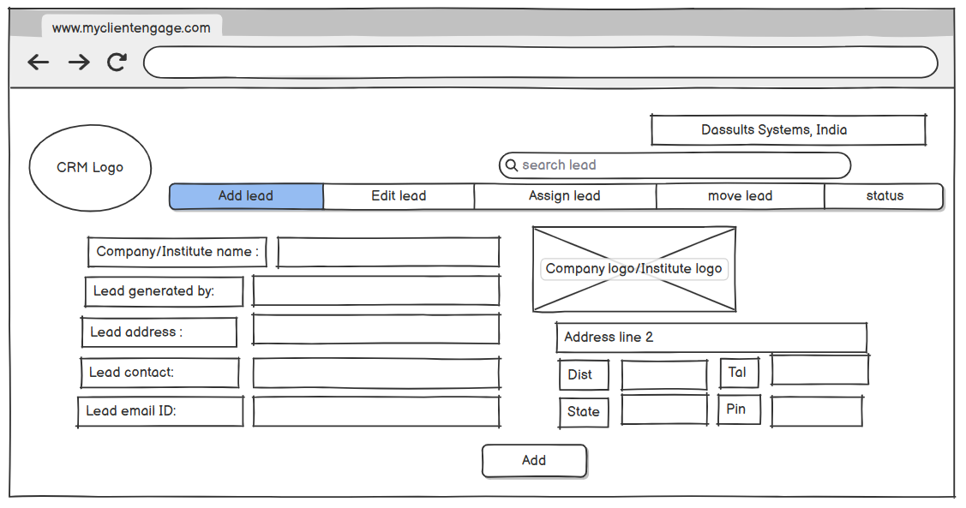
Meeting creation page:
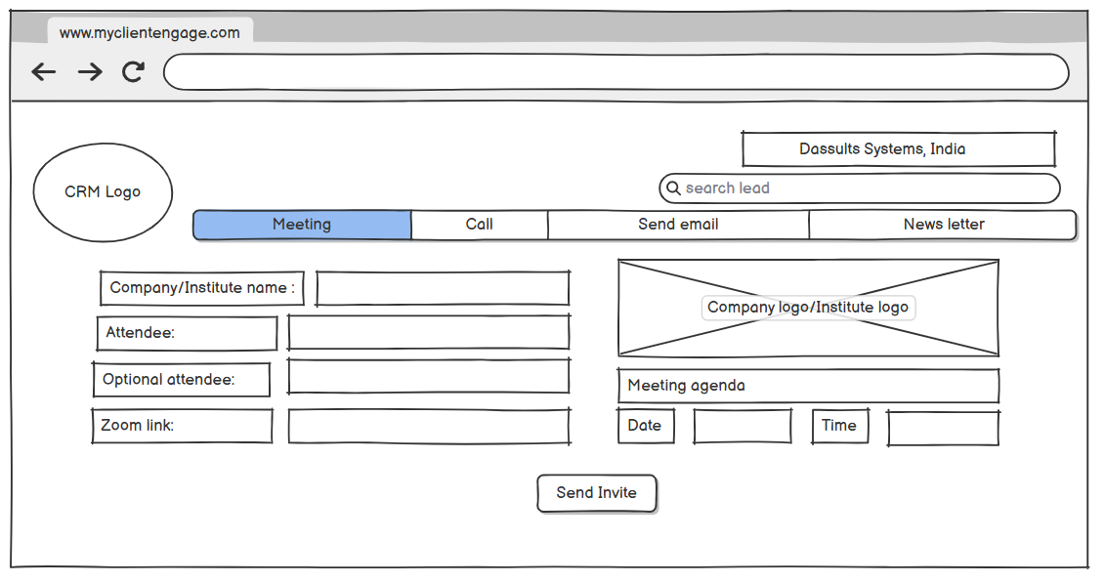
Email send page:
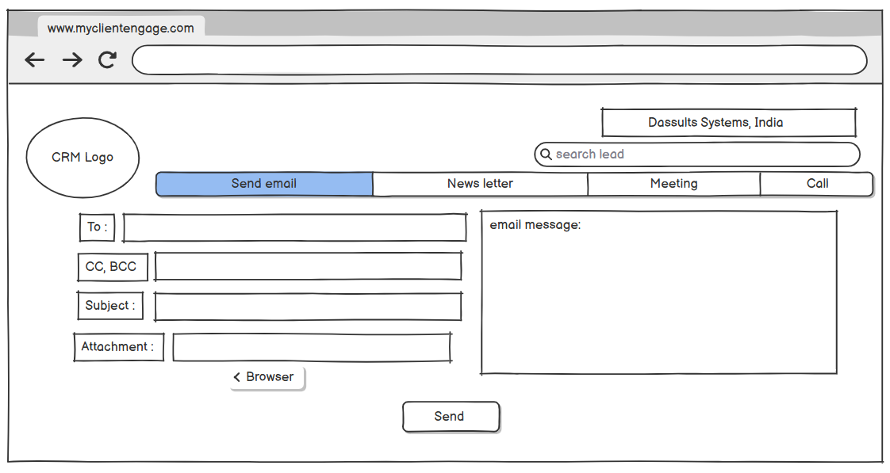
Estimation calculation:
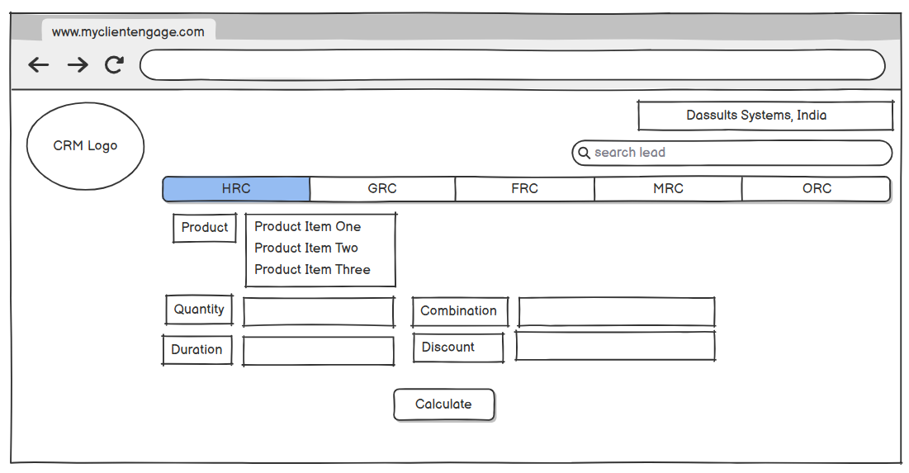

Document 8- Tools-Visio and Axure
As a Business Analyst involved in the development of an in-house My client engagement CRM application, the use of Visio and Axure proved instrumental in driving the project’s success.
Visio was utilized extensively to create clear, professional process flow diagrams, helping stakeholders visualize the end-to-end customer journey and understand complex workflows with ease. These diagrams played a crucial role in aligning business requirements with technical implementation.
Meanwhile, Axure enabled the creation of interactive wireframes and high-fidelity prototypes, allowing stakeholders to engage with a functional mock-up of the application early in the development process. This significantly reduced ambiguity, streamlined feedback loops, and facilitated informed decision-making.
Together, these tools enhanced communication across teams, ensured accurate requirement gathering, and reduced rework—ultimately helping me, as a Business Analyst, bridge the gap between business needs and technical solutions effectively and deliver a product that met both user expectations and organizational goals.
Document 9- BA experience:
My experience as BA in following phases:
1. Requirement gathering:
● To gather requirements, we used MOSCOW technique.
● Client is not available for some period of time during this phase. So as a BA i need to source out point of contacts from his side and get the information ASAP.
● I validate the requirements using FURPS technique
● There are many requirements which are duplicated or repeated. We need to remove them immediately
● Prototyping is used to give more specific requirements
2. Requirement Analysis:
● We need to draw UML diagrams to visually describe the requirements
● Activity diagrams also used to describe the process flow
● Communicate the diagrams to team. Some team members might not agree with them and might make changes. As a BA we need to consider the points and make modifications
● Prepare BRS and SRS
3. Design:
● From the use case diagrams, we prepare test cases
● Communicate with client on design and solution documents
● Write negative test cases as well along with positive test cases.
● Do not miss a single test case. It might have huge impact on project development in later stages
● Prepare test data for testing
● Update RTM. This is just as we need to make sure that all the requirements are met
4. Development:
● Organized JAD sessions
● Clarifying queries of tech team during coding
● There might be some team members who doesn't agree with the concept or who doesn’t cooperate during JAD sessions. As a BA i handle the situation gently and had one on one discussion with them. Explained how their actions are going to affect the project. Setup healthy environment within the team.
● Referred diagrams to code the Unit
● Conduct regular meetings with technical team and client which is challenging. Some team members might not be available for the meeting. Recording the session and providing that to missed one and having one to one discussion later with that missed person is all i need to do
5. Testing:
● Prepare test cases from use cases
● Perform high level testing
● Test data is requested by BA from client
● Updated RTM , Take signoff from client
● Prepare client for UAT
6. Deployment:
● Forwarded RTM to client which should be attached to project closure document
● Coordinates to complete and share end user manuals
● Plans and organizes training sessions
● Make sure all the candidates attend the meeting

